**LỚP 8 GHK1 FORM 2026 TEST 2**

***Mark the letter A, B, C or D on your answer sheet to indicate the word whose underlined part differs from the other three in pronunciation in each of the following questions.***

| **Question 1.** A. keep | B. know | C. kitchen | D. keen |
| --- | --- | --- | --- |
| **Question 2.** A tourist | B. join | C.choice | D. soil |

***Mark the letter A, B, C or D on your answer sheet to indicate the word that differs from the other three in the position of primary stress in each of the following questions.***

| **Question 3.** A. happen | B. enter | C. listen | D. begin |
| --- | --- | --- | --- |
| **Question 4.** A. concentrate | B. interested | C. enjoyable | D. atmosphere |

***Mark the letter A, B, C or D on your answer sheet to indicate the correct answer to each of the following questions.***

**Question 5.** There are a lot of amusement parks___________ our neighborhood.

| A. on | B. in | C. at | D. in front of |
| --- | --- | --- | --- |

**Question 6.** Ann is__________ her homework at the moment.

| 1. playing | B. making | C. skipping | D. doing |
| --- | --- | --- | --- |

**Question 7.** What do you usually……………..for breakfast?

A. to have B. have C. having D. has

**Question 8.** My younger brother is _________ on making models in his free time

| A. interested | B. fond | C. keen | D. crazy |
| --- | --- | --- | --- |

**Question 9.** It’s _________ time, so the villagers are busy cutting and gathering their crops.

| A. festival | B. harvest | C. growing | D. planting |
| --- | --- | --- | --- |

**Question 10.** I think countryside dwellers live _________ than city dwellers.

| A. happy | B. happier | C. happily | D. more happily |
| --- | --- | --- | --- |

**Question 11.** Many girls worry about their appearance, _____ they often look at themselves in a mirror.

A. but                     B. or                      C. so                            D. for

**Question 12.** Origami is the timeless Japanese art of _______.

A. paper folding B. car making C. snowboarding D.making models

***Read the following announcement and mark the letter A, B, C or D on your answer sheet to indicate the correct option that best fits each of the numbered blanks from 13 to 16.***

| **EXPLORE YOUR HOBBIES!**  Hobbies help us relax. My friend, Nam, really (13) playing football every weekend. My sister, Mai, loves (14) models and has a big collection. For me, collecting coins is very (15) .  I learn a lot from them. What do you usually do (16) your free time? Share your hobbies with us! | | | |
| --- | --- | --- | --- |
| **Question 13.** A. enjoy | B. enjoys | C. enjoying | D. enjoyed |
| **Question 14.** A. make | B. making | C. makes | D. made |
| **Question 15.** A. bore | B. bored | C. boring | D. boredom |
| **Question 16.** A. at | B. on | C. in | D. for |

***Question 17: Put the sentences (a-c) in the correct order, then fill in the blank to make a logical text.***

We had an unforgettable holiday in Singapore last week. Things didn’t go on as smoothly as we had expected before. _________

1. Upon our arrival at the Safari park 2 hours later, we realized that it was closed for maintenance.
2. It all started when my parents decided to visit the Safari park
3. We were so excited about the trip, but the moment that we left the hotel, it started raining.
4. b-c-a **B**. a-c-b **C**. c-b-a **D**. b-a-c

***Question 18: Choose the sentence that you can end the text (in Question 03) most appropriately.***

1. The we asked a local man who lived nearby how to get to the park.
2. First, the park kis really a must-visit for all nature lovers.
3. We finally got back to the hotel with sadness and disappointment.
4. To begin with, we had a lot of fun exploring the different animal exhibit here.

***Read the following passage and mark the letter A, B, C or D on your answer sheet to indicate option that best fits each numbered blank from 19 to 24.***

I am teaching at Binh Minh Lower Secondary School. My students (19) at grade 6, 7, and 8, and they have different (20) . Lan is studying at class 7A1. She is 13 years old. She likes writing poems and

(21) . Tung is 14 years old, and he has very interesting hobbies. He likes doing puzzles, designing websites, and playing the guitar. Long is 12 years old, and he is (22) class 6T1. His hobbies are playing football and (23) models. My students do many interesting things, and they are often busy. They also love different subjects. Tung is the (24) student in math. Lan is good at literature and arts, and Long is one of the best students in science. Their hobbies help them study well.

**Question 19.** A. is B. are C. be D. being **Question 20.** A. lessons B. subjects C. hobbies D. families **Question 21.** A. drawing B. draw C. to drawing D. to draw **Question 22.** A. at B. in C. about D. from **Question 23.** A. doing B. making C. having D. buying **Question 24.** A. good B. well C. better D. best

***Mark the letter A, B, C or D on your answer sheet to indicate the sentence that closest in meaning to the original sentence in each of the following questions.***

**Question 25.** I find dancing interesting.

1. I think that dancing is interesting.
2. I think dancing to be interesting.
3. Dancing give me interesting
4. Dancing is good for me

**Question 26.** My sister loves talking to her friends in her free time.

1. My sister enjoys talking to her friends in her free time.
2. My sister detests talking to her friends in her free time
3. My sister prefers talking to her friends to being at home.
4. My sister rarely talks to her friends in her free time.

***Mark the letter A, B, C or D on your answer sheet to indicate the sentence that is made from the given cues in each of the following questions.***

**Question 27.** your mother/go/to/market/everyday?

1. Does your mother goes to the market everyday?
2. Does your mother go to the market everyday?
3. Is your mother goes to the market everyday?
4. Is your mother go to the market everyday?

**Question 28.** He/often/get up/at 5 a.m./and/go/jogging/in/park.

1. He often gets up at 5 a.m and go jogging in the park.
2. He often get up at 5 a.m and go jogging in the park.
3. He often gets up at 5 a.m and goes jogging in the park.
4. He often gets up at 5 a.m and go jogging in the park.

**Question 29**: What does the sign say?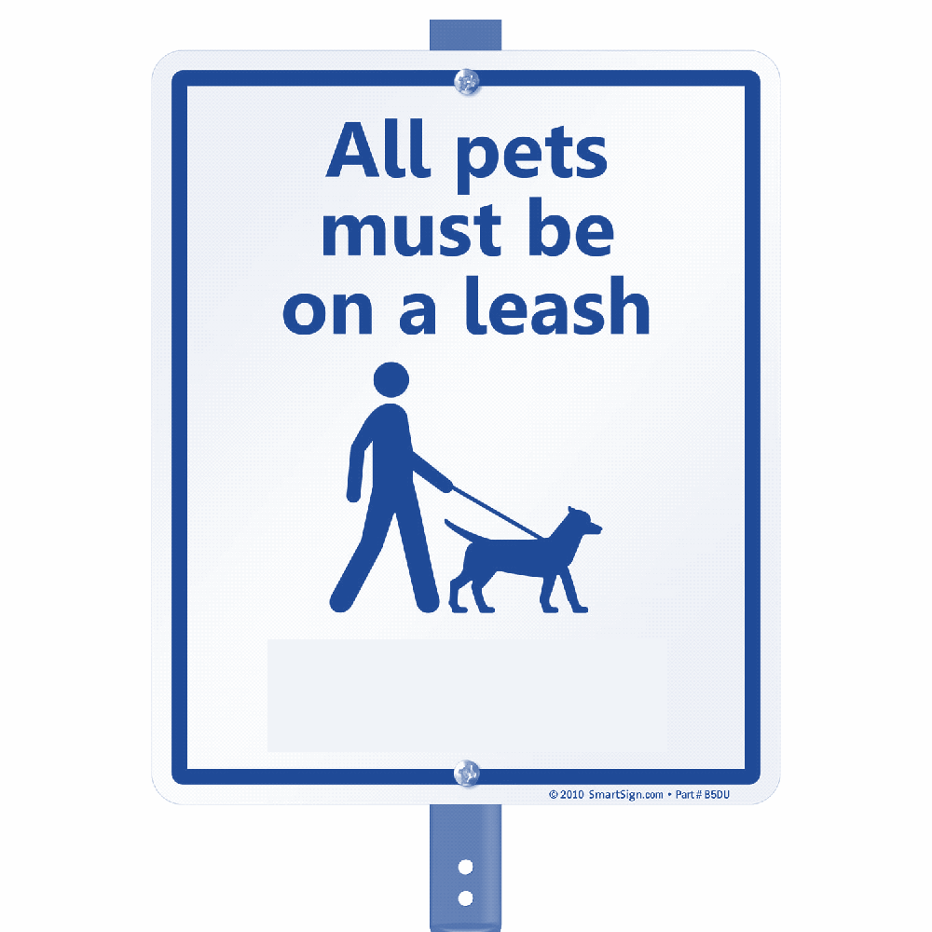

1. A. Anyone is allowed to enter without restrictions.  
   B. Only authorized personnel are permitted to enter.  
   C. No one is allowed to enter the area.  
   D. You should keep your dog on a leash while in the area.

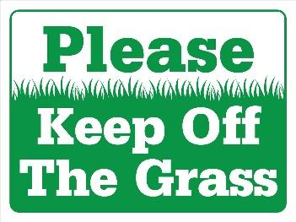

**Question 30:** What does the sign say?

A. You can walk on the grass and play games there.  
B. The grass should be kept clean and free of trash.  
C. You should not walk on the grass to help keep it healthy.  
D. The grass is for sitting and relaxing only.

***Read the following passage and mark the letter A, B, C or D on your answer sheet to indicate the correct answer to each of the following questions from 31 to 36.***

Stamp collecting is an interesting hobby. You can learn many things, such as the geography of a country from stamps. Postal stamps are a source of interesting facts and important dates about every country in the world. It makes stamp collecting become very popular.

As you look at the pages of a stamp album, you can learn interesting details of foreign customs, arts, literature, history and culture. Their colours can make you feel relaxed and happy.

Collecting stamps can become a **business**. If you are lucky in finding a special stamp, it will bring you some money besides knowledge and pleasure.

**Question 31.** Stamp collecting is an interesting hobby because .

1. you can learn many things such as the geography of a country from stamps
2. stamps give you interesting facts and important dates about a country
3. it is very important to collect stamps
4. A and B are correct

**Question 32.** All of the following are true EXCEPT .

1. stamps can make you relaxed and happy
2. stamps can make you know more
3. stamp collecting can make you famous
4. you can earn money from your collection if you are lucky

**Question 33.** According to the passage, it is true to say that .

1. stamp collecting helps you become rich and famous
2. stamp collecting is a very popular hobby
3. stamp collectors can earn a lot of money from stamp collecting
4. stamp collecting is a hobby that costs you a lot of money

**Question 34.** The word “**business**” in the last paragraph is closest in meaning to .

1. the activity of collecting stamps
2. the activity of selling stamps from other countries
3. the activity of buying stamps from other countries
4. the activity of buying or selling something

**Question 35.** The main idea of the passage is .

1. the history of stamp collecting
2. good things from stamp collecting
3. the ways of stamp collecting
4. famous stamp collectors

**Question 36.** What can you learn from looking at a stamp album?

1. How to collect stamps quickly
2. Only about the value of each stamp
3. Foreign customs, arts, literature, history, and culture
4. The names of famous stamp collectors

## ***Four phrases/ sentences have been removed from the text below. For each question, mark the letter A, B, C or D on your answer sheet to indicate the correct option that best fits each of the numbered blanks from 37 to 40.***

Mark always gets up at twelve in the morning. (37) . Mark likes having hamburgers, pizza, crisps and hot dogs for lunch. (38) . So there are not any vegetables or fruit at home. After lunch, (39) - 300 meters far away. At six o’clock, Mark goes to the bus stop and comes back home. He sits on his dad’s sofa and watches TV for three hours. When he is hungry, (40) . He usually goes to sleep at eleven or twelve because that he likes playing computer games. He usually stays at home all day at weekends.

* 1. he takes the bus to school
  2. he eats lots of sweets or chocolate biscuits and he always drinks cola
  3. He does not have breakfast
  4. He always has fizzy drinks like cola

**Question 37. Question 38. Question 39. Question 40.**