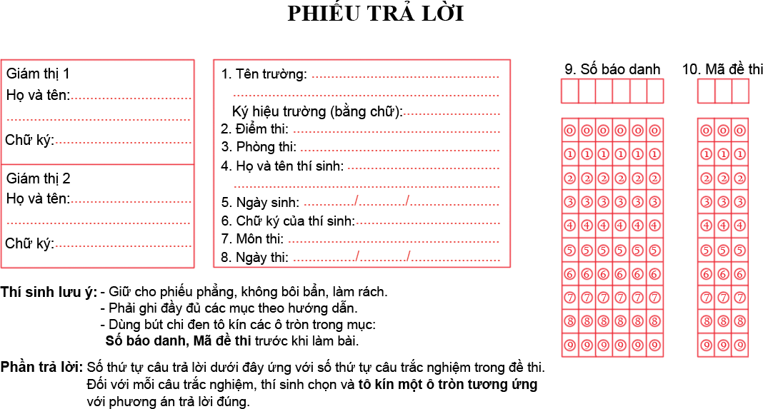

Phần trắc nghiệm khách quan:
01. | 05. | 09. | 13.
02. | 06. | 10. | 14.
03. | 07. | 11. | 15.
04. | 08. | 12. | 16.

Phần tự luận
Bài làm:
………………………………………………………………………………………………………………………………………………………………………………………………………………………………………………………………………………………………………………………………………………………………………………………………………………………………………………………………………………………………………………………………………………………………………………………………………………………………………………………………………………………………………………………………………………………………………………………………………………………………………………………………………………………………………………………………………………………………………………………………………………………………………………………………………………………………………………………………………………………………………………………………………………………………………………………………………………………………………………………………………………………………………………………………………………………………………………………………………………………………………………………………………………………………………………………………………………………………………………………………………………………………………………………………………………………………………………………………………………………………………………………………………………………………………………………………………………………………………………………………………………………………………………………………………………………………………………………………………………………………………………………………………………………………………………………………………………………………………………………………………………………………………………………………………………………………………………………………………………………………………………………………………………………………………………………………………………………………………………………………………………………………………………………………………………………………………………………………………………………………………………………………………………………………………………………………………………………………………………………………………………………………………………………………………………………………………………………………………………………………………………………………………………………………………………………………………………………………………………………………………………………………………………………………………………………………………………………………………………………………………………………………………………………………………………………………………………………………………………………………………………………………………………………………………………………………………………………………………………………………………………………………………………………………………………………………………………………………………………………………………………………………………………………………………………………………………………………………………………………………………………………………………………………………………………………………………………………………………………………………………………………………………………………………………………………………………………………………………………………………………………………………………………………………………………………………………………………………………………………………………………………………………………………………………………

