|  |  |  |
| --- | --- | --- |
|  | ĐỀ KIỂM TRA __________ Năm học: 20__ - 20__ Tiếng Anh - Lớp 5 Thời gian làm bài: 30 phút | |
| Trường: ________________________ Họ tên: _______________________ Lớp: _____________ | Điểm | Nhận xét của giáo viên |

|  |
| --- |
| **Tiếng Anh 5 i-Learn Smart Start - Kiểm tra cuối kỳ 1 Time allotted: 30 minutes** |

|  |  |
| --- | --- |
| **PART 1** | **LISTENING (10 questions)** |

**1. Listen and draw lines. There is one example. (3 questions)**

|  |  |  |  |
| --- | --- | --- | --- |
| Emma | Sarah | Fred | Harry |

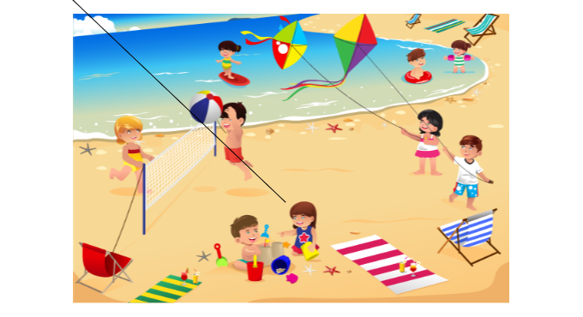

**4. Listen and match. There is one example. (3 questions)**

|  |  |  |  |
| --- | --- | --- | --- |
|  |  |  |  |

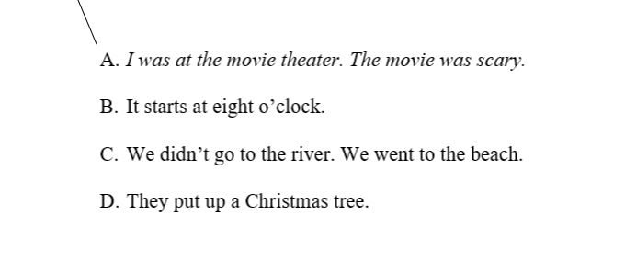

**Listen and choose the correct picture. There is one example. (4 questions)**

**Example:**

Where did William go on the holiday?

|  |  |  |
| --- | --- | --- |
|  |  |  |
| **A. ☑** | **B. ☐** | **C. ☐** |

**Questions:**

7. Who did William go with?

|  |  |  |
| --- | --- | --- |
|  |  |  |
| **A. ☐** | **B. ☐** | **C. ☐** |

8. How did he get there?

|  |  |  |
| --- | --- | --- |
|  |  |  |
| **A. ☐** | **B. ☐** | **C. ☐** |

9. What did he do there?

|  |  |  |
| --- | --- | --- |
|  |  |  |
| **A. ☐** | **B. ☐** | **C. ☐** |

10. When did he get home?

|  |  |  |
| --- | --- | --- |
|  |  |  |
| **A. ☐** | **B. ☐** | **C. ☐** |

|  |  |
| --- | --- |
| **PART 2** | **READING (10 questions)** |

**Read and match. There is one example. (3 questions)**

|  |  |  |  |
| --- | --- | --- | --- |
| **Example:** | Some people like climbing it and you can often see snow on the top of it. | ●  ● | A. mountain |
| 11. | A ghost movie is like this. |  | B. Halloween |
| 12. | You study this to know about bad things and good things. |  | C. scary |
| 13. | This holiday is on October 31st and people often wear costumes on that day. |  | D. ethics |

**Read the text. Fill in the blanks with the words from the box. There is one example. (3 questions)**

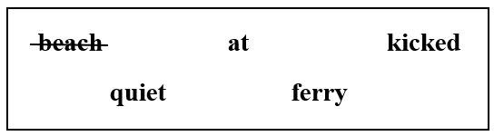

Fred and Jack went to the  *beach*  with their parents on holiday. Their dad gave them a huge ball to play with. "Let's play soccer with it," Jack said.
  
It was not easy to play with a huge ball but Fred scored three goals.
  
"I love soccer!" he said.
  
"Look! The monkeys like soccer too!" said Jack. He pointed to two monkeys in a tree. "They are watching us." Then Fred (14)___________ the ball hard again. It flew into the forest behind Jack. The forest was (15)___________ at that time.
  
"I'm sorry!" said Fred. Jack suddenly shouted, "The monkeys have gotten it!"
  
Jack and Fred laughed aloud. "The monkeys are playing soccer too! They are very good (16)___________ playing soccer."

**Read and choose circle True or False. (4 questions)**

|  |
| --- |
| **Nick's holiday**  Nick went to a small school in town. On the last day of school, Nick's teacher said that they had homework. It was to take a funny holiday photo. The next day, Nick went with his family to the forest. They didn't go to the beach. They went there by minibus and then they walked into the forest. His mom cooked, and everyone said it was delicious. His mom showed him how to bake cookies. Nick wanted to bake some for his family. Just then, the wind blew strongly to the fire and the cookies were black because it was too hot. "Oh no! Now we have black cookies!" said Nick. The black cookies were yucky, but his family wanted to eat them. Their mouths were black too. Nick's dad took a photo of them with black mouths. "That's my homework photo!" Nick said when he came back to school at the end of the holiday. |

| **Answers** | **True** | **False** |
| --- | --- | --- |
| 17. The family went to the forest by car. | **◯** | **◯** |
| 18. Nick's mother cooked delicious food. | **◯** | **◯** |
| 19. The cookies Nick baked were black. | **◯** | **◯** |
| 20. Nick had a funny photo for his homework. | **◯** | **◯** |

|  |  |
| --- | --- |
| **PART 3** | **WRITING (10 questions)** |

**Order the letters. There is one example. (3 questions)**

**Example:**

|  |  |  |
| --- | --- | --- |
|  |  | Keywords: y/h/o/i/s/t/r  → h i s t o r y |

**Questions:**

|  |  |  |
| --- | --- | --- |
| 21. |  | Keywords: o/c/n/d/s/e  → ....................................... |

|  |  |  |
| --- | --- | --- |
| 22. |  | Keywords: i/a/S/n/p  → ....................................... |

|  |  |  |
| --- | --- | --- |
| 23. |  | Keywords: i/g/s/n/k/a/o/k/e/r/a  → ....................................... |

**Reorder the words to make a correct sentence. There is one example. (4 questions)**

**Example:**

|  |  |
| --- | --- |
|  | Keywords: went/last/South/Korea/I/to/month/.  → I went to South Korea last month . |

**Questions:**

|  |  |
| --- | --- |
| 24. | Keywords: didn't/by/park/to/amusement/the/minibus/go/We/.  → ....................................... |

|  |  |
| --- | --- |
| 25. | Keywords: do/Lunar/What/to/celebrate/New Year/do/people/?  → ....................................... |

|  |  |
| --- | --- |
| 26. | Keywords: movie/at/family/was/with/theater/Tom/the/his/.  → ....................................... |

|  |  |
| --- | --- |
| 27. | Keywords: class/His/on/starts/science/Thursdays/9 a.m./at/.  → ....................................... |

**Look, read, and write. (3 questions)**

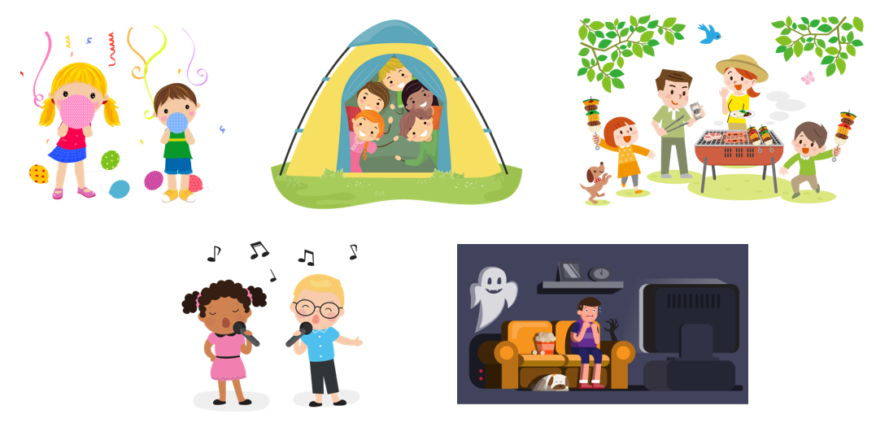

To: Mark2014@gmail.com
  
Subject: Weekend
  
​​
  
​Dear Mark,
  
How are you? How was your weekend?
  
I had a great weekend with my  *friends* . We had a party at my house on Saturday. We had a (28)___________ in the garden. We also played games and sang (29)___________ at night. In Vietnam, children like singing. Nam, my friend, wanted to watch a movie. The movie was (30)___________, but we had a lot of fun. Because it was late, they had a sleepover at my house. It was a great weekend. Here are the photos of us. Do you like them? Write me about your weekend.
  
Best wishes,
  
Hoa

**---THE END---**