School: ……………………………………….. | Date:……………………………………..
Class: ……………………………..................... | Period: …………………………….........

UNIT 1: FREE TIME
Lesson 3.2 – Speaking and Writing (Page 11)

I. OBJECTIVES
By the end of the lesson, Ss will be able to:
1.1. Language knowledge and skills
- use some adjectives to talk about extreme sports (exciting, dangerous, fascinating, challenging, adventurous).
- invite a friend to join an activity.
- write an invitation email to ask a friend to join an activity.
1.2. Competences
- improve communication, collaboration, writing and critical thinking skills.
1.3. Attributes
- take up a sport and practice it regularly.
- be careful when trying extreme sports.

II. TEACHING AIDS AND LEARNING MATERIALS
1. Teacher’s aids: Student book and Teacher’s book, class CDs, Digital Book (DCR phần mềm tương tác SB, DHA (từ vựng/ cấu trúc) phần mềm trò chơi tương tác), projector/interactive whiteboard / TV (if any), PowerPoint slides.
2. Students’ aids: Student’s book, workbook, notebook.

III. ASSESSMENT EVIDENCE
Performance Tasks | Performance Products | Assessment Tools
- Speaking: Discuss what you think the activities in the pictures are like.  - Choose one of the extreme sports or choose your own activity. Then, take turns asking and answering the questions below.  - Writing: Read about writing invitation emails and number the parts.  - Reorder the parts of the email. Use the skill box.  - Write an invitation email to ask a friend to join you for an activity. | - Ss’ answers.  - Ss’ performance.  - Ss’ answers.  - Ss’ answers.  - Ss’ answers/ presentation. | - T’s feedback.  - T’s observation/ DCR.  - T’s observation.  - T’s feedback/Peers’ feedback.  - T’s feedback/Peers’ feedback.  - T’s observation and feedback.

IV. PROCEDURES
A. Warm up: (5’)
a) Objective: Introduce the new lesson and set the scene for Ss to acquire new language; get students' attention at the beginning of the class by enjoyable and short activities as well as to engage them in the follow-up steps.
b) Content: Review names of some extreme sports.
c) Expected outcomes: Ss remember names of some extreme sports that they are going to talk about in the lesson.
d) Organization of the activity:
TEACHER’S ACTIVITIES | STUDENTS’ ACTIVITIES
Option 1: Jigsaw puzzle  - Divide class into groups.  - Give each group a set of many pieces of paper, have them use these pieces to make a right picture about an extreme sport, then give the name of the extreme sport.  - The group which has a correct picture and give the right name of that extreme sport in the shortest time will be the winner.  - Give a small present to the winner and the runner-up.  - Ask Ss extra question: What do you think about this extreme sport?  - Have Ss give answers.  - Give feedback and evaluation.  - Lead to the new lesson.  (T can use same activity for the picture: windsurfing.)    - Option 2:  - Give Ss icons of some extreme sports.  - Have Ss give the right name of each icon.  - Call Ss to give answers.  - Give feedback.  àLead to the new lesson.   | - Take part the games in groups.  - Give answers.  - Listen.  Answer keys    Name of the extreme sport: mountain biking  - Work in pairs.  - Look and give answers.  - Listen.  Answer keys  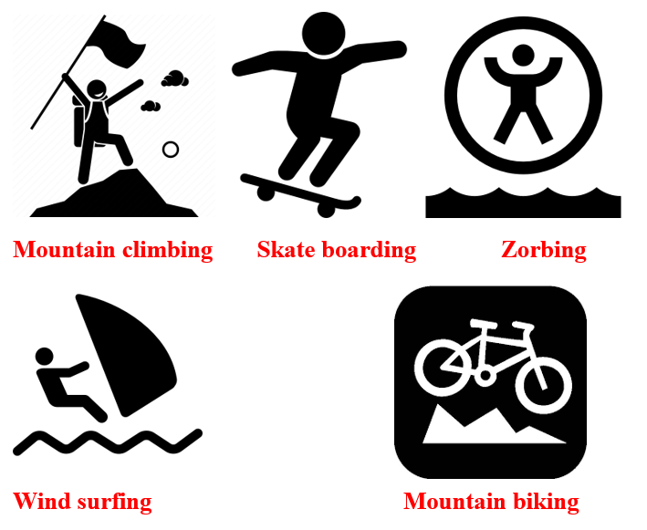

B. New lesson (35’)
- Activity 1: Pre-Writing (Speaking) (10’)
a) Objective: Ss prepare for what they are going to write about.
b) Content:
- Speaking: Discuss what you think the activities in the pictures are like.
- Asking and answering the questions about planning for joining an extreme sport activity.
c) Expected outcomes: Ss can use some adjectives to talk about extreme sports and they can apply the language from speaking to their writing.
d) Organization of the activity:
TEACHER’S ACTIVITIES | STUDENTS’ ACTIVITIES
Task a. Look at the pictures in the lesson. Discuss what you think the activities are like.  - Have Ss observe the pictures (using DCR), then work in pairs to discuss what they think the activities are like.  - Remind Ss to use more adjectives to describe (exciting, dangerous, fascinating, challenging, adventurous, …)  - Have some Ss share their ideas with the class.  - Give feedback and evaluation.  Task b. Choose one of the extreme sports or choose your own activity. Then, take turns asking and answering the questions below and note your ideas.  - Have Ss choose an extreme sport (from the pictures in the books or their own).  - Have Ss take turns asking and answering the questions, then note their ideas in the table.  - Have some pairs share their ideas with the class  - Give feedback and evaluation. | - Look and discuss.  - Give answers.  - Work in pairs: Choose an extreme sport, asking and answering the questions, then note discussed ideas in the table.  - Present.
- Activity 2: While - Writing (20’)
a) Objective: Students can develop their writing skill.
b) Content: - Numbering the parts of an invitation email.
- Reordering the parts of an invitation email.
- Writing an invitation email to ask a friend to join you for an activity.
c) Expected outcomes: Students can write an invitation email, using the Present Continuous, prepositions of place and structures of suggestion.
d) Organization of the activity:
TEACHER’S ACTIVITIES | STUDENTS’ ACTIVITIES
Task a. Read about writing invitation emails. Then, read Mark’s email again and number the parts.  -Briefly explain the Writing skill box (using DCR).  - Have Ss read the Writing skill box and Mark’s email again (page 10), then number the pars of his email.  - Have Ss check their answers with a partner.  - Call Ss to give answers.  - Check answer as a whole class.  Task b. Reorder the parts of the email. Use the skill box to help you.  - Use DCR to show the task.  - Have Ss read the email and reorder the parts.  - Have Ss check their answers with a partner.  - Call Ss to give answers.  - Check answer as a whole class.  *Let’s Write: Now, write an invitation email to ask a friend to join you for an activity. Use the feedback form to help you.  - Draw Ss’ attention to the feedback form (using DCR).  - Have Ss use their notes in speaking part and the form of the invitation email to write an invitation email to ask a friend to join them for an activity.  - Have some Ss write their emails in front of the class. | - Listen.  -Work in pairs.  - Exchange their answers with a partner.  - Give answers.  Answer keys  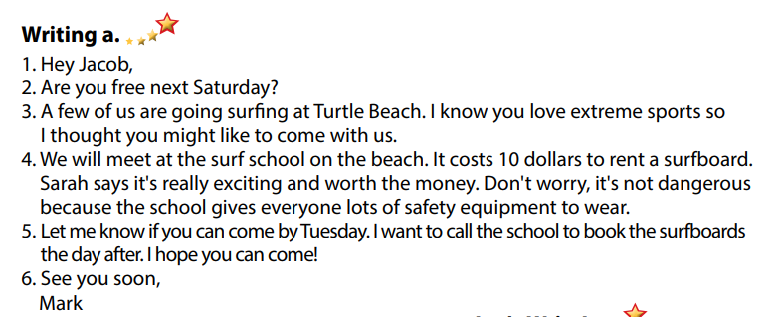  - Read and reorder the parts.  - Exchange answers.  - Give answers.  Answer keys  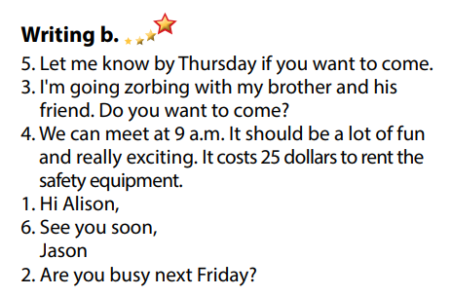  - Look and listen.  - Do the writing part.  -Write.  Sample answer  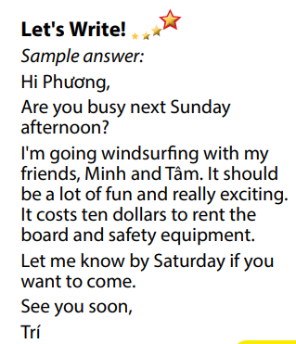

- Activity 3: Post - Writing (5’)
a) Objective: Help Ss realize their mistakes in writing and correct them.
b) Content: Correcting Ss’ writings.
c) Expected outcomes: Students know whether their emails follow the model and uses the correct structures, whether their writings are interesting and understandable or not.
d) Organization of the activity:
TEACHER’S ACTIVITIES | STUDENTS’ ACTIVITIES
Conversation skill  - Give feedback, correct Ss’ mistakes.  - Use the feedback form to give evaluation. Focus on:  + the format, the structures.  + the understandability.  + the coherence and cohesion. | - Look, listen and correct mistakes.

C. Consolidation and homework assignments (5’)
* Consolidation:
- Adjectives to describe extreme sports: exciting, dangerous, fascinating, challenging, adventurous, …
- Format of an invitation email:
1. Start with a greeting
2. Check their availability
3. Write the invitation
4. Give more details
5. Ask for a reply
6. Sign off
* Homework
- Remember how to write an invitation letter.
- Finish the writing part.
- Do the exercises in WB: Writing (page 7).
- Complete the grammar notes in Tiếng Anh 7 i-Learn Smart World Notebook (page 9).
- Play consolation games in Tiếng Anh 7 i-Learn Smart World DHA App on www.eduhome.com.vn
- Prepare: Unit 1 – Review (page 84).

D. Reflection
a. What I liked most about this lesson today:
…………………………………………………………………………………………
- What I learned from this lesson today:
…………………………………………………………………………………………
c. What I should improve for this lesson next time:
…………………………………………………………………………………………

