Date of preparing: ………………………………….
Date of teaching: ………………………………….

Period……
UNIT 3: FRIENDS
Lesson 4 - REVIEW (Page 90)

I. OBJECTIVES
By the end of the lesson, Ss will be able to…
1. Knowledge
- review people’s appearance and character.
- activities friends do together.
- review the use of English: The Present and Present Continuous.
2. Ability
- improve the listening, reading, speaking and writing skills
3. Quality
- have positive attitude in English language learning so that they actively participate in all classroom activities.
- review the old lesson and have good preparation for any assessment.

II. TEACHING AIDS AND LEARNING MATERIALS
Lesson plan, PPT slides, student’s book, workbook, notebook, personal computer (if any), projector/TV, speakers, DCR & DHA on Eduhome, handouts
III. PROCEDURES
A. Warm up: (5’)
a) Objective: Introduce the new lesson and set the scene for Ss to review the target language; get students' attention at the beginning of the class by means of enjoyable and short activities as well as to engage them in the steps that follow.
b) Content: Revision of vocabulary.
c) Product: Ss can be ready for the lesson.
d) Competence: Collaboration, critical thinking.
e) Organization of the activity:
Teacher’s Activities | Students’ Activities
- Give greetings  - Check attendance  - Option 1: Vocabulary (page 91)  - Use the vocabulary part (page 91) and pictures for the warm-up activities  - Have Ss close all books.  - Have Ss read the sentences (and the pictures), guess and give answers  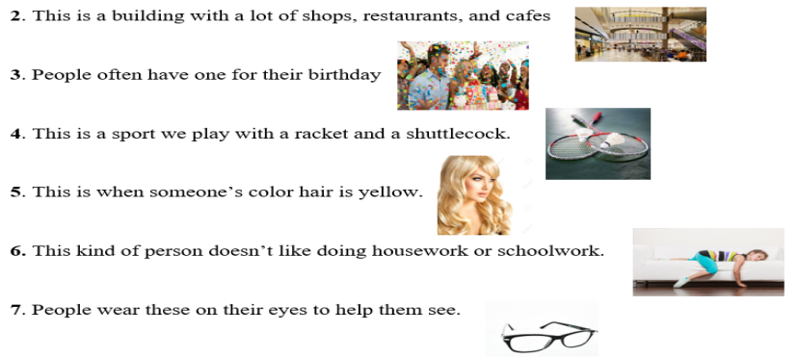  → Lead to the new lesson.  - Option 2: Word Dictation  - Choose 7 words from Vocabulary task (page 91), find mp3 sound  - Play each word, have Ss listen and write the word down on the board  - Check and correct Ss’ answers  - Give feedback  → Lead to the new lesson | - Greet T  - Look and give answers  Answer keys  2. mall  3. party  4. badminton  5. blond  6. lazy  7. glasses  - Look and give answers  Answer Keys  1. kind  2. mall  3. party  4. badminton  5. blond  6. lazy  7. glasses

B. New lesson (36’)
- Activities 1: Listening (10’)
a) Objective: Ss improve their listening skill
b) Content:
- Listening and choosing the correct answer
c) Products: Ss listen for details and get familiar with the listening test format.
d) Competence: Collaboration, analytical and synthesizing skills.
e) Organization of the activity:
Teacher’s Activities | Students’ Activities
You will hear Jenny and Tom talking about their brothers and sisters (twice). Answer each question by choosing the correct answer (A, B or C)  - Have Ss read the questions, guess answers  - Demonstrate the activity by using the example  - Play the audio (CD 2 – Track 65)  - Have Ss check answers with pairs and then give answers  - Check answers as a whole class | - Read in silence  - Listen and then give answers  - Check and correct mistakes  Answer keys  1.B 2.C 3.B 4.C 5.A
- Activity 2: Reading (7’)
a) Objective: Ss can improve reading skill.
b) Content: Reading a text and choose the correct answer.
c) Products: Ss read for comprehension and get familiar with the reading test format.
d) Competence: Collaboration, analytical and synthesizing skills.
e) Organization of the activity:

Teacher’s Activities | Students’ Activities
Read the text. Choose the best word (A, B or C) for each space  - Demonstrate the activity by using the example  - Have Ss read the text and choose the correct answer  - Call Ss to give answers, explain  - Give feedback and evaluation | - Observe and listen  - Work individually  - Give answers  Answer keys  1.A 2.C 3.A 4.C 5.B
- Activity 3: Vocabulary (9’)
Notes: no need to carry out this activity if teacher has picked the “Vocabulary” part for the warm-up activity.
a) Objective: Ss can review vocabulary about appearance, characteristics and activities
b) Content: Writing the correct words from the unit on the lines.
c) Products: they can use these vocabularies correctly, confidently in communication.
d) Competence: Collaboration, analytical and synthesizing skills.
e) Organization of the activity:

Teacher’s Activities | Students’ Activities
Fill in the blanks with the words from the box  - Have Ss read the sentences  - Ask Ss to work in pairs to write  - Have Ss give answers,  - Check answers as a whole class | - Look  - Work in pairs  - Give answers  - Listen, correct mistakes  Answer keys  1. kind  2. mall  3. party  4. badminton  5. blond  6. lazy  7. glasses
- Activity 4: Grammar (5’)
a) Objective: Ss can review the use of English: The Present and Present Continuous.
b) Content: Circling the correct words.
c) Products: Ss can review the target language learnt and use it correctly, confidently in communication.
d) Competence: Collaboration, communication, analytical and synthesizing skills.
e) Organization of the activity:

Teacher’s Activities | Students’ Activities
Circle the correct words  - Ask Ss to work individually to circle the correct answer  - Have Ss work in pairs to check each other’s work  - Call Ss to give answers, explain for their choice  - Check answers as a whole class | - Work individually  - Work in pairs  - Give answers  - Listen, correct mistakes  Answer keys  1. is  2. doing  3. like  4. is  5. not  6. does  7. having
- Activity 5: Pronunciation (5’)
a) Objective: Ss can review the word stress, vowels and consonants
b) Content: Circling the word that has the underlined part pronounces differently from the others and circling the word that has different stress from the rest.
c) Products: Ss know how to pronounce these words correctly in communication.
d) Competence: analytical and synthesizing skills, communication, collaboration.
e) Organization of the activity:

Teacher’s Activities | Students’ Activities
Circle the word that has the underlined part pronounced differently from the others.  - Have Ss distinguish the sound /i/ and / ai/  - Have Ss review the sound /bl/  - Ask Ss to work individually  - Have Ss work in pairs to check each other’s work  - Call Ss to give answers, pronounce the words again  - Give feedback, correct Ss’ pronunciation if necessary  Circle the word that differs from the other three in the position of primary stress in each of the following questions.  - Remind Ss some basic rules of putting stress on words with 2 or 3 syllables.  - Ask Ss to work individually  - Have Ss work in pairs to check each other’s work  - Call Ss to give answers, pronounce the words again  - Give feedback, correct Ss’ pronunciation if necessary | - Listen  - Work individually  - Work in pairs  - Give answers  - Listen, correct mistakes  Answer keys  1. B 2. C 3. D  - Listen  - Work individually  - Work in pairs  - Give answers  - Listen, correct mistakes  Answer keys  4. A 5. B 6. C

C. Consolidation (3’)
* Grammar of Unit 3: The Present and Present Continuous
* Vocabulary of Unit 3: Vocabulary about people’s appearance and character, activities friends do together

D. Homework (2’)
- Review vocabulary, grammar of unit 3.
- Do exercises in Workbook: Review of Unit 3 (page 64).
- Prepare: Unit 4 – Vocabulary and Listening (page 30 – SB).

