BỘ ĐỀ ÔN LUYỆN NƯỚC RÚT  ĐỀ THI THỬ SỐ 05  (Đề thi có 7 trang) | KỲ THI TỐT NGHIỆP TRUNG HỌC PHỔ THÔNG  Môn thi: TIẾNG ANH  Thời gian làm bài: 50 phút, không kể thời gian phát đề
Họ, tên thí sinh: ……………………………………………  Số báo danh: ………………………………………………. |  | Mã đề: 1126

Read the following message and mark the letter A, B, C or D on your answer sheet to indicate the option that best fits each of the numbered blanks from 1 to 6.
Corporate Communications Department Memorandum

TO: All Staff Members
FROM: IT Support Team
DATE: October 25, 2025
RE: New Phone System Implementation
Dear Colleagues,
We are pleased to announce that our company has successfully (1) ______ over to a state-of-the-art digital telephone system. This upgrade will enhance communication efficiency across all departments.
1. Key Features
The new system provides (2) ______ of advanced capabilities including call forwarding, voicemail-to-email, conference calling, and automated attendant services.
2. Making Calls
To place external calls, dial 9 first, (3) ______ enter the complete phone number including area code. Internal extensions remain unchanged.
3. Technical Support
Our (4) ______ help desk team is available 24/7 to address any technical issues. For assistance, please call extension 5000 (5) ______ submit a support ticket through the company portal.
We encourage everyone to (6) ______ themselves with the new system’s user manual, which has been emailed to all staff members. Training sessions will be conducted next week.
Thank you for your cooperation.
  - (Adapted from corporate communication guidelines)
Question 1. A. switched B. transferred C. converted D. transformed
Question 2. A. an array B. a volume C. an amount D. a quantity
Question 3. A. then B. so C. yet D. for
Question 4. A. dedicated technical multilingual B. multilingual dedicated technical
C. technical multilingual dedicated D. multilingual technical dedicated
Question 5. A. or B. and C. but D. nor
Question 6. A. familiarize B. accustom C. habituate D. orientate

Read the following passage and mark the letter A, B, C or D on your answer sheet to indicate the option that best fits each of the numbered blanks from 7 to 11.
Public education systems emerged in the 19th century as nations recognized the importance of an educated citizenry. (7) _______. This movement reflected growing beliefs that literacy and basic knowledge were essential for economic development and social progress.
Early public schools faced numerous challenges, including inadequate funding and resistance from traditional institutions. (8) _______. Despite these obstacles, reformers continued advocating for universal access to education, arguing it would reduce poverty and crime.
The establishment of compulsory attendance laws marked a turning point in educational history. (9) _______. This legislation ensured that children from all social classes received at least elementary instruction in reading, writing, and arithmetic.
Teacher training programs evolved to meet the demands of expanding school systems across Europe and America. (10) _______. These institutions helped standardize educational practices and improve the quality of instruction in public classrooms.
By the early 20th century, public education had become a cornerstone of modern society. (11) _______. Today, access to free education is widely recognized as a fundamental human right and a prerequisite for democratic participation.
  - (Adapted from Britannica, “Education: Western Education in the 19th Century”)
Question 7. A. Prussia instituted free, state-funded schooling during the early 1800s, a model other European nations subsequently adopted
B. State-funded schooling introduction occurred in other European countries following Prussia’s early 1800s free school adoption
C. Other European countries emulated free schooling after Prussia introduced state-funded schools throughout the early 1800s
D. Free schooling adoption by Prussia prompted other European nations to institute state-funded educational systems in the early 1800s
Question 8. A. Numerous families depended on children’s labor for income; consequently, school attendance entailed losing valuable workers
B. Children’s labor constituted valuable workers for families, making school attendance equivalent to income loss
C. Sending children to school meant families relinquished valuable workers upon whom they relied for income
D. Valuable workers were dispatched to school, representing income loss for families dependent on children’s labor
Question 9. A. Governments instituted mandatory school attendance for children aged six to fourteen during this epoch
B. This period witnessed governments initiating compulsory school attendance requirements for children aged six to fourteen
C. School attendance became obligatory for children between six and fourteen as governments established requirements during this period
D. Children aged six to fourteen experienced this period when governments mandated school attendance
Question 10. A. Normal schools were established to prepare individuals for teaching careers, providing both academic and practical training
B. Individuals received academic training through normal schools established for teaching career preparation with practical components
C. Teaching career preparation occurred through normal school establishment, offering individuals both academic and practical training
D. Academic and practical training characterized normal schools established to prepare individuals for teaching professions
Question 11. A. Educational systems persist in expanding opportunities, furnishing specialized instruction that prepares students for diverse careers
B. Specialized instruction facilitates diverse career preparation as educational systems continue opportunity expansion for students
C. Diverse careers receive specialized instruction through educational systems continuing opportunity expansion for student preparation
D. Students receive preparation through educational systems perpetually expanding opportunities and providing specialized instruction

Read the passage and mark the letter A, B, C or D on your answer sheet to indicate the best answer to each of the following questions from 12 to 19.
Influencer marketing leverages creators whose audiences trust their recommendations to publicize a brand’s offer. Rather than renting attention through ads, brands borrow credibility, reaching people predisposed to care. The practice typically remunerates creators to deliver content from a negotiated brief and timeline; outcomes are then tracked. Because the creator’s authority is pre-existing, such campaigns can rival paid media for efficiency, especially when audience–product fit is tight. In short, influence works by converting trust into action across preferred platforms.
Defining an influencer hinges on demonstrable pull: the capacity to nudge followers to click, read, subscribe, or purchase. Creators range from nano and micro to macro and mega tiers. Budget matters, but suitability matters more: audience relevance and engagement rates are pivotal. Micro creators often sustain 3–7% engagement, whereas mega figures hover nearer 1%. As follower counts swell, passive onlookers accumulate, diluting interaction. Consequently, many brands court smaller, highly-engaged niches where persuasion feels conversational rather than broadcast.
Brands pursue influencers because results are both potent and legible. Marketers widely judge the channel effective, not least since audiences treat creator guidance as credible and specific. Partnerships also filter for better customers by targeting communities already intrigued by a category. Crucially, sponsored posts yield measurable signals – conversions, click-throughs, views, and reach – so performance can be attributed to particular creators and platforms. When numbers clarify what works, budgets migrate accordingly; they also encourage repeat collaborations that scale what already resonates.
A typical program proceeds methodically: find aligned creators; agree a brief; manage production; approve assets; publish; measure ROI. Contracts codify deliverables, deadlines, tracking links, and ownership, while disclosures keep campaigns lawful. Brands should plan in detail yet leave room for the creator’s distinctive voice. Integration with wider efforts – ads, SEO, email – amplifies impact, and network choice follows the target audience, whether Instagram, YouTube, LinkedIn, or emerging streams. Above all, transparent labeling ensures content is compliant with advertising rules.
  - (Adapted from ManyChat Blog: “What Is Influencer Marketing?”)
Question 12. Which of the following is NOT mentioned in paragraph 2 as a factor when selecting influencers?
A. audience relevance B. engagement rates
C. production equipment quality D. budget considerations
Question 13. The word legible in paragraph 3 can be best replaced by ______?
A. decipherable B. ornamental C. precarious D. redundant
Question 14. The word compliant in paragraph 4 is OPPOSITE in meaning to ______.
A. defiant B. obedient C. amenable D. acquiescent
Question 15. The word they in paragraph 3 refers to ______.
A. budgets B. numbers C. collaborations D. platforms
Question 16. Which of the following best paraphrases the underlined sentence in paragraph 4?
A. Thorough preparation is necessary, though brands must allow creators sufficient latitude to maintain their unique personal style.
B. Detailed planning is essential, but creators should retain stylistic freedom to engage their audiences authentically.
C. Comprehensive planning should balance brand consistency with preserving the creator’s signature communication approach.
D. Strategic planning requires precision, yet accommodating the creator’s authentic expression strengthens campaign resonance.
Question 17. Which of the following is TRUE according to paragraph 1?
A. Influencer campaigns convert existing audience trust into action, often matching paid ads in efficiency.
B. Influencer posts cannot be tracked reliably, so outcomes are mostly inferred from brand sentiment.
C. Brands usually avoid briefs and timelines, preferring spontaneous content to increase authenticity.
D. Audience–product fit is ignored because reach is the only determinant of campaign performance.
Question 18. Which paragraph mentions that micro creators often maintain higher engagement percentages than mega figures?
A. Paragraph 1 B. Paragraph 2 C. Paragraph 3 D. Paragraph 4
Question 19. Which paragraph mentions legal disclosure and adherence to advertising rules?
- Paragraph 1 B. Paragraph 2 C. Paragraph 3 D. Paragraph 4

Read the passage and mark the letter A, B, C or D on your answer sheet to indicate the best answer to each of the following questions from 20 to 29.
Right to Repair affirms that if you bought a device, you should be free to fix it – yourself or wherever you choose. Many manufacturers corral repairs into proprietary channels, imposing restrictive regimes that gatekeep diagnostics and parts. [I] This consolidation creates a monopoly on repair, letting companies name their price, dictate turnaround, and decline “uneconomical” fixes, with predictable fallout: gadgets are discarded prematurely. Legally and ethically, critics argue, such lock-ins externalize waste while eroding consumer autonomy and local repair economies.
Legislative proposals seek to redress that asymmetry by requiring manufacturers to supply repair documentation, parts, and tools to consumers and independent shops. By mandating open access to manuals, parts, and tools, lawmakers aim to puncture manufacturers’ repair monopolies rather than micromanage how people repair. The practical effect would be to normalize community repair and allow informed DIY. [II] Opponents warn about safety and intellectual property; supporters counter that transparency, not secrecy, is the credible route to safe, affordable, environmentally prudent maintenance.
Since 2003, iFixit has agitated for repair-friendly design and policy. Early on, industry largely ignored these calls; persistence turned iFixit into a repair authority that publishes teardowns, assigns repairability scores, and publicly calls out unfixable designs. In 2014, the group helped craft the first-ever electronics Right to Repair bill. [III] Subsequent campaigns have supported legislation in forty-six U.S. states and in the European Union, building a transatlantic coalition that reframes repair as infrastructure, not niche hobby.
Advocacy has been concrete as well as conceptual: iFixit publicly urged New York Governor Kathy Hochul to sign a state repair bill via a billboard along her commute. It even drove a tractor to the Colorado legislature to celebrate the first agricultural repair law’s passage. The group co-sponsored California’s bill, which cleared the State Senate in June 2023. [IV] In Europe, iFixit has been a founding member of coalitions such as Repair.eu and Runder Tisch Reparatur, sustaining momentum.
  - (Adapted from https://www.ifixit.com/right-to-repair-action)
Question 20. According to paragraph 1, the manufacturers’ repair monopoly allows them to ______.
A. set high prices and refuse fixes, hastening devices’ needless disposal
B. standardize community repair, reducing e-waste through shared service manuals
C. expand consumer choice by licensing any shop without rigorous oversight
D. subsidize neighborhood workshops to ensure equitable access to routine maintenance
Question 21. The word restrictive in paragraph 1 mostly means ______.
A. severely limiting B. loosely generous
C. overtly permissive D. mildly expansive
Question 22. Which of the following best summarises paragraph 2?
A. Lawmakers propose transparency mandates providing manuals, parts, and tools, to break repair monopolies while encouraging safe DIY and community repair practices.
B. Governments plan to nationalize repair centers and set uniform prices, ensuring consumer protection through centralized oversight and technical certification.
C. Proposals focus on banning independent shops entirely to minimize safety risks and reduce counterfeit parts entering fragile consumer markets.
D. Parliamentary committees encourage secrecy around manuals and tools to protect intellectual property while promoting extended warranties as the only remedy.
Question 23. What helped iFixit become regarded as an authority on repair?
A. Persisted with teardowns and repairability scores, publicly challenging unfixable, opaque product designs.
B. Purchased major manufacturers and redirected their service divisions toward consumer education initiatives.
C. Filed dozens of patents to control diagnostic tools and license them globally.
D. Shifted into retail, selling only new gadgets and discontinuing community forums entirely.
Question 24. What happened to California’s Right to Repair bill in June 2023?
A. It cleared the State Senate. B. It died in committee.
C. It was signed by Hochul. D. It replaced the federal statute.
Question 25. The phrase a monopoly on repair in paragraph 1 refers to ______.
A. manufacturers B. consumers C. legislators D. recyclers
Question 26. Which of the following best paraphrases the underlined sentence in paragraph 2?
By mandating open access to manuals, parts, and tools, lawmakers aim to puncture manufacturers’ repair monopolies rather than micromanage how people repair.
A. Legislative interventions mandate unrestricted diagnostic resource availability to erode proprietary concentration while deliberately refraining from prescriptive specification of acceptable maintenance methodologies.
B. Governmental initiatives propose replacing decentralized repairs with regulated facilities providing standardized protocols, ensuring quality through mandatory certification guiding citizens systematically.
C. Policy frameworks primarily subsidize manufacturers’ proprietary platforms, granting conditional manual access while requiring professional certification before citizens may legally attempt disassembly.
D. Legislative proposals seek prohibiting independent repair enterprises, asserting consumer protection mandates exclusive brand-controlled servicing guaranteeing compliance with evolving safety standards.
Question 27. Which of the following can be inferred from the passage?
A. If documentation and parts become widely accessible, fewer devices will be discarded prematurely because more owners and local shops can attempt safe, cost-effective repairs.
B. iFixit’s advocacy relies exclusively on courtroom litigation, avoiding symbolic public actions that might alienate potential legislative allies or confuse general audiences.
C. Right to Repair is principally concerned with strengthening manufacturers’ intellectual property claims against unauthorized reuse of manuals, diagnostic software, and replacement components.
D. European organizations like Repair.eu emerged independently of iFixit’s efforts and explicitly oppose cooperation with American repair advocates on transatlantic policy.
Question 28. Where in the passage does the following sentence best fit?
Such access would allow independent shops to offer safe, affordable repairs.
A. [I] B. [II] C. [III] D. [IV]
Question 29. Which of the following best summarises the passage?
A. The text argues for Right to Repair, outlines legislation, and profiles iFixit’s advocacy across states and Europe using public, strategic pressure.
B. It explains how smartphones are designed, comparing component layouts and benchmarking repair times across several flagship devices released between 2019 and 2024.
C. It proposes a technical manual for DIY repairs, listing specific instructions, torque settings, and soldering techniques for consumer electronics and agricultural machinery.
D. It surveys warranty law and corporate taxation, prioritizing liability allocation over consumer rights or environmental externalities associated with premature disposal.

Read the following announcement and mark the letter A, B, C or D on your answer sheet to indicate the option that best fits each of the numbered blanks from 30 to 35.
Da Nang University Launches Groundbreaking Pickleball Training Program
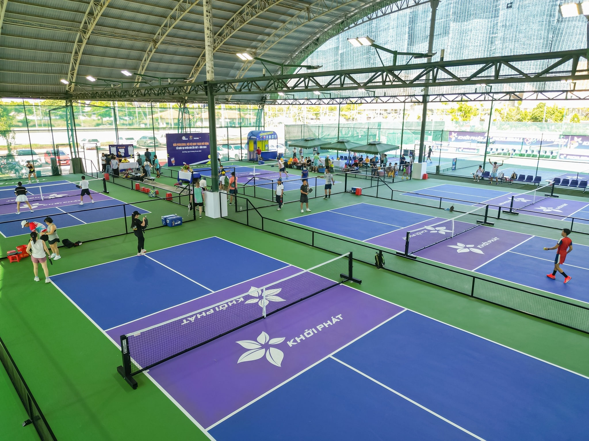
Program Overview
Da Nang University of Physical Education and Sports has introduced Vietnam’s first specialized pickleball training program, (30) ______ offers comprehensive instruction in this rapidly growing sport. The curriculum combines practical skills development with sports management and coaching methodologies.
Curriculum Details
Students (31) ______ in the program will study biomechanics, nutrition science, and advanced training techniques alongside technical pickleball skills. The university has invested in state-of-the-art facilities featuring a considerable (32) ______ of professional courts and equipment. Faculty members include international coaches (33) ______ expertise spans competitive play and sports science research.
Career Prospects
Graduates will be (34) ______ positioned to pursue careers as professional athletes, coaches, or sports administrators as pickleball continues its explosive growth across Asia. The program aims to (35) ______ Vietnam’s potential in developing world-class pickleball talent and establishing the nation as a regional training hub.
Applications open March 1st. Visit https://dnupes.edu.vn/pickleball-program for enrollment information.
  - (Adapted from https://dantri.com.vn)
Question 30. A. which B. where C. when D. whom
Question 31. A. enroll B. enrolled C. enrolling D. to enroll
Question 32. A. collection B. selection C. assembly D. accumulation
Question 33. A. that B. whose C. who D. of which
Question 34. A. strategically B. strategic C. strategize D. strategy
Question 35. A. set aside B. bring about C. tap into D. look after

Mark the letter A, B, C or D on your answer sheet to indicate the best arrangement of utterances or sentences to make a cohesive and coherent exchange or text in each of the following questions from 36 to 40.
Question 36. a. Sophie: Thanks so much! I promise I’ll return it by tomorrow afternoon.
b. Sophie: Could I possibly borrow your English literature textbook for tonight’s assignment?
c. Mark: Sure, no problem at all. Just take good care of it, please.
A. b-a-c B. a-b-c C. b-c-a D. c-b-a
Question 37. a. Concurrently, public awareness campaigns were launched, encouraging households to participate actively in separation schemes at the source.
b. Recycling facilities were expanded considerably, with specialized plants dedicated to processing plastic, organic matter, and electronic waste.
c. This transformation signifies a paradigm shift towards circular economy principles and environmental stewardship in Vietnamese urban centers.
d. Major cities like Hanoi and Da Nang initiated comprehensive waste segregation programs beginning in the late 2010s.
e. The implementation was further reinforced by stringent penalties for non-compliance, ensuring widespread adherence to new regulations.
A. d-a-b-e-c B. d-b-a-c-e C. c-d-b-a-e D. d-b-e-a-c
Question 38. a. We are introducing a diversified investment and protection package tailored to moderate risk profiles.
b. To begin, complete the suitability assessment and share income statements through our encrypted link.
c. Our advisors will construct an allocation and confirm underwriting results within three business days.
d. Please note, introductory bonuses apply to applications submitted before 30 September this year.
e. For a consultation, reply to this email or schedule via the client portal.
A. a-b-c-d-e B. b-a-c-d-e C. a-c-b-d-e D. a-b-d-c-e
Question 39. a. After receiving harsh feedback on my literature essay, I initially felt discouraged and wanted to give up entirely.
b. My teacher pointed out numerous weaknesses, yet I had expected praise for what I considered excellent work.
c. This difficult moment ultimately helped me develop a growth mindset and embrace constructive criticism more openly.
d. I decided to meet with my teacher regularly and worked hard to strengthen my analytical writing skills.
e. During sophomore year, I submitted what I believed was my best analytical essay about Shakespeare’s themes.
A. e-b-a-d-c B. a-e-b-d-c C. e-a-b-c-d D. c-e-b-a-d
Question 40. a. Rachel: Do you still read printed newspapers every morning?
b. Tom: Exactly, that’s why traditional journalism still carries a sense of credibility.
c. Tom: Not really. I mostly scroll through social media for quick updates.
d. Rachel: Yes, both platforms inform the public in their own unique ways.
e. Rachel: I agree, but social media spreads unverified news quite often.
A. a-b-c-d-e B. a-b-d-c-e C. b-a-c-e-d D. a-c-e-b-d
--------------------- THE END ---------------------
- Thí sinh không được sử dụng tài liệu;
- Giám thị không giải thích gì thêm.

