Week: Date of planning:
Period: Date of teaching:
UNIT 9: NATURAL DISASTERS
Lesson 7: Looking back + Project
I. OBJECTIVES
By the end of this lesson, students will be able to:
1. Knowledge:
- Revise more vocabulary items they have learnt in the unit.
- Revise the differences between the past simple and past continuous.
- Revise the past continuous.
- Have an opportunity to research more deeply into a natural disaster.
2. Core competence:
- Develop communication skills and creativity.
- Be collaborative and supportive in pair work.
- Actively join in class activities
3. Personal qualities
- Develop awareness of Natural disasters.
- Be concerned to Natural disasters.
II. MATERIALS
- Grade 8 textbook, Unit 9- Looking back + Project
- Computer connected to the Internet
- Projector / TV/ pictures and cards
- Phần mềm tương tác hoclieu.vn
III. PROCEDURES
1. WARM-UP (5 mins)
a. Objectives:
- To create an active atmosphere in the class before the lesson.
- To lead into the new lesson.
b. Content:
- Mind Map
c. Expected outcomes:
- Ss can tell the teacher what they have learnt in unit 4.
d. Organisation
TEACHER’S AND STUDENTS’ ACTIVITIES | CONTENTS
Teacher writes on the board “Unit 9” and asks students to think of what they have already learnt in this unit.  - Students work in groups to do the task.  - Teacher calls some students to retell.  - Teacher confirms and leads them to do all the exercises in books. | 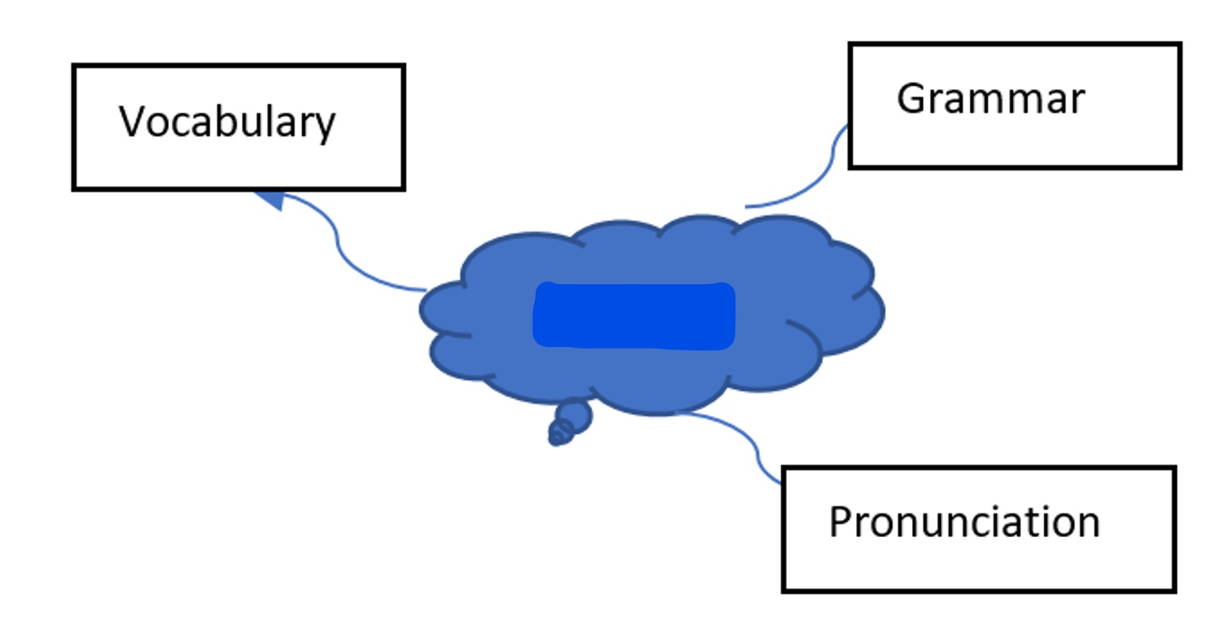  Unit 9
2. ACTIVITY 1: PRESENTATION (6 mins)
a. Objectives:
- To help Ss revise the vocabulary they have learnt in the unit through pictures.
- To help Ss revise more vocabulary items they have learnt in the unit in different contexts.
b. Content:
- Task 1. Write the name of a natural disaster in each blank.
c. Expected outcomes:
- Ss can use the words they have learnt in different contexts.
d. Organisation
TEACHER’S AND STUDENTS’ ACTIVITIES |  | CONTENTS
Task 1. Write the name of a natural disaster in each blank. (6 mins)
- Teacher asks Ss to work individually, read the  sentences and look at the pictures.  - Ss write the name of a natural disaster in each  blank.  - Teacher asks Ss to compare their answers with a  partner.  - Teacher calls some Ss to share their answers.  - Teacher confirms the correct answers as a class. | Answer key:  1. flood  2. storm  3. earthquake  4. volcanic eruption  5. Landslide
3. ACTIVITY 2: PRACTICE (20mins)
a. Objectives:
- To help Ss revise the vocabulary items they have learnt in the unit.
- To help Ss revise the differences between the past simple and past continuous.
- To help Ss revise the past continuous by completing the sentences about them and their family members.
b. Content:
- Fill in each blank with the correct form of the word in brackets.
- Put the verbs into the correct tense: the past simple or past continuous.
- Complete the sentences about you and your family members.
c. Expected outcomes:
- Ss know how to use the words they have learnt in different contexts.
- Students can make differentiate between the past simple and past continuous.
d. Organisation
TEACHER’S AND STUDENTS’ ACTIVITIES | CONTENTS
Task 2. Fill in each blank with the correct form of the word in brackets.
(7 mins)
- Teacher asks Ss to work individually and read 5  sentences carefully.  - Ss complete the sentences using the correct form of the words given.  - Teacher asks Ss to share their answers with a  partner.  - Teacher invites some Ss to write their answers on  the board.  - Teacher confirms the correct answers. |  | Answer key:  1. destruction  2. predictions  3. victims  4. warned  5. Workers
Task 3: Put the verbs into the correct tense: the past simple or past continuous.
- Teacher asks Ss to work individually and read the sentences carefully.  - Ss give correct form of the verbs (the simple past or past continuous).  - Teacher asks them to compare their answers with a partner.  - Teacher confirms the correct answers as a class. |  | Answer key:  1. were … doing  2. destroyed  3. was watering; came  4. were calling; appeared  5. Were … listening
Task 4. Complete the sentences about you and your family members. (8 mins)
- Teacher asks Ss to work individually and write  sentences about their family members, using the past continuous.  - Teacher asks Ss to compare their sentences with a partner.  - Teacher invites some Ss to write their sentences on the board.  - Teacher comments on their answers. |  | At 7 p.m. yesterday, …  1. I was _________________.  2. my grandmother / grandfather ___.  3. my mother ______________. 4. my father _______________.  5. my sister / brother_________.
4. ACTIVITY 3: PRODUCTION – PROJECT (10 mins)
a. Objectives:
To provide Ss with an opportunity to research more deeply into a natural disaster.
b. Content:
Work in groups, choose a natural disaster you want to learn more about, create a poster about this natural disaster. Draw pictures or find suitable photos for it, present the poster to the class.
c. Expected outcomes:
Ss can create a poster about this natural disaster and present it to the class.
d. Organisation
TEACHER AND STUDENTS’ACTIVITIES | CONTENTS
- Teacher asks Ss to read the instructions and makes sure they understand what to do.  - Teacher asks Ss to work in groups to do the project.  - Teacher instructs Ss how to carry out this project and asks them to try to search for information to answer the questions given and create a poster about the natural disaster they have chosen.  - Teacher asks Ss to present their poster to the class | SS’ presentation
5. CONSOLIDATION (3 mins)
a. Wrap-up
Teacher asks Ss to summarise the main points of the lesson.
b. Homework
- Do exercises in the workbook.
- Prepare for Unit 10 – Getting started

