ĐỀ VIP 9+ - ĐỀ SỐ 10

Read the following notice and mark the letter A, B, C, or D to indicate the correct option that best fits each of the numbered blanks from 1 to 6.
Are you ready to explore exciting career opportunities and (1) with professionals? Join us at the upcoming job fair to meet several (2) who will guide you through today’s dynamic job market. This fair is based (3) the latest employment trends and offers workshops, panel discussions, and networking sessions, allowing you to gain valuable insights into various industries and roles.
We highly recommend (4) prepared with questions and an open mind to (5) the most of this experience. This is a unique chance to present yourself as a confident, well-prepared candidate, connect with potential employers, and learn about (6) that align with your goals.
Date: April 15, 2024
Location: City Convention Centre Time: 9:00 AM – 5:00 PM
Don’t miss this opportunity to take a step toward your future career. See you there!

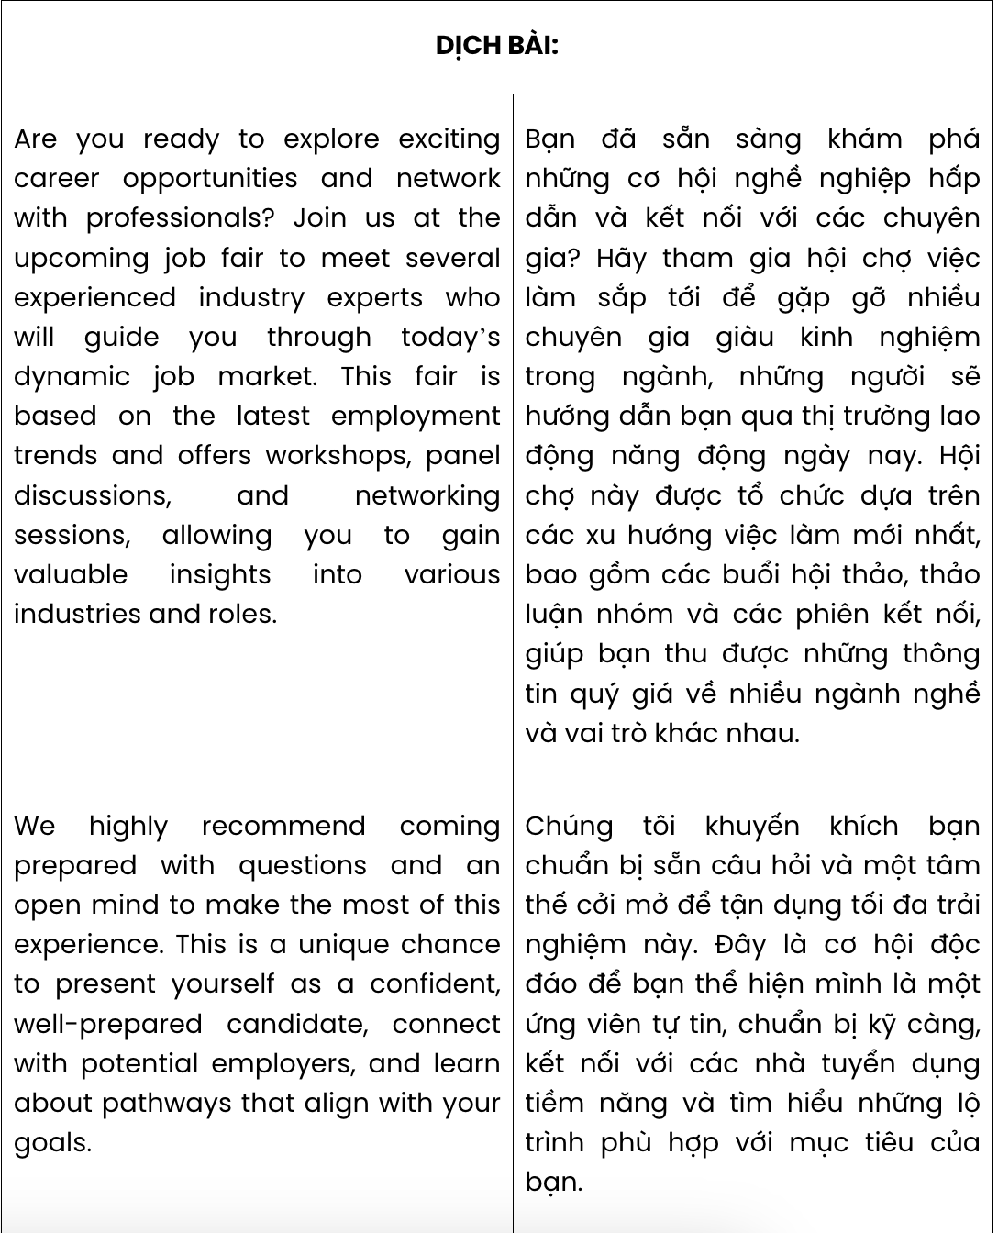
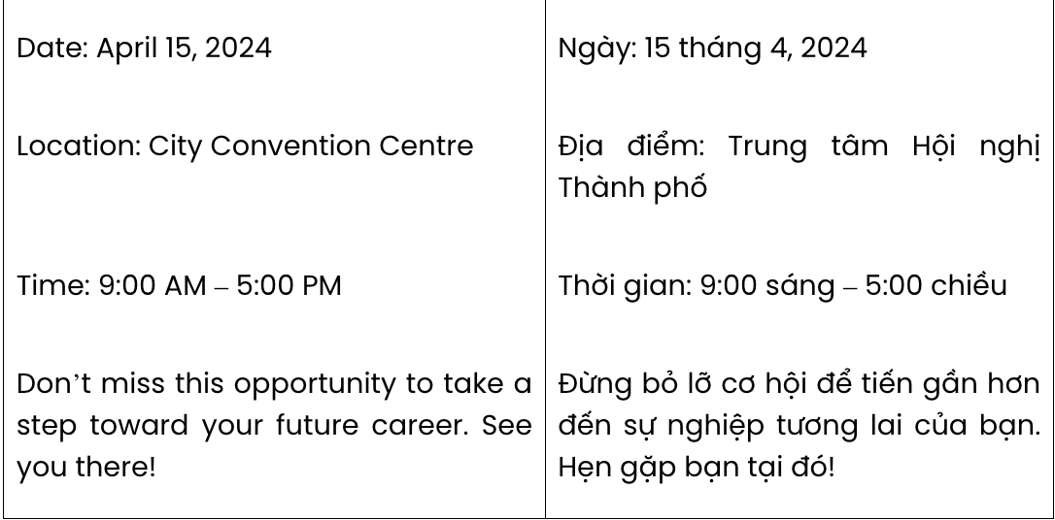
Question 1. A. associate B. network C. link D. collaborate
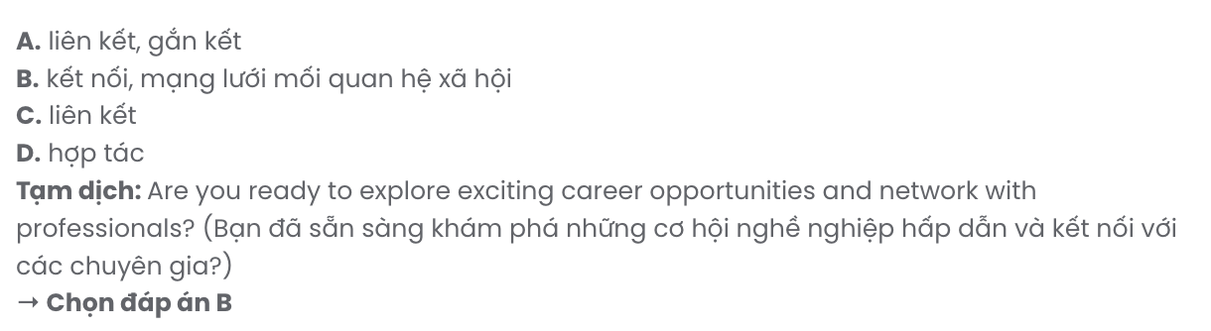
Question 2. A. experienced industry experts B. experienced experts industry
C. experts experienced industry D. industry experienced experts

Question 3. A. in B. at C. for D. on
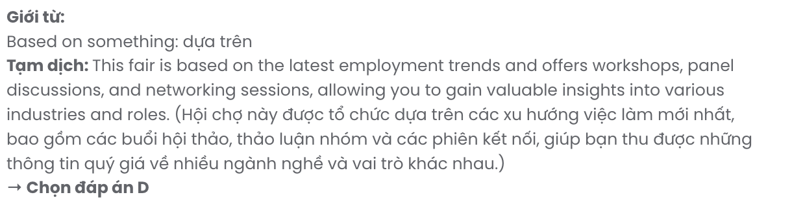
Question 4. A. to coming B. to come C. coming D. come
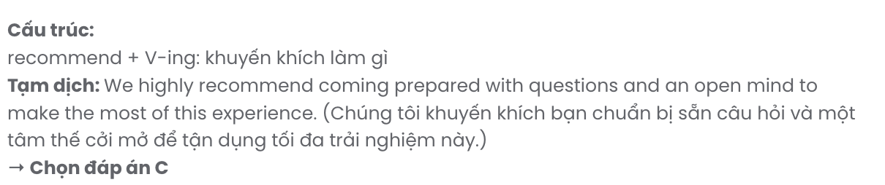
Question 5. A. take B. make C. put D. run
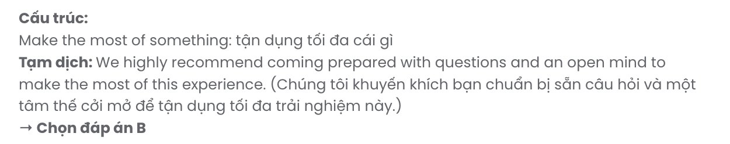
Question 6. A. pathways B. journeys C. routines D. situations
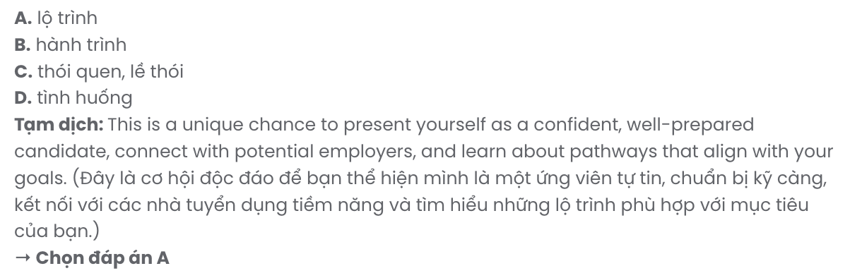
Read the following advertisement and mark the letter A, B, C, or D to indicate the correct option that best fits each of the numbered blanks from 7 to 12.

ONLINE GUITAR LESSONS
Are you (7) a way to improve your guitar skills from the comfort of your own home? Join our online guitar lessons, (8) by seasoned instructors with years of experience. You’ll be (9)
by the level of expertise and personalised guidance you receive, helping you to play confidently and creatively.
In our programme, you'll connect with (10) like-minded individuals, all eager to grow as musicians. We focus on developing creativity (11) just technical skills, making each lesson both fun and fulfilling. Expect a high (12) of support and attention throughout your learning journey.
Enrol today and discover a learning experience tailored to your passion!

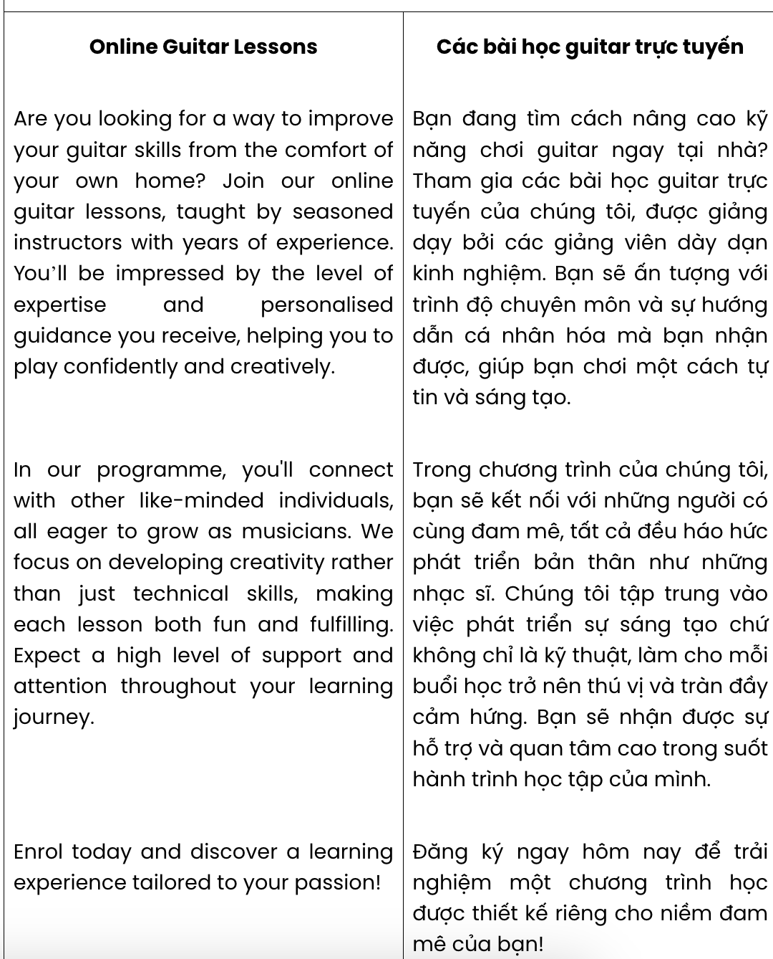
Question 7. A. passing down B. looking for C. making up D. putting away
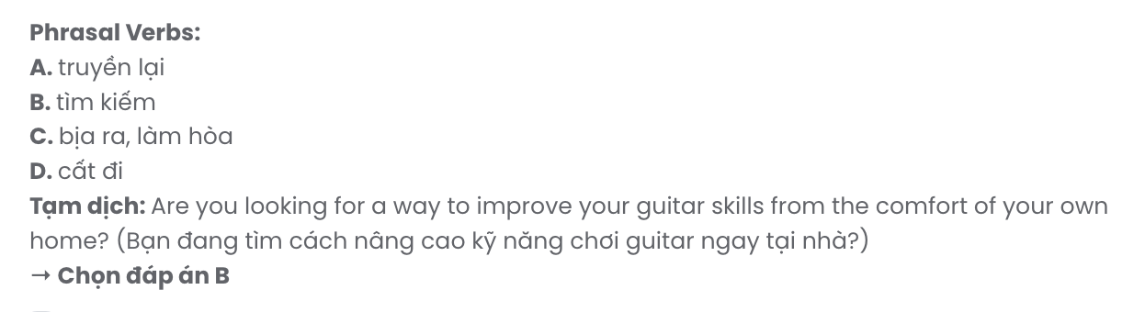
Question 8. A. which teach B. teaching C. are taught D. taught

Question 9. A. impression B. impressively C. impressed D. impressive

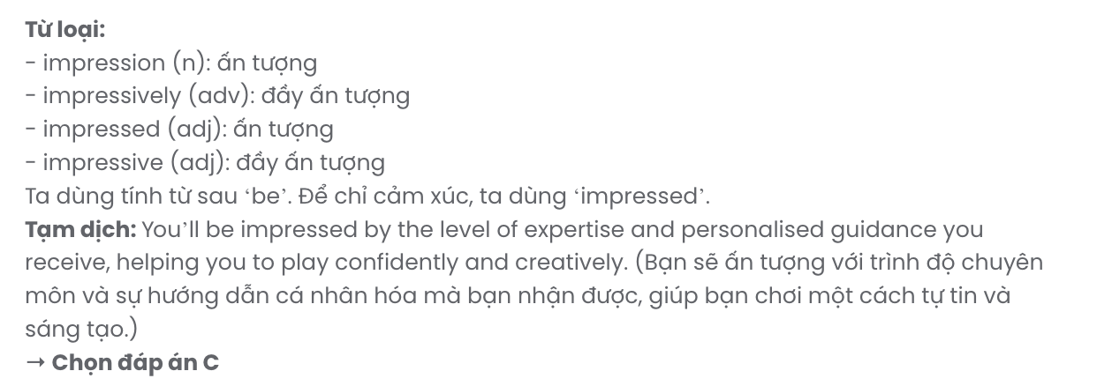

Question 10. A. every B. another C. other D. the others
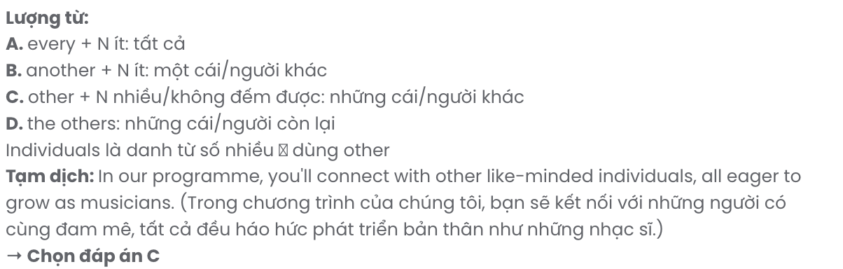
Question 11. A. except for B. rather than C. on account of D. regardless of

Question 12. A. level B. number C. variety D. handful
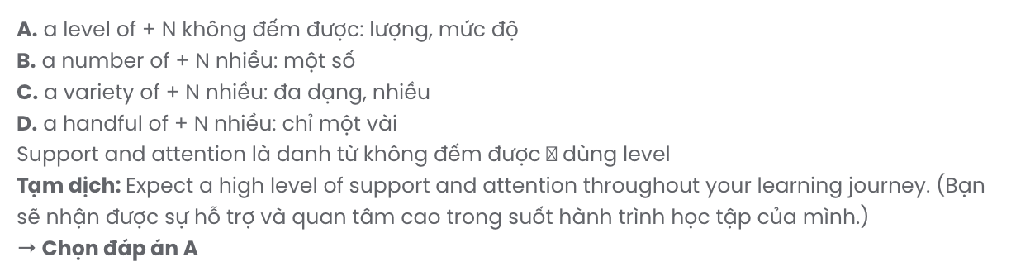
Mark the letter A, B, C or D to indicate the best arrangement of utterances or sentences to make a meaningful exchange or text in each of the following questions from 13 to 17.

Question 13.
- This increased visibility helps both pedestrians and drivers feel safer, reducing the likelihood of confrontations or accidents.
- This simple yet effective measure is widely recognised as essential for enhancing neighbourhood security.
- Additionally, the presence of street lights can increase community vigilance, as residents can easily spot and report suspicious behaviour.
- Street lights play a significant role in preventing crime by illuminating public areas, making it harder for criminals to operate under cover of darkness.
- By lighting up areas that are often hidden or poorly visible, such as alleyways and corners, these lights also deter illegal activities.
A. d – a – e – c – b B. d – b – c – a – e C. d – c – e – b – a D. d – e – b – a – c
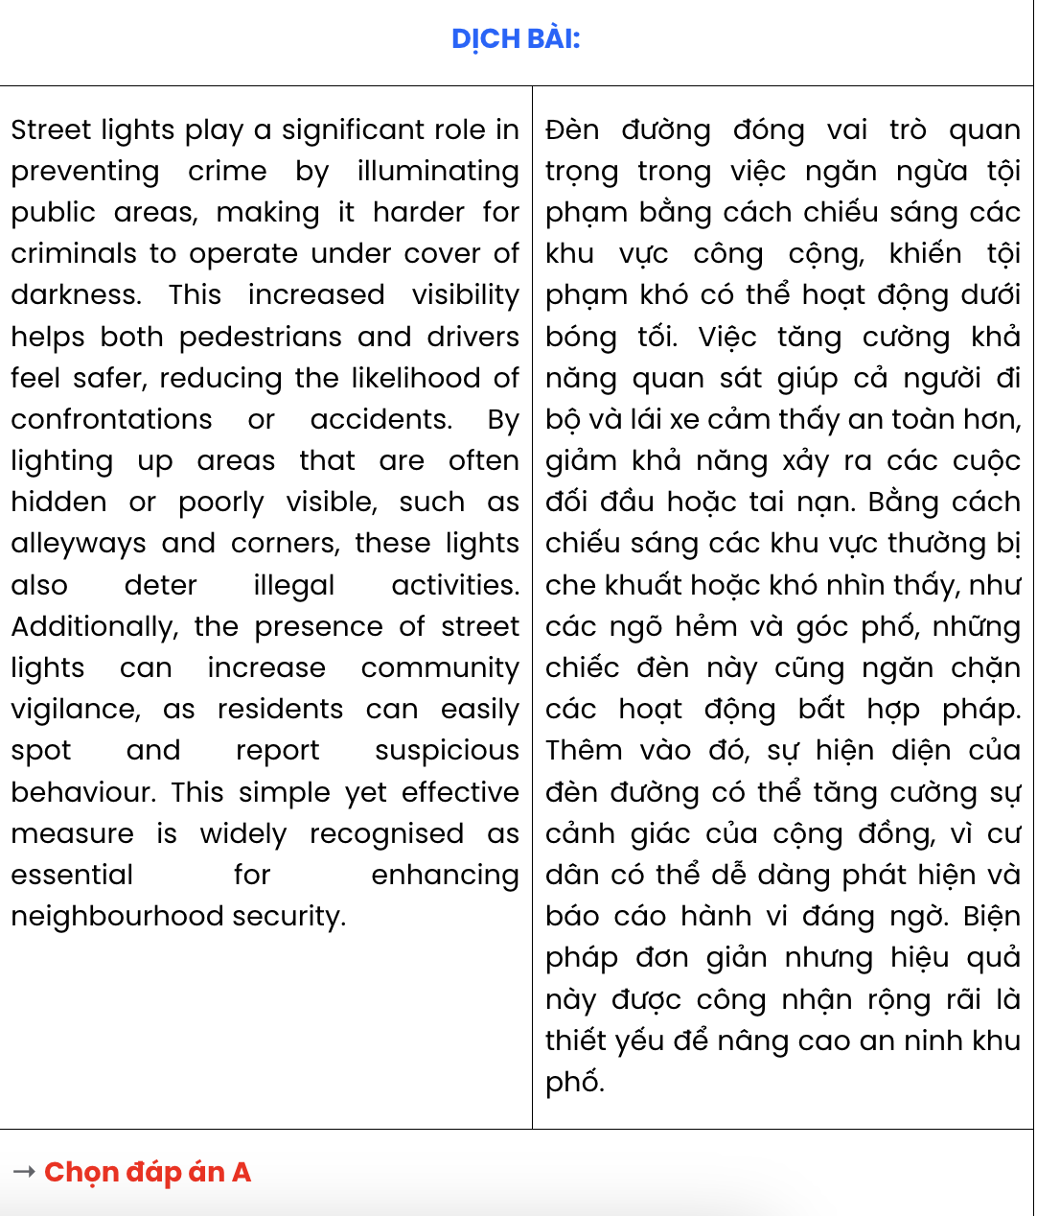

Question 14.
- Anna: I don’t quite agree. I think knowing how to work well with others can really boost your career.
- Anna: What do you think about the importance of soft skills in the workplace?
- Ben: I think technical skills are what really matter. Communication and teamwork feel a bit overrated to me.
- Ben: Maybe, but I still believe being good at the actual job is more important.
- Anna: I feel like soft skills make a huge difference, especially when you’re in a team setting.
A. e – d – a – c – b B. e – c – a – d – b C. b – d – a – c – e D. b – c – e – d – a
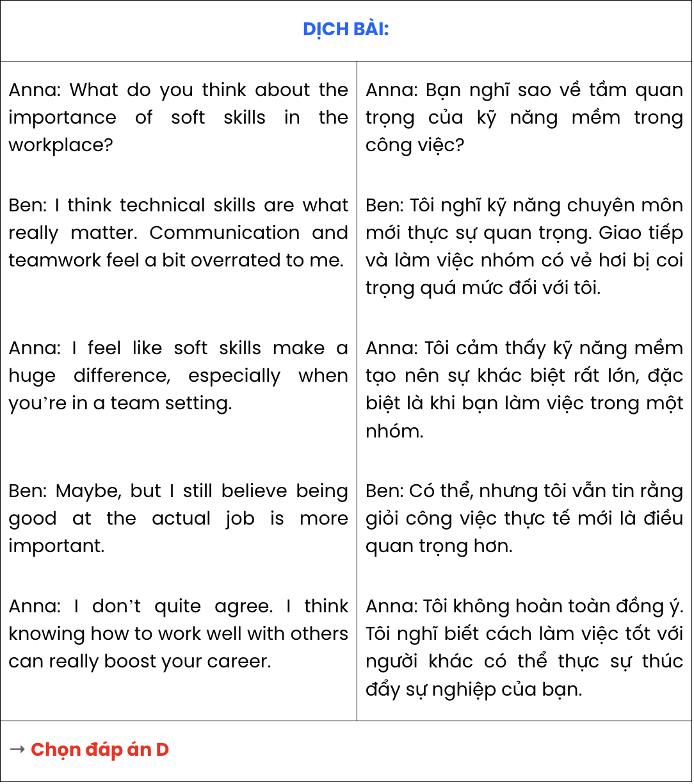

Question 15.
- Tom: Yeah, my family and I are going camping in the mountains. What about you?
- Lily: I’m going to visit my grandparents by the beach. I can’t wait for some relaxing days by the sea!
- Lily: So, Tom, do you have any plans for the summer holiday?
A. c – b – a B. c – a – b C. a – b – c D. b – a – c


Question 16.
- There were moments of doubt when I faced unforeseen issues, like dealing with a leaky faucet or budgeting for groceries.
- This experience demanded a level of self-discipline I hadn’t needed before, as I learned to manage finances, daily chores, and my own well-being.
- These challenges, however, gradually taught me resilience, and I began to appreciate the autonomy that comes with making my own decisions.
- This journey of self-reliance has, without a doubt, been a transformative phase in my life.
- Feeling like stepping into a completely new world, I began my independent living journey when I went to university.
A. a – c – e – b – d B. b – e – c – a – d C. c – a – e – b – d D. e – b – a – c – d

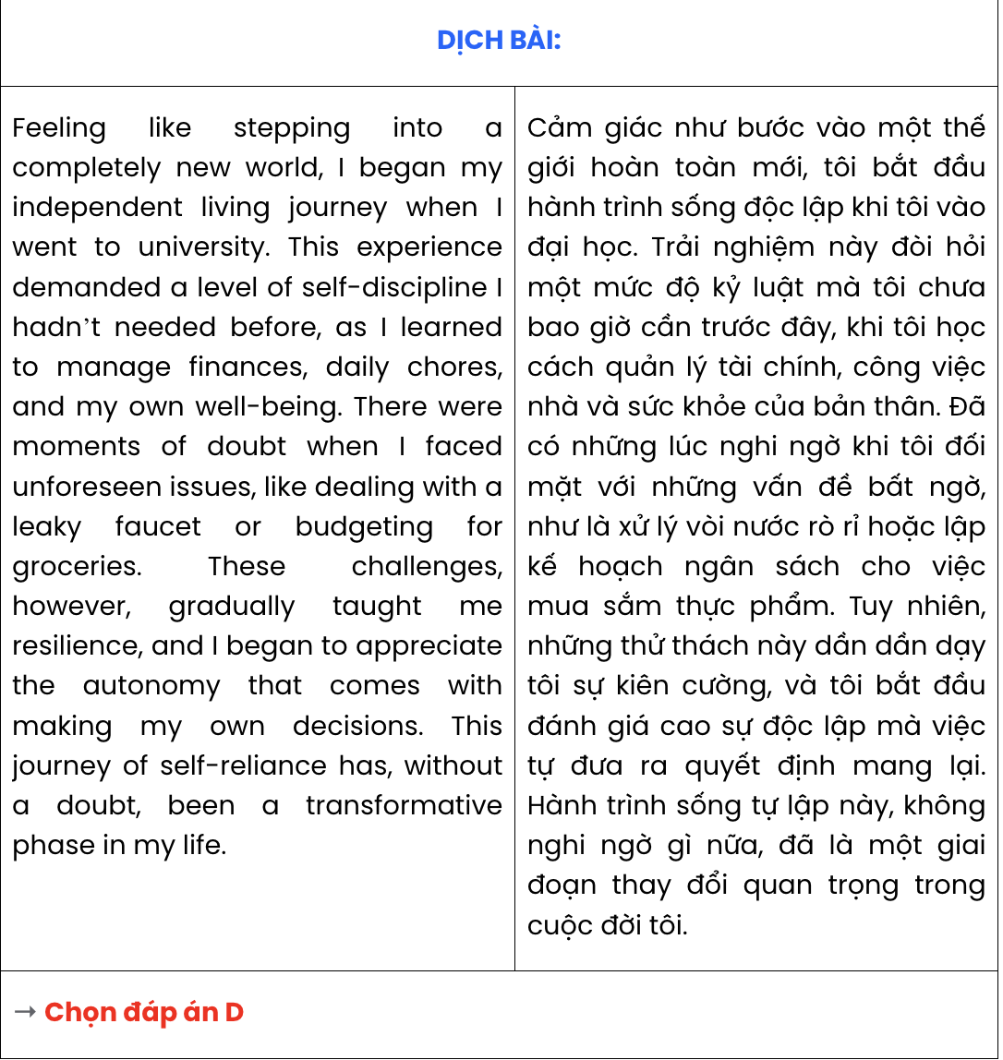

Question 17.
Dear Mark,
- You won’t believe what happened to me last weekend - I got completely lost in the woods!
- The experience taught me to always stay on the path and not to underestimate the wilderness.
- After a few hours of walking in circles, I began to feel a mix of panic and regret for leaving that familiar path.
- It all started when I wandered off the main trail to explore a small clearing, thinking I’d easily find my way back.
- Thankfully, I spotted a tall tree with some unique markings, which eventually led me back to the main trail.
Take care, Sam
A. b – d – e – c – a B. d – c – e – a – b C. a – d – c – e – b D. a – e – d – c – b

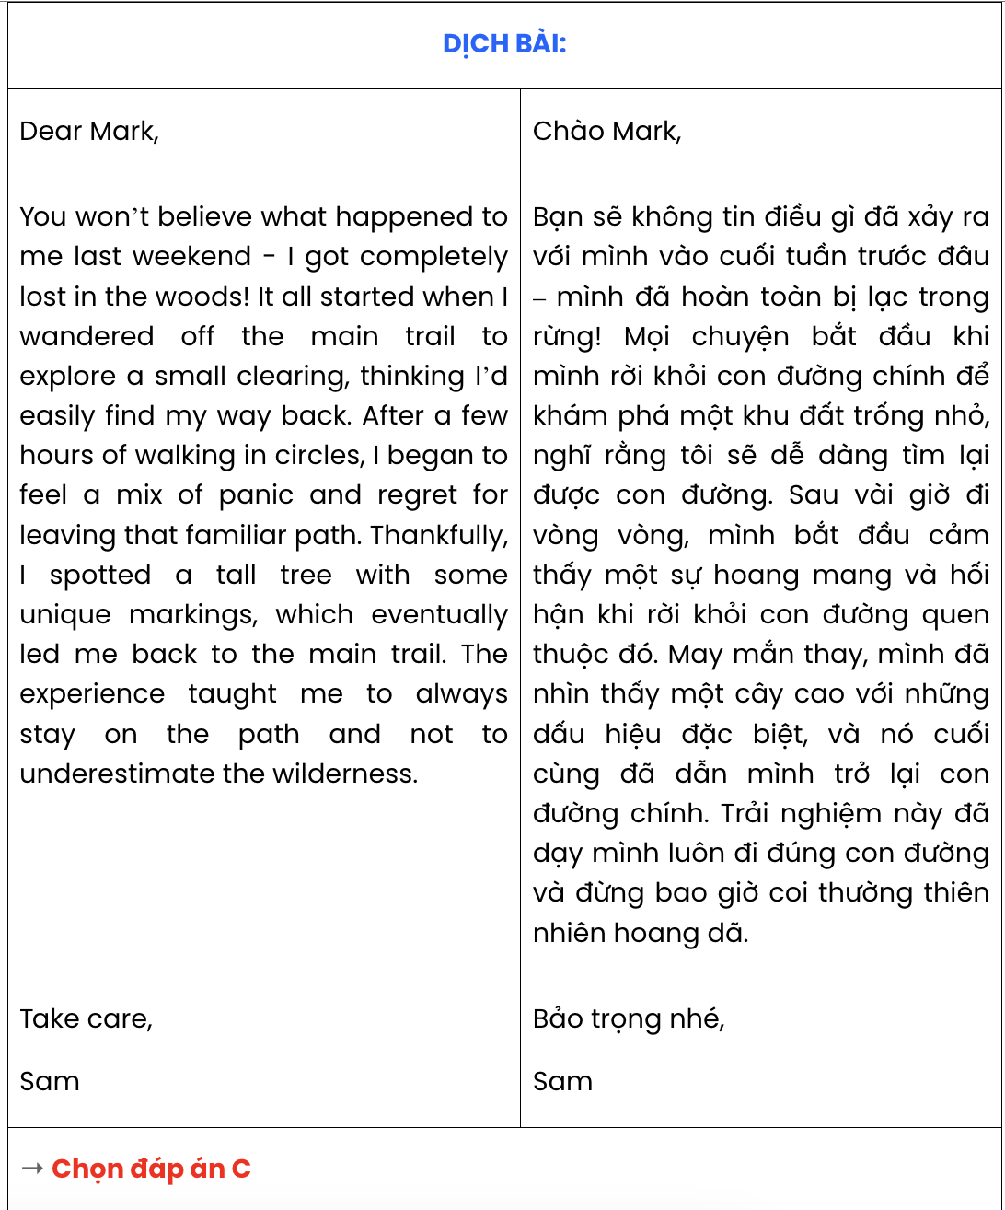

Read the following passage about deforestation and the spread of contagious diseases and mark the letter A, B, C, or D to indicate the correct option that best fits each of the numbered blanks from 18 to 22.
Deforestation, an escalating environmental issue, (18) . As forests are cleared, the ecosystems which support a diverse range of species are disrupted, causing animals to move closer to human settlements. This shift in habitat increases contact between humans and animals, raising the risk of zoonotic diseases - illnesses transmitted from animals to humans.
Driven by agricultural expansion and urban development, (19) , which directly affects biodiversity. Exposing soil and destroying plant life, deforestation contributes to the loss of natural barriers (20) . These creatures, now deprived of their natural habitats, migrate into urban spaces, thus spreading pathogens previously contained within forested regions.
Moreover, (21) . The degradation of forests not only reduces biodiversity but also threatens health security. (22) , yet much remains to be done to prevent further outbreaks. Addressing the root causes of deforestation can thus play a crucial role in preventing the spread of contagious diseases and protecting global health.
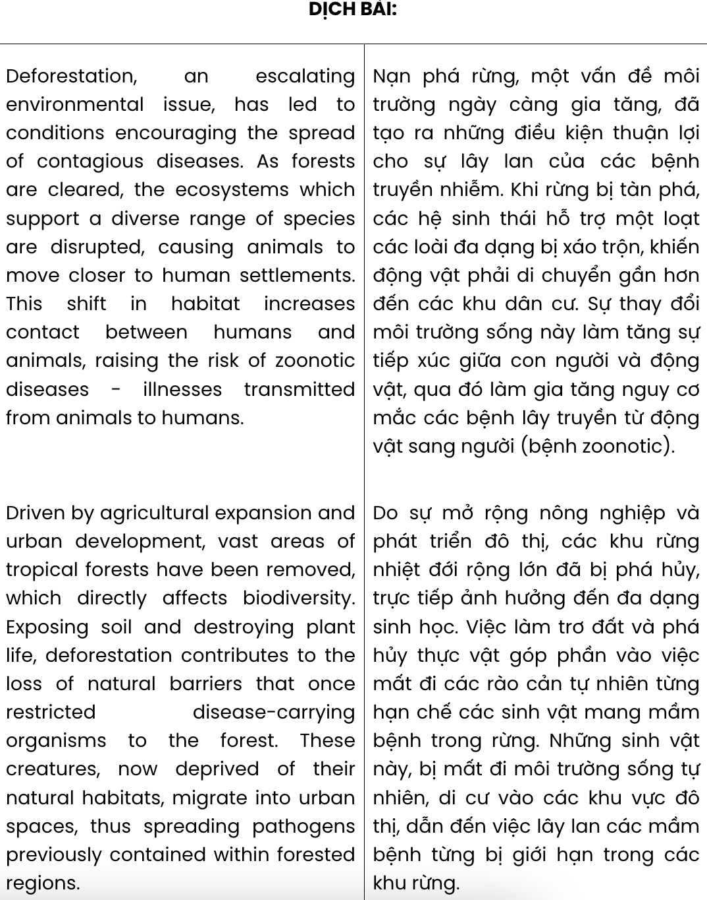
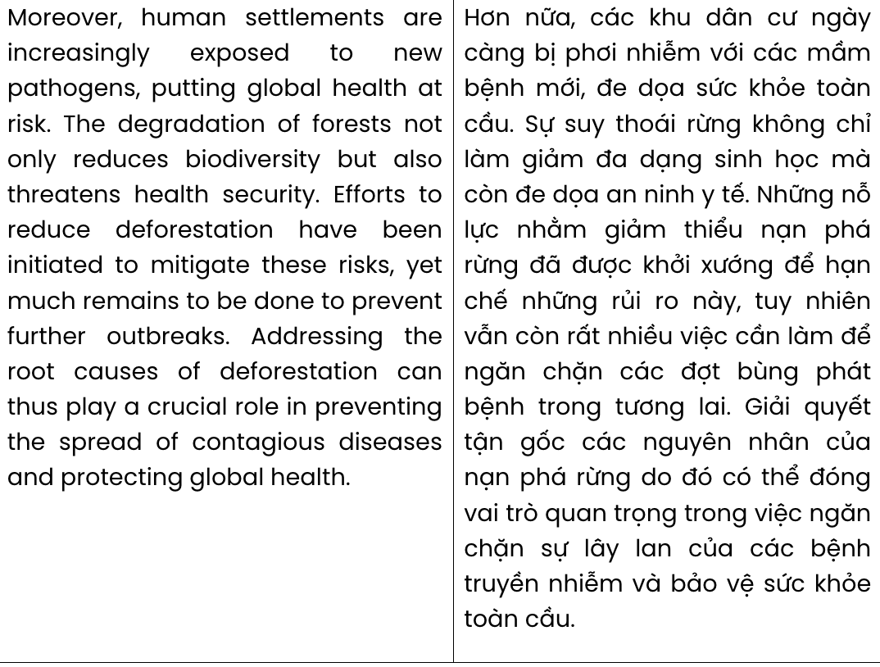

Question 18.
  - of which the increased spread of infectious diseases has been promoted
  - has led to conditions encouraging the spread of contagious diseases
  - having created conditions that promote the spread of infectious diseases
  - which fostered an environment where contagious diseases can easily spread
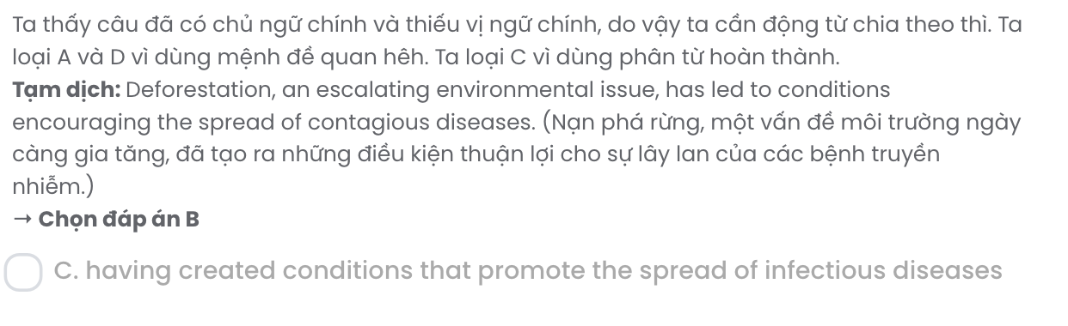

Question 19.
- vast areas of tropical forests have been removed
- humans have been removing vast areas of tropical forests
- the removal of areas of tropical forests has been documented
- removing vast areas of tropical forests has become common
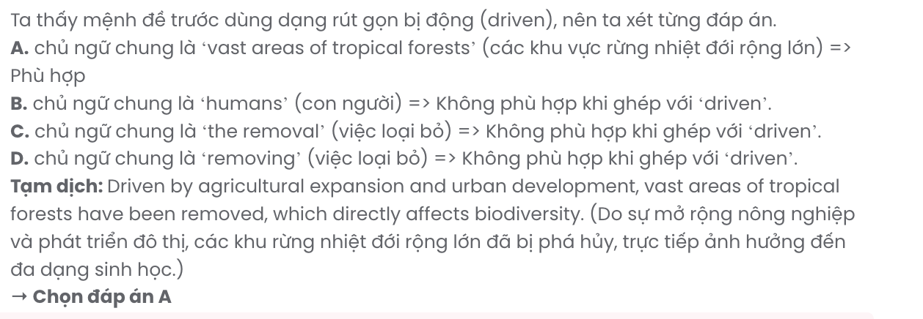

Question 20.
- succeeded in limiting disease-carrying organisms to the forest
- attempted to restrict disease-carrying organisms to the forest
- whose purpose of restricting disease-carrying organisms to the forest
- that once restricted disease-carrying organisms to the forest

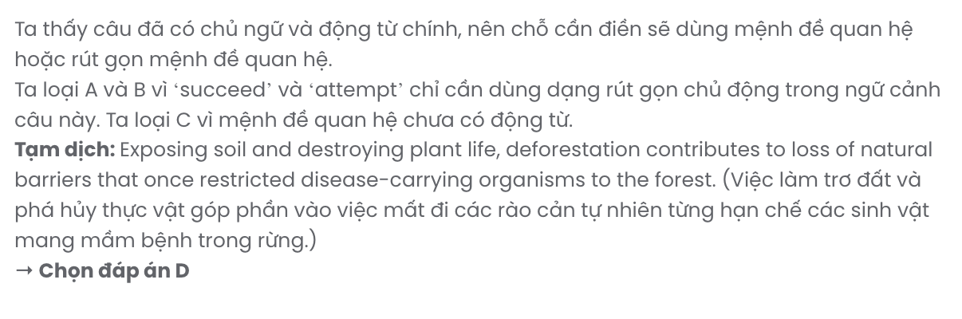

Question 21.
- increasingly exposed to new pathogens, global health is at risk due to human settlements
- the increased exposure to new pathogens puts global health risk due to human settlements
- new pathogens are increasingly exposed to human settlements so that global health is at risk
- human settlements are increasingly exposed to new pathogens, putting global health at risk
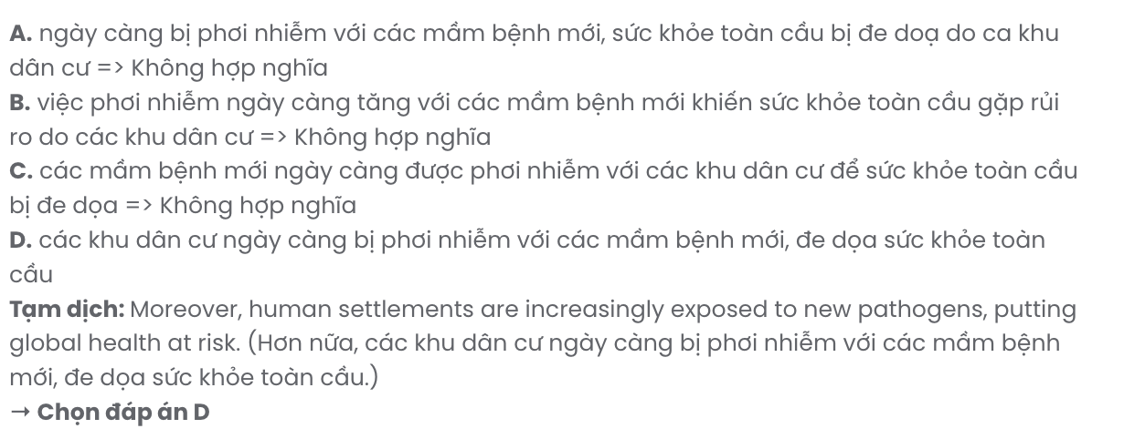

Question 22.
- Efforts to reduce deforestation have been initiated to mitigate these risks
- Intending to reduce these risks, efforts have been made to decrease deforestation
- The attempts to minimise these risks have resulted in a decline in deforestation
- These risks have been addressed thanks to efforts made to reduce deforestation
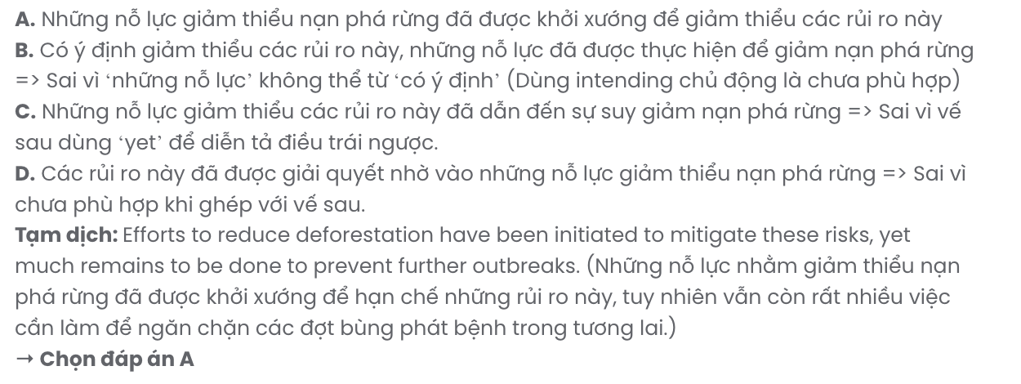

Read the following passage about theatre for the deaf and mark the letter A, B, C, or D to indicate the correct answer to each of the questions from 23 to 30.
Deaf people should enjoy a play as much as the hearing audience. This is the thinking behind the Americans with Disabilities Act, which requires that theatres become accessible to deaf people. Theatre producers, on the other hand, are beginning to realise that such a feature makes their product attractive to a wider audience - with considerable financial rewards.
Interpreted theatre usually takes place at two or three performances in a theatre season. Preference for tickets is given to the deaf, but tickets are also sold to hearing people who are interested in seeing theatre interpreters at work.
It is a colossal project for the interpreters. Ian Cox works for SeeTheatre, a Chicago-based association of interpreters. He says, "for about a month we work with the support of a Sign Language consultant to translate and rehearse an entire play. The workload is immense. Consider that each actor in the play has about four weeks to rehearse his or her lines; we have to learn the whole play in as much time. And, when interpreting musicals, where timing, rhythm and harmonies must be practised, the workload doubles."
The most important technical aspect of theatre interpretation for the deaf is the location of the interpreter. Placement strategies can be categorised into three styles: ‘placed’, where interpreters are located outside the acting space and do not move; ‘zoned’, where interpreters are within the acting space, but usually move only during a change of scene or act; and, finally, ‘shadowed’, where interpreters move freely within the acting space, shadowing the movement of the actors for whom they are interpreting.
(Adapted from Upstream)

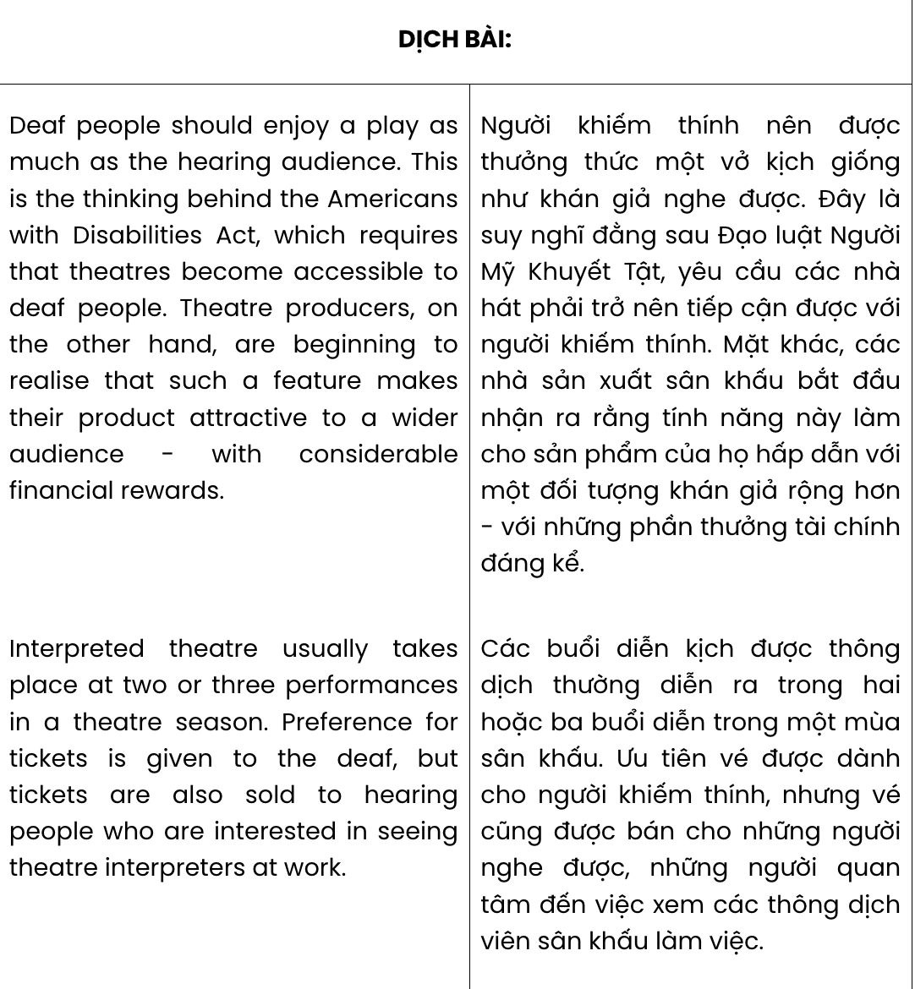

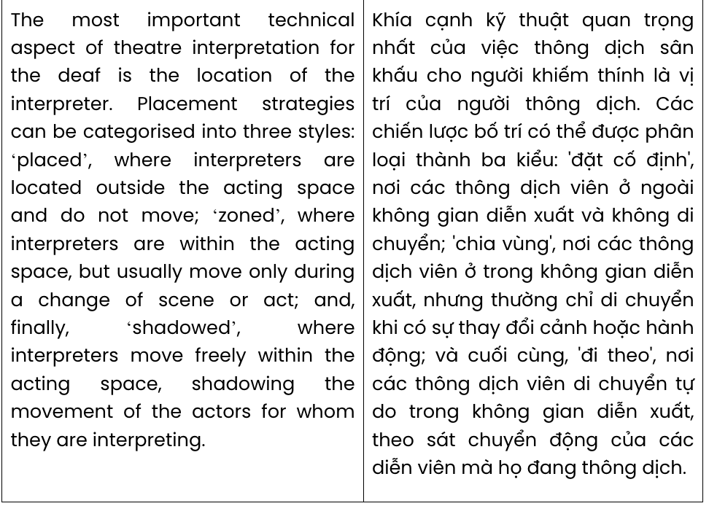

Question 23. The word Preference in paragraph 2 is closest in meaning to .
A. abundance B. separation C. priority D. concentration
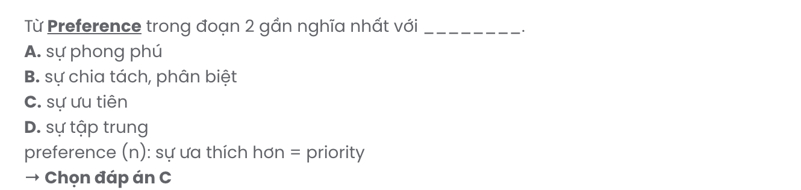
Question 24. According to paragraph 2, what is said about interpreted theatre?
- It sells tickets for deaf people and hearing audiences.
- There are at least 3 performances in a theatre season.
- Only qualified theatre interpreters are chosen for the job.
- Many people are interested in seeing theatre interpreters.
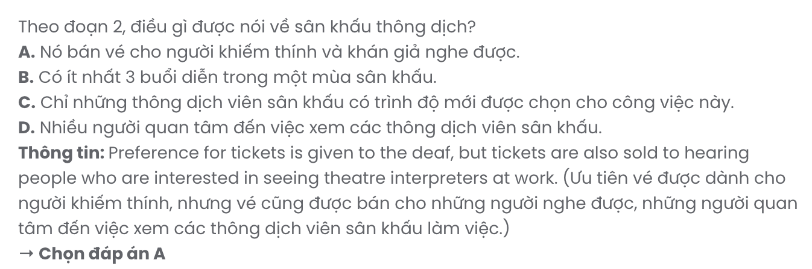
Question 25. The word immense in paragraph 3 is OPPOSITE in meaning to .
A. equal B. limited C. significant D. enormous

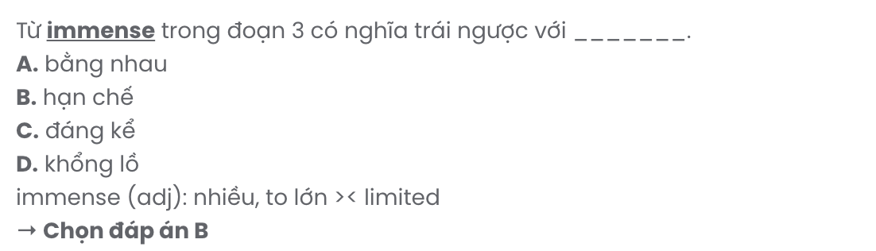
Question 26. Which of the following best paraphrases the underlined sentence in paragraph 4?

The most important technical aspect of theatre interpretation for the deaf is the location of the interpreter.
- The essential technical factor in interpreting theatre for the deaf is the clarity of the interpreter's gestures.
- The interpreter's position on stage plays the most significant role in enhancing sound effects for deaf viewers.
- The placement of the interpreter is the primary technical factor in ensuring effective theatre interpretation for deaf audiences.
- An important technical requirement in theatre interpretation for the deaf is the interpreter's position.
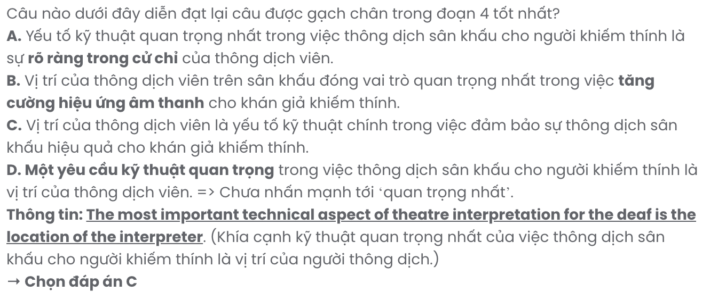
Question 27. The word they in paragraph 4 refers to .
A. styles B. strategies C. interpreters D. actors
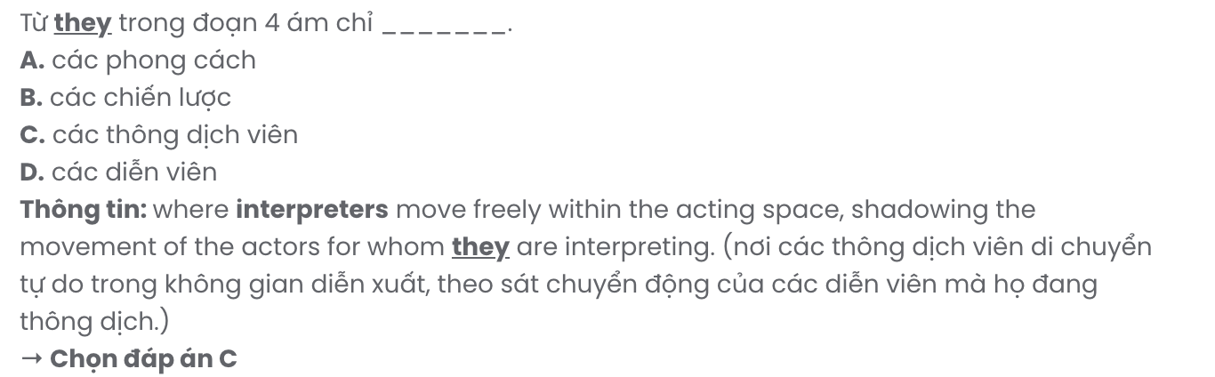
Question 28. Which of the following is NOT true according to the passage?
- Theatre interpreters work with a sign language consultant for nearly one month.
- Theatre producers are aware that interpreted theatre can bring enormous profits.
- Interpreters in theatre for the deaf can be positioned in three different styles.
- The placement strategy of ‘zoned’ gives a theatre interpreter more flexibility on stage.
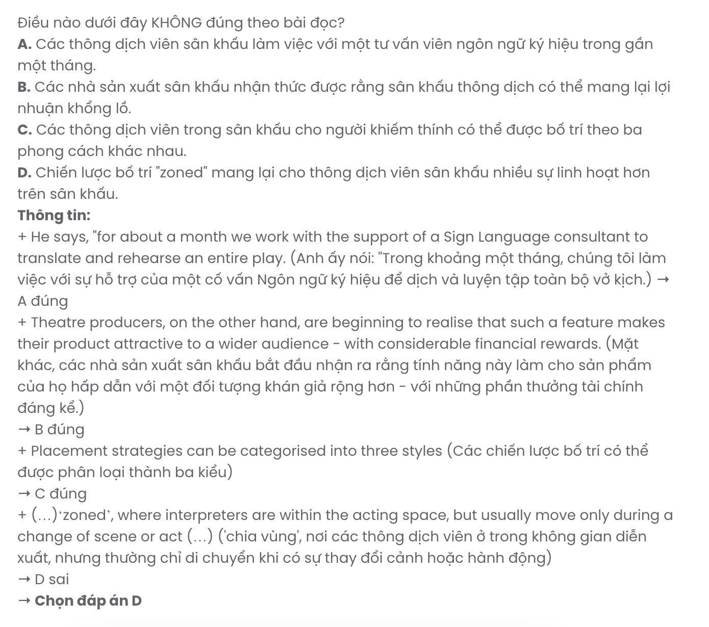
Question 29. In which paragraph does the writer mention a motive for making theatre accessible to deaf people?
A. Paragraph 1 B. Paragraph 2 C. Paragraph 3 D. Paragraph 4

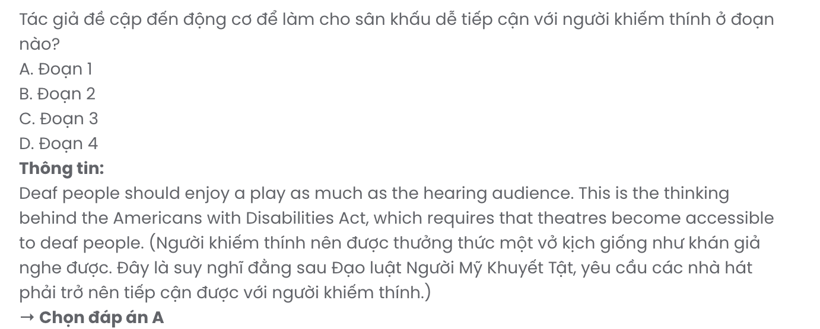
Question 30. In which paragraph does the writer compare the workload of actors and interpreters in theatre for deaf people?
A. Paragraph 1 B. Paragraph 2 C. Paragraph 3 D. Paragraph 4

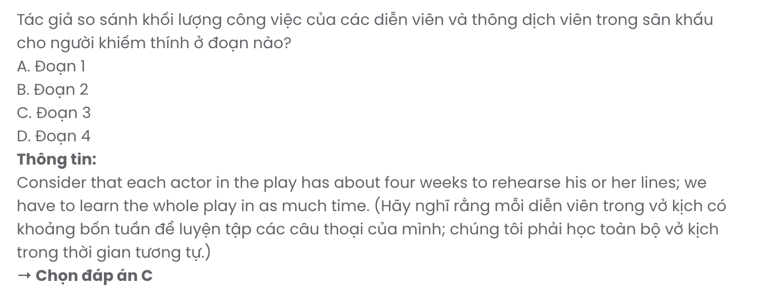

Read the following passage about global warming and mark the letter A, B, C, or D to indicate the correct answer to each of the questions from 31 to 40.
Most scientists agree that global warming presents the greatest threat to the environment. There is little doubt that the Earth is getting warmer. In the last century, the average temperature rose about 0.6 degrees C around the world. Many experts warn that global warming will cause sea levels to rise dramatically. In the past 100 year,s the oceans have risen 10 to 20 cms - but that's nothing compared to what would happen if, for example, Greenland's massive ice sheet were to melt.
Just as the evidence is clear that temperatures have risen in the last century, it's also well established that carbon dioxide in the Earth's atmosphere has increased about 30 per cent, allowing the atmosphere to trap too much heat. However, the exact link, if any, between the increase in carbon dioxide emissions and the higher temperatures is still being disputed. Most scientists believe that humans, by burning fossil fuels such as coal and petroleum, are largely to blame for the increase in carbon dioxide. But some scientists also point to natural causes, such as volcanic activity.
The current rate of warming is faster than ever before, however, which suggests it probably is not a natural occurrence. [I] And a large number of scientists believe the rise in temperatures will, in fact, speed up. A recent study suggested that Greenland's ice sheet will begin to melt if the temperature there rises by three degrees C. [II] That is something many scientists think is likely to happen in another hundred years. [III] The complete melting of the Greenland ice cap would raise sea levels by seven metres. [IV] Such a rise would have a devastating impact on low-lying islands, such as the Maldives, which would be entirely submerged.

Other scientists emphasise that such doomsday scenarios may be hundreds of years in the future. 'You can't say with any certainty that sea-level rises are going to have a huge impact on society,' says Stouffer. 'Who knows what the planet will look like 5000 years from now?' Most climate scientists, however, agree that global warming is a threat that has gone unchecked for too long. 'Is society aware of the seriousness of climate warming? I don't think so,' says Marianne Douglas, professor of geology at the University of Toronto. 'Otherwise, we'd all be leading our lives differently. We'd see a society that used alternative sources of energy, with less dependence on fossil fuels.'
(Adapted from Objective for IELTS)
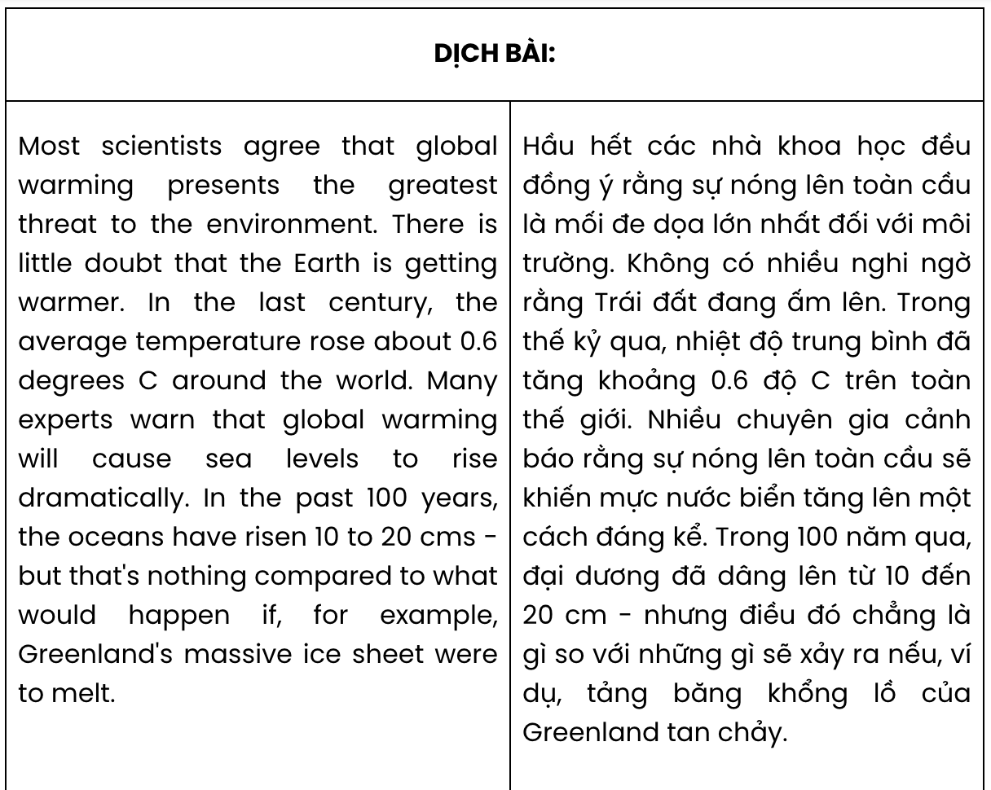
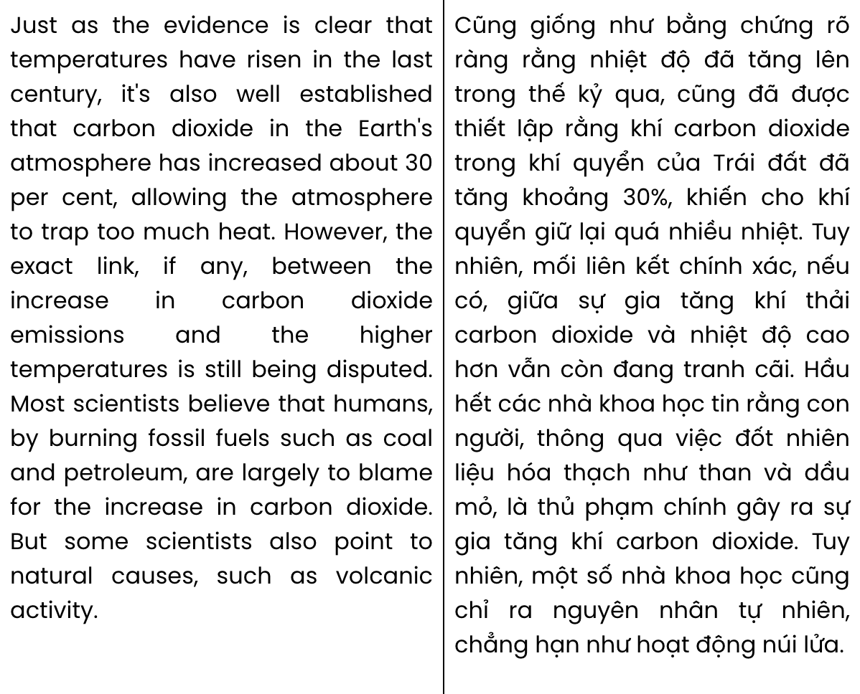
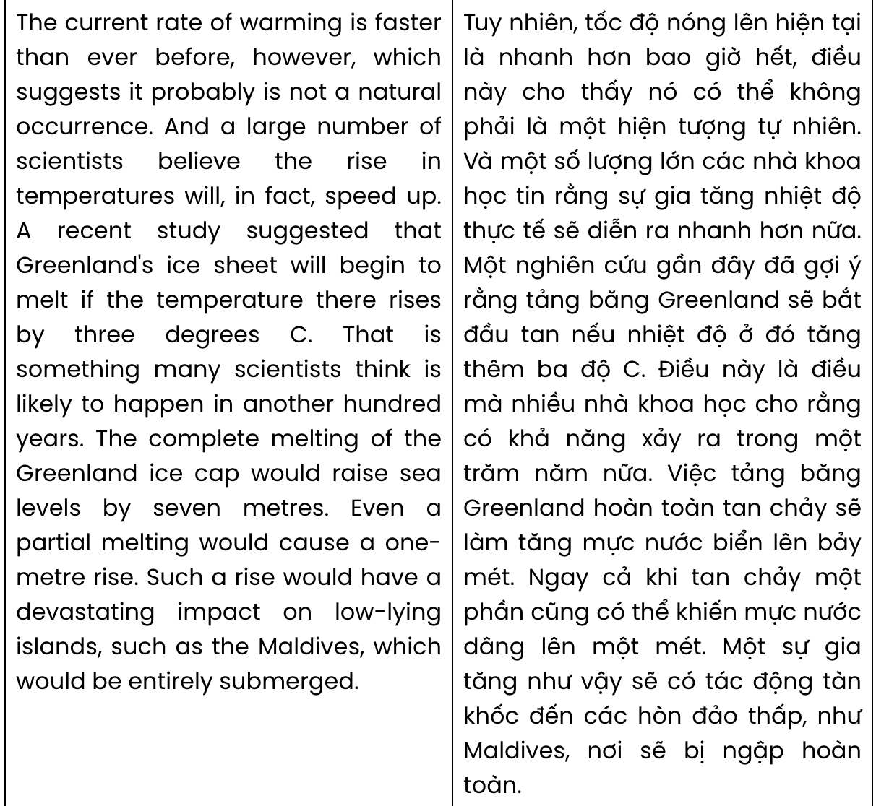
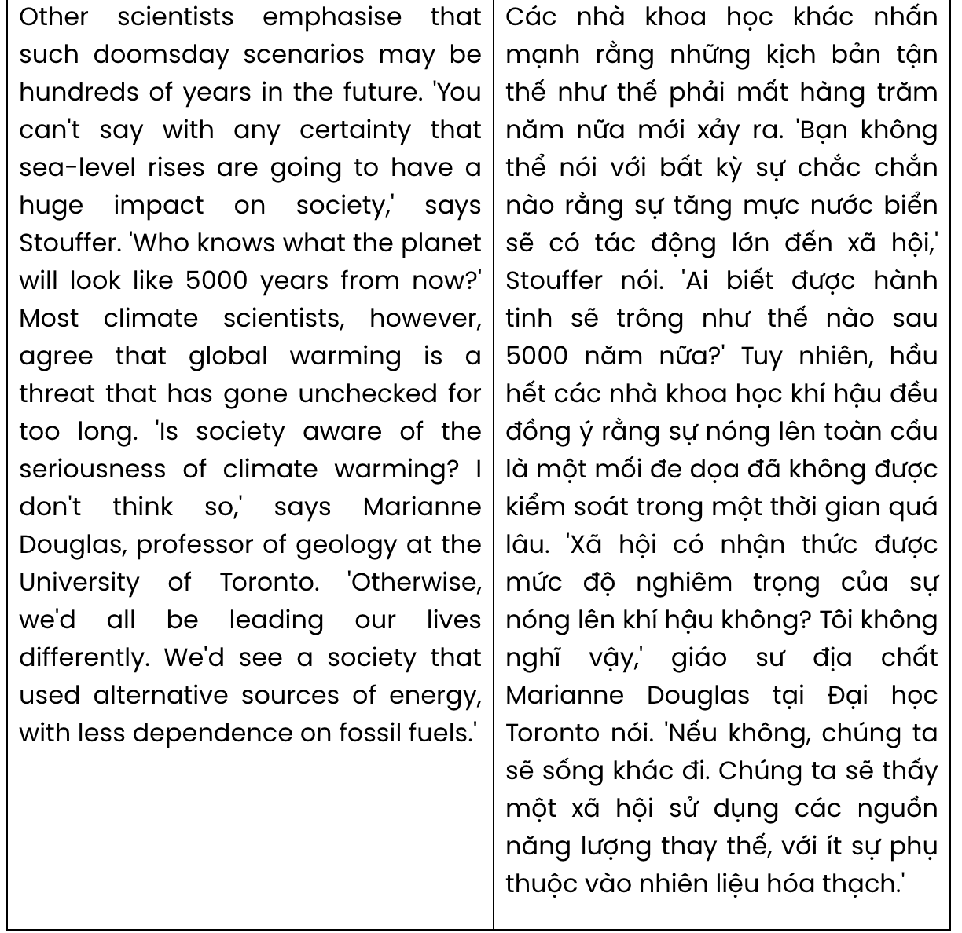
Question 31. According to paragraph 1, what is indicated about global warming?
- It has been exacerbated by recent human activities.
- It can lead to a considerable rise in sea levels.
- It has resulted in global ice melting at an alarming rate.
- It has posed a threat to the lives of coastal communities.
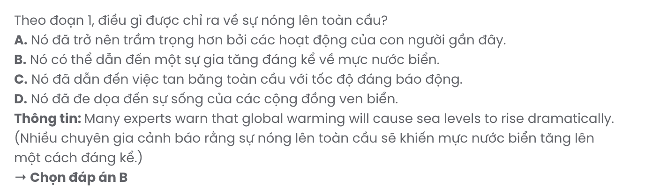
Question 32. The word disputed in paragraph 2 mostly means .
A. thorough B. complicated C. disagreed D. supported
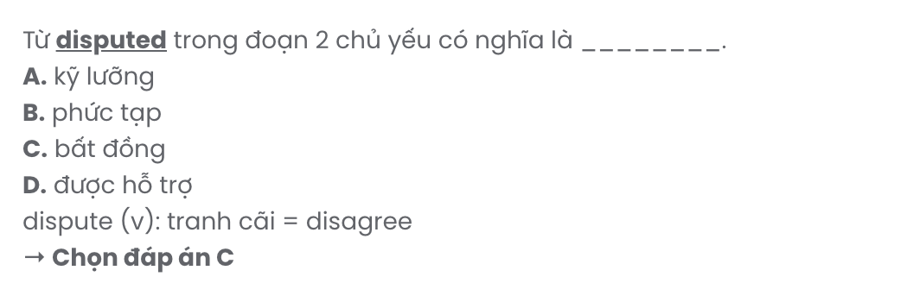
Question 33. Which of the following best summarises paragraph 2?
- There is a definite connection between rising temperatures and increased atmospheric carbon dioxide, though natural causes are also suggested.
- Evidence shows that rising temperatures and higher carbon dioxide levels are linked, though it remains scientifically debated.
- A few scientists blame fossil fuel use for rising carbon dioxide, while others attribute it to natural causes.
- Temperatures and atmospheric carbon dioxide levels have risen, with fossil fuels likely contributing, though debates continue.
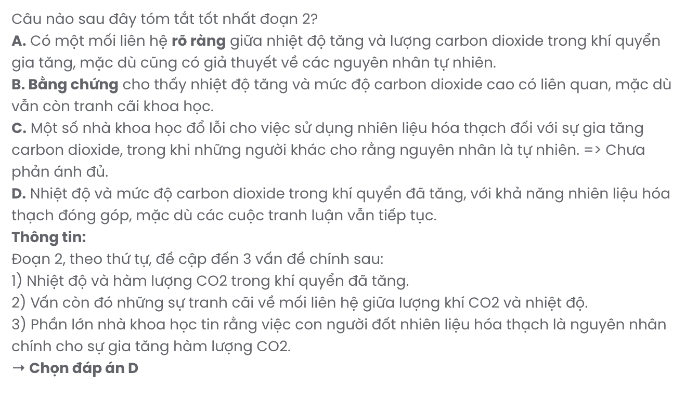
Question 34. The word it in paragraph 3 refers to .
- the current rate of warming B. the rise in temperatures
C. a natural occurrence D. Greenland's ice sheet
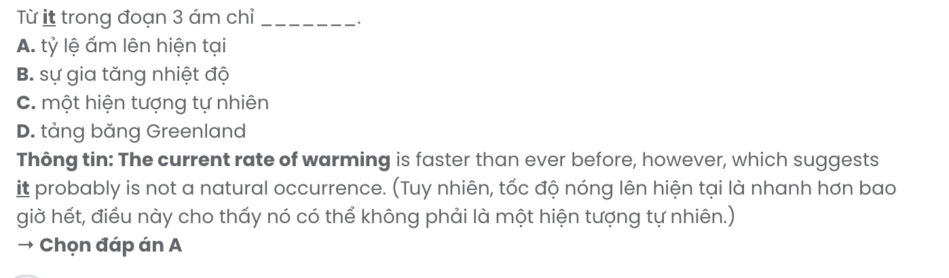
Question 35. Where in paragraph 3 does the following sentence best fit?

Even a partial melting would cause a one-metre rise.
A. [I] B. [II] C. [III] D. [IV]
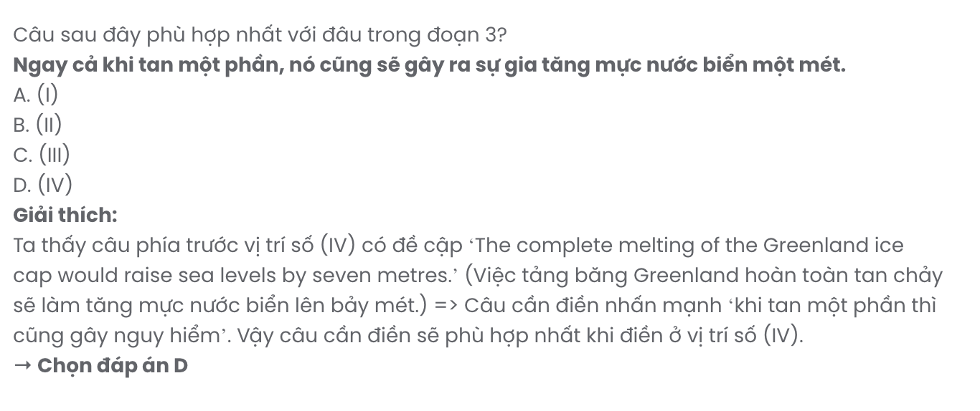
Question 36. The word devastating in paragraph 3 is OPPOSITE in meaning to .
A. insignificant B. disastrous C. gradual D. intense
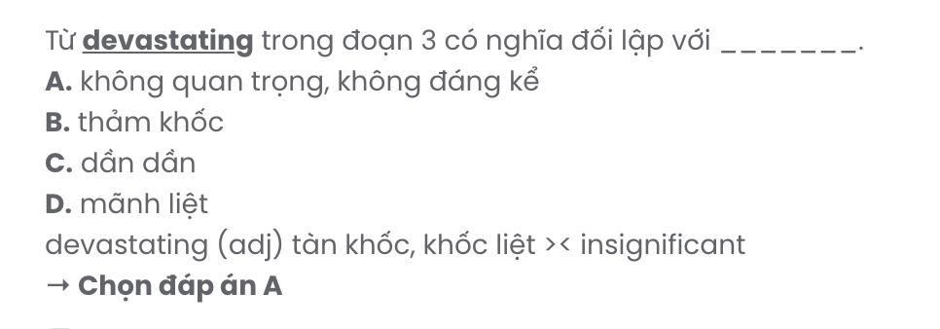
Question 37. Which of the following best paraphrases the underlined sentence in paragraph 4?

Other scientists emphasise that such doomsday scenarios may be hundreds of years in the future.
A. Other scientists suggest that worst-case scenarios are unlikely to happen due to improved technology.
B. Certain scientists claim these events are exaggerated and may never happen as described.
C. Other scientists argue that these drastic predictions are purely speculative and lack scientific basis.
D. Some scientists stress that catastrophic events could still be far off, occurring centuries from now.
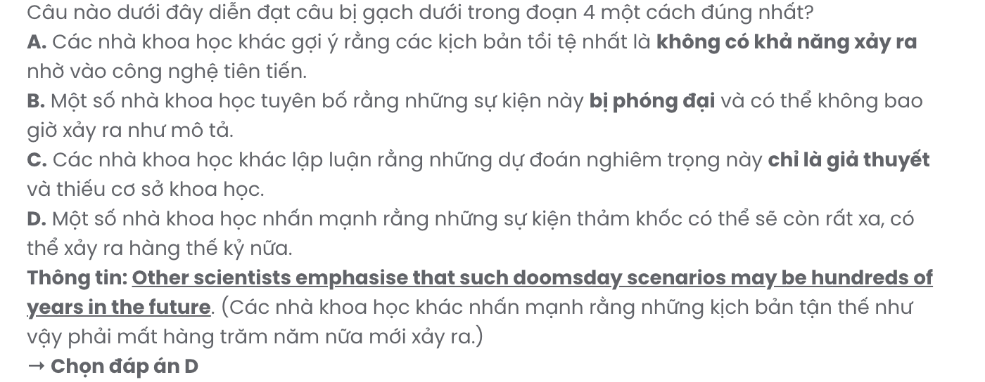
Question 38. Which of the following is NOT true according to the passage?
A. Scientists are at loggerheads with each other over the causes of global warming.
B. If Greenland’s ice sheet melted, it would cause an unprecedented rise in sea level.
C. Low-lying islands, including the Maldives, could be displaced if sea levels rose.
D. It remains to be seen whether carbon dioxide in the Earth's atmosphere has increased.

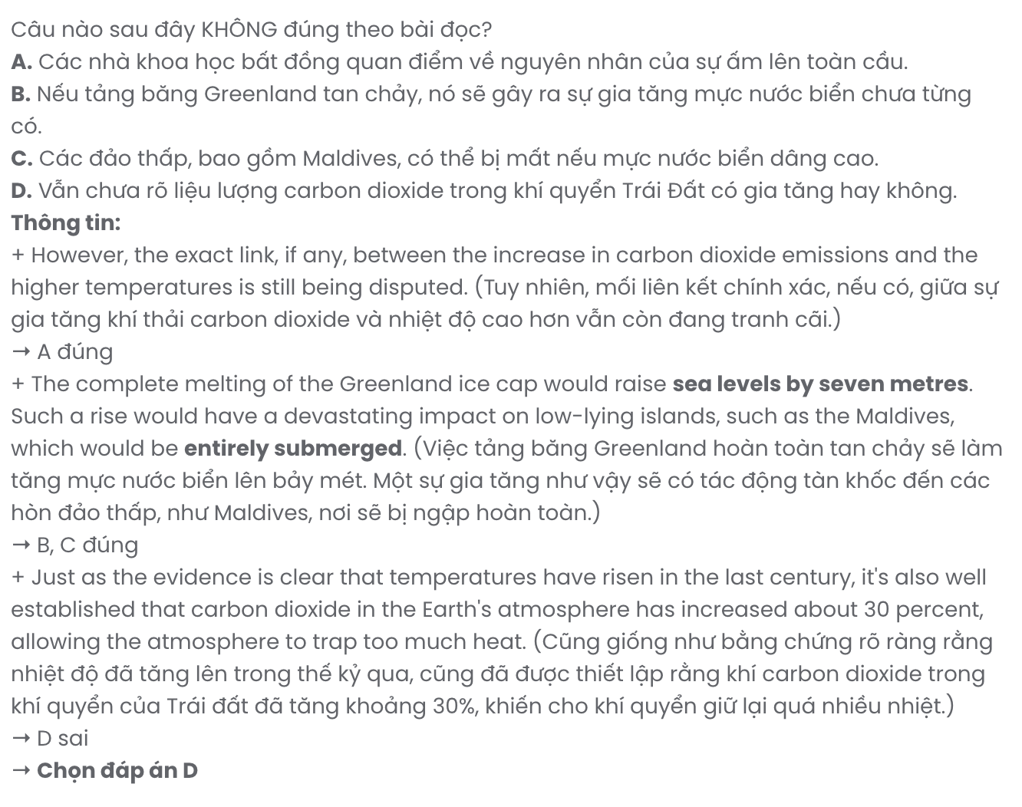
Question 39. Which of the following can be inferred from the passage?
A. People nowadays are still heavily dependent on non-renewable energy sources.
B. Stouffer and Marianne Douglas share the idea that global warming is unpredictable.
C. The disappearance of coastal cities can be the worst-case scenario of global warming.
D. Humans are increasingly aware of the serious consequences of climate warming.
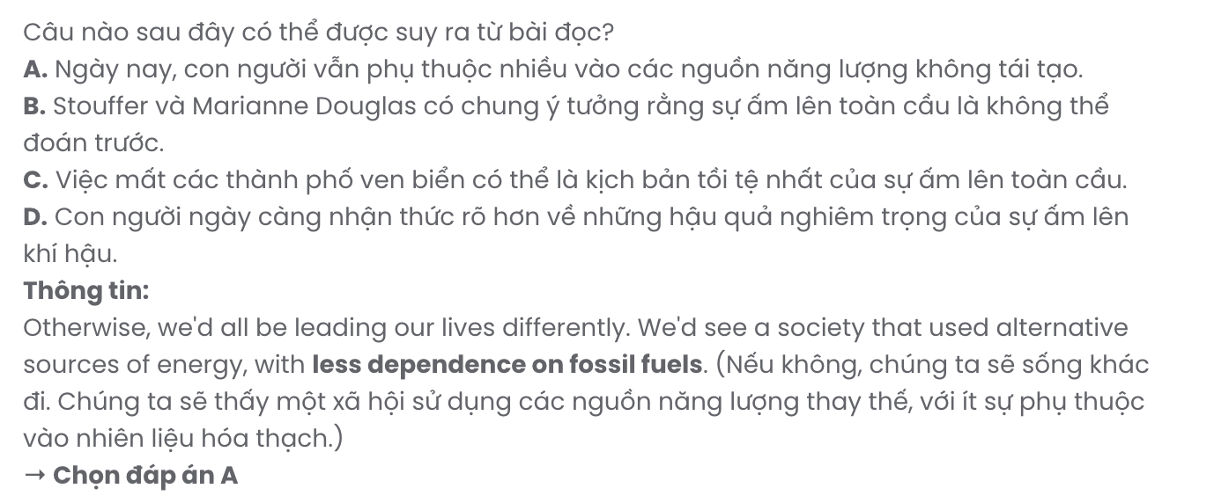
Question 40. Which of the following best summarises the passage?
A. Most scientists agree that global warming poses a major threat, with rising temperatures and sea levels likely impacting low-lying areas significantly, though some believe such events will not become a reality.
B. Global warming, driven by fossil fuels, is raising temperatures and sea levels, with scientists concerned that Greenland's ice melt could cause devastating rises, though most scientists do not link it to carbon emissions.
C. Rising global temperatures and carbon emissions from fossil fuels threaten the environment, with scientists warning of dramatic sea-level rise and low-lying islands at risk, while debates continue over timing and causes.
D. While many scientists warn that global warming threatens Earth, others believe any severe impacts, such as sea-level rise, are far in the future and uncertain due to possible technological solutions.

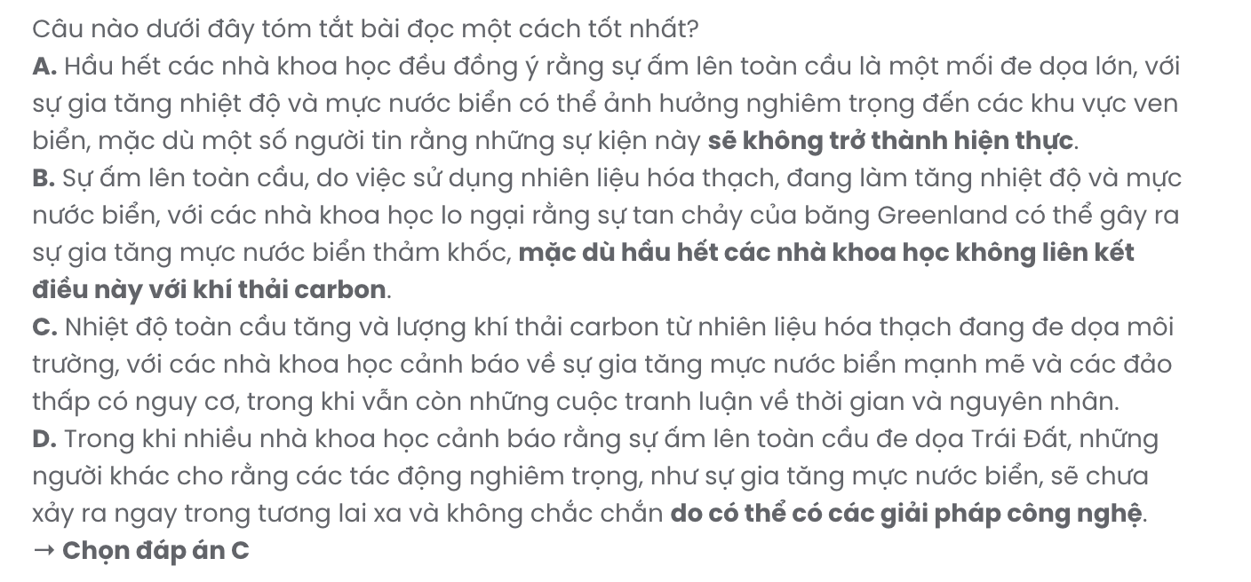
BẢNG TỪ VỰNG
STT | Từ vựng | Từ loại | Phiên âm | Nghĩa
1 | career | n | /kəˈrɪər/ | sự nghiệp
2 | opportunity | n | /ˌɒp.əˈtjuː.nə.ti/ | cơ hội
3 | professional | adj/n | /prəˈfeʃ.ən.əl/ | chuyên nghiệp, chuyên gia
4 | network | v | /ˈnet.wɜːk/ | kết nối
5 | upcoming | adj | /ˈʌpˌkʌm.ɪŋ/ | sắp tới
6 | job fair | n | /ˈdʒɒb ˌfeər/ | hội chợ việc làm
7 | dynamic | adj | /daɪˈnæm.ɪk/ | năng động
8 | job market | n | /ˈdʒɒb ˌmɑː.kɪt/ | thị trường việc làm
9 | employment | n | /ɪmˈplɔɪ.mənt/ | việc làm, sự thuê mướn
10 | various | adj | /ˈveə.ri.əs/ | đa dạng
11 | industry | n | /ˈɪn.də.stri/ | ngành công nghiệp
12 | valuable | adj | /ˈvæl.jə.bəl/ | có giá trị
13 | well-prepared | adj | /ˌwel prɪˈpeərd/ | chuẩn bị kỹ lưỡng
14 | candidate | n | /ˈkæn.dɪ.dət/ | ứng viên
15 | potential | adj/n | /pəˈten.ʃəl/ | tiềm năng
16 | employer | n | /ɪmˈplɔɪ.ər/ | nhà tuyển dụng
17 | present | v | /prɪˈzent/ | trình bày
18 | expert | n | /ˈek.spɜːt/ | chuyên gia
19 | seasoned | adj | /ˈsiː.zənd/ | dày dặn kinh nghiệm
20 | instructor | n | /ɪnˈstrʌk.tər/ | giảng viên, người hướng dẫn
21 | guidance | n | /ˈɡaɪ.dəns/ | sự hướng dẫn
22 | like-minded | adj | /ˌlaɪkˈmaɪn.dɪd/ | cùng chí hướng
23 | eager | adj | /ˈiː.ɡər/ | háo hức
24 | creativity | n | /ˌkriː.eɪˈtɪv.ɪ.ti/ | sự sáng tạo
25 | technical | adj | /ˈtek.nɪ.kəl/ | kỹ thuật, chuyên môn
26 | fulfilling | adj | /fʊlˈfɪl.ɪŋ/ | thỏa mãn, mang lại sự hài lòng
27 | attention | n | /əˈten.ʃən/ | sự chú ý
28 | passion | n | /ˈpæʃ.ən/ | niềm đam mê
29 | visibility | n | /ˌvɪz.əˈbɪl.ə.ti/ | tầm nhìn
30 | pedestrian | n | /pəˈdes.tri.ən/ | người đi bộ
31 | confrontation | n | /ˌkɒn.frʌnˈteɪ.ʃən/ | sự đối đầu, cuộc chạm trán
32 | essential | adj | /ɪˈsen.ʃəl/ | thiết yếu, quan trọng
33 | enhance | v | /ɪnˈhɑːns/ | nâng cao, cải thiện
34 | security | n | /sɪˈkjʊə.rɪ.ti/ | an ninh, sự bảo vệ
35 | vigilance | n | /ˈvɪdʒ.ɪ.ləns/ | sự cảnh giác
36 | suspicious | adj | /səˈspɪʃ.əs/ | đáng ngờ, khả nghi
37 | report | v | /rɪˈpɔːt/ | báo cáo, thông báo
38 | criminal | n | /ˈkrɪm.ɪ.nəl/ | tội phạm
39 | illuminate | v | /ɪˈluː.mɪ.neɪt/ | chiếu sáng, làm sáng tỏ
40 | deter | v | /dɪˈtɜːr/ | ngăn cản, răn đe
41 | illegal | adj | /ɪˈliː.ɡəl/ | bất hợp pháp

42 | alleyway | n | /ˈæl.i.weɪ/ | ngõ hẻm, lối đi nhỏ
43 | boost | v | /buːst/ | tăng cường, thúc đẩy
44 | overrate | v | /ˌəʊ.vəˈreɪt/ | đánh giá quá cao
45 | soft skill | n | /ˈsɒft skɪl/ | kỹ năng mềm
46 | resilience | n | /rɪˈzɪl.jəns/ | khả năng phục hồi, kiên cường
47 | autonomy | n | /ɔːˈtɒn.ə.mi/ | quyền tự chủ
48 | unforeseen | adj | /ˌʌn.fɔːˈsiːn/ | không lường trước, bất ngờ
49 | groceries | n | /ˈɡrəʊ.səriz/ | thực phẩm, hàng tạp hóa
50 | independent | adj | /ˌɪn.dɪˈpen.dənt/ | độc lập, tự lập
51 | transformative | adj | /trænsˈfɔː.mə.tɪv/ | có tính chuyển đổi, biến đổi
52 | phase | n | /feɪz/ | giai đoạn
53 | regret | n | /rɪˈɡret/ | sự hối tiếc, sự nuối tiếc
54 | deforestation | n | /ˌdiː.fɔːˈres.təˈreɪ.ʃən/ | nạn phá rừng
55 | escalate | v | /ˈeskəleɪt/ | leo thang, tăng lên
56 | ecosystem | n | /ˈiː.kəʊˌsɪs.təm/ | hệ sinh thái
57 | diverse | adj | /daɪˈvɜːs/ | đa dạng
58 | species | n | /ˈspiːʃiːz/ | loài
59 | disrupt | v | /dɪsˈrʌpt/ | làm gián đoạn, phá vỡ
60 | settlement | n | /ˈset.əl.mənt/ | sự giải quyết, khu dân cư
61 | habitat | n | /ˈhæbɪtæt/ | môi trường sống
62 | urban | adj | /ˈɜːbən/ | thuộc về đô thị
63 | agriculture | n | /ˈæɡ.rɪ.kʌl.tʃər/ | nông nghiệp
64 | expansion | n | /ɪkˈspæn.ʃən/ | sự mở rộng
65 | illness | n | /ˈɪl.nəs/ | bệnh tật
66 | transmit | v | /trænˈsɪt/ | truyền, phát tán
67 | biodiversity | n | /ˌbaɪəʊˈdɪvəsəti/ | sự đa dạng sinh học
68 | degradation | n | /ˌdeɡ.rəˈdeɪ.ʃən/ | sự suy thoái
69 | threaten | v | /ˈθretən/ | đe dọa
70 | outbreak | n | /ˈaʊtˌbreɪk/ | sự bùng phát
71 | migrate | v | /maɪˈɡreɪt/ | di cư
72 | expose | v | /ɪkˈspəʊz/ | phơi bày, tiếp xúc
73 | barrier | n | /ˈbæriər/ | rào cản, trở ngại
74 | crucial | adj | /ˈkruːʃəl/ | quan trọng, quyết định
75 | contagious | adj | /kənˈteɪdʒəs/ | dễ lây lan, truyền nhiễm
76 | audience | n | /ˈɔːdiəns/ | khán giả
77 | disability | n | /ˌdɪsəˈbɪləti/ | khuyết tật, tàn tật
78 | accessible | adj | /əkˈsesəbl/ | dễ tiếp cận, có thể truy cập
79 | reward | n | /rɪˈwɔːd/ | phần thưởng
80 | considerable | adj | /kənˈsɪdərəbl/ | đáng kể, lớn
81 | preference | n | /ˈprefrəns/ | sự ưa chuộng, sự ưu tiên
82 | interpret | v | /ɪnˈtɜːprɪt/ | giải thích, phiên dịch
83 | immense | adj | /ɪˈmens/ | mênh mông, to lớn
84 | entire | adj | /ɪnˈtaɪə/ | toàn bộ, tất cả
85 | harmony | n | /ˈhɑːməni/ | sự hòa hợp, sự hòa thuận

86 | consultant | n | /kənˈsʌltənt/ | tư vấn viên
87 | rehearse | v | /rɪˈhɜːs/ | tập dượt, luyện tập
88 | workload | n | /ˈwɜːk.ləʊd/ | khối lượng công việc
89 | priority | n | /praɪˈɒrəti/ | ưu tiên
90 | separation | n | /ˌsepəˈreɪʃən/ | sự phân chia, sự tách rời
91 | abundance | n | /əˈbʌndəns/ | sự phong phú, sự dồi dào
92 | concentration | n | /ˌkɒnsənˈtreɪʃən/ | sự tập trung
93 | strategy | n | /ˈstrætədʒi/ | chiến lược
94 | global warming | n | /ˈɡləʊbəl ˈwɔːmɪŋ/ | sự nóng lên toàn cầu
95 | dramatically | adv | /drəˈmætɪkli/ | mạnh mẽ, đột ngột
96 | occurrence | n | /əˈkʌrəns/ | sự kiện, hiện tượng
97 | submerge | v | /səbˈmɜːdʒ/ | làm chìm, nhấn chìm
98 | scenario | n | /sɪˈnɑːriəʊ/ | kịch bản, tình huống
99 | dependence | n | /dɪˈpendəns/ | sự phụ thuộc
100 | non-renewable | adj | /ˌnɒn rɪˈnjuːəbl/ | không thể tái tạo
101 | unpredictable | adj | /ˌʌnprɪdɪkˈteɪəbl/ | không thể đoán trước, khó  lường
102 | disappearance | n | /ˌdɪsəˈpɪərəns/ | sự biến mất, sự mất tích
103 | coastal | adj | /ˈkəʊstəl/ | ven biển
104 | drastic | adj | /ˈdræstɪk/ | quyết liệt, mạnh mẽ
105 | catastrophic | adj | /ˌkætəsˈtrɒfɪk/ | thảm khốc, tai hại
106 | exaggerate | v | /ɪɡˈzædʒəreɪt/ | phóng đại, thổi phồng
107 | exacerbate | v | /ɪɡˈzæsəbeɪt/ | làm trầm trọng thêm, làm tồi tệ  hơn

BẢNG CẤU TRÚC

STT | Cấu trúc | Nghĩa
1 | guide someone through | chỉ dẫn ai đó
2 | gain insights into | có hiểu biết sâu sắc về
3 | recommend doing something | đề xuất làm gì
4 | make the most of something | tận dụng tối đa cái gì
5 | align with | phù hợp với
6 | make up | bịa ra, làm hòa
7 | put away | cất đi, dọn dẹp
8 | look for | tìm kiếm
9 | pass down | truyền lại
10 | rather than | thay vì
11 | regardless of | bất kể, bấp chấp
12 | on account of | vì lý do, do
13 | except for | ngoại trừ
14 | a handful of | một ít, một vài
15 | a variety of | một loạt, nhiều loại
16 | go camping | đi cắm trại
17 | make a decision | đưa ra quyết định
18 | deal with | giải quyết, đối phó với
19 | be deprived of | bị tước đi, mất đi
20 | contribute to | đóng góp vào, góp phần vào
21 | take place | diễn ra, xảy ra
22 | present a threat to | gây ra mối đe dọa đối với
23 | be to blame for something | là nguyên nhân của cái gì, đáng bị trách
24 | be likely to | có khả năng làm gì
25 | have a huge impact on | có ảnh hưởng lớn đến
26 | be heavily dependent on | phụ thuộc nhiều vào
27 | be at loggerheads with someone | mâu thuẫn với ai đó

