Thời gian làm bài: 40 phút (Không kể thời gian giao đề)
-------------------------
Họ tên thí sinh: .................................................................
Số báo danh: ......................................................................
Mã Đề: 039.
Câu 1. When does the science club meet?
Science Club Notice:
Science club opening soon! Meets Tues/Thurs after school in room 205. First meeting on Sept. 14th at 3:30 pm.
A. Monday and Wednesday after school B. Tuesday and Thursday after school
C. Sunday afternoon D. Saturday morning
Câu 2. Look at the signs. Choose the best answer for the question.
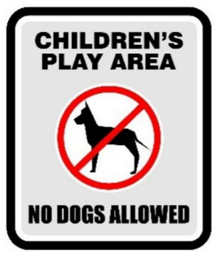
A. Don’t let your children play here because of the dogs.
B. Dogs are not allowed to play with children in this area.
C. Dogs cannot be taken into this place as it is a children’s play area.
D. Dogs are not safe for children in this play area.
Câu 3. Look at the signs. Choose the best answer for the question.
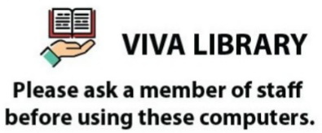
A. You have to be a member of staff in order to use the computers.
B. You must ask for a computer when you go to Viva Library.
C. A member of staff will give you a computer.
D. You need to ask for permission when you want to use the computer.
Câu 4. What is the offer at the Tennis Club?

A. €10 to join the club
B. Tennis lessons for children on Tuesdays and Thursdays
C. Tennis lessons for adults on Mondays and Fridays
D. Tennis lessons for children on Mondays and Fridays for €5 to join
Câu 5. Why is Dom urging Matt to hurry up?
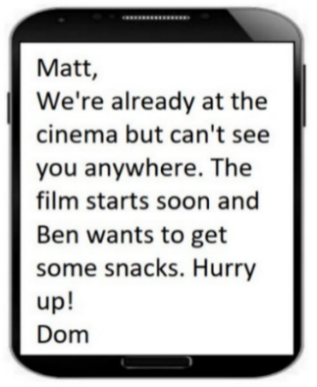
A. The snack bar is closing soon B. They can't find seats in the cinema
C. The movie has already started D. The film is about to start soon
Câu 6. Look at the signs. Choose the best answer for the question.
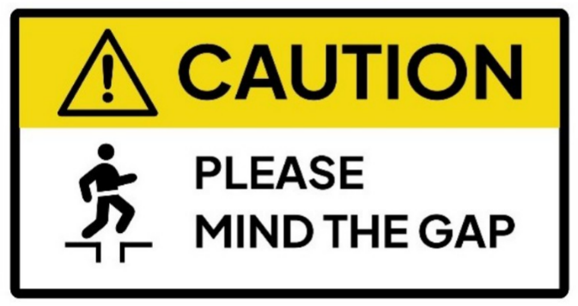
A. You need to think about the gap. B. You need to stay away from the gap.
C. You need to be careful about the gap. D. You need to remember the gap.
Câu 7. What caused damage to the library?
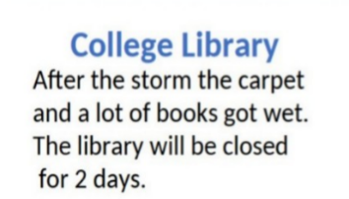
A. Renovation work B. Vandalism C. A storm D. A fire
Câu 8. What activity is being proposed in the message?
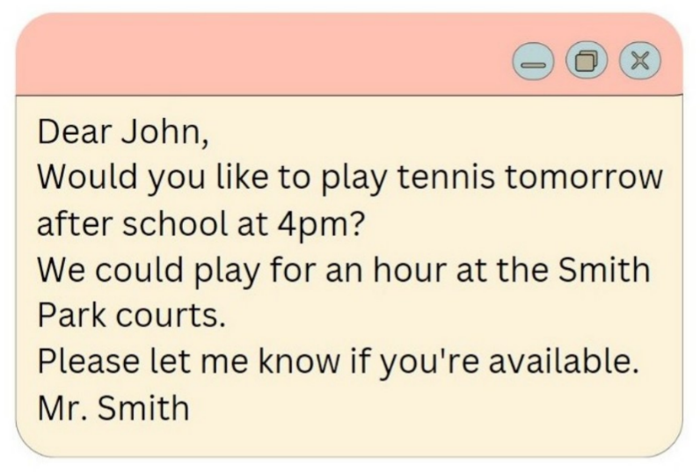
A. Playing tennis B. Going swimming C. Playing basketball D. Going for a run
Câu 9. What does the sign say?
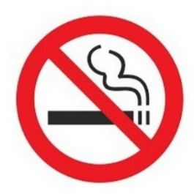
A. Smoking is compulsory here. B. Smoking is optional here.
C. Smoking is not permitted here. D. Smoking is useful here.
Câu 10. Look at the signs. Choose the best answer for the question.
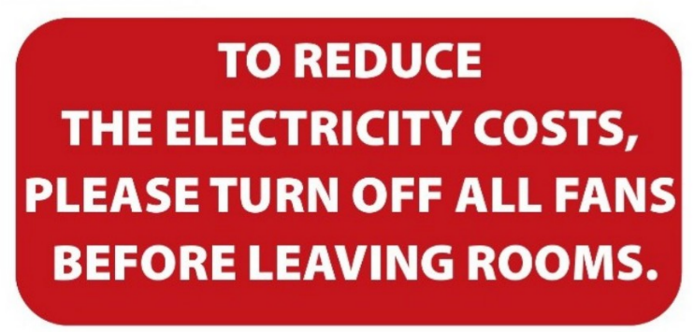
A. Please switch off fans when you finish using a room to save electricity.
B. When you leave, please reduce the number of fans in your room.
C. Please reduce the costs of electricity by leaving the room.
D. Please leave the fans in the room after you go out.
----HẾT---

