ĐỀ VIP 9+ - ĐỀ SỐ 13
Read the following advertisement and mark the letter A, B, C, or D to indicate the correct option that best fits each of the numbered blanks from 1 to 6.

STAY SAFE WITH QUAKEGUARD – YOUR ULTIMATE SAFETY APP
Are you prepared for unexpected emergencies like earthquakes? QuakeGuard is designed to help you
(1) precautions before, during, and after a disaster strikes.
Packed with cutting-edge technology, the app provides real-time alerts, enabling users (2) vital information and safety tips instantly. (3) user benefits from features like personalised safety plans and location-specific warnings tailored to their needs.
Developed by experts in disaster management, QuakeGuard offers a high (4) of reliability and accuracy, ensuring you’re always (5) . The app also includes a (6) guide, covering everything from creating emergency kits to securing your home effectively.
Don’t wait for an emergency to catch you off guard. Download QuakeGuard today and take the first step toward protecting yourself and your loved ones.
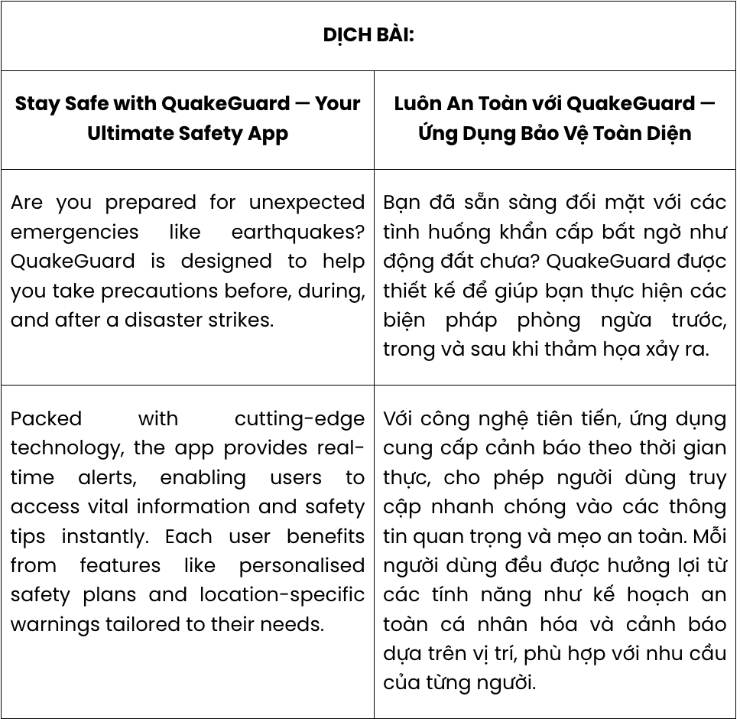
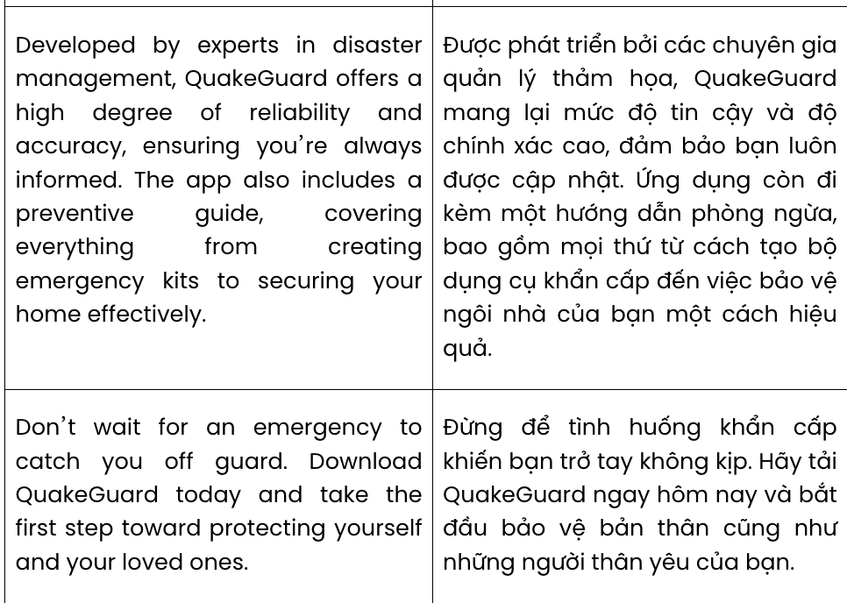
Question 1. A. take B. make C. put D. leave
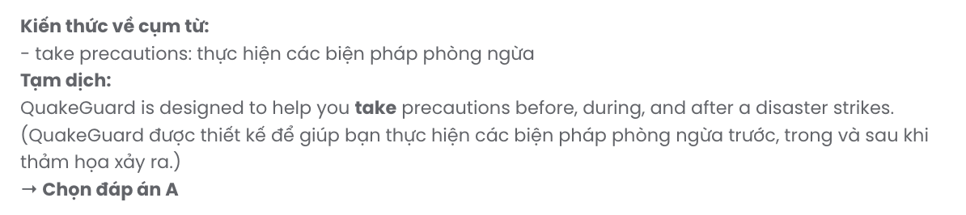
Question 2. A. accessing B. to accessing C. access D. to access
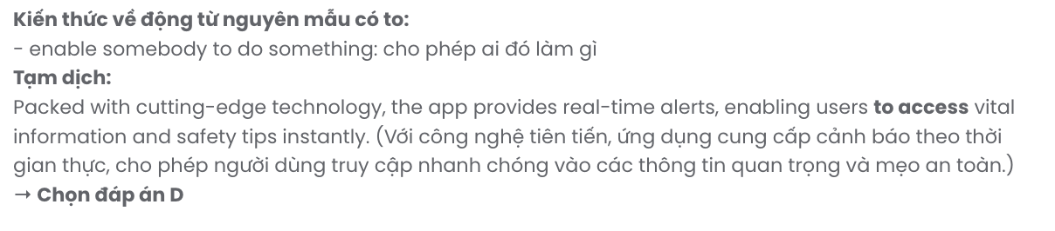
Question 3. A. Many B. Each C. Other D. A few
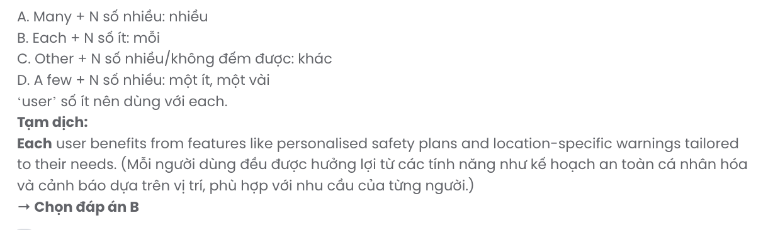
Question 4. A. degree B. handful C. variety D. majority
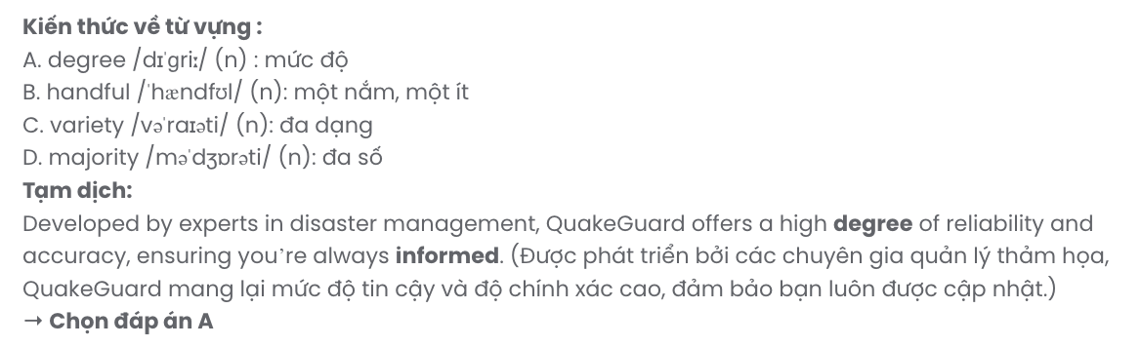
Question 5. A. informative B. information C. inform D. informed
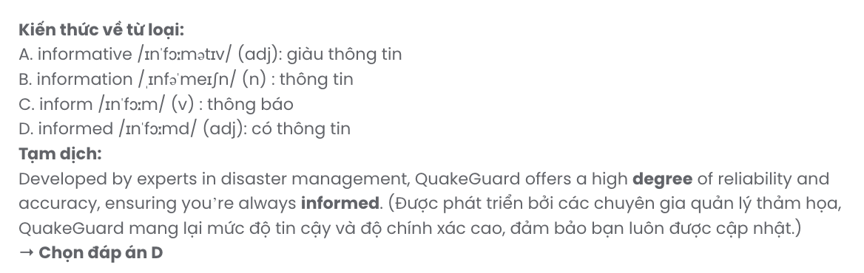
Question 6. A. defensive B. cautionary C. preventive D. protected
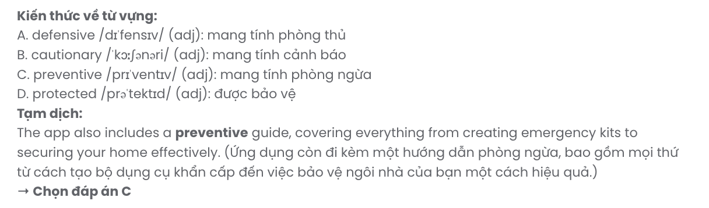
Read the following leaflet and mark the letter A, B, C, or D to indicate the correct option that best fits each of the numbered blanks from 7 to 12.

Opening Ceremony of the Harmony Folk Singing Club
We are delighted to announce the grand opening of the (7) dedicated to preserving the art of folk singing. This special event will take place on Sunday at the Community Arts Center.
The club welcomes all enthusiasts passionate about traditional music to be involved (8) exciting activities such as singing workshops and performances. Founded by experienced musicians, the club creates an environment (9) creativity and collaboration.
(10) the dedication of local artists and supporters, this initiative aims to (11) cherished folk songs to future generations. Members will gain opportunities to (12) the cultural and historical significance of these timeless melodies.
Don’t miss the chance to join this unique community and celebrate the beauty of folk music. For more details, contact us at harmonyfolkclub@example.com.
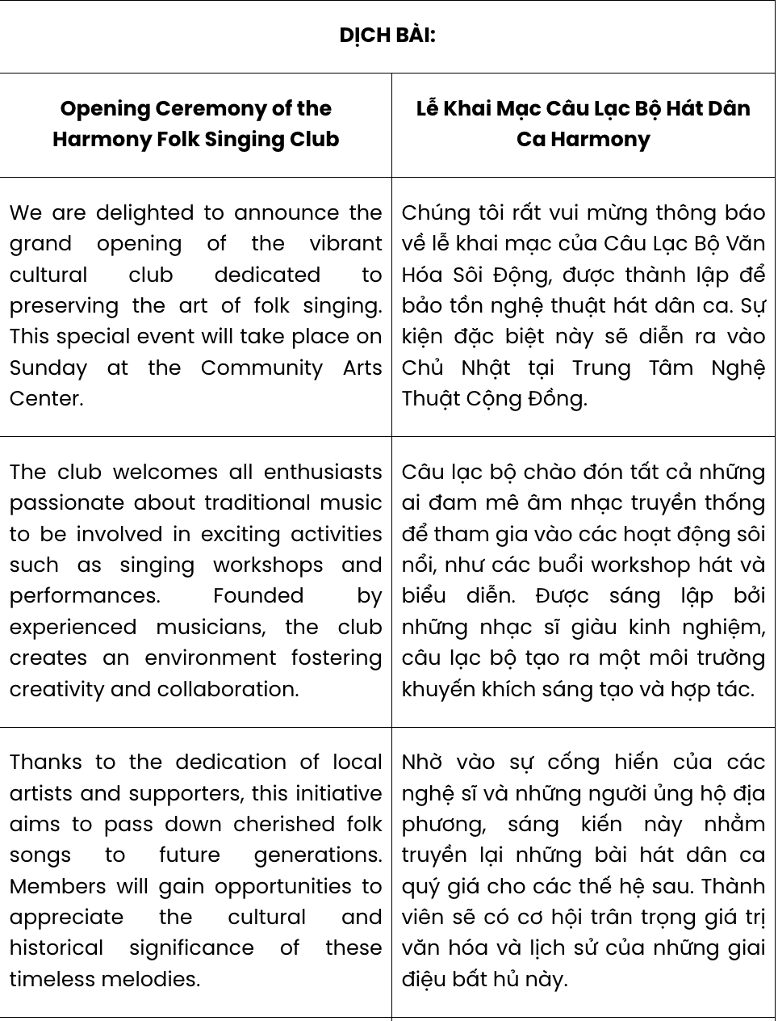
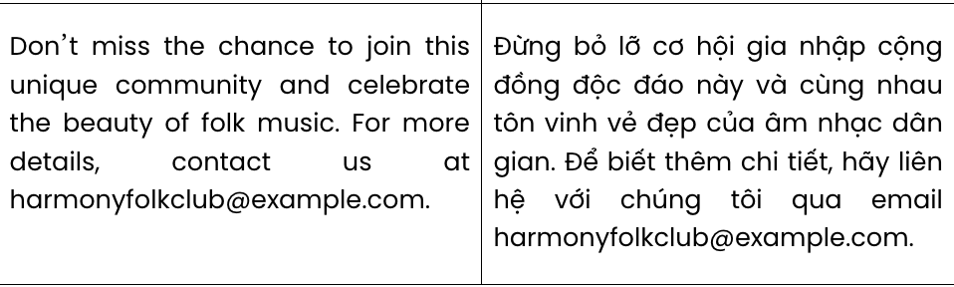
Question 7. A. cultural vibrant club B. cultural club vibrant GIA SƯTẠI HUẾ (079.3833.272)
C. vibrant cultural club D. vibrant club cultural
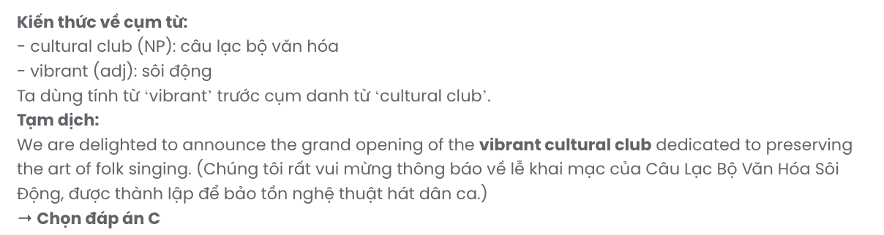
Question 8. A. with B. on C. for D. in
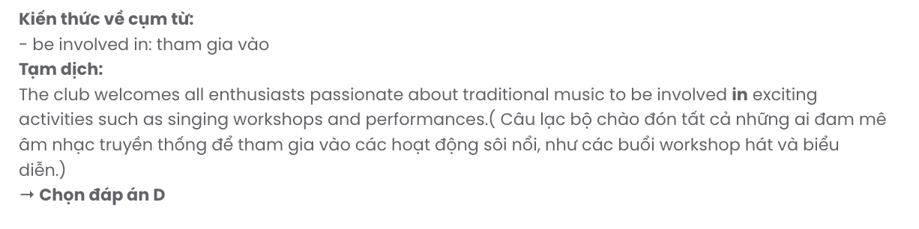
Question 9. A. fostered B. fostering C. is fostered D. which foster
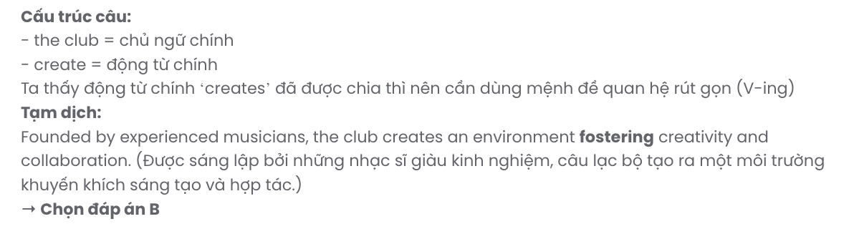
Question 10. A. Except for B. Rather than C. Regardless of D. Thanks to
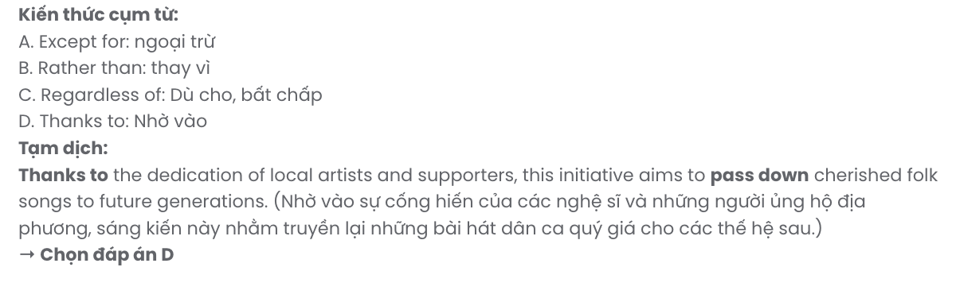
Question 11. A. take on B. put out C. pass down D. give off
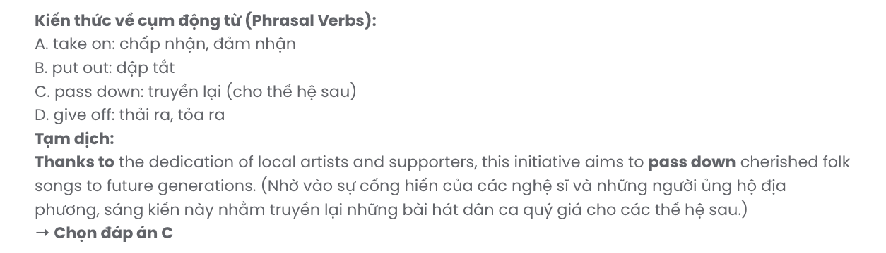
Question 12. A. recognise B. appreciate C. contribute D.integrate

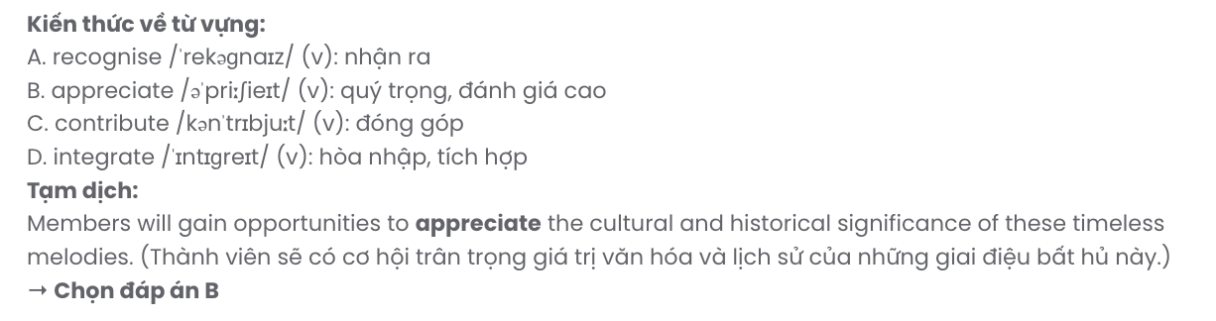

Mark the letter A, B, C or D to indicate the best arrangement of utterances or sentences to make a meaningful exchange or text in each of the following questions from 13 to 17.

Question 13.
- Reflecting on the event, I realise how such initiatives can inspire students to embrace eco-conscious habits.
- Participating in the green fashion competition at my school was a transformative experience.
- My team, inspired by the theme of "nature’s resilience," crafted an ensemble adorned with leaves and old fabric, which garnered much admiration.
- Through the project, we not only honed our design skills but also deepened our understanding of environmental issues.
- Designed to promote sustainability, the competition challenged us to create outfits from recycled materials, sparking a wave of creativity among participants.
A. e – c – d – b – a B. d – c – b – e – a C. b – e – c – d – a D. c – d – e – b – a
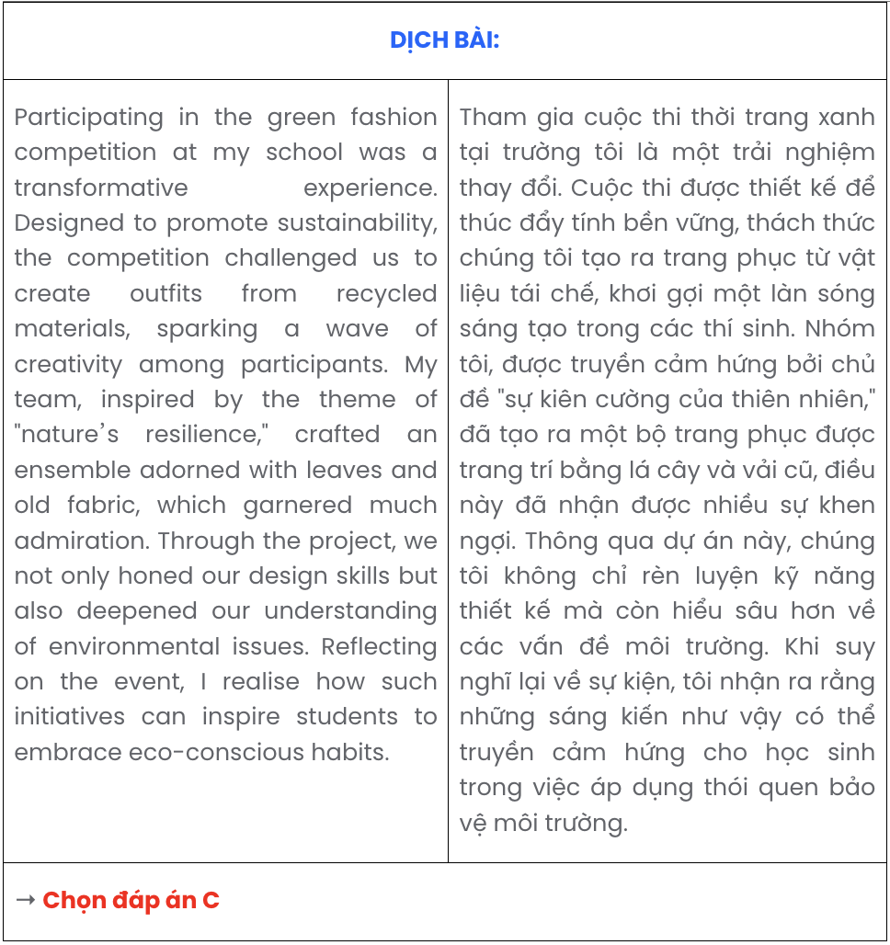

Question 14.
- Mai: I agree. Those who embrace lifelong learning are more likely to adapt to changes and succeed.
- Tung: It also keeps life exciting, don’t you think? Exploring new areas constantly is so rewarding.
- Tung: I think it’s essential in today’s world. Skills and knowledge become outdated so quickly.
- Mai: What’s your opinion on lifelong learning?
- Mai: Lifelong learning is like investing in yourself, and that’s always worth it.
A. d – c – a – b – e B. d – b – a – c – e C. e – b – a – c – d D. e – c – a – b – d
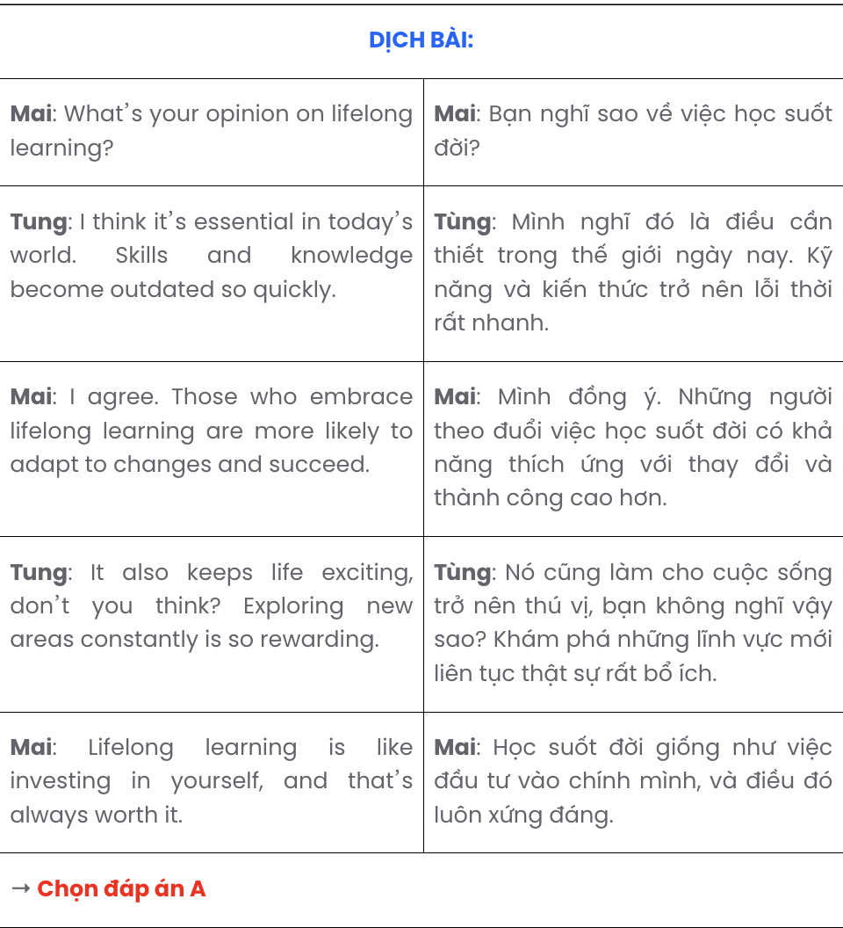

Question 15.
- Minh: Hi, Linh. I’m just adding a few images to make them more engaging. Have you practised your part?
- Linh: Hi, Minh, have you finished preparing the slides for our presentation tomorrow?
- Linh: Not yet, but I’ll go over it tonight to make sure everything flows smoothly.
A. a – c – b B. c – a – b C. c – b – a D. b – a – c
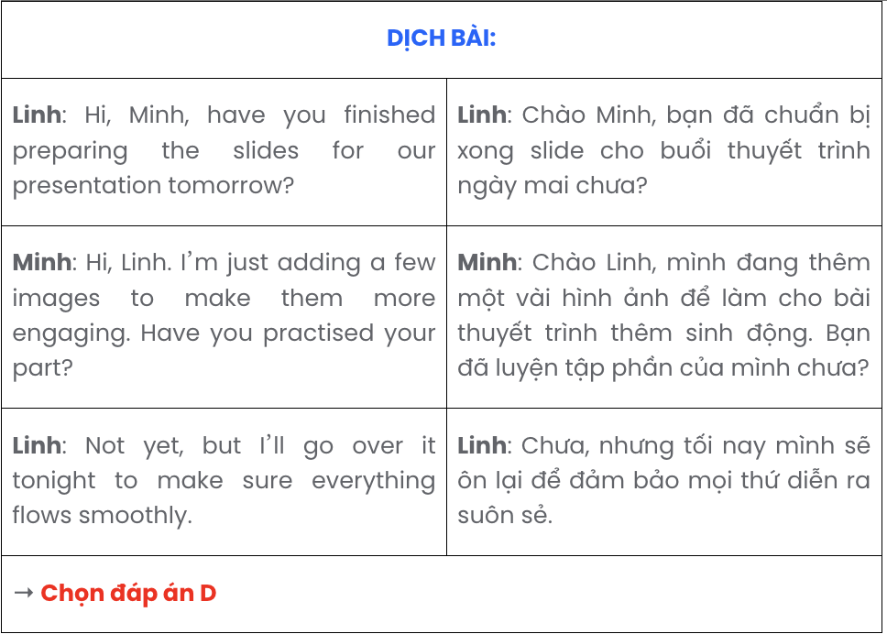

Question 16.
- Such efforts not only enhanced the learning environment but also inspired the Hmong community to value education as a tool for progress.
- Despite the programme’s efforts to provide solar-powered lights and textbooks, its limited funding prevented many villages in Ha Giang from benefiting equally.
- The resources provided, such as solar-powered lights and textbooks, enabled students to continue their studies despite the area's limited infrastructure.
- Designed to improve access to education, the initiative provided essential school supplies, renovated classrooms in Dong Van District, and trained teachers to address the unique challenges of the region.
- The "Bright Futures" educational programme in Ha Giang, a remote mountainous province in Vietnam, has brought transformative opportunities to local children.
A. e – b – c – a – d B. e – a – c – b – d C. e – d – a – c – b D. e – c – d – b – a

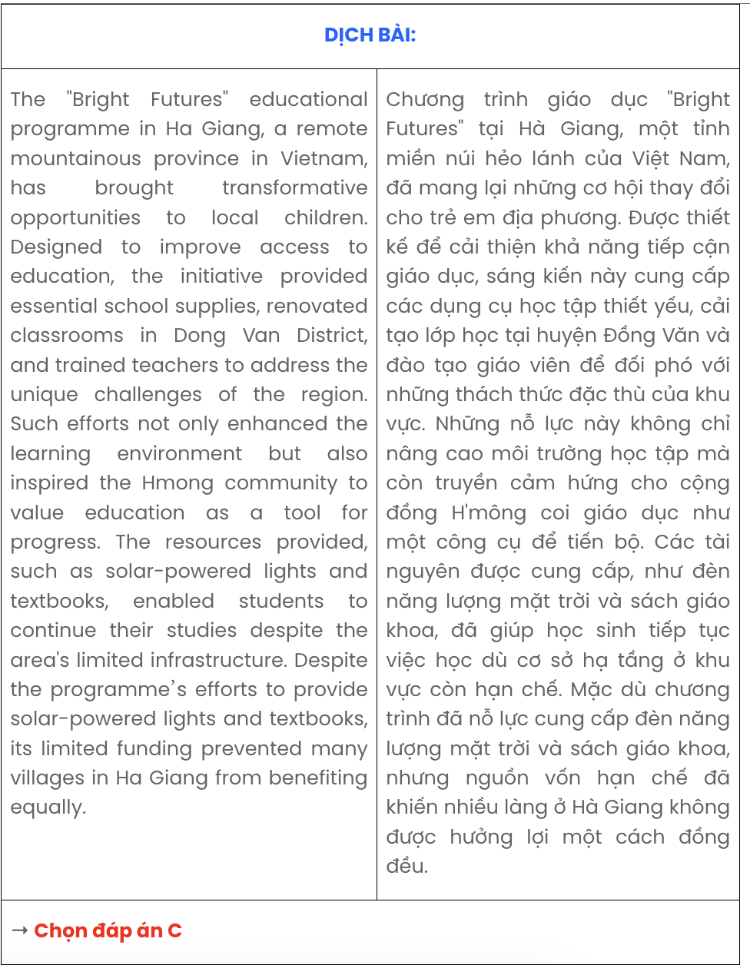

Question 17.
Dear Mom and Dad,
- Being at the army camp has been an incredible experience so far.
- This training has shown me the importance of teamwork, as we rely on each other to succeed.
- The daily drills and exercises have pushed me out of my comfort zone, but these routines are helping me build both strength and discipline.
- I can’t wait to share more stories with you when I get home.
- Yesterday, we learned to set up tents and navigate using a compass, which were skills I had never tried before.
Love, Martin
A. e – d – b – c – a B. d – c – b – e – a C. b – e – a – d – c D. a – c – e – b – d

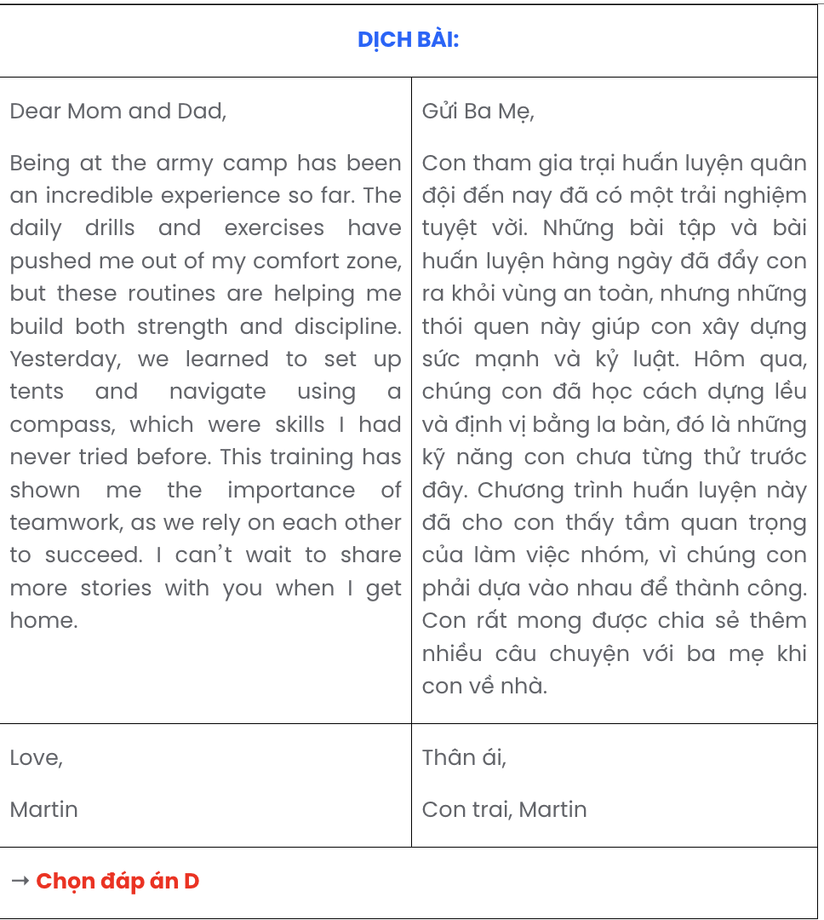

Read the following passage about Vietnamese customs and cultures and mark the letter A, B, C, or D to indicate the correct option that best fits each of the numbered blanks from 18 to 22.

Air conditioners, invented to regulate indoor temperatures, have become an essential part of modern life. These devices, (18) , not only cool the air but also improve overall air quality by filtering dust and allergens.
Reducing indoor humidity levels, (19) , which, in turn, enhance productivity and well- being. However, their widespread use has led to significant energy consumption, contributing to environmental challenges.
(20) , modern air conditioners are built with energy-saving technologies, making them more sustainable than earlier models. In some homes, faulty units are repaired by professionals to ensure proper functionality, highlighting the reliance on expert maintenance for their upkeep.
While providing much-needed comfort, air conditioners also contribute significantly to environmental challenges, primarily through energy consumption and greenhouse gas emissions caused by refrigerants. To mitigate these impacts, (21) . Encouraging habits that reduce energy use, such as setting optimal temperatures and ensuring proper maintenance, (22) . By making informed choices, users can balance the convenience of air conditioning with the need to protect the environment for future generations.
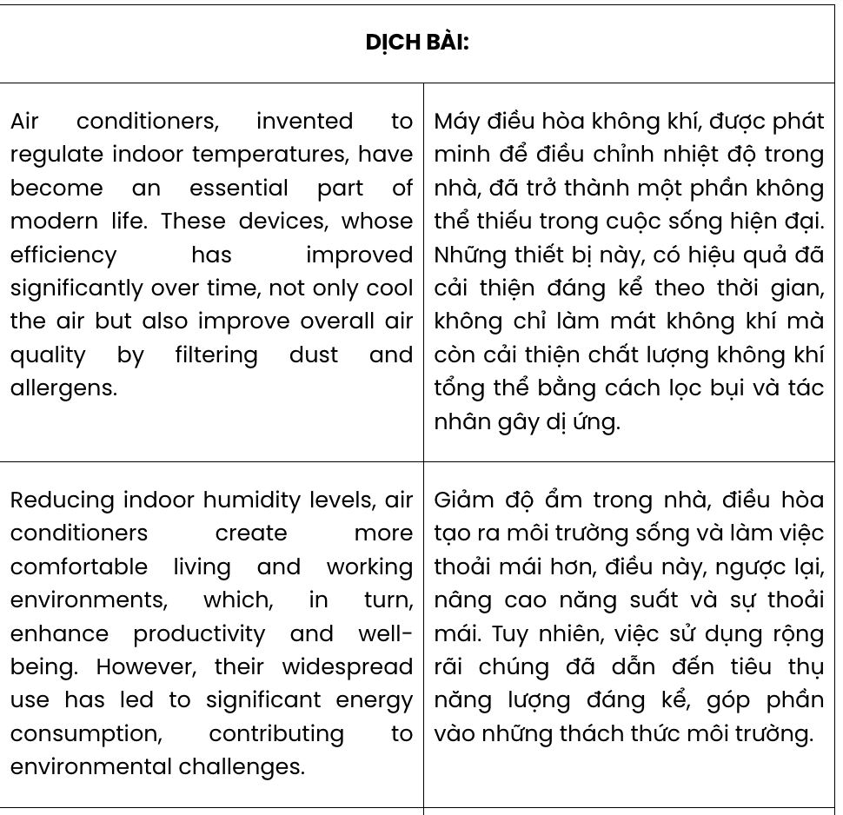
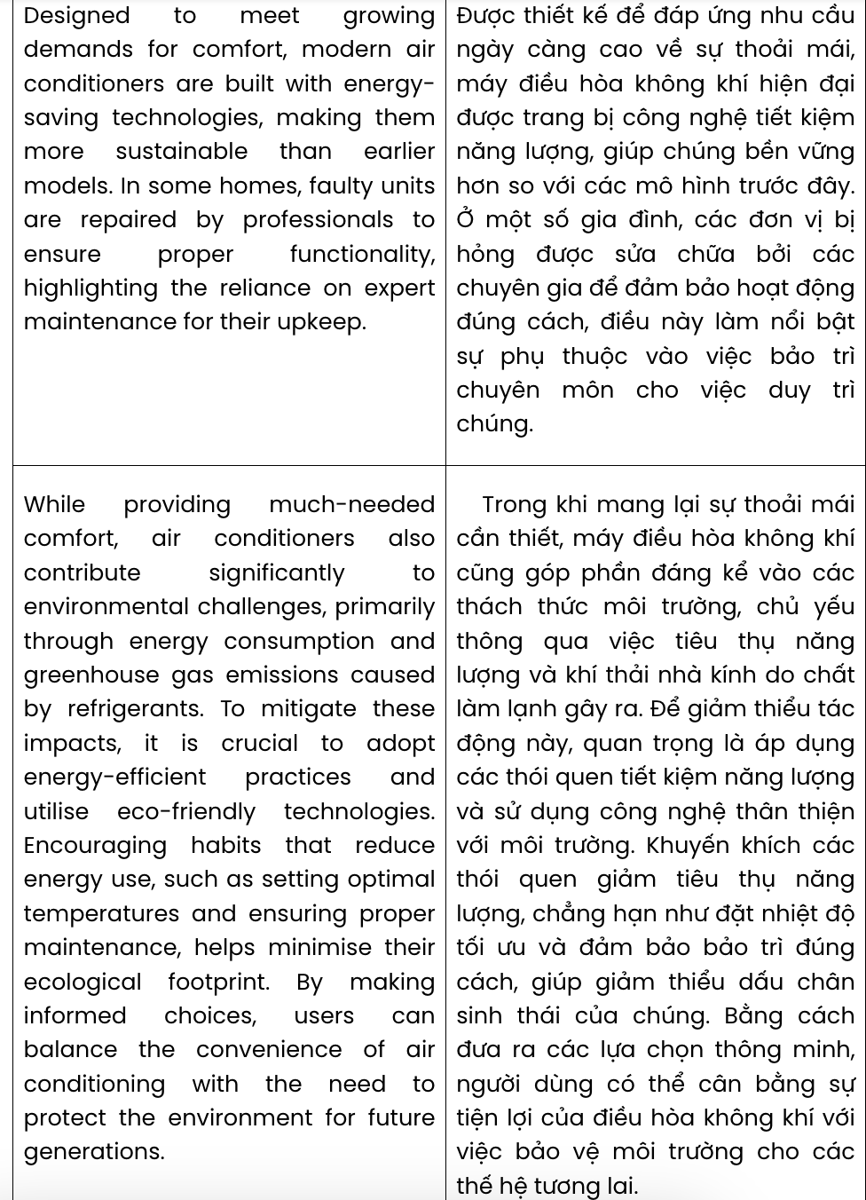

Question 18.
A. have seen remarkable progress in efficiency over time
B. of which significant improvement in efficiency over time
C. whose efficiency has improved significantly over time
D. made noticeable progress in efficiency over time
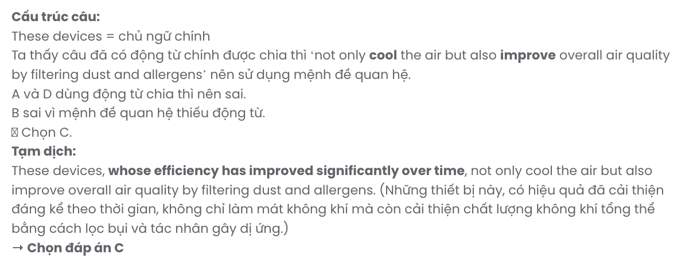

Question 19.
A. air conditioners create more comfortable living and working environments
B. living and working environments are created by comfortable air conditioners
C. creating living and working environments is comfortable thanks to air conditioners
D. they create more comfortable living and working environments by air conditioners
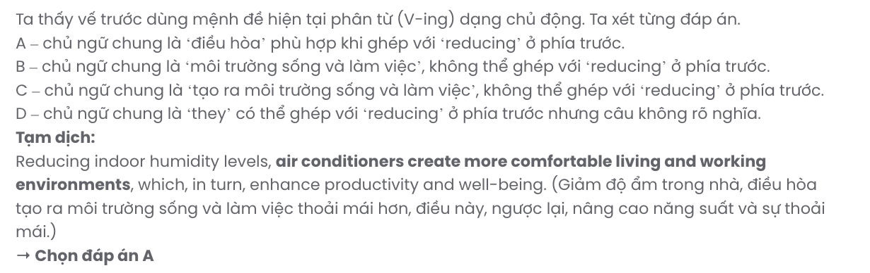

Question 20.
A. Meeting growing demands for comfort with its design
B. Having met demands for comfort by its design growth
C. Designing for comfort to meet growing demands
D. Designed to meet growing demands for comfort GIASƯ TẠI HUẾ (079.3833.272)

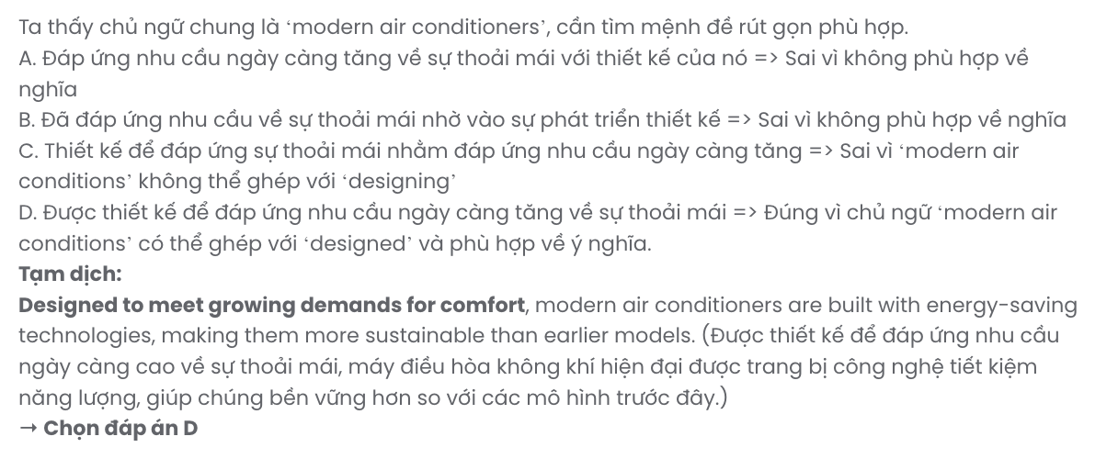

Question 21.
A. utilising eco-friendly technologies is important without energy-efficient practices
B. it is crucial to adopt energy-efficient practices and utilise eco-friendly technologies
C. it is vital to adopt energy-efficient practices, making use of eco-friendly technologies
D. adopting energy-efficient practices is key to utilising eco-friendly technologies
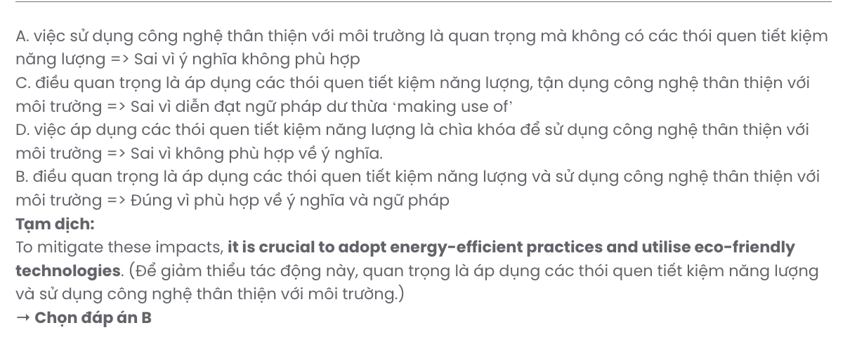

Question 22.
A. which contributes to reducing their ecological footprint
B. having their ecological footprint cut down
C. that brings about their reduced ecological footprint
D. helps minimise their ecological footprint
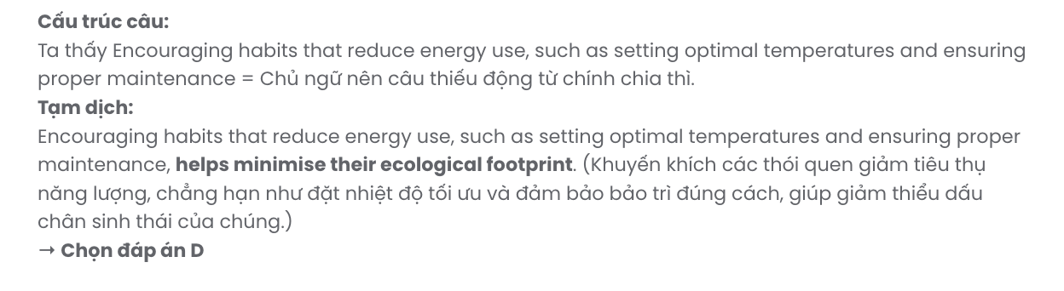

Read the following passage about a male nursery school teacher and mark the letter A, B, C, or D on your answer sheet to indicate the correct answer to each of the questions from 23 to 30.
In the Indian city of Agra, close to the Yamuna River, stands the Taj Mahal, a well-known mausoleum and a UNESCO World Heritage Site. The huge white dome in the centre of the Taj Mahal is its most iconic feature. It is surrounded by four smaller domes and is 35 metres high. The interior spaces of the building are decorated with lovely arches and priceless stones set into the walls. There are gardens with walkways, pools, and fountains around the structures.
The Taj Mahal's construction began in 1631 and was completed in 1648. It was built using materials in India and other Asian countries. However, the main material is white marble. The Indians also used other high-quality building materials at that time.
Emperor Shah Jahan had the Taj Mahal built as a burial place for his wife, Mumtaz Mahal. According to legend, he intended to create a black Taj Mahal on the other side of the river, but this never came true. During the Indian Rebellion of 1857, British soldiers destroyed many areas of the Taj Mahal, taking some of the precious stones from its walls. The Taj Mahal has suffered from environmental damage over the years, and significant government efforts have been made to preserve its beauty.
The Taj Mahal is one of India's most well-known landmarks. Every year, millions of people come to see the mausoleum. The Taj Mahal is mentioned in lists of iconic buildings to see and is considered one of the New Seven Wonders of the World.
(Adapted from Bright)
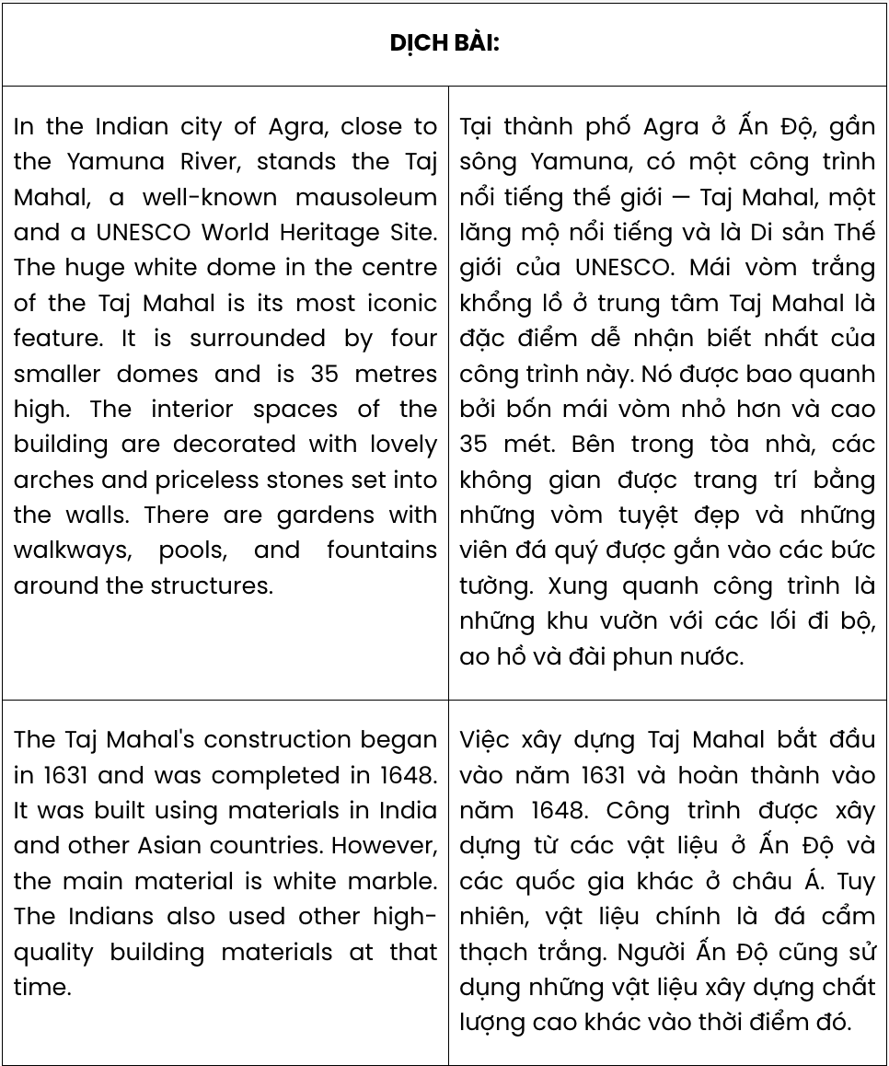
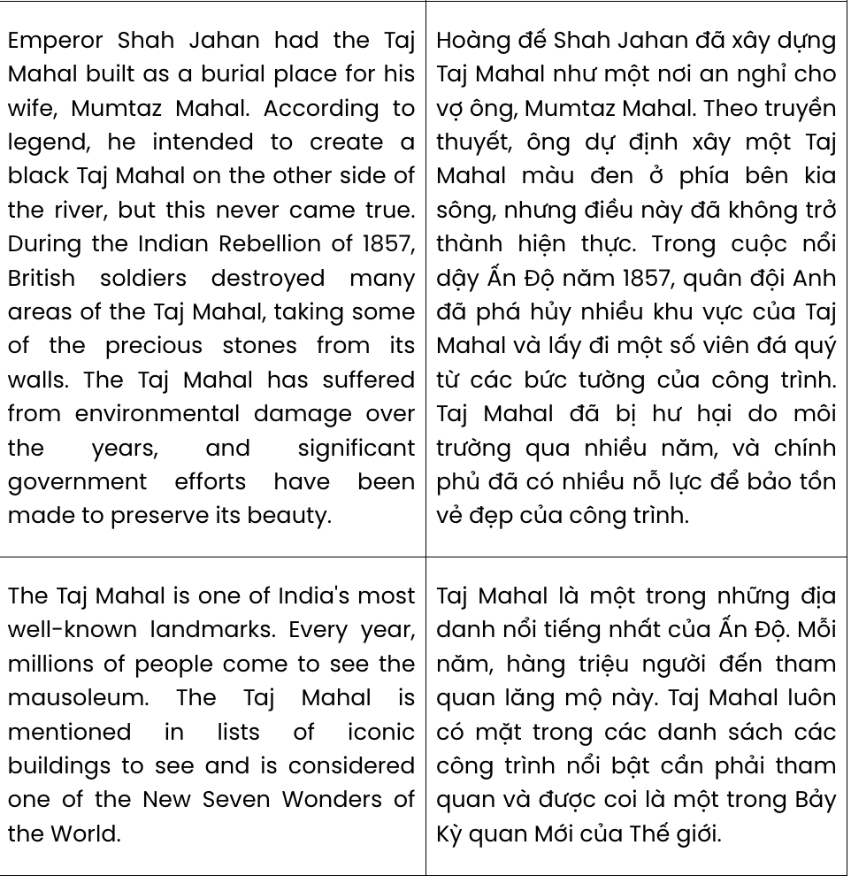
Question 23. According to paragraph 1, which of the following is the most impressive feature of the Taj Mahal?
A. the interior spaces with arches B. lovely gardens around the landmark
C. the huge white dome in the centre D. the modern architectural style
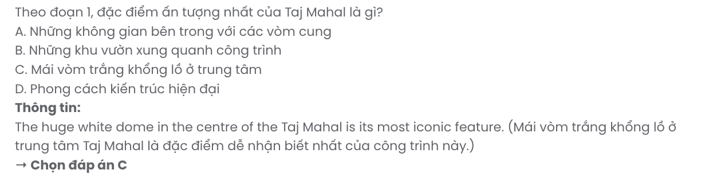
Question 24. The word priceless in paragraph 1 is OPPOSITE in meaning to .
A. valueless B. affordable C. prohibitive D. invaluable
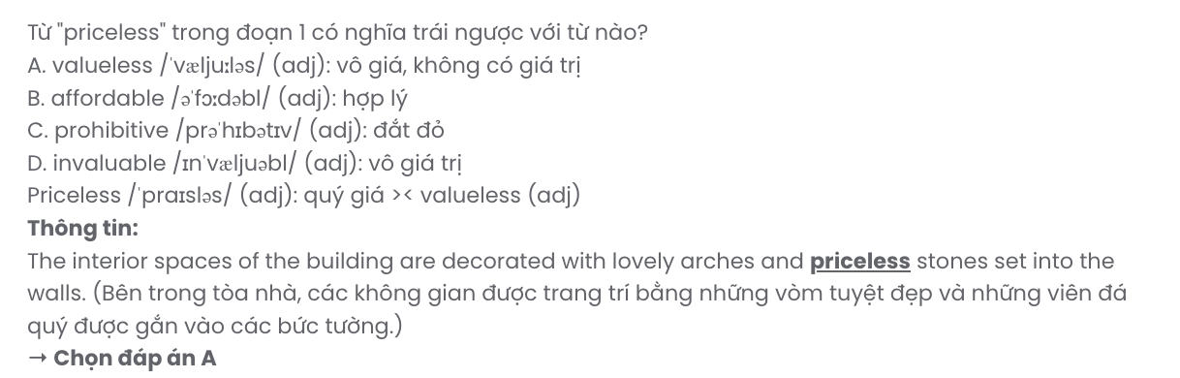
Question 25. Which of the following best paraphrases the underlined sentence in paragraph 3?
A. Emperor Shah Jahan constructed the Taj Mahal himself to honour his wife, Mumtaz Mahal.
B. The Taj Mahal was commissioned by Emperor Shah Jahan as a final resting place for his wife, Mumtaz Mahal.
C. Emperor Shah Jahan built the Taj Mahal as a temple dedicated to his wife, Mumtaz Mahal.
D. The Taj Mahal was built during Emperor Shah Jahan’s reign to serve as his burial site alongside Mumtaz Mahal.

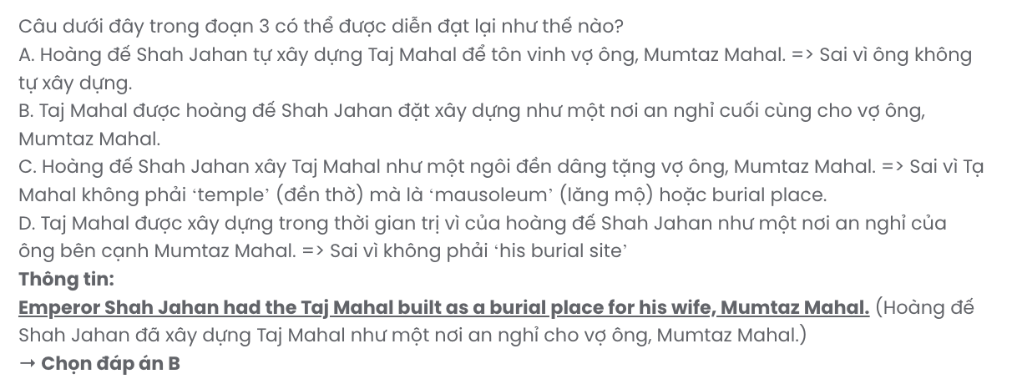
Question 26. The word its in paragraph 3 refers to ?
A. the Indian Rebellion B. the other side of the river
C. the Taj Mahal D. a burial place
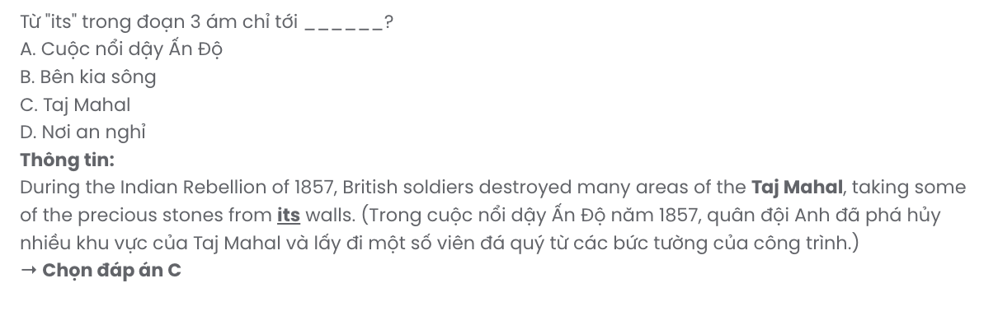
Question 27. The word considered in paragraph 4 is closest in meaning to .
A. realised B. recognised C. described D. named
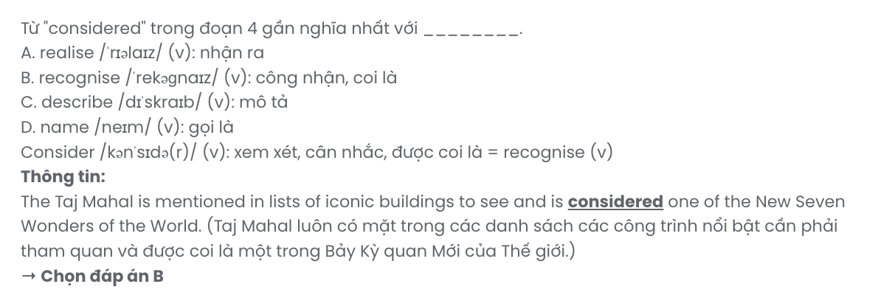
Question 28. Which of the following is NOT stated about the Taj Mahal in the passage?
A. The Indians used materials in India and other Asian countries during its construction.
B. Emperor Shah Jahan had it constructed in memory of his wife Mumtaz Mahal.
C. It is recognised as a new man-made wonder of the world thanks to its artistic features.
D. The government of India has made significant efforts to preserve its original charm.
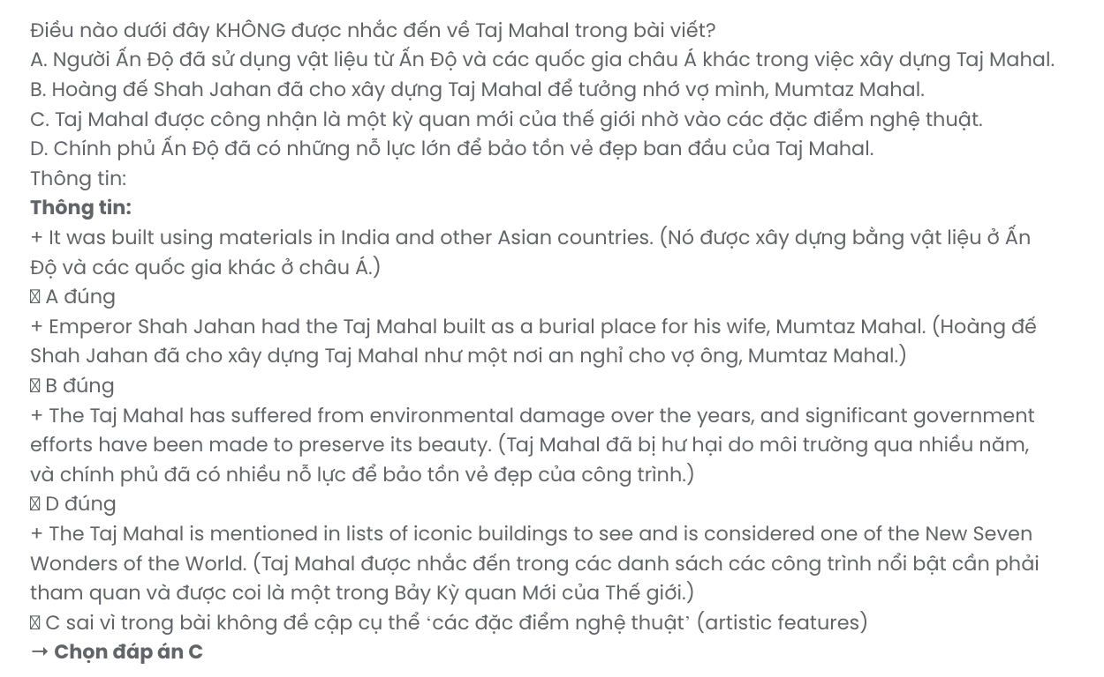
Question 29. In which paragraph does the writer mention an unachievable dream?
A. Paragraph 1 B. Paragraph 2 C. Paragraph 3 D. Paragraph 4
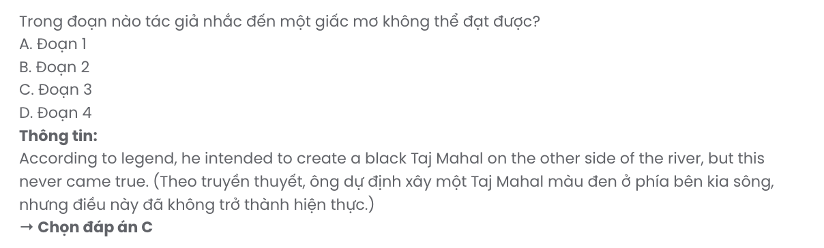
Question 30. In which paragraph does the writer describe the Taj Mahal as a tourist attraction?
A. Paragraph 1 B. Paragraph 2 C. Paragraph 3 D. Paragraph 4
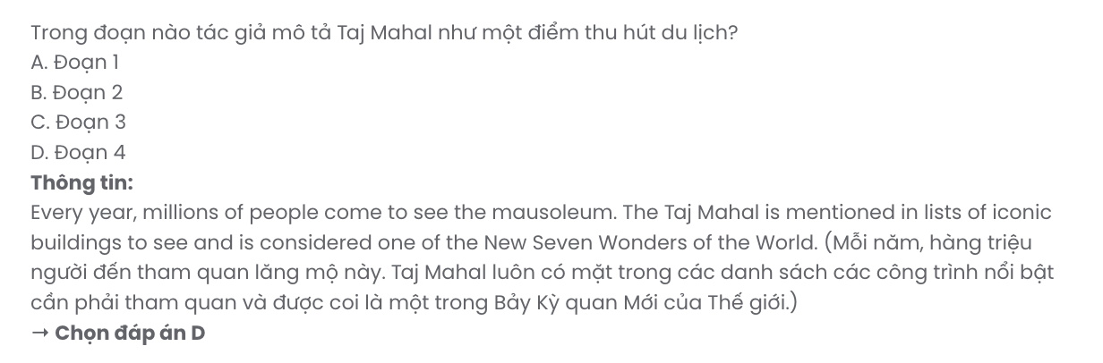
Read the following passage about ugly fruits and vegetables and mark the letter A, B, C, or D on your answer sheet to indicate the correct answer to each of the questions from 31 to 40.
In the days before the Internet, the word 'troll' had two different meanings. As a noun, 'a troll' was an ugly, bad-tempered creature. As a verb, 'to troll' means to fish using a line pulled slowly behind a boat. Perhaps it's easy to see why the word 'troll' has changed over time to describe anonymous individuals who 'fish' for victims by deliberately insulting and attacking people in online forums.
There are two main reasons for a troll's behaviour. [I] The first is boredom. [II] Trolls lack
stimulation in their everyday lives and so seek satisfaction by attempting to humiliate and harm others.
[III] As well as being at a loose end, these people desire attention. [IV]
Dealing with online trolls requires self-control and thinking ahead. They are attention seekers, so by engaging with them we are actually giving them exactly what they want. Instead, leave them starved of attention. A more sensible approach is this: delete, block, report, move on.
Those who are suffering at the hands of trolls or because of online bullying can seek help in various ways. The first place to turn for support might be friends and family. There are also support communities which exist to help victims of online bullying and abuse from trolls. Victims should also remember that any threats of violence made online are illegal and can be reported to Internet service providers, or the police. Given the size of the online community and the anonymity that the Internet allows, it is unlikely that the problem of trolls will ever disappear completely. For now perhaps the best we can do is starve them of the attention they seek.
(Adapted from High Note)
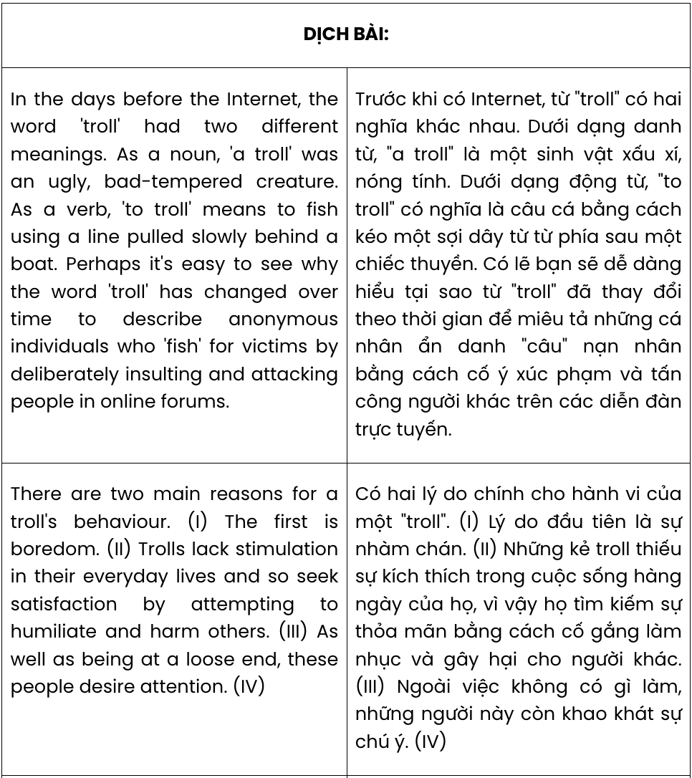
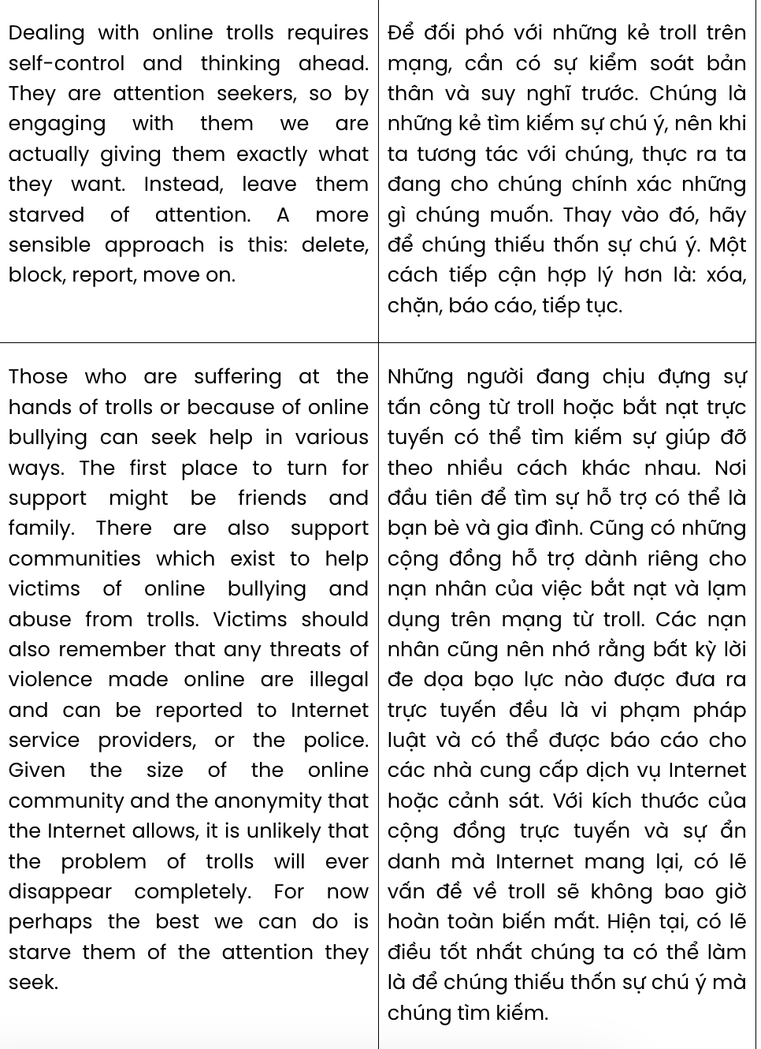
Question 31. The word insulting in paragraph 1 is OPPOSITE in meaning to .
A. offending B. challenging C. praising D. complementing
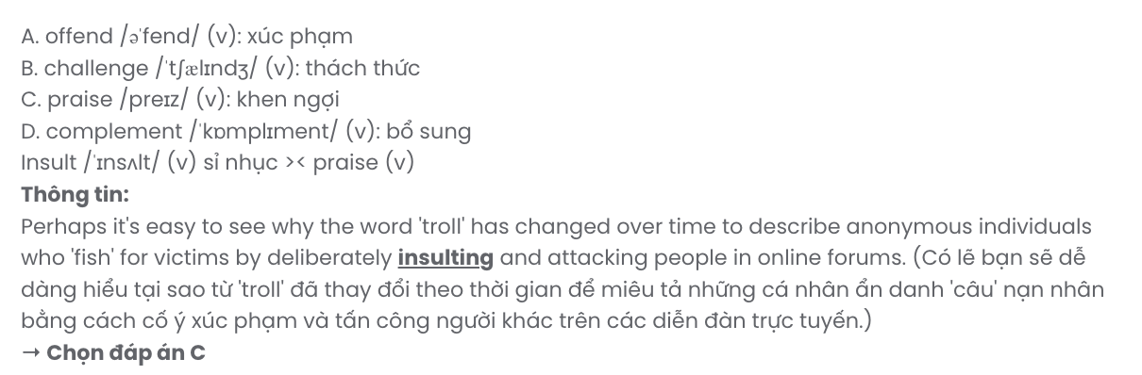
Question 32. According to paragraph 1, in the digital age today, the word ‘troll’ is used to describe someone who .
- enjoys hacking one’s social media account
- intentionally attacks others in online forums
- deliberately hurts some of their acquaintances
- tricks an Internet user into giving them money
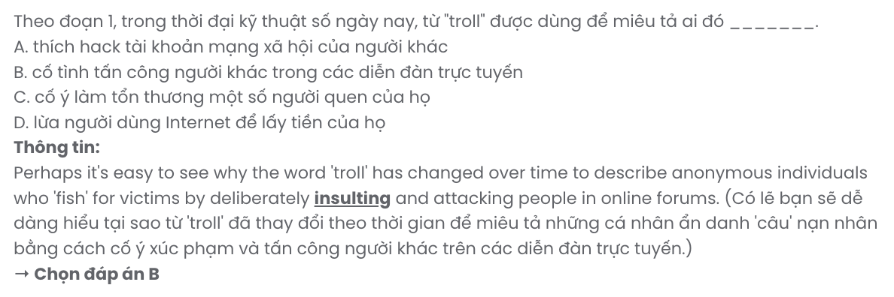
Question 33. The word stimulation in paragraph 2 can be best replaced by .
A. concentration B. confidence C. excitement D. experience

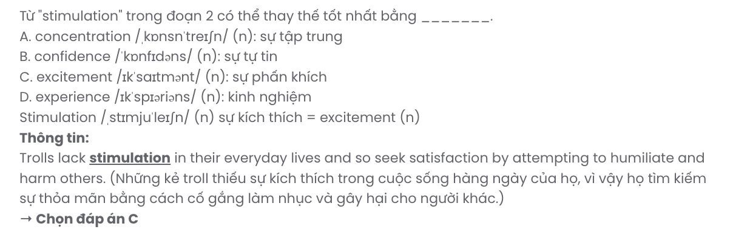
Question 34. Where in paragraph 2 does the following sentence best fit?

They want people to react to them regardless of whether the response is negative.
A. [I] B. [II] C. [III] D. [IV]
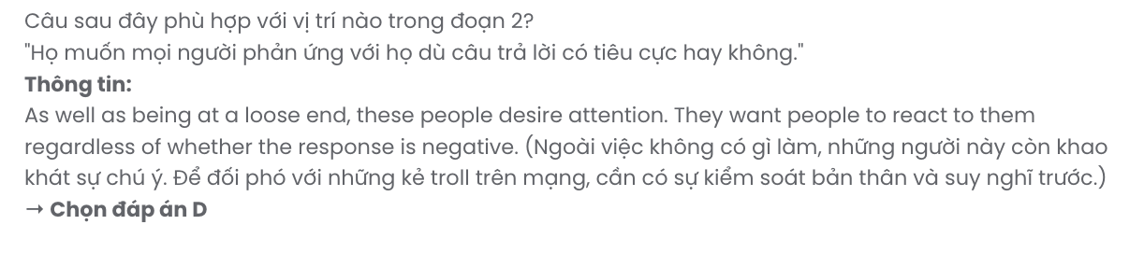
Question 35. The word them in paragraph 3 refers to .
A. seekers B. online trolls C. individuals D. victims
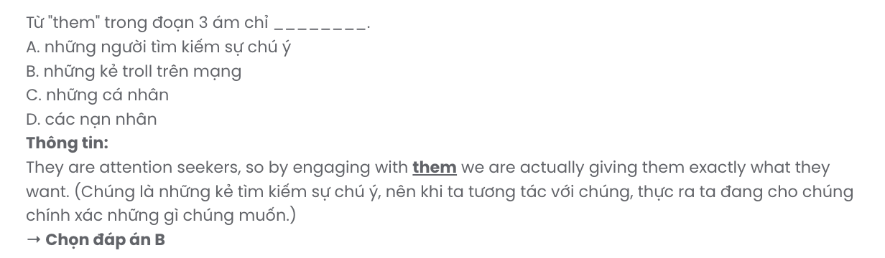
Question 36. Which of the following best summarises paragraph 3?
- Engaging with online trolls helps control their behaviour and prevents them from seeking more attention.
- Online trolls thrive on attention; ignoring, blocking, and reporting them is the most effective approach.
- Deleting online trolls' comments will encourage them to stop posting and seek less attention.
- Self-control and debating trolls online are key to addressing their constant need for validation.
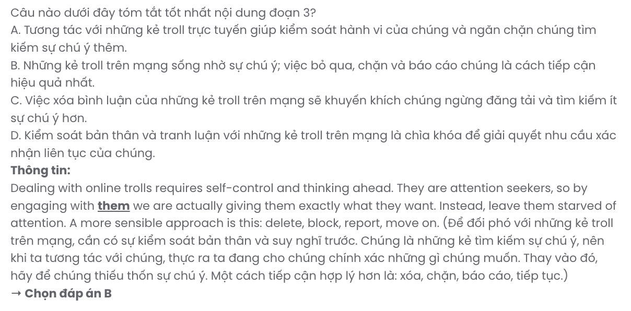
Question 37. Which of the following best paraphrases the underlined sentence in paragraph 4?
- Victims of online trolls and bullying are helpless though they can seek help in different ways.
- Online trolls and bullies often target those who cannot find ways to seek assistance.
- People suffering from online bullying should seek external help rather than confront their trolls directly.
- Help is available through different means for people affected by trolling or online bullying.
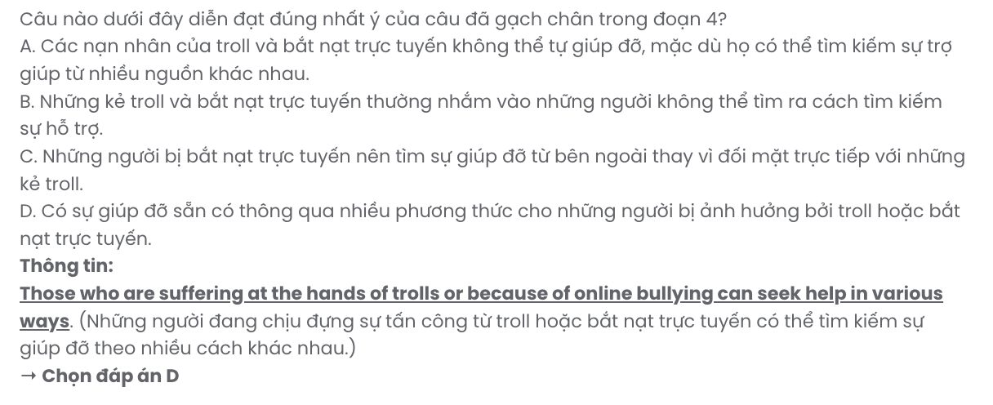
Question 38. Which of the following is NOT mentioned in the passage?
- Online trolls are individuals who spend their time provoking others because they crave attention.
- Compared to other challenges on the Internet, managing online trolls is significantly more challenging.
- Responding to online trolls is not a logical approach, as it only fulfils their desire for attention.
- Those who experience online bullying can find assistance and emotional support by joining dedicated support communities.
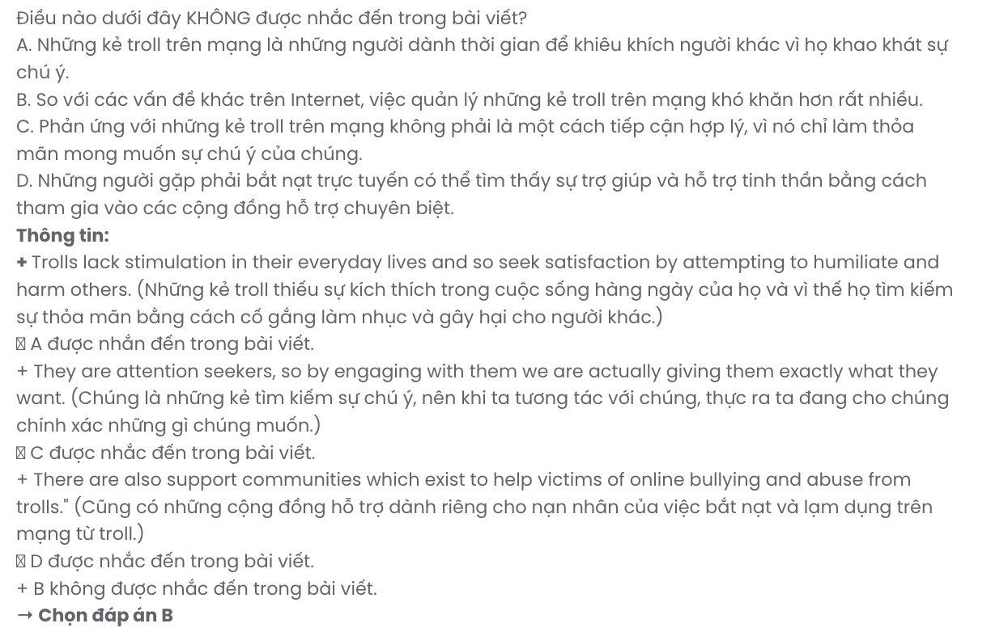
Question 39. Which of the following can be inferred from the passage?
- The issue of online trolls will eventually diminish as online communities grow stronger and more vigilant.
- Cyberbullying is considered a criminal offence and requires stricter enforcement and attention from law enforcement authorities.
- The anonymity provided to Internet users is believed to contribute significantly to the persistence of trolling behaviour.
- Simply ignoring or blocking online trolls might not always prove effective in addressing their disruptive actions.
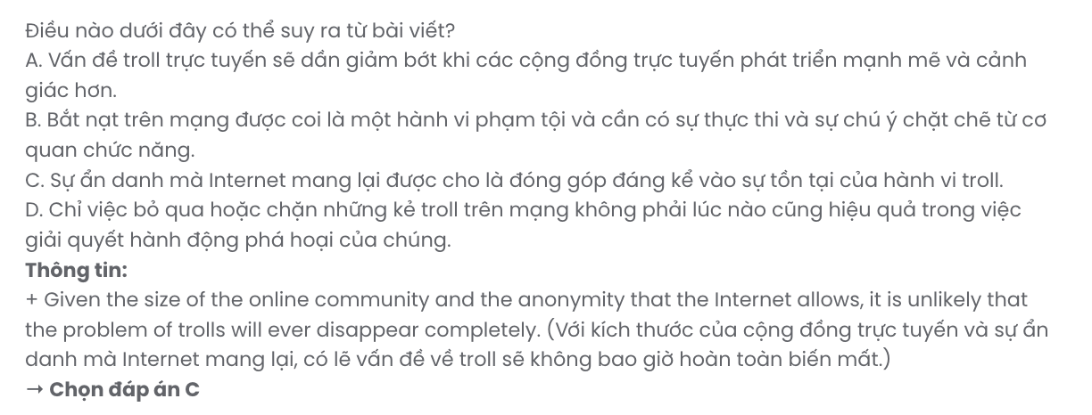
Question 40. Which of the following best summarises the passage?
- Online trolls behave aggressively due to boredom and seek satisfaction; blocking them is always effective.
- Trolls insult and harm for attention; victims should seek support, avoid engagement, and report serious threats.
- Dealing with trolls is not without challenges but reacting calmly and debating them reduces their disruptive online behaviour.
- Trolls exist due to the Internet’s anonymity; ignoring them entirely solves the problem permanently.

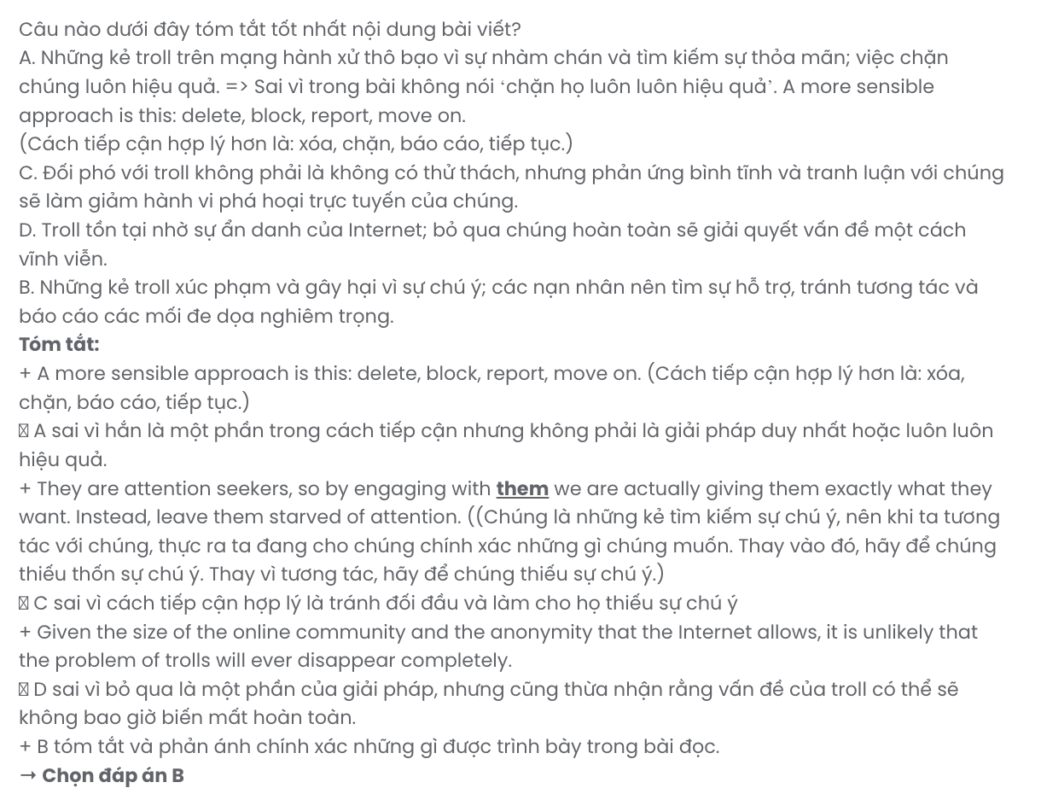

GIA SƯ TẠI HUẾ(079.3833.272)

BẢNG TỪ VỰNG
STT | Từ vựng | Từ loại | Phiên âm | Nghĩa
1 | accuracy | n | /ˈækjʊrəsi/ | độ chính xác
2 | advertisement | n | /ədˈvɜːtɪzmənt/ | quảng cáo
3 | alert | adj | /əˈlɜːt/ | cảnh giác
4 | artist | n | /ˈɑːtɪst/ | nghệ sĩ
5 | adorn | v | /əˈdɔːn/ | trang trí
6 | admire | v | /ədˈmaɪə(r)/ | ngưỡng mộ
7 | ambitious | adj | /æmˈbɪʃəs/ | tham vọng
8 | benefit | n | /ˈbɛnɪfɪt/ | lợi ích
9 | challenge | n | /ˈtʃælɪndʒ/ | thử thách
10 | cherish | v | /ˈtʃɛrɪʃ/ | trân trọng
11 | choice | n | /tʃɔɪs/ | sự lựa chọn
12 | collaboration | n | /kəˌlæbəˈreɪʃən/ | sự hợp tác
13 | compass | n | /ˈkʌmpəs/ | la bàn
14 | comfort | n | /ˈkʌmfət/ | sự thoải mái
15 | community | n | /kəˈmjuːnəti/ | cộng đồng
16 | construction | n | /kənˈstrʌkʃən/ | sự xây dựng
17 | consumption | n | /kənˈsʌmpʃən/ | sự tiêu thụ
18 | creativity | n | /ˌkriːeɪˈtɪvɪti/ | sự sáng tạo
19 | cultural | adj | /ˈkʌltʃərəl/ | văn hóa
20 | cutting - edge | adj | /ˈkʌtɪŋ ɛdʒ/ | tiên tiến, hiện đại
21 | dedication | n | /ˌdɛdɪˈkeɪʃən/ | sự cống hiến
22 | deepen | v | /ˈdiːpən/ | làm sâu sắc thêm
23 | disaster | n | /dɪˈzɑːstə(r)/ | thảm họa
24 | discipline | n | /ˈdɪsəplɪn/ | kỷ luật
25 | drill | n | /drɪl/ | bài tập luyện
26 | education | n | /ˌɛdʒʊˈkeɪʃən/ | giáo dục
27 | emergency | n | /ɪˈmɜːdʒənsi/ | tình huống khẩn cấp
28 | enable | v | /ɪˈneɪbl/ | làm cho có thể
29 | environmental | adj | /ɪnˌvaɪrənˈmɛntəl/ | thuộc về môi trường
30 | environment | n | /ɪnˈvaɪərənmənt/ | môi trường
31 | equally | adv | /ˈiːkwəli/ | một cách công bằng
32 | engaging | adj | /ɪnˈɡeɪdʒɪŋ/ | hấp dẫn
33 | enhance | v | /ɪnˈhɑːns/ | nâng cao
34 | ensure | v | /ɪnˈʃʊə(r)/ | đảm bảo
35 | enthusiast | n | /ɪnˈθjuːzɪæst/ | người đam mê
36 | exercise | n | /ˈɛksəsaɪz/ | bài tập
37 | experience | n | /ɪksˈpɪərɪəns/ | kinh nghiệm
38 | expert | n | /ˈɛkspɜːt/ | chuyên gia
39 | exploring | v | /ɪkˈsplɔːrɪŋ/ | khám phá
40 | feature | n | /ˈfiːtʃə(r)/ | đặc điểm, tính năng
41 | fabric | n | /ˈfæbrɪk/ | vải, chất liệu
42 | funding | n | /ˈfʌndɪŋ/ | tài trợ
43 | functionality | n | /ˌfʌŋkʃəˈnæləti/ | tính năng hoạt động

44 | heritage | n | /ˈhɛrɪtɪdʒ/ | di sản
45 | historical | adj | /hɪˈstɒrɪkəl/ | lịch sử
46 | hone | v | /həʊn/ | mài giũa, trau dồi
47 | iconic | adj | /aɪˈkɒnɪk/ | mang tính biểu tượng
48 | initiative | n | /ɪˈnɪʃətɪv/ | sáng kiến
49 | issue | n | /ˈɪʃuː/ | vấn đề
50 | landmark | n | /ˈlændmɑːk/ | cột mốc, dấu ấn
51 | learning | n | /ˈlɜːnɪŋ/ | sự học hỏi, học tập
52 | lifelong | adj | /ˈlaɪflɒŋ/ | suốt đời
53 | limited | adj | /ˈlɪmɪtɪd/ | hạn chế
54 | material | n | /məˈtɪərɪəl/ | vật liệu
55 | meaningful | adj | /ˈmiːnɪŋfəl/ | có ý nghĩa
56 | navigate | v | /ˈnævɪɡeɪt/ | điều hướng
57 | opportunity | n | /ˌɒpəˈtjuːnɪti/ | cơ hội
58 | performance | n | /pəˈfɔːməns/ | hiệu suất, màn trình diễn
59 | personalise | v | /ˈpɜːsənəlaɪz/ | cá nhân hóa
60 | precaution | n | /prɪˈkɔːʃən/ | sự phòng ngừa
61 | preserve | v | /prɪˈzɜːv/ | bảo tồn
62 | presentation | n | /ˌpriːzənˈteɪʃən/ | bài thuyết trình
63 | providing | v | /prəˈvaɪdɪŋ/ | cung cấp
64 | rewarding | adj | /rɪˈwɔːdɪŋ/ | đáng giá, bổ ích
65 | rebellion | n | /rɪˈbɛljən/ | cuộc nổi loạn
66 | resilience | n | /rɪˈzɪlɪəns/ | khả năng phục hồi
67 | region | n | /ˈriːdʒən/ | khu vực, vùng
68 | reliability | n | /rɪˌlaɪəˈbɪləti/ | độ tin cậy
69 | real-time | adj | /ˈriːəl taɪm/ | thời gian thực
70 | resource | n | /rɪˈzɔːs/ | tài nguyên
71 | strength | n | /strɛŋkθ/ | sức mạnh
72 | strike | v | /straɪk/ | đình công, tấn công
73 | sustainable | adj | /səˈsteɪnəbl/ | bền vững
74 | sustainability | n | /səˌsteɪnəˈbɪləti/ | sự bền vững
75 | supporter | n | /səˈpɔːtə/ | người ủng hộ
76 | tailored | adj | /ˈteɪlərd/ | được điều chỉnh, phù hợp
77 | technology | n | /tɛkˈnɒlədʒi/ | công nghệ
78 | teamwork | n | /ˈtiːmwɜːk/ | làm việc nhóm
79 | timeless | adj | /ˈtaɪmləs/ | vượt thời gian
80 | transformation | n | /ˌtrænsfɔːˈmeɪʃən/ | sự biến đổi
81 | transformative | adj | /trænsˈfɔːmətɪv/ | có tác động lớn, mang tính chuyển đổi
82 | vital | adj | /ˈvaɪtl/ | quan trọng, thiết yếu
83 | warning | n | /ˈwɔːnɪŋ/ | cảnh báo

BẢNG CẤU TRÚC
STT | Cấu trúc | Nghĩa
1 | take precautions | phòng ngừa, đề phòng
2 | pass down | truyền lại
3 | take place on | diễn ra vào
4 | set up | thiết lập, chuẩn bị
5 | suffer from | chịu đựng, mắc phải
6 | being at a loose end | cảm thấy không biết làm gì, rảnh rỗi
7 | it is vital to | điều quan trọng là

