Date of preparing: ………………………………….
Date of teaching: ………………………………….

Period …
UNIT 4: FESTIVALS and FREE TIME
Lesson 1 - Part 3 (Page 32) – Pronunciation and Speaking

I. OBJECTIVES
By the end of the lesson, Ss will be able to…
1. Knowledge
- stress the adverbs for emphasis.
- ask and answer about the frequency of activities.
- find out their “spirit animal”.
2. Ability
- improve speaking skills.
3. Quality
- have positive attitude in English language learning so that they actively participate in all classroom activities.
- take part in useful activities in their free time.

II. TEACHING AIDS AND LEARNING MATERIALS
Lesson plan, PPT slides, student’s book, workbook, notebook, personal computer (if any), projector/TV, speakers, DCR & DHA on Eduhome, handouts…

III. PROCEDURES
A. Warm up: (5’)
a) Objective: to introduce the new lesson and set the scene for Ss to acquire new language; to get students' attention at the beginning of the class by means of enjoyable and short activities as well as to engage them in the steps that follow
b) Content: revision of adverbs of frequency
c) Product: Ss get familiar with adverbs of frequency and use them in speaking.
d) Competence: collaboration, observation, memorizing, creativity.
e) Organization of the activity:
Teacher’s Activities | Students’ Activities
- Give greetings  - Check attendance  - Option 1:  - Show 5 sentences, have Ss choose any adverb of frequency to put in appropriate place in the sentences given  1. He gets up early  2. She is late for school.  3. Lan practices speaking English.  4. Thao is a hard-working student.  5. I watch movies on the weekends.  - Have Ss share their answers with the class  - Give feedback  Lead to the new lesson  - Option 2: SONG: Adverbs of frequency  - Let Ss listen to the song about “Adverbs of frequency”. Ss can sing together while the song is being played. (T doesn’t need to play all song)  - Have Ss listen to the song and try to remember the adverbs of frequency they can hear  - Have Ss give answers  - Link from YouTube:  https://www.youtube.com/watch?v=WPTu1j6-B30  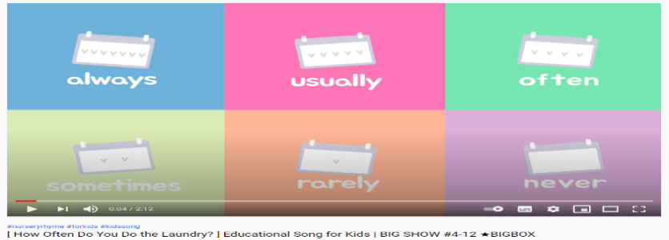  - Give feedback  Lead to the new lesson. | - Greet T  - Work in pairs  Suggested answers  1. He sometimes gets up early  2. She is never late for school.  3. Lan often practices speaking English.  4. Thao is always a hard-working student.  5. I usually watch movies on the weekends.  The answers may vary.  - Give answers  - Listen  - Listen  - Listen and remember  - Give answers  - Listen

B. New lesson (36’)
- Activities 1: Pronunciation (10’)
a) Objective: Ss know how to stress the adverbs for emphasis.
b) Content:
- recognizing the stress of the adverbs, listen and check, find mistakes.
- Practicing saying them.
c) Products: Ss can put stress on the adverbs for emphasis to improve their speaking skill.
d) Competence: communication, collaboration.
e) Organization of the activity:
Teacher’s Activities | Students’ Activities
a + b. Listen to the sentences and focus on the stress of the adverbs  - Play the recording (CD1, track 45)  - Ask Ss to listen and pay attention to the stress of the adverbs  - Call Ss to make their comments on how the adverbs are stressed  - Give feedback, explain the pronunciation feature: In speaking, we often stress the adverbs for emphasis  - Play the recording again, have Ss listen and repeat with a focus on the pronunciation feature  c + d. Listen and cross out the one with the wrong stress, then read the sentences with the correct sentence stress to a partner  - Play the recording, have Ss listen and cross out the option that doesn’t use the correct stress  - Call Ss to give answers  - Play the recording again and check answers as a whole class  - Then have Ss practice saying the sentences with a partner, using the correct stress, encourage Ss to make up their own sentences -using adverbs of frequency – and put stress on the adverbs  - Call some pairs to read in front of the class.  - Give feedback, correct Ss’ pronunciation if necessary | - Listen  - Comment  - Listen  - Listen and cross out the wrong sentence stress  - Listen  - Work in pairs  - Present
- Activity 2: Practice (12’)
a) Objective: Ss can ask and answer about frequency.
b) Content: asking and answering by using the pictures and model sentences.
c) Products: Ss can apply what they have learnt to producing the language in communication.
d) Competence: collaboration, communication, creativity, public speaking.
e) Organization of the activity:
Teacher’s Activities | Students’ Activities
Ask and answer  - Option 1:  - Emphasize the structure used to ask about frequency:  How often do you …?  - Demonstrate the activity by asking and answering with a student  - Have Ss work in pairs to ask and answer, using the pictures and the time phrase  - Have some pairs demonstrate the activity in front of the class  - Give feedback and evaluation  - Option 2: (for class with better students)  - Follow the same steps as option 1  - Then have Ss ask and answer about frequency, using their own ideas  - Have some pairs demonstrate the activity in front of the class  - Have another pair act out the conversation in front of the class without looking at the book  - Give feedback and evaluation | - Listen, take notes  - Listen  - Work in pairs  - Present  Suggested conversation  1. A: How often do you go swimming?  B: I often go swimming on the weekends.  2. A: How often do you play video games?  B: I sometimes play video games after school.  3. A: How often do you do yoga?  B: I usually do yoga in the afternoons.  4. A: How often do you play tennis?  B: I always play tennis on Saturdays.  - Work in pairs  - Present  - Present
- Activity 3: Speaking – What’s your “Spirit Animal”? (14’)
a) Objective: Ss can get used to the adverbs of frequency.
b) Content: asking and answering questions to find out their “spirit animal”.
c) Products: Ss use what they have learnt to produce the language naturally and successfully.
d) Competence: collaboration, communication, creativity.
e) Organization of the activity:
Teacher’s Activities | Students’ Activities
a. You are doing a quiz about your free time activities to find out your “spirit animal”. Add three more activities and then ask your friend to complete the quiz.  - Demonstrate the activity by asking and answering the first question with a student  - Have Ss work in pairs to ask, answer and add 3 more activities.  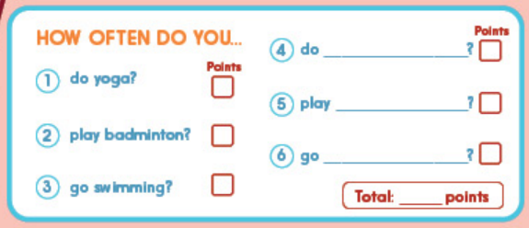  - Have pairs take turns to ask the quiz questions and add up the points  - Observe, give help if necessary  b. Turn to page 125, file 13 to find out what your partner’s “spirit animal” is. Share with the class.  - Have Ss turn to page 125, file 13 to find out what your partner’s “spirit animal” is    - Have some Ss share their findings with the class  - Give feedback and evaluation | - Observe and listen  - Work in pairs  Suggested activities  4. do: aerobics, homework, …  5. play: badminton, chess, …  6. go: fishing, hiking, shopping, …  - Work in pairs  - Present

C. Consolidation (2’)
* Stress: Stress on the adverbs for emphasis
* Asking about frequency
How often do you…?

D. Homework (2’)
- Practice the Stress on the adverbs for emphasis.
- Review the structures used to ask and answer about frequency.
- Do exercises in WB: Writing, page 21.
- Prepare: Lesson 2 – New Words and Reading (page 33 – SB).

