Date of preparing: ………………………………….
Date of teaching: ………………………………….

Period …
UNIT 5: AROUND TOWN
Lesson 1 - Part 3 (Page 40) – Pronunciation and Speaking

I. OBJECTIVES
By the end of the lesson, Ss will be able to…
1. Knowledge
- use sound changes in the question: “Do you have …?”
- ask about clothes and prices when shopping.
2. Ability
- improve speaking skills.
3. Quality
- have positive attitude in English language learning so that they actively participate in all classroom activities.
- behave politely when shopping.

II. TEACHING AIDS AND LEARNING MATERIALS
Lesson plan, PPT slides, student’s book, workbook, notebook, personal computer (if any), projector/TV, speakers, DCR & DHA on Eduhome, handouts…

III. PROCEDURES
A. Warm up: (5’)
a) Objective: Introduce the new lesson and set the scene for Ss to acquire new language; get students' attention at the beginning of the class by means of enjoyable and short activities as well as to engage them in the steps that follow.
b) Content: Revision of asking about prices when shopping
c) Product: Ss review knowledge in the previous lesson and they are ready for the new lesson
d) Competence: collaboration, observation, communication
e) Organization of the activity:
Teacher’s Activities | Students’ Activities
- Give greetings  - Check attendance  - Option 1: Asking about prices  - Show pictures about clothes and prices, have Ss ask and answer about the prices  - Call Ss to give answers  - Give feedback, correct Ss’ answers if necessary  Lead to the new lesson.    - Option 2: Clip: In the shop  - Show a video clip about buying clothes / things in a store. (T only plays 1 minute 20 seconds)  Link: https://www.youtube.com/watch?v=I9YYtue3_Cs  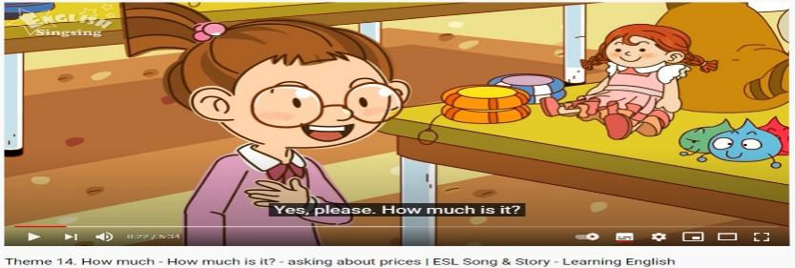  - Have Ss watch the clip and remember: What do they buy what are the prices?  - Call Ss to give answers  - Give feedback, check answers as a whole class.  Lead to the new lesson. | - Greet T  - Look, then work in pairs  - Give answers  Answers keys  1. How much is the yellow hat?  - It’s VND 30,000  2. How much is the white dress?  - It’s 20 dollars  3. What is the price of the blue shirt?  - It’s 30,000 won  4. How much does the red sweater cost?  - It’s 10 pounds.  - Watch the video clip, then give answers  - Check answers with the teacher.  Answers keys  They buy: a doll (five hundred won)  a toy car (two hundred won)  a kite (5 dollars)  a hat (10 dollars)

B. New lesson (35’)
- Activities 1: Pronunciation (10’)
a) Objective: Ss know how to use sound changes in the question: “Do you have …?”
b) Content:
- Recognizing the sound changes in the question: “Do you have …?”
- Listening and focusing pronunciation feature, finding and correcting mistakes
- Practicing
c) Products: Ss can use the sound changes correctly in communication.
d) Competence: communication, collaboration
e) Organization of the activity:
Teacher’s Activities | Students’ Activities
a + b. Listen. Notice the sound changes of the underlined words  - Play the recording (CD1, track 59)  - Ask Ss to listen and pay attention to the sound changes  - Call Ss to make their comments on the sound changes of the questions: “Do you have …?”  - Give feedback, explain the pronunciation feature: “Do you have …?” often sounds like /dʒə hӕv/  - Play the recording again, have Ss listen and repeat with a focus on the pronunciation feature.  c + d. Listen and cross out the one with the wrong sound changes, then read the sentences with the correct sound changes to a partner.  - Play the recording, have Ss listen and cross out the option that doesn’t use the correct sound changes  - Call Ss to give answers  - Play the recording again and check answers as a whole class.  - Then have Ss practice saying the sentences with a partner, using the correct sound changes, then encourage Ss to use their own sentences  - Call some Ss to read their sentences in front of the class.  -Check and correct Ss’ pronunciation | - Listen  - Comment  - Listen  - Listen again and repeat  - Listen and cross out  - Give answers  - Listen again and check  - Work in pairs  - Read
- Activity 2: Practice (10’)
a) Objective: Ss can ask and answer questions with structures and pronunciation they have learnt
b) Content: Practice of a conversation about buying clothes
c) Products: Ss can use what they have learnt in producing the language.
d) Competence: collaboration, communication, creativity, public speaking.
e) Organization of the activity:
Teacher’s Activities | Students’ Activities
a. Practice the conversation. Swap the roles and repeat. (controlled practice)  - Option 1:  - Demonstrate the activity by practicing role-play with a student  - Emphasize the structures used when giving something to someone: Here you are  Phrasal verb: try on (to put on (clothes etc) to see if they fit)  - Have pairs practice the conversation  - Call some pairs to read in front of the class  - Have pairs swap roles and repeat-using the information on the right.  - Have some pairs demonstrate the activity in front of the class  - Check Ss’ pronunciation  - Option 2: (for class with better students)  - Follow the same steps as option 1  - Then give Ss an extra activity: Practice the conversation in the text book; however, they try to remember the conversation content.  - Have some pairs demonstrate the activity in front of the class, not looking at the textbook; encourage Ss to present as naturally as possible.  - Give feedback and evaluation  b. Practice with your own ideas. (free - practice)  - Have pairs practice the conversation with their own ideas, then swap roles.  - Go round, observe Ss’ work and give help if necessary  - Call some pairs to demonstrate the activity in front of the class  - Give feedback and evaluation | - Observe and listen  - Listen and take notes  - Work in pairs  - Act out the conversation  - Listen to the instruction and work in pairs. Ss can practice the new conversation with the information in the pictures.  - Act out the conversation  - Listen  - Work in pairs  - Present
- Activity 3: Speaking (15’)
a) Objective: Ss can discuss items to buy and their prices when shopping
b) Content: Asking and answering questions about clothes and prices
c) Products: Ss can use what they have learnt in producing the language in a meaningful way.
d) Competence: teamwork, communication, creativity, presentation/ public speaking.
e) Organization of the activity:
Teacher’s Activities | Students’ Activities
a. You’re shopping for clothes. Work in pairs. Student B goes to page 121, file 4. Student A is a customer. Choose 3 items below and note the size and color you want. Ask sales assistant.  - Demonstrate the activity by practicing role-play with a student  - Remind Ss to use the sound changes in their conversation  - Have student A stay on the current page and student B turn to page 121, file 4  - Have Ss A choose 3 of the items below to buy and write the size and color they want on the lines  - Have Ss ask and answer  - Have some Ss demonstrate the role-play in front of the class  - Give feedback and evaluation  b. Swap the roles and repeat. You’re a sales assistant at a store. You have the clothes below.  - Have Ss swap the roles and repeat  - Have some Ss demonstrate the role-play in front of the class  - Give feedback and evaluation  c. In groups, discuss the items you bought and how much you spent  - Have Ss work in groups  - Have SS discuss the items they bought and how much they spent  - Have some Ss share their findings with the class  - Give feedback and evaluation | - 1 S practices role-play with the teacher  - Listen  - Work in pairs  - Role play  - Work in pairs  - Present  - Work in groups  - Present

C. Consolidation (3’)
* Pronunciation: “Do you have …?” often sounds like /dʒə hӕv/
* Some useful languages
Can I help you?
Here you are
Try it on

D. Homework (2’)
- Practice using sound changes in the question: “Do you have …?”
- Practice asking and answering about buying clothes.
- Prepare: Lesson 2: New Words and Reading (page 41 – SB).

