School: ……………………………………….. | Date: ……………………………..
Class: ……………………………..................... | Period: ………………………......

UNIT 9: ENGLISH IN THE WORLD
Lesson 2.1 – New words and Listening (page 71)

I. OBJECTIVES
By the end of the lesson, Ss will be able to:
1.1. Language knowledge and skills
- know more words about tourism (souvenirs, sightseeing, swimsuit, postcards, photos, beach, wallet).
- talk about things to do on holidays and holidays in English speaking countries.
- listen to and understand a conversation of two people talking about their holiday (for general and specific details).
- know how to end a conversation.
1.2. Competences
- improve communication, collaboration, and critical thinking skills.
1.3. Attributes
- love studying English, love travelling.
- have good preparation for any trip.

II. TEACHING AIDS AND LEARNING MATERIALS
1. Teacher’s aids: Student book and Teacher’s book, class CDs, Digital Book (DCR phần mềm tương tác SB, DHA (từ vựng/ cấu trúc) phần mềm trò chơi tương tác), projector/interactive whiteboard / TV (if any), PowerPoint slides.
2. Students’ aids: Student’s book, workbook, notebook.

III. ASSESSMENT EVIDENCE
Performance Tasks | Performance Products | Assessment Tools
- Number the pictures. | - Ss’ answers. | - T’s feedback/Peers’ feedback.
- Listen and repeat. | - Ss’ presentation. | - T’s feedback/Peers’ feedback.
- Talk about the things you do on holiday. | - Ss’ presentation/ answers. | - T’s feedback/Peers’ feedback.
- Listen to Peter and Janet talking about their holidays. Who enjoyed their holiday more? | - Ss’ answers. | - T’s feedback/Peers’ feedback.
- Listen and fill in the blanks. | - Ss’ answers. | - T’s feedback/Peers’ feedback.
- Speak: What did you like most about your last holiday? | - Ss’ answers/ presentation. | - T’s observation and feedback.

IV. PROCEDURES
A. Warm up: (5’)
a) Objective: Introduce the new lesson and set the scene for Ss to acquire new language; get students' attention at the beginning of the class by enjoyable and short activities as well as to engage them in the follow-up steps.
b) Content: Introduce words about tourism, holiday / Introduce: Language to begin and end a conversation.
c) Expected outcomes: Ss get to know some new words / structures they are going to study in the lesson.
d) Organization of the activity:
TEACHER’S ACTIVITIES | STUDENTS’ ACTIVITIES
- Option 1: Number the pictures. Listen and repeat.  - Use the “New words” part a– page 71 for the warm-up activity.  - Show words and pictures using DCR, have Ss look and number the pictures (in pairs).  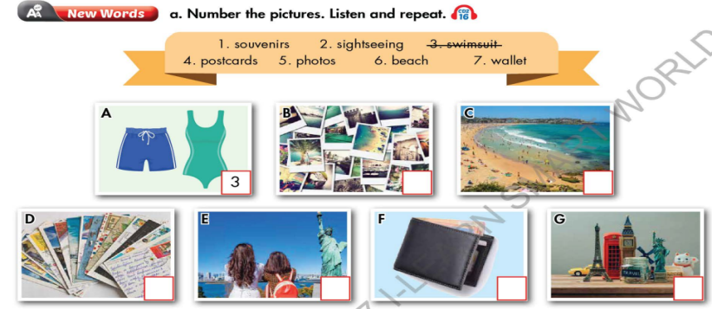  - Call Ss to give answers.  - Give feedback and show correct answers.  - Lead to the new lesson.  - Play the audio (CD2 – Track 16), have Ss listen and repeat.  - Correct Ss’ pronunciation if necessary.  - Option 2: Starting a conversation or Ending a conversation?  - Let Ss read the expressions which are commonly used when people are chatting.  - Have Ss work in pairs to place them under the appropriate heading: Starting a conversation or Ending / Closing a conversation.  - Call Ss to give answers.  - Check Ss’s answers and give feedback.  - Lead to the new lesson.  *Illustration:  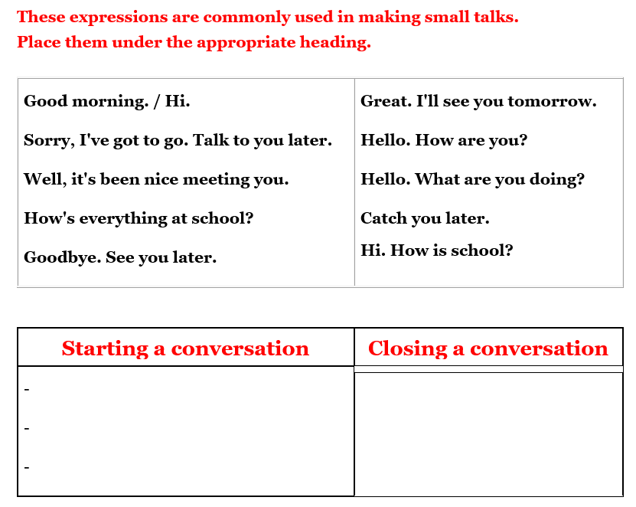 | - Work in pairs to number the pictures.  - Give answers.  - Listen.  - Listen and repeat.  Answer keys  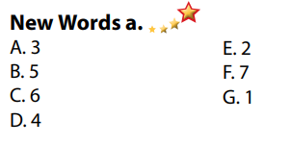  - Work in pairs to place them under the appropriate heading: Starting a conversation or Ending / Closing a conversation.  - Read answers.  - Listen.  Answers keys  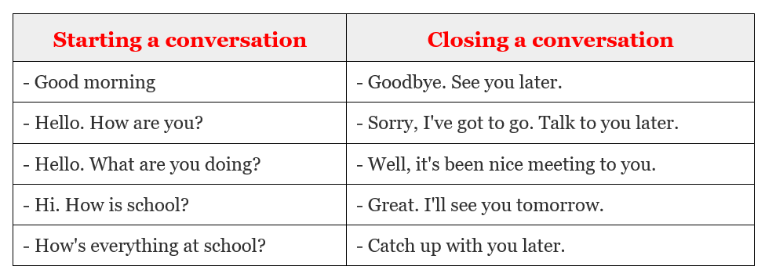

B. New lesson (35’)
- Activity 1: Pre-Listening (Vocabulary) (12’)
a) Objective: Ss get to know words about tourism / holiday.
b) Content:
- Vocabulary study (souvenirs, sightseeing, swimsuit, postcards, photos, beach, wallet).
- Speaking: Talk about the things you do on holiday.
c) Expected outcomes: Ss know how to pronounce the new words correctly and use them when they do some listening tasks.
d) Organization of the activity:
TEACHER’S ACTIVITIES | STUDENTS’ ACTIVITIES
Task a. Number the pictures. Listen and repeat.  - Option 1 (If the teacher hasn’t used this part for the Warm-up activity.)  - Demonstrate the activity on DCR, using the example.  - Have Ss number the pictures.  - Divide class into pairs and have them check their answers with their partners.  - Call Ss to give answers.  - Check answers as a whole class using DCR.  - Play audio (CD2 – Track 16). Have Ss listen and repeat.  - Correct Ss’ pronunciation.  - Option 2: (If the teacher has used part a. for the Warm-up activity.) Fill in the blanks.  - Have Ss look at the pictures and fill in the blanks by the words they have known in Task a (from Warm up activity. (T uses different pictures from those in the textbook.)  - Have Ss give answers and tell the meaning of words / phrases again.  - Check answers as a whole class.  - Call some Ss to read the words again.  - Correct Ss’ pronunciation if necessary.  *Illustration:  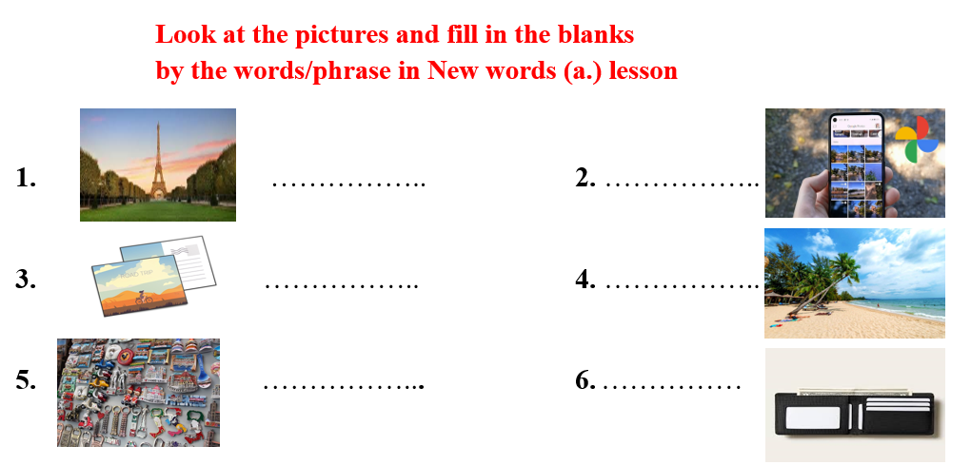  Task b. In pairs: Talk about the things you do on holiday.  - Have Ss work in pairs to talk about the things they do on holiday.  - Go round and give help if necessary.  - Have some pairs demonstrate the activity in front of the class.  - Give feedback and evaluation. | - Look and listen.  - Work individually.  - Work in pairs.  - Give answers.  - Listen and repeat.  Answer keys  - Work in pairs  - Give answers, meaning.  - Read.  Answer keys  1 sightseeing  2 postcards  3 souvenirs  4 photos  5 beach  6 wallet  - Work in pairs to discuss.  - Present.  Sample answers  
- Activity 2: While - Listening (17’)
a) Objective: Students can develop their listening skill.
b) Content:
- Listen to Peter and Janet talking about their holidays. Who enjoyed their holiday more?
- Listen and fill in the blanks.
c) Expected outcomes: Ss can listen to and understand a conversation of two people talking about their holidays (for general and specific details).
d) Organization of the activity:
TEACHER’S ACTIVITIES | STUDENTS’ ACTIVITIES
Task a. Listen to Peter and Janet talking about their holidays. Who enjoyed their holiday more?  - Have Ss read the question, guess the answer.  - Play audio (CD2 - Track 17).  - Have Ss listen and give answers.  - Check answers as a whole class using DCR.  Task b. Now, listen and fill in the blanks  - Have Ss read the through the content of Task b, underline the key words.  - Play the audio again (CD2 - Track 17).  - Have Ss listen and fill in the blanks.  - Remind Ss to use short answer for each question (ONE word only).  - Have Ss check answers with their partners.  - Call Ss to give answers.  - Give feedback and show correct answers using DCR. | -Work individually.  - Listen.  - Give the correct answers.  Answer keys    - Read, underline the key words.  - Do the task.  - Exchange answers.  Answer keys  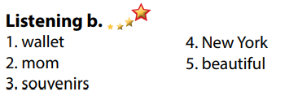

- Activity 3: Post - Listening (6’)
a) Objective: Students can use the vocabulary and the content in listening part to develop their speaking skill.
b) Content: Speaking: What did you like most about your last holiday?
c) Expected outcomes: Students can talk about their personal belongings for travelling.
d) Organization of the activity:
TEACHER’S ACTIVITIES | STUDENTS’ ACTIVITIES
Conversation skill  - Have Ss look at the Conversation skill box and read.  - Play audio (CD 2 - Track 18), have Ss listen and repeat (using DCR).  - Ask Ss to find more ways to end a conversation.  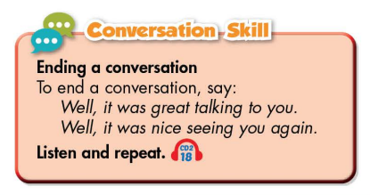  Task c. In pairs: What did you like most about your last holiday?  - Have Ss work in pairs to discuss the question.  - Observe and give help if necessary.  - Call some pairs to share their ideas with the class.  - Give feedback and evaluation. | - Look and read.  - Listen and repeat.  - Give answers.  - Work in pairs.  - Present.

C. Consolidation and homework assignments (5’)
* Consolidation:
- Words relating to tourism / holiday (souvenirs, sightseeing, swimsuit, postcards, photos, beach, wallet).
- Language for ending a conversation:
- Well, it was great talking to you
- Well, it was night seeing you again.
- Goodbye. See you later.
- Sorry, I've got to go. Talk to you later.
- Well, it's been nice meeting to you.
- Great. I'll see you tomorrow.
- Catch up with you later.
* Homework
- Learn the new words by heart.
- Practice talking about things you do on holiday.
- Do the exercises in WB: New words and Listening (page 52).
- Do the vocabulary exercise in Tiếng Anh 7 i-Learn Smart World Notebook (page 56).
- Play consolation games in Tiếng Anh 7 i-Learn Smart World DHA App on www.eduhome.com.vn
- Prepare: Lesson 2.2 – Grammar (page 72 – SB).

D. Reflection
a. What I liked most about this lesson today:
…………………………………………………………………………………………
- What I learned from this lesson today:
…………………………………………………………………………………………
c. What I should improve for this lesson next time:
…………………………………………………………………………………………

