Chuyên đề
USING AI APPS TO ASSIST TEACHERS IN DESIGNING
READING AND LISTENING TASKS FOR GIFTED STUDENTS

ABSTRACT

In learning English, reading and listening are considered receptive skills that help learners lay a foundation for speaking and writing and encourage students to use information from texts in debates, presentations, or creative writing. If teachers wish to create entirely new reading passages, the process of writing, editing, and ensuring appropriateness for students’ proficiency levels requires a significant amount of time. Developing accompanying questions is also a challenge, particularly when designing a system of questions that range from easy to difficult. However, with the rapid advancement of Information technology and the emergence of AI apps, and with the dedication of a teacher in charge of teaching students at high schools for the gifted, I strongly believe that if a teacher really wants to enhance reading and listening skills for gifted students, he or she can take advantage of AI tools to generate a wide variety of reading and listening materials to suit students’ level of English as well as their need and interest.

TABLE OF CONTENTS
ABSTRACT
PART I: INTRODUCTION
1. What is AI?
2. What is an AI app?
3. Rise of AI in education
4. Importance of differentiated instruction for gifted students
5. Rationale of the study
6. Aim and scope of the study
PART II: DEVELOPMENT
A.Literature Review
1. Aims of teaching listening and reading skills
2. The importance of listening and reading
3. The importance of designing tasks for listening and reading materials for gifted students
4. Current practices in designing reading and listening tasks for gifted students.
5. Significance of the study
B. Procedure
1. Designing READING tasks for gifted students using AI apps

1.1. Outlining the criteria in order to be able design tasks that align with gifted students’ ability and needs
1.1.1. The target group of students that the teacher aims to support

1.1.2. What the target group of students are expected to achieve
1.1.3. Types of reading tasks
1.2. Selecting an AI app based on your needs
1.2.1. AI apps for generating customized reading texts: ChatGPT & Writesonic
1.2. 2. AI apps for comprehension and quizzes: Question Well
1.2.3. AI apps for text complexity adjustment: Textcompactor

1.3. Generating reading materials
1.3.1. Options
1.3.2. Prompt example for ChatGPT/ Writesonic
2. Designing LISTENING tasks for gifted students using AI apps

2.1. Determining what gifted learners are expected to achieve
2.1.1. Listening task types
2.1.2. Aims of listening activities
2.1.3. Listening materials for gifted students
2.2. Choosing an AI app based on your needs
2.3. Generating listening tasks and producing audio
3. Lists of suggested topics for teachers to choose from to ask AI apps to generate reading passages together with comprehension questions.
4. Reviewing and editting the generated passage for difficulty level, vocabulary, and grammar accuracy
5. Making the best use of the vocabulary, expressions and collocations in reading materials generated by AI apps in order to help gifted students enrich their vocabulary
PART III: CONCLUSION
1. The benefits of using AI apps in designing reading and listening tasks for gifted students
2. Limitation
PART IV: REFERENCES
APPENDIX
Products
1. Reading
Reading passages and comprehehsion questions generated by AI apps
2. Litening
- Scripts, Listening tasks and Audios generated by AI apps
3. Reviewing and editting the generated passage for difficulty level, vocabulary, and grammar accuracy
4. Making the best use of the vocabulary, expressions and collocations in reading materials generated by AI apps in order to help gifted students enrich their vocabulary

PART I: INTRODUCTION
1. What is AI?
AI, or Artificial Intelligence, refers to computer systems that can perform tasks typically requiring human intelligence, such as learning, problem-solving, and decision-making. These systems are designed to process information, make inferences, and take actions based on the data they have been trained on.
Key Aspects of AI:
• Learning: AI systems can learn from data, improving their performance over time as they are exposed to new information.
• Reasoning: AI can analyze data, identify patterns, and make logical inferences.
• Decision-making: AI can make decisions based on the information it has learned and the context of the situation.
• Perception: AI can "see," "hear," and "understand" the world around it through techniques like image recognition and natural language processing.
• Adaptability: AI systems can adapt to new situations and learn from their mistakes.
Sources of reference:
(https://www.google.com/search?q=What+is+AI+%3F&oq=What+is+AI+%3F&aqs=chrome..69i57.5459j0j15&sourceid=chrome&ie=UTF-8)
2. What is an AI app?
An AI app, or artificial intelligence application, is a software program that uses AI techniques to perform tasks that usually require human intelligence. These apps can learn, reason, solve problems, understand language, and make decisions, often with the help of technologies like machine learning, deep learning, natural language processing, and computer vision.
Here's a more detailed explanation:
Key Features of AI Apps:
• Learning and Adaptation: Unlike traditional apps that follow predefined rules, AI apps can learn from data and improve their performance over time.
• Machine Learning: Many AI apps rely on machine learning algorithms to analyze data, make predictions, and make decisions.
• Natural Language Processing (NLP): NLP allows AI apps to understand and generate human language, enabling features like virtual assistants and chatbots.
• Personalization: AI apps can tailor experiences to individual users, offering customized recommendations and content.
• Automation: AI can automate tasks and processes, improving efficiency and reducing human workload.
• Enhanced Decision-Making: AI can analyze complex data and provide insights to help users make informed decisions.
Examples of AI Apps:
• Chatbots: HubSpot, Drift.
• Personalized Content Platforms: TikTok.
• Image Recognition Apps: Google Lens.
• Education Apps: Quizlet.
• Smart Cameras: Google Cameras.
• Generative AI Tools: Perplexity, ChatGPT.
Sources of reference:
(https://www.google.com/search?q=What+is+an+AI+app%3F&oq=What+is+an+AI+app%3F&aqs=chrome..69i57.9048j0j15&sourceid=chrome&ie=UTF-8)
3. Rise of AI in education
The emergence of AI has breathed a new life into learning and teaching. More and more teachers and students have gained access to the world of AI. AI technology has revolutionalized traditional learning and teaching methods, offering efficient and personalized solutions to both students and teachers. AI has assisted teachers and students in improving the quality of teaching and learning, offering immediate feedback and supplementary resources to help teachers adjust to the requirements of a specific student and allow students to overcome particular challenges. AI has reduced teachers’workload such as grading process, creating teaching materials, allowing instructors more time for creative teaching and deep-student engagement. How to use these advanced tools without sacrificing the essential human elements is what we have to pay attention to.
4. Importance of differentiated instruction for gifted students
Differentiated instruction is essential for gifted students because it recognizes and caters to their high academic requirements, allowing them to reach their full potential.Gifted students are more likely to learn concepts faster and at a higher level than the rest, and without being challenged adequately, they can become disenchanted or under-stimulated in an average classroom environment. Differentiated instruction causes acceleration, enrichment, and independent learning opportunities to engage and challenge gifted students. Through adjusting content, process, and product to meet the readiness levels, interests, and profiles of the students, teachers can create a responsive yet challenging learning environment. It not only leads to academic success but also develops creativity, critical thinking, and an ongoing curiosity in gifted students.
5. Rationale of the study
Listening and reading are considered to be two of the important skills that account for more than 50% of total score in National English Competition for gifted students each year. Creating challenging reading and listening exercises for gifted students participating in yearly National English Competitions presents several challenges to teachers. One of the most important challenges is the formulation of materials that are difficult enough to assess high-ability leamers without being too difficult and therefore becoming demotivating to them. These students are likely to require authentic, content-rich texts outside of formal curricula, and teachers are challenged to produce or collect materials of high lexical and syntactic complexity. The assignments must also elicit higher-order thinking skill-inference, analysis, and synthesis without sacrificing format and timing requirements of the competition. A middle ground between creativity and test-preparation can sometimes be especially difficult to achieve, as teachers must keep activities engaging without sacrificing sense.Time limits, insufficient training in the education of the gifted, and limited access to more advanced facilities also complicate task design. Therefore, the teacher must think creatively on a constant basis and come up with mentally demanding and skill-enhancing tasks that meet both the academic and competitive needs of the gifted student.
6. Aim and scope of the study

The study has been conducted with a view to assisting teachers of high schools for the gifted in designing advanced reading and listening tasks for gifted students by using AI apps. With the increasing availability of AI-powered educational tools, there is growing potential to enhance instructional design through adaptive content generation, real-time feedback, and personalized learning pathways. This study aims to find out what AI applications can contribute to the development of high-level reading and listening, the skills often required in national competitions for gifted learners. Moreover, the study intends to examine how AI apps can reduce the workload for teachers by streamlining the task creation process, providing access to curated materials, and suggesting differentiated content which is suitable for students’ abilities and interests. Finally, the study strongly desires to bridge the gap between emerging technologies and pedagogical practices, ensuring that the integration of AI into the classroom environment leads to meaningful and challenging learning experiences for gifted students.
PART II: DEVELOPMENT
- Lierature Review
1. Aims of teaching listening and reading skills
The major objectives of teaching listening and reading are to enhance learners’ capacity to understand, interpret, and critically react to spoken and written language. “Acquiring the ability to understand what L2 speakers say is not an optional extra. On the contrary; listening is the principal means by which learners expand their knowledge of spoken forms of the target language.” (Field, J. (2008). Listening skills help learners decipher spoken language, determine key ideas, infer meaning, and react suitably in real-time communication. Reading skills prepare learners to read texts, recognize patterns, analyze information, and acquire vocabulary and “By making predictions readers use their experiences and knowledge, interact positively with the reading passages, and increase their motivation and interest.” (Grabe& Stoller, 2011). Both of these skills are essential for academic achievement and everyday communication since they facilitate effective leaming in all subjects. In the case of talented students, instructions in these skills must extend beyond simple understanding to encompass higher-order thinking tasks like critical thinking, integration of ideas, and judging arguments. These skills in listening and reading provide the basis for further language skills like speaking and writing as well. They also stimulate learner autonomy and enable students to access knowledge independently. Thus, teaching these receptive skills alone serves not only to develop greater linguistic competence but also to develop lifelong learning habits and provide incentives for intercultural awareness.
2. The importance of listening and reading
Reading and listening are essential receptive skills. Rost emphasizes that “listening is considered as a foundation for communication and lifelong learning.” (Rost, M. 2011). Through listening, one is able to develop the ability to comprehend verbal language as it is spoken, enabling them to actively participate in academic, social, and work settings. Reading, on the other hand, enhances critical thinking and vocabulary, as well as knowledge of grammar and content through exposure to a diversity of texts and ideas. "Effective reading involves the integration of decoding skills with higher-level processes such as inference, evaluation, and synthesis." (Urquhart, S, & Weir, C. (1998). Together, these abilities complement basic language ability and enable the development of productive skills such as writing and speaking. Reading and listening, in educational environments, particularly for gifted students, unlock the doors of access to complex materials, independent leaming, and cross-disciplinary education. They make it possible for leamers to access and process vast amounts of information, sift through differing perceptions, and make informed decisions. Besides, mastery of such skills facilitates students' academic performance and prepares them to face challenges in an information-based society in the future. Therefore, strategic instruction of listening and reading is significant in creating well-rounded, self-motivated, and globally competitive learners.
3. The importance of designing tasks for listening and reading materials for gifted students
It is particularly important for gifted learners that listening and reading tasks be well crafted so that they have the opportunity to dig in and receive the benefit of complex content and upper-level thinking skills. “Gifted students often need tasks that are more abstract, complex, open-ended, and multifaceted than their peers.” (p. 32) (Tomlinson, C. A. (2014). Unlike general learners, gifted learners require intellectually stimulating material that goes beyond the surface level of comprehension. Well-developed tasks prompt them to infer meaning, analyze points of view, locate implicit information, and make judgmental decisions. These activities also enable the learning of metacognitive strategies, wherein students are able to monitor their understanding and process texts more strategically. Furthermore, differentiated activities may cater to their respective learning styles, allowing them to process topics at greater depth or from different perspectives. In listening activities; for example, the use of authentic audio materials with challenging themes taxes their cognitive processing and strengthens their ability to infer tone, intention, and implied messages. Similarly, “Gifted leamers need access to texts and tasks that challenge their analytical abilities, encourage cross-disciplinary exploration, and develop their capacity for independent inquiry.” (VanTassel-Baska, J., & Stambaugh, T. (2006) (P.89)
4. Current practices in designing reading and listening tasks for gifted students
Until now, teachers have typically searched for listening and reading comprehension materials for gifted students on websites or in library resources. However, these sources are limited and lack diversity in topics, making it very challenging for teachers to find suitable materials and design a variety of task types for their students. Moreover, teachers often face time constraint, which adds pressure when preparing materials. Purchasing books that contain reading passages and listening practice exercises appropriate for the proficiency level of gifted learners is also difficult, as original editions are often very expensive. In addition, some teachers are responsible for preparing exam papers for selecting students for gifted teams that participate in academic competitions, making access to rich and relevant learning resources even more essential. So the fact that teachers should use AI apps with a view to helping teachers design reading and listening tasks is a must.
5. Significance of the study
This study has great significance for educational policymakers, curriculum developers, and teachers who seek new strategies to meet the advanced learning needs of gifted students. Developing appropriate reading and listening activities for this group is especially difficult, as these students often require intellectually stimulating to activities beyond the standard curriculum. By examining the role that AI applications can play in assisting teachers with this complex task, the study contributes both daily classroom practice and to broader educational research. Moreover, it appears to provide insight into how AI may be leveraged to balance workload demands, increase efficiency, and support differentiated instruction in the language classroom. At a policy level, the research provides empirical evidence to inform future investment in AI-powered education technologies so that they are effectively introduced to support advanced learners. Lastly, this study aims to provide teachers with the technology that amplifies the learning experience, raises gifted students’ independence and critical thinking, and allows easier access to quality, high-level educational materials.
B. Procedure
1. Designing READING tasks for gifted students using AI apps:
1.1 Outlining the criteria in order to be able design tasks that align with gifted students’ ability and needs
1.1.1 The target group of students that the teacher aims to support:
- Gifted students in general
- The academic competition team

1.1.2. What the target group of students are expected to achieve
- Gifted students need tasks that go beyond basic comprehension.
- The academic competition team needs high-order tasks (e.g., synthesis, evaluation, creativity, inference, perspective-taking, and critical thinking)
1.1.3 Types of reading tasks
- Open Questions (Wh- questions) (Who, What, Where, When, Why, How)
- True/ False /Not given statements
- Multiple-choice questions
- Open Cloze questions
- Guided cloze questions
- Matching
- Table or chart completion
- Arranging events in the correct order (sequencing)
- Paraphrasing or summarizing the text in their own words
1.1.4. What gifted students gain after reading activities
a. Develop reading comprehension skills
- Help students understand the main ideas, supporting details, and inferred meanings in a text.
- Help learners to distinguish between fact and opinion, identify the author's tone or bias, and draw inferences.

b. Enrich vocabulary and improve language pattern
- Expose learners to new words, collocations, idioms, and grammatical structures in context.
- Enable them to guess meaning from context and notice language patterns.

c. Improve critical thinking
-Help students to analyze, evaluate, and synthesize information from the text.
-Develop their ability to question assumptions, compare viewpoints, and form opinions.
d. Improve reading strategies
-Teach techniques such as skimming (for gist), scanning (for specific information), predicting, and summarizing.
- Build independence in approaching different text types (narratives, editorials, instructions, etc.).

e. Promote fluency and reading confidence
- Increase reading speed and understanding through practice.
- Build students’ self-confidence in handling longer or more challenging texts.

f. Connect with real-world knowledge and themes
- Use reading as a springboard for discussions, projects, and research.
- Link texts to global issues, social values, literature, science, or cultural topics.

g. Support other skills
- Provide a foundation for speaking, writing, and listening activities.
1.2. Selecting an AI app based on your needs
1.2.1. AI apps for generating customized reading texts: ChatGPT, and Writesonic
a. ChatGPT
- ChatGPT can generate reading passages based on specific requirements and can create relevant comprehension questions.
- Link: https://www.google.com/search?q=chatgpt&oq=&aqs=chrome.0.35i39i362l7j69i59i450.70841684j0j15&sourceid=chrome&ie=UTF-8


Figure 1: The interface of ChatGPT
b. Writesonic
- Write sonic can also generate reading passages based on specific requirements and can create relevant comprehension questions.
- Link to video tutorial on “how to use Writesonic”
https://www.google.com/search?q=Huong+dan+cach+su+dung+Writesonic&oq=Huong+dan+cach+su+dung+Writesonic&aqs=chrome..69i57.17383j0j15&sourceid=chr


Figure 1: The Interface of Writesonic


Figure 2: Clicking “Sign in with Google”

Figure 3: The Writesonic interface is ready for use
1.2. 2. AI apps for comprehension and quizzes:
- AI apps for generating higher-order questions: Question Well
Link: “QuestionWell”: https://questionwell.org/

Figure 1: QuestionWell’s Interface


Figure 2: How to sign up: Click “Sign in with Google”


Figure 3: Choosing an account
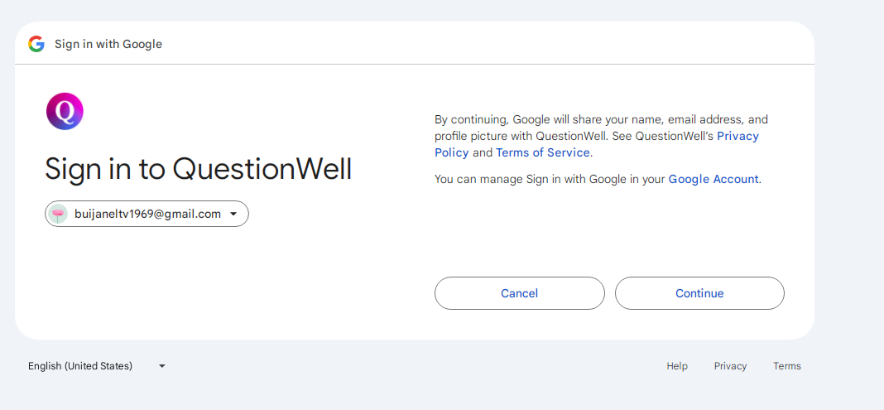
Figure 4: Clicking “Continue”

Figure 5: QuestionWell is ready for use
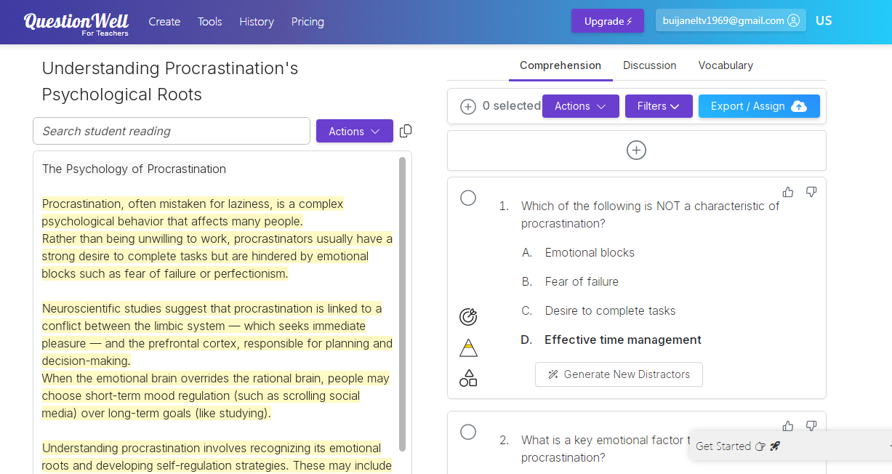
Figure 6: The Pasting of “the text” for Question Well to create comprehension questions
1.2.3. AI apps for text complexity adjustment:
- AI apps for simplyfying or enriching texts: Text Compactor, and ChatGPT
a. Text Compactor (AI app for simplyfying/ summarizing texts)
- Text Compactor can summarize long stories and texts with a maximum of 2500 words.
Link: https://www.textcompactor.com/

Figure 1: Text Compactor’s interface

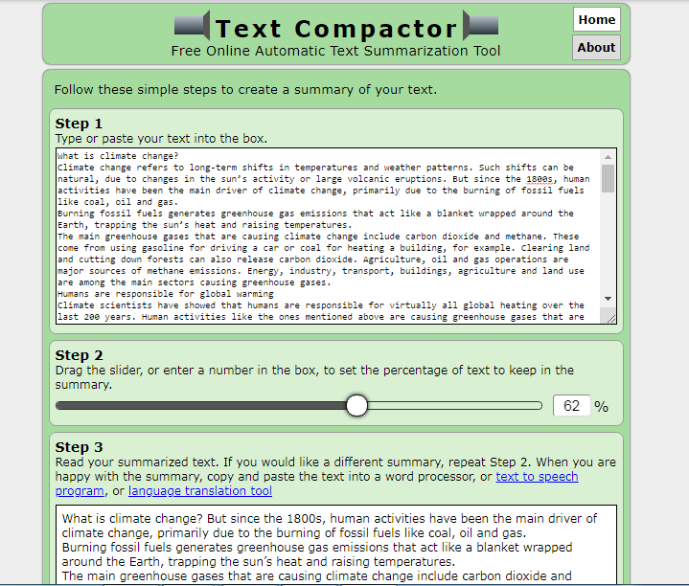

Figure 2: The Pasting of the text for Text Compactor to summarise the text
b. ChatGPT: can summarize long stories and texts

1.3. Generating reading materials

1.3.1. Options:
  - Choose a complex text from literature, news, science, or philosophy. Ask ChatGPT to generate challenging comprehension questions.
  - Choose a topic and ask ChatGPT or Writesonic to generate a reading text together with comprehension questions.
  - Choose a sample reading passage with reading tasks and ask ChatGPPT or Writesonic to generate a similar reading text with similar reading tasks but on the selected topic.
1.3.2. Prompt Example for ChatGPT/ Writesonic:

Reusable Prompt Template for English Language Tasks:
Prompt opening:
Always begin your prompt with: “You are an expert in ….”
Prompt components:

-Task Type:
Clearly specify the nature of the task you want the AI to generate:
e.g., Write 10 multiple choice questions
Create a reading comprehension exercise
Generate a vocabulary quiz

-Topic or Content:
e.g. Based on the passage below
Using the 10 vocabulary words provided
About social media marketing

-Format or Structure:
• Use A, B, C, D options
• Include one blank per sentence
• Add an answer key at the end
• Provide the result in .docx format

- Level or Audience:
e.g., Intermediate students
IELTS learners
High school ESL students

-Tone or Style (optional):
e.g., Simple academic tone
Friendly and clear

- Other Instructions:
e.g., Use each word only once
Avoid passive voice
Keep questions concise
Example Prompts
Example 1:
You are an expert in generating reading texts.
- Generate a 300-word reading passage on climate change for gifted high school students.
- Use advanced vocabulary and include a controversial viewpoint.
- Write 10 multiple choice questions. Use A, B, C, D options
- Maintain academic tone
- Add an answer key at the end
- Provide the result in .docx format
Example 2:
-You are an expert in designing assessment tasks for advanced learners.
- Please generate a 600-word reading passage on “Social issues”
- Create a set of multiple-choice (3-5 questions), True/False (3-5 questions), and short-answer (3-5 questions)
- The questions should cover main ideas, supporting details, vocabulary in context, and inference.
-Target audience: gifted high school students (upper-intermediate to advanced level).
- Output in .docx format with an answer key.
Guidance for teachers:
- Teachers should break complex prompts into smaller ones, as AI has the ability to remember and build on previous instructions.
- Teachers should revise and adjust prompts numerous times until they achieve the best possible result.
- If a teacher prefers not to write a prompt manually, they may provide AI apps with a sample reading passage along with corresponding comprehension questions and request the AI to generate a similar task on a new topic selected by the teacher. Save and reuse effective prompts to build a library of high-quality templates.
Tips:
-The clearer and more detailed the prompt, the higher the quality of the reading passages and questions.
- The longer and more coherent your input text, the richer the output questions.
2. Designing LISTENING tasks for gifted students using AI apps
2.1. Determining what gifted learners are expected to achieve
- Listening for gist, specific information, inference, evaluating perspectives,
- Understand the main ideas and arguments in a spoken text
- Analyze speaker viewpoints and underlying assumptions.
2.1.1. Listening task types:
a. General listening: (for main ideas and details)
- Fill in the blanks with missing information
- Multiple-choice questions (with main ideas or details)
- True/false statements
- Table or chart completion
- Labeling a diagram or map

b. Higher-Order Listening (for inference, opinion, attitude, or relationships)
- Identify the speaker’s opinion or attitude
- Analyze relationships between people in a dialogue
- Compare and contrast perspectives
- Explain motives or intentions
- Summarize main points and draw conclusions

2.1.2. Aims of listening activities:
- Develop higher-order thinking skills through listening.
- Improve listening for main ideas, details, relationships, and attitudes.
- Provide creative expression and collaborative opportunities following the listening activity.
- Expand vocabulary related to the topic.
2.1.3. Listening materials for gifted Students
- Authentic, challenging materials (lectures, news stories) related to your students’ interests.
- A complex piece (such as a short documentary, a news report, or a dramatic dialogue with moral conflict).
- Dialogue (with complex relationships, humor, or conflict)
Teachers can request AI apps to generate these materials together with listening tasks.
2.2. Selecting an AI app based on your needs
Suggested AI apps for converting a text or a script into speech:
- Luvvoice
Link: https://luvvoice.com/

Figure 1: Luvvoice’s interface


Figure 2: Clicking “Sign in with Google
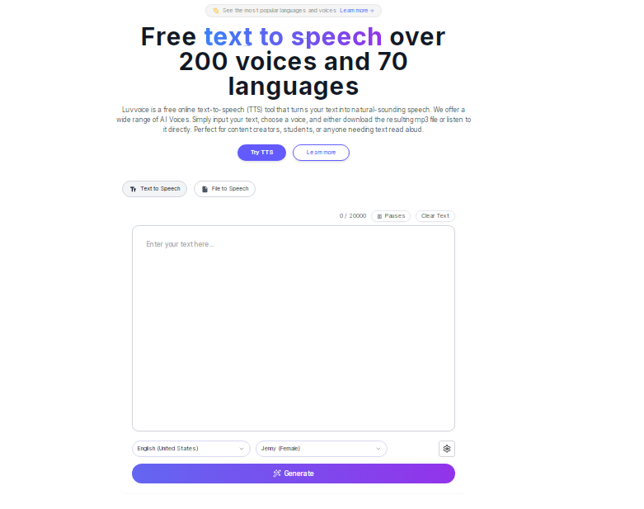
Figure 3: The App is ready for use


Figure 4: Text to Speech and the audio is ready for download

Google AI studio

Link: aistudio.google.com
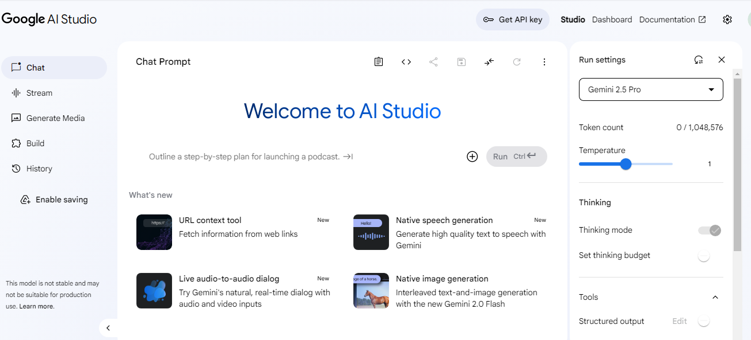
Figure 1: The interface of aistudio.google when you have finished “Sign in with Google”
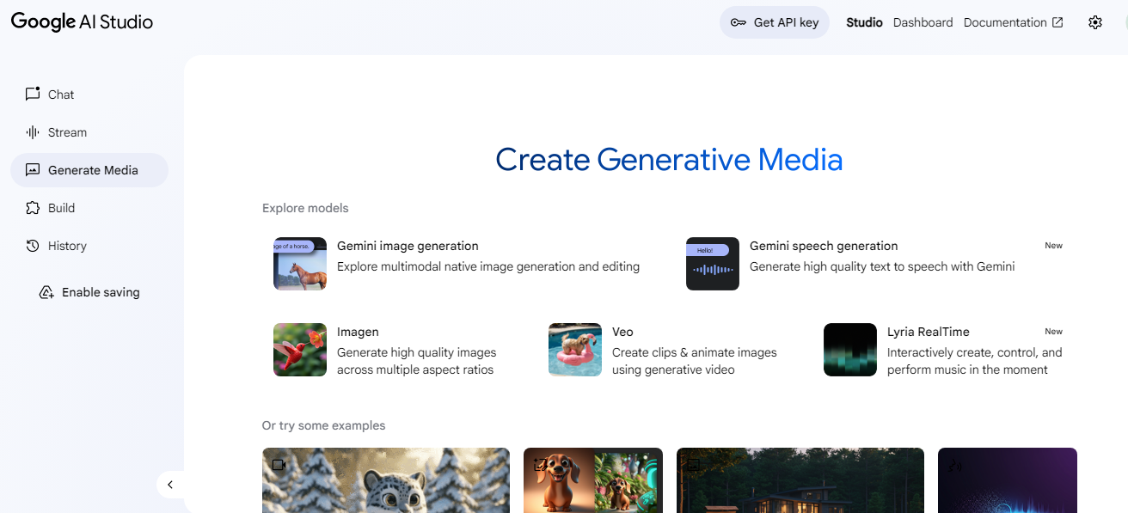
Figure 2: Clicking “Generate media”
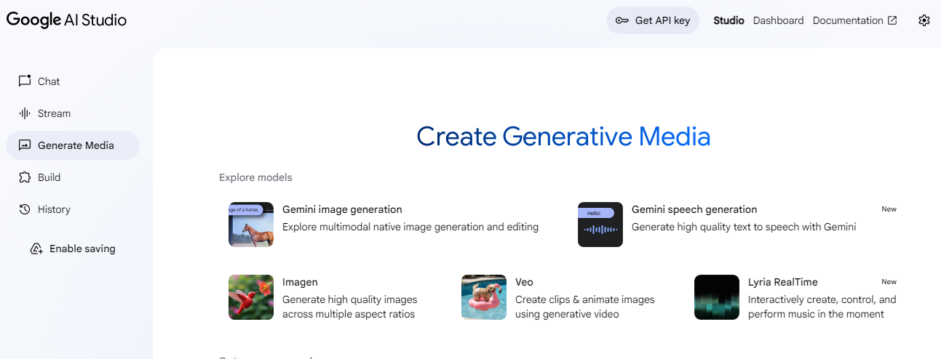
Figure 3: Clicking “Gemini speech generation”
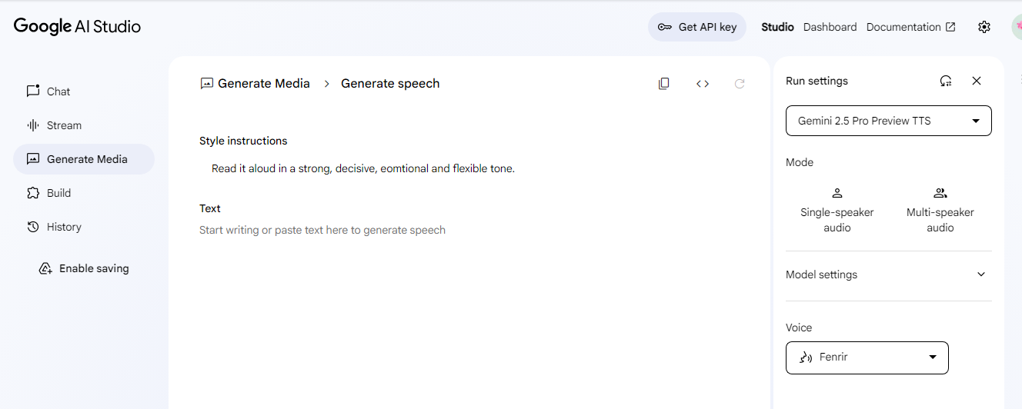
Figure 4: Choosing “Mode”
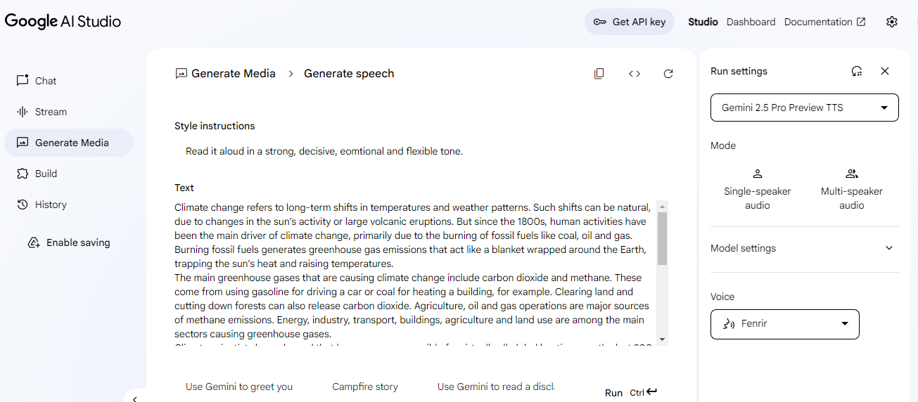
Figure 5: Pasting the text
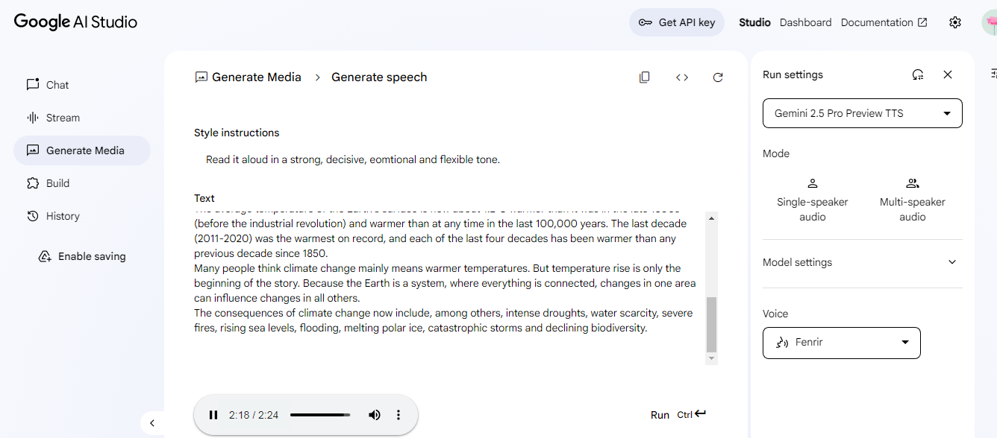
Figure 6: Audio is ready to download

-Link to Video on how to use “Google AI Studio”
https://www.youtube.com/watch?v=unOg69DPzhE
2.3. Generating listening tasks and producing audio
2.3.1. Options
- Choose reading passages/ pieces of news/ dialogues, ask Question Well or ChatGPT to generate comprehension questions and request Luvvoice or Google AI Studio to convert reading passges / pieces of news / dialogues into audio.
- Ask ChatGPT or Write Sonic to generate texts /dialogues along with tasks and then use Google AI to convert texts /dialogues into audio.
2.3.2. Prompts for generating listening tasks
- Use the prompt in 1.3.2. (Prompt Example for ChatGPT/ Writesonic)
Example:
Based on the transcript/ text provided below, please generate:
- 3 multiple-choice questions (gist, attitude, or detail)
- 2 short-answer questions
2.3.3. Downloading the audio
3. Lists of suggested topics for teachers to choose from to ask AI apps to generate reading passages / scripts together with comprehension questions.
- A topic may contain numerous aspects. Teachers should determine the aspects that are related to the topic they wish AI apps to generate reading passages on.
3.1. Young people
- The role of social media in shaping the identity of young people today
- Youth unemployment: causes, consequences, and solutions
- The young generation and environmental responsibility
- The impact of technology on the education of the younger generation
- Peer pressure: how it shapes the choices and behavior of young people
- Youth and political participation: engaging the next generation of leaders
- Mental health challenges among the young: causes and solutions
- The young and their role in preserving cultural heritage in the digital age
3.2. The Young and Social Media:
- The impact of social media on the mental health of young people
- Social media and the development of communication skills in youth
- The role of social media in shaping the identity of young people
- Social media and academic performance: a double-edged sword
- The influence of social media on youth activism and social awareness
- The risks of cyberbullying and online harassment among young people
- Social media and fomo (fear of missing out) among teenagers

3.3 Academic Development and Challenges
- The pros and cons of specialized gifted education programs
- Balancing advanced academics and emotional well-being in gifted students
-The role of early identification in nurturing gifted students
- Tthe challenge of boredom: how schools can keep gifted students engaged
- The role of early identification in nurturing gifted students
- The impact of technological advancements on students' future job opportunities
3.4 Generational gap
-The causes and consequences of the generation gap
-How the generation gap affects family relationships
-Bridging the generation gap
-Technology and the widening generation gap
3.5. Independent life
- The meaning and importance of leading an independent life
- Cultural expectations prevent many young people from becoming independent
- Financial independence is more important than emotional independence
- Living alone teaches more life skills than living with family
- The long-term effects of over-dependence on family support
- Causes and consequences of delayed independence in young adults
- Problems young people face when trying to live independently
3.6. Social issues
- The impact of social issues on youth and education
- How social media shapes our understanding of social problems
- Poverty exists not because of scarcity, but because of inequality
-Youth unemployment: causes, consequences, and possible solutions
- Cyberbullying: a modern social issue with serious psychological effects
3.7. Ecosystem
- The role of biodiversity in maintaining ecosystem stability
- Ecosystems and their interdependence with human life
- The difference between natural and artificial ecosystem
- Ecosystem protection in developed countries vs. developing countries
- Solutions to restore degraded ecosystems around the world
3.8. Social Media
- The psychological effects of excessive social media use on teenagers’ mental health and social development.
- The effects of social media on cultural identity and the globalization of fashion, music, and lifestyle trends.
- The role of social media in shaping political awareness and activism among young people.
3.9. Global Warming
- The impact of global warming on biodiversity and ecosystem stability
- The role of renewable energy in combating global warming and discuss the barriers to its widespread adoption
- The effectiveness of international agreements such as the Paris Agreement in addressing global warming.
3.10. World Heritage Conservation
- The challenges of balancing tourism development with the conservation of World Heritage Sites
- The role of UNESCO in safeguarding World Heritage Sites and assess its effectiveness in preventing irreversible damage
3.11. Education in the Future
- The potential impact of Artificial Intelligence (AI) and virtual reality (VR) on future teaching and learning processes
- How education systems in the future can better promote creativity, critical thinking, and innovation
3.12. Health and Lifespan
- The role of mental health in achieving a long, healthy, and fulfilling life in the 21st century
- The challenges and implications of an ageing population on healthcare systems and economic sustainability
3.13. The Future of Cities
- The impact of urbanization on social inequality and the quality of life in future cities
- The role of artificial intelligence, big data, and the Internet of Things (IoT) in shaping future urban living
3.14. Family Life
- The impact of technology and social media on communication and relationships within families
- The role of family life in shaping children's character, values, and future success
- The role of dual-income households in shaping family life and child development
3.15. Entertainment
- The role of entertainment in promoting social change and raising awareness about global issues
-The ethical responsibilities of the entertainment industry in portraying violence, gender roles, and diversity
3.16. Serving the Community
3.17. World-changing Inventions
3.18. Ecotourism
3.19. Humans and the environment
3.20. New learning methods
4. Reviewing and editing the generated passage for difficulty level, vocabulary, and grammar accuracy
ChatGPT or other AI apps can make mistakes, so teachers must carefully assess whether the language complexity aligns with the students’ proficiency level and cognitive abilities. This process involves analyzing the vocabulary to ensure that it is sufficiently challenging yet accessible, refining sentence structures for clarity and sophistication, correcting any grammatical errors that may hinder comprehension and editting comprehension questions.
5. Making the best use of the vocabulary, expressions and collocations in reading materials generated by AI apps in order to help gifted students enrich their vocabulary
PART III: CONCLUSION

1. The benefits of using AI apps in designing reading and listening tasks for gifted students
The application of Al tools in language instruction offers a wide range of benefits, particularly in developing reading and listening tasks for the needs of gifted learners. For reading tasks, AI apps can generate reading passages based on selected topics, length and difficulty level within seconds. Also, Al automatically adjust texts by level of complexity, offer vocabulary that is hard to read in context, and generate comprehension questions challenging higher-order thinking skills such as inference, analysis, and evaluation. In listening lessons, Al mobile applications can provide real audio content access, realtime transcription, and facilitate individual pacing or listen again for deeper understanding. Overall, AI enhances the creativity and productivity of task creation, allowing teachers to cater to more advanced cognitive and language needs of exceptional students while encouraging autonomy and self-learning. In summary, AI apps help teachers save time, reduce workload and provide gifted students with numerous reading and listening materials.
2. Limitation
- Teachers need to familiarize themselves with new technology.
- Some tools require a paid subscription.
- AI-generated content must be reviewed to avoid errors.
-Teachers need to review and edit the generated passage for difficulty level, vocabulary, and grammar accuracy.
- It is sometimes risky in listening, where tone, irony, or speaker attitude are subtle but important.
- Over-reliance on AI can reduce a teacher’s engagement in creative task design or critical text selection, which are essential professional skills.
PART IV: SOURCES OF DATA AND REFERENCES
- Field, J. (2008). Listening in the language classroom. Cambridge University Press.
- Grabe, W., & Stoller, F. L. (2011). Teaching and Researching Reading (2nd ed.) Routledge.
- Rost, M. (2011). Teaching and researching listening (2nd ed.) Routledge

- Tomlinson, C. A. (2014). The Differentiated Classroom: Responding to the Needs of All Learners (2nd ed.). ASCD
- Urquhart, S., & Weir, C. (1998). Reading in a Second Language
- VanTassel-Baska, J., & Stambaugh, T. (2006). Comprehensive Curriculum for Gifted Learners (3rd ed.). Pearson Education.
APPENDIX
Products
1. READING
Reading passages and comprehehsion questions generated by AI apps:
1.1. Practice 1: (Generated by Writesonic)
(Prompts: You are an expert in generating reading texts.
- Generate a 300-word reading passage on “Generation Gap” for gifted high school students.
- Use advanced vocabulary and include a controversial viewpoint.
- Write 10 multiple choice questions. Use A, B, C, D options
- Use academic tone
- Add an answer key at the end)

The Intergenerational Schism: Bridging Ideological Chasms in Modern Society
In contemporary society, the generational divide has transcended beyond mere temporal demarcation to become a profound sociocultural phenomenon that permeates various facets of human interaction. This intergenerational schism manifests in divergent ideological perspectives, communicative paradigms, and technological proclivities that collectively contribute to a complex tapestry of social dynamics. While generational categorizations—Baby Boomers (1946-1964), Generation X (1965-1980), Millennials (1981-1996), and Generation Z (1997-2012)—serve as convenient taxonomic constructs, they simultaneously risk oversimplification of nuanced individual experiences and the perpetuation of reductive stereotypes.
The technological revolution has indubitably accelerated the generational bifurcation. Generation Z, characterized as “digital natives,” has never experienced existence without ubiquitous connectivity, resulting in neurological adaptations that potentially alter cognitive processing. Research conducted by neuroscientists at the University of California suggests that consistent digital immersion may precipitate changes in neural pathways associated with attention distribution and information assimilation. Conversely, older generations often exhibit technological reticence, not necessarily due to intellectual limitations, but rather from a philosophical divergence regarding human-technology integration.
A particularly contentious perspective posits that generational disparities are deliberately exacerbated by corporate entities and media conglomerates to foster demographic antagonism, thereby obfuscating more significant socioeconomic inequities. This Machiavellian manipulation ostensibly redirects collective ire from systemic deficiencies toward intergenerational scapegoating. The proliferation of pejorative phraseology such as “OK, Boomer” and reciprocal derision of “entitled Millennials” exemplifies the commodification of generational discord for capital accumulation through viral engagement metrics.
The workplace has become a microcosm of these tensions, where disparate expectations regarding professional hierarchy, communication protocols, and work-life equilibrium often collide. Traditional organizational structures that valorize longevity and experiential wisdom increasingly conflict with contemporary paradigms that prioritize innovation, adaptability, and technological proficiency. This dissonance necessitates a fundamental recalibration of institutional frameworks to accommodate multigenerational collaboration without sacrificing operational efficacy.
Paradoxically, evidence suggests that certain putative generational characteristics may be more accurately attributed to developmental stages rather than cohort-specific attributes. The apparent narcissism ascribed to younger generations, for instance, may simply reflect normative psychological development during adolescence and early adulthood—a phase through which all generations inevitably traverse. This perspective challenges the very premise of generational exceptionalism and suggests a cyclical pattern of intergenerational critique that has persisted throughout human history.
The resolution of generational discord requires transcendence beyond reductive generalizations toward authentic empathetic understanding. Each generation’s formative experiences—whether the post-war prosperity and sociopolitical turbulence of the 1960s, the technological revolution of the 1990s, or the economic volatility and environmental consciousness of the 2010s—have shaped distinctive worldviews that merit recognition and respect. Rather than perpetuating divisive rhetoric, society might benefit from leveraging complementary generational strengths: the institutional knowledge and experiential wisdom of older generations alongside the technological fluency and adaptability of their younger counterparts.
In conclusion, while generational differences undeniably exist and present legitimate challenges for social cohesion, their exaggeration and exploitation serve no constructive purpose. The path forward necessitates reciprocal acknowledgment of diverse generational perspectives and the cultivation of integrative dialogue that transcends superficial categorizations to address fundamental human concerns that inevitably traverse generational boundaries.

Choose the best answer.
- The author characterizes the generational divide primarily as:
A. A natural evolutionary process
B. A complex sociocultural phenomenon
C. An artificial marketing construct
D. A temporary communication barrier
- According to the passage, “digital natives” refers to:
A. Technology industry professionals
B. Those who primarily communicate through digital means
C. People who have never experienced life without ubiquitous connectivity
D. Individuals who prefer digital media over traditional forms
- The passage suggests that neurological adaptations in younger generations are:
A. Definitively proven by extensive research
B. Completely fabricated by technology companies
C. Potentially occurring due to consistent digital immersion
D. Irreversible and detrimental to cognitive function
- Which controversial viewpoint does the author present regarding generational differences?
A. Older generations are intellectually inferior to younger ones
B. Generational disparities are deliberately exacerbated by corporate entities
C. Younger generations are inherently more narcissistic
D. Technological advancement is the sole cause of generational conflict
- The term “Machiavellian manipulation” in the passage refers to:
A. Political strategies employed by government officials
B. The calculated redirection of collective anger from systemic issues
C. Psychological warfare between generations
D. Technological algorithms designed to influence behavior
- In the workplace context, the passage indicates that traditional organizational structures:
A. Are superior to modern management approaches
B. Should be completely abandoned
C. Increasingly conflict with contemporary paradigms
D. Are preferred by all generational cohorts
- The author suggests that certain generational characteristics might actually be:
A. Permanent psychological traits
B. Reflections of developmental stages rather than cohort-specific attributes
C. Genetically predetermined tendencies
D. Artificially constructed by sociological research
- The resolution to generational discord, according to the passage, requires:
A. Younger generations adapting to established norms
B. Technological standardization across all age groups
C. Empathetic understanding and transcendence beyond generalizations
D. Corporate regulation of intergenerational messaging
- The passage characterizes pejorative phrases like “OK, Boomer” as examples of:
A. Necessary intergenerational communication
B. Harmless generational humor
C. The commodification of generational discord
D. Effective conflict resolution techniques
- The author’s tone throughout the passage can best be described as:
A. Nostalgically reminiscent
B. Analytically critical
C. Sarcastically dismissive
D. Optimistically visionary

Answer Key
- B
- C
- C
- B
- B
- C
- B
- C
- C
- B
1.2. Practice 2: (Generated by Writesonic)
(Prompt: You are an expert in generating reading texts.
-Please read the following sample reading together with the reading task and create a similar one on any topic you like.
- Use academic tone.
- Add an answer key at the end)

In the passage below, seven paragraphs have been removed. For questions 1-7, read the passage and choose from the paragraphs A–H the one which fits each gap. There is ONE extra paragraph which you do not need to use. Write your answers in the numbered boxes provided.

The curious evolution of artificial intelligence
The concept of creating machines that can "think" has fascinated humanity for centuries. From ancient myths of mechanical servants to today's sophisticated neural networks, artificial intelligence has evolved through distinct phases, each reflecting the technological capabilities and philosophical questions of its era.
The term "artificial intelligence" was officially coined in 1956 at the Dartmouth Conference, where a group of scientists proposed that "every aspect of learning or any other feature of intelligence can be so precisely described that a machine can be made to simulate it." This declaration marked the formal beginning of AI as a field of research, though the groundwork had been laid decades earlier.
1. ______
Early AI systems were primarily rule-based, programmed with explicit instructions for every scenario they might encounter. These systems could solve specific problems but lacked flexibility. The limitations became apparent when researchers tried to apply them to more complex tasks like natural language processing or visual recognition, areas where humans excel through intuition rather than by following explicit rules.
2. ______
The 1970s and early 1980s saw what became known as the "AI winter," a period of reduced funding and interest following unrealized promises. The computational demands of AI far exceeded the hardware capabilities of the time, and progress stalled. Some critics declared the entire enterprise fundamentally flawed, arguing that true intelligence couldn't be reduced to computational processes.
3. ______
By the late 1990s and early 2000s, AI research began to flourish again. Rather than trying to program explicit rules, researchers developed systems that could learn from data. This shift from rule-based to data-driven approaches revolutionized the field. Machine learning algorithms could improve their performance over time without being explicitly programmed to do so.
4. ______
The real breakthrough came with the development of deep learning, a subset of machine learning based on artificial neural networks with multiple layers. These systems, inspired by the structure of the human brain, proved remarkably effective at tasks like image and speech recognition. In 2012, a neural network called AlexNet dramatically outperformed traditional approaches in a prestigious computer vision competition, marking a turning point.
5. ______
Modern AI systems have achieved capabilities that would have seemed like science fiction a decade ago. They can generate human-like text, create original artwork, compose music, and even engage in sophisticated conversations. The GPT (Generative Pre-trained Transformer) models developed since 2018 have demonstrated an unprecedented ability to understand and generate human language.
6. ______
As AI becomes more integrated into daily life, critical questions about its development and deployment have emerged. Who is accountable when AI systems make mistakes? How can we ensure these systems don't perpetuate existing biases? What happens to jobs displaced by automation? The answers will require collaboration between technologists, policymakers, ethicists, and the broader public.
7. ______

Missing paragraphs
A. However, these achievements have come with growing concerns. As AI systems become more powerful and autonomous, questions of control and alignment with human values become increasingly urgent. The concept of artificial general intelligence (AGI) – machines with the full range of human cognitive abilities – remains a subject of debate. Some researchers believe AGI could arrive within decades, while others consider it a distant possibility or even fundamentally unattainable.
B. The most significant factor in AI's recent ascendance has been the exponential increase in computational power. Modern graphics processing units (GPUs) can perform the complex mathematical calculations required for machine learning at unprecedented speeds. Equally important has been the explosion of available data – billions of images, text documents, and other information sources that provide the raw material for training sophisticated models.
C. Before electronic computers existed, the concept of mechanical reasoning appeared in folklore and literature worldwide. The ancient Greeks had myths of automatons created by Hephaestus, the god of craftsmanship. In Jewish folklore, the golem was an animated anthropomorphic being created from inanimate matter. These stories reflected humanity's enduring dream of creating entities that could think and act like humans while serving their creators' purposes.
D. Despite these remarkable advances, current AI systems remain narrow in their capabilities, excelling at specific tasks while lacking the general intelligence that characterizes human cognition. They don't truly understand the content they generate or the decisions they make in the way humans do. Critics describe this as "shallow pattern recognition" rather than genuine intelligence, pointing out that these systems can produce convincing outputs without any actual comprehension.
E. The next frontier may involve systems that combine the pattern-recognition strengths of modern AI with more structured forms of knowledge representation. Some researchers are exploring hybrid approaches that integrate neural networks with symbolic reasoning, potentially offering both the flexibility of learning-based systems and the reliability of rule-based ones. Others are investigating ways to make AI systems more transparent and explainable, addressing the "black box" problem that makes many current systems difficult to trust in critical applications.
F. A second wave began in the 1980s with the development of expert systems, programs designed to mimic the decision-making abilities of human experts in specific domains. These systems found commercial applications in fields like medicine and finance but ultimately faced similar limitations. They couldn't adapt to novel situations or acquire new knowledge without human intervention, and maintaining their complex rule bases proved increasingly challenging as domains evolved.
G. Yet the dream refused to die. Two developments helped revive AI research. First, researchers began developing more probabilistic approaches that could handle uncertainty better than rigid rule systems. Second, the internet emerged, generating vast amounts of data that could be used to train new kinds of algorithms. These developments laid the groundwork for the data-driven approaches that would eventually transform the field.
H. This progression reflects a fundamental shift in how we conceptualize machine intelligence. Rather than trying to replicate human reasoning processes directly, modern AI focuses on achieving human-like results through entirely different mechanisms. The neural networks powering today's AI don't reason step-by-step like humans; instead, they extract patterns from enormous datasets, identifying correlations that may not be obvious even to human experts.

Answer Key:
- C
- F
- G
- B
- H
- A
- E

1.3. Practice 3: (Generated by ChatGPT)
(Prompt: You are an expert in generating reading texts.
- Please create a 700-word- advanced-level reading passage on the topic “Google Earth” together with 10 challenging true/false questions and a summary with blanks for students to fill in with words/ phrases picked up from the reading.
-The vocabulary and sentence structures are rich and intellectually stimulating, suitable for high-ability learners.
- Use academic tone.
- Add an answer key at the end)
Google Earth: Mapping the World and Beyond
In an era where digital technology has profoundly reshaped the way we perceive and interact with the world, Google Earth stands out as a groundbreaking innovation. Since its debut in 2005, this sophisticated application has transcended the boundaries of traditional cartography, offering users an immersive and interactive platform to explore our planet. Combining satellite imagery, aerial photography, and geographic information systems (GIS), Google Earth provides a detailed, three-dimensional representation of Earth that has revolutionized navigation, education, and environmental awareness.
The origins of Google Earth can be traced back to Keyhole, Inc., a company specializing in geospatial data visualization. Acquired by Google in 2004, Keyhole’s technology became the foundation of what would eventually become Google Earth. Initially designed for desktop use, the application has evolved into a versatile tool accessible on mobile devices and web browsers. Its functionality has expanded over the years to include features like Street View, 3D imagery, and even virtual tours of Mars and the Moon.
The technological prowess behind Google Earth lies in its ability to compile massive amounts of data from disparate sources. High-resolution satellite images, contributions from governments and scientific institutions, and user-generated content are seamlessly integrated to produce a dynamic model of the planet. The use of algorithms ensures that images are updated and stitched together, creating a cohesive and visually striking experience for users.
Google Earth’s versatility has rendered it indispensable in numerous fields. One of its most profound impacts has been in education. Geography classes, for instance, are no longer confined to static maps and textbooks. Students can now embark on virtual field trips to the Amazon Rainforest, the Great Barrier Reef, or ancient ruins in Greece, all from the comfort of their classrooms. This interactive approach enhances learning by fostering curiosity and engagement.
In addition to its academic applications, Google Earth has proven invaluable in environmental conservation. Organizations like the World Wildlife Fund (WWF) and Greenpeace use the platform to monitor deforestation, track wildlife migration, and document climate change. By providing a visual representation of environmental challenges, Google Earth enables policymakers and the public to grasp the urgency of global issues more effectively.
Furthermore, Google Earth has found utility in urban planning and disaster response. Urban planners utilize its detailed maps to design infrastructure, assess land use, and anticipate future development needs. In the wake of natural disasters, relief agencies employ Google Earth to identify affected areas, coordinate rescue operations, and deliver aid efficiently. Its ability to provide real-time data has made it a critical tool in crisis management.
While the benefits of Google Earth are manifold, its widespread use has not been without controversy. Privacy advocates have raised concerns about the application’s ability to capture detailed imagery of private properties and sensitive locations. The introduction of Street View in 2007, which provides panoramic views of streets and neighborhoods, sparked debates over the potential invasion of individual privacy. Although Google has implemented measures such as blurring faces and license plates, questions about the ethical implications of such technology persist.
Moreover, some governments have expressed apprehension regarding the availability of high-resolution images of military bases, nuclear facilities, and other critical infrastructure. These concerns highlight the delicate balance between providing access to information and safeguarding national security.
As technology continues to advance, the potential for Google Earth is boundless. Artificial intelligence (AI) and machine learning are likely to play a pivotal role in enhancing its functionality. For example, AI could be used to identify patterns in urban development, predict natural disasters, or even map previously uncharted territories.
Additionally, Google Earth’s integration with augmented reality (AR) and virtual reality (VR) promises to elevate the user experience to unprecedented levels. Imagine donning a VR headset and walking through a hyper-realistic recreation of ancient Rome or diving into the depths of the Mariana Trench. Such innovations could transform how we explore not only our planet but also the broader universe.
Google Earth represents a remarkable convergence of technology, imagination, and utility. Its ability to connect people with distant places, illuminate global challenges, and inspire exploration underscores its transformative impact on modern society. However, as its capabilities expand, so too must the dialogue surrounding its ethical use. By navigating these challenges responsibly, Google Earth will continue to serve as an invaluable tool for discovery, education, and global awareness. (719 words)

Are these statements TRUE or FALSE?
- Google Earth was developed entirely by Google from the beginning.
- Google Earth allows users to explore Mars and the Moon virtually.
- Google Earth is primarily used for navigation and has limited applications in other fields.
- Street View sparked debates about privacy concerns when it was introduced in 2007.
- Artificial intelligence and machine learning are expected to play a minimal role in the future development of Google Earth.
- Google Earth’s high-resolution images have raised security concerns in some countries.
- Google Earth currently uses virtual reality (VR) extensively to allow users to experience places interactively.
- The application’s ability to combine satellite imagery and geographic data has made it a critical tool for crisis management.
Answer key:
- F
- T
- F
- T
- F
- T
- F
- T
Complete the SUMMARY below.
Choose NO MORE THAN TWO WORDS from the passage for each blank.
Google Earth is a (1)………………….tool that has transformed how people explore and understand the world. Launched in 2005 and built on technology from Keyhole, Inc., it combines (2). …………., GIS, and other data to create a detailed 3D representation of Earth. Over time, its features have expanded to include Street View, 3D imagery, and even virtual tours of Mars and the Moon.
Google Earth is widely used in various fields, such as (3). ………….., where it enhances learning by enabling virtual field trips, and environmental conservation, where organizations use it to monitor deforestation and (4). ……………. It also plays a vital role in urban planning and disaster response. However, its widespread adoption raises ethical concerns, including (5). ………….. with Street View and national security risks due to the visibility of (6). …………..
The future of (7). ………. lies in integrating artificial intelligence (AI), augmented reality (AR), and virtual reality (VR), which could further enhance its capabilities and user experiences. Despite challenges, Google Earth remains a powerful tool for (8). …………….., education, and global awareness.
Answer key:
1. groundbreaking
2. satellite imagery
3. education
4. climate change
5. privacy issues
6. sensitive locations
7. Google Earth
8. discovery

1.4. Practice 4: (Generated by Writesonic)
(Prompt: You are an expert in generating reading texts.
- Please read the following sample comprehension questions and create a similar one on any topic you like.
- Use academic tone.
- Add an answer key at the end)

Choose the letter A, B, C, or D to indicate the best arrangement of utterances or sentences to make a meaningful exchange or text in each of the following questions from 11 to 15.

Question 1
a. Furthermore, these developments in quantum computing could fundamentally alter our approach to data encryption and cybersecurity protocols.
b. Quantum computing represents one of the most significant technological breakthroughs of the 21st century.
c. Unlike classical computers that use bits, quantum computers utilize quantum bits or “qubits,” which can exist in multiple states simultaneously.
d. This property, known as superposition, enables quantum computers to process vast amounts of information at unprecedented speeds.
e. Scientists predict that fully functional quantum computers will eventually solve complex problems that would take conventional computers millennia to complete.
A. b – c – d – e – a B. c – d – b – a – e
C. b – c – d – a – e D. c – d – e – b – a

Question 2
a. Research indicates that students who engage in regular metacognitive practices demonstrate improved critical thinking abilities and academic performance.
b. Metacognition refers to the awareness and understanding of one’s own thought processes.
c. Educators can foster metacognitive skills by encouraging students to reflect on their learning strategies and problem-solving approaches.
d. Developing these skills enables learners to identify their cognitive strengths and weaknesses, ultimately becoming more autonomous in their educational journey.
e. Techniques such as self-questioning, journaling, and peer discussion can significantly enhance metacognitive development.
A. b – d – c – e – a B. b – d – e – c – a
C. b – c – e – d – a D. b – a – c – e – d

Question 3
a. The Anthropocene epoch, characterized by significant human impact on Earth’s geology and ecosystems, presents unprecedented challenges for environmental conservation.
b. Evidence of human influence is visible in various phenomena, including climate change, ocean acidification, and widespread species extinction.
c. Consequently, scientists and policymakers are collaboratively developing innovative approaches to mitigate anthropogenic damage.
d. These strategies encompass renewable energy implementation, sustainable agricultural practices, and comprehensive ecosystem restoration initiatives.
e. Ultimately, addressing the complexities of the Anthropocene requires an interdisciplinary approach integrating scientific research, economic considerations, and ethical frameworks.
A. a – b – c – d – e B. b – a – c – e – d
C. a – c – b – d – e D. a – b – c – e – d

Question 4
a. This theory suggests that cognitive development occurs through social interactions, particularly with more knowledgeable individuals.
b. Vygotsky’s sociocultural theory has profoundly influenced educational psychology and pedagogical approaches.
c. The concept of the Zone of Proximal Development (ZPD) represents the distance between what a learner can accomplish independently and what they can achieve with guidance.
d. Effective educational scaffolding within this zone gradually transfers responsibility from instructor to student, fostering autonomous learning.
e. Contemporary educational frameworks continue to incorporate Vygotskian principles, emphasizing collaborative learning environments and culturally responsive teaching methodologies.
A. b – a – c – d – e B. c – a – b – d – e
C. b – c – a – d – e D. a – b – c – e – d

Question 5
a. Neural plasticity refers to the brain’s remarkable ability to reorganize itself by forming new neural connections throughout life.
b. This phenomenon challenges previous assumptions that brain development occurs primarily during childhood and adolescence.
c. Recent neuroimaging studies have demonstrated that even adult brains exhibit significant structural and functional changes in response to environmental stimuli and learning experiences.
d. Understanding neural plasticity has revolutionary implications for rehabilitation strategies following brain injuries and cognitive impairments.
e. Moreover, these insights into brain adaptability have informed educational approaches that optimize learning conditions across the lifespan.
A. a – c – b – d – e B. a – b – c – d – e
C. c – a – b – e – d D. a – b – e – c – d

Answers:

Question 1
Answer: A. b – c – d – e – a
Explanation:
The paragraph should begin with sentence b as it introduces the main topic: “Quantum computing represents one of the most significant technological breakthroughs of the 21st century.” This serves as the topic sentence.
Sentence c logically follows by explaining a fundamental aspect of quantum computers: “Unlike classical computers that use bits, quantum computers utilize quantum bits or ‘qubits,’ which can exist in multiple states simultaneously.”
Sentence d builds directly on c by explaining the concept introduced (qubits): “This property, known as superposition, enables quantum computers to process vast amounts of information at unprecedented speeds.”
Sentence e provides a concrete application or consequence of the previously explained capabilities: “Scientists predict that fully functional quantum computers will eventually solve complex problems that would take conventional computers millennia to complete.”
Sentence a concludes with a broader implication, indicated by “Furthermore”: “Furthermore, these developments in quantum computing could fundamentally alter our approach to data encryption and cybersecurity protocols.”

Question 2
Answer: C. b – c – e – d – a
Explanation:
Sentence b introduces the concept of metacognition with a definition: “Metacognition refers to the awareness and understanding of one’s own thought processes.”
Sentence c follows by explaining how educators can apply this concept: “Educators can foster metacognitive skills by encouraging students to reflect on their learning strategies and problem-solving approaches.”
Sentence e logically follows c as it provides specific examples of the techniques mentioned in c: “Techniques such as self-questioning, journaling, and peer discussion can significantly enhance metacognitive development.”
Sentence d then explains the benefits of developing these skills: “Developing these skills enables learners to identify their cognitive strengths and weaknesses, ultimately becoming more autonomous in their educational journey.”
Sentence a concludes with research-based evidence supporting the importance of metacognition, as indicated by “Research indicates”: “Research indicates that students who engage in regular metacognitive practices demonstrate improved critical thinking abilities and academic performance.”

Question 3
Answer: A. a – b – c – d – e
Explanation:
Sentence a introduces the main topic—the Anthropocene epoch—and frames the issue: “The Anthropocene epoch, characterized by significant human impact on Earth’s geology and ecosystems, presents unprecedented challenges for environmental conservation.”
Sentence b naturally follows by providing evidence of the human impact mentioned in a: “Evidence of human influence is visible in various phenomena, including climate change, ocean acidification, and widespread species extinction.”
Sentence c logically follows by explaining the response to these challenges, signaled by “Consequently”: “Consequently, scientists and policymakers are collaboratively developing innovative approaches to mitigate anthropogenic damage.”
Sentence d elaborates on the “innovative approaches” mentioned in c by providing specific examples: “These strategies encompass renewable energy implementation, sustainable agricultural practices, and comprehensive ecosystem restoration initiatives.”
Sentence e provides a concluding statement that broadens the perspective, indicated by “Ultimately”: “Ultimately, addressing the complexities of the Anthropocene requires an interdisciplinary approach integrating scientific research, economic considerations, and ethical frameworks.”

Question 4
Answer: A. b – a – c – d – e
Explanation:
Sentence b introduces the main subject—Vygotsky’s sociocultural theory: “Vygotsky’s sociocultural theory has profoundly influenced educational psychology and pedagogical approaches.”
Sentence a follows with an explanation of what the theory suggests: “This theory suggests that cognitive development occurs through social interactions, particularly with more knowledgeable individuals.”
Sentence c introduces a key concept within the theory: “The concept of the Zone of Proximal Development (ZPD) represents the distance between what a learner can accomplish independently and what they can achieve with guidance.”
Sentence d builds directly on c by explaining how ZPD is applied in education: “Effective educational scaffolding within this zone gradually transfers responsibility from instructor to student, fostering autonomous learning.”
Sentence e concludes with the contemporary relevance and applications of the theory: “Contemporary educational frameworks continue to incorporate Vygotskian principles, emphasizing collaborative learning environments and culturally responsive teaching methodologies.”

Question 5
Answer: B. a – b – c – d – e
Explanation:
Sentence a introduces the main concept—neural plasticity: “Neural plasticity refers to the brain’s remarkable ability to reorganize itself by forming new neural connections throughout life.”
Sentence b naturally follows by highlighting why this concept is significant, challenging previous assumptions: “This phenomenon challenges previous assumptions that brain development occurs primarily during childhood and adolescence.”
Sentence c provides scientific evidence supporting the concept: “Recent neuroimaging studies have demonstrated that even adult brains exhibit significant structural and functional changes in response to environmental stimuli and learning experiences.”
Sentence d introduces practical applications in one field: “Understanding neural plasticity has revolutionary implications for rehabilitation strategies following brain injuries and cognitive impairments.”
Sentence e extends the applications to another field (education), indicated by “Moreover”: “Moreover, these insights into brain adaptability have informed educational approaches that optimize learning conditions across the lifespan.”

1.5. Practice 5: Guided cloze test with multiple choice questions: “Nuclear Power” (Generated by ChatGPT)
(Prompt: You are an expert in creating reading passages. Please generate a 250-word advanced-level guided cloze test on "Nuclear Power". The test includes 10 blanks, covering a range of grammatical categories: verbs, nouns, adjectives, tenses, articles, and prepositions. Each blank comes with four challenging options, designed to test vocabulary, grammar, and contextual understanding- perfect for gifted learners.)
Read the text and choose the best answer for each blank.
Nuclear power has long been a subject of intense debate. On one hand, it is considered a (1) ________ energy source because it produces large amounts of electricity without emitting greenhouse gases. On the other hand, concerns regarding safety, radioactive waste, and political implications have caused many to (2) ________ its widespread adoption.
Unlike fossil fuels, nuclear power plants release no carbon dioxide during operation, making them an attractive option for countries seeking to reduce their (3)________ footprint. However, the consequences of accidents, such as those that occurred (4)________ Chernobyl and Fukushima, have cast a shadow over its perceived safety.
Nuclear energy is generated through the process of nuclear fission, where the nucleus of an atom is split, (5)________ a significant amount of energy. This process relies primarily on uranium, a metal that must be mined, processed, and safely transported to specialized facilities. Critics argue that the storage of radioactive waste, which remains hazardous for thousands of years, poses an (6) ________ risk to both the environment and future generations.
Despite these concerns, many scientists and policymakers continue to advocate for nuclear power as a critical component in the transition (7) ________ fossil fuels. Advances in reactor design and safety protocols have aimed to (8) ________ public concerns, though skepticism remains.
Ultimately, the decision to invest in nuclear power requires a careful (9) ________ of long-term benefits and potential risks, particularly in light of the growing demand (10)________ clean, reliable energy in an increasingly carbon-conscious world.
1. A. perishable B. sustainable C. synthetic D. cumulative
Answer: B
2. A. contradict B. embrace C. oppose D. forecast
Answer: C
3. A. nitrogen B. nuclear C. carbon D. environmental
Answer: C
4. A. beside B. through C. at D. under
Answer: C
5. A. reducing B. releasing C. restoring D. recycling
Answer: B
6. A. outgoing B. outdated C. ongoing D. overrated
Answer: C
7. A. beside B. from C. against D. through
Answer: B
8. A. accumulate B. alleviate C. aggravate D. abolish
Answer: B
9. A. association B. assumption C. assessment D. alteration
Answer: C
10. A. at B. with C. of D. for
Answer: D

1.6. Practice 6: (Generated by ChatGPT)
(Prompt: You are an expert in English language education and assessment design. Create a reading comprehension activity on the topic of ecotourism that includes a reading passage and associated IELTS-style tasks (e.g., Matching Headings, Multiple Choice Questions, Sentence Completion).
The passage should:
- Use elevated vocabulary appropriate for advanced or gifted students
- Contain complex and varied sentence structures
- Be composed of longer, academic-style paragraphs
- Challenge learners' higher-order reading comprehension skills)

The Complexity and Promise of Ecotourism

A
Over the past few decades, the evolution of global tourism has prompted critical reflection on the environmental and socio-cultural consequences of conventional travel. Mass tourism, once heralded for its economic potential, has come under scrutiny for its contribution to environmental degradation, cultural commodification, and unsustainable resource consumption. In this context, ecotourism has emerged as a conscientious alternative—an approach that attempts to harmonize leisure travel with environmental ethics and local empowerment. Rather than merely offering passive sightseeing, ecotourism seeks to cultivate a form of travel that is ecologically responsible, culturally sensitive, and economically inclusive. As climate change intensifies and biodiversity loss accelerates, the principles underlying ecotourism are gaining increased traction among both policymakers and global citizens.

B
At the core of ecotourism lies an educational imperative. Unlike traditional forms of tourism, which often prioritize entertainment and relaxation, ecotourism emphasizes the acquisition of ecological literacy. Guided excursions into fragile ecosystems—whether it be tropical rainforests, coral reefs, or mountainous reserves—are often accompanied by interpretive narratives delivered by trained experts. These experiences are designed not only to foster appreciation but also to instill a sense of environmental stewardship in travelers. In Costa Rica and Madagascar, for instance, visitors are introduced to complex ecological networks and conservation strategies, enabling them to grasp the nuanced interplay between human activity and ecological equilibrium. The pedagogical potential of ecotourism thus transcends the individual experience, contributing to a broader environmental consciousness.

C
Perhaps one of the most compelling arguments in favor of ecotourism is its capacity to function as a vehicle for community-based development. By prioritizing local employment, sourcing goods from regional producers, and encouraging participatory governance, ecotourism initiatives can redirect tourism revenue into areas that are often marginalized by mainstream development agendas. Dr. Mariana Cortez, a leading figure in environmental economics, contends that well-regulated ecotourism not only redistributes economic benefits equitably but also incentivizes the conservation of natural resources. When local stakeholders perceive direct benefits from ecological preservation, they are more inclined to support and sustain conservation efforts. In this regard, ecotourism creates a symbiotic relationship between economic vitality and ecological integrity.

D
Nonetheless, the implementation of ecotourism is not without paradoxes. Despite its ostensibly benign objectives, ecotourism can inadvertently exert pressure on the very environments it purports to protect. The influx of well-meaning but ill-informed travelers may lead to habitat disruption, trail erosion, or increased waste in remote ecosystems. Furthermore, the term “ecotourism” itself is vulnerable to semantic dilution through “greenwashing”—a marketing strategy whereby companies exploit eco-friendly rhetoric to attract conscientious consumers without adhering to genuine environmental standards. In the absence of rigorous accreditation mechanisms, the label may be applied indiscriminately, undermining the credibility of the concept altogether.

E
Technological innovation is increasingly being enlisted to address such challenges. Artificial intelligence and digital surveillance tools are being integrated into ecotourism infrastructure to monitor environmental impact, predict visitor flow, and identify potential ecological stressors. In some national parks, AI-driven drones and motion-sensor cameras track wildlife patterns and ensure compliance with protected zone regulations. Meanwhile, mobile applications are educating tourists on sustainability principles, ethical travel behavior, and local cultural norms. These digital interventions, if implemented ethically, may help ecotourism scale responsibly while preserving the authenticity of natural habitats.

F
Looking ahead, the future of ecotourism will depend on the sector's ability to navigate the tension between growth and sustainability. As global demand for eco-conscious travel intensifies, policymakers, conservationists, and community leaders must collaborate to design frameworks that protect ecosystems while fostering socio-economic resilience. Infrastructure development must be balanced with carrying capacity, and short-term profits must never eclipse long-term ecological considerations. As Dr. Cortez asserts, “Ecotourism must evolve beyond a fashionable label—it must become a blueprint for sustainable coexistence between humanity and the Earth.”
Choose the correct heading (i–viii) for each paragraph from the list below.
Write the correct number in boxes 1–6.
Headings:
i. The use of technology to support ecotourism practices
ii. The pedagogical dimension of ecotourism
iii. The future sustainability of ecotourism
iv. Critiques and contradictions of ecotourism
v. The expansion of commercial tourism in the Global South
vi. The rise of ecotourism in response to global concerns
vii. The economic benefits of local stakeholder involvement
viii. An analysis of tourism-related emissions
1. Paragraph A _______
2. Paragraph B _______
3. Paragraph C _______
4. Paragraph D _______
5. Paragraph E _______
6. Paragraph F _______
Choose TWO letters, A–E
Which TWO of the following are claimed as benefits of ecotourism?
A. It protects endangered ecosystems through long-term conservation partnerships.
B. It allows local people to benefit financially from preserving their environment.
C. It generates high-volume tourism without harming the environment.
D. It ensures that governments meet international climate targets.
E. It enhances travelers’ understanding of complex ecological systems.
Complete the sentences below using ONE WORD ONLY from the passage.
9. In ecotourism, guides are often responsible for providing detailed ecological __________ to educate tourists.
10. According to Dr. Cortez, ecotourism provides an economic __________ to protect natural resources.
11. The phenomenon of falsely advertising tourism ventures as environmentally responsible is called __________.
12. AI-powered devices such as drones and cameras are used to monitor tourist behavior in protected __________.
13. Dr. Cortez believes ecotourism should become a global __________ for sustainable human-nature interaction.

Answer Key
1. vi
2. ii
3. vii
4. iv
5. i
6. iii
7. B, E
8. E, B
9. interpretation
10. incentive
11. greenwashing
12. Zones
13. Blueprint
1.7. Practice 7: (Generated by ChatGPT)

(Prompt: You are an expert in designing reading materials with comprehension questions. Please read the following and make a similar one with the same level of vocabulary and sentence structures and answer key at the end. The topic is “Social Media’s Role in Revolutionizing Fashion Trends among Young People”)

Teachers need to provide ChatGPT with the sample reading materials with comprehension questions.

Social Media’s Role in Revolutionizing Fashion Trends among Young People
A. Social media has become a transformative force in shaping fashion trends, particularly among the younger generation. With platforms such as Instagram, TikTok, and Pinterest gaining immense popularity, young people are increasingly turning to digital sources rather than traditional media for inspiration. Unlike in the past, where fashion ideas were disseminated through elite designers and fashion magazines, social media has democratized style, allowing ordinary individuals to influence global fashion trends. Through viral content, hashtags, and influencer marketing, trends can now emerge, evolve, and fade in the span of days. This dynamic has significantly accelerated the pace of the fashion industry.
B. The accessibility of social media allows for the emergence of micro-trends and niche aesthetics that cater to diverse identities and tastes. However, this rapid shift in trends presents unique challenges, particularly in sustainability. Fast fashion brands, eager to capitalize on the latest viral looks, often engage in overproduction, contributing to environmental degradation. Moreover, the affordability of such fashion allows for disposable consumption, where items are worn only briefly before being discarded. Addressing this requires an integrated approach that not only involves brands and consumers but also policymakers who can implement regulations that encourage ethical practices.
C. A key component in this revolution is the power of digital communities. Online spaces provide platforms for expression, where users from diverse backgrounds can share and celebrate their unique styles. This inclusivity fosters a sense of belonging and empowerment. At the same time, it underscores the importance of digital literacy, as misinformation and unrealistic beauty standards can also proliferate. Educating young people on the impact of their consumption choices, both socially and environmentally, becomes increasingly essential in this context.
D. One promising direction is the promotion of slow fashion and sustainable consumption through social media itself. Influencers advocating for ethical brands, upcycling, and minimalist wardrobes can have a significant impact. While large-scale change requires governmental support and industry transformation, individual lifestyle changes are equally vital. Research suggests that when people are given simple, actionable steps, they are more likely to adopt and maintain new habits. For instance, sharing styling tips on how to re-wear clothing creatively can subtly shift consumer attitudes toward more sustainable behaviors.
E. Ultimately, meaningful change in fashion consumption patterns necessitates cooperation at every level. Governments must enact policies that hold brands accountable for environmental impacts, industries need to innovate eco-friendly production methods, and individuals should be encouraged to make informed choices. The preservation of the planet's resources is inextricably linked to how societies approach fashion in the digital age. It is imperative that all stakeholders engage proactively if sustainable fashion is to transition from a niche concern to a mainstream reality.

Questions 1-10: In which section are the following mentioned?
- Government intervention is necessary to enforce accountability.
- Short-lived fashion trends emerge rapidly due to social media.
- Digital platforms can both empower and mislead users.
- Collaboration across multiple sectors is essential.
- Consumption choices are tied to environmental impact.
- Influencers can encourage ethical consumer habits.
- Laws can help align industrial practices with sustainability goals.
- Individuals tend to adopt simple behavioral changes more readily.
- Fast fashion's affordability leads to overconsumption.
- Communities built around shared style foster inclusivity.
Your answers:
1 | 2 | 3 | 4 | 5 | 6 | 7 | 8 | 9 | 10

Answers:
- E
- A
- C
- B
- C
- D
- E
- D
- B
- C
1.8. Practice 8 (Generated by ChatGPT)
(Prompt: You are an expert in designing reading passages.
Would you please generate a 600- word reading passage on the topic: “Gender Equality in the 21st Century “ together with a full set of comprehension tasks based on the passage, designed for gifted students, including multiple-choice, True/False, vocabulary exercises, and a matching headings task.)

Breaking Barriers: Advancing Gender Equality in the 21st Century
A.Throughout history, patriarchy has shaped the social, political, and economic structures of societies worldwide, often limiting opportunities for women and marginalized groups. In many cultures, deep-rooted patriarchal norms have defined gender roles, creating systemic barriers that prevent women from accessing the same rights, freedoms, and opportunities as men. Today, despite significant progress, women continue to face systemic inequality in various sectors, from politics and education to the workplace and family life.
B. One of the most visible forms of inequality is the persistent glass ceiling that limits women’s advancement to top leadership positions. This invisible barrier, reinforced by gender bias and stereotyping, prevents many women from reaching executive roles, even when they possess equal or superior qualifications compared to their male counterparts. Additionally, income disparity remains a pressing concern, as women in many countries still earn less than men for performing the same work. Such gender discrimination not only undermines women’s economic independence but also perpetuates inequality across generations.
C. To bridge the gender gap and achieve gender parity, many organizations and governments have introduced inclusive policies aimed at creating equal opportunities for all. For example, enact equal pay legislation is one effective measure to ensure fair compensation for women and men performing the same roles. Similarly, governments have begun to implement gender mainstreaming—the process of assessing the implications of any planned action for both women and men—to ensure that policymaking is equitable and balanced.
D. In the workplace, achieving workforce parity requires more than simply hiring more women. It involves transforming organizational cultures to promote gender inclusivity and address unconscious bias that may exist in hiring, promotion, and evaluation processes. Additionally, organizations must work to combat gender stereotypes that label women as less competent leaders or unsuited for high-pressure roles. Breaking these stereotypes is crucial in helping women achieve social mobility and participate fully in economic and political life. Another key aspect of gender equality is ensuring equal representation in decision-making roles. Efforts to advance women’s rights must go hand in hand with efforts to empower marginalized voices, including those of women of color, LGBTQ+ individuals, and those from low-income backgrounds. Only by creating diverse and inclusive leadership can societies truly challenge patriarchal norms and foster a more just world.
E. Gender inequality extends beyond the workplace. Many women are still victims of domestic violence, facing physical, emotional, and economic abuse within their own homes. Addressing this issue requires not only legal protections but also societal change to shift attitudes that tolerate or excuse such violence. Similarly, sexual discrimination remains a reality in many settings, from schools to public spaces, creating environments where women feel unsafe or undervalued. To empower women and create lasting change, a multi-faceted approach is essential. Education plays a key role in raising awareness and reshaping social attitudes. Media representation also has the power to combat gender stereotypes and inspire young girls to dream big. Policy changes must continue to push for inclusive policies that protect rights and promote equity. Ultimately, achieving true equality requires persistent effort from all members of society. By working collectively to promote gender inclusivity, bridge the gender gap, and advance women’s rights, we can move closer to a future where every individual, regardless of gender, has the opportunity to thrive.

Choose the best answer.
- According to the passage, what is the glass ceiling?
A. A legal restriction preventing women from working
B. An invisible barrier limiting women's advancement to leadership positions
C. A policy promoting gender equality
D. A type of workplace architecture
Answer: B
Explanation: The passage defines the glass ceiling as an invisible barrier that prevents women from reaching top leadership positions.
- What is one proposed solution to income disparity mentioned in the passage?
A. Increasing working hours
B. Introducing equal pay legislation
C. Hiring only female leaders
D. Reducing taxes on women
Answer: B
Explanation: The passage mentions enacting equal pay legislation as a solution to income disparity.
- Which of the following is not listed as a key to achieving gender parity?
A. Media representation
B. Promoting inclusive policies
C. Reducing unconscious bias
D. Eliminating all political parties
Answer: D
Explanation: The passage does not mention political parties as part of gender equality efforts.

Read the following and decide whether the statements are True or False.
- Gender mainstreaming means assessing how policies affect both men and women.
- Workforce parity is achieved simply by hiring more women.
- Victims of domestic violence only require legal protections.
Answers:
  - True
  - False
Explanation: The passage says cultural transformation is also needed.
  - False
Explanation: The passage emphasizes the need for societal change as well.

Match the word to its meaning
Vocabulary | Meaning
1. Patriarchy | A. Policies that include people of all genders fairly
2. Stereotyping | B. The unfair treatment of people based on gender
3. Inclusive policies | C. A system where men hold power over women
4. Gender discrimination | D. Oversimplified ideas about a group of people
5. Achieve social mobility | E. Moving up or down in social and economic status
Answers:
1 → C
2 → D
3 → A
4 → B
5 → E
Match the following headings (i–v) to the correct paragraphs (A–E):
Headings | Paragraph
i. The Invisible Barrier: The Glass Ceiling
ii. Policy Solutions to Gender Inequality
iii. The Role of Education and Media in Gender Equality
iv. Gender Inequality Beyond the Workplace
v. The Historical Roots of Patriarchy and Systemic Inequality
Answers
A → v
B → i
C → ii
D → iv
E → iii
2. LISTENING
2.1. Script 1: (Source: https://www.un.org/en/climatechange/what-is-climate-change)
Climate Change
Climate change refers to long-term shifts in temperatures and weather patterns. Such shifts can be natural, due to changes in the sun’s activity or large volcanic eruptions. But since the 1800s, human activities have been the main driver of climate change, primarily due to the burning of fossil fuels like coal, oil and gas.
Burning fossil fuels generates greenhouse gas emissions that act like a blanket wrapped around the Earth, trapping the sun’s heat and raising temperatures.
The main greenhouse gases that are causing climate change include carbon dioxide and methane. These come from using gasoline for driving a car or coal for heating a building, for example. Clearing land and cutting down forests can also release carbon dioxide. Agriculture, oil and gas operations are major sources of methane emissions. Energy, industry, transport, buildings, agriculture and land use are among the main sectors causing greenhouse gases.
Climate scientists have showed that humans are responsible for virtually all global heating over the last 200 years. Human activities like the ones mentioned above are causing greenhouse gases that are warming the world faster than at any time in at least the last two thousand years.
The average temperature of the Earth’s surface is now about 1.2°C warmer than it was in the late 1800s (before the industrial revolution) and warmer than at any time in the last 100,000 years. The last decade (2011-2020) was the warmest on record, and each of the last four decades has been warmer than any previous decade since 1850.
Many people think climate change mainly means warmer temperatures. But temperature rise is only the beginning of the story. Because the Earth is a system, where everything is connected, changes in one area can influence changes in all others.
The consequences of climate change now include, among others, intense droughts, water scarcity, severe fires, rising sea levels, flooding, melting polar ice, catastrophic storms and declining biodiversity.
Questions: (Generated by ChatGPT)
(Prompt: Write 5 multiple choice questions. Use A, B, C, D options
- Use academic tone
- Add an answer key at the end)
Question 1: Based on the passage, which of the following would most likely intensify the effects of climate change?
A. Increasing investment in renewable energy sources like solar and wind.
B. Reforestation in previously deforested areas.
C. Expanding agricultural lands by clearing forests.
D. Regulating methane emissions from livestock.
Answer: C
Explanation: Clearing forests increases carbon dioxide emissions. This intensifies climate change, whereas the other choices either reduce emissions or mitigate effects.

Question 2: What is the primary reason greenhouse gases lead to a rise in global temperatures?
A. They prevent volcanic activity from cooling the atmosphere.
B. They absorb solar energy and amplify sunlight.
C. They act as a barrier, stopping the Earth's surface from releasing heat.
D. They reflect sunlight away from the Earth's surface.
Answer: C
Explanation: Greenhouse gases "trap the sun’s heat" like a blanket around the Earth, preventing the release of heat and thereby warming the planet.

Question 3: Which of the following best synthesizes the connection between human activity and recent temperature records?
A. Natural weather cycles explain the rise in global temperatures observed in recent decades.
B. The warming trend is due to a combination of solar activity and reduced volcanic eruptions.
C. Human activities have driven consistent increases in temperature, resulting in each recent decade being warmer than the last.
D. Urban development has prevented accurate global temperature measurement.
Answer: C
Explanation: The passage clearly states that human activities are responsible for “virtually all global heating” and that recent decades have been the warmest on record.

Question 4: Which statement below is most logically supported by the passage?
A. Methane emissions from agriculture are more dangerous than carbon dioxide emissions from transport.
B. Climate change is a natural process and human impact is insignificant.
C. A rise in temperature affects only the climate in the area where it occurs.
D. Climate change is a complex issue with widespread consequences across interconnected systems.
Answer: D
Explanation: The passage emphasizes how the Earth is an interconnected system and details wide-ranging effects like droughts, fires, and storms.

Question 5: Which of the following sectors is not explicitly mentioned in the passage as a major contributor to greenhouse gas emissions?
A. Energy B. Education C. Transport D. Agriculture
Answer: B

-Audio: “Climate Change”
- Link : https://drive.google.com/file/d/1kCX-PwMxjUFLrOstpTH-y_eWuSRib79R/view?usp=sharing
2. 2. Script 2: (Generated by Writesonic)
(Prompt: Please create a 500-word- advanced-level reading passage on the topic “The Amazon rainforest” together with 10 challenging multiple choice questions
-The vocabulary and sentence structures are rich and intellectually stimulating, suitable for high-ability learners.
- Use academic tone.
- Add an answer key at the end)
The Amazon rainforest
The Amazon rainforest, often referred to as the "lungs of the Earth," is a mesmerizing tapestry of life, stretching over 5.5 million square kilometers across nine countries. As you step into this verdant paradise, the air thickens with humidity, and the symphony of nature envelops you: the rustle of leaves, the distant calls of exotic birds, and the gentle buzz of countless insects. This vibrant ecosystem is home to an astonishing array of biodiversity, housing approximately 10% of all known species on the planet.
The flora of the Amazon is nothing short of spectacular. Towering trees, some reaching heights of over 60 meters, create a dense canopy that filters sunlight and nurtures an undergrowth teeming with life. Among these giants, the majestic Brazil nut tree and the iconic rubber tree stand tall, their canopies providing shelter for countless species. The forest floor, often shrouded in shadow, is a world of its own, where ferns, orchids, and a myriad of fungi thrive, each playing a crucial role in the intricate web of life.
But it's not just the plants that make the Amazon remarkable; its fauna is equally diverse. The rainforest is home to over 2.5 million insect species, thousands of plants, and a staggering variety of animals, including jaguars, sloths, and pink river dolphins. Imagine standing silently in a clearing as a vibrant toucan flits by, its beak a riot of color against the lush green backdrop. Or picture a family of capybaras lounging by a riverbank, their gentle presence a reminder of the peaceful coexistence of species within this ecosystem.
The interdependence among these species is a testament to the delicate balance of the Amazon's ecosystems. Pollinators like bees and butterflies play a pivotal role in the reproduction of many plants, while larger animals, such as monkeys, disperse seeds, ensuring the growth of future generations of trees. This intricate dance of life, where each species relies on another, underlines the importance of preserving this unique habitat.
However, the Amazon faces unprecedented threats. Deforestation, driven by agriculture, logging, and mining, is decimating vast swathes of this vital ecosystem. The consequences are dire: loss of habitat, extinction of species, and the release of carbon dioxide into the atmosphere, exacerbating climate change. As you ponder the fate of the Amazon, consider the interconnectedness of our world. The health of this rainforest directly impacts global climate patterns, biodiversity, and even our own well-being.
As stewards of the Earth, we have a responsibility to protect the Amazon and its irreplaceable ecosystems. By supporting sustainable practices and advocating for conservation efforts, we can ensure that future generations inherit this extraordinary treasure. Let us not forget that every small action counts; whether it's reducing paper consumption, supporting eco-friendly products, or spreading awareness, we can all contribute to the preservation of the Amazon. Together, we can be the voice for the rainforest, echoing its importance in our hearts and minds.
In the words of environmentalist Wangari Maathai, "It’s the little things citizens do. That’s what will make the difference. My little thing is planting trees." Embrace the Amazon, and let it inspire you to take action.
Multiple Choice Questions: (Generated by Writesonic)

Question 1: Which statement best explains why scientists refer to the Amazon as “Earth’s air conditioner” rather than “Earth’s lungs”?
A. The Amazon produces more carbon dioxide than oxygen
B. The Amazon regulates temperature and moisture cycles rather than primarily producing oxygen
C. The Amazon produces only 20% of Earth’s oxygen, while phytoplankton produce 70%
D. The term “air conditioner” is simply more scientifically accurate
Answer: B

Question 2: Based on the information about the Amazon’s biodiversity, which conclusion is LEAST supported by the evidence?
A. The Amazon contains more species diversity than any other rainforest on Earth
B. The Amazon’s biodiversity is primarily due to its stable climate over millions of years
C. Many Amazonian species remain undiscovered or uncatalogued
D. The Amazon’s biodiversity is evenly distributed throughout all nine countries in the basin
Answer: D

Question 3: What inference can be made about the relationship between the Amazon rainforest and indigenous communities?
A. Indigenous knowledge is unnecessary for forest conservation efforts
B. Indigenous communities represent a threat to forest preservation
C. Indigenous territories help protect biodiversity and forest integrity
D. Most indigenous groups have abandoned traditional forest management practices
Answer: C
Question 4: Which factor presents the most immediate existential threat to the Amazon rainforest ecosystem?
A. Natural climate fluctuations similar to those that occurred in the Oligocene era
B. The increasing number of indigenous communities establishing territories
C. The discovery of ancient civilizations beneath the forest canopy
D. The combination of deforestation and human-induced climate change
Answer: D
Question 5: Which statement about the Amazon river system is most accurate?
A. It contains approximately half of Earth’s freshwater supply
B. It carries the largest volume of freshwater of any river system on Earth
C. It covers exactly 4,000 miles from source to mouth
D. It contains 44% of all known freshwater fish species
Answer: B

Question 6: What can be inferred about tree species in the Amazon based on the information provided?
A. Most tree species in the Amazon have now been documented and classified
B. Tree diversity is consistent throughout the entire Amazon basin
C. Approximately 16,000 different tree species may exist in the region
D. Individual tree species typically have very large geographical ranges
Answer: C
Question 7: Which conclusion about the Amazon’s ecological role is best supported by the evidence?
A. The Amazon’s primary value is as a carbon sink for global emissions
B. The Amazon functions as an isolated ecosystem with little impact beyond its boundaries
C. The Amazon influences rainfall and climate patterns throughout South America
D. The Amazon’s biodiversity is interesting but not essential to planetary health
Answer: C
Question 8: Which statement about the historical development of the Amazon rainforest is accurate?
A. The rainforest formed during the Pleistocene era, approximately 2 million years ago
B. The rainforest has maintained consistent boundaries throughout its existence
C. The rainforest expanded during the Middle Miocene but contracted during glacial periods
D. The rainforest is a relatively recent ecological development, forming less than 10,000 years ago
Answer: C
Question 9: Based on the information provided, what is the most accurate estimate of the current rate of deforestation in the Amazon?
A. Approximately 1-2% per year, with complete loss projected within 40 years
B. Approximately 17% total loss over the past 40-50 years
C. Approximately 30% total loss, primarily in Brazil and Colombia
D. Approximately 40% total loss, mirroring the rainforest’s coverage of South America
Answer: B

Question 10: Which statement about scientific understanding of the Amazon ecosystem is most accurate?
A. Scientists have catalogued most plant and animal species in the Amazon
B. Scientists believe the Amazon contains about 90,790 tonnes of living plants per square kilometer
C. Scientists have definitively mapped the boundaries of the original pre-human Amazon
D. Scientists agree that the Amazon produces the majority of Earth’s oxygen
Answer: B

-Audio: The Amazon rainforest (Generated by Luvvoice)
-Link:
https://drive.google.com/file/d/16oXaAYvpT7dlbg7vQiJbaxLQHglCXotC/view?usp=sharing

2.3. Script 3: (Generated by ChatGPT)
(Prompt: Please create a 500-word advanced-level dialogue between an advisor and a gifted student discussing how to choose a future career.The vocabulary and sentence structures are rich and intellectually stimulating, suitable for high-ability learners and create challenging True/false questions based on the dialogue. )

Choosing a Future Career
Advisor: Good afternoon, Emma. I understand you’ve scheduled this session to discuss potential career paths. I'm glad you did. Navigating this decision can be both exhilarating and overwhelming.
Student: Yes, thank you, Dr. Bennett. I’ve been grappling with so many options. I have a multitude of interests—science, literature, and even political theory. It’s difficult to know which direction to pursue with confidence.
Advisor: That’s perfectly natural, especially for someone with a wide intellectual range like yours. The key is not to narrow your focus too hastily but to develop clarity about your values, strengths, and aspirations. May I ask, what drives you? What compels you to learn?
Student: I think what truly excites me is the intersection between knowledge and impact—being able to use what I know to influence real-world outcomes, whether in public policy, technological innovation, or education.
Advisor: That’s an insightful reflection. Careers that converge knowledge with influence might include policy analysis, scientific research, or even international relations. But rather than jumping to labels, let’s first consider how your intrinsic motivations align with vocational realities. Have you taken any psychometric or aptitude assessments?
Student: Yes, I took a strengths inventory last semester. It highlighted analytical thinking, problem-solving, and verbal reasoning. But it also pointed out a tendency toward perfectionism and indecisiveness.
Advisor: Those are valuable insights. Analytical prowess is a formidable asset, but perfectionism can indeed become a double-edged sword—especially in careers where ambiguity and unpredictability are the norm. You might thrive in roles that value precision and complexity, such as law, academia, or systems design. However, you’ll need to cultivate resilience and decision-making agility.
Student: That makes sense. But how do I reconcile my varied passions with the need to specialize?
Advisor: That’s an excellent question. You don’t necessarily have to sacrifice breadth for depth. Think in terms of interdisciplinary domains. For example, data journalism blends communication and statistical analysis; environmental law intersects science and legal reasoning. Exploring hybrid careers allows you to remain intellectually stimulated while still developing expertise.
Student: That’s encouraging. I hadn’t considered how fields can merge in such dynamic ways. What about the practical aspects—job prospects, financial stability, or global demand?
Advisor: Practicality matters, certainly. A career should ideally be viable as well as fulfilling. That said, market trends fluctuate. Instead of chasing what’s lucrative now, invest in transferrable skills—critical thinking, communication, digital literacy, adaptability. These will render you agile in the face of change.
Student: That’s a strategic way of looking at it. So, would you recommend internships or shadowing experiences?
Advisor: Absolutely. Experiential learning is invaluable. Internships, research assistantships, or mentorships give you a tactile sense of the field—beyond abstract theory. They often reveal what resonates with you on a personal level.
Student: Thank you, Dr. Bennett. This conversation has really helped me gain perspective. I feel less pressured to “pick one thing” and more empowered to explore with purpose.
Advisor: I’m glad to hear that. Remember, career paths are rarely linear. They evolve as you do. Embrace curiosity, stay reflective, and above all, pursue a future that aligns with both your intellect and your integrity.

- True/False Questions (Generated by ChatGPT)
- The student expresses frustration about having too few career interests to choose from.
False
Explanation: The student mentions having a multitude of interests, not a lack of them.
- The advisor encourages the student to quickly narrow their focus to one specific career path.
False
Explanation: The advisor advises against narrowing focus too hastily and instead recommends gaining clarity first.
- The student is motivated by the idea of applying knowledge to make a real-world impact.
True
Explanation: The student says, “What truly excites me is the intersection between knowledge and impact.”
- According to the advisor, perfectionism can be both an asset and a liability in professional settings.
True
Explanation: The advisor describes perfectionism as a “double-edged sword,” especially in unpredictable careers.
- The advisor suggests that interdisciplinary careers may be suitable for individuals with diverse interests.
True
Explanation: The advisor provides examples like data journalism and environmental law as interdisciplinary options.
- The student dismisses the importance of financial stability when choosing a career.
False
Explanation: The student explicitly brings up practical concerns such as financial stability and job prospects.
- The advisor argues that students should follow careers that are currently lucrative in the job market.
False
Explanation: The advisor says not to chase what’s lucrative now, but to develop transferable skills for long-term success.
- Internships and experiential learning are recommended by the advisor to help students understand their career preferences.
True
Explanation: The advisor recommends internships, shadowing, and research assistantships for real-world exposure.
- The advisor believes that career paths are typically straightforward and predictable.
False
Explanation: The advisor says that “career paths are rarely linear” and they evolve over time.
- By the end of the conversation, the student feels more confident and less pressured to make an immediate decision.
True
Explanation: The student expresses feeling “less pressured” and “more empowered to explore with purpose.”

- Audio: Choosing a Future Career (Generated by Google AI)

- Link: https://drive.google.com/file/d/19J24dI0h9XSAvaJoltxmhToIekHMcHnr/view?usp=sharing

2.4. Script 4: (Adapted from https://english.thesaigontimes.vn/french-firms-eye-nuclear-power-high-speed-rail-projects-in-vietnam/)

HCMC – Major French corporations have expressed interest in developing nuclear power and high-speed rail projects in Vietnam, and in expanding cooperation in the aerospace sector, according to the Government news site.
CMC - Major French corporations have expressed interest in developing nuclear power and high-speed rail projects in Vietnam, and in expanding cooperation in the aerospace sector, according to the Government news site.
Prime Minister Pham Minh Chinh met with leaders of several major French and European corporations in Paris, including energy giant EDF, on the morning of June 11 (local time) as part of his official visit to France.
Bernard Fontana, chairman and CEO of energy group EDF, said the company hopes to cooperate with Vietnam in developing nuclear power, renewable energy, and other sectors such as telecommunications and artificial intelligence.
The firm affirmed its readiness to support Vietnam in strengthening its capabilities in key areas, such as technology and workforce training.
EDF is a multinational energy group, majority-owned by the French Government. It is the world's first major electricity producer with no direct CO2 emissions. The company is also a global and European leader in nuclear power operations and renewable energy generation.
Meeting with PM Chinh the same day, Henri Poupart-Laffarge, CEO of Alstom, said the company aims to accelerate the construction of Hanoi Metro Line 3's Phase 2, HCMC Metro Line 2, and other new urban rail projects through 2035.
The leading transport solution provider also expressed interest in participating in Vietnam's high-speed rail project and is willing to share its technology in this field. The firm seeks to partner with Vietnamese firms to help develop the country's rail industry.
Also on the same day, Prime Minister Pham Minh Chinh visited the National Company of the French Railways. As a state-owned enterprise with over 80 years of experience, SNCF is one of the world's leading rail operators and infrastructure managers.
The French side, including SNCF, expressed their readiness to support Vietnam in developing its railway infrastructure, especially high-speed rail projects.
Leaders of technology group Thales proposed joint projects in satellite telecommunications, including a telecom satellite for Vinasat 3.
Wouter van Wersch, chairman of aerospace group Airbus, proposed cooperation in space technology, particularly in providing advanced optical satellite solutions.
Airbus also expressed interest in working with Vietnam on fuel-efficient and environmentally friendly technologies, as well as the development of artificial intelligence (AI).
Listening tasks: (Generated by ChatGPT)
(Prompt: Based on the following article please make a summary for gifted students to fill in the blanks with the words or phrases picked from the article:
Or based on the article create a fill-in-the-blank summary task designed for gifted students, using vo cabulary and phrases directly extracted or adapted from the article.)
Fill in the blanks using the words or phrases from the article. There are more words than blanks.
During his official visit to France, Prime Minister Pham Minh Chinh met with executives from major French and European corporations to promote cooperation in critical sectors.
The energy group 1__________, chaired by Bernard Fontana, expressed its interest in collaborating with Vietnam in areas such as 2__________, renewable energy, and telecommunications. The company also committed to assisting Vietnam in 3__________ development and **4__________ training.
In the railway sector, Henri Poupart-Laffarge of 5__________ shared plans to accelerate projects like Hanoi Metro Line 3, HCMC Metro Line 2, and to engage in Vietnam’s proposed 6__________. The company is also open to 7__________ its rail technology and forming partnerships with Vietnamese firms.
PM Chinh also visited 8__________, a French state-owned enterprise with over 80 years of experience in railway management. The firm affirmed its readiness to support Vietnam’s ambitions in railway infrastructure, particularly in high-speed rail.
On the same day, Airbus and Thales Group voiced interest in working with Vietnam on satellite telecommunications, space technology, and environmentally friendly innovations. Airbus highlighted a desire to partner in 9__________ technologies and the development of 10__________.

Answer Key
- EDF
- nuclear power
- technology
- workforce
- Alstom
- high-speed rail
- sharing
- SNCF
- fuel-efficient
- artificial intelligence
-Audio: (Generated by Luvvoice)
-Link:

https://drive.google.com/file/d/1ccdDa7c2j7qVYDjS_5y_cQ3fiV5LfR8m/view?usp=sharing
2.5. Script 5: (Generated by ChatGPT)
(Prompt: Please create a 500-word advanced-level text on the topic “World-Changing Inventions”, followed by a table completion task based on the content.)

World-Changing Inventions
Throughout human history, certain inventions have catalyzed profound transformations in the way people live, work, and interact with the world. From the wheel to the internet, technological breakthroughs have consistently redefined civilizations. This text explores several landmark inventions that have significantly shaped our global society.

Arguably one of the earliest and most influential inventions, the printing press, developed by Johannes Gutenberg in the mid-15th century, democratized knowledge. Prior to its invention, books were laboriously hand-copied, making them rare and expensive. The printing press enabled the mass production of books, dramatically lowering their cost and increasing literacy. It facilitated the spread of revolutionary ideas, empowering movements like the Renaissance and the Reformation, and laid the foundation for modern education systems.

The steam engine, perfected by James Watt in the 18th century, played a pivotal role in launching the Industrial Revolution. It mechanized production, reduced reliance on human labor, and enabled the development of railways and steamships. This invention not only boosted industrial output but also revolutionized transport and commerce, shrinking distances and accelerating globalization.

Fast-forward to the 20th century, the internet emerged as a transformative invention with far-reaching impact. Developed from military research during the Cold War and later expanded for public use, the internet has connected billions across continents. It has revolutionized communication, commerce, education, and entertainment. Information is now more accessible than ever, and people can collaborate in real time, regardless of location.

Another life-altering invention is electricity generation, particularly via alternating current (AC) systems, championed by Nikola Tesla. Electricity became the backbone of modern civilization, powering homes, industries, and digital devices. Without it, most of the inventions we rely on daily would not function.

In the realm of medicine, the development of vaccines has drastically improved human health and longevity. From smallpox to COVID-19, vaccines have saved countless lives and prevented widespread disease outbreaks. Their invention is a testament to human ingenuity and scientific progress.

Inventions do not exist in isolation. Their impact often depends on how societies integrate them. While some technologies solve pressing problems, others create new ethical or environmental dilemmas. Nevertheless, the world-changing inventions mentioned above exemplify how human innovation continues to shape the future of our global community.

Complete the following table using NO MORE THAN THREE WORDS from the text for each answer.

Invention | Inventor/Contributor | Main Impact
Printing Press | Johannes Gutenberg | Lowered the cost of books and increased (1)__________
Steam Engine | James Watt | Boosted production and revolutionized (2)__________
Internet | (3) _______ | Enabled (4)__________ and global collaboration
Electricity (AC) | Nikola Tesla | Became the (5)__________ of modern civilization
Vaccines | (6) _______ | Helped prevent (7)__________

Answer Key
- literacy
- transport and commerce
- Not specified
- communication
- backbone
- Not specified
- disease outbreaks

-Audio: World-Changing Inventions (Generated by Luvvoice)
- Link:
https://drive.google.com/file/d/1ceaa4Qyb07mg_5rSk0AdWLQ3O49jLA4e/view?usp=sharing
- Reviewing and editing the generated passage for difficulty level, vocabulary, and grammar accuracy.
3.1 Example1:
(Prompt: Please create a 200-word upper-intermediate level reading passage on the topic “Social issues” together with 10 challenging multiple choice questions
- Use academic tone.
- Add an answer key at the end)

Social Issues
Modern societies face numerous social issues that affect people's quality life. Social inequality continues to limit opportunities for many individuals, king it difficult to achieve social mobility. For example, the gap between the 1 and the poor, known as income disparity, prevents equal access to basic ds like affordable housing, education, and healthcare.
Poverty also leads to child malnutrition, as many families struggle to provide nutritious food for children. Additionally, racial injustice and gender discrimination create further barriers, limiting education and employment opportunities. While progress has been made toward gender equality, women in some parts of the world still get unequal pay and fewer leadership opportunities. Protecting human rights is essential to ensuring fairness and dignity for all.
Social problems such as substance abuse and juvenile delinquency often arise from poverty, lack of education, and unstable family environments. Victims of domestic violence may hesitate to seek help due to social stigma, fearing judgment from others. However, rehabilitation programs and community service initiatives offer support to those in need.
Another growing concern is environmental degradation, which threatens public health and future generations. Addressing these issues requires cooperation, education, and policies that promote fairness, sustainability, and equal opportunities for all.
Choose the best answer.
Question 1. According to the passage, what prevents equal access to housing, education, and healthcare?
A. Government policies B. Social mobility
C. Income disparity D. Urban development
Question 2. The word “numerous” in paragraph 1 is closest in meaning to:
A. new B. many C. few D. serious

Question 3. The word “they” in paragraph 3 refers to:
A. family environments B. victims of domestic violence
C. social problems D. support programs

(The teacher has to review and edit the question because the word “they”does not exist in paragraph 3 of the passage.)

Question 4. Which of the following is the best paraphrase of the underlined sentence “Protecting human rights is essential to ensuring fairness and dignity for all”?
A. Supporting only women's rights will bring equality.
B. Human rights are the key to a fair and respectful society.
C. Human rights often limit what governments can do.
D. Fairness should come before the protection of rights.
Question 5. The word “degradation” in paragraph 4 is closest in meaning to:
A. pollution B. conservation C. improvement D. development
Question 6. Which of the following is TRUE according to the passage?
A. Women now earn the same as men in all countries.
B. Most victims of violence receive immediate help.
C. Poverty contributes to both health and behavioral issues.
D. Juvenile delinquency is mostly caused by peer pressure.
Question 7. In which paragraph does the writer discuss gender discrimination in leadership?
A. Paragraph 1 B. Paragraph 2
C. Paragraph 3 D. Paragraph 4
Question 8. According to the passage, what is required to solve today’s social and environmental problems?
A. Less government interference
B. Higher taxes for the wealthy
C. A balance of cooperation, education, and fair policies
D. Stronger legal punishment for offenders

Answer Key:
- C
- B
- C
- B
- A
- C
- D
- C
  - . Example 2:
ASEAN

Source: https://www.cfr.org/backgrounder/what-asean

Introduction

The Association of Southeast Asian Nations (ASEAN) is a regional grouping that aims to promote economic and security cooperation among its ten members: Brunei, Cambodia, Indonesia, Laos, Malaysia, Myanmar, the Philippines, Singapore, Thailand, and Vietnam. As of 2024, ASEAN countries have a total population of 678 million people—making it the third most populous region in the world—and a combined gross domestic product (GDP) of $3.9 trillion. The group has played a central role in Asian economic integration, joining negotiations to form the world’s largest free trade agreement and signing six free trade deals with other governments in the region. This year’s 2025 ASEAN summit in Kuala Lumpur is chaired by Malaysia. The member states are meeting as they face global trade uncertainties resulting from U.S. President Donald Trump’s proposed tariff increases, which are expected to affect several export-dependent economies in the region.

Yet, experts say ASEAN’s influence is limited by a lack of strategic vision, diverging priorities among member states, and weak leadership. The bloc’s biggest challenges, they argue, are developing a unified approach to Myanmar’s civil war and China—particularly in response to territorial disputes in the South China Sea.

How ASEAN Works

ASEAN is headed by a chair—a position that rotates annually among member state leaders—and is assisted by a secretariat based in Jakarta, Indonesia. Important decisions are usually reached through consultation and consensus guided by the principles of noninterference in internal affairs and peaceful resolution of conflicts. Many experts see this approach to decision-making as a drawback of the organization. “These norms of consensus and noninterference have increasingly become outdated, and they have hindered ASEAN’s influence on issues such as dealing with China and crises in particular ASEAN states,” according to CFR’s senior fellow for Southeast Asian studies, Joshua Kurlantzick.

Supporters of ASEAN, such as Kishore Mahbubani, who served as Singapore’s permanent representative to the United Nations, say the group has improved previously hostile regional relations. “[ASEAN’s] culture of consultations and consensus generated geopolitical miracles, some so stealthy that few outside the region have noticed them,” says Mahbubani.

The Bloc’s History

Formed in 1967, ASEAN united Indonesia, Malaysia, the Philippines, Singapore, and Thailand, who sought to create a common front against the spread of communism. In 1976, the members signed the Treaty of Amity and Cooperation in Southeast Asia, which emphasizes mutual respect and noninterference in other countries’ affairs.

Membership doubled by the end of the 1990s. The resolution of Cambodia’s civil war in 1991, the end of the Cold War, and the normalization of relations between the United States and Vietnam in 1995 brought relative peace to mainland Southeast Asia, paving the way for more states to join ASEAN. With the addition of Brunei (1984), Vietnam (1995), Laos and Myanmar (1997), and Cambodia (1999), the group started to launch initiatives to boost regional cooperation. The members signed a treaty in 1995 to refrain from developing, acquiring, or possessing nuclear weapons. Timor-Leste was the latest country to join ASEAN: after the country applied for membership in 2011, the group granted it observer status in 2022, and it is on track for full membership by 2025 or 2026.

Faced with the 1997 Asian financial crisis, which started in Thailand, ASEAN members pushed to further integrate their economies. For instance, the Chiang Mai Initiative was a currency swap arrangement initiated in 2000 among ASEAN members, China, Japan, and South Korea to provide financial support to one another and fight currency speculation.

In 2007, the ten members adopted the ASEAN Charter, a constitutional document that provided the grouping with legal status and an institutional framework. The charter enshrines core principles and delineates requirements for membership. The charter laid out a blueprint for a community made up of three branches: the ASEAN Economic Community (AEC), the ASEAN Political-Security Community, and the ASEAN Socio-Cultural Community.

ASEAN’s Diversity

ASEAN brings together countries with significant differences. Singapore has the highest GDP per capita in the group, at around $85,000, according to 2023 World Bank figures; Myanmar’s is the lowest, at around $1,200 for the same year. Demographics differ across the region, too, with many religious and ethnic groups represented. For example, Singapore is one of the world’s most religiously diverse countries, according to the Pew Research Center, while Buddhist-majority Cambodia and Muslim-majority Indonesia are relatively homogeneous. ASEAN’s geography includes archipelagos and continental land masses with low plains and mountainous terrain.

The members’ political systems include flawed democracies, authoritarian states, and hybrid regimes. The past decade has seen some previously semi-democratic governments, like Indonesia and Cambodia, grow increasingly authoritarian. Today, Timor-Leste remains the only fully free democracy in Southeast Asia, according to research and advocacy group Freedom House.

Economic Progress

ASEAN has made some progress toward economic integration and free trade. In 1992, members created the ASEAN Free Trade Area (AFTA) with the goals of creating a single market, increasing intra-ASEAN trade and investments, and attracting foreign investment. In 1996, the average tariff rate across the bloc was around 7 percent [PDF]; today, intra-ASEAN tariffs are effectively zero. The bloc has prioritized eleven sectors for integration, including: electronics, automotives, rubber-based products, textiles and apparels, agro-based products, and tourism.

In November 2020, all ASEAN members joined Australia, China, Japan, New Zealand, and South Korea in signing the Regional Comprehensive Economic Partnership (RCEP), a free trade agreement in the works since 2012. Although the RCEP doesn’t cut tariffs drastically, it covers more of the world’s population—30 percent—than any other trade agreement and promotes economic integration between Northeast and Southeast Asia. ASEAN is also party to six free trade agreements with countries outside of the grouping, including India.

However, there remain major challenges to economic integration within ASEAN, such as non-tariff barriers, government-mandated investment prohibition areas, and massive differences in GDP per capita. The bloc’s intra-ASEAN trade share remains low, at 22 percent [PDF] of its total in 2023. Domestic issues, such as instability and corruption in certain countries, have also hurt trade within the bloc.

Moreover, the COVID-19 pandemic was severely disruptive to economic growth. ASEAN attempted to coordinate a regional response in 2020 to address economic and health-care challenges, but successful pandemic management ultimately hinged on individual states’ policy decisions. Member states agreed to coordinate economic recovery plans and keep trade open. However, prolonged lockdowns severely reduced industrial production, construction, and consumer spending. Additionally, travel restrictions hampered intra-bloc trade and tourism, which contributed almost $400 billion to ASEAN member economies in 2019.

Regional Security Challenges

ASEAN remains divided over how to address security challenges. These include China’s claims in the South China Sea, human rights abuses, political repression by member states, drug trafficking, refugee flows, natural disasters, and terrorism.

A primary challenge for ASEAN has been developing a response to the February 2021 coup in Myanmar. The junta violently suppressed protests, and the conflict with opposition forces escalated into civil war. Timor-Leste sided with Myanmar’s exiled government, leading to Myanmar’s military junta expelling Timor-Leste’s top diplomat from Myanmar. During the 2023 ASEAN Summit held in Jakarta, Indonesia, ASEAN nations decided to suspend Myanmar’s role as rotating chair for the 2026 summit, substituting the Philippines instead.

Another long-standing challenge has been forming a joint response to China, particularly to maritime disputes with Beijing in the South China Sea. Brunei, Indonesia, Malaysia, the Philippines, and Vietnam claim features in waters contested with China. For those countries, China’s moves to reclaim land and build artificial islands are seen as violations of their national sovereignty. In response, some have invested in modernizing their militaries.

For other ASEAN members, tensions in the South China Sea are geographically distant and not a priority. A few, such as Cambodia, even tend to support China’s claims and block joint ASEAN statements on the South China Sea. In 2002, ASEAN and China signed the nonbinding Declaration of Conduct of Parties in the South China Sea, though they have not yet negotiated a legally binding code and it is unlikely they will do so anytime in the near future.

The United States has a strong interest in preventing China from controlling access to the South China Sea. It has continued military cooperation with ASEAN members, including the Philippines, Thailand, Singapore, Indonesia, and Vietnam, and has increased its maritime presence in the region to enforce freedom of navigation in international waters.

ASEAN members are divided over their ties to the United States and China. The region is in need of investment, trade, and infrastructure development. Beijing has moved to meet these needs primarily through becoming the leading trading partner of ASEAN, as well as through its sweeping Belt and Road Initiative. Its dominant trade relationship with most Southeast Asian states, and its massive investment in Southeast Asia, gives it enormous leverage in the region. For instance, China invested $7.3 billion in Indonesia’s first high-speed railway, which began construction in 2015 and is set to expand throughout the main island of Java, despite delays, cost overruns, and anger among people whose land was expropriated.

Most ASEAN countries now believe that China has more overall influence [PDF] in the region than the United States when it comes to economic, political, and strategic power. But some member states are anxious about becoming economically dependent on China and seek defense cooperation with the United States to hedge against China’s growing military power.

U.S.-ASEAN Relations

The United States is ASEAN’s second-largest trading partner in terms of goods, trailing China. In 2024, the United States’ total trade in goods with ASEAN was an estimated $476.8 billion.

The United States has launched subregional and bilateral initiatives to boost ties, including the Mekong-U.S. Partnership, which aims to deepen cooperation between the United States and Cambodia, Laos, Myanmar, Thailand, and Vietnam on issues related to the environment, health, education, and infrastructure development. U.S. presidents have also met Southeast Asian leaders during ASEAN summits and the annual East Asia Summit, which is hosted by ASEAN and also attended by the heads of state of Australia, China, India, Japan, New Zealand, Russia, and South Korea.

President Barack Obama’s administration, as part of its so-called “pivot” or “rebalance” to Asia, increased U.S. participation in activities with ASEAN. Obama and other senior officials even attended some ASEAN summits. The administration also named the first resident ambassador to ASEAN, joined the Treaty of Amity and Cooperation, and established an annual U.S.-ASEAN summit. In 2015, the United States and ASEAN elevated their relationship to a strategic partnership. The following year, Obama hosted the first U.S.-ASEAN leaders’ summit in California.

Although the first Trump administration sent high-ranking officials to Southeast Asia, including Vice President Mike Pence and the secretaries of state and defense, some experts in Southeast Asia say the Trump administration’s inconsistent engagement with the region caused U.S.-ASEAN relations to deteriorate. The U.S. withdrawal in 2017 from the Comprehensive and Progressive Agreement for Trans-Pacific Partnership (CPTPP), a free trade agreement formerly known as the TPP, set back broader U.S. efforts to demonstrate commitment to the region’s trade integration, they say. The United States is not part of the more recent RCEP trade deal.

President Biden sought to boost ties with ASEAN by collaborating on issues such as climate change, global supply chains, and the COVID-19 pandemic. In 2022, Biden established the U.S.-ASEAN Comprehensive Strategic Partnership, aimed at deepening U.S.-ASEAN ties. However, CFR’s Kurlantzick said the administration struggled to deliver on its promise to strengthen economic ties with the region. The Indo-Pacific Economic Framework (IPEF) for regional economic cooperation, launched in 2022 and still undergoing negotiations, falls short of an actual trade deal. The United States offers no market access to countries involved, alienating many of them and leaving them disappointed with the IPEF. This contrasts starkly with regional trade deals led by China and Japan that successfully improved trade across Asia.

Southeast Asian countries are among those facing the highest “reciprocal tariff” rates proposed by the Trump administration in April 2025. Cambodia and Vietnam, both of which heavily depend on U.S. export markets to buoy their economies, were hit with proposed 49 and 46 percent tariffs, respectively.

Experts fear the move could destabilize ASEAN economies and the future of U.S.-ASEAN trade relations. CFR’s Kurlantzick wrote that after the proposed tariffs, which were put on a ninety-day pause starting April 9, the United States will no longer be seen by some trading partners as a safe haven for future direct, equity, or bond investment. “It is unclear if Washington can ever undo this negative sentiment,” he adds.

(2094 words)

By using Text Compactor the teacher got the summarized version from the Original above



Figure 1: Using TextCompactor to summarize the reading material
ASEAN
Introduction
The Association of Southeast Asian Nations (ASEAN) is a regional grouping that aims to promote economic and security cooperation among its ten members: Brunei, Cambodia, Indonesia, Laos, Malaysia, Myanmar, the Philippines, Singapore, Thailand, and Vietnam. The member states are meeting as they face global trade uncertainties resulting from U.S. President Donald Trump’s proposed tariff increases, which are expected to affect several export-dependent economies in the region.

Yet, experts say ASEAN’s influence is limited by a lack of strategic vision, diverging priorities among member states, and weak leadership. The bloc’s biggest challenges, they argue, are developing a unified approach to Myanmar’s civil war and China—particularly in response to territorial disputes in the South China Sea.
How ASEAN Works
ASEAN is headed by a chair—a position that rotates annually among member state leaders—and is assisted by a secretariat based in Jakarta, Indonesia. “These norms of consensus and noninterference have increasingly become outdated, and they have hindered ASEAN’s influence on issues such as dealing with China and crises in particular ASEAN states,” according to CFR’s senior fellow for Southeast Asian studies, Joshua Kurlantzick
.
Supporters of ASEAN, such as Kishore Mahbubani, who served as Singapore’s permanent representative to the United Nations, say the group has improved previously hostile regional relations. The resolution of Cambodia’s civil war in 1991, the end of the Cold War, and the normalization of relations between the United States and Vietnam in 1995 brought relative peace to mainland Southeast Asia, paving the way for more states to join ASEAN. Timor-Leste was the latest country to join ASEAN: after the country applied for membership in 2011, the group granted it observer status in 2022, and it is on track for full membership by 2025 or 2026.
Faced with the 1997 Asian financial crisis, which started in Thailand, ASEAN members pushed to further integrate their economies. For instance, the Chiang Mai Initiative was a currency swap arrangement initiated in 2000 among ASEAN members, China, Japan, and South Korea to provide financial support to one another and fight currency speculation.
In 2007, the ten members adopted the ASEAN Charter, a constitutional document that provided the grouping with legal status and an institutional framework. The charter laid out a blueprint for a community made up of three branches: the ASEAN Economic Community (AEC), the ASEAN Political-Security Community, and the ASEAN Socio-Cultural Community.
ASEAN’s Diversity
ASEAN brings together countries with significant differences. In 1992, members created the ASEAN Free Trade Area (AFTA) with the goals of creating a single market, increasing intra-ASEAN trade and investments, and attracting foreign investment. The bloc has prioritized eleven sectors for integration, including: electronics, automotives, rubber-based products, textiles and apparels, agro-based products, and tourism.
In November 2020, all ASEAN members joined Australia, China, Japan, New Zealand, and South Korea in signing the Regional Comprehensive Economic Partnership (RCEP), a free trade agreement in the works since 2012. ASEAN is also party to six free trade agreements with countries outside of the grouping, including India.
However, there remain major challenges to economic integration within ASEAN, such as non-tariff barriers, government-mandated investment prohibition areas, and massive differences in GDP per capita. During the 2023 ASEAN Summit held in Jakarta, Indonesia, ASEAN nations decided to suspend Myanmar’s role as rotating chair for the 2026 summit, substituting the Philippines instead.
Another long-standing challenge has been forming a joint response to China, particularly to maritime disputes with Beijing in the South China Sea. In response, some have invested in modernizing their militaries.
For other ASEAN members, tensions in the South China Sea are geographically distant and not a priority. In 2002, ASEAN and China signed the nonbinding Declaration of Conduct of Parties in the South China Sea, though they have not yet negotiated a legally binding code and it is unlikely they will do so anytime in the near future. It has continued military cooperation with ASEAN members, including the Philippines, Thailand, Singapore, Indonesia, and Vietnam, and has increased its maritime presence in the region to enforce freedom of navigation in international waters.
ASEAN members are divided over their ties to the United States and China. For instance, China invested $7.3 billion in Indonesia’s first high-speed railway, which began construction in 2015 and is set to expand throughout the main island of Java, despite delays, cost overruns, and anger among people whose land was expropriated.
Most ASEAN countries now believe that China has more overall influence [PDF] in the region than the United States when it comes to economic, political, and strategic power. But some member states are anxious about becoming economically dependent on China and seek defense cooperation with the United States to hedge against China’s growing military power.
U.S.-ASEAN Relations
The United States is ASEAN’s second-largest trading partner in terms of goods, trailing China. In 2024, the United States’ total trade in goods with ASEAN was an estimated $476.8 billion.
The United States has launched subregional and bilateral initiatives to boost ties, including the Mekong-U.S. Partnership, which aims to deepen cooperation between the United States and Cambodia, Laos, Myanmar, Thailand, and Vietnam on issues related to the environment, health, education, and infrastructure development. U.S. presidents have also met Southeast Asian leaders during ASEAN summits and the annual East Asia Summit, which is hosted by ASEAN and also attended by the heads of state of Australia, China, India, Japan, New Zealand, Russia, and South Korea.
President Barack Obama’s administration, as part of its so-called “pivot” or “rebalance” to Asia, increased U.S. participation in activities with ASEAN. The United States is not part of the more recent RCEP trade deal.
President Biden sought to boost ties with ASEAN by collaborating on issues such as climate change, global supply chains, and the COVID-19 pandemic. This contrasts starkly with regional trade deals led by China and Japan that successfully improved trade across Asia.
Southeast Asian countries are among those facing the highest “reciprocal tariff” rates proposed by the Trump administration in April 2025. Cambodia and Vietnam, both of which heavily depend on U.S. export markets to buoy their economies, were hit with proposed 49 and 46 percent tariffs, respectively. Experts fear the move could destabilize ASEAN economies and the future of U.S.-ASEAN trade relations.

(1035 words)
And the comprehension questions (Generated by ChatGPT):

(Prompt: You are an expert in designing reading tasks and creating comprehension questions. Please read the following and create suitable comprehension questions for gifted students. You can choose the reading task types.)

Choose the best answer:
- What is one of the main objectives of ASEAN?
A. To create a single military alliance
B. To promote economic and security cooperation among member states
C. To expand ASEAN membership to all Asian countries
D. To reduce trade with China
Answer: B
- According to experts, which of the following weakens ASEAN's influence?
A. Strong ties with the United States
B. Shared cultural heritage
C. Diverging priorities and lack of strategic vision
D. Effective leadership rotation
Answer: C
- What is the purpose of the Chiang Mai Initiative?
A. To promote tourism within ASEAN
B. To strengthen currency stability and fight speculation
C. To resolve maritime disputes with China
D. To expand the ASEAN Charter
Answer: B
- Why was Myanmar suspended from the 2026 ASEAN chair role?
A. Due to its economic policies
B. To respond to international pressure over its civil war
C. Because of trade disagreements
D. Due to delays in joining RCEP
Answer: B
- What was a key outcome of the ASEAN Charter adopted in 2007?
A. ASEAN became a legal entity with three community pillars
B. ASEAN expanded to include Australia
C. ASEAN established a military headquarters
D. ASEAN eliminated all tariffs between members
Answer: A

Read the following and decide if the statements are True or False:
- ASEAN is headquartered in Jakarta, Indonesia.
True
- The Regional Comprehensive Economic Partnership (RCEP) includes ASEAN and the United States.
False
- ASEAN has successfully negotiated a legally binding code of conduct with China for the South China Sea.
False
- The United States is ASEAN’s largest trading partner.
False
- Some ASEAN members are concerned about over-dependence on China’s economy.
True
Match the correct heading to each paragraph (A–E) below.
Headings:
- The Foundation and Objectives of ASEAN
- Challenges in Achieving Unity and Influence
- Economic Integration and Regional Cooperation
- Diverging Interests and External Relations
- The Role of the United States in ASEAN
Paragraph A:
Paragraph B:
Paragraph C:
Paragraph D:
Paragraph E:
(Students cannot complete the matching heading task properly because there are no clear paragraph divisions. The teacher has to review and edit the comprehension questions. Maybe this part of comprehension should be omitted.)
4. Making the best use of the vocabulary, expressions, and collocations in reading materials generated by AI apps in order to help gifted students enrich their vocabulary.
4.1. Example 1:
Social Issues (Generated by ChatGPT)
A.Throughout history, patriarchy has shaped the social, political, and economic structures of societies worldwide, often limiting opportunities for women and marginalized groups. In many cultures, deep-rooted patriarchal norms have defined gender roles, creating systemic barriers that prevent women from accessing the same rights, freedoms, and opportunities as men. Today, despite significant progress, women continue to face systemic inequality in various sectors, from politics and education to the workplace and family life.
B. One of the most visible forms of inequality is the persistent glass ceiling that limits women’s advancement to top leadership positions. This invisible barrier, reinforced by gender bias and stereotyping, prevents many women from reaching executive roles, even when they possess equal or superior qualifications compared to their male counterparts. Additionally, income disparity remains a pressing concern, as women in many countries still earn less than men for performing the same work. Such gender discrimination not only undermines women’s economic independence but also perpetuates inequality across generations.
C. To bridge the gender gap and achieve gender parity, many organizations and governments have introduced inclusive policies aimed at creating equal opportunities for all. For example, enact equal pay legislation is one effective measure to ensure fair compensation for women and men performing the same roles. Similarly, governments have begun to implement gender mainstreaming—the process of assessing the implications of any planned action for both women and men—to ensure that policymaking is equitable and balanced.
D. In the workplace, achieving workforce parity requires more than simply hiring more women. It involves transforming organizational cultures to promote gender inclusivity and address unconscious bias that may exist in hiring, promotion, and evaluation processes. Additionally, organizations must work to combat gender stereotypes that label women as less competent leaders or unsuited for high-pressure roles. Breaking these stereotypes is crucial in helping women achieve social mobility and participate fully in economic and political life. Another key aspect of gender equality is ensuring equal representation in decision-making roles. Efforts to advance women’s rights must go hand in hand with efforts to empower marginalized voices, including those of women of color, LGBTQ+ individuals, and those from low-income backgrounds. Only by creating diverse and inclusive leadership can societies truly challenge patriarchal norms and foster a more just world.
E. Gender inequality extends beyond the workplace. Many women are still victims of domestic violence, facing physical, emotional, and economic abuse within their own homes. Addressing this issue requires not only legal protections but also societal change to shift attitudes that tolerate or excuse such violence. Similarly, sexual discrimination remains a reality in many settings, from schools to public spaces, creating environments where women feel unsafe or undervalued. To empower women and create lasting change, a multi-faceted approach is essential. Education plays a key role in raising awareness and reshaping social attitudes. Media representation also has the power to combat gender stereotypes and inspire young girls to dream big. Policy changes must continue to push for inclusive policies that protect rights and promote equity. Ultimately, achieving true equality requires persistent effort from all members of society. By working collectively to promote gender inclusivity, bridge the gender gap, and advance women’s rights, we can move closer to a future where every individual, regardless of gender, has the opportunity to thrive.

List of advanced vocabulary:
- Patriarchy : a system where men hold power and women are largely excluded
- Empowerment: giving individuals or groups the power and confidence to take control of their lives.
- Glass ceiling: an invisible barrier preventing women from reaching top positions.
- Gender bias: unfair difference in treatment based on gender.
- Sexual discrimination: treating someone unfavorably because of their gender or sex.
- Stereotyping : assigning fixed, oversimplified characteristics to a gender
- Equal representation : having balanced numbers of men and women in various sectors
- Inclusive policies: regulations that promote fairness and diversity
- Workforce parity :equal presence and treatment of genders in the workplace
- Gender mainstreaming : integrating gender perspectives into all policies and programs

List of high-level collocations:
- Bridge the gender gap – reduce differences between genders in income, opportunities, etc.
- Combat gender stereotypes – actively challenge false generalizations about genders
- Promote gender inclusivity – encourage policies and practices that include all genders
- Achieve gender parity – reach equal status and participation of all genders.
- Face systemic inequality – deal with deeply rooted unfairness in society.
- Challenge patriarchal norms – question traditions or rules that favor men.
- Enact equal pay legislation – pass laws ensuring men and women receive the same pay.
- Empower marginalized voices – give support to underrepresented individuals or groups.
- Advance women’s rights – work to improve the legal and social rights of women.
- Address unconscious bias – recognize and correct hidden prejudices in decisions or behavior.
4.2. Example 2: (Generated by ChatGPT)

The Impact of Cutting-Edge Technology on Modern Society
In the 21st century, cutting-edge technology is rapidly reshaping every aspect of our daily lives. From how we communicate and work to how we consume entertainment, technological advancements continue to drive digital transformation across industries. This transformation has brought undeniable benefits, but it has also introduced new challenges that societies must address to ensure that technological progress is inclusive, ethical, and sustainable.
One of the most noticeable changes has occurred in the entertainment sector, where streaming services have revolutionized how people access movies, television shows, and music. Gone are the days when audiences were limited to scheduled programming on television or physical media. With just a few clicks, millions of people worldwide can access vast libraries of content on demand. While this convenience is celebrated, it also highlights the digital divide that persists globally. Many individuals, particularly in developing regions, lack access to high-speed internet and modern devices, preventing them from participating fully in the digital revolution.
In the workplace, being tech-savvy has become an essential skill. Professionals must navigate a complex array of digital tools, protect their online security, and manage their digital footprint carefully. Poor digital hygiene can lead to significant risks, including identity theft and data breaches. The growing importance of cybersecurity has prompted organizations to invest heavily in safeguarding sensitive information, especially as remote work and online collaboration have become more prevalent. Meanwhile, individuals who are computer-illiterate face increasing challenges in both employment and social integration, underscoring the need for educational initiatives that help people develop digital literacy skills from an early age.
Technological advancements are not limited to communication and entertainment. Innovations such as autonomous vehicles and augmented reality are reshaping transportation and human interaction with digital environments. Self-driving cars promise to reduce traffic accidents and transform urban planning, while augmented reality is enhancing fields ranging from education to healthcare by overlaying digital information onto the physical world.
However, with these innovations come significant risks. The internet has become a double-edged sword, as bad actors can spread misinformation with unprecedented speed, leading to social and political instability. Cybercriminals can exploit personal data for financial gain, blackmail, or manipulation, eroding trust in digital systems. As such, governments, businesses, and individuals must work together to minimize the adverse impacts of technological abuse by promoting responsible digital citizenship and enforcing stricter regulations.
To truly benefit from technological progress, it is crucial to bridge the digital divide by ensuring equal access to technology and education. Societies must foster environments where everyone has the opportunity to become tech-savvy, protect their online security, and actively participate in the digital economy. Only by addressing these challenges can we harness the full potential of cutting-edge technology while safeguarding against its unintended consequences.

List of advanced vocabulary:
- Cutting-edge technologym: The latest and most advanced technology available.
- Digital transformation: The process of using digital technology to change how organizations operate and deliver value to customers.
- Streaming services: Online platforms that allow users to watch videos, listen to music, or access content instantly without downloading it.
- Digital divide: The gap between people who have easy access to modern technology and those who do not.
- Tech-savvy: Having strong knowledge and skills in using modern technology and digital devices.
- Online security: Measures taken to protect information and systems when using the internet.
- Digital footprint: The record of everything a person does online, including websites visited, emails sent, and information shared.
- Cybersecurity: The practice of protecting computers, networks, and data from unauthorized access or attacks.
- Computer-illiterate: Lacking the knowledge or skills to use computers or digital devices effectively.
- Autonomous vehicles: Self-driving vehicles that operate without human intervention using sensors and artificial intelligence.
- Augmented reality: A technology that overlays digital information, such as images or sounds, onto the real world through devices like smartphones or smart glasses.
- Digital economy: An economy that is based on digital computing technologies, including online business, e-commerce, and digital services.
- Digital environments: Virtual spaces created by digital technology where users can interact, such as online platforms, games, or social media.
List of high-level collocations:
- Develop digital literacy skills: To build the ability to use digital tools, understand online information, and engage safely and responsibly in the digital world.
- Spread misinformation: To share false or inaccurate information, often unintentionally, through digital platforms or social media.
- Exploit personal data: To misuse or take unfair advantage of someone’s private information, often for profit or manipulation.
- Minimize the adverse impacts of technological abuse: To reduce the harmful effects caused by the misuse of technology.
- Bridge the digital divide: To close the gap between those who have access to technology and those who do not, ensuring equal digital opportunities.
- Drive digital transformation: To lead or accelerate the process of adopting digital technologies within organizations or societies.

-------------------------------------------------

