ĐỀ VIP 8+ SỐ 2
Read the following advertisement and mark the letter A, B, C or D on your answer sheet to indicate the option that best fits each of the numbered blanks from 1 to 6.

Exclusive Hotel Deals
Are you looking for the best but affordable getaway? (1) advantage of our exclusive hotel room sale and enjoy luxury (2) an unbeatable price! Our rooms, (3) modern amenities, spacious layouts, and (4) , ensure your stay is nothing short of exceptional.
From cosy king-sized beds to high-speed Wi-Fi and room service, we have everything you need for comfort and (5) . This limited-time sale allows you (6) all of this at a fraction of the cost. Whether you're planning a romantic weekend, a business trip, or a family vacation, our hotel is the ideal destination.
Don’t miss out on this opportunity—book your stay now and indulge in a memorable experience without breaking the bank!
Question 1. | A. Take | B. Get | C. Do | D. Save
Question 2. | A. to | B. on | C. at | D. by
Question 3. | A. provides | B. provided | C. providing | D. to provide
Question 4. | A. nature stunning views  C. views stunning nature |  | B. stunning nature views  D. nature views stunning
Question 5. | A. relaxed | B. relax | C. relaxing | D. relaxation
Question 6. | A. to experience | B. experiencing | C. experience | D. experienced
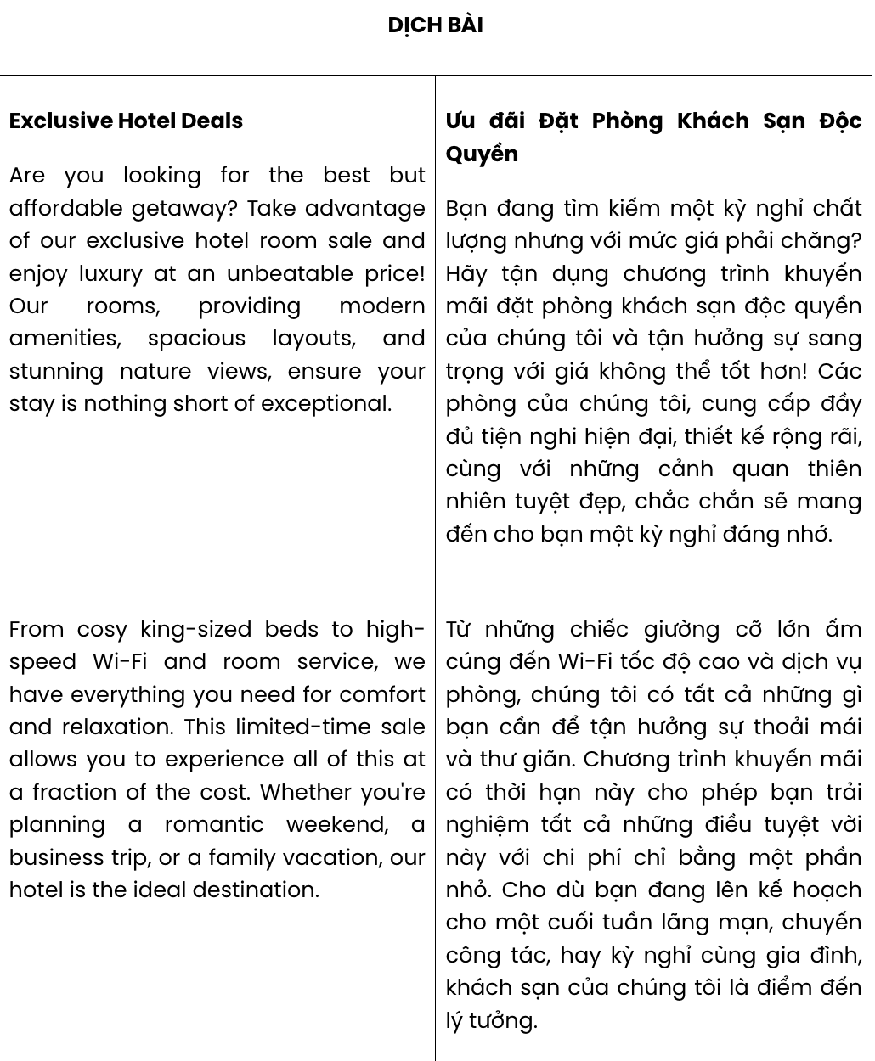
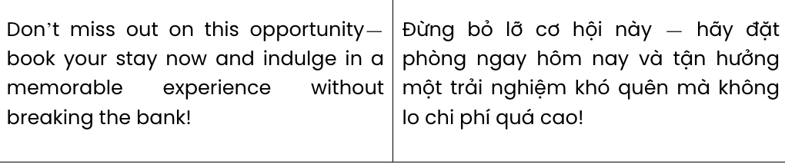
GIẢI CÂU 1:
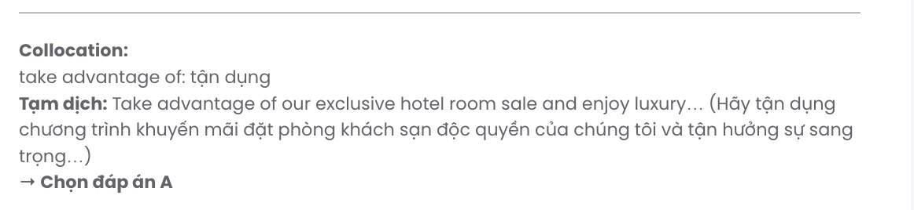
GIẢI CÂU 2:
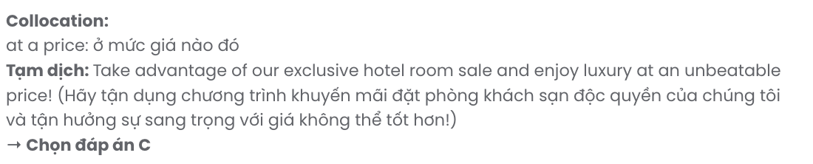
GIẢI CÂU 3:
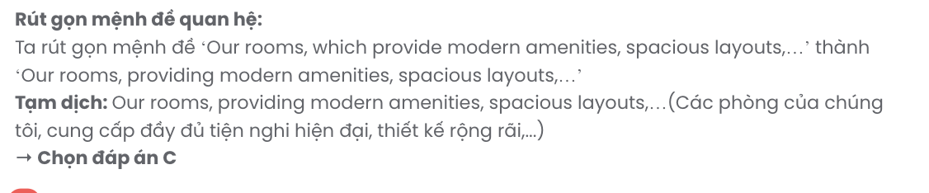
GIẢI CÂU 4:
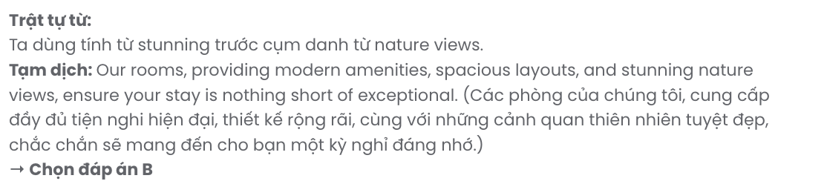
GIẢI CÂU 5:
GIẢI CÂU 3:
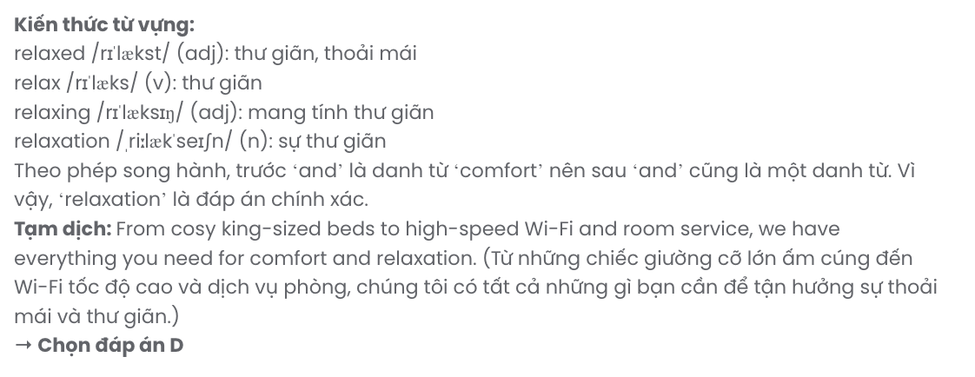
GIẢI CÂU 6:
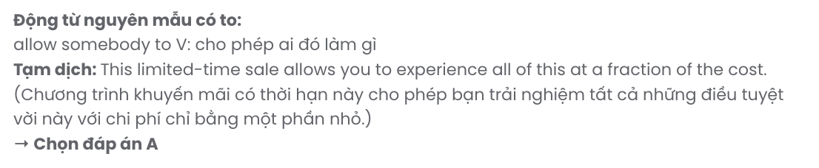
Read the following leaflet and mark the letter A, B, C or D on your answer sheet to indicate the option that best fits each of the numbered blanks from 7 to 12.

Outdoor Workout
Let’s discover how it is different from indoor exercise.

*L+◆* Facts about indoor routines:
- Doing indoor workouts can lead to boredom and (7) loss over time.
- The limited space and (8) nature of these exercises often make it difficult to stay engaged.
- Being indoors for long periods can contribute to feelings of restlessness and low energy.

+◆*L* And why should we (9) outdoor activities?
✔ Switch up your routine and boost your mood with fresh air and natural surroundings.
✔ Enjoy higher (10) of energy and vitamin D exposure from direct sunlight.
✔ Explore new parks, trails and (11) local places (12) getting a full-body workout.
✔ Connect with nature, which helps reduce stress and clear your mind.

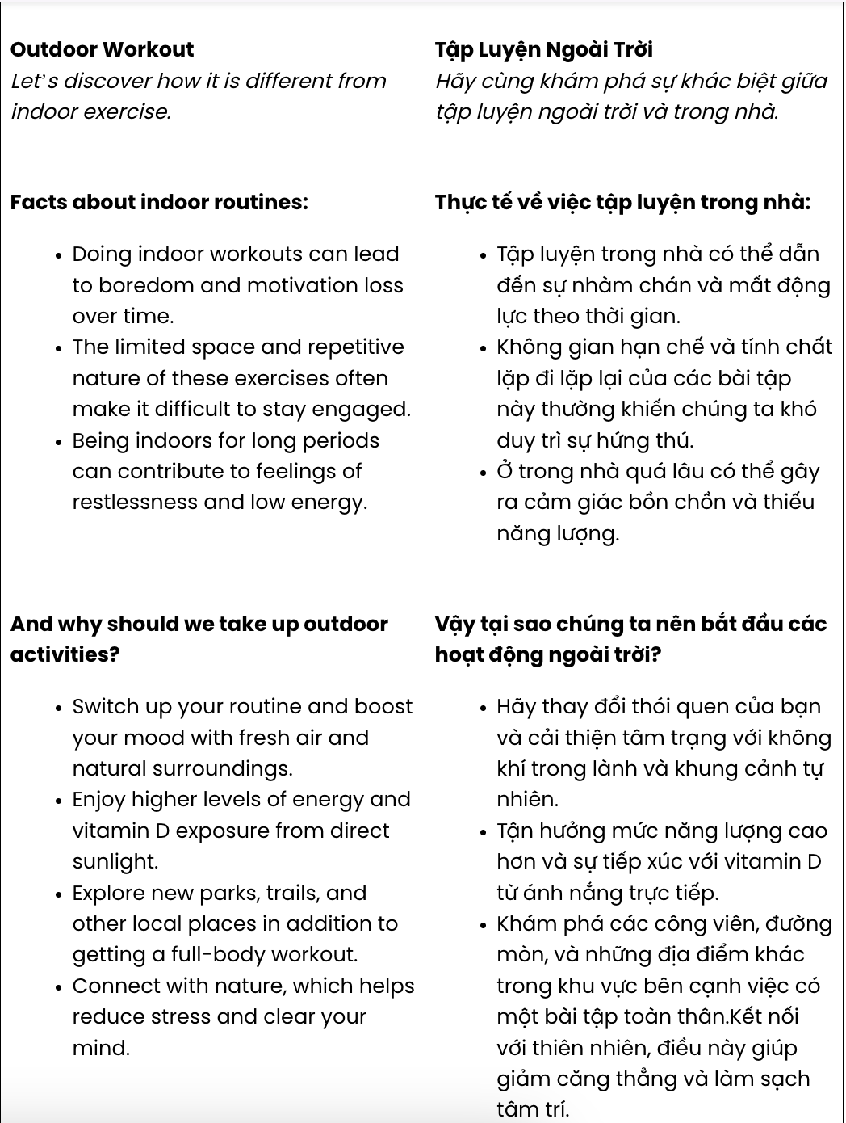

GIẢI CÂU 7:

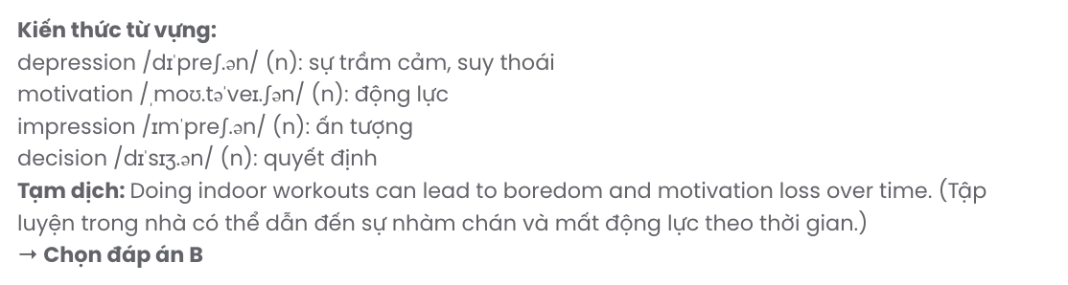
GIẢI CÂU 8:

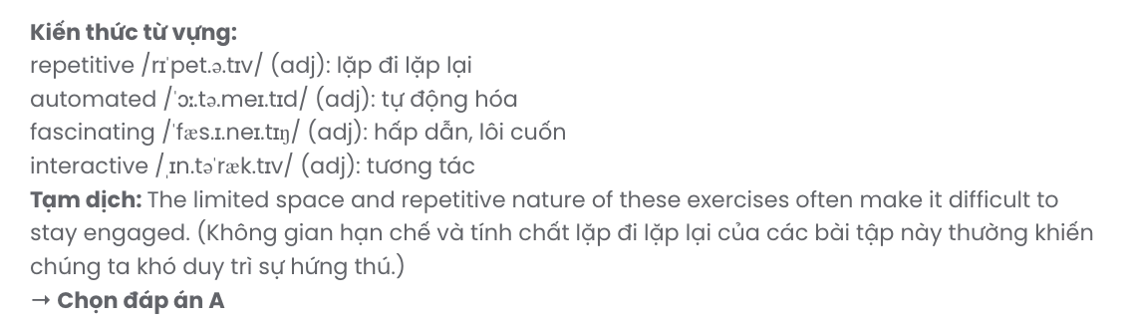
GIẢI CÂU 9:

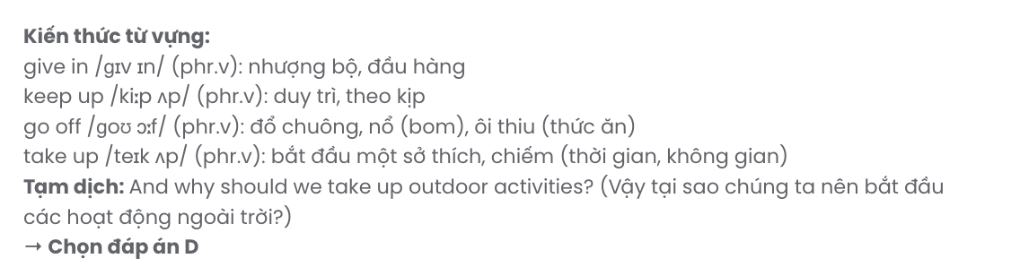
GIẢI CÂU 10:

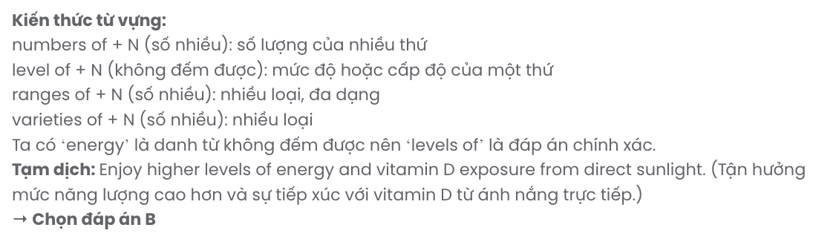

GIẢI CÂU 11:

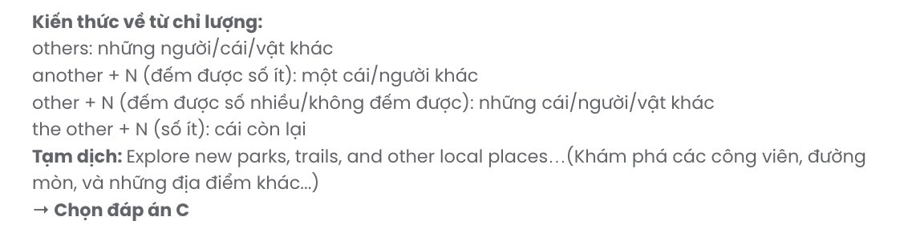
GIẢI CÂU 12:

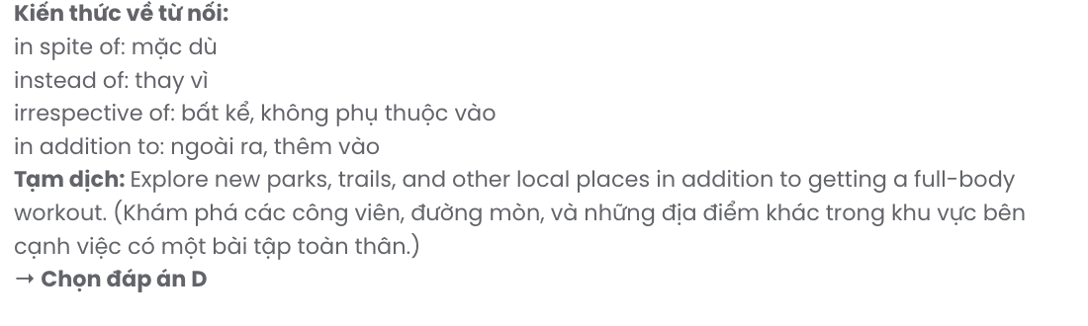

Question 7. | A. depression | B. motivation | C. impression | D. decision
Question 8. | A. repetitive | B. automated | C. fascinating | D. interactive
Question 9. | A. give in | B. keep up | C. go off | D. take up
Question 10. | A. numbers | B. levels | C. ranges | D. varieties
Question 11. | A. others | B. another | C. other | D. the other
Question 12. | A. in spite of | B. instead of | C. irrespective of | D. in addition to

Mark the letter A, B, C or D on your answer sheet to indicate the best arrangement of utterances or sentences to make a meaningful exchange of text in each of the following questions from 13 to 17.

Question 13.
- Mia: Hi, Alex! Crazy weather today, isn’t it?
- Mia: Thankfully, no. I managed to get home just before it started.
- Alex: Hey, Mia! Yeah, I wasn’t expecting this sudden rain. Did you get caught in it?
A. b – a – c B. b – c – a C. c – a – b D. a – c – b
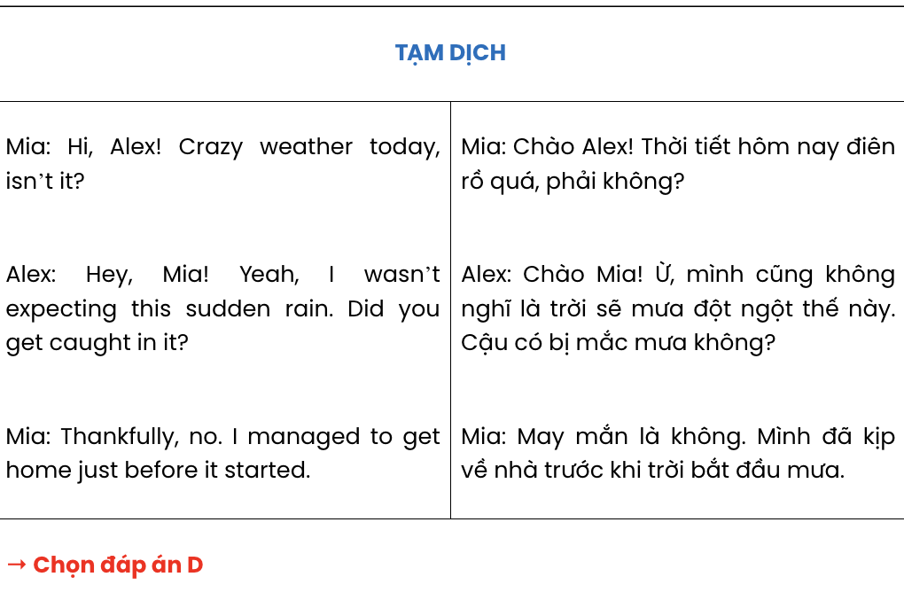

Question 14.
- Rachel: I got a job offer that was too good to pass up. It’s a great opportunity.
- Rachel: I’m excited but a little nervous about adjusting to a new place.
- Matt: That’s amazing! I bet you’ll adapt quickly. Good luck!
- Matt: How are you feeling about your upcoming move, Rachel?
- Matt: What made you decide to move?
A. d – a – c – b – e B. e – a – d – b – c C. c – b – d – a – e D. d – b – e – a – c
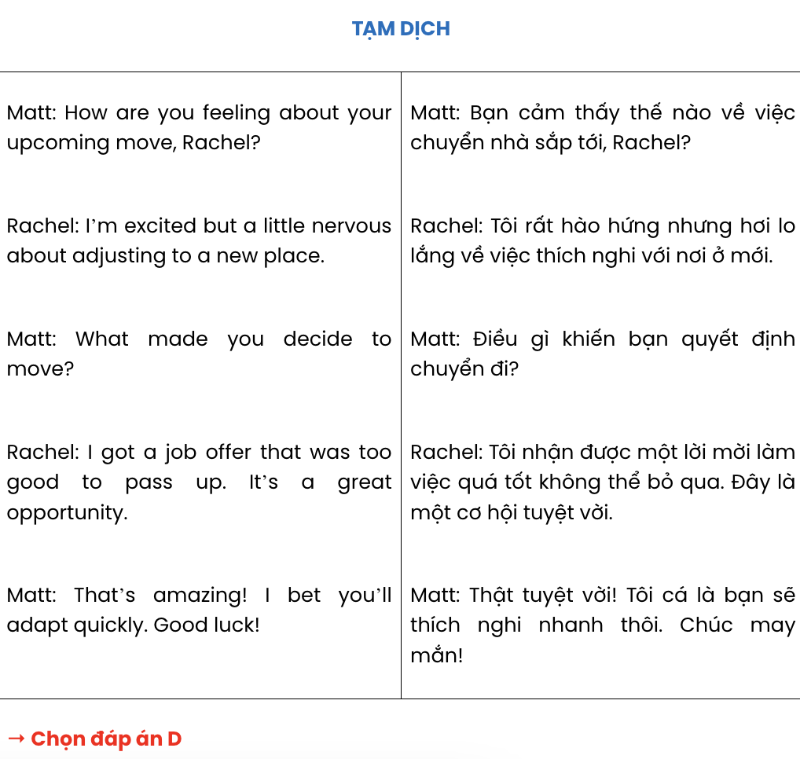

Question 15.
Hi Ben,
- You must feel excited now but I guess you may be also a little nervous about the move, aren't you?
- This is such amazing news, and I couldn’t be happier for you.
- I've recently heard that you got accepted into your dream university in London!
- Let me know if you’d like to catch up before you leave.
- How are you planning to celebrate this big achievement? Congrats again,
Laura
A. c – b – e – a – d B. c – a – e – b – d C. a – c – b – e – d D. c – e – b – d – a
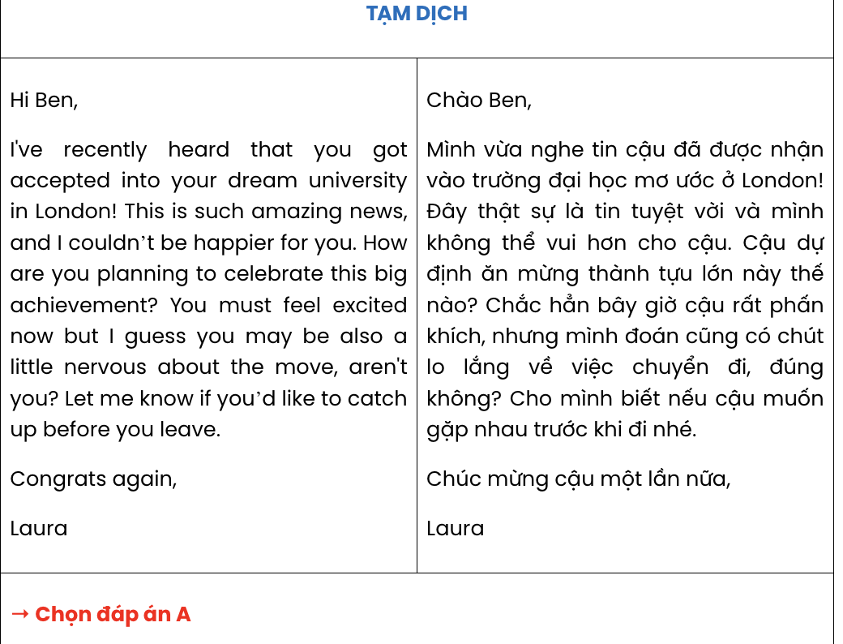

Question 16.
- Participating in team projects has taught me valuable lessons in collaboration and communication.
- However, there were still occasional conflicts, and we had to work together to reach a common agreement.
- When the project ended, I realised that these experiences had strengthened my teamwork skills and made me more adaptable.
- Working closely with others improved my ability to share ideas openly and listen to different perspectives.
- It was last month that I took part in a group project which required constant brainstorming and problem- solving.
A. d – e – a – c – b B. e – d – c – b – a C. a – e – c – b – d D. a – e – d – b – c

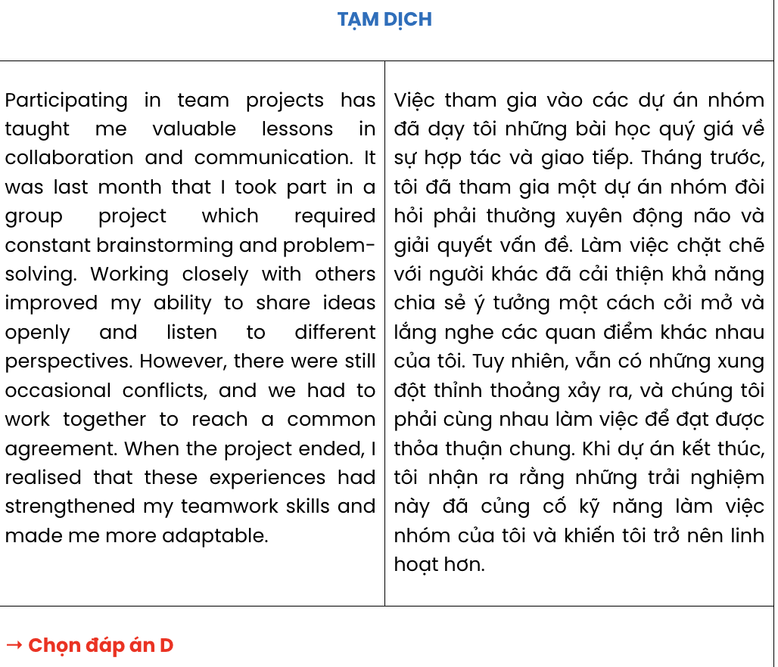

Question 17.
- The flood was a tragic event, yet it revealed the solidarity and compassion within the community.
- As houses and streets were submerged, residents came together to protect what belongings they could before evacuating.
- Due to the heavy rainfall, rivers overflowed, which caused widespread damage throughout the town.
- Community centres were soon transformed into shelters, providing temporary refuge and essential supplies for affected families.
- In 2017, the town of Clearwater was struck by devastating floods after days of relentless rain.
A. a – e – d – c – b B. e – c – b – d – a C. e – a – c – d – b D. e – b – d – a – c
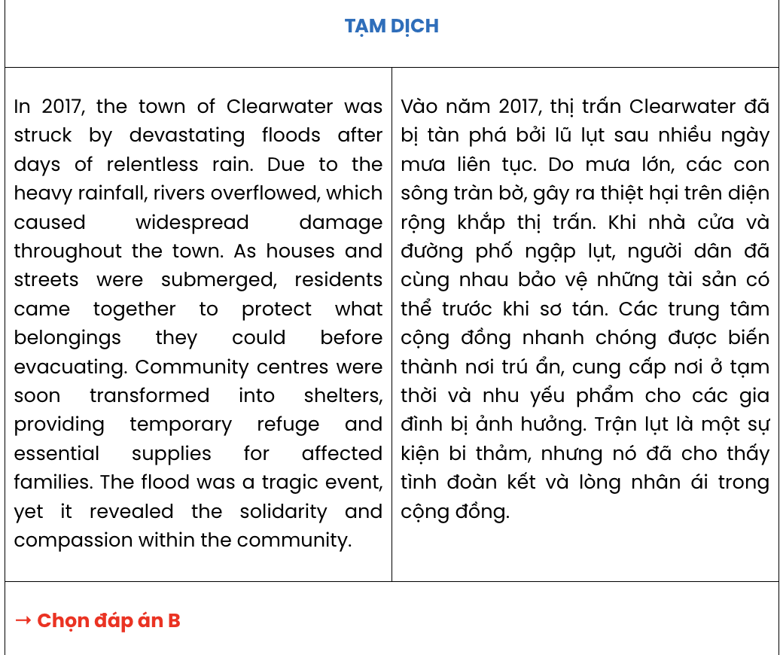
Read the following passage and mark the letter A, B, C, or D on your answer sheet to indicate the correct option that best fits each of the numbered blanks from 18 to 22.

The Amazon Rainforest Reserve: A Natural Wonder Worth Protecting
The Amazon Rainforest Reserve, which stretches across multiple South American countries, (18)
. The dense vegetation and towering trees in the Amazon create a unique ecosystem (19) . This vast rainforest is also home to an extraordinary variety of wildlife, including jaguars, sloths, and countless bird species.
(20) . Conservation organisations, working alongside local communities, are implementing sustainable practices to reduce habitat loss and preserve biodiversity. Thanks to these ongoing concerted efforts, more and more parts of the rainforest are now being safeguarded, allowing ecosystems to recover and thrive. By preserving the Amazon Rainforest Reserve, (21) .
The Amazon Rainforest Reserve offers unique eco-tours that allow visitors to connect with nature unforgettably. Participating in these eco-tours, (22) . These guided tours not only promote environmental awareness but also contribute to the local economy, providing essential support for nearby communities.
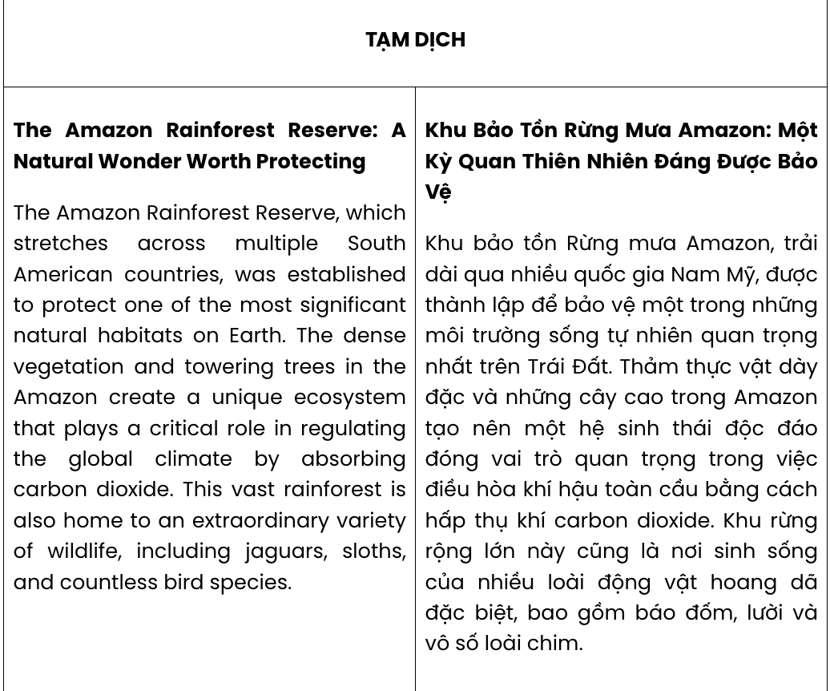
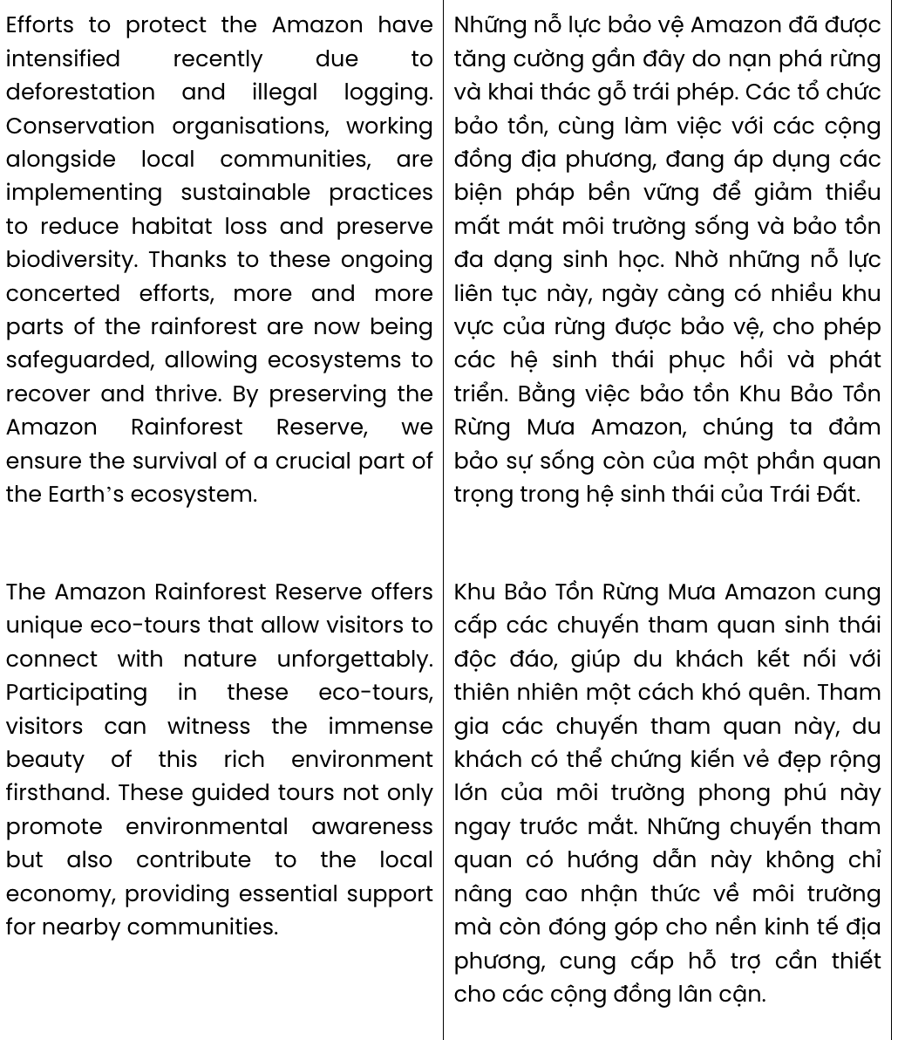

Question 18.
  - of which establishment aimed at the protection of the Earth's most significant natural habitats
  - established aiming to the protection of one of the most important natural habitats on Earth
  - was established to protect one of the most significant natural habitats on Earth
  - whose establishment and protection of the most significant natural habitats on Earth
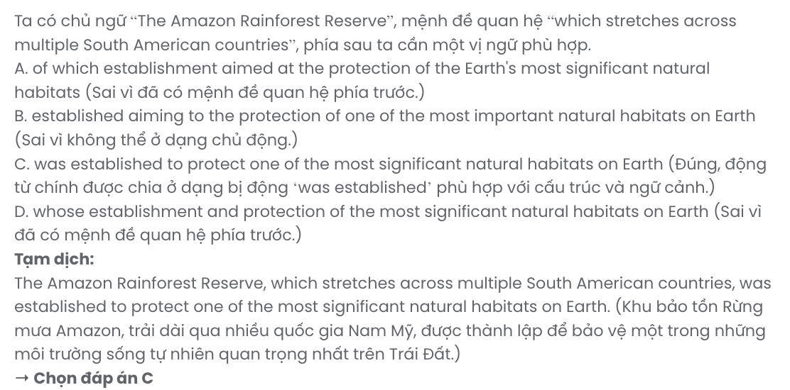

Question 19.
- that plays a critical role in regulating the global climate by absorbing carbon dioxide
- absorbs carbon dioxide so then plays a critical role in regulating the global climate
- thanks to its ability to absorb carbon dioxide, it contributes to regulating the climate worldwide
- is responsible for absorbing carbon dioxide by regulating the global climate

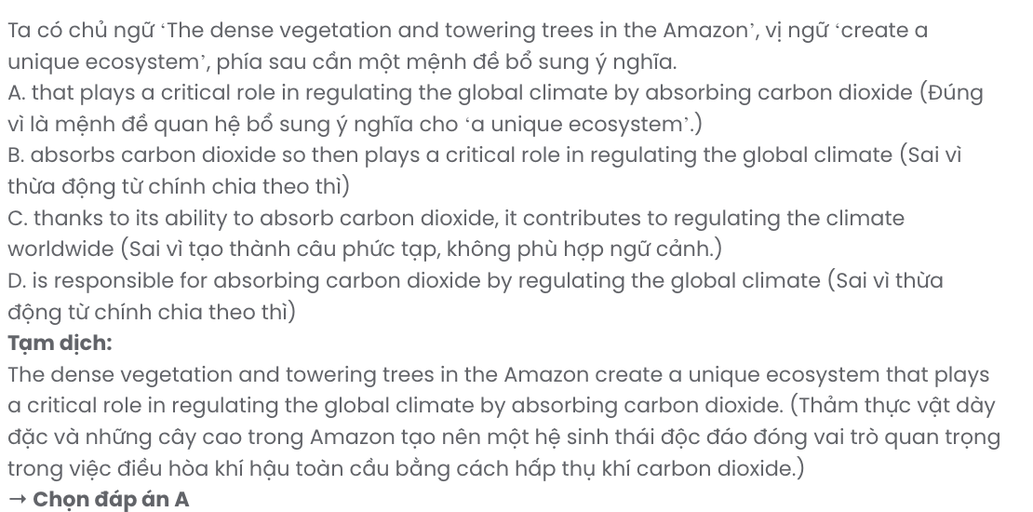

Question 20.
- Governments have yet to take practical measures despite illegal hunting and deforestation
- The introduction or invasion of some alien species into the Amazon has raised many worries
- There has been growing concern about extreme weather events in the Amazon in recent years
- Efforts to protect the Amazon have intensified recently due to deforestation and illegal logging

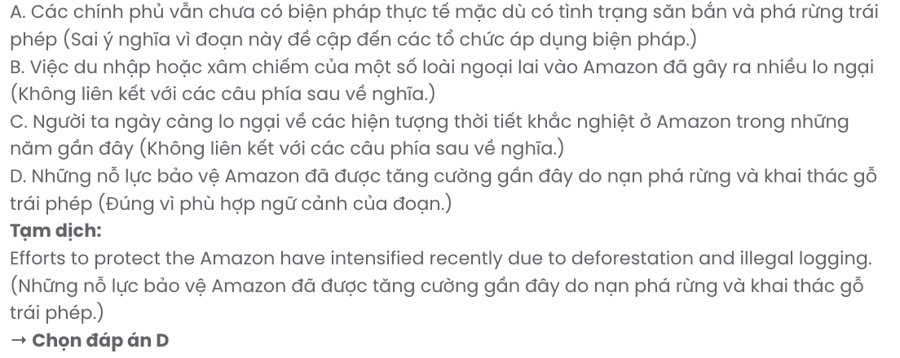

Question 21.
- we ensure the survival of a crucial part of the Earth’s ecosystem
- and ensuring that a crucial part of the Earth's ecosystem survive
- this crucial part of the Earth's ecosystem will no longer exist
- human activities negatively affect the biodiversity of the Earth's ecosystems

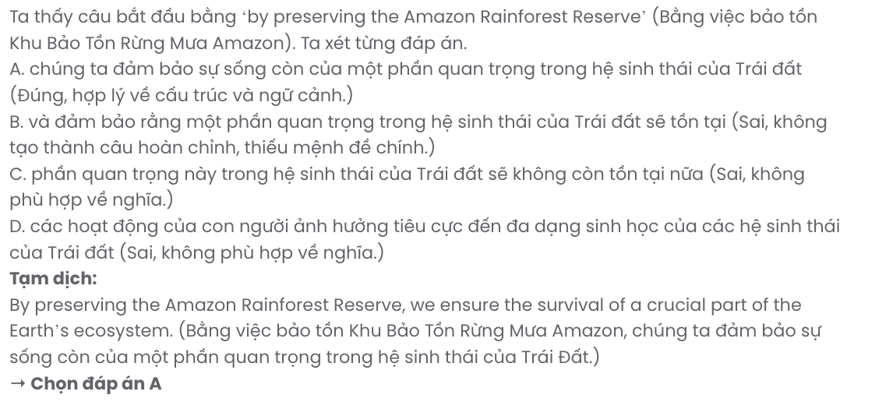

Question 22.
- visitors can witness the immense beauty of this rich environment firsthand
- it enables travellers to experience directly the beauty of the Amazon rainforest
- exploring a diverse ecosystem always brings thrilling experiences
- local people will guide visitors through areas with the richest flora and fauna
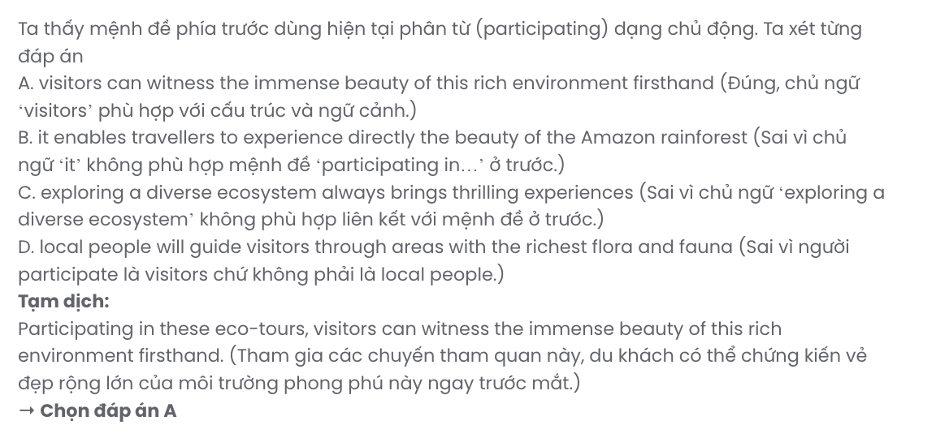
Read the following passage and mark the letter A, B, C, or D on your answer sheet to indicate the best answer to each of the following questions from 23 to 30.
Soft and hard skills are both crucial in various jobs. Soft skills are interpersonal and personal characteristics that help people interact effectively, while hard skills are specific abilities that can be measured and quantified.
In many professions, such as teaching, soft skills like communication, empathy, and patience are crucial. Teachers need to effectively communicate with students and colleagues to create a positive learning environment. Empathy helps teachers understand students' needs and concerns while patience helps them handle difficult situations calmly. In the business world, soft skills like communication and leadership are highly valued. Effective communication enables employees to convey ideas, collaborate, and build strong relationships with clients and colleagues. Leadership skills are necessary for guiding teams toward common goals.
In contrast, hard skills like subject knowledge, lesson planning, and classroom management are also essential for teachers. A solid understanding of the subject matter allows teachers to deliver accurate lessons. Effective lesson planning ensures that learning objectives are met, while strong classroom management skills help maintain discipline and order. Hard skills like medical knowledge, technical proficiency, and attention to detail are essential in healthcare. Healthcare professionals must have sufficient medical knowledge to diagnose and treat patients accurately. Technical proficiency in operating medical equipment ensures accurate diagnosis and treatment, while attention to detail is crucial for patient safety. Hard skills such as analytical thinking and project management are essential in business. Analytical thinking helps professionals analyze data and ensures effective budgeting.
In conclusion, both soft and hard skills are essential in different jobs. Both types of skills complement each other and are crucial for achieving excellence in various professions.
(Adapted from English Workbook 12 – iLearn Smart World)
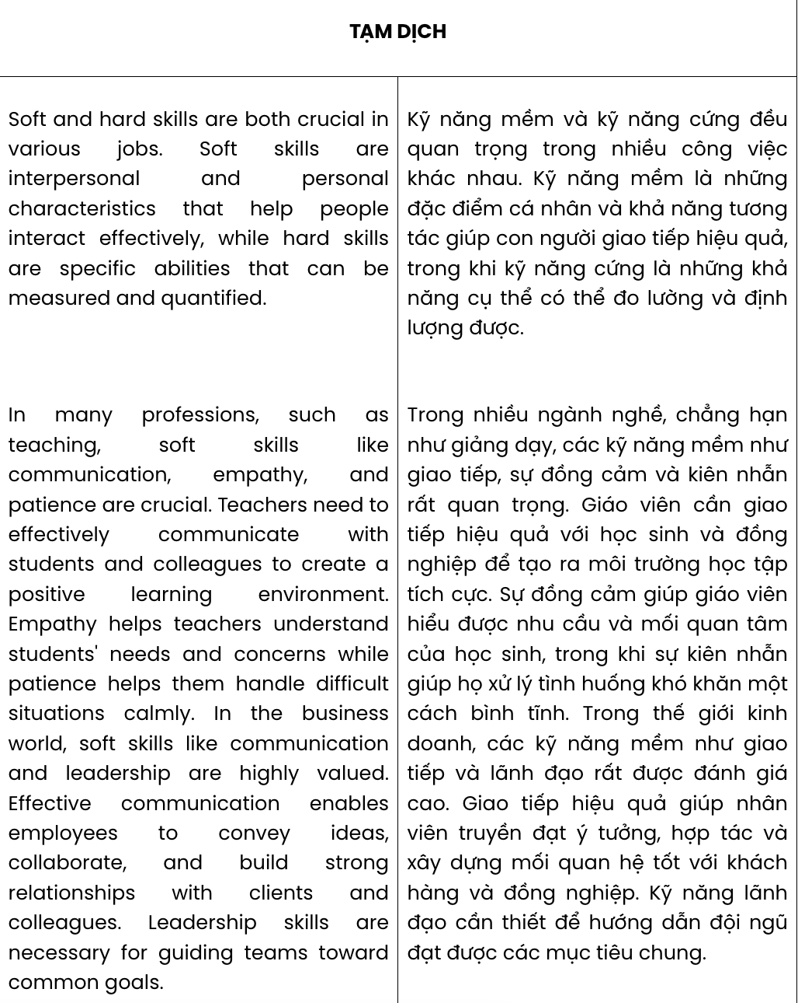
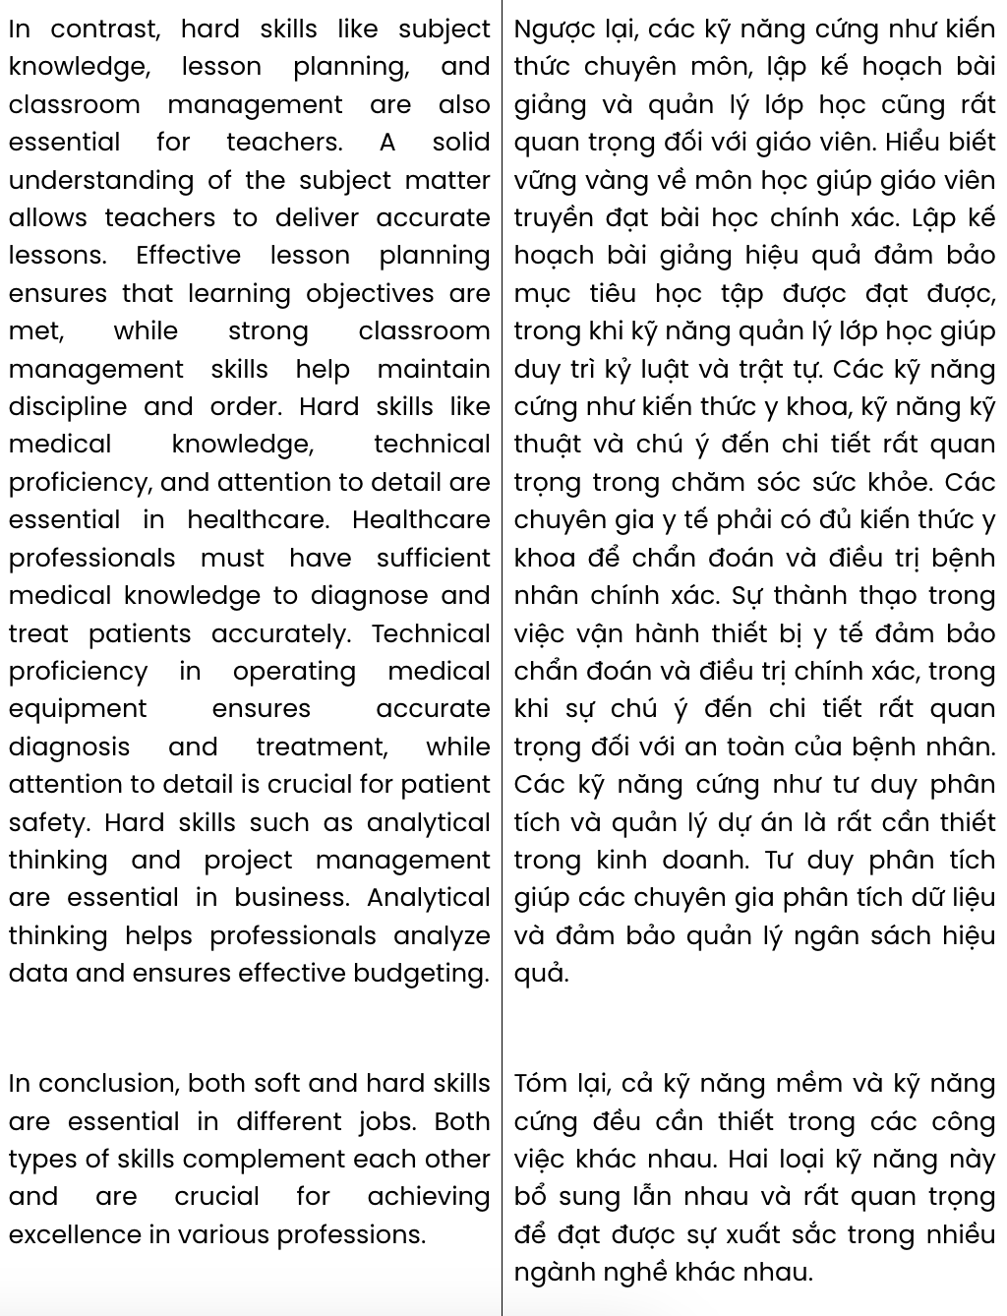
Question 23. Which of the following is NOT mentioned as one of the soft skills?
A. leadership B. communication C. patience D. teaching
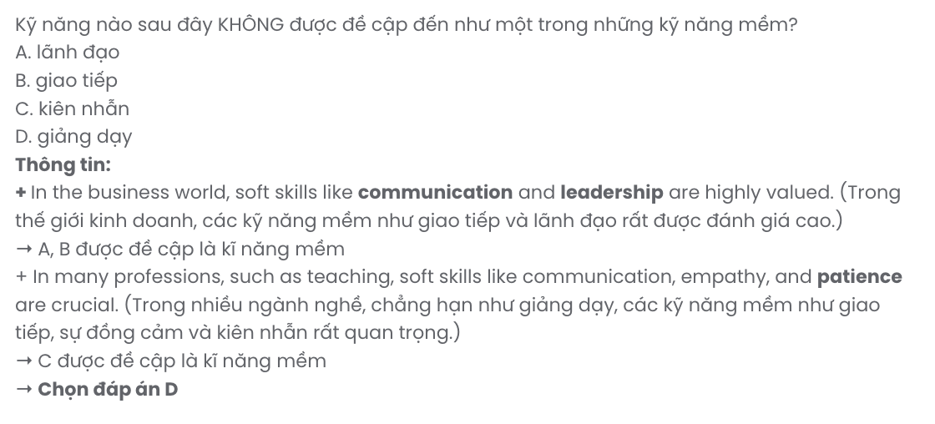
Question 24. The word solid in paragraph 3 is OPPOSITE in meaning to .
A. strong B. increased C. unreliable D. doubtful
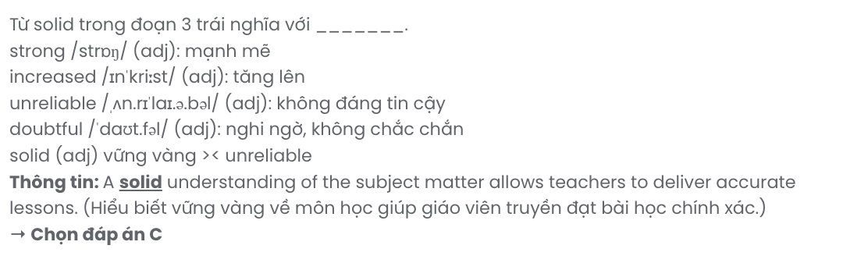
Question 25. The word them in paragraph 2 refers .
A. needs B. teachers C. students D. colleagues
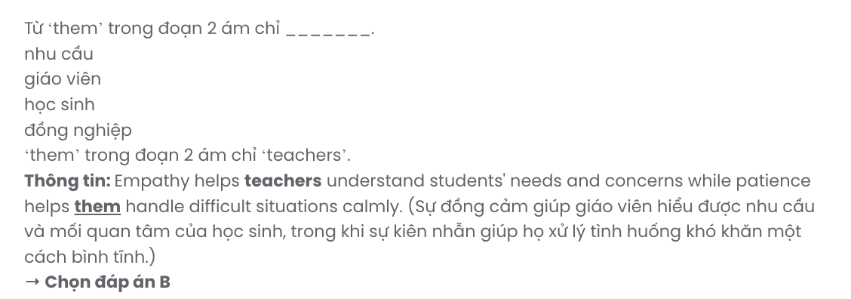
Question 26. The word convey in paragraph 2 can be best replaced by .
A. conduct B. respect C. express D. brainstorm
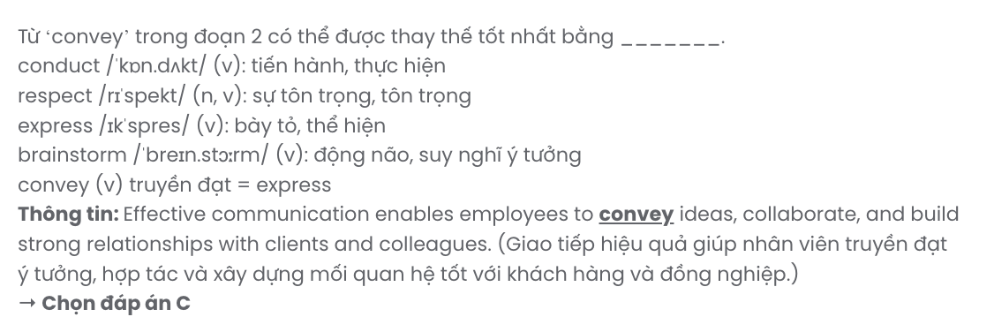
Question 27. Which of the following best paraphrases the underlined sentence in paragraph 3? Healthcare professionals must have sufficient medical knowledge to diagnose and treat patients accurately.
- Proper diagnosis and treatment require medical workers to have adequate medical expertise.
- To examine and treat patients better, medical staff must have excellent soft skills.
- Medical workers must learn all life long to keep their knowledge up to date and improve skills.
- Full medical knowledge is the most basic requirement of every healthcare employee.

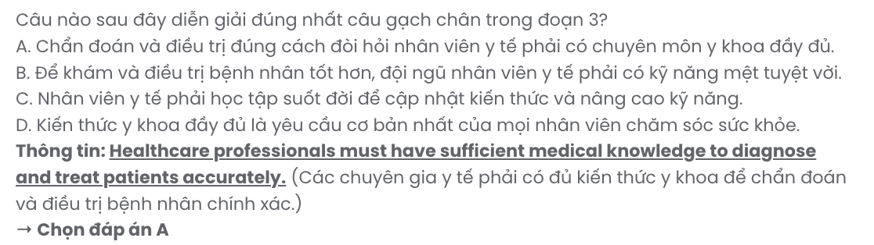
Question 28. Which of the following is TRUE according to the passage?
- In some professions, like healthcare, hard skills are more important than soft skills.
- All doctors and nurses are required to be proficient in the use of medical equipment.
- Analytical thinking helps workers work better with information, numbers and finances.
- If teachers manage the class poorly, male students will be more likely to misbehave.
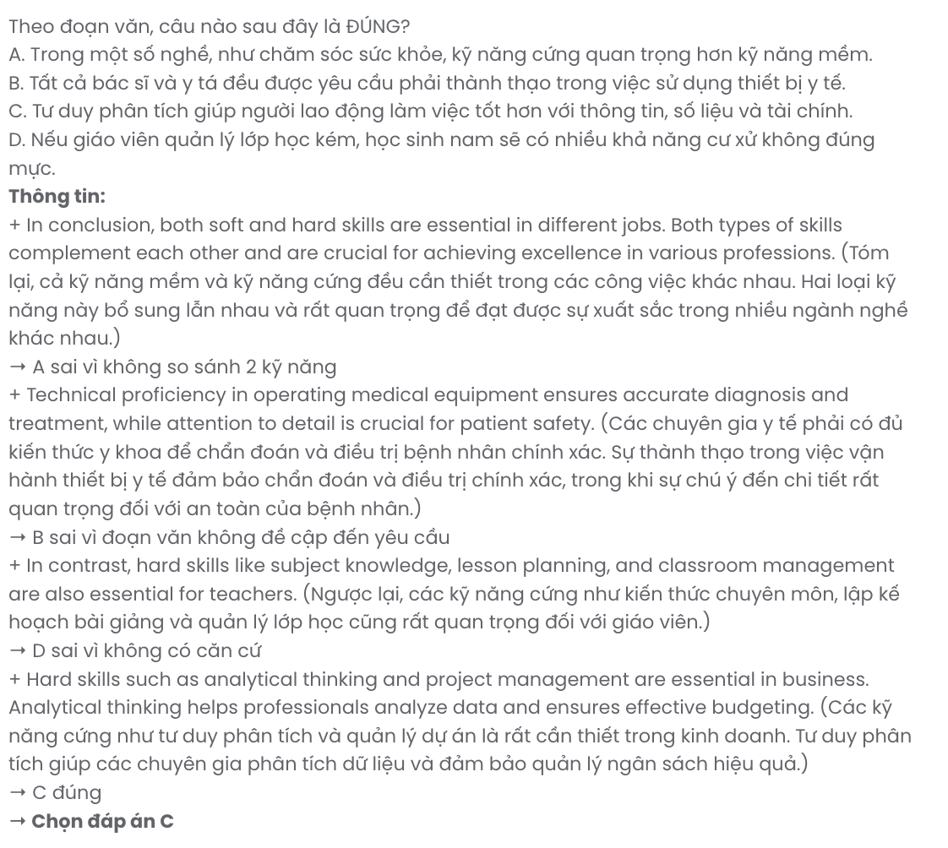

Question 29. In which paragraph does the author draw a comparison between soft skills and hard skills?
A. Paragraph 1 B. Paragraph 2 C. Paragraph 3 D. Paragraph 4
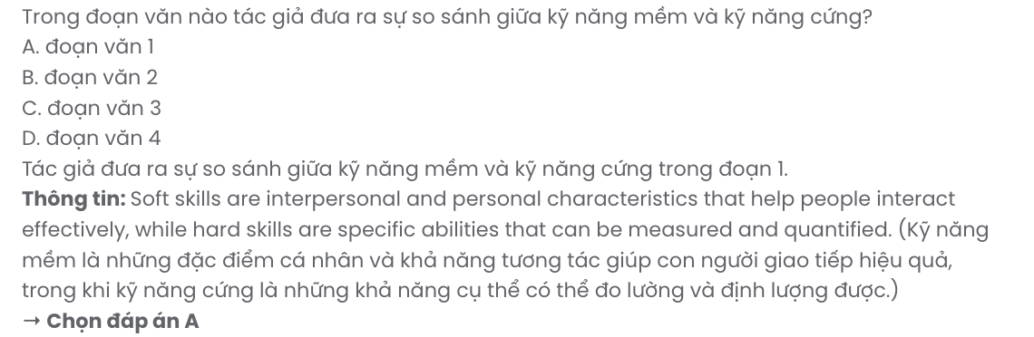
Question 30. In which paragraph does the author mention the connection between hard skills and soft skills?
A. Paragraph 1 B. Paragraph 2 C. Paragraph 3 D. Paragraph 4
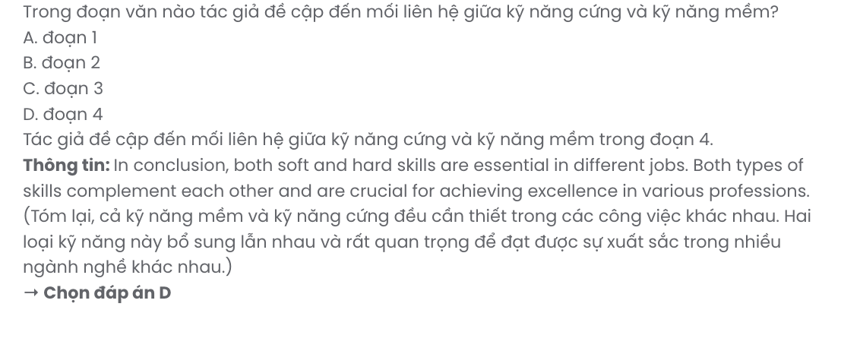
Read the following passage and mark the letter A, B, C, or D on your answer sheet to indicate the best answer to each of the following questions from 31 to 40.

Biomass Fuel And Tidal Energy
Biomass is material that comes from trees, recycled paper, animal waste, food waste and some crops, such as corn, soy and sugar cane. In other words, most kinds of produce waste can be converted to biomass fuel.
The biomass is dried and then burnt as biomass fuel to create heat or generate electricity. Biomass fuel is easy to store for use when we need it. However, burning biomass produces carbon dioxide, a greenhouse gas, so it is not completely environmentally friendly. The good news is that biomass fuel is carbon neutral because it only releases the same amount of carbon into the atmosphere as the plants, the source of biomass fuel, absorb in their life cycle.
We can also make biofuel from biomass and use it to power vehicles. A reduction in emissions goes hand in hand with the use of biofuel. To illustrate, E5 petrol contains 95% of normal petrol and 5% of ethanol, a kind of biofuel; E5 really helps reduce carbon emissions from traffic. However, growing crops for biomass fuel uses a lot of land and is only renewable if we replant trees.
Tidal energy involves converting the energy of the waves in large bodies of water such as seas, oceans and lakes into electricity. [I] Similar to hydroelectricity, continuous ocean currents can turn huge turbines and generate electricity. [II] Tidal power doesn't produce any greenhouse gases. It is a highly efficient form of energy because it can produce electricity continuously at all times of the year. [III] However, tidal power hasn't been popular yet because it requires huge investments, effective management and regular maintenance. [IV]
(Adapted from English Workbook 12 – Bright)
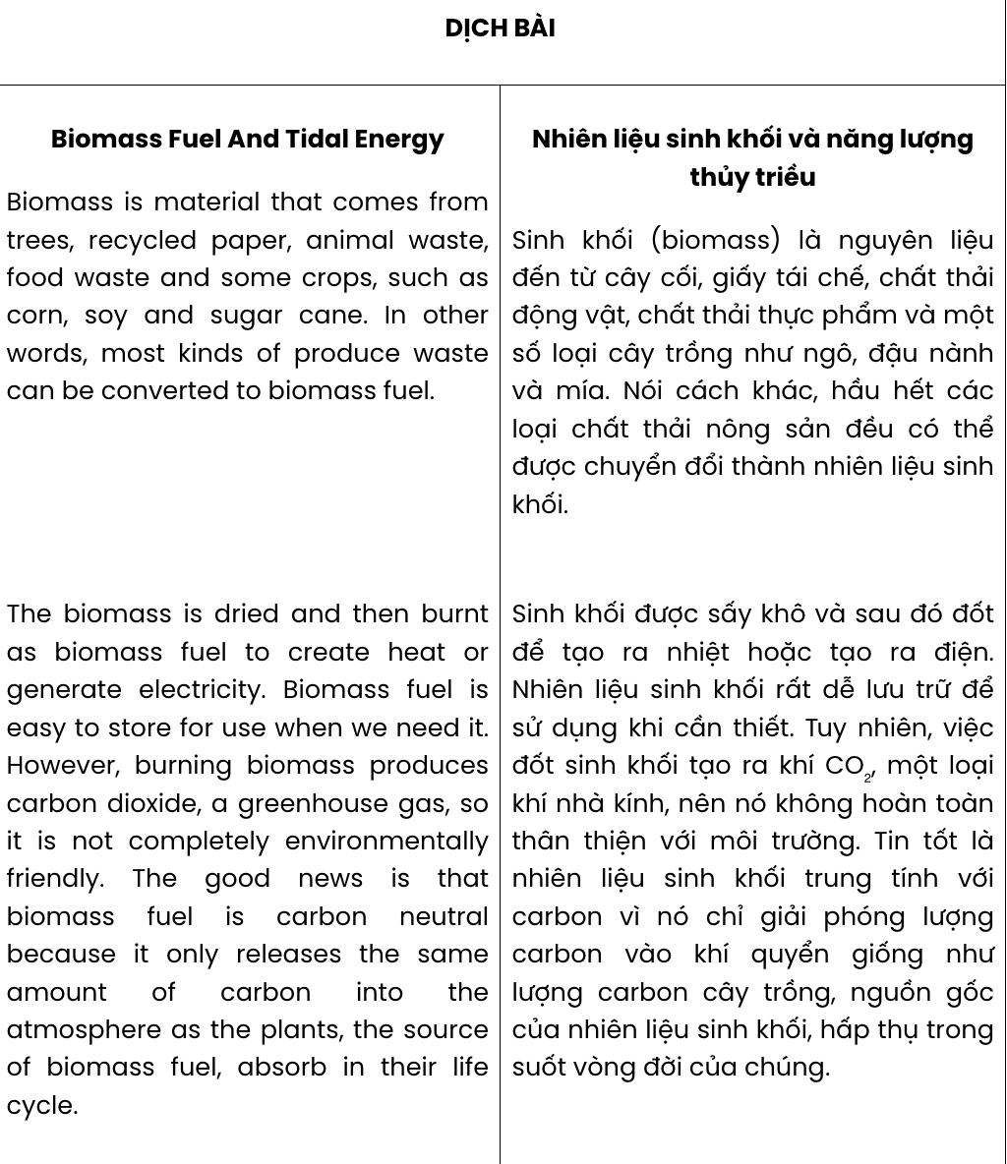
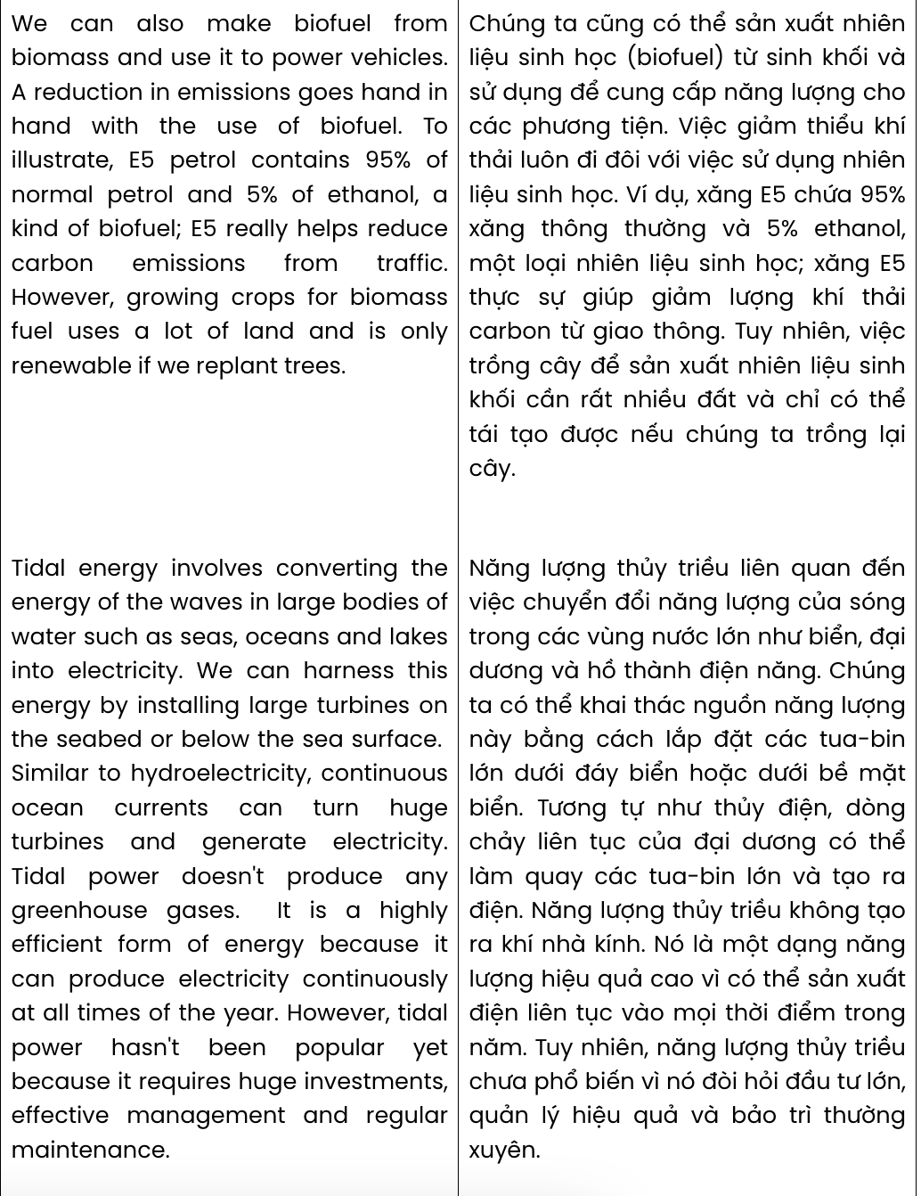
Question 31. Where in paragraph 4 does the following sentence best fit?

We can harness this energy by installing large turbines on the seabed or below the sea surface.
A. [I] B. [II] C. [III] D. [IV]
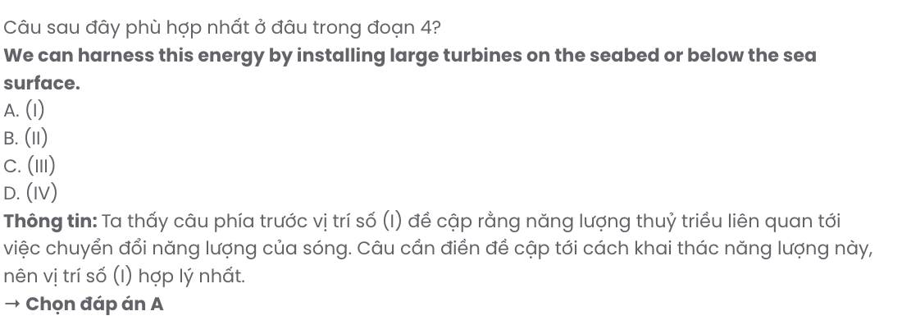
Question 32. The phrase goes hand in hand with in paragraph 3 could be best replaced by .
A. leads to B. makes up C. gets by D. results from
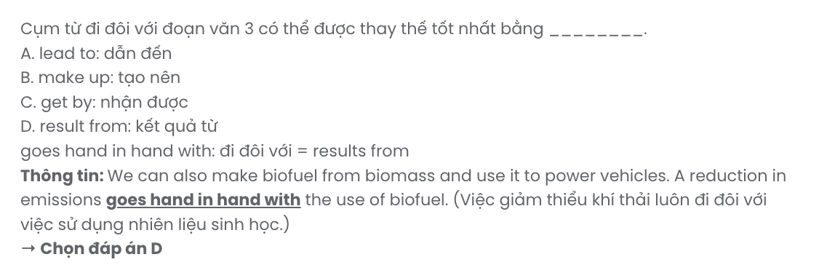
Question 33. The word it in paragraph 2 refers to .
A. greenhouse gas B. good news C. biomass fuel D. carbon
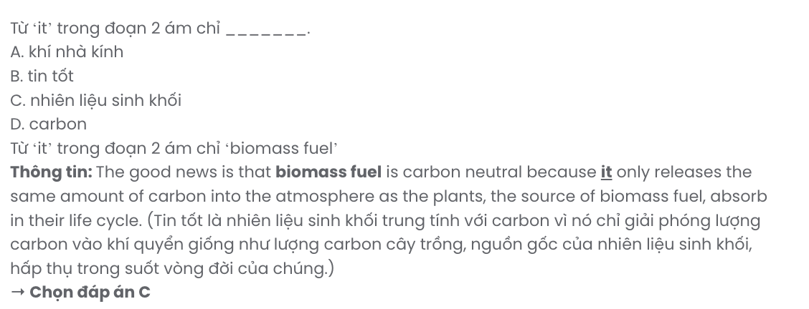
Question 34. Which of the following is NOT mentioned as one of the features of biomass fuel?
- It is carbon neutral. B. It can directly provide energy for vehicles.
C. It can used to generate electricity. D. It is made from produce waste.

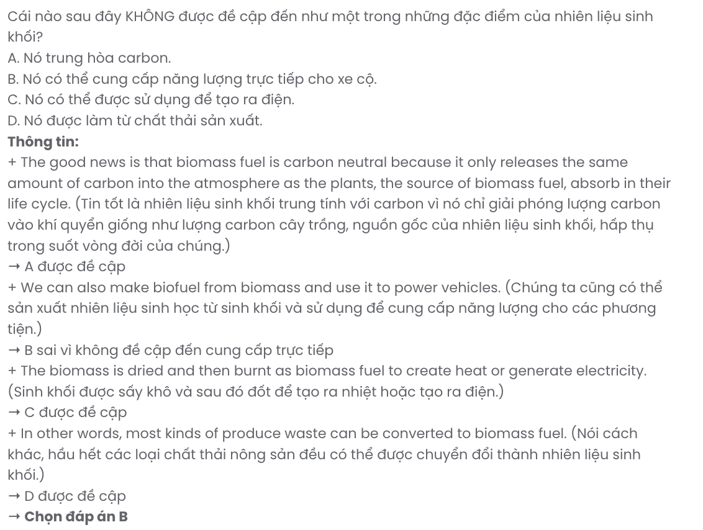
Question 35. Which is the following best summarises paragraph 2?
A. Despite its negative environmental impacts, biomass helps reduce agricultural waste.
B. Biomass fuel, a product of biomass, is carbon neutral and can be stored or burnt to generate energy.
C. Biomass, or biomass fuel, is not environmentally friendly because it requires plants to produce.
D. We can store biomass fuel that can generate energy but contributes to air pollution.
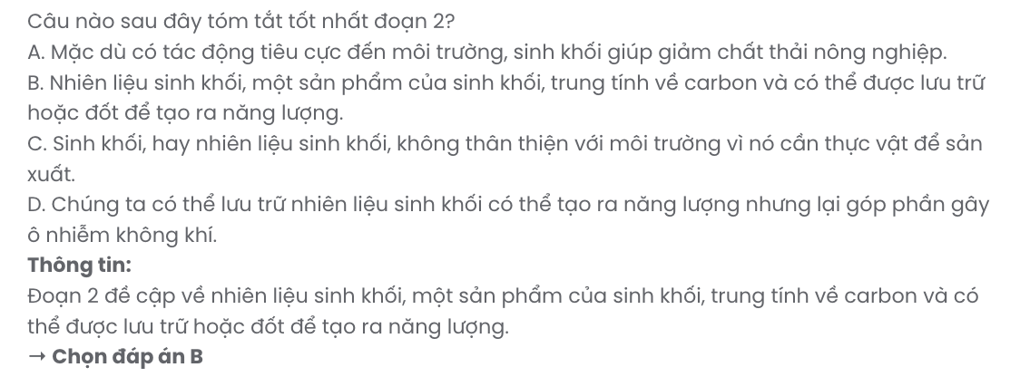
Question 36. The word regular in paragraph 4 is OPPOSITE in meaning to .
A. fluent B. relevant C. permanent D. infrequent
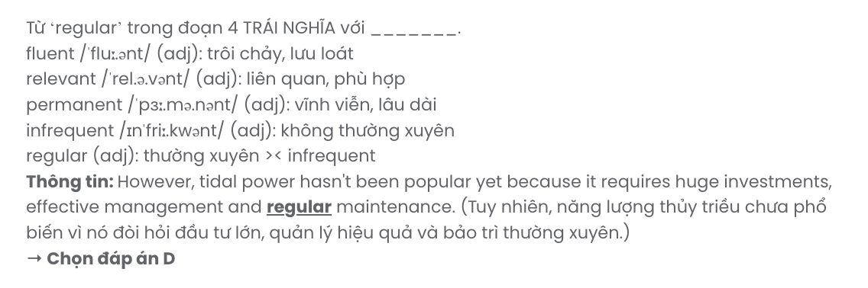
Question 37. Which of the following is TRUE according to the passage?
A. Tidal energy is obtained from the movement of waves and the flow of rivers.
B. Vehicles powered by biofuel can create less environmental impact.
C. When burned, biomass fuel releases less CO2 than the trees, its source, take in.
D. Tidal energy emits smaller amounts of greenhouse gases compared to other sources.
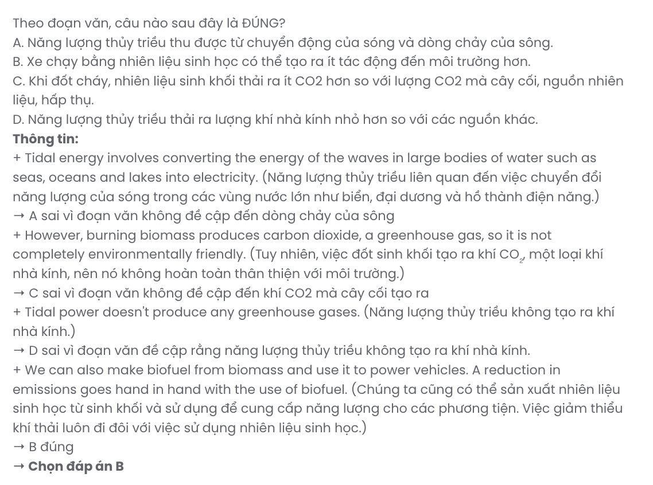
Question 38. Which of the following best paraphrases the underlined sentence in paragraph 5?

It is a highly efficient form of energy because it can produce electricity continuously at all times of the year.
A. Able to generate electricity year-round without interruption, it’s a very efficient energy source.
B. This type of energy is effective only during peak seasons and fails to generate power continuously.
C. It can produce electricity all year round so it is a more efficient source of energy than other sources.
D. Despite producing electricity all year round, its efficiency and effectiveness are not very high.
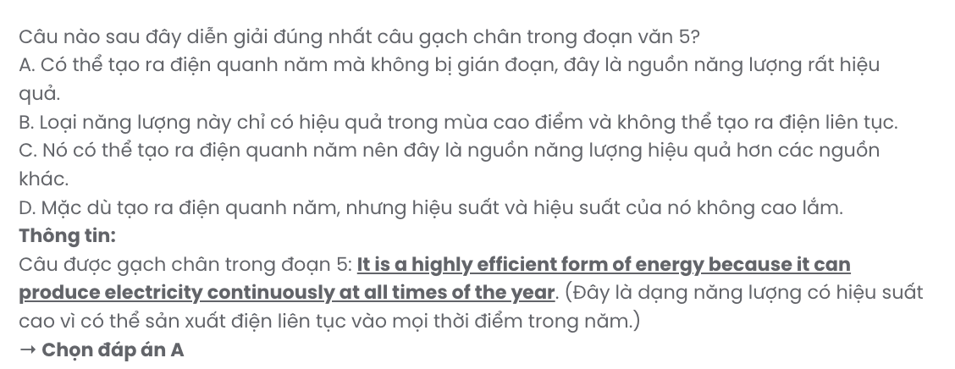
Question 39. Which of the following can be inferred from the passage?
A. No energy source is completely renewable or environmentally friendly.
B. Biomass not only helps solve energy problems but also industrial waste.
C. Tidal energy outperforms biomass energy in terms of efficiency.
D. The exploitation of tidal energy requires substantial resources.
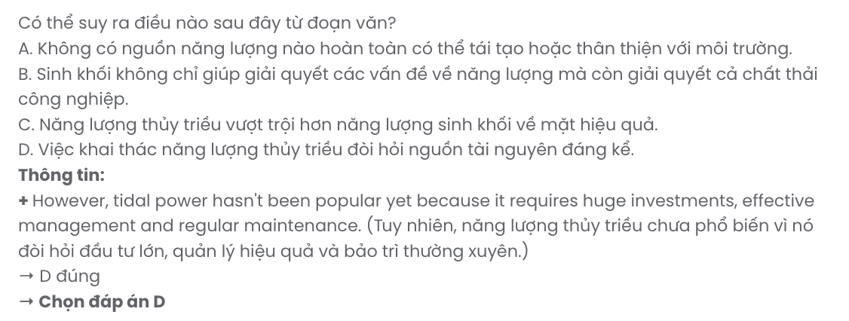
Question 40. Which of the following best summarises the passage?
A. Biomass fuel and tidal energy require minimal land and investment, making them easy to implement globally.
B. Biomass fuel and tidal energy are two of the most effective renewable sources, generating electricity with little environmental impact.
C. Tidal power and biomass fuel are considered to be able to solve current environmental and waste problems.
D. Biomass and tidal energy are renewable sources, but both remain challenges regarding the environment or investment.

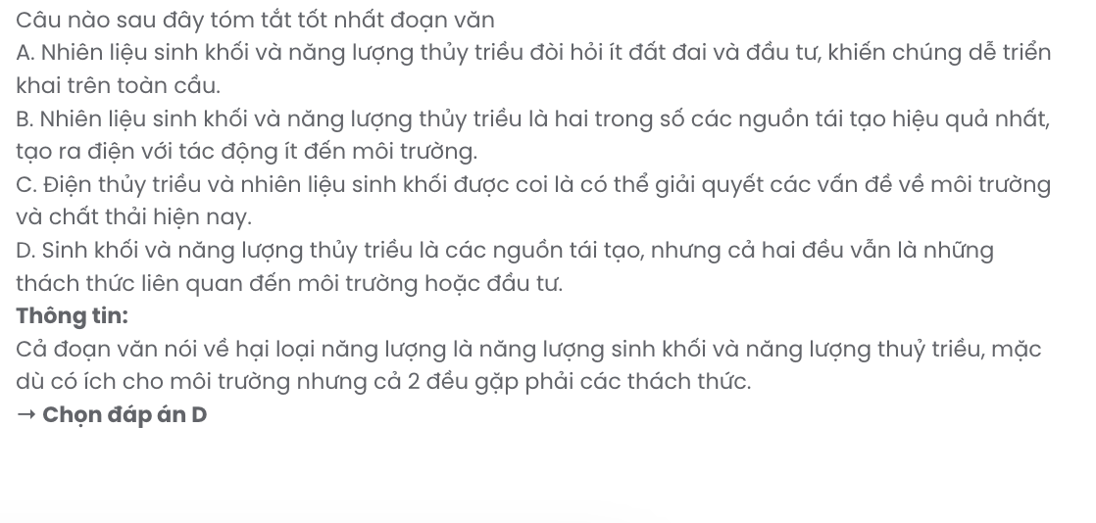

BẢNG TỪ VỰNG
STT | Từ vựng | Từ loại | Phiên âm | Nghĩa
1 | affordable | adj | /əˈfɔːrdəbl/ | phải chăng, vừa túi tiền
2 | advantage | n | /ədˈvæntɪdʒ/ | lợi thế
3 | exclusive | adj | /ɪkˈskluːsɪv/ | độc quyền, dành riêng
4 | unbeatable | adj | /ʌnˈbiːtəbl/ | không thể đánh bại
5 | amenity | n | /əˈmenəti/ | tiện nghi
6 | spacious | adj | /ˈspeɪʃəs/ | rộng rãi
7 | ensure | v | /ɪnˈʃʊr/ | đảm bảo
8 | exceptional | adj | /ɪkˈsepʃənl/ | xuất sắc, đặc biệt
9 | indulge | v | /ɪnˈdʌldʒ/ | nuông chiều, thưởng thức
10 | stunning | adj | /ˈstʌnɪŋ/ | tuyệt đẹp
11 | indoor | adj | /ˈɪndɔːr/ | trong nhà
12 | boredom | n | /ˈbɔːrdəm/ | sự buồn chán
13 | repetitive | adj | /rɪˈpetətɪv/ | lặp đi lặp lại
14 | restlessness | n | /ˈrestləsnəs/ | sự bồn chồn
15 | workout | n | /ˈwɜːrkaʊt/ | buổi tập luyện
16 | collaboration | n | /kəˌlæbəˈreɪʃən/ | sự hợp tác
17 | communication | n | /kəˌmjuːnɪˈkeɪʃən/ | sự giao tiếp
18 | brainstorming | n | /ˈbreɪnstɔːrmɪŋ/ | động não
19 | problem-solving | n | /ˈprɑːbləm ˈsɑːlvɪŋ/ | giải quyết vấn đề
20 | perspective | n | /pərˈspektɪv/ | quan điểm
21 | occasional | adj | /əˈkeɪʒənəl/ | thỉnh thoảng
22 | adaptable | adj | /əˈdæptəbl/ | có thể thích nghi
23 | relentless | adj | /rɪˈlentləs/ | không ngừng nghỉ
24 | widespread | adj | /ˈwaɪdspred/ | lan rộng, phổ biến
25 | reveal | v | /rɪˈviːl/ | tiết lộ
26 | establish | v | /ɪˈstæblɪʃ/ | thành lập
27 | extraordinary | adj | /ɪkˈstrɔːrdəneri/ | phi thường
28 | recover | v | /rɪˈkʌvər/ | hồi phục
29 | thrive | v | /θraɪv/ | phát triển mạnh
30 | unforgettably | adv | /ˌʌnfərˈɡetəbli/ | một cách khó quên
31 | essential | adj | /ɪˈsenʃl/ | cần thiết
32 | nearby | adj/adv | /ˌnɪrˈbaɪ/ | gần đây, ở gần
33 | crucial | adj | /ˈkruːʃl/ | quan trọng
34 | interpersonal | adj | /ˌɪntərˈpɜːrsənl/ | giữa các cá nhân
35 | characteristic | n/adj | /ˌkærəktəˈrɪstɪk/ | đặc điểm; tiêu biểu
36 | measure | v/n | /ˈmeʒər/ | đo lường; biện pháp
37 | empathy | n | /ˈempəθi/ | sự đồng cảm

38 | objective | n/adj | /əbˈdʒektɪv/ | mục tiêu; khách quan
39 | proficiency | n | /prəˈfɪʃənsi/ | sự thành thạo
40 | biomass | n | /ˈbaɪəʊmæs/ | sinh khối
41 | material | n | /məˈtɪriəl/ | vật liệu; vật chất
42 | convert | v | /kənˈvɜːrt/ | chuyển đổi
43 | generate | v | /ˈdʒenəreɪt/ | tạo ra
44 | atmosphere | n | /ˈætməsfɪr/ | bầu không khí
45 | reduction | n | /rɪˈdʌkʃən/ | sự giảm
46 | renewable | adj | /rɪˈnuːəbl/ | có thể tái tạo
47 | replant | v | /ˌriːˈplænt/ | trồng lại
48 | fluent | adj | /ˈfluːənt/ | trôi chảy
49 | relevant | adj | /ˈreləvənt/ | liên quan
50 | permanent | adj | /ˈpɜːrmənənt/ | vĩnh viễn
51 | infrequent | adj | /ɪnˈfriːkwənt/ | không thường xuyên
52 | interruption | n | /ˌɪntəˈrʌpʃən/ | sự gián đoạn
53 | efficiency | n | /ɪˈfɪʃənsi/ | tính hiệu quả
54 | effective | adj | /ɪˈfektɪv/ | hiệu quả
55 | implement | v | /ˈɪmplɪment/ | triển khai
56 | maintenance | n | /ˈmeɪntənəns/ | sự bảo trì
57 | illustrate | v | /ˈɪləstreɪt/ | minh họa
58 | investment | n | /ɪnˈvestmənt/ | sự đầu tư

BẢNG CẤU TRÚC
STT | Cấu trúc | Nghĩa
1 | look for | tìm kiếm
2 | take advantage of | tận dụng
3 | allow somebody to V | cho phép ai làm gì đó
4 | miss out on | bỏ lỡ (cơ hội, lợi ích, trách nhiệm)
5 | be different from | khác biệt so với (cái gì hoặc ai đó)
6 | lead to something | dẫn đến, gây ra (kết quả hoặc hậu quả)
7 | make something + adj | làm cho cái gì đó trở nên như thế nào
8 | take up | bắt đầu một hoạt động hoặc sở thích mới
9 | switch up | thay đổi hoặc điều chỉnh (để làm mới hoặc cải thiện)
10 | connect with | kết nối, giao tiếp (với ai đó); cảm thấy gắn kết
11 | contribute to something | đóng góp, góp phần vào (cái gì đó)
12 | go hand in hand with | đi đôi với, có mối liên hệ mật thiết với (hai thứ xảy  ra hoặc tồn tại cùng nhau)

