School: ……………………………………….. | Date:……………………………………..
Class: ……………………………..................... | Period: …………………………….........

UNIT 2: HEALTH
Lesson 1.2 - Grammar (Page 13)

I. OBJECTIVES
By the end of the lesson, Ss will be able to:
1.1. Language knowledge and skills
- listen to 2 people asking and answering about eating pizza.
- use indefinite quantifiers to talk about how much people so something.
- review countable and uncountable nouns.
1.2. Competences
- improve speaking, listening skills.
- improve the use of English.
1.3. Attributes
- lead a healthy lifestyle and give up bad ones.

II. TEACHING AIDS AND LEARNING MATERIALS
1. Teacher’s aids: Student book and Teacher’s book, class CDs, Digital Book (DCR phần mềm tương tác SB, DHA (từ vựng/ cấu trúc) phần mềm trò chơi tương tác), projector/interactive whiteboard / TV (if any), PowerPoint slides, handouts.
2. Students’ aids: Student’s book, Workbook, Notebook.

III. ASSESSMENT EVIDENCE
Performance Tasks | Performance Products | Assessment Tools
- Listen and repeat.  - Circle the correct words.  - Look at the table and answer the questions.  - Ask your partner about the activities in task c. | - Ss’ performance.  - Ss’ answers.  - Ss’ answers.  - Ss’ answers/ presentation. | - T’s feedback.  - T’s feedback/Peers’ feedback.  - T’s feedback/Peers’ feedback.  - T’s observation, T’s feedback/Peers’ feedback.

IV. PROCEDURES
A. Warm up: (5’)
a) Objective: Introduce the new lesson and set the scene for Ss to acquire new language; get students' attention at the beginning of the class by enjoyable and short activities as well as to engage them in the follow-up steps.
b) Content: Reviewing countable and uncountable nouns / singular and plural nouns.
c) Expected outcomes: Ss review old grammar points which are very useful for them in the new lesson.
d) Organization of the activity:
TEACHER’S ACTIVITIES | STUDENTS’ ACTIVITIES
- Option 1: Countable and Uncountable nouns  - Give a list of some nouns, have Ss divide them into 2 groups: Countable and Uncountable nouns.  - Call Ss to give answers.  - Check Ss’ answers, give feedback.  *Noun list: pizza, exercises, water, junk food, cake, soda, salad, student, candy, juice  à Lead to the new lesson  - Option 2: Singular nouns and Plural nouns  - Give a list of some nouns, have Ss divide them into 2 groups: Singular nouns and Plural nouns.  - Call Ss to give answers.  - Check Ss’ answers, give feedback.  *Noun list: bananas, chocolate, carrots, milk, juice, apples, sandwiches, cheese, candies, cereal  à Lead to the new lesson. | - Work in groups.  - Read answers.  Answers keys  - Countable nouns: exercises, student, candy, cake  - Uncountable nouns: soda, water, salad, pizza, junk food, juice  - Work in groups.  - Read answers.  Answers keys  - Singular nouns: milk, chocolate, juice, cheese, cereal  - Plural nouns: bananas, carrots, apples, sandwiches, candies

B. New lesson (35’)
- Activity 1: Presentation (10’)
a) Objective: Introduce indefinite quantifiers.
b) Content:
- Listen and repeat.
- Go through the grammar point.
c) Expected outcomes: Ss know about indefinite quantifiers and use it in some exercises that follow.
d) Organization of the activity:
TEACHER’S ACTIVITIES | STUDENTS’ ACTIVITIES
Task a. Listen and repeat  - Have Ss look at the picture (using DCR).  - Play audio (CD1 – Track 14) and have Ss listen and read the speech bubbles.  - Play the audio again and have Ss listen and repeat.  Grammar box  - Option 1:  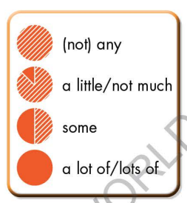  - Have Ss look at the grammar explanation (using DCR).  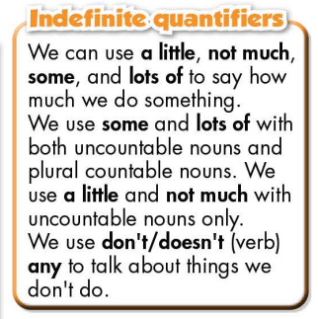  - Have Ss look at the box and read examples of different forms.  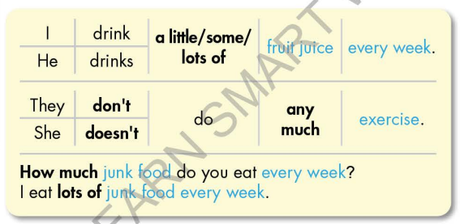  - Ask Ss to give more examples using indefinite quantifiers.  - Option 2:  - Have Ss close books.  - Show some model sentences (using DCR), ask Ss to look at the nouns in blue and decide which are countable and which are uncountable.  - Then have Ss pay attention to the bold words, make comment on the way they use the bold words with countable or uncountable nouns.  àIntroduce: indefinite quantifiers.  - Show grammar box, have Ss look and read.  - Ask Ss to make more examples using indefinite quantifiers.  - Give feedback and evaluation. | - Look.  - Listen, then read.  - Listen and repeat.  - Look and read.  - Read.  - Read examples of different forms.  - Give more examples.  - Close all books.  - Look and give answers.  - Give answers.  - Look and read.  - Give more examples.
- Activity 2: Practice (19’)
a) Objective: Students can use the indefinite quantifiers to do the given exercises.
b) Content:
- Circle the correct words.
- Look at the table and answer the questions.
c) Expected outcomes: Students can get used to the use of the indefinite quantifiers and use them correctly.
d) Organization of the activity:

TEACHER’S ACTIVITIES | STUDENTS’ ACTIVITIES
Task b. Circle the correct words  - Demonstrate the activity, using the example (using DCR).  - Have Ss read the sentences and circle the correct words.  - Have Ss work in pairs to check each other’s work.  - Have some Ss share their answers with the whole class.  - Give feedback, correct Ss’ answers if necessary.  Task c. Look at the table and answer the questions  - Demonstrate the activity, using the example (using DCR).  - Have Ss look at the table and answer the questions.  - Have Ss check answers with their partners.  - Call Ss to write answers.  - Check Ss’ answers, give feedback and evaluation. | - Look and listen.  - Work individually.  - Work in pairs.  - Read answers.  Answer keys  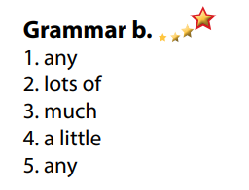  - Look and listen.  - Work individually.  - Work in pairs.  - Write answers.  Answer keys  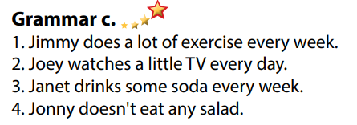

- Activity 3: Production (6’)
a) Objective: Students master the grammar point they study in the lesson.
b) Content: Speaking: Ask your partner about the activities in Task c.
c) Expected outcomes: Ss produce the new language successfully, and they can use indefinite quantifiers in everyday speaking and writing.
d) Organization of the activity:
TEACHER’S ACTIVITIES | STUDENTS’ ACTIVITIES
Task d. In pairs: Ask your partner about the activities in Task c  - Divide class into pairs.  - Have Ss take turns asking their partner about the activities in Task c.  - Have some pairs demonstrate the activity in front of the class.  - Give feedback and evaluation.  - For more practice, have Ss play a game with DHA. | - Have conversation in pairs.  - Present.  - Listen.

C. Consolidation and homework assignments (5’)
* Consolidation:
- Indefinite quantifiers: a little, not much, some, lots of / a lot of, not any.

* Homework:
- Make 3 sentences, use Indefinite quantifiers.
- Do the exercises in WB: Grammar (page 9).
- Complete the grammar notes in Tiếng Anh 7 i-Learn Smart World Notebook (page 11).
- Play consolation games in Tiếng Anh 7 i-Learn Smart World DHA App on www.eduhome.com.vn
- Prepare: Lesson 1 – Pronunciation and Speaking (page 14 – SB).

D. Reflection
a. What I liked most about this lesson today:
…………………………………………………………………………………………
- What I learned from this lesson today:
…………………………………………………………………………………………
c. What I should improve for this lesson next time:
…………………………………………………………………………………………

