School: ……………………………………….. | Date: ………………………………..
Class: ……………………………..................... | Period: ………………………..........

UNIT 9: ENGLISH IN THE WORLD
Lesson 4 – Review (pages 108, 109)

I. OBJECTIVES
By the end of the lesson, Ss will be able to:
1.1. Language knowledge and skills
- review words about tourism and culture (photos, sightseeing, wallet, historic, tour guide, flight, souvenirs, stadium, …) and talk about them.
- review grammar: Past Simple with irregular verb, articles (“the” and “zero article”).
- talk about tourist attractions, cultures and holiday in English-speaking countries.
- pronoun some vowels and consonants correctly: /ɪ/, /e/, /æ/, /ə, /ð /, / θ /.
- put stress on nouns with two and three syllables.
1.2. Competences
- improve speaking, listening, reading and writing skills.
- improve the use of English.
1.3. Attributes
- have positive attitude in English language learning so that they actively participate in all classroom activities.
- review the old lesson and have good preparation for any assessment.

II. TEACHING AIDS AND LEARNING MATERIALS
1. Teacher’s aids: Student book and Teacher’s book, class CDs, Digital Book (DCR phần mềm tương tác SB, DHA (từ vựng/ cấu trúc) phần mềm trò chơi tương tác), projector/interactive whiteboard / TV (if any), PowerPoint slides, handouts.
2. Students’ aids: Student’s book, workbook, notebook.

III. ASSESSMENT EVIDENCE
Performance Tasks | Performance Products | Assessment Tools
- Listening: You will hear Anna talking to her friend, Jamie, about her trip to the UK. Where's she going to visit on each day? For each question, write a letter (A – H) next to each day. You will hear the conversation twice. | - Ss’ answers. | - T’s feedback/Peers’ feedback.
- Reading: Read about the three people. Choose the correct answer (A, B, or C). | - Ss’ answers. | - T’s feedback/Peers’ feedback.
- Vocabulary: Fill in the blanks with the words in the box. | - Ss’ answers. | - T’s feedback/Peers’ feedback.
- Grammar: Fill in the blanks using the or Ø (zero article).  - Write sentences in the Past Simple using the prompts. | - Ss’ answers. | - T’s feedback/Peers’ feedback.
-Pronunciation: Circle the word that has the underlined part pronounced differently from the others.  + Circle the word that differs from the other three in the position of primary stress in each of the following questions. | - Ss’ answers/ presentation. | - T’s observation, T’s feedback/Peers’ feedback.

IV. PROCEDURES
A. Warm up: (5’)
a) Objective: Introduce the new lesson and set the scene for Ss to acquire new language; get students' attention at the beginning of the class by enjoyable and short activities as well as to engage them in the follow-up steps.
b) Content: Review: Past Simple with Irregular verbs / Review: Tourist Attractions in the UK.
c) Expected outcomes: Ss are ready for the new lesson.
d) Organization of the activity:
TEACHER’S ACTIVITIES | STUDENTS’ ACTIVITIES
- Option 1: Review: Past Simple with Irregular verbs.  - Have Ss review Past Simple with Irregular verbs by giving the past form of the verbs given.  1. make  2. take  3. come  4. see  5. go  6. buy  7. have  8. be  9. do  10. eat  11. meet  12. sell  13. lose  14. wear  - Give feedback.  - Lead to the new lesson.  - Option 2: Review: Tourist Attractions in the UK.  - Introduce Ss to some Tourist Attractions in the UK which are in their listening section.  - Lead to the new lesson.  *Illustration:  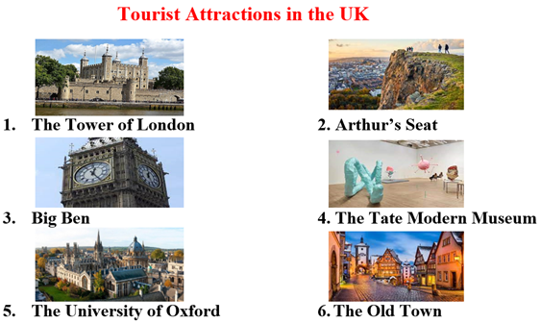 | - Give answers.  Answer keys  1. make - made  2. take - took  3. come - came  4. see - saw  5. go - went  6. buy - bought  7. have - had  8. be – was, were  9. do - did  10. eat - ate  11. meet - met  12. sell - sold  13. lose - lost  14. wear - wore  - Listen.  - Look.  - Listen.

B. New lesson (35’)
- Activity 1: Listening (7’)
a) Objective: Help Ss improve their listening skill.
b) Content:
- You will hear Anna talking to her friend, Jamie, about her trip to the UK. Where's she going to visit on each day? For each question, write a letter (A – H) next to each day. You will hear the conversation twice.
c) Expected outcomes: Ss listen in details and get familiar with the listening test format.
d) Organization of the activity:
TEACHER’S ACTIVITIES | STUDENTS’ ACTIVITIES
You will hear Anna talking to her friend, Jamie, about her trip to the UK. Where's she going to visit on each day? For each question, write a letter (A – H) next to each day. You will hear the conversation twice.  - Have Ss read through the listening part.  - Demonstrate the activity on DCR by using the example.  - Play the audio (CD 2 – Track 43). Have Ss listen and choose the correct answer.  - Have Ss check answers with pairs, then read answers.  - Check answers as a whole class using DCR. | - Read in silence.  - Listen and read answers.  Answer keys  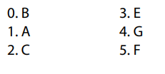
- Activity 2: Reading (7’)
a) Objective: Students can improve their reading skill.
b) Content:
- Read about the three people. Choose the correct answer (A, B, or C).
c) Expected outcomes: Ss read for comprehension and get familiar with the reading test format.
d) Organization of the activity:

TEACHER’S ACTIVITIES | STUDENTS’ ACTIVITIES
Read about the three people. Choose the correct answer (A, B, or C).  - Demonstrate the activity on DCR by using the example.  - Have Ss look and read, then choose the correct answer (A, B, or C).  - Call Ss to give answers, explain.  - Give feedback and evaluation. | - Observe and listen.  - Listen and choose the correct answer (A, B, or C).  - Give answers, explain.  Answer keys  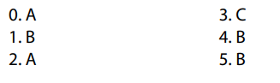

- Activity 3: Vocabulary (7’)
a) Objective: Ss can review vocabulary about tourism and cultures.
b) Content: Fill in the blanks with the words in the box.
c) Expected outcomes: Ss produce the new language successfully, and they can use these words in speaking and writing.
d) Organization of the activity:
TEACHER’S ACTIVITIES | STUDENTS’ ACTIVITIES
Fill in the blanks with the words in the box.  - Have Ss read the sentences,  - Ask Ss to work in pairs to fill in the blanks with the words in the box.  - Have Ss give answers, tell the meaning of the words /phrase again.  - Check answers as a whole class using DCR. | - Read the sentences.  - Work in pairs to fill in the blanks.  - Give answers.  Answer keys  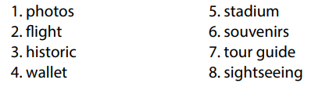
- Activity 4: Grammar (10’)
a) Objective: Ss can review the use of English: Past Simple with irregular verb, articles (“the” and “zero article”).
b) Content:
- Fill in the blanks using the or Ø (zero article).
- Write sentences in the Past Simple using the prompts.
c) Expected outcomes: Ss produce the new language successfully, and they can use the grammar points in speaking and writing.
d) Organization of the activity:
TEACHER’S ACTIVITIES | STUDENTS’ ACTIVITIES
Task a. Fill in the blanks using the or Ø (zero article).  - Have Ss tell the way to use the or Ø (zero article) again.  - Ask Ss to work individually to fill in the blanks using the or Ø (zero article).  - Have Ss work in pairs to check each other’s work.  - Call Ss to give answers, explain for their choice.  - Check answers as a whole class using DCR.  Task b. Write sentences in the Past Simple using the prompts.  - Ask Ss to read the content of Task b.  - Have Ss write sentences in the Past Simple using the prompts.  - Have Ss work in pairs to check each other’s work.  - Call Ss to give answers.  - Check answers as a whole class using DCR. | - Answer.  - Work individually.  - Work in pairs.  - Give answers.  Answer keys  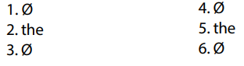  - Read.  - Work individually.  - Work in pairs.  - Give answers.  Answer keys  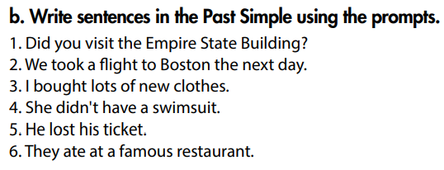
- Activity 5: Pronunciation (4’)
a) Objective: Ss can review the stress of nouns with 2 and 3 syllables, vowels and consonants: /ɪ/, /e/, /æ/, /ə, /ð /, / θ /.
b) Content:
- Circle the word that has the underlined part pronounces differently from the others.
- Circle the word that differs from the other three in the position of primary stress in each of the following questions.
c) Expected outcomes: Ss produce the new language successfully.
d) Organization of the activity:
TEACHER’S ACTIVITIES | STUDENTS’ ACTIVITIES
Task a. Circle the word that has the underlined part pronounced differently from the others.  - Have Ss distinguish vowels and consonants: /ɪ/, /e/, /æ/, /ə, /ð /, / θ /.  - Ask Ss to work individually to circle the answer.  - Have Ss work in pairs to check each other’s work  - Call Ss to give answers, pronounce the words again.  - Give feedback, correct Ss’ pronunciation if necessary.  Task b. Circle the word that differs from the other three in the position of primary stress in each of the following questions.  - Remind Ss some basic rules of putting stress on nouns with 2 or 3 syllables.  - Ask Ss to work individually.  - Have Ss work in pairs to check each other’s work.  - Call Ss to give answers, pronounce the words again.  - Give feedback, correct Ss’ pronunciation if necessary. | - Review.  - Work individually.  - Work in pairs.  - Give answers.  Answer keys  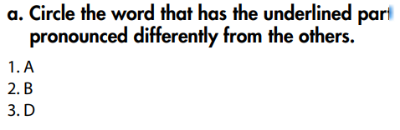  - Listen.  - Work individually.  - Work in pairs.  - Give answers.  Answer keys  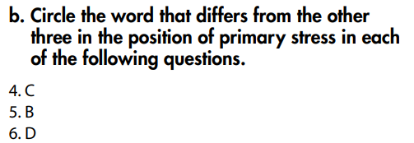

C. Consolidation and homework assignments (5’)
* Consolidation:
Grammar of Unit 9: Past Simple with irregular verb, articles (“the” and “zero article”).
Vocabulary of Unit 9: Words about tourism and culture (photos, sightseeing, wallet, historic, tour guide, flight, souvenirs, stadium, etc.).
* Homework:
- Review vocabulary, grammar of unit 9.
- Do the exercises in WB: Review of Unit 9 (page 70).
- Prepare: Unit 10 – New words and Listening (page 76 – SB).

D. Reflection
a. What I liked most about this lesson today:
…………………………………………………………………………………………
- What I learned from this lesson today:
…………………………………………………………………………………………
c. What I should improve for this lesson next time:
…………………………………………………………………………………………

