i-Learn Smart World 6 (Workbook)

Week: Date of teaching:
Period: 1
UNIT 1: HOME
Lesson 1 (p.2)
- Objectives:
By the end of this lesson, students will consolidate:
- Language knowledge and skills
Vocabulary: words related to people’s homes
Grammar: Present simple
→ Students will be able to decode the numbers, search for vocabulary related to people’s home and use present simple.
- Core competencies and Personal qualities
- Developing self-study skills and creativity
- Developing communication skills
- Demonstrating teamwork skills
- Having responsibility for doing housework
- Teaching aids:
- Teacher’s aids: workbook and teacher’s book, class CDs, IWB software, projector/interactive whiteboard/laptop/TV.
- Students’ aids: notebooks, workbooks.
- Procedures:
Time | Steps/Activities | Organization
5’ | Warm-up  Option 1: Game: Shark attack.  - Have students get through the rules of the games.  - Divide the class into two teams to compete with each other.  - Teacher and students play and join the fun.  Clues:  - This word has three letters.  - It’s a place for people to work and to relax.  - You can do some fitness training here  Answer: Gym  Option 2: What place is it?  - Teacher shows pictures of people who work / play there or pictures of things relating to a place.  - Students have to guess what place it is.  - Teacher checks and gives the correct answer.  Option 2: Sticking  - Teacher shows pictures of places around the house, students stick / match them with the correct words.  - Display the flashcards of letters on the board.  - Some students volunteer to stick a word that matches with the picture.  - One plus mark for every student having a correct answer. | - Teacher – whole class/ groups  - Teacher-whole class/ individuals  - Teacher – whole class/ individuals
  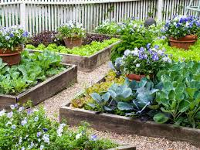 | 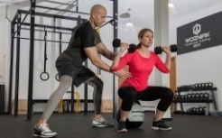 | 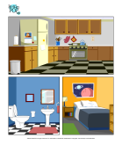 | 
  Trees, flowers | Trainee, trainers | Bedroom, living room, kitchen | Place outside the room
25’ | New lesson  A-Practice. (10’) New words  Activity 1. Fill in the blanks.  - Have students review the numbers as well as the alphabet.  - Ask students to fill in the table with letters based on the numbers; the first one is done as modeling. (pair work) (exercise a/p. 2)  - Teacher checks and gives feedback.  Answer:  - gym  - garage  - yard  - balcony  - pool  - apartment  Activity 2: Number the letters in the table  - After finding out words, students write the missing numbers in the table.  Activity 3: CROSSWORD  - Have students use words in task A to fill in the blanks in task b/p. 2.  - Have students work in pairs.  - Pairs cross-check the answer  - Some students share their answers.  - Teacher checks and corrects.  Answer:  - gym  - garage  - yard  - balcony  - pool  - apartment  Activity : fill in the blanks with words in task A. (game: Shark Attack):  - Have students work in groups, read and choose the best word to fill in each blank.  - The students do as directed.  - Two fastest groups show the answers.  - Teacher checks, corrects or gives feedback.  Answer:  - gym  - pool  - garage  - yard  - balcony  - apartment | - Teacher – whole class/ individuals  - Teacher -whole class/ individuals  - Teacher – whole class/ pairs  - Teacher – whole class/ groups
  A | B | C | D | E | F | G | H | I | J | K | L | M
  2 | 6 | 10 | 14 | 18 | 22 | 26 |  | 34 |  |  | 46 | 50
  N | O | P | Q | R | S | T | U | V | W | X | Y | Z
  54 | 58 | 62 |  | 70 |  | 78 | 82 | 86 |  |  | 98 | 102
5’ | Wrap-up  Option 1: Speaking  - Teacher asks students to read the clues, then give the place where people can do it.  - Students do as directed.  - Have students work in pairs, find the answer for the sentences.  - Some pairs present in front of the class.  Questions:  - Cara is interested in fitness training. She often goes to the……………  - Every morning, my dad drinks coffee and read newspaper at the ………………  - I like spending my free time planting trees and flowers in the ………..  - This apartment has a big ………………for us to park our car.  Answers:  - Gym  - Balcony  - Garden  - garage  Option 2: Do some multiple choices to review present simple tense.  - Teacher shows some sentences.  - Ask students to work in groups, read the sentences, then find the subjects that are suitable for them.  - Some students give the answers to the class.  Sentences:  - Minh ……………….plants, animals and flowers.  - like B. likes C. liked  - Nhi ……………….. interested in singing English songs.  - is B. am C. are  - My family lives in an ……………. in the city.  - house B. flat C. apartment  - Phong likes sports. He often plays games on the…………  - garden B. pool C. sport ground  - My mom often …………… in the supermarket on the ground floor.  - go shopping B. goes shopping C. goes shop  Answers:  - B  - A  - C  - C  - B  Option 3: Which places you like best in your neighborhood?  - Have students talk individually about their favorite place in the neighborhood.  - Teacher may add more information if necessary. | - Teacher – whole class/ pairs  - Teacher –Students in groups  - Teacher –whole class/ individuals
5’ | Wrap-up  Option 1: Speaking  - Teacher asks students to practice A&A the questions in writing (p. 5).  - What housework do you do?  - What housework does your mother do?  - What housework does your father do?  - What housework does your brother or sister do?  - Who does the most housework?  - Have students work in pairs, ask and answer about them.  - Some pairs present in front of the class. | - Teacher – whole class/ pairs
Homework
Write sentences about the housework you like or don’t like. Give the reason why.

i-Learn Smart World 6 (workbook)

Week: Date of teaching:
Period: 2
UNIT 1: HOME
Lesson 1 (p. 3)
- Objectives:
By the end of this lesson, students will consolidate:
- Language knowledge and skills
Consolidate
Vocabulary: words related to people’s homes
Grammar: Present simple – Y/N Questions
→ Students will be able to listen to people talking about their homes; correct mistakes in sentences using simple present; use simple present to write Y/N questions.
- Core competencies and Personal qualities
- Developing self-study skills and creativity
- Developing communication skills
- Demonstrating teamwork skills
- Building love for their houses
- Self-correcting
- Teaching aids:
- Teacher’s aids: workbook and teacher’s book, class CDs, IWB software, projector/interactive whiteboard/laptop/TV.
- Students’ aids: notebooks, workbooks.
- Procedures:
Time | Steps/Activities | Organization
5’ | Warm-up  Option 1: Song: Home sweet Home!  - Play audio (The “Home sweet Home” song) to review the theme of the lesson.  - Teacher and students sing along and greet together.  Option 2: Which place you like or don’t like in your neighborhood? (homework)  - Some students volunteer to share ideas about their ideal place in the neighborhood.  - Students follow, make question if they want.  - Teacher checks and gives the correct answer.  Option 3: Sticking  - Teacher divides class into two groups. Each group has the same hands-out but in different color.  - Teacher shows pictures of places and some equipment, students stick / match the equipment to suitable places.  - Groups’ members take turn to match as directed.  - One plus mark for every student having a correct answer. | - Teacher – whole class/ individuals  - Teacher – whole class/ individuals  - Teacher - whole class/ groups
25’ | New lesson  A-Listening. (10’)  - Teacher shows four pictures (A, B, C, D) and asks students to describe them before listening.  Activity 1. Listen and match  - Teacher lets students listen and match each person with their favorite place to live. (p. 3)  - Some students give their answers.  - Teacher and other students check and correct.  Answer:  - A  - C  - D  - D  Activity 2: Reporting  - Have some students report the listening (change subject pronouns and the verbs)  - Some students share their answers.  - Teacher checks and corrects.  Answer:  - ………….likes to live in …………  - ………………….  - ……………..  - …………………..  B- Grammar. (10’)  - Teacher asks students to work in pairs, read the sentences and choose the correct answer.  - Get the answers from students. Ask them to give explanation.  - Teacher checks and corrects.  Suggested answer  - Could  - Yes  - Do  - Live  - Have  - Doesn’t  - Has  - Have  - Does  - Has | - Teacher – whole class/ individuals  - Teacher- whole class/ individuals  - Teacher – whole class/ pairs
5’ | Wrap-up  Option 1: Speaking  - Teacher asks students some questions about their house/ place of living, uses the same format as the dialogue above.  - Remind students the ways to answer Yes - No question and Or question.  Do you live in a house or an apartment?  - I live in ………………  Does it have a pool?  - Yes / No, ………………………  Does it have a garden?  - Yes / No, ……………………  How many rooms are there?  - It has……………………..rooms: …………………, ………………  Do you like it?  - Yes/ No, ……………..  - Students answer teacher’s questions.  - Have students work in pairs, ask and answer about them.  - Some pairs present in front of the class.  Option 2: Writing.  - Teacher shows some sample sentences.  - Ask students to finish, then write the answers on the board.  - Teacher checks and corrects | - Teacher – whole class/ pairs  - Teacher –whole class/ individuals
Homework
Rewrite the conversation with your partner at home

i-Learn Smart World 6 (workbook)

Week: Date of teaching:
Period: 3
UNIT 1: HOME
Lesson 2 (p. 4)
- Objectives:
By the end of this lesson, students will consolidate:
- Language knowledge and skills
Consolidate
Vocabulary: family members and housework
Grammar: Present simple – Wh-questions
→ Students will be able to remember words of family members and housework and use them in the right context.
- Core competencies and Personal qualities
- Developing self-study skills and creativity
- Developing communication skills
- Demonstrating teamwork skills
- Having responsibility for doing housework
- Teaching aids:
- Teacher’s aids: workbook and teacher’s book, class CDs, IWB software, projector/interactive whiteboard/laptop/TV.
- Students’ aids: notebooks, workbooks.
- Procedures:
Time | Steps/Activities | Organization
5’ | Warm-up  Option 1: What activity is it?  - Teacher shows pictures of Nam’s daily routines; students give the words of the activities.  - Teacher checks and gives the correct answer.    Option 2: Rearranging  - Teacher shows pictures / flashcards of daily activities; students arrange the activities in chronological order.  - Students from two groups take turn (one by one) do as directed.  - Which team has more correct answers wins the game. | - Teacher – whole class/ individuals  - Teacher – whole class/ groups
25’ | New lesson  A-New words. (10’) - Activity 1.  - Teacher has students read all the words before completing the task. (a/p. 4)  - Ask students to write the words of the activity below the pictures.  - Students show their answers on the board.  - Teacher and other students check and correct.  Answer:  - Make dinner  - Do the laundry  - Clean the kitchen  - Clean the bathroom  - Make the bed  - Make breakfast  - Make lunch  - Do the dishes  - Go shopping / do the shopping  - Have students read all the words again.  Activity 3: Read the sentences and tick the boxes. (game: The Magic hat  - Have students work in pairs, read and choose the best answers.  - Teacher shows the answers through games.  - Ask some students to give their answers, more explanation for their choices.  - Teacher checks, corrects or gives feedback.  Answer:  - A  - B  - B  - A  - B  - B | - Teacher – whole class/ individuals  - Teacher -whole class/ pairs
5’ | Wrap-up  Option 1: Speaking  - Teacher asks 2 questions and ask a student to answer as an example.  Example:  Do you often do the housework at home?  Yes, I do  What housework do you do?  I often do the dishes.  - Have students use words in task A to practice speaking in pairs.  - Some pairs present in front of the class.  - Teacher checks and corrects.  - Teacher asks students about the subjects each person likes.  Option 2: Game: Who is faster?  - Two students play against each time.  - Student who gives faster clap answers the question or fills in missing words in each sentence.  - More explanation for each answer.  Sentences:  - My moms ……………………. breakfast for my family.  - After dinner, I have to do the………………….  - I wash / do my clothes after school. (choose the correct word)  - My dad doesn’t drinks coffee in the evening. (correct the mistake)  - After getting up, Nhi brushes / washes her teeth.  Answers:  - Makes  - Dishes  - Wash  - Drinks – drink  - Brushes | - Teacher – whole class/ individuals/ pairs  - Teacher –whole class/ students in pairs
Homework
Write about the housework you do at home.

i-Learn Smart World 6 (workbook)

Week: Date of teaching:
Period: 4
UNIT 1: HOME
Lesson 2 (p. 5)
- Objectives:
By the end of this lesson, students will consolidate:
- Language knowledge and skills
Consolidate
Vocabulary: family members and housework
Grammar: Present simple – Wh-questions
→ Students will be able to listen and write family members; correct mistakes in sentences using present simple; rearrange the words to make Wh-questions and answer them.
- Core competencies and Personal qualities
- Developing self-study skills and creativity
- Developing communication skills
- Demonstrating teamwork skills
- Having responsibility for doing housework
- Self-correcting
- Teaching aids:
- Teacher’s aids: workbook and teacher’s book, class CDs, IWB software, projector/interactive whiteboard/TV.
- Students’ aids: Student books, notebooks, workbooks.
- Procedures:
Time | Steps/Activities | Organization
5’ | Warm-up  Option 1: Speaking: Talk about the housework you do at home  - Teacher has some students volunteer to share their story to class.  - Teacher checks and gives feedback.  Option 2: Matching  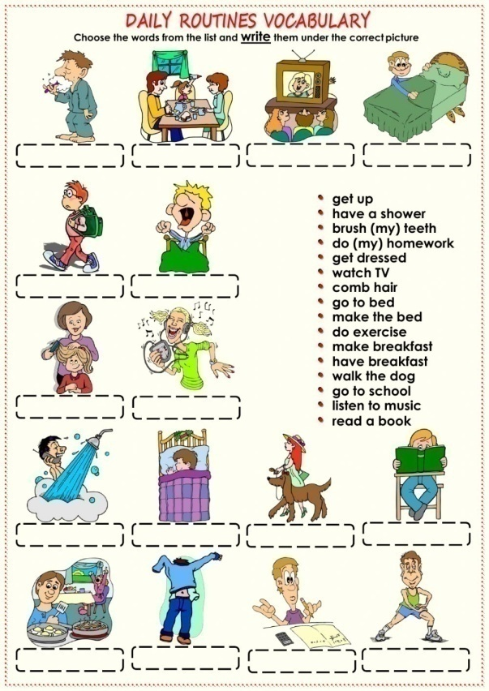  - Teacher gives hands-out to students.  - Students have to work in pairs, look and complete the boxes with words given.  - Students take turns showing the answers on the board.  - Teacher checks and corrects.  - One plus mark for every student who has a correct answer. | - Teacher – whole class/ individuals  - Teacher – whole class/ students in pairs

25’ | New lesson  - Teacher shows a picture to review subjects at school.  - Ask students to circle the name of subjects (picture 1), or look at the symbols and tell the subjects (picture 2).  A-Listening. (10’):  Activity 1: Listen and write the family members  - Teacher lets students fill in the blanks. (exercise a/p. 5)  - Students show their answers on the board.  - Teacher and other students check and correct.  Answer:  - Brother  - mom  - dad  - dad  - sister  - mom  - sister  - mom  Activity 2: Reporting  - Have students look at pictures in task A and make full sentences about who does what. (individually)  - Some students share their answers.  - Teacher checks and corrects.  Answer:  - Peter’s brother does the dishes.  - His mom does the shopping  - His dad cleans the bathroom  - His dad vacuums the carpet  - His sister makes the bed  - His mom makes breakfast  - His sister cleans the kitchen  - His mom does the laundry.  B- Grammar (10’)  - Teacher shows an example sentence on the board, helps students review Simple present tense.  - Explain the way to do task b/p. 5  - Students read and choose the best answers.  - Some students give the answers, explain why.  - Teacher checks and corrects.  Suggested answer  - Makes  - Does  - Does  - Makes  - Clean  - Does  - Make  - Cleans  - Does  C- Writing (10’): arrange the words into sentence, then answer it.  - Teacher shows a sentence on the board, rearranges it, then answers the question (as an example).  - Have students practice in pairs, do as directed.  Answer:  - What housework do you do?  - What housework does your mother do?  - What housework does your father do?  - What housework does your brother or sister do?  - Who does the most housework? | - Teacher – whole class/ individuals  - Teacher - whole class/ individuals  - Teacher – whole class/ individuals  - Teacher – whole class/ individuals  - Teacher – whole class/ pairs
5’ | Wrap-up  Option 1: Speaking  - Teacher asks students to practice A&A the questions in writing (p. 5).  - What housework do you do?  - What housework does your mother do?  - What housework does your father do?  - What housework does your brother or sister do?  - Who does the most housework?  - Have students work in pairs, ask and answer about them.  - Some pairs present in front of the class. | - Teacher – whole class/ pairs
Homework
Write sentences about the housework you like or don’t like. Give the reason why.

i-Learn Smart World 6 (workbook)

Week: Date of teaching:
Period: 5
UNIT 1: HOME
Lesson 3 (p. 6)
- Objectives:
By the end of this lesson, students will consolidate:
- Language knowledge and skills
consolidate
Vocabulary: villages, towns and cities.
Grammar: Present simple
→ Students will be able to remember words of villages, towns and cities; listen to a description of a city.
- Core competencies and Personal qualities
- Developing self-study skills and creativity
- Developing communication skills
- Demonstrating teamwork skills
- Developing the love for community, country and the world
- Teaching aids:
- Teacher’s aids: workbook and teacher’s book, class CDs, IWB software, projector/interactive whiteboard/laptop/TV.
- Students’ aids: notebooks, workbooks.
- Procedures:
Time | Steps/Activities | Organization
5’ | Warm-up  Where is it?  - Teacher shows the map of Vietnam, points at the directions, students give out the words. (north, south, east, west, …..)  - Teacher checks and gives the correct answer.  - Teacher has students read all the words.  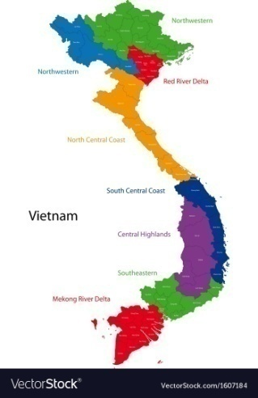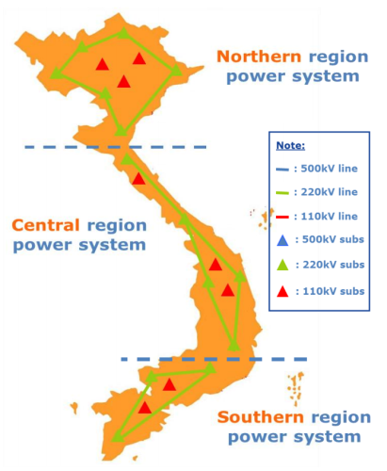 | - Teacher – whole class/ individuals
25’ | New lesson  A-New words. (10’) -  Activity 1: Unscramble words.  - Have students work in pairs, look at the pictures and find the words in the crossword. (exercise a/p. 6)  - The two first groups with corrects answers get plus marks.  - Teacher checks and gives feedback.  Answer:  - North  - City  - Center  - Town  - South  - West  - Village  - East  - Have students read all the words again.  Activity 2: Find the words in the crossword. (game: The Magic hat  - Have students work in pairs, look at the pictures and find the words in the crossword.  - Ask some students to give their answers, more explanation for their choices.  - Teacher gives help if necessary.  - Teacher checks, corrects or gives feedback.  Answer:  - Village  - Center  - East  - West  - South  - North  - Town  - city  Further practice  - Teacher shows a picture or point at a position, students give the words.  Example:  - Hanoi – city  - Lao cai – town  - Ca mau is in the ……………..of Vietnam  Activity 3: Listening (7’)  - Have students look at the sentences in the task.  - Have students guess the answers for the questions.  - Have students listen and answer True – False (1st time)  - Listen again to check the answers.  - Ask students to correct the false ones.  Answer:  - False  - True  - True  - True  - false | - Teacher – whole class/ groups  - Teacher - whole class/ pairs  - Teacher – whole class/ individuals
5’ | Wrap-up  Option 1: Summarizing  - Teacher asks students to make a summary for New York, use the information in the Listening.  - Teacher adds some more information if necessary.  - Representatives from groups share the ideas.  Option 2: Listening  - Teacher asks students some questions about Ho Chi Minh city (or Hanoi) for more information.  Example:  - Is Ho Chi Minh city in the north of Vietnam?  No, it’s in the south of Vietnam  - What is the population of HCM City?  About 195,000 people (2020) / I don’t know.  - Have students watch a clip about HCM City, then fill in the blanks.  - Some students present in front of the class.  - Teacher checks and corrects.  Ho Chi Minh city  - Area:  - Position:  - Population:  - Weather:  - Landmarks: | - Teacher – whole class/ groups  - Teacher –whole class/ individuals
Homework
Write a short paragraph about HCM City.

i-Learn Smart World 6 (workbook)

Week: Date of teaching:
Period: 6
UNIT 1: HOME
Lesson 3 (p. 7)
- Objectives:
By the end of this lesson, students will consolidate:
- Language knowledge and skills
Consolidate
Vocabulary: review villages, towns and cities; seaffod, hometown, island, cheap # expensive
Grammar: Present simple
→ Students will be able to read an email about an island in Italy; write an email giving a tourist information.
- Core competencies and Personal qualities
- Developing self-study skills and creativity
- Developing communication skills
- Demonstrating teamwork skills
- Developing the love for community, country and the world
- Teaching aids:
- Teacher’s aids: workbook and teacher’s book, class CDs, IWB software, projector/interactive whiteboard/laptop/TV.
- Students’ aids: notebooks, workbooks.
- Procedures:
Time | Steps/Activities | Organization
5’ | Warm-up  Option 1: Where is it?  - Teacher shows the map of Vietnam to help students review the areas. (north, south, east, west, …..)  - Teacher shows some landmarks in areas, asks them which areas they are.  - Teacher checks and gives the correct answer.  - Teacher has students read all the words.  Ha Long – the north  Cầu cổng vàng – Da Nang – the center  Phu Quoc – the south  Option 2:  - Teacher shows a picture of Bruno, asks students some questions about it  - Do you know this place?  - Have you ever been there?  - Where is it?  - Is it beautiful?  - Teacher gets answers from students, adds some information, then leads to new lesson. | - Teacher – whole class/ individuals  - Teacher – whole class/ individuals
  
  
  
25’ | New lesson  A-Reading. (10’) -  Activity 1: teach new words.  - Teacher introduces and elicits meaning of some new words.  - Have students follow her, look at the pictures and guess the meaning of new words.  New words:  - Hometown (simple Eng)  - Seafood (n)  - Cheap # expensive (a)  - Island (n)  - Have students read all the words again.  - Teacher checks their understanding and gives feedback.  Activity 2: read the email, answer the questions  - Teacher asks students to get through the text, then answer the questions.  Guided question: What is Burano famous for?  - Teacher gets the answer, gives feedback, then has students practice.  - Have students work in pairs, read the email and answer the questions (pairs)  - Ask some students to give their answers, more explanation for their answers.  - Teacher gives help if necessary.  - Teacher checks, corrects or gives feedback.  Answer:  - It’s in the north of Italy  - Take waterbus ride from Venice.  - It’s famous for colorful houses and seafood.  - About three thousand people  - It’s in summer  Further question:  Do you want to take a trip to Burano? Why?  - Some students share their ideas.  Activity 3: Speaking & Writing (7’)  - Have students look at the cues words given.  - Practice in pairs, discuss and share ideas.  Question: “Do you want to have a visit to Japan? Why?”  - Some students share ideas to class  - Teacher explains how to do the task.  - Have students work in groups, write the email, then share their email to class.  - The fastest group shows the email on the board, one representative from group shares it.  - Teacher checks and gives feedback. | - Teacher – whole class/ individuals  - Teacher – whole class/ pairs  - Teacher – whole class/ groups
5’ | Wrap-up  Option 1: Speaking  - Teacher asks students about tourism or about their last vacation / their favorite tourist attraction.  - Some students share the ideas.  - Teacher gives feedback, adds more information if necessary.  Option 2: Interviewing  - Have students play role of a journalist and a tourist, A&A about their favorite tourist attraction and the reason why.  - Teacher and other students follow them and give feedback.  Example:  What is your favorite tourist destination?  I like ……………………………………  What is it famous for?  ………………………………………..  What can you do there?  …………………………………… | - Teacher – whole class/ individuals  - Teacher –whole class/ pairs
Homework
Write an email to a friend about your favorite tourist destination.

i-Learn Smart World 6 (workbook)

Week: Date of teaching:
Period: 7
UNIT 1: HOME
REVIEW - (p. 62)
- Objectives:
By the end of this lesson, students will consolidate:
- Language knowledge and skills
Consolidate
Vocabulary: words related to home, family members and housework; towns, cities and villages.
Grammar: Present simple
→ Students will be able to listen to conversations about homes, housework and places; and read about a city.
- Core competencies and Personal qualities
- Developing self-study skills and creativity
- Developing communication skills
- Demonstrating teamwork skills
- Having responsibility for doing housework
- Develop the love for family, community, country and the world
- Teaching aids:
- Teacher’s aids: workbook and teacher’s book, class CDs, IWB software, projector/interactive whiteboard/laptop/TV.
- Students’ aids: notebooks, workbooks.
- Procedures:
Time | Steps/Activities | Organization
5’ | Previous lesson  Option 1: Guessing game (Kim’s game)  - Teacher gives clues; students have to guess what teacher talks about.  Example:  - This is a place most people live in. – house, apartment  - When I need to buy something, I go to this place – shopping mall  - In order to have fit body, you should go to the………everyday - gym  - Teacher gives feedback, leads to new lesson. | - Teacher – whole class/ individuals
25’ | New lesson  Part 1: Listening  Activity 1 - (5’)  - Have students look at the pictures, review the words before listening. (individual)  - Some students give their answers.  - Teacher plays the recording twice, gets students’ answer.  - Listen again to check their answers.  Answer:  - B  - B  - C  - Teacher checks and corrects the answers.  Part 2: Reading:  Read an article about Boston, choose the best answer for each space.  Pre-reading:  - Teacher asks students some questions about Boston.  - Ask students if they know anything about Boston.  - Have students complete the task. (pairs work)  - Teacher gets the answers from students.  Answers:  - A  - C  - C  - B  - A  - A | - Teacher – whole class/ individuals  - Teacher – whole class/ individuals
5’ | Consolidation  Option 1: Interviewing  - Have students play roles of a reporter and a tourist, ask & answer about their favorite tourist destination.  - Teacher checks and gives feedback.  Example:  Which country would you like to visit?  I like ……………………………………  What is it famous for?  ………………………………………..  How can we get there?  ……………………………………………  What can you do there?  ……………………………………  Option 2: Speaking  - Have students play role of a tourist guide, introduce a tourist attraction in Vietnam.  - Teacher may help them by giving an outline.  - Some students share the story.  Outline  Hi, everyone  Have you ever been to my beautiful country, Vietnam?  If not, try it and you will enjoy yourself.  There are lots of scenic places for you to explore here such as ………………  ……………………………………………… | - Teacher – whole class/ pairs
3’ | Homework  Review a scenic spot in Viet Nam you have ever been to.

