School: ……………………………………….. | Date:……………………………………..
Class: ……………………………..................... | Period: 4

UNIT 1: MY WORLD
Overview (Pages 12, 13)

1. Objectives
By the end of this lesson, students will be able to…
1.1. Language knowledge/ skills
- learn and use vocabulary for appearance: wavy, curly, straight, of medium height/slim, chubby, in his (early/mid-/late) twenties.
- practise making sentences with new words.
- improve listening skills and pronunciation.
- talk about people appearance.
1.2. Competences
- improve Ss’ communication, collaboration and critical thinking skills.
1.3. Attributes
- develop their patriotism, kindness and honesty.
2. Teaching aids and materials
- Teacher’s aids: Student’s book and Teacher’s book, class CDs, IWB – Phần mềm tương tác trực quan, projector / interactive whiteboard /TV (if any), PowerPoint slides.
- Students’ aids: Student’s book, Workbook, Notebook.
3. Assessment Evidence
Performance Tasks | Performance Products | Assessment Tools
- Matching pictures to the correct words.  - Listen and repeat.  - Look at the picture and write the answers for the questions.  - Use the words in Exercise 1 to describe the people in the picture.  - Listen to Tim describing his best friend and decide if the statements are R (right) or W (wrong).  - Play a game. | - Ss’ answers.  - Ss’ performance.  - Ss’ answers.  - Ss’ answers.  - Ss’ answers.  - Ss’ presentation. | - Observation.  - Observation.  - Observation.  - Observation.  - Observation.  - Observation.

4. Procedures
A. Warm up: 5 minutes
a. Objectives: to brainstorm the topic and review the vocabulary related to the topic.
b. Content: vocabulary for appearance.
c. Expected outcomes: Ss can recall some vocabulary and think further about the topic.
d. Organization
Teacher’s activities | Students’ activities
Match the pictures to the correct words:  a.b.c.d.  1. curly/ blond  2. short/ brown  3. wavy/ black  4. straight/ long | Answer keys:  - b 2. d 3. a 4. c
B. Presentation: 10 minutes
a. Objectives: to present vocabulary for appearance.
b. Content: task 1.
c. Expected outcomes: Ss can remember and use the words in real context.
d. Organization
Teacher’s activities | Students’ activities
Task 1: Listen and repeat.  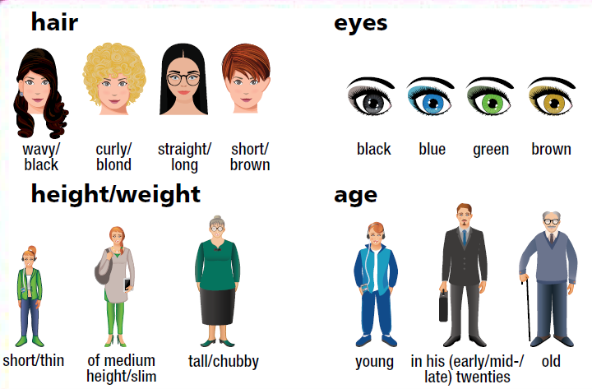  - Direct Ss’ attention to the pictures using IWB.  - Play the recording with pauses for Ss to repeat chorally and/or individually.  - Check Ss’ pronunciation and intonation. | - Look at the book.  - Listen and repeat chorally and/or individually.  - Take notes.

C. Practice: 15 minutes
a. Objectives: to help Ss identify clothes, describe people, listen for details.
b. Content: tasks 2, 3, 4.
c. Expected outcomes: Ss can practise new words and listen for details and do the task correctly.
d. Organization:

Teacher’s activities | Students’ activities
Task 2. Look at the picture. Write the answers for these questions in your notebook.  Who’s wearing …  1. blue shorts and trainers?  2. a red top and gloves?  3. a red and black shirt?  4. a black and white T-shirt?  5. a black suit and high heels?  Revise clothes with Ss.  - Ask: Who is wearing jeans? Elicit that Bruce is wearing jeans.  - Write a list of clothes on the board and go  through them one by one and elicit who  is wearing each one from Ss around the  class, (e.g., skirt, jacket, high heels, gloves,  T-shirt, shorts, tracksuit, top, dress, shirt, trousers, hat, suit).  - Explain the task and read out the questions and elicit answers from Ss around the class.  - Play the video for Ss and elicit their comments (using the IWB). | - Look at the picture.  - Write the answers for these questions in their notebook.  - Listen and take notes.  - Answer keys:  1. Chris 4. Keith  2. Lyn 5. Sue  3. Ken
3. Use the words in Exercise 1 to describe the people in the picture as in the example.  Chris is young, short and thin with short straight fair hair. He’s wearing a grey T-shirt, blue shorts and green and black trainers.  - Have Ss work in pairs, practice describing people in the picture.  - Ask various Ss around the class to describe the people in the picture. | - Use the words in Exercise 1 to describe the people in the picture as in the example.  Suggested Answers:  Bruce is in his early thirties, tall and thin with short fair hair. He’s wearing jeans and a blue  T-shirt.  Lyn is young, tall and thin with long straight blond hair. She’s wearing a white dress and white shoes.  Lucy is young, short and thin with long wavy brown hair. She’s wearing a red T-shirt and black trousers.  Ken is young, tall and thin with short curly brown hair. He’s wearing a red and black shirt and white trainers.  John is old and thin with glasses. He’s wearing a hat and brown shoes.  Jane is young, short and thin with black hair.  She’s wearing a white T-shirt, a black legging and a red schoolbag.  Sue is in her twenties, tall and thin with long wavy brown hair. She’s wearing a black suit and high heels.  Keith is young, tall and thin with short wavy brown hair. He’s wearing a black and white  T-shirt and black trousers.  Anna is young and thin with long straight blond hair and blue eyes. She’s wearing a coat.
4. Listen to Tim describing his best friend. Decide if the statements are R (right) or W (wrong).  1. Bob is in his early twenties.  2. He is of medium height.  3. He’s got wavy black hair and blue eyes.  - Explain the task and ask Ss to read the sentences.  - Play the recording, twice if necessary.  - Check Ss’ answers (using the IWB).  You can play the recording with pauses for Ss to check their answers. | - Read the sentences.  - Listen and complete the task.  - Answer keys:  1. W 2. R 3. W

D. Production: 10 minutes
a. Objectives: to help Ss use the language and information in the real situation.
b. Content: Game.
c. Expected outcomes: Ss can listen and talk about people’ appearance.
d. Organization

Teacher’s activities | Students’ activities
Game!  Choose a person in the picture and describe him/her. Make three mistakes. Your partner corrects them.  A: Chris is tall and thin with short curly fair hair.  He’s wearing a T-shirt and jeans.  B: Chris is short and thin with short straight fair hair. He’s wearing a T-shirt and shorts.  - Ask Ss to play the game in pairs.  - Ask one student to choose a person and then say two sentences about that person referring to their appearance and clothes but making three mistakes. Their partner must correct their mistakes and say the sentences correctly.  - Monitor the activity around the class. | - Play the game in pairs.  - Choose a person and then say two sentences about that person referring to their appearance and clothes but making three mistakes.  - Correct their friends’ mistakes and say the sentences correctly.  - Students’ own answers.

E. Consolidation and homework assignments: 5 minutes
- Vocabulary: wavy, curly, straight, of medium height/slim, chubby, in his (early/mid-/late) twenties.
- Do the exercises in workbook on pages 10, 62.
- Do the vocabulary exercise in TA7 Right On! Notebook pages 1, 2.
- Prepare the next lesson: Reading 1a (page 14).
5. Reflection
a. What I liked most about this lesson today:
…………………………………………………………………………………………
b. What I learned from this lesson today:
…………………………………………………………………………………………
c. What I should improve for this lesson next time:
…………………………………………………………………………………………

