WEEK 19
Class | Date of teaching
4A | January 14th, 2025
4B | January 15th, 2025
4C | January 14th, 2025
PERIOD 73
UNIT 11: MY HOME
LESSON 1 (1-3)
A. OBJECTIVES:
By the end of the lesson, pupils will be able to:
1. Knowledges:
By the end of the lesson, pupils will be able to:
- Understand and correctly repeat the sentences in two communicative contexts (pictures) in which characters ask and answer the question about where Mary lives.
- Correctly say the phrases and use Where do you live? – I live _____. to ask and answer questions about where someone lives.
- Enhance the correct use of Where do you live? – I live _____. to ask and answer questions about where someone lives in a freer context.
2. Skills: Listening and speaking
3. Attributes:
- Show their knowledge about their places/ address.
4. Digital Competence (1.1CB2a):
- Identify information needs: Identify information needs about rooms in the house (e.g., determining what information is needed to describe their home for the project).
B. INSTRUCTIONAL RESOURCES
- Student’s book: Page 7
- Audio tracks 3
- Teacher’s guide: Pages 160, 161, 162
- Flash cards/ pictures and posters (Unit 11)
- Hoclieu.vn
- Computer, projector
C. LEARNING PLAN:
Teacher’s activities | Student’s activities
1. Warm up (5’)  - Greet the class.  Option 1: Watch a chant video about house in Tieng Anh 3 (https://www.youtube.com/watch?v=L08bVyhfKpg&list=PL8_ETpRL2xNY6ptJqBTgFUP3I654rZ9bv&index=21)  Option 2: Sing the song in Unit 10, Lesson 1.  - Ask pupils to sing the song.  - Invite some of them to come to the board to role play, the rest of the pupils will sing.  Option 3: Chant and do activities (Unit 10, Lesson 3).  - Ask pupils to chant and do the actions in Unit 10, Lesson 3 in groups.  - Give points to the groups and encourage them.  2. Presentation (10’)  Activity 1-Vocabulary  * Goals: Ss will be able to know the vocab, before starting the new lesson.  * Procedure:  - T elicits the new words  + home: gia đình/nhà (picture)  + street: đường phố (picture)  + road : con đường (picture)  + live : sống/sinh sống (meaning)  - T models (3 times).  - T writes the words on the board.  - Checking: Rub out and remember  - The disabled: Practice reading vocab.  Activity 2-1. Listen, point and say.  * Goal: To understand and correctly repeat the sentences in two communicative contexts (pictures) in which characters ask and answer the question about where Mary lives.  * Procedure:  - Ask pupils to look at Pictures a and b and identify the characters and say what they can see in the pictures (e.g. 81, Tran Hung Dao Street, lockers, door, building).  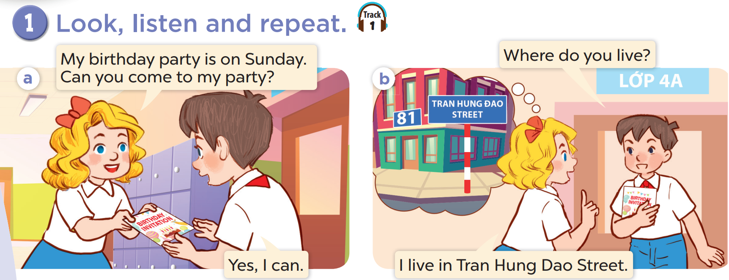  - Have pupils look at Picture a and predict when Mary’s birthday is. Play the recording and have pupils check the prediction. Repeat the same procedure with Picture b.  - Play the recording again and encourage pupils to point at the characters while listening.  - Play the recording again, sentence by sentence, for pupils to listen, point at the sentences and repeat after each character in chorus and individually. Correct their pronunciation where necessary.  - Draw pupils’ attention to the question Where do you live? and the answer I live in Tran Hung Dao Street. Tell them that they are used to asking and answering about where Mary lives.  Extension: Invite a few pairs of pupils to act out the conversations in front of the class.  3. Practice (15’)  Activity 3-2. Listen, point and say.  * Goal: To correctly say the phrases and use Where do you live? – I live _____. to ask and answer questions about where someone lives.  * Procedure:  - Ask pupils to look at Pictures a and b and tell what the words and numbers on the places are about (e.g. the street name, the street / road number).  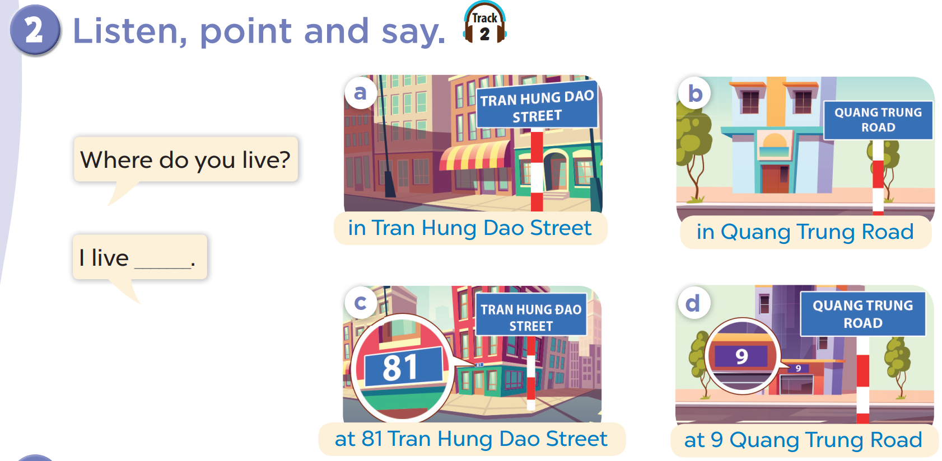  - Play the recording for pupils to listen to and repeat the phrases under the pictures in chorus and individually until they feel confident. Use the flashcards ‘in Tran Hung Dao Street’ and ‘at 81 Tran Hung Dao Street’ to practise the word street and distinguish in and at in the phrases.  - Repeat Steps 1 and 2 with Pictures b and d.  - Draw pupils’ attention to the speech bubbles and elicit the missing phrases in the answer by pointing at Picture a. Play the recording for pupils to repeat the sentences in both bubbles a few times. Repeat Step 3 with Pictures b, c, and d.  - Let pupils practise asking and answering questions in pairs. Go around the classroom to offer help if necessary.  - Invite a few pairs to point at the pictures and ask and answer questions about where someone lives.  – Picture cues:  a. A house (without a house number) in Tran Hung Dao Street  b. A house (without a house number) in Quang Trung Road  c. A house at 81 Tran Hung Dao Street  d. A house at 9 Quang Trung Road  – Speech bubbles:  Where do you live? – I live _____.  – Audio script:  a. in Tran Hung Dao Street b. in Quang Trung Road  c. at 81 Tran Hung Dao Street d. at 9 Quang Trung Road  a. A: Where do you live?  B: I live in Tran Hung Dao Street.  b. A: Where do you live?  B: I live in Quang Trung Road.  c. A: Where do you live?  B: I live at 81 Tran Hung Dao Street.  d. A: Where do you live?  B: I live at 9 Quang Trung Road.  Activity 4-3. Let’s talk.  * Goal: To enhance the correct use of Where do you live? – I live _____. to ask and answer questions about where someone lives in a freer context.  * Procedure:  - Draw pupils’ attention to the maps. Ask questions to help them identify the names of the streets and roads, the house numbers and the houses without specific numbers.  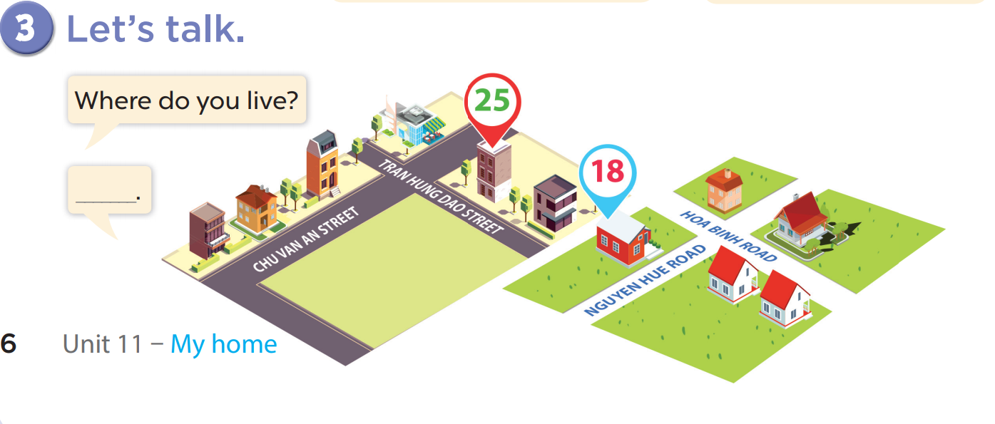  - Elicit an answer to the question and write it on the board. Get pupils to say the completed sentence.  - Ask each pupil to choose a house on the map. Put pupils into pairs to ask and answer about where they live using the map. Go around the classroom to offer support where necessary.  - Invite a few pairs to practise asking and answering questions about where they live in front of the class.  Option 1:  Game: Lucky wheel  Pupils spin the wheel and answer the question. If they have the correct answer, they will get the point.  Option 2:  Using hoclieu.vn, have pupils look at the phrases or sentences of the lesson and repeat after the recordings.  Option 3:  Game: Sentence Puzzle  - Divide the class into groups of four. Give each group a sentence that is broken/cut into pieces. Ask them to arrange them to make a complete sentence, then read it aloud.  - The group that makes it first will be the winner.  Game: Bomstar  - Pupils choose a number and answer the question if they have the correct answer they will get 1 point for their team.  4. Consolidation (3’)  - Ask students to answer the following questions:  1. What have you learnt from the lesson today?  2. What are the core values of the lesson?  5. Homework (2’)  - Learn vocab and structure by heart.  - Prepare the new lesson: Lesson 1 (4,5,6) of Unit 11.  - Preparation for the project: Tell pupils about the project on page 11. Ask them to prepare for it at home by drawing the place (street, road, village, etc.) where they live and preparing how to present it at home. They should say at least five sentences about where they live. Remind pupils to bring the drawing to the class to present it at Project time in Lesson 3, Activity 6. This preparation supports Digital Competence 1.1CB2a by asking pupils to identify what information they need about their home/rooms to complete the project. | - Listen to the techer  - Whole class/ Pair work  - Whole class/  Individual  work  - Ss listen and answer  - Ss listen and repeat  + Choral repetition (3 times).  + Individual repetition (3 ss)  - Ss take note  - Ss look, remember and write  - Listen to the T's instruction  - Listen to the recording  - Individual  work  - Listen and repeat  - Whole class/Pair work  - Listen to the T's instruction  - Listen and repeat  - Listen to the teacher  - Whole class/ Pair work  - Listen to the teacher  - Pair work  Whole class  - Practice in front of class  - Listen to the T's instruction.  - Play game in group  - Whole class/ Group work
D. Recommendation:
…………………………………………………….….……………………………

WEEK 19
Class | Date of teaching
4A | January 14th, 2025
4B | January 15th, 2025
4C | January 14th, 2025
PERIOD 74

UNIT 11: MY HOME
LESSON 1 (4-5)
A. OBJECTIVES:
By the end of the lesson, pupils will be able to:
1. Knowledges:
By the end of the lesson, pupils will be able to:
- Listen to and understand four communicative contexts in which the characters talk about where they live and tick or cross the correct pictures.
- Complete four gapped exchanges with the help of picture cues.
- Practise the target vocabulary and sentence patterns by playing the game Whispering.
2. Skills: Listening and reading
3. Attributes:
- Show their knowledge about their places/ address.
4. Digital Competence (2.1CB2a):
- Select simple digital technologies to interact: Choose appropriate simple digital forms (e.g., text message or voice message) to describe their home address to friends.
B. INSTRUCTIONAL RESOURCES
- Student’s book: Page 7
- Audio tracks 3
- Teacher’s guide: Pages 160, 161, 162
- Flash cards/ pictures and posters (Unit 11)
- Hoclieu.vn
- Computer, projector
C. LEARNING PLAN:
Teacher’s activities | Student’s activities
1. Warm up (5’)  Option 1: Play the game Slap the board. (powerpoint)  Option 2: Chant and do activities (Unit 10, Lesson 3).  - Ask pupils to chant and do the actions in Unit 10, Lesson 3 in groups.  - Give points for the groups and encourage them.  Option 3: Game (Hangman)  - Divide the class into 2 teams.  - Have pupils guess the word letter by letter.  Whenever a team guesses a letter, click that letter. If it belongs to the secret word, it will be filled in the blank, and the team will get one point. If not, parts of the hangman will appear.  2. Practice (25’)  Activity 1-4. Listen and tick or cross.  * Goal: To listen to and understand four communicative contexts in which the characters talk about where they live and tick or cross the correct pictures.  * Procedure:  - Draw pupils’ attention to the pictures and elicit the names of the streets or roads, and the house numbers. Remind them to look at the street or road names, the house numbers and tick or cross in the boxes while they listen.  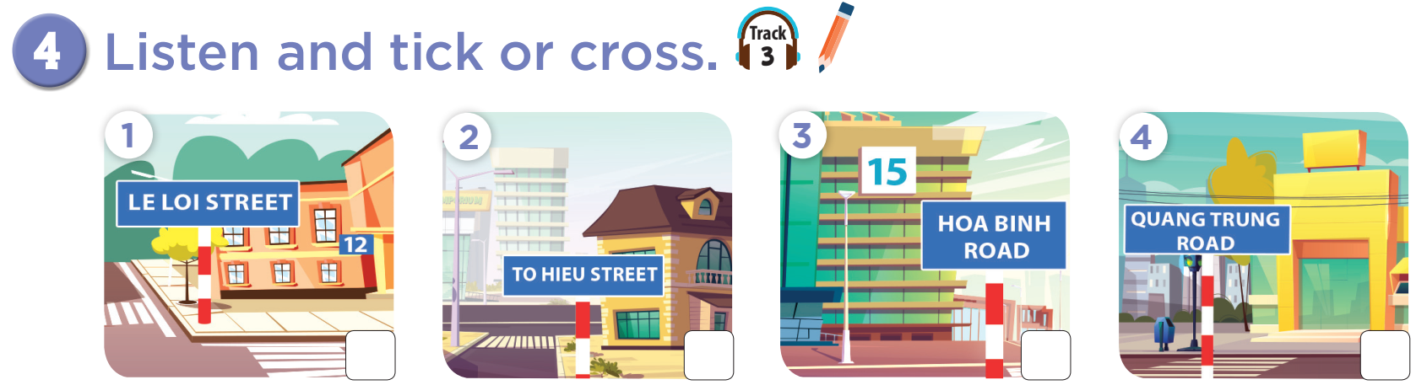  - Play the recording all the way through for pupils to listen. Play the recording again for them to do the task by ticking or crossing the correct pictures. Then play it a third time for pupils to check and complete the activity.  - Get pupils to swap books with a partner to check their answers before checking as a class. Correct the answers, if necessary.  Extension: If time allows, play the recording, sentence by sentence, for pupils to listen and repeat individually and in chorus. Correct their pronunciation where necessary.  Picture cues:  1. A house at 12 Le Loi Street 2. A house in To Hieu Street  3. A house at 15 Hoa Binh Road 4. A house in Quang Trung Road  Audio script:  1. A: Where do you live?  B: I live at 12 Le Loi Street.  2. A: Where do you live?  B: I live in To Hieu Road.  3. A: Where do you live?  B: I live at 50 Hoa Binh Road.  A: 50 Hoa Binh Road.  4. A: I live in Quang Trung Road.  B: Quang Trung Street?  A: No. Quang Trung Road  Key: 1. ✓ 2. x 3. x 4. ✓  - The disabled: Do Ex.4, following the teacher’s guide.  Activity 2-5. Look, complete and read.  * Goal: To correctly say the phrases and use Where do you live? – I live _____. to ask and answer questions about where someone lives.  * Procedure:  - Model Exchange 1. Have pupils read the exchange and guess the missing word in the answer. Then draw pupils’ attention to the picture and elicit the number to fill in the gap (35).  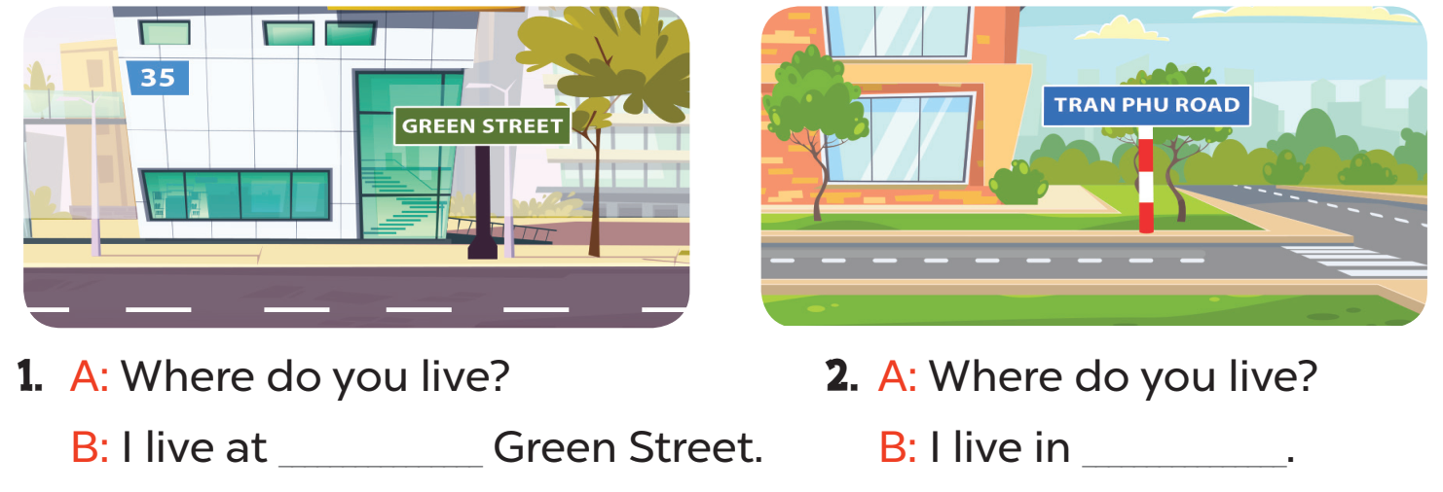  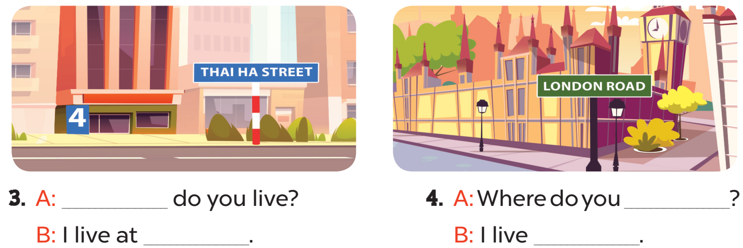  - Give pupils time to do the task independently. Go around the classroom to offer help where necessary.  - Get pupils to swap books with a partner and check their answers before checking as a class. Nominate a pupil to write the answers on the board. Give further support to those pupils who find it difficult to do the task.  - Invite four pairs of pupils to act out four completed exchanges in front of the class. Correct their pronunciation where necessary.  Key:  1. 35  2. Tran Phu Road  3. Where; 4 Thai Ha Street.  4. live; in London Road  Activity 3-6. Let’s play.  * Goal: To practise the target vocabulary and sentence patterns by playing the game Whispering.  * Procedure:  - Invite two or three teams of four pupils to the front. Each team makes a line.  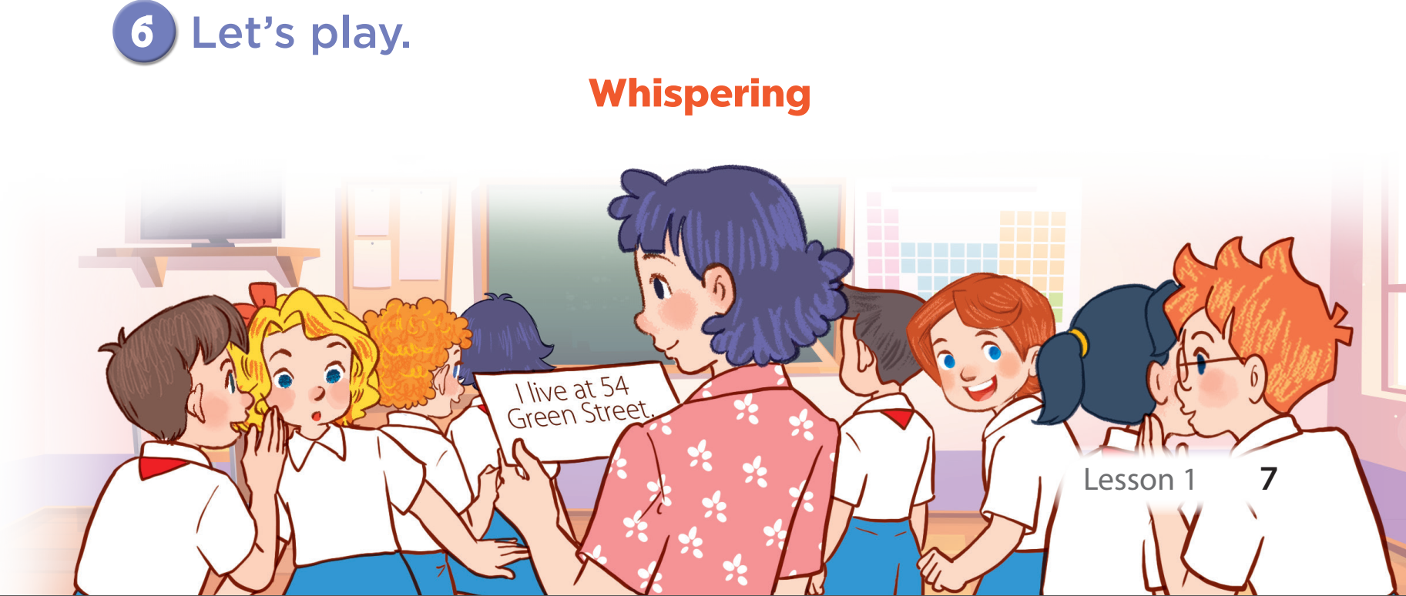  - Show a sentence to the last pupil of each team. Ask them to whisper the sentence to the next pupil. The pupil continues whispering until the one at the front of the line gets the sentence. The pupil at the front of the line shouts out the sentence or writes the sentence on the board. If it is correct, the team gets one star.  - Play the game with other teams in the class.  Game: Bomstar  - Pupils choose a number and answer the question if they have the correct answer they will get 1 point for their team.  3. Consolidation (3’)  Integrated Digital Competence (2.1CB2a): Situation: Teacher asks: "If you want to invite your friend to your house but they are far away, how can you send them your address using a phone/tablet?"  - Selection: Guide pupils to select simple ways: "We can send a text message (SMS/Zalo) or a voice message."  Action: Ask pupils to work in pairs, holding imaginary phones. One pupil asks "Where do you live?" via video call style. The other chooses to "type" or "record" the answer: "I live at [their real address]."  - Ask students to answer the following questions:  1. What have you learnt from the lesson today?  2. What are the core values of the lesson?  4. Homework (2’)  - Redo Ex.4, 5 ad do parts A, B in the workbook at home.  - Prepare the new lesson: Lesson 2 (1,2,3) of Unit 11. | - Listen to the techer  - Whole class/ Pair work  - Whole class/Individual work  - Listen to the T's instruction  - Listen to the recording  - Individual work  - Listen and correct  - Listen to the T's instruction  - Individual work  - Listen to the teacher  Whole class/ Individual work  - Pair work  - Practice in front of class  - Work in groups  - Listen to the T's instruction.  - Play game in group  Whole class/ Individual work
D. Recommendation:
…………………………………………………….….……………………………
………………………………………………………………………………………………………………………………………………………………………………………………
WEEK 19
Class | Date of teaching
4A | January 16th, 2025
4B | January 17th, 2025
4C | January 16th, 2025
PERIOD 75

UNIT 11: MY HOME
LESSON 2 (1-3)
A. OBJECTIVES:
By the end of the lesson, pupils will be able to:
1. Knowledges:
By the end of the lesson, pupils will be able to:
- Understand and correctly repeat the sentences in two communicative contexts (pictures) in which characters ask and answer the question about what a place is like.
- Correctly say the phrases and use What’s the _____ like? – It’s _____. to ask and answer questions about what a place is like.
- Enhance the correct use of What’s the _____ like? – It’s _____. to ask and answer questions about what a place is like in a freer context.
2. Skills: Listening and speaking
3. Attributes:
- Show their pride about their places/ address.
4. Digital Competence (2.1CB2b):
- Identify appropriate communication means (e.g., messaging, video call, location sharing) to ask about the location of objects or places.
B. INSTRUCTIONAL RESOURCES
- Student’s book: Page 8
- Audio tracks 5,6
- Teacher’s guide: Pages 162, 163, 164
- Flash cards/ pictures and posters (Unit 11)
- Hoclieu.vn
- Computer, projector
C. LEARNING PLAN:
Teacher’s activities | Student’s activities
1. Warm up (5’)  - Greet the class, then play the game Whispering with the vocabulary and sentences in Period 2.  - Get pupils to open their books at page 8 and look at Unit 11, Lesson 2, Activity 1. Tell pupils what they will learn in this lesson.  2. Presentation (10’)  Activity 1-Vocabulary  * Goals: Ss will be able to know the vocab, before starting the new lesson.  * Procedure:  - T elicits the new words  + busy : nhộn nhịp (picture)  + quiet : yên tĩnh (picture)  + noisy : ồn ào (picture)  + big : to/lớn (picture)  - T models (3 times).  - T writes the words on the board.  - Checking: Rub out and remember  - The disabled: Practice reading vocab.  Activity 2-1. Look, listen and repeat.  * Goal: To understand and correctly repeat the sentences in two communicative contexts (pictures) in which characters ask and answer the question about what a place is like.  * Procedure:  - Ask pupils to look at Pictures a and b and identify the characters and predict  what they are talking about (e.g. Bill’s house, Minh’s house, the street, the road).  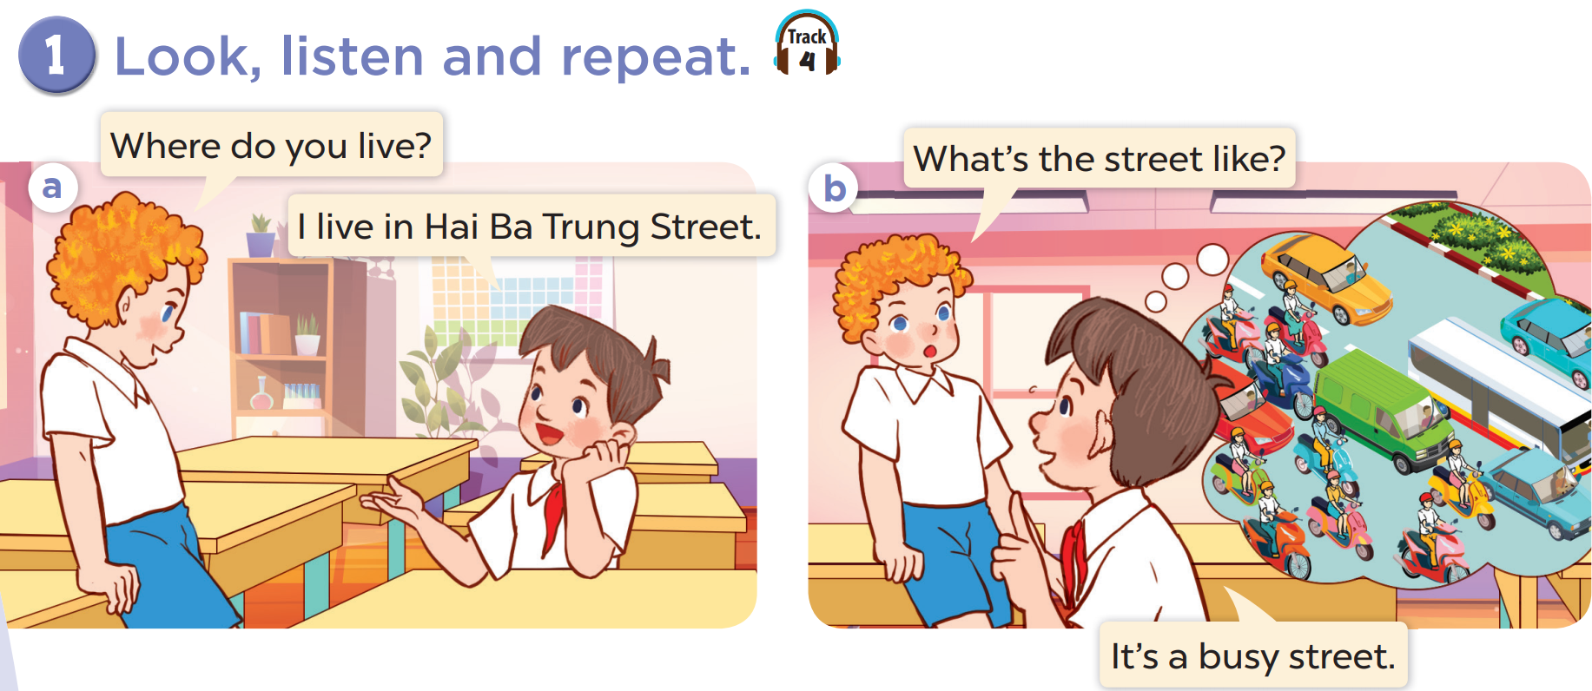  - Ask pupils to look at Picture a. Play the recording for them to listen and check the prediction. Play the recording again, sentence by sentence, for pupils to listen and repeat after each character. Correct their pronunciation where necessary. Repeat the same procedure with Picture b.  - Invite a few pairs to the front of the class to listen to and act out the exchanges.  - Draw pupils’ attention to the question What’s the street like? and the answer It’s a busy street. Explain that they are used to ask and answer about what a place is like.  3. Practice (15’)  Activity 3-2. Listen, point and say.  * Goal: To correctly say the phrases and use What’s the _____ like? – It’s _____. to ask and answer questions about what a place is like.  * Procedure:  - Ask pupils to look at Pictures a, b, c and d and identify the places in the pictures. Have pupils describe what they can see in each picture.  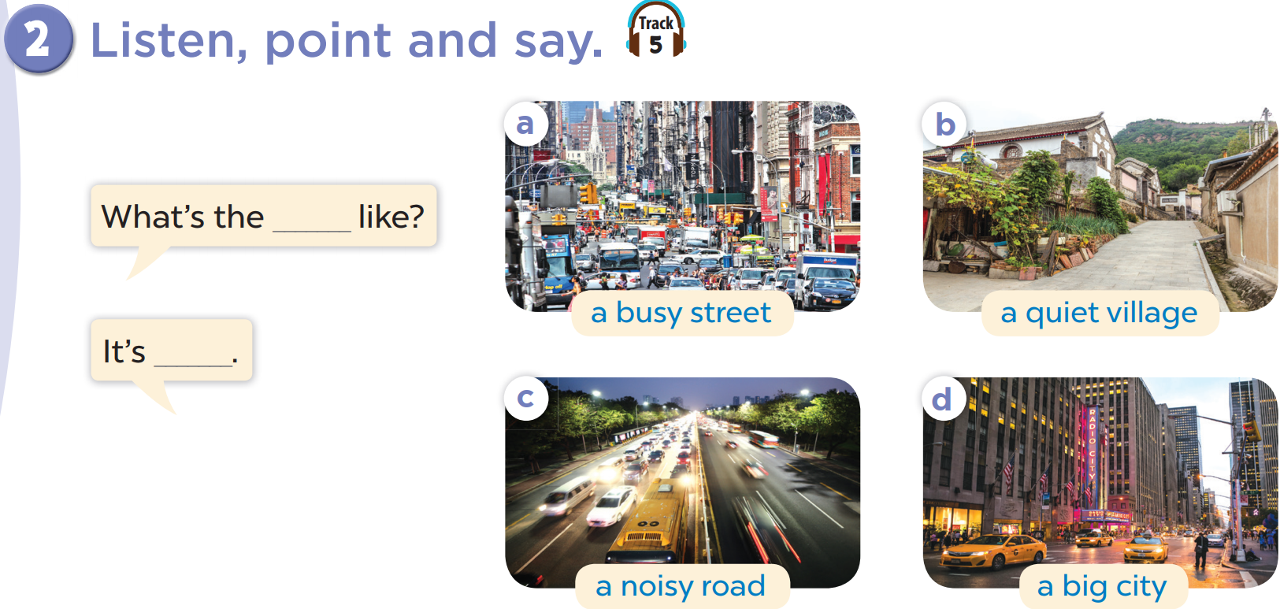  - Play the recording for pupils to listen to and repeat the phrases in chorus and individually until they feel confident. Use the flash cards for a busy street, a quiet village, a noisy road and a big city to practise the phrases.  - Draw pupils’ attention to the speech bubbles and elicit the missing words and phrases in the question and answer by pointing at Picture a. Play the recording for pupils to repeat the sentences in both bubbles a few times. Repeat Step 3 with Pictures b, c and d.  - Let pupils point at the pictures and say the sentences in pairs. Go around the classroom to offer help if necessary.  Extension: Invite a few pairs to act out the exchanges in front of the class.  – Picture cues:  a. a busy street b. a quiet village c. a noisy road d. a big city  – Speech bubbles: What’s the _____ like? – It’s _____.  Audio script:  a. a busy street b. a quiet village  c. a noisy road d. a big city  a. A: What’s the street like?  B: It’s a busy street.  b. A: What’s the village like?  B: It’s a quiet village.  c. A: What’s the road like?  B: It’s a noisy road.  d. A: What’s the city like?  B: It’s a big city  Activity 4-3. Let’s talk.  * Goal: To enhance the correct use of What’s the _____ like? – It’s _____. to ask and answer questions about what a place is like in a freer context.  - Integrated Digital Competence (2.1CB2b): Teacher sets a situation: "If you want to ask a friend about the location of a new vase in their house or describe your street to a distant friend, which means of communication would be appropriate?" Guide pupils to identify suitable means (e.g., Video call to show the object/street, sending a photo via Zalo/Messaging apps).  * Procedure:  - Ask pupils to look at the pictures and elicit the phrase to describe the place in each picture.  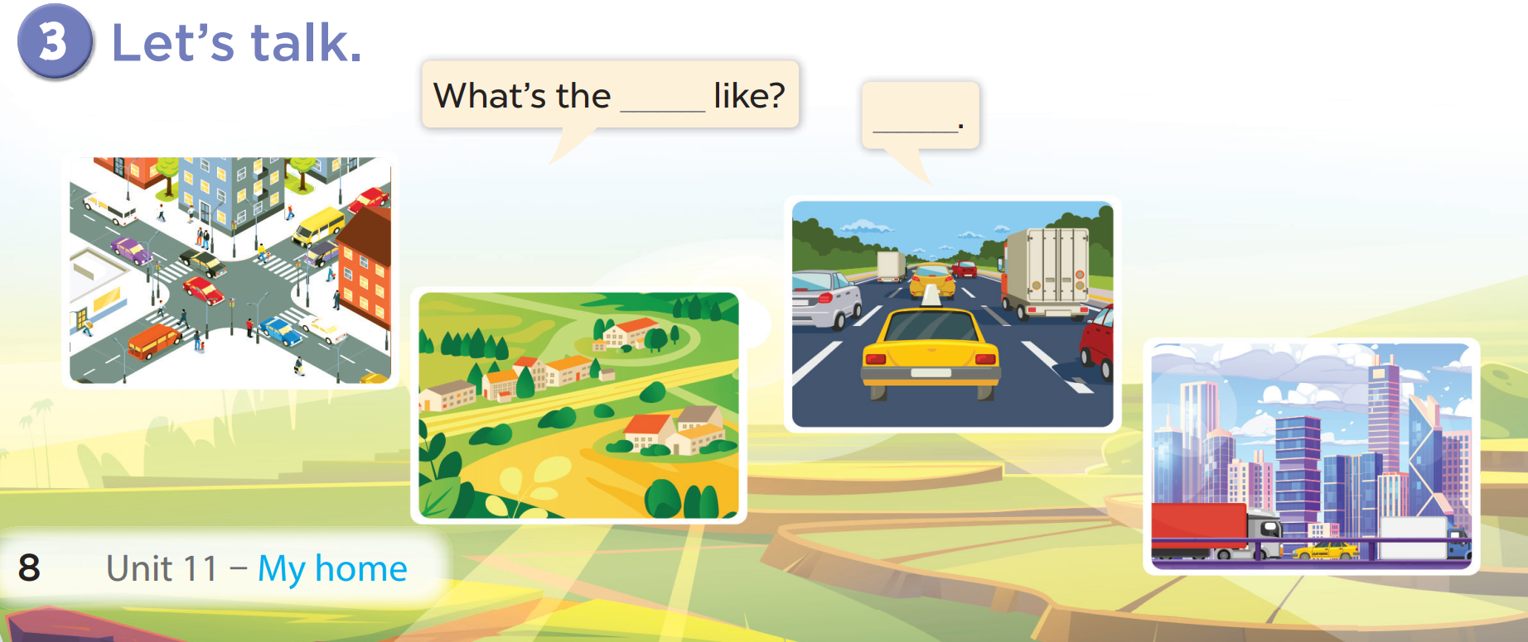  - Give pupils time to work in pairs and take turns pointing at the picture and asking What’s the _____ like? and answering about what the place is like.  - Pupils can use the pictures or part of a picture to ask questions. For example, they can point at a street in the city and ask What’s the street like?.  - Invite a few pairs to come to the front of the class and act out the roles.  Game: Reveal the picture  - Pupils take turns opening one piece of the picture, and whoever has the first correct answer will get one point for their team.  4. Consolidation (3’)  - Ask students to answer the following questions:  1. What have you learnt from the lesson today?  2. What are the core values of the lesson?  5. Homework (2’)  - Learn vocab and structure by heart.  - Prepare the new lesson: Lesson 2 (4,5,6) of Unit 11. | - Listen to the techer  Whole class/ Individual work  - Whole class/Individual work  - Ss listen and repeat  + Choral repetition (3 times).  + Individual repetition (3 ss)  - Ss take note  - Ss look, remember and write  - Listen to the T's instruction  – Context a: Bill: Where do you live? Minh: I live in Hai Ba Trung Street.  – Context b: Bill: What’s the street like? Minh: It’s a busy street.  - Listen to the recording  - Individual  work  - Listen and repeat  - Pair work  - Listen to the T's instruction  - Listen to the teacher  Whole class/ Individual work  - Listen and repeat  - Pair work  - Listen to the teacher  - Pair work  - Listen to the T's instruction.  - Play in group  - Whole class/ Individual work
D. Recommendation:
…………………………………………………….….……………………………
………………………………………………………………………………………………………………………………………………………………………………………………

WEEK 19
Class | Date of teaching
4A | January 16th, 2025
4B | January 17th, 2025
4C | January 16th, 2025
PERIOD 76
UNIT 11: MY HOME
LESSON 2 (4-6)
A. OBJECTIVES:
By the end of the lesson, pupils will be able to:
1. Knowledges:
By the end of the lesson, pupils will be able to:
- Listen to and understand two communicative contexts in which characters ask and answer questions about what a place is like and tick the correct pictures.
- Complete two gapped exchanges with the help of picture cues.
- Sing the song My house with the correct pronunciation, rhythm and melody.
2. Skills: Listening and reading
3. Attributes:
- Show their pride about their places/ address.
4. Digital Competence (1.2CB2a):
- Detect the accuracy of the location information heard (from the digital audio recording) by comparing it with visual data (pictures).
B. INSTRUCTIONAL RESOURCES
- Student’s book: Page 9
- Audio tracks 7,8
- Teacher’s guide: Pages 149,150,151
- Flash cards/ pictures and posters (Unit 11)
- Hoclieu.vn
- Computer, projector
C. LEARNING PLAN:
Teacher’s activities | Student’s activities
1. Warm up (5’)  - Greet the class, then use the flash cards to revise the words and phrases in Activities 2  on pages 6 and 8.  - Get pupils to open their books at page 9 and look at Unit 11, Lesson 2, Activity 4.  - Integrated Digital Competence (1.2CB2a): Play the recording all the way through for pupils to listen. Guide pupils to evaluate the information heard from the audio (digital source) and compare it with the images to detect the accuracy of the location description, then choose the correct picture.  2. Practice (25’)  Activity 1-4. Listen and tick.  * Goal: To listen to and understand two communicative contexts in which characters ask and answer questions about what a place is like and tick the correct pictures.  * Procedure:  - Draw pupils’ attention to the pictures and ask questions to elicit the words and phrases to describe the pictures. Remind them to look at each pair of pictures to compare.  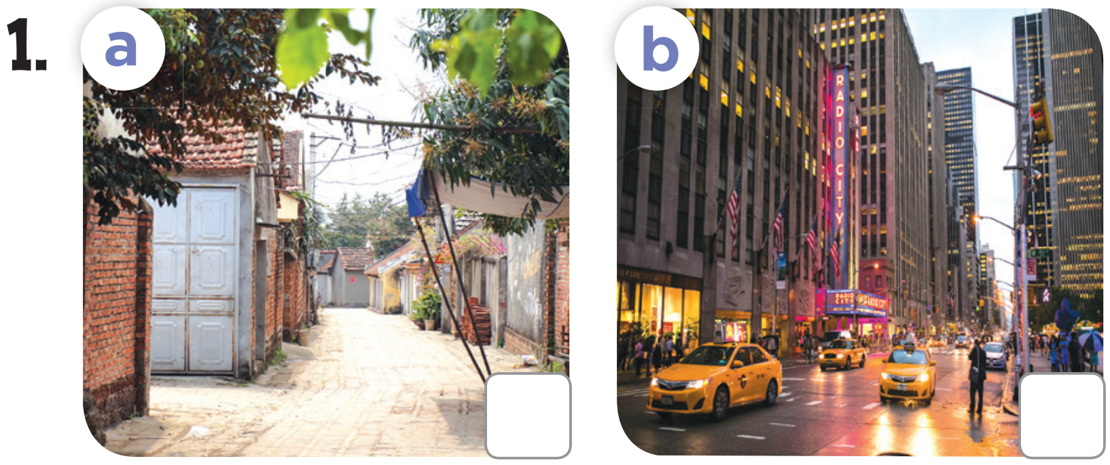  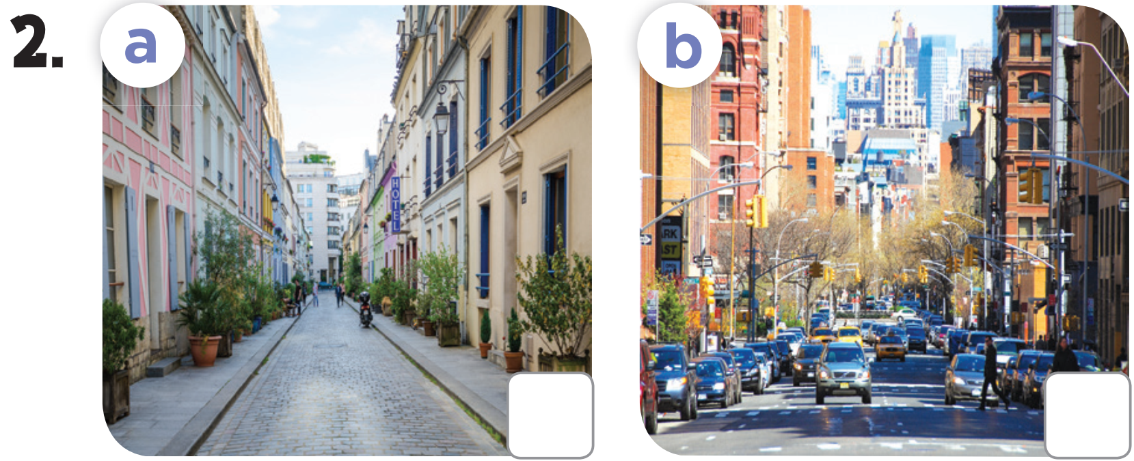  - Play the recording all the way through for pupils to listen. Play again for them to do the task by choosing the places the speakers are talking about. Then play the recording a third time for them to check and complete the activity.  - Get pupils to swap books with a partner to check their answers before checking as a class. Correct the answers, if necessary.  Extension: If time allows, play the recording, sentence by sentence, for pupils to listen and repeat individually and in chorus. Correct their pronunciation where necessary.  Picture cues:  1a. a small village 1b. a big city  2a. a quiet street 2b. a busy street  Audio script:  1. A: Where do you live?  B: I live in a city.  A: What’s the city like?  B: It’s a big city.  2. A: Where do you live?  B: I live in High Street.  A: What’s the street like?  B: It’s a quiet street.  Key: 1. b 2. a  Activity 2-5. Look, complete and read.  * Goal: To complete two gapped exchanges with the help of picture cues.  * Procedure:  - Model the first gapped sentence. Have pupils read the sentence and guess the missing words. Then draw pupils’ attention to the picture and elicit the house number  to complete the answer.  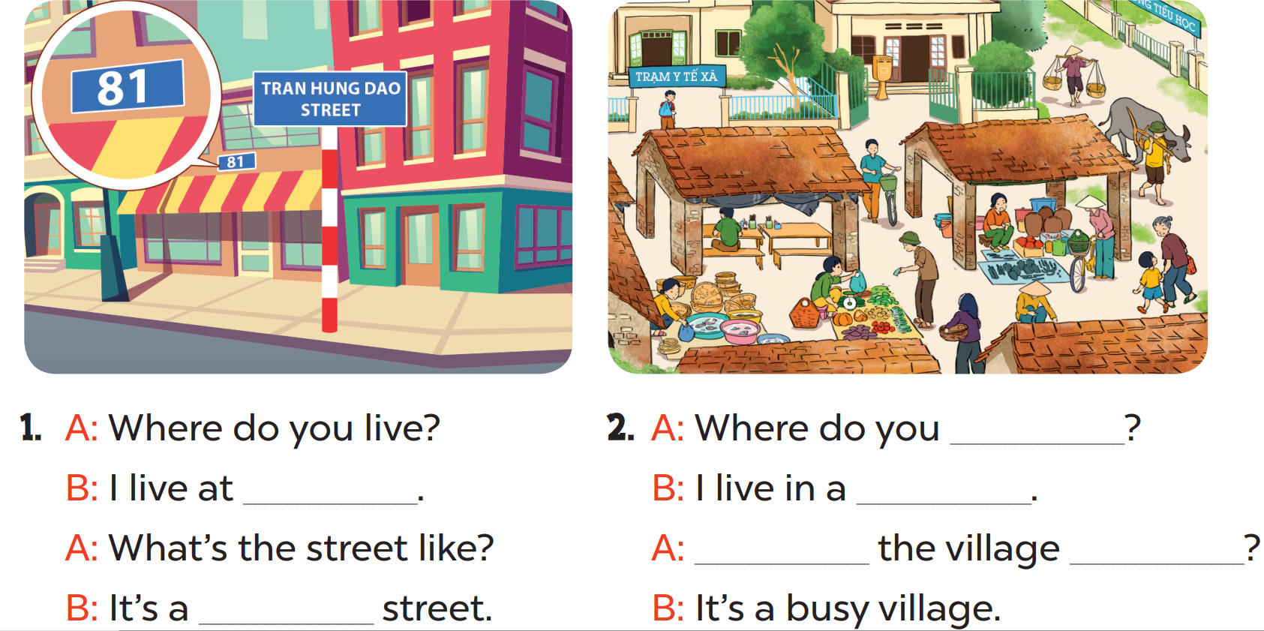  - Give pupils a time limit to read the gapped sentences, look at the pictures and fill in the gaps independently. Go around the classroom and give further support to pupils who find it difficult to do the task.  - Get pupils to swap books with a partner and check their answers before checking as a class. Invite one pupil to write the answers on the board.  Extension: Invite two pairs of pupils to act out the completed exchanges in front of the class.  Key:  1. 81 Tran Hung Dao Street/quiet  2. live/village/What’s/like  Activity 3-6. Let’s sing.  * Goal: To sing the song My house with the correct pronunciation, rhythm and melody.  * Procedure:  - Draw pupils’ attention to the title and the lyrics of the song. Encourage them to point at the places in the pictures to reinforce their understanding.  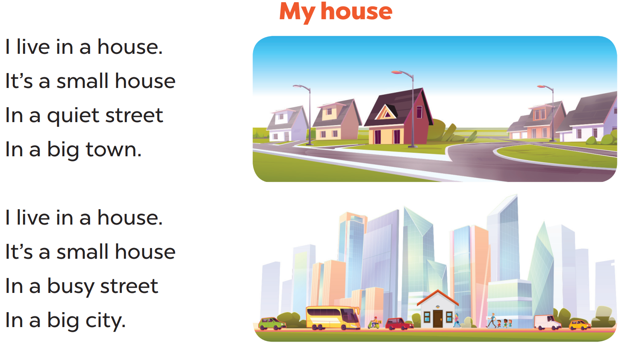  - Have pupils read the first verse of the lyrics.  - Explain that the first verse is about a house in a town. Have pupils listen to the first verse, drawing their attention to the pronunciation, rhythm and melody. Then let them listen to and practise singing it, line by line, while making gestures for small, quiet and big  - Repeat Steps 1 and 2 for the second verse. Explain that it is about a house in a city. Check comprehension and give feedback.  - Ask pupils to listen to and sing the whole song while making gestures. Go around the classroom and offer help if necessary.  - Invite a few groups to the front of the class to sing the song. The class may sing along and clap to reinforce the activity.  Game: Sentence Puzzle  - Divide the class into groups of four. Give each group a sentence that is broken/cut into pieces. Ask them to arrange the words to make a complete sentence, then read it aloud.  3. Consolidation (3’)  - Ask students to answer the following questions:  1. What have you learnt from the lesson today?  5. Homework (2’)  - Redo Ex.4, 5 and do parts C, D in the workbook.  - Prepare the new lesson: Lesson 3 (1,2,3) of Unit 11. | - Listen to the techer  Whole class/ Individual work  - Whole class/Individual work  - Listen to the T's instruction  - Individual work  - Check  - Listen to the T's instruction  - Read and complete  - Listen to the teacher  - Whole class/ Pair work  - Listen to the teacher  - Group work  - Repeat  - Listen to the T's instruction.  - Play in group  - Whole class/ Individual work
D. Recommendation:
…………………………………………………….….……………………………
………………………………………………………………………………………………………………………………………………………………………………………………

WEEK 20
Class | Date of teaching
4A | January 21st, 2025
4B | January 22nd, 2025
4C | January 21st, 2025

PERIOD 77
UNIT 11: MY HOME
LESSON 3 (1-3)
A. OBJECTIVES:
By the end of the lesson, pupils will be able to:
1. Knowledges:
By the end of the lesson, pupils will be able to:
- Correctly pronounce the sounds of the letters i and ee in isolation, in the words big and street, and in the sentences They live in a big village., and They live in Green Street.
- Identify the specific information by listening 2 sentences to identify the target word;
- Perform the chant in interesting ways, using appropriate and meaningful gestures;
2. Skills: Listening
3. Attributes:
- Show their pride about their places/ address.
4. Digital Competence (1.1CB2d):
- Identify simple search strategies to find digital content related to the new sounds /i/ and /ee/ (e.g., identifying correct keywords like "sound i", "sound ee", "English phonics" to search on the Internet/Youtube).
B. INSTRUCTIONAL RESOURCES
- Student’s book: Page 10
- Audio tracks 9,10,11
- Teacher’s guide: Pages 151,152
- Flash cards/ pictures and posters (Unit 11)
- Hoclieu.vn
- Computer, projector
C. LEARNING PLAN:
Teacher’s activities | Student’s activities
1. Warm up (5’)  - Greet the class, then sing the song My house on page 9.  - Get pupils to open their books at page 10 and look at Unit 11, Lesson 3, Activity 1.  - Tell them what they will learn in this lesson.  2. Presentation (10’)  Activity 1-1. Listen and repeat.  * Goal: To correctly repeat the sounds of the letters i and ee in isolation, in the words big and street, and in the sentences They live in a big village. and They live in Green Street. with the correct pronunciation and intonation.  - Integrated Digital Competence (1.1CB2d): Ask pupils: "If you want to find a video to practice these sounds (i, ee) again at home on the computer or phone, what would you type in the search bar?"  - Guide pupils to identify simple search strategies by choosing the right keywords (e.g., "sound i and ee", "English pronunciation big street").  * Procedure:  - Have pupils point at the letter i, the word big, and the sentence They live in a big village. Play the recording for them to listen and repeat in chorus and individually until they feel confident. Correct their pronunciation when necessary.  - Invite a few pupils to listen to and repeat the sound, the word and the sentence in front of the class. Praise them when their pronunciation is good.  - Repeat Steps 1 and 2 for the letters, the word and the sentence in the second line. Go around the classroom and correct their pronunciation if necessary.  - Let pupils work in pairs or groups, pronouncing the sounds, saying the words, and reading the sentences until they feel confident.  - The disabled: Correctly pronounce the sounds of the letters i and ee in isolation, following the teacher’s guide.  3. Practice (15’)  Activity 2-2. Listen and circle.  * Goal: To identify the target words big and street while listening.  * Procedure:  - Tell pupils the goal of the activity. Explain that they have to listen to the recording and circle the correct options. Check comprehension.  - Get pupils to read the options and guess the sentences they may hear in the recording.  - Play the recording for pupils to listen to. Play the recording again for them to do the task by circling the correct options. Play a third time for them to double-check their answers. Get pupils to swap books with a partner and check their answers before checking as a class.  - Invite a few pupils to read aloud all the options in front of the class. Go around the classroom and correct their pronunciation if necessary.  Audio script:  1. I am in a big town.  2. He is at Green Hotel.  Key: 1. a 2. b  Activity 3-3. Let’s chant.  * Goal: To say the chant with the correct pronunciation and rhythm.  * Procedure:  - Have pupils look at the pictures and tell what they can see in the pictures and predict what the pupils can do. Play the recording and have pupils check the prediction.  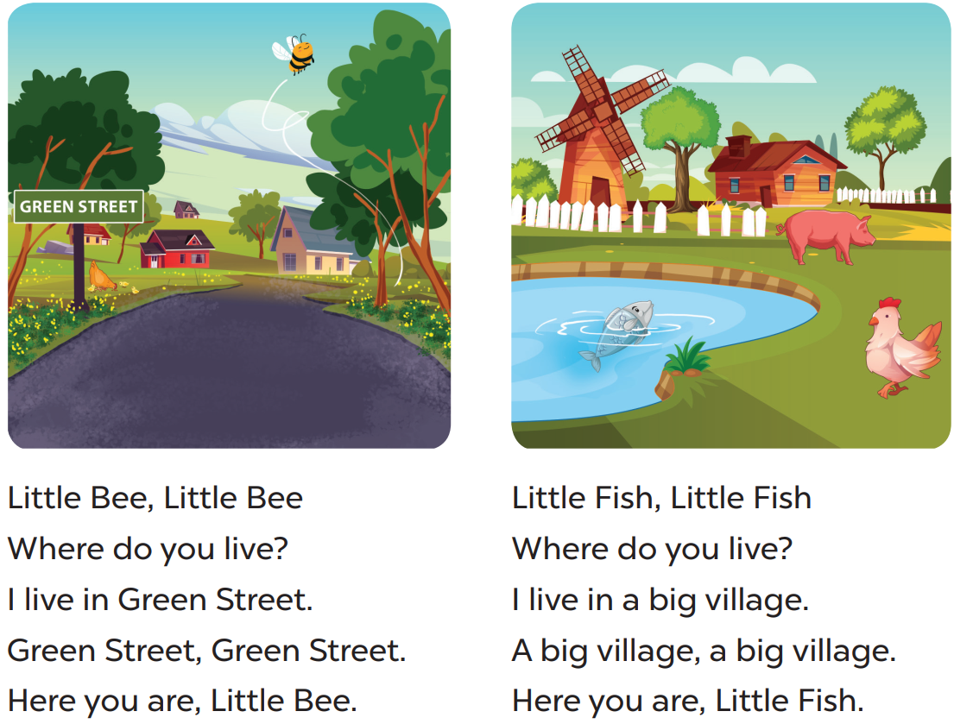  - Have pupils read the first verse of the chant and draw their attention to the sounds of the letters i and ee, the words with the sounds such as live, in, Little, Bee, Green, and Street. Check comprehension.  - Play the recording of the first verse for pupils to be familiar with the chant. Play the recording again, line by line, for pupils to listen and repeat. Draw their attention tothe rhythm and pronunciation. Encourage them to clap while chanting.  - Repeat Steps 2 and 3 with the second verse of the chant. Draw pupils’ attention to the sounds of the letters i and ee, the words with the sounds such as live, in, big, village, Little and Fish.  - Play the recording all the way through for pupils to chant and clap.  Game: Spin the wheel  - Pupils spin the wheel and say the words with the target sound.  4. Consolidation (3’)  - Ask students to answer the following questions:  1. What have you learnt from the lesson today?  2. What are the core values of the lesson?  5. Homework (2’)  - Practice reading the chant at home.  - Prepare the new lesson: Lesson 3 (4,5,6) of Unit 11. | - Listen to the techer  Whole class/ Individual work  - Whole class  - Listen to the T's instruction  - Listen and repeat  - Pair work  - Listen to the teacher  - Whole class/ Individual wor  - Pair work  - Listen to the teacher  - Group work  - Listen and repeat  - Listen to the T's instruction.  - Play in group  - Whole class/ Individual work
D. Recommendation:
…………………………………………………….….……………………………
………………………………………………………………………………………………………………………………………………………………………………………………
WEEK 20
Class | Date of teaching
4A | January 21st, 2025
4B | January 22nd, 2025
4C | January 21st, 2025

PERIOD 78
UNIT 11: MY HOME
LESSON 3 (4-6)
I. OBJECTIVES:
By the end of the lesson, pupils will be able to:
1. Knowledges:
By the end of the lesson, pupils will be able to:
- Identify the specific information by scanning the text and circle the correct answers;
- Write about a student’s home;
- Present picture to the class at the Project time.
2. Skills: Reading and writing
3. Attributes:
- Show their pride about their places/ address.
4. Digital Competence (3.1CB2a):
- Create simple digital content (Draw/Describe the house using simple drawing software like Paint or typing text).
B. INSTRUCTIONAL RESOURCES
- Student’s book: Page 11
- Teacher’s guide: Pages 152,153,154
- Flash cards/ pictures and posters (Unit 11)
- Hoclieu.vn
- Computer, projector
C. LEARNING PLAN:
Teacher’s activities | Student’s activities
1. Warm up (5’)  - Greet the class, then invite one or two groups of pupils to the front of the class to say the chant in Lesson 3, Activity 3. The rest of the class may chant and clap along.  - Ask pupils to open their books at page 11 and look at Unit 11  2. Practice (25’)  Activity 1-4. Read and circle.  * Goal: To read and show the understanding of the text by circling the correct options to fill in the blanks.  * Procedure:  - Tell pupils the goal of the activity and explain that they should read the text and circle the correct options to complete the gapped sentences. Check comprehension.  - Do Sentence 1 as an example. First, have pupils read Sentence 1 and decide what information they need to find in the text. Then, have them read the text carefully and find the information about the flat where the writer lives to decide if option a or b is correct. Circle the correct option.  - Set a time limit for pupils to do the task independently. Go around the classroom and offer help if necessary.  - Get pupils to swap their books with a partner and check their answers before checking as a class. Correct the answers where necessary.  Extension: Invite one or two pupils to read the text in front of the class. Correct their pronunciation where necessary  - The disabled: Do Ex.4, following the teacher’s guide.  Key: 1. b 2. a 3. b 4. a  Activity 2-5. Let’s write.  * Goal: To use the target language to complete a gapped text about the place where pupils live.  * Procedure:  - Tell the class the goal of the activity and explain that they should read the gapped text and fill in the gaps with their own information. Explain that the gaps in the text focus on the place pupils live in. Check comprehension.  - Have pupils do the first gapped sentence together as an example. Ask them to read the first sentence and elicit the words (e.g. house, flat). Then have them write it in the gap.  - Give pupils time to complete the text independently. Go around the classroom and offer help if necessary.  - Get pupils to swap their books with a partner, check and read their friend’s writing.  Suggested answer:  I live in a small house with my family. It is in a small village. It is very peaceful and quiet. There are not many trees, but there is a small garden with beautiful flowers. I love my house so much.  Extension: Invite one or two pupils to read their completed texts in front of the class. Check pronunciation if necessary.  Activity 3-6. Project.  * Goal: To draw a picture of the place where they live and present it to the class, using thetarget language.  - Integration of Digital Competence (3.1CB2a): Guide pupils to choose one of two ways to create content: 1. Draw a picture of their house on paper as usual. 2 (Digital): Use a simple drawing application (like MS Paint on computer/tablet) to draw their house OR use a word processor to type the description of their house.  * Procedure:  - Tell pupils the goal of the activity. Explain the project again that pupils are introducing their home.  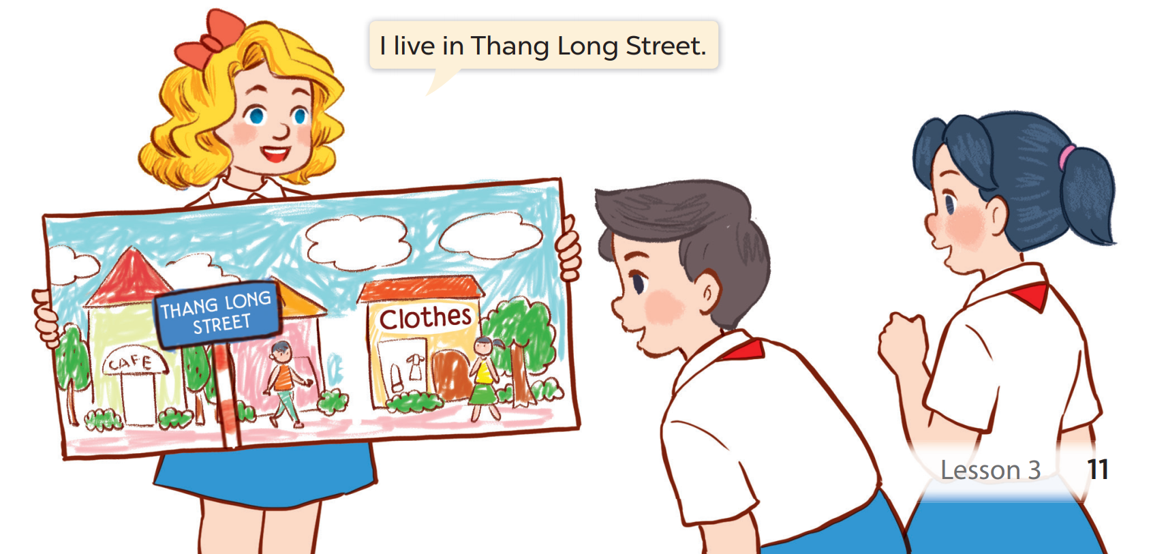  - Pupils draw a picture of the place (street, road, village, etc.) where they live and prepare how to present it at home. They should talk at least five sentences about where they live. Ask pupils to show their completed pictures that they have prepared at home and present them to the class.  - Use Mary’s presentation as an example. Act as Mary to make a presentation, for example, “I live in Thang Long Street. It is a small street. There are some shops. There are many trees. I like my street.”  - Have pupils work in their groups. Each pupil shows his or her picture and talks about it. Go around the classroom and offer help if necessary.  - Invite a few pupils to show the pictures and make a presentation about their beautiful homes. Praise pupils when they do the task well.  Game: George beats the dragon  - Pupils take turns to answer the quiz. They will get 1 point if they have the correct answer.  3. Consolidation (3’)  - Ask students to answer the following questions:  1. What have you learnt from the lesson today?  2. What are the core values of the lesson?  5. Homework (2’)  - Redo Ex.4, 5 at home.  - Prepare the new lesson: Lesson 1 (1,2,3) of Unit 12. | - Listen to the techer  Whole class/ Individual work  - Whole class/Individual work  - Listen to the T's instruction  - Whole class/Do the task independently  - Listen to the T's instruction  - Whole class/ Individual work  - Pair work  - Listen to the teacher  - Play in group  - Listen to the T's instruction.  - Whole class/ Individual work
D. Recommendation:
WEEK 20
Class | Date of teaching
4A | January 23rd, 2025
4B | January 24th, 2025
4C | January 23rd, 2025

PERIOD 79
UNIT 12: JOBS
LESSON 1 (1-3)
A. OBJECTIVES:
By the end of the lesson, pupils will be able to:
1. Knowledges:
By the end of the lesson, pupils will be able to:
- Understand and correctly repeat the sentences in two communicative contexts in which pupils ask and answer the questions about the job of a family member.
- Correctly say the words and use What does he / she do? – He’s / She’s _____. to ask and answer questions about jobs.
- Enhance the correct use of What does he / she do? – He's / She's _____. to ask and answer questions about jobs in a freer context.
2. Skills: Listening and speaking
3. Attributes:
- Show pride in what they can do and great respect for other people’s abilities by using appropriate gestures and intonation when asking and answering about abilities.
4. Digital Competence (1.1CB2b):
- Find data, information, and content through simple search (specifically finding images or information about jobs for the project).
B. INSTRUCTIONAL RESOURCES
- Student’s book: Page 12
- Audio tracks 12, 13
- Teacher’s guide: Pages 155-157
- Hoclieu.vn
- Flash cards/ pictures and posters (Unit 12)
- Computer, projector
C. LEARNING PLAN:
Teacher’s activities | Student’s activities
1. Warm up (5’)  - Greet the class and encourage pupils to respond to the greeting.  Option 1: Guess the job (powerpoint)  Option 2: miming game  - Ask pupils to think about jobs, name one thing related to the job they choose, ask the rest to say the name of the job their friend describes. If possible, prepare some working tools for a policeman (a hat/ white gloves…), a farmer, an office worker and an actor to make the game more exciting.  2. Presentation (10’)  Activity 1-Vocabulary  * Goals: Ss will be able to know the vocab, before starting the new lesson.  * Procedure:  - T elicits the new words  + policeman : công an (picture)  + office worker : nhân viên VP (picture)  + actor : diễn viên nam (picture)  - T models (3 times).  - T writes the words on the board.  - Checking: Rub out and remember  - The disabled: Practice reading vocab.  Activity 2-1. Look, listen and repeat.  * Goal: To understand and correctly repeat the sentences in two communicative contexts in which pupils ask and answer the questions about the job of a family member.  * Procedure:  - Ask pupils to look at Pictures a and b and identify the characters in the pictures. Ask Who is he / she? and Where is he / she?  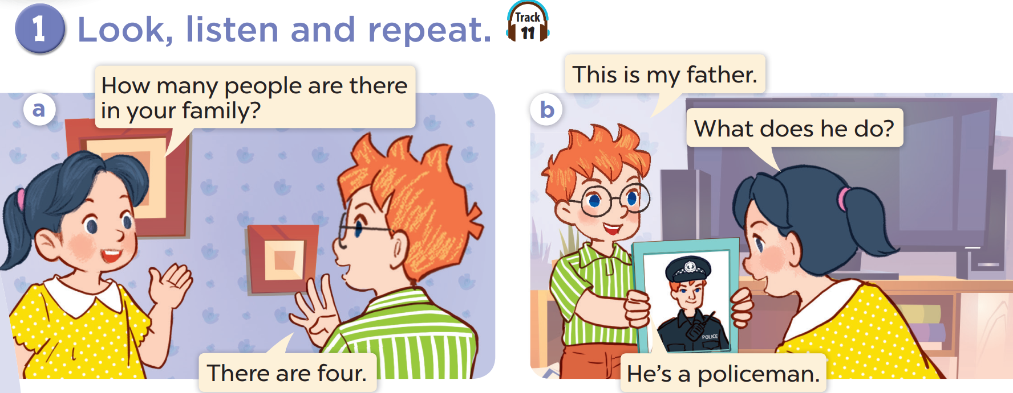  - Ask pupils to look at Picture a. Play the recording for them to listen. Play the recording again, sentence by sentence, for pupils to listen and repeat. Repeat the same procedure with Picture b. Correct their pronunciation where necessary.  - Play the recording again, sentence by sentence, for pupils to listen, point at the sentences and repeat in chorus and individually. Correct their pronunciation where necessary.  - Draw pupils’ attention to the question What does he do? and the answer He’s a policeman. Explain that they are used to ask and answer questions about jobs.  Extension: Invite a few pairs of pupils to act out the conversations in front of the class.  3. Practice (5’)  Activity 3-2. Listen, point and say.  * Goal: To correctly say the words and use What does he / she do? – He’s / She’s _____. to ask and answer questions about jobs.  * Procedure:  - Ask pupils to look at Pictures a, b, c and d and identify the jobs of the people in the pictures.  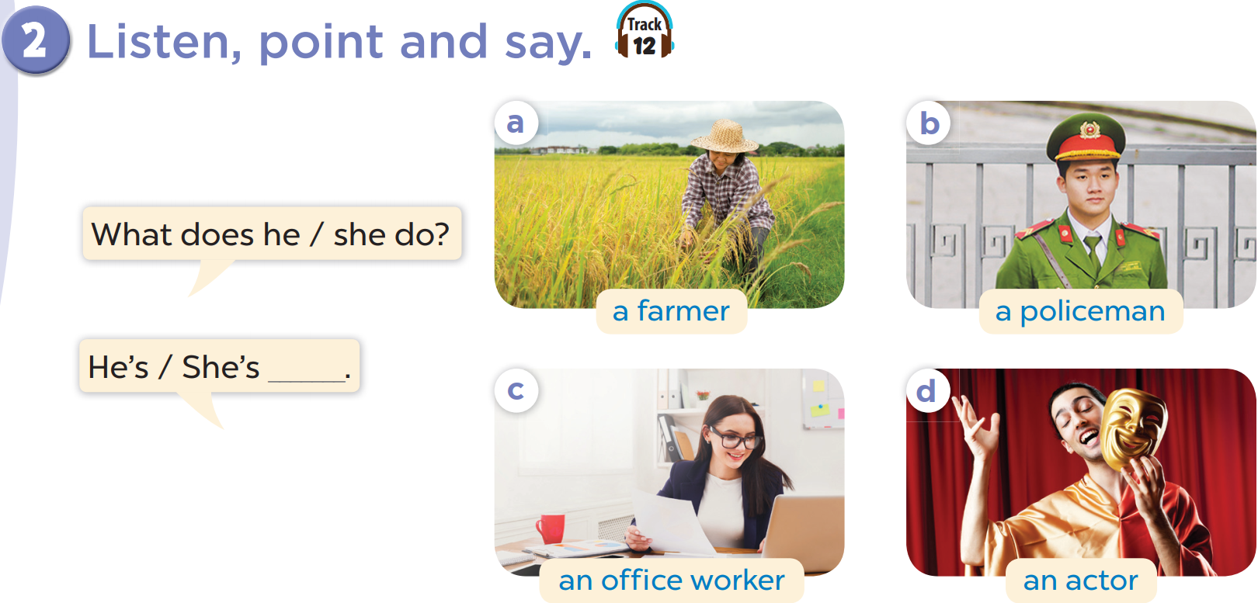  - Play the recording for pupils to listen to and repeat the phrases under the pictures in chorus and individually until they feel confident.  - Draw pupils’ attention to the speech bubbles and elicit the missing words in the answer by pointing at Picture a. Play the recording for pupils to repeat the sentences in both bubbles a few times.  - Repeat Step 3 with Pictures b, c and d. Then let pupils practise asking and answering questions in pairs. Go around the classroom to offer help if necessary.  - Invite a few pairs to point at the pictures and ask and answer questions about the jobs of the people in the pictures.  – Picture cues:  a. A woman working on a farm  b. A policeman  c. A woman working in an office  d. A man acting in a film  – Speech bubbles: What does he / she do? – He’s / She’s _____.  Audio script:  a. a farmer b. a policeman  c. an office worker d. an actor  a. A: What does she do?  B: She’s a farmer.  b. A: What does he do?  B: He’s a policeman.  c. A: What does she do?  B: She’s an office worker.  d. A: What does he do?  B: He’s an actor.  Activity 4-3. Let’s talk.  * Goal: To enhance the correct use of What does he / she do? – He's / She's _____. to ask and answer questions about jobs in a freer context.  * Procedure:  - Draw pupils’ attention to the pictures. Ask questions to help them identify the jobs of the people in the pictures (see Input).  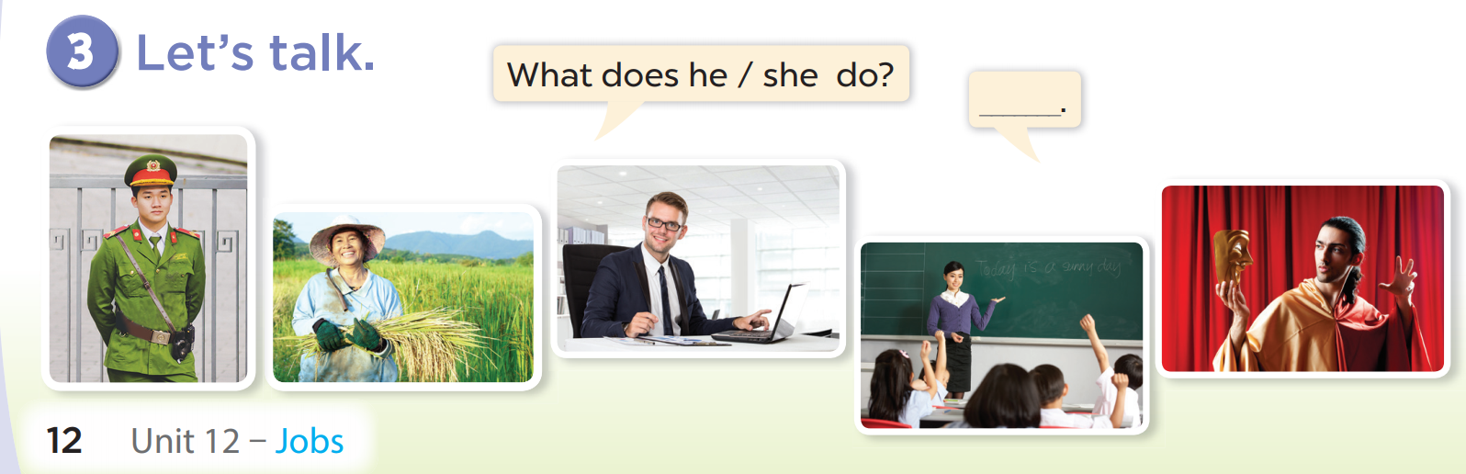  - Elicit the missing words in the speech bubble and write them on the board. Get pupils to say the completed sentence.  - Put pupils into pairs to practise the exchanges. Go around the classroom to offer support where necessary.  - Invite a few pairs to point at the pictures and ask and answer questions about the jobs of the people in the pictures.  Extension: If time allows, get a few pairs to ask and answer questions about their real family members.  4. Consolidation (3’)  - Integrated Digital Competence (1.1CB2b): Guide pupils on how to find data/images about jobs. Instruct them to use a search engine (like Google) at home with their parents to find images if they don't have photos (e.g., search keywords: "police officer photo", "doctor clip art").  - Tell pupils about the project on page 17. Ask them to prepare for it at home by collecting photos or drawing pictures of their family members, focusing on their jobs and workplaces. They should ask their parents if they do not know their parents’ jobs or workplaces. Remind pupils to bring their photos or drawings to the class at Project time in Lesson 3, Activity 6. wrap-up:  Option 1: ppt  Option 2: play an online quiziz game  Option 3: Board Games  5. Homework (2’)  - Practice reading the chant at home.  - Prepare the new lesson: Lesson 1 (4,5,6) of Unit 12. | - Listen to the techer  Whole class/ Individual work  - Whole class/Individual work  - Ss listen and answer  - Ss listen and repeat  + Choral repetition (3 times).  + Individual repetition (3 ss)  - Ss take note  - Ss look, remember and write  - Listen to the T's instruction  - Listen to the recording  - Individual work  - Listen and repeat  - Whole class/Pair work  - Listen to the T's instruction  - Listen to the teacher  Whole class/ Individual work  - Listen and repeat  - Pair work  - Listen to the teacher  - Practice in front of class  - Listen to the T's instruction.  - Whole class/ Individual work
D. Recommendation:
…………………………………………………….….……………………………
…………………………………………………………………………………………
WEEK 20
Class | Date of teaching
4A | January 23rd, 2025
4B | January 24th, 2025
4C | January 23rd, 2025

PERIOD 80
UNIT 12: JOBS
LESSON 1 (4-6)
A. OBJECTIVES:
By the end of the lesson, pupils will be able to:
1. Knowledges:
- Listen to and understand four communicative contexts in which pupils ask and answer questions about the jobs of family members.
- Complete four gapped exchanges with the help of picture cues.
- Sing the song My lovely family with the correct pronunciation, rhythm and melody.
2. Skills: Listening and reading
3. Attributes:
- Gain knowledge about their’s and their’s friends parents jobs.
4. Digital Competence (2.2CB2a):
- Recognize where to organize data: Identify the correct folder, file, or digital section to store and share information about "Dream Jobs" on the computer.
B. INSTRUCTIONAL RESOURCES
- Student’s book: Page 13
- Audio tracks 14, 15
- Teacher’s guide: Pages 157-159
- Flash cards/ pictures and posters (Unit 12)
- Hoclieu.vn
- Computer, projector
C. LEARNING PLAN:
Teacher’s activities | Student’s activities
1. Warm up (5’)  Greet the class.  - Spend a few minutes revising the previous lesson by inviting a few pairs of pupils to come to the front of the class to ask and answer questions about the jobs of the people in Activity 3 on page 12, using What does he / she do? – He’s / She’s _____.  2. Practice (25’)  Activity 1-4. Listen and tick or cross.  * Goal: To listen to and understand four communicative contexts in which pupils ask and answer questions about the jobs of family members.  * Procedure:  - Draw pupils’ attention to the pictures and ask the questions What does he / she do? Elicit the answers from pupils. Tell pupils that they have to look at the people in the pictures, recognise their jobs and tick or cross the boxes while listening.  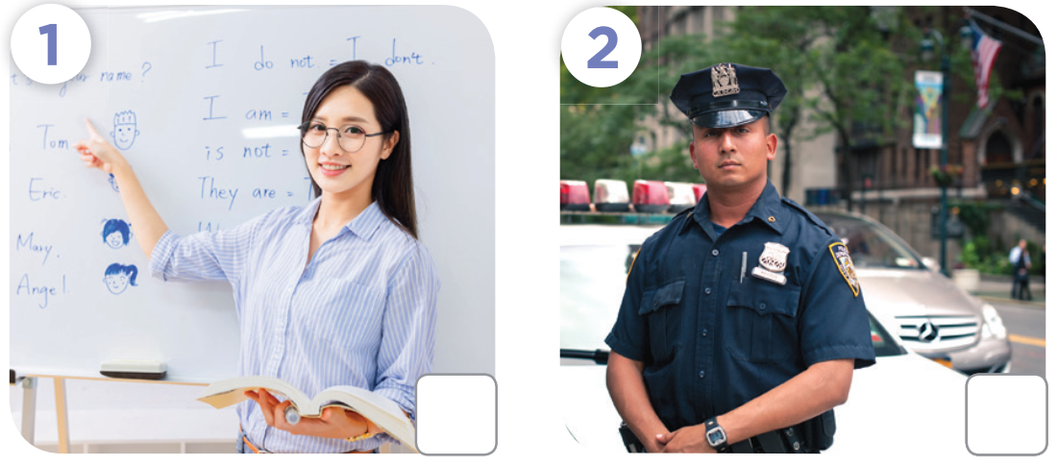    - Play the recording all the way through for pupils to listen. Then play the recording again for them to listen and tick or cross the pictures.  - Get pupils to swap books with a partner to check their answers before checking as a class. Correct the answers, if necessary.  Extension: If time allows, play the recording, sentence by sentence, for pupils to listen and repeat in chorus. Correct their pronunciation where necessary.  - The disabled: Do Ex.4, following the teacher’s guide.  Picture cues:  c. an office worker d. an actor  Audio script:  1. A: What does your mother do?  B: She’s a farmer.  2. A: What does your father do?  B: He’s a policeman.  3. A: Is your mother an office worker?  B: Yes, she is.  4. A: What does your father do?  B: He’s a farmer.  Key: a. x b. ✓ c. ✓ d. x  Activity 2-5. Look, complete and read.  * Goal: To complete four gapped exchanges with the help of picture cues.  * Procedure:  - Model Exchange 1. Have pupils read the exchange and guess the missing word in the answer. Then draw pupils’ attention to the picture and elicit the woman’s job that can be used to fill in the gap (e.g. office worker).  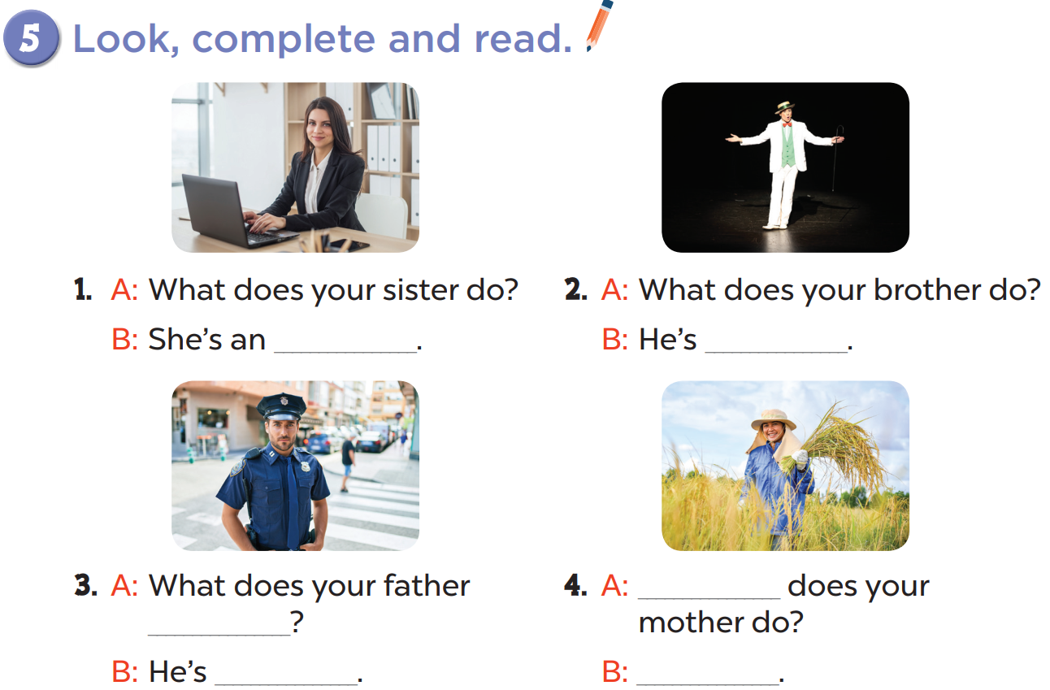  - Give pupils time to do the task independently. Go around the classroom to offer help where necessary.  - Get pupils to swap books with a partner and check their answers before checking as a class. Nominate a pupil to write the answers on the board. Give further support to those pupils who find it difficult to do the task.  - Invite four pairs of pupils to act out four completed exchanges in front of the class. Correct their pronunciation where necessary.  Key: 1. office worker 2. an actor 3. do; a policeman 4. What; She’s a farmer.  Activity 3-3. Let’s sing.  * Goal: To sing the song My lovely family with the correct pronunciation, rhythm and melody.  * Procedure:  - Draw pupils’ attention to the title and lyrics of the song. Encourage them to point at the pictures to reinforce their understanding.  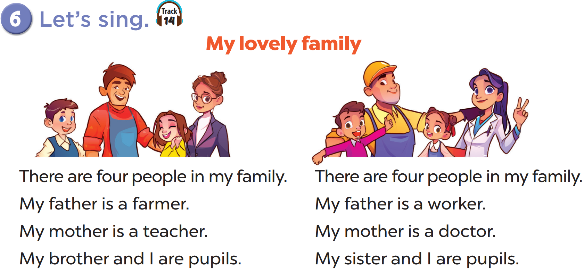  - Have pupils read the first verse of the lyrics.  - Explain that the first verse is about a family’s jobs. - Have pupils listen to the first verse, drawing their attention to the pronunciation, rhythm and melody.  - Then let them listen to and practise singing it line by line while clapping their hands.  - Repeat Steps 1 and 2 with the second verse.  - Explain that it is about the jobs of another family. Check comprehension and give feedback.  - Ask pupils to listen to and . Go around the classroom and offer help if needed.  - Invite a few groups to the front of the class to sing the song. The class may sing along and clap to reinforce the activity.  - Karaoke competition: “Beo dat may troi” version  - Pick some male and female pupils, divide them into two sex groups standing face to face, call them “lien anh” “lien chi”.  - Play the music track 15, they take turn to sing in “Beo dat may troi” version.  - If pupils perform well prepare some flashcards with other jobs to change the lyrics  3. Consolidation (3’)  - Integrated Digital Competence (2.2CB2a): Teacher asks: "If we want to share our dream jobs on the class computer, where should we save the file so everyone can find it?"  - Teacher projects a computer screen showing 3 folders: [Games], [Music], [Our Dream Jobs].  - Ask students to answer the following questions:  1. What have you learnt from the lesson today?  2. What are the core values of the lesson?  4. Homework (2’)  - Redo Ex. 4, 5 and do parts A, B in the workbook at home.  - Prepare the new lesson: Lesson 1 (4,5,6) of Unit 12. | - Listen to the techer  Whole class/ Individual work  - Listen to the T's instruction  - Listen to the recording  - Individual work  - Listen and correct  - Whole class  - Listen to the T's instruction  - Individual work  - Pair work  - Listen to the teacher  - Practice in front of the class  - Listen to the T's instruction.  - Whole class/ Individual work
  a. a teacher | b. a policeman
D. Recommendation:
…………………………………………………….….……………………………
…………………………………………………………………………………………
Duyệt của TT Chuyên môn Người thực hiện

NguyễnThị Thu Hiền
Nguyễn Thị Thu Hà

