**KIỂM TRA**

**MÔN: TIẾNG ANH 7**

**HK2 - Lần 3**

**Thời gian: 15 phút**

**PART 1: Write the words next to the pictures: (2.0pts)**



 Parking enter

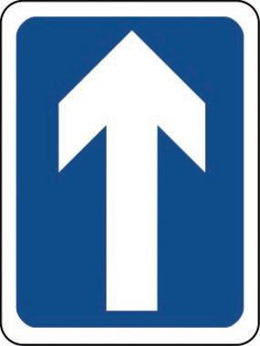 one way 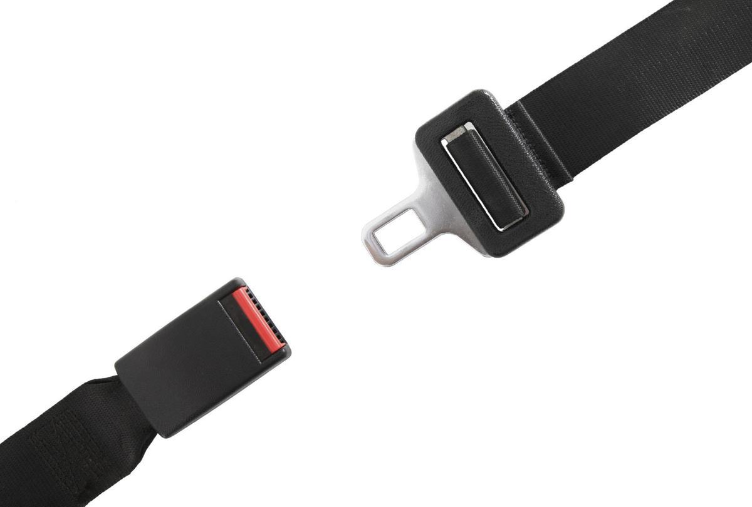seat belt

green light  speech limit

**PART 2: Use the words in the box to make phrases: (2.0pts)**



1. Bus _stop_________.
2. Subway ___station____.
3. Train ___station____.
4. Bus ____station___.
5. Taxi ____stand_____.

**PART 3:**

**A. Match the parts of the words and write them on the lines: (2.0pts)**

| steam | ship |  | 1. steamship |
| --- | --- | --- | --- |
| air | car |  | 2. airship |
| horse | and cart |  | 3. horse and cart |
| street | ship |  | 4. streetcar |
| side | car |  | 5. sidecar |

**B. Match the words in A with the correct descriptions: (2.0pts)**

1. People put it onto the side of our motorbike, so one more person could ride on it. (sidecar)
2. People used to use it to fly to other countries 100 years ago. (airship)
3. People could put many things on this means of transportation, which was pulled by an animal. (horse and cart)
4. About 100 years ago, people traveled across the sea on this big boat, which used power from hot gas. (steamship)
5. It ran on electricity and moved on rails along the streets. (streetcar)

**PART 4: Write the sentences using “used to” and the given information: (2.0pts)**

1. People/ travel/ around the city/ horse and cart.

__People used to travel around the city by horse and cart. __________

1. My grandma/ travel/ airship.

___My grandma used to travel by airship. ____________________________

1. You/ travel/ other countries/ steamship?

_Did you use to travel to other countries by steamship? _________

1. They/ not/ travel/ around the city/ streetcar.

____They didn’t use to travel around the city by streetcar. _________

1. People/ ride/ horses/ work.

___People used to ride horses to work. __________________________