|  |  |  |
| --- | --- | --- |
|  | ĐỀ KIỂM TRA __________ Năm học: 20__ - 20__ Tiếng Anh - Lớp 5 Thời gian làm bài: 30 phút | |
| Trường: ________________________ Họ tên: _______________________ Lớp: _____________ | Điểm | Nhận xét của giáo viên |

|  |
| --- |
| **Tiếng Anh 5 i-Learn Smart Start - Kiểm tra cuối kỳ 1 Time allotted: 30 minutes** |

|  |  |
| --- | --- |
| **PART 1** | **LISTENING (10 questions)** |

**1. Listen and match. There is one example. (3 questions)**

|  |  |  |  |
| --- | --- | --- | --- |
|  |  |  |  |

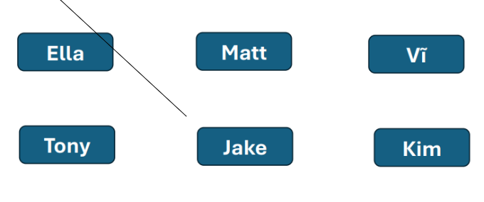

**Listen and write. There is one example. (3 questions)**

Thư has art,  *math* , and English on Friday mornings.
  
  
Her favorite subject is (4)___________.
  
  
She often (5)___________ about the past in her history class.
  
  
Her P.E. class starts at (6)___________.

**Listen and choose the correct picture. There is one example. (4 questions)**

**Example:**

How did Nick go to Brazil?

|  |  |  |
| --- | --- | --- |
|  |  |  |
| **A. ☑** | **B. ☐** | **C. ☐** |

**Questions:**

7. Which holiday does Emma like?

|  |  |  |
| --- | --- | --- |
|  |  |  |
| **A. ☐** | **B. ☐** | **C. ☐** |

8. Where did Richard go on his vacation?

|  |  |  |
| --- | --- | --- |
|  |  |  |
| **A. ☐** | **B. ☐** | **C. ☐** |

9. Which subject does Anh like?

|  |  |  |
| --- | --- | --- |
|  |  |  |
| **A. ☐** | **B. ☐** | **C. ☐** |

10. What did Kim's mother do yesterday?

|  |  |  |
| --- | --- | --- |
|  |  |  |
| **A. ☐** | **B. ☐** | **C. ☐** |

|  |  |
| --- | --- |
| **PART 2** | **READING (10 questions)** |

**Read, choose the correct words in the box and write them on the lines. There is one example. (3 questions)**



It's opposite to "fast".  *slowly* 
  
​In this subject, you learn about the past. (11)___________
  
​It's a large area of salt water. (12)___________
  
​This word means that the food is good. (13)___________

**Read and match. There is one example. (3 questions)**

|  |  |
| --- | --- |
| 14. Did they go to the beach last week? | a. I was at the stadium. It was busy. |
| 15. What time does your ethics class start? | b. Yes, sure. |
| 16. Where were you last month? | c. No, they didn't. |
|  | d. She likes Vietnamese. |
|  | e. It starts at a quarter past eight. |

**Read and circle. There is one example. (4 questions)**

|  |
| --- |
| Hello, my name is Joy. I live in Laos. I'm in the fifth grade. My favorite subject is science. I like doing experiments. I aslo like using computers. Yesterday, I went to the computer club with my friend. It was noisy. I often invite my friends to my house. Last month was my birthday and we had a party. My friends came and gave me a lot of presents. My mom cooked delicious food for us. After party, my friends and I sang karaoke. We had a great time together. |

**Example:**

Joy lives in **Cambodia / Laos / Thailand**.

|  |  |  |
| --- | --- | --- |
| A. Cambodia | B. Laos | C. Thailand |

**Questions:**

17. Her favorite subject is **I.T. / history / science**.

|  |  |  |
| --- | --- | --- |
| A. I.T. | B. history | C. science |

18. Joy went to the computer club **today / yesterday / this morning**.

|  |  |  |
| --- | --- | --- |
| A. today | B. yesterday | C. this morning |

19. Her friends gave her **presents / food / flowers** at her birthday party.

|  |  |  |
| --- | --- | --- |
| A. presents | B. food | C. flowers |

20. They **cooked / danced / sang karaoke** after the party.

|  |  |  |
| --- | --- | --- |
| A. cooked | B. danced | C. sang karaoke |

|  |  |
| --- | --- |
| **PART 3** | **WRITING (10 questions)** |

**Order the letters. There is one example. (3 questions)**

**Example:**

|  |  |  |
| --- | --- | --- |
|  |  | Keywords: v/e/r/r/i  → r i v e r |

**Questions:**

|  |  |  |
| --- | --- | --- |
| 21. |  | Keywords: n/I/n/e/d/a/o/s/i  → ....................................... |

|  |  |  |
| --- | --- | --- |
| 22. |  | Keywords: t/r/i/h/d  → ....................................... |

|  |  |  |
| --- | --- | --- |
| 23. |  | Keywords: o/g/g/i/n/b/o/l/w  → ....................................... |

**Reorder the words to make a correct sentence. There is one example. (4 questions)**

**Example:**

|  |  |
| --- | --- |
|  | Keywords: yesterday/some/I/flowers/planted/.  → I planted some flowers yesterday . |

**Questions:**

|  |  |
| --- | --- |
| 24. | Keywords: like/because/solving/math/I/problems/I/like/.  → ....................................... |

|  |  |
| --- | --- |
| 25. | Keywords: go/month/South/didn't/last/Korea/to/He/.  → ....................................... |

|  |  |
| --- | --- |
| 26. | Keywords: you/up/Could/paper/colored/put/?  → ....................................... |

|  |  |
| --- | --- |
| 27. | Keywords: brother/paper/His/badly/makes/crafts/.  → ....................................... |

**Look, read, and write the missing words. There is one example. (3 questions)**

I'm Helen, and my best friend is Grace. She is my classmate. She lives next to me, and we usually go to school  *by*  minibus. Grace and I love doing things together. Last Saturday was Christmas. We had a really fun sleepover. Grace is good at (28)___________ cupcakes. She made a delicious Christmas cake last week. We also like going to the movie theater together. We (29)___________ a scary movie last night. It was called "Alien". Grace and I don't like painting (30)___________ or singing karaoke. They are boring activities.

**---THE END---**