REVIEW 3 (UNITS 7-8-9)

Lesson 1: Language

  - Lesson aim(s)
By the end of this review, students will be able to revise the language they have learnt and the skills they have practised in Units 7-8-9.

  - Materials (referenced)
- Grade 6 textbook, Review 3, Language
- Pictures, printed chart
- sachmem.vn

Anticipated difficulties | Solutions
1. Students may find the lesson boring due to a large number of language exercises. | - Encourage students to work in pairs, in groups so that they can help each other.  - Design as many exercises as games as possible.  - Provide feedback and help if necessary.
2. Some students will excessively talk in the class. | - Define expectations in explicit detail.  - Have excessive talking students practise.  - Continue to define expectations in small chunks (before every activity).

  - Board Plan

Date of teaching

Review 3

Lesson 1: Language

* Warm-up
Brainstorming

1. Pronunciation
Task 1: Circle the word with the different underlined sound.
2. Vocabulary
Task 2: Choose A, B, or C to fill the gaps in the passage.
Task 3: Complete the sentences with the words/phrase in the box.
3. Grammar
Task 4: Choose the correct answer A, B, or C.
Task 5: Correct the underlined question word(s) if needed.
* Homework

Stage | Stage aim | Procedure | Interaction | Time
Warm-up | To remind students the knowledge that they have learnt in Units 7-8-9. | * Brainstorming:  - Teacher divides the class into 4 big groups.  - Teacher gives each group an unfinished chart which summarizes the language that students have learnt in Units 7, 8, 9 and asks them to complete the chart.  - The group which finishes correctly and more quickly is the winner.  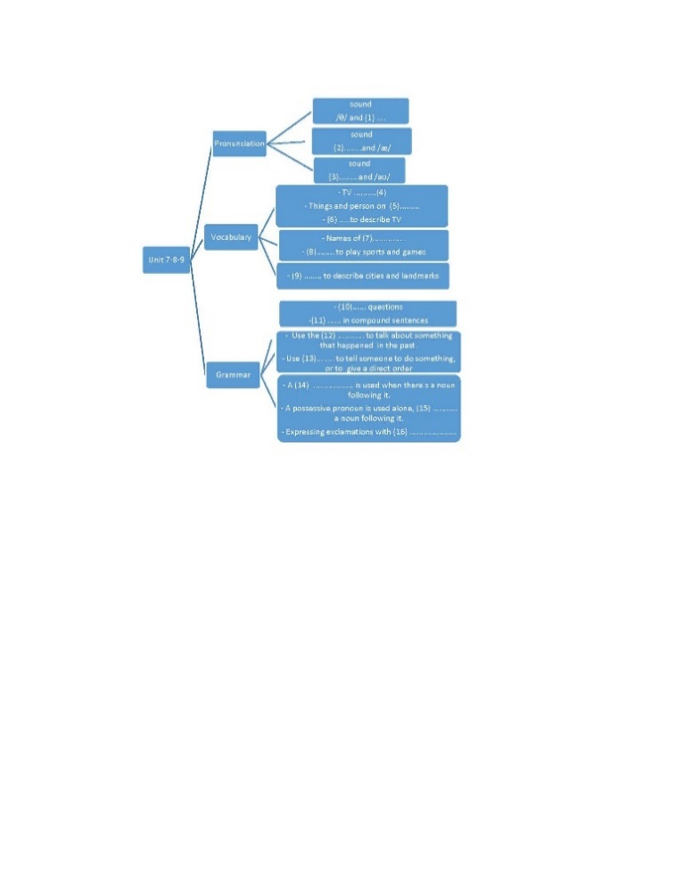  1. /ð  2. /e/  3. /əʊ/  4. programmes  5. TV  6. Adjectives  7. sports and games  8. Things/ equipment  9. Adjectives  10. WH  11. Conjunctions  12. past simple  13. imperative  14. possessive adjectives  15. without  16. What | Group work | 5 mins
Practice | To help students review the pronunciation of the sounds learnt in Units 7-8-9.  To test students’ ability to choose the correct word to be used in a certain context.  To help students review the words/phrases learnt.  To help students review grammar elements taught in the three units: wh-questions, conjunctions, possessive adjectives, possessive pronouns, the past simple and imperatives.  To help students revise the use of question words. | PRONUNCIATION  Task 1: Circle the word with the different underlined sound. Listen and check.  - Students do this exercise individually then share their answers with their partners.  - Teacher gives feedback and confirms the answers.  Answer key:  1. C  2. A  3. A  4. C  5. B  VOCABULARY  Task 2: Choose A, B, or C to fill the gaps in the passage.  - Allow students to do this task separately.  - Ask students to read the passage carefully and pause at each blank to decide which word is the best answer.  - Guide students to look for clues for their answers.  - Swap their answers with their partners.  - Check students’ answers as a class.  Answer key:  1. A  2. C  3. A  4. A  5. C  Task 3: Complete the sentences with the words/phrase in the box.  - Ask students to read each sentence carefully and choose the correct word/ phrase.  - Check students’ answers as a class.  Answer key:  1. landmark  2. football  3. television  4. city  5. Summer sports  GRAMMAR  Task 4: Complete the sentences with the correct answer A, B, or C.  - Teacher has students do the exercise individually.  - Teacher allows students to exchange their answers and discuss if there is any difference in their answers then checks students’ answers as a class, and explains if needed.  Answer key:  1. B  2. C  3. A  4. A  5. C  6. B  Task 5: Correct the underlined question word(s) if needed.  - Students must by now be familiar with, and quite skillful in using question words.  - Teacher may revise by writing a long sentence on the board.  E.g. Yesterday, I went to the cinema and watched The Dolphins with my cousins.  - Then underline some words and ask students what question word they use for each underlined information.  - Ask students to open their books on page 36 and do the task individually.  - Check their answers as a class. For the wrong one(s), explain why it is/they are incorrect  Answer key:  1. What  2. Correct  3. Why  4. How  5. Where | S  T-Ss  S  Ss- Ss  T-Ss  S  T- Ss  S  Ss-Ss  T-Ss  S  T-Ss | 35 mins
Consolidation | To consolidate what students have learnt in the lesson. | Teacher asks students to talk about what they have learnt in the lesson. | T-Ss | 4 mins
Homework | To prepare for the next lesson. | Prepare for Review 3 – Skills. | T-Ss | 1 min

REVIEW 3 (UNITS 7-8-9)

Lesson 2: Skills

  - Lesson aim(s)
By the end of this review, students will be able to revise the language they have learnt and the skills they have practised in Units 7-8-9.

Materials (referenced)
- Grade 6 textbook, Review 3 – Skills
- CD player
- sachmem.vn

Anticipated difficulties | Solutions
1. Students may find the lesson boring due to a large number of language exercises. | - Encourage students to work in pairs, in groups so that they can help each other.  - Design as many exercises as games as possible.  - Provide feedback and help if necessary.
2. Some students will excessively talk in the class. | - Define expectations in explicit detail.  - Have excessive talking students practise.  - Continue to define expectations in small chunks (before every activity).

  - Board Plan

Date of teaching

Review 3

Lesson 2: Skills

*Warm-up

Chatting
Practice
1. Reading: STRANGE SPORTS

Task 1: Read the two descriptions of strange sports and choose titles for them.
Task 2: Use the information from the passages above to tick () the correct box.
2. Speaking
Task 3: Interview your classmates about their likes.
3. Listening
Task 4: Listen to a talk about Singapore and fill the missing information.
4. Writing
Task 5: Look at the information on Mark’s visit to India last summer. Write a paragraph of about 50 words about his visit.
*Homework

Stage | Stage aim | Procedure | Interaction | Time
Warm-up | To increase students’ interest and lead them into the lesson. | Chatting:  - Teacher asks students some questions to lead them into the lesson:  - Do you like playing sports?  - Have you ever played a strange sports?  - Teacher lead in the reading part of the lesson. | T-Ss | 3 mins
Practice | To help students practise reading for general information.  To help students practise reading for specific information.  To help students practise asking about their likes for cities, sports, and TV programmes  To help students practise listening for specific information (gap-filling).  To help students write a paragraph describing a visit to a holiday city, based on the information provided. | READING  Task 1: Read the two descriptions of strange sports and choose titles for them.  - Ask students to look at the photos and the names of the sports and ask if they know anything about these sports.  - If they don’t, ask if they can make a guess.  - Have students read the passages individually and do the matching.  - Ask them to underline 2 – 3 key words for their quick answers.  - Check students’ answers as a class.  Answer key:  1. B  2. A  Task 2: Use the information from the passages above to tick () the correct box.  - Ask students to read the questions and the passages again carefully for details for their answers.  - Ask students to swap their answers with their partners and show where they find the information for their answers.  - Check students’ answers as a class.  ANSWER KEY  1. Cheese Rolling  2. Toe Wrestling  3. Cheese Rolling  4. Cheese Rolling  5. Toe Wrestling  SPEAKING  Task 3: Interview your classmates about their likes.  - Ask students to take turns to ask the questions and take notes of their partners’ answers.  - Encourage them to add more questions with Why, Where, With whom, etc.  - Go round and offer help if needed.  - Call some groups to report the results to the class.  LISTENING  Task 4: Listen to a talk about Singapore and fill the missing information.  - Ask students to look at the pictures and read the phrases underneath.  - Ask them if they know what they are.  - Make sure they pronounce the phrases correctly (which helps make the listening easier).  - Now ask students to read the questions and determine what information is needed for the answers.  - Play the recording as many times as needed. Allow students some time to write the answers.  - Check students’ answers as a class.  - Play the recording again and pause when the answers appear if needed.  Answer key:  1. visitors  2. slowly  3. 35  4. 30  5. little  Audio script:  Travel agent: Here we have a four-day programme for you...  Mai’s mother: Do we visit somewhere natural?  Travel agent: Oh yes. We have two days for nature: one day at the National Park and one day at the zoo.  Mai’s mother: How about Sentosa?  Travel agent: Sentosa is a ‘must’ for families. We spend one day there.  Mai’s mother: Is it enough?  Travel agent: We start early and return late. There we visit the Sea Aquarium...  Mai’s mother: What is it?  Travel agent: It’s a zoo for fish.  Mai’s mother: Great.  Travel agent: In the evening we will watch the Light and Sound Show. And the last day is for ...  WRITING  Task 5: Look at the information on Mark’s visit to India last summer. Write a paragraph of about 50 words about his visit.  - Ask students to read the information in the table carefully.  - Ask them what tense to be used for their writing.  - Have students write. Go round and offer help if needed. Students might want to change some details from the table or the order that the information appears.  - Encourage them to do so.  - Call on one or two volunteers to read aloud their answers.  - Call for other students’ comments.  - Collect some writings to correct at home. | T-Ss  S  T-Ss  S  Ss-Ss  T-Ss  Group work  T-Ss  T-Ss  T-Ss  S  T-Ss | 38 mins
Consolidation | To consolidate what students have practice in the lesson. | Teacher asks students to talk about what they have practice in the lesson. | T-Ss | 3 mins
Homework | To prepare for the next lesson. | Prepare for Unit 10 – Lesson 1. | T-Ss | 1 min

