School: ……………………………………….. | Date:……………………………………..
Class: ……………………………..................... | Period: 20

UNIT 2: FIT FOR LIFE
Reading 1a (Page 30)

1. Objectives
By the end of this lesson, students will be able to…
1.1. Language knowledge/ skills
- learn and use vocabulary: martial art, level, pad, protection, punch, respect.
- practise talking about a type of martial art.
- practise reading for specific information and read for detail.
- collect information about a martial art you know and make notes
- improve listening skills and pronunciation.
1.2. Competences
- improve Ss’ communication, collaboration, analytical, critical thinking skills.
1.3. Attributes
- develop their patriotism, kindness, honesty and accountability.
2. Teaching aids and materials
- Teacher’s aids: Student’s book and Teacher’s book, class CDs, IWB – Phần mềm tương tác trực quan, projector/interactive whiteboard /TV (if any), PowerPoint slides.
- Students’ aids: Student’s book, Workbook, Notebook.
3. Assessment Evidence
Performance Tasks | Performance Products | Assessment Tools
- Explore the pictures.  - Read the text and fill in the table with the information from the text.  - Read the text again and decide if the statements are right or wrong.  - Name other martial arts you know and talk about it.  - Collect information about a martial art you know and make notes under the headings name, origin and equipment and prepare a presentation to the class. | - Ss’ answers.  - Ss’ answers.  - Ss’ answers.  - Ss’ answers.  - Ss’ answers/ presentation. | - Observation.  - Observation.  - Observation.  - Observation.  - Observation.

4. Procedures
A. Warm up: 5 minutes
a. Objectives: to brainstorm the topic and have some ideas about the sport.
b. Content: task 1.
c. Expected outcomes: Ss can have some ideas and think about the topic.
d. Organization
Teacher’s activities | Students’ activities
Task 1. Look at the pictures. Which sport do they show? What do you know about this sport?  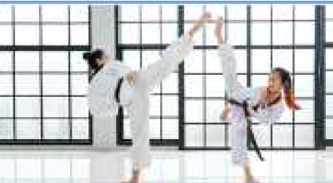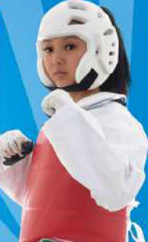  - Ask Ss to look at the pictures in the text. Then ask Ss to guess what the sport is and tell what they know about the sport.  - Check Ss’ answers. | - Look at the pictures in the text.  - Guess what the sport is and tell what they know about the sport.  Suggested Answer:  The sport is taekwondo. It’s from Korea.  People kick and punch. They wear a special uniform, a helmet and pads to do it.

B. Pre – reading: 10 minutes
a. Objectives: to present some key words related to the topic.
b. Content: vocabulary.
c. Expected outcomes: Ss can learn and use key words and prepare for reading for details.
d. Organization
Teacher’s activities | Students’ activities
Vocabulary:  + martial art  + level  + pad  + protection  + punch  + respect  - Ask Ss to read the text and underline the words above.  - Get Ss to try to guess their meanings in the context first.  - Explain the meanings of the words.  - Ask Ss to listen and repeat chorally and individually  - Check if Ss remember the words. | - Read the text and underline the words.  - Try to guess their meanings in the context.  - Listen to the teachers and take notes the meanings of those words.  - Listen and repeat chorally and individually  - Answer the teacher.

C. While – reading: 15 minutes
a. Objectives: to help Ss have some ideas about Gang’s Sport Club and read for specific information.
b. Content: task 2 and task 3.
c. Expected outcomes: Ss can read for specific information and have some information about Gang’s Sport Club.
d. Organization:
Teacher’s activities | Students’ activities
Task 2: Read the text. Fill in the table with the information from the text.  - Give Ss time to read the text again and then fill in the table according to what they read.  - Check Ss’ answers (using the IWB).  - Play the video for Ss and elicit their comments. | - Read the text again and then fill in the table according to what they read.  Answer keys:  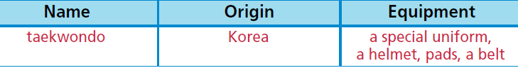
Task 3: Read the text again. Decide if the statements are R (right) or W (wrong).  1 Giang started taekwondo lessons last year.  2 Taekwondo is a new martial art.  3 Giang’s teacher has got a black belt.  4 Taekwondo teaches us respect.  - Give Ss time to read the text again and then read the statements and mark them according to what they read.  - Check Ss’ answers (using the IWB). | - Read the text again and then read the statements and mark them according to what they read.  Answer keys:  1. W 2. W 3. R 4. R

D. Post – reading: 10 minutes
a. Objectives: to help Ss expand the topic, develop research skills; to practise presentation skills.
b. Content: tasks 4, 5.
c. Expected outcomes: Ss can make notes on a text, talk about other martial arts and develop research skills.
d. Organization
Teacher’s activities | Students’ activities
Task 4. Name other martial arts you know. Would you like to try them? Why? Tell your partner.  - Give Ss time to think of other martial arts and consider their answers.  - Ask various Ss to share their answers with the class. | - Think of other martial arts and consider their answers.  - Do the task in groups of four.  - Share their answers with the class.  Suggested Answer:  muay Thai, judo and hapkido  I would like to try hapkido because this type of martial art makes you learn techniques on self-defence.
Task 5. Collect information about a martial art you know and make notes under the headings name, origin and equipment. Prepare a presentation to the class.  - Give Ss time to research online about a martial art they know and make notes under the headings.  - Explain the task and give Ss time to write their presentations. Alternatively, assign the task for homework.  - Ask various Ss to present their findings to the class. | - Research online about a martial art they know and make notes under the headings.  - Write their presentations.  - Present their findings to the class.  Suggested Answer:  Name: hapkido  Origin: Korean  Equipment: special uniform  Do you like to exercise while learning how to protect yourself?  Well, I have the perfect sport for you, hapkido.  This is a Korean martial art. It combines many self-defence techniques.  Choi Yong- Sool started this martial art after  World War II. He lived in Japan for 30 years and learnt various martial arts there like judo, jujutsu, aikido, etc. Then, he combined them in order to make people learn how to protect themselves.  People wear a special uniform to do hapkido.  This sport teaches you how to control and use  your inner power by not harming your  opponent, but rather using your opponent’s strength against him.
E. Consolidation and homework assignments: 5 minutes
- Vocabulary: martial art, level, pad, protection, punch, respect.
- Do the exercises in workbook on page 16.
- Prepare the next lesson: Reading 1a (page 31).
5. Reflection
a. What I liked most about this lesson today:
…………………………………………………………………………………………
b. What I learned from this lesson today:
…………………………………………………………………………………………
c. What I should improve for this lesson next time: …………………………………………………………………………………………

