ĐỀ THAM KHẢO SỐ 6

***Mark the letter A, B, C, or D on your answer sheet to indicate the word whose underlined part differs from the other three in pronunciation in each of the following questions.***

**Question 1.** A. horizon B. diary C. disaster D. climate

**Question 2.** A. Wednesday B. handkerchief C. bridge D. building

***Mark the letter A, B, C, or D on your answer sheet to indicate the word that differs from the other three in the position of primary stress in each of the following questions.***

**Question 3.** A. exchange B. damage C. bargain D. offer

**Question 4.** A. annoyance B. vehicle C. consumer D. excitement

Mark the letter A, B, C, or D on your answer sheet to indicate the correct answer to each of the following questions.

**Question 5.** The village was crowded with people attending the opening _____ of the village festival.

A. ceremony B. gathering C. activity D. movement

**Question 6.** My cousin, Giang, loves to take up new and _____ activities like rock climbing and skydiving.

A. dangerous B. experienced C. adventurous D. fascinated

**Question 7.** Is Ken _____ in exploring aliens and life on other planets?

A. excited B. interested C. keen D. passionate

**Question 8.** I've decided to follow a strict diet and work out every day to stay _____.

A. on good condition B. with good health

C. at healthy form D. in good shape

**Question 9.** Harry wants to improve his study habits.

Trung: "Why don't you set a regular time to study each day? It'll really help you." - Harry: "_____ "

A. I don't think so. Maybe later. B. That sounds good! I'll start doing that.

C. I'm not sure. It's a waste of time. D. No way! I'm busy all day.

**Question 10.** The farmers will start sei I ing the crops as soon as they _____ the harvest.

A. will finish B. finished C. had finished D. finish

**Question 11.** In our town, _____ a lot of entertainment for teenagers.

A. it is B. there are C. there is D. they are

**Question 12.** The car _____ tires are flat belongs to his new neighbour.

A. whose B. who's C. that D. which

***Read the following announcement and mark the letter A, B, C, or D on your answer sheet to indicate the correct option that best fits each of the numbered blanks from 13 to 16.***

**VOLUNTEER FOR OUR ENGLISH-SPEAKING CONTEST!**

Help us make this event a success and gain valuable experience!

Your tasks will include:

1. Setting up (**13**) _____ event space.

2. Welcoming and registering contestants.

3. Distributing and collecting score sheets.

4. Helping (**14**) _____ with timing and microphones.

5. Packing up supplies and (**15**) _____ after the event.

Join our team by signing up (**16**) _____ the school office before Friday!

**Question 13.** A. the B. an C. a D. ∅(no article)

**Question 14.** A. participations B. participate C. participating D. participants

**Question 15.** A. picking up B. going up C. tidying up D. setting up

Question 16. A. on B. in C. of D. from

***Mark the letter A, B, C, or D on your answer sheet to indicate the correct answer to each of the following questions from 17 to 18.***

**Question 17. *Put the sentences (a - c) in the correct order, then fill in the blank to make a logical paragraph.***

When I first started at my new school, I was a bit nervous. But I soon realised that everyone was friendly. _____

a. It took a little time, but I eventually made some great friends.

b. I joined the school club and started talking to people there.

c. I also sat with some other students at lunch.

A. a-b-c B. b-c-a C. a-c-b D. b-a-c

**Question 18. *Choose the sentence that can end the paragraph (in Question 17) most appropriately.***

A. I couldn't make friends with anyone in my new school.

B. Now I'm happy to be part of this school community.

C. I didn't find anyone friendly in the school club.

D. Everything was strange and difficult at first.

***Mark the letter A, B, C, or D on your answer sheet to indicate the correct option that best fits each of the numbered blanks from 19 to 24.***

On Monday, floods and a landslide caused by tropical storm Yagi, also known as Enteng, killed seven people in the Philippines. The storm brought heavy rain to Manila and (**19**) _____ areas. In Antipolo, a hilly community east of Manila, a landslide (**20**) _____ two houses, killing two schoolboys and a pregnant woman. The local disaster management chief, Relly Bernardo, said they had warned residents (**21**) _____ to safer areas. In Rizal province, four more people drowned (**22**) _____ the flooding. Many homes were covered by water, and the government stopped work and classes. The Philippines experiences around 20 tropical storms each year, with landslides being a major (**23**) _____ of deaths. Yagi continued to move across Luzon, (**24**) _____ island in the Philippines, bringing strong winds and more rain.

**Question 19.** A. nearby B. nearest C. near D. nearly

**Question 20.** A. hurt B. ran C. hit D. moved

**Question 21.** A. moved B. to move C. moving D. were moving

**Question 22.** A. because of B. so that C. instead of D. according to

**Question 23.** A. choice B. cause C. option D. reason

**Question 24.** A. the larger B. larger C. large D. the largest

Mark the letter A, B, C, or D on your answer sheet to indicate the sentence that is closest in meaning to the original sentence in each of the following questions.

**Question 25.** Keep your mobile phone on silent mode or you'll disturb the meeting!

A. If you don't keep your mobile phone on silent mode, you'll disturb the meeting.

B. If you keep your mobile phone on silent mode, you didn't disturb the meeting.

C. Unless you keep your mobile phone on silent mode, you won't disturb the meeting.

D. In case you keep your mobile phone on silent mode, you'll disturb the meeting.

**Question 26.** "Do you know the history of Diwali in India?" Ann asked me.

A. Ann asked me did I know the history of Diwali in India.

B. Ann asked me whether to know the history of Diwali in India.

C. Ann asked me if I knew the history of Diwali in India.

D. Ann asked me whether she knew the history of Diwali in India.

***Mark the letter A, B, C, or D on your answer sheet to indicate the sentence that is made from the given cues in each of the following questions.***

**Question 27.** Sam's teacher / ask / attend / class / regular.

A. Sam's teacher asked him to attend class more regular.

B. Sam's teacher asked him to attend class more regularly.

C. Sam's teacher asked him attending class more regularly.

D. Sam's teacher asked him attend class more regular.

**Question 28.** Many girls / apply / sun cream / avoid / get sunburn / day.

A. Many girls apply sun cream to avoid getting sunburn during the day.

B. Many girls apply sun cream to avoid to get sunburn during the day.

C. Many girls apply sun cream in order avoid getting sunburn during the day.

D. Many girls apply sun cream to avoid to get sunburn on the day.

Read the following sign or notice and mark the letter A, B, C, or D on your answer sheet to indicate the correct answer to each of the following questions.

**Question 29.** what does the sign say?

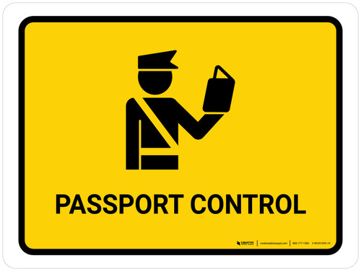

A. You must turn left to find passport control.

B. You can change your passport here.

C. This is where you need to show your passport.

D. This is where you check out at the airport.

**Question 30.** What does the notice say?

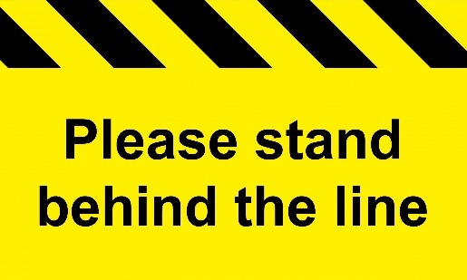

A. You should be ready to wait near the train doors.

B. You should stand close to the yellow line.

C. You should sit down while waiting for safety.

D. You should wait behind the yellow line for safety.

***Read the following passage and mark the letter A, B, C, or D on your answer sheet to indicate the correct answer to each of the following questions from 31 to 36.***

Starting from 11 September, students in Greece will need to keep their mobile phones in their bags during the whole school day. This new rule was introduced by Prime Minister Kyriakos Mitsotakis and Education Minister Kyriakos Pierrakakis to help students focus better in the classroom. The **initiative,** called the 'Cell phone in the School Bag' campaign, aims to keep students **attentive** to their studies without the interruption of mobile phones.

Studies have shown that mobile phones can make it harder for students to learn. Because of this, the government decided that mobile phones should not be used during school hours. If a student is found using their phone during school, they might not be allowed to come to school for one day. If it happens again, they could be kept out of class for more days.

The new rules also focus on stopping students from using their phones to take videos of others without permission. If a student takes videos of their classmates or teachers without asking, they could be told to leave the school for good. The government hopes that students, parents, and teachers will understand the importance of focusing on learning and keeping mobile phones out of the classroom.

**Question 31.** What is the main goal of the 'Cell phone in the School Bag' campaign?

A. To stop students from bringing mobile phones to school completely

B. To make students keep phones in their bags at break time

C. To allow students to use phones only outside school hours

D. To help students pay more attention during their lessons

**Question 32.** The word **initiative** in paragraph 1 is CLOSEST in meaning to _____.

A. a new rule B. an important choice

C. a first lesson D. a new type of phone

**Question 33.** The word **attentive** in paragraph 1 is OPPOSITE in meaning to _____.

A. silent B. distracted C. focused D. careful

**Question 34.** What might happen if a student is found using their phone during the school day?

A. They could be asked to leave school for several days.

B. They might be required to hand over the phone.

C. They could be kept out of class for just one day.

D. They might have to delete any videos recorded in school.

**Question 35.** Why could a student be told to leave the school permanently?

A. For not following the rule of keeping phones in bags

B. For using their phone during class time repeatedly

C. For taking videos of teachers without permission

D. For filming classmates during lessons more than once

**Question 36.** What is the government's hope with these new rules?

A. Students will focus better on their studies in class.

B. Parents will support the use of phones in school.

C. Teachers will find it easier to enforce phone rules.

D. Students will stop bringing phones to school entirely.

***Four phrases/ sentences have been removed from the text below. Mark the letter A, B, C, or D on your answer sheet to indicate the correct option that best fits each of the numbered blanks from 37 to 40.***

Jet lag is the effect on the body when people travel across different time zones. Our bodies have natural timers that are set by the 24-hour pattern of light and dark, according to scientist Sofia Axelrod. Every morning, special cells in our eyes send a signal to the brain when they receive daylight. (**37**).

When we travel to another time zone, our eyes get the daylight signal at a different time than usual, causing our body's timing to adjust. (**38**). Business travellers should arrive a day or two before important meetings to avoid poor decisions caused by jet lag, says Russell Foster, an expert on body rhythms. (**39**).

To reduce jet lag, Foster suggests getting as much light as possible when arriving at a new destination. (**40**).

A. If that doesn't work, a cup of coffee might help fight off the sleepiness

B. This adjustment can take time, and during this period, we experience jet lag

C. Tourists should also get enough sleep before doing anything risky, like driving

D. This signal helps keep our body's timing matched to the local time

**Question 37.** ______ **Question 38.** ______

**Question 39.** ______ **Question 40.** ______