School:
Teacher’s name:
Class:

LESSON PLAN
(Based on Official Letter No. 5512/BGDĐT-GDTrH dated December 18, 2020 of the MOET)

UNIT 3: MY FRIENDS
Lesson 1: Getting started – A surprise guest

I. OBJECTIVES
By the end of this lesson, Ss will be able to:
1. Knowledge
- use the lexical items related to the topic My friends
- use vocabulary to talk about body parts and appearance to describe people
2. Competences
- Develop communication skills and creativity
- Be collaborative and supportive in pair work and teamwork
3. Personal qualities
- Be kind and friendly to other friends
- Be responsible and participate in school activities
- Actively join in class activities

II. MATERIALS
- Grade 6 textbook, Unit 3, Getting started
- Computer connected to the Internet
- Projector / TV
- hoclieu.vn

Language analysis
Form | Pronunciation | Meaning | Vietnamese equivalent
1. glasses (n) | /ˈɡlɑːsɪz/ | things people wear when they have eyes’ problems | mắt kính
2. cheek (n) | /tʃiːk/ | the parts under people’s eyes | má
3. foot (n-s)  feet (n-p) | /fʊt/  /fiːt/ | ​the body part we use to stand on | bàn chân

Assumption
Anticipated difficulties | Solutions
1. Students may lack knowledge about body parts and structures to describe people’s appearance. | Prepare some handouts on vocabulary and structures to describe people’s appearance .
2. Students may have underdeveloped listening, speaking and co-operating skills. | - Play the recording many times if necessary.  - Encourage students to work in pairs, in groups so that they can help each other.  - Provide feedback and help if necessary.

III. PROCEDURES
1. WARM-UP (5 mins)
a. Objectives:
- To activate students’ knowledge on the topic of the unit.
- To recall words of body parts.
b. Content:
- Listen and do along (The body part song)
c. Expected outcomes:
- Students can listen, understand and do the actions.
d. Organisation:

TEACHER’S ACTIVITIES | STUDENTS’ ACTIVITIES | CONTENTS
- Teacher plays the song on speakers.  - Teacher and students sing along and point at the mentioned body parts in the song lyrics.  - Do 2-3 times and make it faster each time. | - Students listen to the song and do the right actions. | Link: https://www.youtube.com/watch?v=YGi3f_fHIzg
e. Assessment
- T asks follow-up questions to check students’ understanding.

2. ACTIVITY 1: PRESENTATION (5 mins)
a. Objectives:
- To provide students with vocabulary.
- To help students be well-prepared for the task.
b. Content:
- Vocabulary pre-teaching
c. Expected outcomes:
- Students can identify some new words about body parts and appearance.
d. Organisation

TEACHER’S ACTIVITIES | STUDENTS’ ACTIVITIES | CONTENTS
Vocabulary pre-teaching  - Teacher introduces the vocabulary.  - Teacher explains the meaning of the new vocabulary by showing pictures or giving explanations | - Students guess the meaning of words. | New words:  1. glasses (n)  2. cheek (n)  3. foot - feet (n)
e. Assessment
- Teacher checks students’ pronunciation and gives feedback.

3. ACTIVITY 2: PRACTICE (20 mins)
a. Objectives:
- To help Ss deeply understand the text.
- To revise and provide Ss with some vocabulary to describe parts of the body.
b. Content:
- Task 1: Listen and read.
- Task 2: Fill the blanks with the words from the conversation.
- Task 3: Label the body parts with the words in the box.
- Task 4: Work in groups. Complete the word webs.
c. Expected outcomes:
- Students understand the conversation and topic of the lesson and can complete the task successfully.
d. Organisation

TEACHER’S ACTIVITIES | STUDENTS’ ACTIVITIES | CONTENTS
Task 1: Listen and read. (6 mins)
- Teacher draws students’ attention to the picture in the textbook and asks them questions about the picture.  - Teachers ask students to work in pairs to guess the answers.  - Teacher plays the recording, and asks students to underline the words they have learnt in the vocabulary part.  - Teacher can play the recording more than once. | - Students observe the picture and work in pairs to guess the answers.  - Students listen and read.  - Students check their guesses. | Questions:  1. What are Phong and Nam doing?  2. What is Phong's favourite magazine?  3. Who do Phong and Nam see?  4. Where are the two girls going?  Suggested answers:  1. They are having a picnic.  2. It’s 4Teen  3. They see their friends.  4. They are going to the bookstore.
Task 2: Fill the blanks with the words from the conversation. (5 mins)
- Teacher asks students to do the task individually.  - Teacher asks students to share their answers with their partners before discussing as a class.  - Teacher asks students to explain where they can find the answer.  - Teacher corrects students’ answers. | - Students do the task individually and then share the answers with their partners.  - Students show the evidence to their answers. | Answer key:  1. picnic  2. favourite magazine  3. Mai - Chau  4. glasses - long black hair  5. are going to
Task 3: Label the body parts with the words in the box. (4 mins)
- First ask them to label the body parts they know using the words given. Have Ss read out loud their answers and then compare with a classmate.  - Teacher checks Ss’ answers and confirms the correct ones. Teacher asks them to complete the task.  - If there are any body parts Ss do not know, quickly point to them and teach them.  - Have Ss work in groups of four to list other words for body parts in 1 minute.  - Teacher invites some groups to share their answers. | - Students do the task with the words they know first.  - Students check their answers and then complete the task.  - Students work in groups of four to list other words of body parts and then share their answers. | Answer key:  1. eye  2. nose  3. shoulder  4. hand  5. leg  6. foot  7. arm  8. mouth  9. cheek  10. hair  Some more words are: head, lip, tooth, stomach, ear, etc.
Task 4: Work in groups. Complete the word webs. (4 mins)
- Teacher asks students to work in groups of four to do the word webs.  - Teacher explains that some words go together, e.g. long + hair, but some don’t, e.g. long + eye.  - Teacher checks and confirms the correct answers. | - Students work in groups to complete this task.  - Students check the answer. | Suggested answers:  • long / short: legs, arms, hair, etc.  • big / small: head, hands, ears, feet, eyes, nose, etc.  • hair: black, straight, fair, curly, wavy, long / short, etc.
e. Assessment
- Teacher checks students’ exercises individually and gives feedback.

4. ACTIVITY 3: PRODUCTION (10 mins)
a. Objectives:
- To help students practise asking and answering about where they live.
- To check students’ vocabulary and improve group work skills.
b. Content:
- Task 5: Game: Guessing
c. Expected outcomes:
- Students can use the learned vocabulary to describe their friends.
d. Organisation

TEACHER’S ACTIVITIES | STUDENTS’ ACTIVITIES | CONTENTS
Task 5: Game: Guessing
Work in groups. Take turns to describe a classmate. Other group members guess who he / she is.
- Teacher asks Ss to work in groups of four to describe a classmate. Other members guess.  - Move around to observe and oﬀer help.  - Invite one or two Ss to describe a classmate in front of the class. Other Ss guess. | - Students work in groups of four to describe a classmate for other group members to guess.  - One or two students describe a classmate in front of the class. | Example:  A: She has long hair and big eyes.  B: Is that Lan?  A: That’s right.
e. Assessment
- T and other Ss listen to the answers and comment.

5. CONSOLIDATION (5 mins)
a. Wrap-up
- Teacher asks students to talk about what they have learnt in the lesson.
b. Homework
- Write some sentences to describe at least 3 classmates.
- Do exercises in the workbook.
- Start preparing for the Project of the unit:
Teacher asks each student to draw and interview the friend sitting next to them, using the cue in Project (page 35). After that, students will write a short description about that friends, decorate and design as a poster and Lesson 7 – Looking back and Project.
(Teacher should check the progress of students’ preparation after each lesson.)

Board plan
Date of teaching
Unit 3: My friends
Lesson 1: Getting started
* Warm-up
Listen and do along

* Vocabulary
1. glasses (n)
2. cheek (n)
3. foot - feet (n)

Task 1: Listen and read.
Task 2: Fill the blanks.
Task 3: Label the body parts.
Task 4: Complete the word webs.
Task 5: Game: Guessing

*Homework

UNIT 3: MY FRIENDS
Lesson 2: A closer look 1

I. OBJECTIVES
By the end of this lesson, Ss will be able to:
1. Knowledge
- Use the lexical items related to the topic My friends;
- Use the vocabulary and structures to talk about personality;
- Pronounce correctly and recognise the sounds /b/ and /p/.
2. Competences
- Be collaborative and supportive in pair work and teamwork
- Access and consolidate information from a variety of sources
3. Personal qualities
- Be kind and friendly to other friends
- Be responsible and participate in school activities
- Develop self-study skills

II. MATERIALS
- Grade 6 textbook, Unit 1, A closer look 1
- Computer connected to the Internet
- Projector / TV
- hoclieu.vn

Language analysis
Form | Pronunciation | Meaning | Vietnamese equivalent
1. confident (adj) | /ˈkɒnfɪdənt/ | feeling sure about your own ability to do things and be successful | tự tin
2. caring (adj) | /ˈkeərɪŋ/ | kind, helpful and showing that you care about other people | quan tâm
3. active (adj) | /ˈæktɪv/ | always busy doing things, especially physical activities | năng động
4. careful (adj) | /ˈkeəfl/ | giving attention or thought to what you are doing | cẩn thận
5. creative (adj) | /kriˈeɪtɪv/ | involving the use of skill and the imagination to produce something new or a work of art | sáng tạo
6. shy (adj) | /ʃaɪ/ | = reserved, >< confident | nhút nhát
7. kind (adj) | /kaɪnd/ | = good, caring, >< cruel/ evil, | tốt bụng
8. clever (adj) | /ˈklevə(r)/ | = intelligent/ smart | thông minh

Assumption
Anticipated difficulties | Solutions
Students may have difficulties in distinguishing two sounds /s/ and /z/. | Provide students some tips by identifying the letters that may include each sound.
Students may lack knowledge about some lexical items. | Provide students with the meaning and pronunciation of some lexical items.

III. PROCEDURES
1. WARM-UP (5 mins)
a. Objectives:
- To activate students’ prior knowledge and vocabulary related to the topic.
b. Content:
- Game: Simon says
c. Expected outcomes:
- Students can recall vocabulary about body parts.
d. Organisation:

TEACHER’S ACTIVITIES | STUDENTS’ ACTIVITIES | CONTENTS
Game: Simon says
- Teacher explains the game rules: Students have to touch the body parts that teacher calls out by the sentence “Simon says touch your...”  - Teacher says the body parts and touches the wrong one.  - Student who does the wrong action is out of the game. | - Students listen and watch the teacher’s actions.  - Students must do what Simon says, not following the wrong action of the teacher. | Teacher’s commands
e. Assessment
- Teacher observes and gives feedbacks

2. ACTIVITY 1: VOCABULARY (20 mins)
a. Objectives:
- To provide students with some personality adjectives.
- To help students practise using the vocabulary in context.
b. Content:
- Task 1: Match the adjectives to the pictures.
- Vocabulary teaching
- Task 2: Use the adjectives in the box to complete the sentences. Pay attention to the highlighted
words / phrases.
- Task 3: Game: Friendship flower
c. Expected outcomes:
- Students can understand the meaning of some personality adjectives and use them in a context.
d. Organisation

TEACHER’S ACTIVITIES | STUDENTS’ ACTIVITIES | CONTENTS
Task 1: Match the adjectives to the pictures. (4 mins)
- Teacher asks Ss to look at the pictures and brieﬂy describe them.  - Have Ss look at the personality adjectives given. Check if they understand the meaning of each word.  - Teacher asks Ss to do the matching individually and then compare their answers in pairs.  - Teacher checks and confirms the correct answers. | - Students describe the pictures and then say the meaning of the adjectives on the left.  - Students do the matching individually and then compare with their partners. | Answer key:  1. c  2. e  3. d  4. a  5. b
Vocabulary teaching (6 mins)
- Teacher introduces the vocabulary by:  + providing the synonym or antonym of the words  + providing the definition of the words  - Teacher asks students to repeat and practice pronouncing the words. | - Students guess the meaning of words.  - Students read aloud the words. | New words:  1. confident (adj)  2. caring (adj)  3. active (adj)  4. careful (adj)  5. creative (adj)  6. shy (adj)  7. kind (adj)  8. clever (adj)
Task 2: Use the adjectives in the box to complete the sentences. Pay attention to the highlighted
words / phrases. (6 mins)
- Have Ss look at the pictures and brieﬂy describe what they see.  - Teacher asks Ss to read the adjectives in the box. Then ask Ss to read each sentence. Tell them  to pay attention to the highlighted parts.  - Ask them to do the exercise individually and then compare their answers in pairs. Tell Ss they will only need five of the six adjectives.  - Check and confirm the correct answers. | - Students brieﬂy describe what they see in the pictures, then read the words in the box and read the sentences.  - Students do the task individually. Then compare with their partners | Answer key:  1. creative  2. kind  3. friendly  4. careful  5. clever
Task 3: Game: Friendship flower (7 mins)
Work in groups. Write two personality adjectives for each group member.
- Students work in groups. Draw a ﬂower with the number of petals equal to the number of their group members  - Teacher asks students to write at least 2-3 personalities to describe each member.  - Move around to observe and provide help if needed.  - Invite some Ss to report the adjectives their group members have used. | - Students work in groups to do the task.  - Some students report the adjectives used in class. | Suggested answers:  careful, creative, smart, friendly, funny, active, shy, talkative,…
e. Assessment
- Teacher’s observation and feedback.

3. ACTIVITY 2: PRONUNCIATION (12 mins)
a. Objectives:
- To help students identify how to pronounce the sounds /b/ and /p/.
- To help students practise pronouncing these sounds correctly in words and in sentences.
b. Content:
- Task 4: Listen and circle the words you hear. Then repeat.
- Task 5: Listen. Then practise the chant. Notice the rhyme.
c. Expected outcomes:
- Students can identify the two sounds /b/ and /p/.
- Students can pronounce the sounds in words and in sentences correctly.
d. Organisation

TEACHER’S ACTIVITIES | STUDENTS’ ACTIVITIES | CONTENTS
Task 4: Listen and circle the words you hear. Then repeat. (5 mins)
- Teacher asks Ss to read the word pairs first. Then ask them to listen to the recording and circle the word  they hear in each pair.  - Play the recording again for them to repeat the words.  * Teacher may ask students to watch the pronunciation video before class to prepare for the lesson.  https://www.youtube.com/watch?v=ok3k3QAv17M&list=PL8_ETpRL2xNbMMSCSok5UNHcQOpjKgvAn&index=3 | - Students work independently to circle the words they have listened to. | 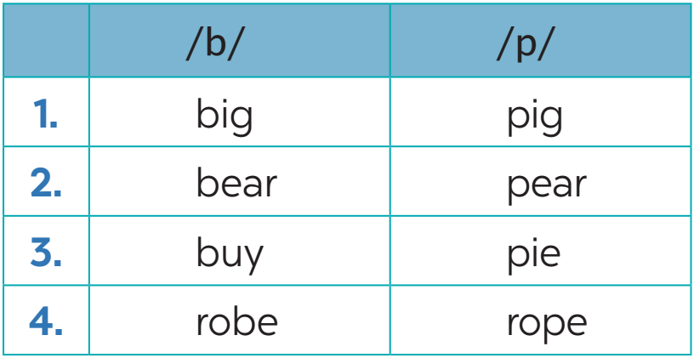
Task 5: Listen. Then practise the chant. Notice the rhyme. (7 mins)
- Teacher ask Ss to look at the chant. Make sure they understand the meaning of the chant.  - Play the recording again and ask Ss to chant along. Tell them to pay attention to the words that have the sounds /b/ and /p/ and the rhyme.  - Teacher divides the class into 2 groups and has them sing alternate lines. | - Students read the chant to understand the meaning.  - Listen to the chant and pay attention to the learned sounds.  - Work in 2 groups to chant alternate lines. | 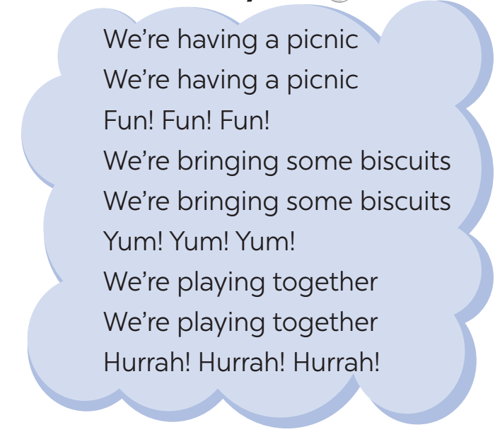
e. Assessment
- Teacher’s observation and feedback on student’s pronunciation.

4. CONSOLIDATION (5 mins)
a. Wrap-up
- Teacher asks students to talk about what they have learnt in the lesson.
b. Homework
- Do exercises in the workbook.

Board Plan

Date of teaching …

Unit 3: My friends
Lesson 2: A closer look 1

*Warm-up
Game: Simon says

* Vocabulary
1. confident (adj)
2. caring (adj)
3. active (adj)
4. careful (adj)
5. creative (adj)
6. shy (adj)
7. kind (adj)
8. clever (adj)

Task 1: Match.
Task 2: Complete the sentences.
Task 3: Game: Friendship flower

* Pronunciation
Task 4: Listen and circle.
Task 5: Listen. Then practise the chant.

*Homework

UNIT 3: MY FRIENDS
Lesson 3: A closer look 2

I. OBJECTIVES
By the end of this lesson, Ss will be able to:
1. Knowledge
- Use the present continuous
2. Competences
- Develop communication skills
- Be collaborative and supportive in pair work and teamwork
3. Personal qualities
- Be kind and friendly to other friends
- Be responsible and participate in school activities
- Develop self-study skills

II. MATERIALS
- Grade 6 textbook, Unit 3, A closer look 2
- Computer connected to the Internet
- Projector / TV
- hoclieu.vn

Language analysis
The present continuous
Form | Example
S + am/ is/ are + V-ing | She is playing basketball in the garden.
S + am not/ isn’t/ aren’t + V-ing | They are not going to school at the  moment.
Am/ Is/ Are + S + V-ing? | Are you having lunch?
Wh + am/ is/ are + S + V-ing? | Why is he standing over there?

Assumption
Anticipated difficulties | Solutions
Students may find it confusing when to use the grammar points. | Give short and clear explanations with legible examples for each case.

III. PROCEDURES
1. WARM-UP (5 mins)
a. Objectives:
- To activate students’ prior knowledge and vocabulary related to the targeted grammar of present continuous and to increase students' interest.
- To enhance students’ skills of cooperating with team mates.
b. Content:
- Game: Sentence puzzling
c. Expected outcomes:
- Students can rearrange the words in meaningful sentences.
d. Organisation

TEACHER’S ACTIVITIES | STUDENTS’ ACTIVITIES | CONTENTS
Game: Sentence puzzling
- Teacher divides the class into 4 groups.  - Teacher delivers a set of word cards which are jumbled sentences in the present continuous to each group.  - Students will have to work in groups to create as many  correct sentences from the word cards as possible.  - The group with more correct sentences will be the winner. | - Students work in groups to play the game. | Suggested answers:  1. She is learning English now.  2. He is taking his dog for a walk in the park.  3. Phong and Trang are talking about their new friends.  4. Susan isn’t playing the piano.  5. My parents are visiting me.
e. Assessment
- Teacher corrects students’ answers (if needed).

2. ACTIVITY 1: PRESENTATION (10 mins)
a. Objectives:
- To have students get to know about the structures and use of present continuous.
b. Content:
- Grammar explanation
c. Expected outcomes:
- Students identify the structures and when to use the present continuous.
d. Organisation

TEACHER’S ACTIVITIES | STUDENTS’ ACTIVITIES | CONTENTS
The present continuous
- Teacher draws students’ attention to the form of the sentences created in the game and asks them whether they know the target tense.  - Teacher provides or confirms the answers and leads in the grammar focus of the lesson.  - Ask Ss to look at the usage and  examples of the present continuous tense in the Remember! box. Explain to Ss that this tense is used to describe actions that are happening now.  - Teacher ask some students to make sentences using the present continuous. | - Students read the Remember box carefully and listen to the teacher.  - Students make some sentences using the present continuous. | 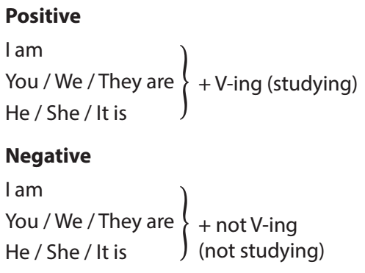  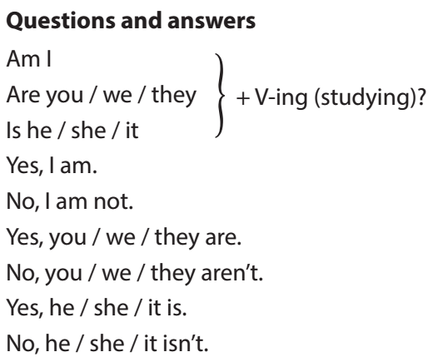
e. Assessment
- Teacher checks students’ understanding by asking some questions.

3. ACTIVITY 2: PRACTICE (23 mins)
a. Objectives:
- To help Ss practise using the correct form of the present continuous based on context.
b. Content:
- Task 1: Put the verbs in brackets in the present continuous.
- Task 2: Look at the pictures. Write sentences like the example. Use positive or negative present continuous verbs.
- Task 3: Work in pairs. Look at the pictures. Ask and answer.
- Task 4: Put the verbs in brackets in the present simple or present continuous.
c. Expected outcomes:
- Students understand how to use the target grammar and when to use present simple or present continuous.
d. Organisation

TEACHER’S ACTIVITIES | STUDENTS’ ACTIVITIES | CONTENTS
Task 1: Put the verbs in brackets in the present continuous. (5 mins)
- Teacher asks Ss to do the task individually. Remind them to pay attention to the subject of each sentence.  - Teacher lets students work in pairs and exchange the answers.  - Teacher calls on some Ss to read aloud their answers. Check and confirm the correct ones. | - Students work independently to do task 1.  - Students exchange the answers in pairs before checking with the class. | Answer key:  1. is reading  2. are playing  3. isn’t making  4. am going  5. Are they talking
Task 2: Look at the pictures. Write sentences like the example. Use positive or negative present continuous verbs. (6 mins)
- Teacher asks students to work independently.  - Teacher calls 1 or 2 students to write their answers on the board, and checks their answers sentence by sentence. | - Students work independently to do the task.  - Students come to the board to write the answers. | Answer key:  1. Nam and Ba are not / aren’t eating ice cream.  2. Lan and Trang are taking photos.  3. Ha is / Ha’s writing a letter.  4. Duong and Hung are not / aren’t playing badminton.  5. Phong is not / isn’t drawing a picture.
Task 3: Work in pairs. Look at the pictures. Ask and answer. (7 mins)
- Teacher asks students to read the example carefully and then work in pairs to do the task.  - Remind them to write their questions and answers in their notebooks.  - Teacher invites some pairs to practise their conversations.  - Teacher checks and confirms the correct answers. | - Students read the example individually and then do the task in pairs.  - Some students practise their conversations in front of the class. | Answer key:  1. Is your friend swimming? – Yes, he is.  2. Are they listening to music? – No, they aren’t. (They’re / They are having a picnic.)  3. Is Mi playing the piano? – No, she isn’t. (She’s / She is doing karate.)  4. Are they learning English? – Yes, they are.  5. Are your friends cycling to school? – No, they aren’t. (They’re / They are walking to school.)
Task 4: Put the verbs in brackets in the present simple or present continuous. (5 mins)
- Teacher asks students to read the Remember! box carefully. Then ask them to give the form and usage of the present simple (ask about the signals used, e.g. every day, every afternoon, always, usually, etc. and the present continuous, e.g. now, at the moment, at present, etc.)  - Ask Ss to do this exercise individually and then compare their answers with their partners.  - Invite some Ss to write their answers on the board.  - Confirm the correct answers. | - Students read the Remember! box carefully.  - Students tell the form and usage of the present simple and the present continuous.  - Students do the task individually and then compare with their partners.  - Students correct their answers. | Answer key:  1. does not / doesn’t walk; cycles  2. is he playing  3. Do your friends study  4. am / ’m writing  5. is not / isn’t doing; is / ’s reading
e. Assessment
- Teacher corrects the students’ answers and pronunciation as a whole class.

4. ACTIVITY 3: PRODUCTION (8 mins)
a. Objectives:
- To help students practise using the present continuous.
b. Content:
- Task 5: Game: Charades
c. Expected outcomes:
- Students can use the target grammar in contexts.
d. Organisation

TEACHER’S ACTIVITIES | STUDENTS’ ACTIVITIES | CONTENTS
Task 5: Game: Charades
Take turns to mime diﬀerent actions. Others guess what you are doing.
- Option 1: Have Ss play the game in groups of four. Move around to observe and provide help if needed.  - Option 2: Organise as a competitive game  Teacher organise as a competitive game by asking volunteers to form 2 groups. One student mimes and the two groups take turns to guess. The group with a correct answer gets one point. The group with the most points wins. Continue the game until the time is up. | - Students practise in groups as in option 1 or do the task as a game as in option 2. | 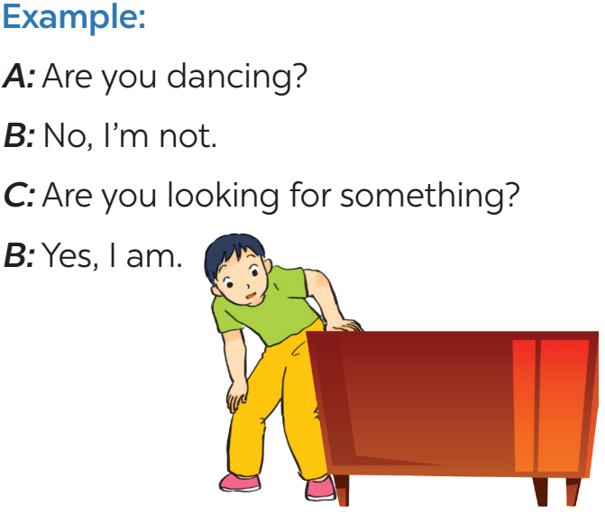
e. Assessment
- Teacher corrects the students if necessary.

4. CONSOLIDATION (5 mins)
a. Wrap-up
- Summarise the main points of the lesson.
b. Homework
- Do exercises in the Workbook.

Board Plan

Date of teaching
Unit 1: My new school
Lesson 3: A closer look 2
* Warm-up
Game: Memory game

I. Grammar
The present continuous

II. Practice
Task 1: Put the verbs in the present continuous.
Task 2: Write sentences.
Task 3: Work in pairs. Ask and answer.
Task 4: Put the verbs in the present simple or present continuous
Task 5: Game: Charades.

* Homework

UNIT 3: MY FRIENDS
Lesson 4: Communication

I. OBJECTIVES
By the end of this lesson, Ss will be able to:
1. Knowledge
- Know how to ask and answer about people’s appearance and personalities
- Ask appropriate questions when making friends at school
2. Competences
- Develop communication skills and creativity
- Be collaborative and supportive in pair work and teamwork
3. Personal qualities
- Be kind and friendly to other friends
- Be responsible and participate in school activities
- Develop self-study skills & actively join in class activities

II. MATERIALS
- Grade 6 textbook, Unit 3, Communication
- Computer connected to the Internet
- Projector / TV
- hoclieu.vn

Assumption
Anticipated difficulties | Solutions
Students may lack knowledge about the topic. | Provide students with information about the knowledge they do not know.
Students may have underdeveloped reading, speaking and co-operating skills. | - Encourage students to work in pairs, in groups so that they can help each other.  - Provide feedback and help if necessary.
Some students will excessively talk in the class. | - Define expectation in explicit detail.  - Have excessively talkative students practise.  - Continue to define expectations in small chunks (before every activity).

III. PROCEDURES
1. WARM-UP (5 mins)
a. Objectives:
- To introduce the topic.
- To enhance students’ skills of cooperating with teammates.
b. Content:
- Game: Bingo
c. Expected outcomes:
- Students can recall adjectives about personality
d. Organisation
TEACHER’S ACTIVITIES | STUDENTS’ ACTIVITIES | CONTENTS
- Teacher asks students to make a table into their notebooks and fill in with different personality adjectives.  - Teacher reads out loud 9 personalities. The student has a line of three words can shout: BINGO.  - Teacher checks the answer. | - Students write adjectives as instructed and play the game. | Suggested personality adjectives: active, clever, kind, smart, hard-working, funny, caring, confident, friendly, …
e. Assessment
- Teacher corrects students (if needed).

2. ACTIVITY 1: EVERYDAY ENGLISH (13 mins)
a. Objectives:
- To introduce how to ask about appearance and personality.
- To help Ss practise asking about appearance and personality.
b. Content:
- Task 1: Listen and read the dialogue between Linda and Mi. Pay attention to the highlighted questions.
- Task 2: Work with a classmate. Ask him / her about his / her best friend. Remember to use the two questions highlighted in 1.
c. Expected outcomes:
- Students can ask and answer about appearance and personality
d. Organisation
TEACHER’S ACTIVITIES | STUDENTS’ ACTIVITIES | CONTENTS
Task 1: Listen and read the dialogue between Linda and Mi. Pay attention to the highlighted questions. (6 mins)
- Play the recording for students to listen and read the dialogue between Linda and Mi at the same time.  - Ask students to pay attention to the highlighted questions. Elicit the structure to ask about appearance: What does your best friend look like? and the structure to ask about personality What’s she like? as well as the language used to answer these two questions.  - Have students practise the dialogue in pairs.  - Call some pairs to practise the dialogue in front of the class . | - Students listen to the recording, pay attention to the highlighted part.  - Students learn the structure to ask about appearance and personality and the language used to answer.  - Students practise the dialogue in pairs and then practise in front of the class. | 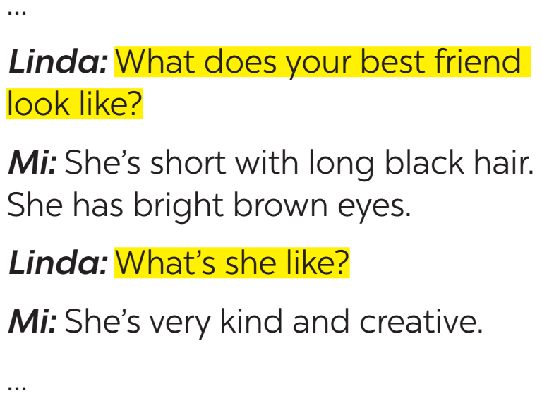
Task 2: Work with a classmate. Ask him / her about his / her best friend. Remember to use the two questions highlighted in 1. (7 mins)
- Teacher asks students to work in pairs to make similar dialogues about their best friend, using the questions learnt.  - Teacher moves around to observe and provide help if needed.  - Call on some pairs to practise in front of the class. | - Students work in pairs to make similar conversations.  - Some pairs practise in front of the class. | Suggested answer:  A: What does he look like?  B: He is tall and slim. He has short black hair. He has glasses.  A: What’s he like?  B: He is hard-working and creative. He is kind, too.
e. Assessment
- Teacher checks students’ understanding by asking some checking questions.

3. ACTIVITY 2: ﻿DATE OF BIRTH AND PERSONALITY (20 mins)
a. Objectives:
- To help Ss practise asking and answering about personality.
b. Content:
- Task 3: Read about these students in 4Teen magazine. Use one or two adjectives to describe them.
- Task 4: Read the descriptions below. Do you think they match the friends in 3?
- Task 5: Read the descriptions in 4. Share your opinion with the class.
c. Expected outcomes:
- Students can use the learnt vocabulary to talk about personalities.
d. Organisation
TEACHER’S ACTIVITIES | STUDENTS’ ACTIVITIES | CONTENTS
Task 3: Read about these students in 4Teen magazine. Use one or two adjectives to describe them. (5 mins)
- Teacher asks students to work in groups of four. Each group reads about one friend only.  - Have students give their answers and give the reasons for their answers.  - Teacher writes the answers on the board to prepare for Activity 4. | - Students work in groups of four to do the task.  - Students give their answers and the reasons for their answers. | Suggested answers:  – Vinh: clever, hard-working  – John: creative, kind
Task 4: Read the descriptions below. Do you think they match the friends in 3? (7 mins)
- Teacher tells students that each person has a star sign, depending on his / her birthday, and the star sign may decide a person’s personality.  - Ask students to read the descriptions and check if they match the friends in Task 3.  - Then teacher asks students to work in pairs and compare the descriptions. | - Students read the descriptions and check if they match their friends.  - Students can refer to the answers to Activity 3 that have been written on the board.  - Students work in pairs to compare the descriptions. | 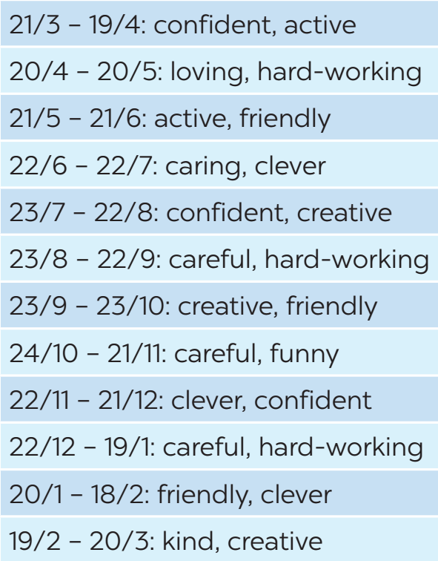
Task 5: Read the descriptions in 4. Share your opinion with the class. (8 mins)
- Teacher asks students to read the descriptions in 4 and complete the three sentences in the book individually.  - Teacher asks students to work in groups to share their answers.  - Teacher invites some students to share their opinion with the class. | - Students work individually to read and complete the sentences in the book.  - Students work in groups to share their answers. | 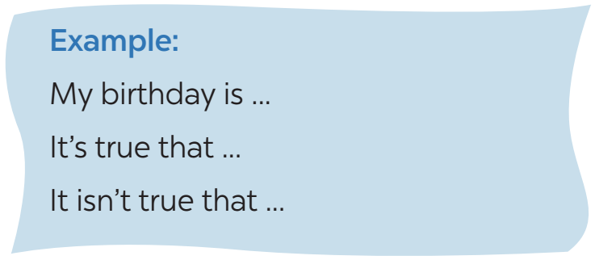
e. Assessment
- Teacher goes around and corrects students while they’re practising.

4. CONSOLIDATION (5 mins)
a. Wrap-up
- Have Ss say what they have learnt in the lesson.
b. Homework
- Do exercises in the workbook.
- Prepare for the next lesson: Skills 1

Board Plan

Date of teaching
Unit 3: My friends
Lesson 4: Communication
*Warm-up
BINGO

* Everyday English
Asking about appearance and personality
Task 1: ﻿Listen and read.
Task 2: Make similar questions.

* Date of birth and personality
Task 3: Use adjectives to describe.
Task 4: ﻿Read and answer the question.
Task 5: ﻿Read and share.

*Homework

UNIT 3: MY FRIENDS
Lesson 5: Skills 1

I. OBJECTIVES
By the end of this lesson, Ss will be able to:
1. Knowledge
- read for general and specific information about friends and a summer camp
- talk about friends and a summer camp
2. Competences
- Develop communication skills and creativity
- Be collaborative and supportive in pair work and teamwork
- Develop presentation skill
3. Personal qualities
- Be kind and friendly to other friends
- Be responsible and participate in school activities
- Develop self-study skills

II. MATERIALS
- Grade 6 textbook, Unit 3, Skills 1
- Computer connected to the Internet
- Projector / TV
- hoclieu.vn

Language analysis
Form | Pronunciation | Meaning | Vietnamese equivalent
1. superb (adj) | /suːˈpɜːb/ | of the highest quality | siêu đẳng
2. perfect (adj) | /ˈpɜːfɪkt/ | as good, correct, or accurate as it is possible to be | hoàn hảo
3. leadership (n) | /ˈliːdəʃɪp/ | ​the skill that allow a person to help and guide others | kĩ năng lãnh đạo
4. field trip (n) | /ˈfiːld trɪp/ | a visit to a place that gives students the chance to study something in a real environment | chuyến tham quan

Assumption
Anticipated difficulties | Solutions
1. Students may lack knowledge about some lexical items. | Provide students with the meaning and  pronunciation of words.
2. Students may have underdeveloped reading, speaking and co-operating skills. | - Let students read the text again (if needed).  - Create a comfortable and encouraging environment for students to speak.  - Encourage students to work in pairs, in groups so that they can help each other.  - Provide feedback and help if necessary.

III. PROCEDURES
1. WARM-UP (5 mins)
a. Objectives:
- To create an active atmosphere in the class before the lesson;
- To recall vocabulary used to describe people appearance
b. Content:
- Listen to the song and list the adjectives
c. Expected outcomes:
- Students can recall the adjectives to describe people.
d. Organisation
TEACHER’S ACTIVITIES | STUDENTS’ ACTIVITIES | CONTENTS
- Teacher plays the song on speakers.  - Teacher and students sing along and try to remember all the adjectives in the song lyrics.  - Teacher calls some students to list the adjectives in the song and some more adjectives they know to describe appearance. | - Students listen to the song and try to remember all the adjectives. | https://www.youtube.com/watch?v=LWQn3mbignQ
e. Assessment
- Teacher corrects students’ answers (if needed).

2. ACTIVITY 1: READING (20 mins)
a. Objectives:
- To help Ss learn new vocabulary in the reading text.
- To improve Ss’ skill of reading for details (scanning).
b. Content:
- Task 1: Look at the advertisement above and answer the questions.
- Vocabulary pre-teach
- Task 2: Read the text and write T (True) or F (False). Correct the false statements.
c. Expected outcomes:
- Students can understand the text and complete the tasks successfully.
d. Organisation
TEACHER’S ACTIVITIES | STUDENTS’ ACTIVITIES | CONTENTS
Task 1: Look at the advertisement above and answer the questions. (6 mins)
- Teacher asks students to work in pairs to read the poster and discuss the questions.  - Teacher may have to explain some words / phrases before having Ss do this activity.  - Teacher invites some Ss to give their answers. | - Students work in pairs to do the task and then share the answer with the whole class. | Questions:  1. Who is the Superb Summer Camp for?  2. What can people do at this summer camp?  Suggested answers:  1. It’s for kids between 10 and 15 years old.  2. They can play sports and games, draw pictures, play music, learn life skills, go on field trips, etc.
Vocabulary pre-teach (5 mins)
- Teacher asks students to guess the meaning of the words in context.  - Teacher provides their meanings by giving explanations, says the words and asks Ss to repeat as a whole class. | - Students say the meaning of the words.  - Students write the new words into their notebooks and repeat the words. | New words:  1. superb (adj)  2. perfect (adj)  3. leadership (n)  4. field trip (n)
Task 2: Read the text and write T (True) or F (False). Correct the false statements. (8 mins)
- Teacher explicits the targeted skills.  - Teacher explains how to scan and skim and asks students to practise with the advertisement.  - Set a time limit for them to do the task. If the statement is false, ask them to correct it.  - Have students work in pairs and compare their answers before having them discuss as a class. Ask students to support their answers with  information from the text. | - Students listen to explanations about skimming and scanning.  - Students do the task individually and then compare with their partners.  - Students give evidence to their answers. | Answer key:  1. F (They speak English only.)  2. F (He has three.)  3. F (Jimmy likes taking photos.)  4. T  5. T
e. Assessment
- Teacher corrects students’ answers.

3. ACTIVITY 2: SPEAKING (15 mins)
a. Objectives:
- To help Ss explain how the Superb Summer Camp is suitable for certain students and for themselves
b. Content:
- Task 3: Work in groups. Read about the three students below. Is the Superb Summer Camp suitable for all of them? Why or Why not?
- Task 4: Think about yourself. Do you want to go to this kind of camp? Why or Why not?
c. Expected outcomes:
- d. Organisation
TEACHER’S ACTIVITIES | STUDENTS’ ACTIVITIES | CONTENTS
Task 3: Work in groups. Read about the three students below. Is the Superb Summer Camp suitable for all of them? Why or Why not? (7 mins)
- Teacher has students look at the advertisement for the Superb Summer Camp again and underline the requirements for the students if they want to join the camp and the types of activity Ss can do at the camp.  - Teacher asks students to read the information about the three students Mi, An and Vy, underline the features of each student and compare these with the information stated in the advertisement.  - Teacher asks them to work in groups and decide if the Superb Summer Camp is suitable for these students and explain why.  - Invite students from different groups to share their answers. | - Students read the advertisement in Task 1 again and note down the requirements.  - Students read the descriptions about 3 students and then work in groups to decide if the Superb Summer Camp is suitable for them and explain. | Suggested answers:  1. The camp is suitable for her because it suits her age and she can use English. She can also develop her creativity at the camp.  2. The camp does not seem to suit An. He may be too old for the camp and he can’t speak English.  3. The camp suits Vy. It suits her age and it can help her improve her English.
Task 4: Think about yourself. Do you want to go to this kind of camp? Why or Why not? (8 mins)
- Teacher has students think about themselves and decide if the camp suits them. Encourage them to give the reasons for their answers.  - Teacher asks students to work in groups and share their opinions. Move around to observe and provide help if needed.  - Call on some Ss to share their answers. | - Students do the task individually and then work in groups and then share their answers with the class. | Suggested answers:  - I think Superb Summer Camp is suitable for me because I’m 12.  - Superb summer camp is good for me because I want to speak English all the time.
e. Assessment
- Teacher gives corrections and feedback.

4. CONSOLIDATION (5 mins)
a. Wrap-up
- Summarise the main points of the lesson.
b. Homework
- Do exercises in the workbook

Board Plan

Date of teaching
Unit 3: My friends
Lesson 5: Skills 1
*Warm-up
Listen to the song and list the adjectives

* Reading
Task 1: Answer the questions.
New words:
1. superb (adj)
2. perfect (adj)
3. leadership (n)
4. field trip (n)
Task 2: Write T or F.

* Speaking
Task 4: Read and answer the question.
Task 5: What kind of camp do you like?

*Homework

UNIT 3: MY FRIENDS
Lesson 6: Skills 2

I. OBJECTIVES
By the end of this lesson, Ss will be able to:
1. Knowledge
- Listen for specific information about best friends
- Write a diary entry about best friends
2. Competences
- Develop communication skills and creativity
- Be collaborative and supportive in pair work and teamwork
3. Personal qualities
- Be kind and friendly to other friends
- Be responsible and participate in school activities
- Develop self-study skills

II. MATERIALS
- Grade 6 textbook, Unit 1, Skills 2
- Computer connected to the Internet
- Projector / TV
- hoclieu.vn

Assumption
Anticipated difficulties | Solutions
1. Students may lack knowledge and experiences about the topic. | Prepare some hand-outs about the key language of describing people.
2. Students may have underdeveloped listening, writing and co-operating skills. | - Play the recording many times if necessary.  - Encourage students to work in pairs, in groups so that they can help each other.  - Provide feedback and help if necessary.
2. Some students will excessively talk in the class. | - Define expectation in explicit detail.  - Have excessively talkative students practise.  - Continue to define expectations in small chunks (before every activity).

III. PROCEDURES
1. WARM-UP (5 mins)
a. Objectives:
- To help students recall the adjectives to describe personality;
- To lead into the new lesson.
b. Content:
- Game: Jumble words
c. Expected outcomes:
- Students can recall the adjectives to describe personality.
d. Organisation
TEACHER’S ACTIVITIES | STUDENTS’ ACTIVITIES | CONTENTS
- Teacher sticks some jumbled words onto the board.  - Teacher asks students to work in pairs to play the game.  - Teacher calls the 3 fastest teams to write the answer on the board.  - Teacher checks the answers as the whole class. | - Students work in pairs to play the game.  - Students raise hands to answer. | Answer key:  1. TACIEV -> ACTIVE  2. LFIEDRNY -> FRIENDLY  3. UNFNY -> FUNNY  4. RCUFEAL -> CAREFUL  5. TOFCNDITEN -> CONFIDENT
e. Assessment
- Teacher corrects for students (if needed)

2. ACTIVITY 1: LISTENING (20 mins)
a. Objectives:
- To help Ss develop their skill of listening for specific information about best friends
b. Content:
- Task 1: What are the students doing in each picture?
- Task 2: Listen to Mi and Minh talking about their best friends. Look at the picture below and
say which one is Lan and which one is Chi.
- Task 3: Listen to the talk again. Fill each blank with a word / number you hear.
c. Expected outcomes:
- Ss can listen for general and specific information and complete the learning tasks.
d. Organisation
TEACHER’S ACTIVITIES | STUDENTS’ ACTIVITIES | CONTENTS
Task 1: What are the students doing in each picture? (5 mins)
- Teacher tells students to look at the pictures and guess what they are doing.  - Elicit the answers from students and then lead to the listening part. | - Students look at the pictures and answer the question. | Answer key:  a. They are talking.  b. They are playing football.  c. They are walking.
Task 2: Listen to Mi and Minh talking about their best friends. Look at the picture below and
say which one is Lan and which one is Chi. (7 mins)
- Teacher asks students to look at the pictures and note down some descriptions about the 2 girls.  - Tell students that they are going to  listen to Mi and Minh talking about their best friends.  - Teacher plays the recording.  - Teacher asks students to listen and do the task.  - Teacher checks students’ answers as a class. | - Students brieﬂy describe the two girls.  - Students listen to the recording and do the task. | Answer key:  Lan is the girl wearing a red and white jacket and a red cap. Chi is the girl wearing a white T-shirt and a blue skirt.
Task 3: Listen to the talk again. Fill each blank with a word / number you hear. (7 mins)
- Teacher asks students to read the questions carefully and determine what information they need to fill the gaps (numbers, words).  - Teacher plays the recording for students to fill the gaps.  - Teacher asks them to swap their answers in pairs before checking their answers as a class. | - Students read through all the sentences.  - Students do the task individually and then swap their answers in pairs.  - Students check the answers as a class. | Answer key:  1. 6A  2. black - mouth  3. friendly  4. big  5. kind
e. Assessment
- Teacher checks students’ answers as a whole class.

3. ACTIVITY 2: WRITING (18 mins)
a. Objectives:
- To help Ss practise writing a paragraph ﻿about their best friend.
b. Content:
- Task 4: Work in pairs. Ask and answer about your best friend. Use these notes to help you.
- Task 5: Write a diary entry of about 50 words about your best friend. Use the answers to the questions in 4.
c. Expected outcomes:
- Students can use the learned vocabulary and grammar to write a paragraph about their best friend.
d. Organisation
TEACHER’S ACTIVITIES | STUDENTS’ ACTIVITIES | CONTENTS
Task 4: Work in pairs. Ask and answer about your best friend. Use these questions to help you. (7 mins)
- Teacher asks students to take short notes of the answers for later use (in Task 5).  - Teacher allows students to review the unit for useful language.  - Have students ask and answer the questions in pairs in full sentences.  - Teacher goes around and helps if needed. | - Students work in pairs to do the task. | 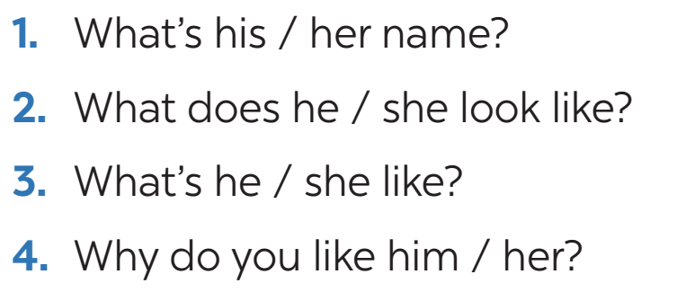
Task 5: Write a diary entry of about 50 words about your best friend. Use the answers to the questions in 4. (11 mins)
- Ask students to write the diary entry individually.  - Ask one or two students to write their entry on the board.  - Other students and teacher comment on the entries on the board.  - Teacher asks students to exchange their textbooks to check their friends’ writing.  - Teacher then gives feedback as a class discussion. | - Students write the diary entry individually.  - 1-2 students write their entry on the board.  - Students exchange their textbook to check the writing. | 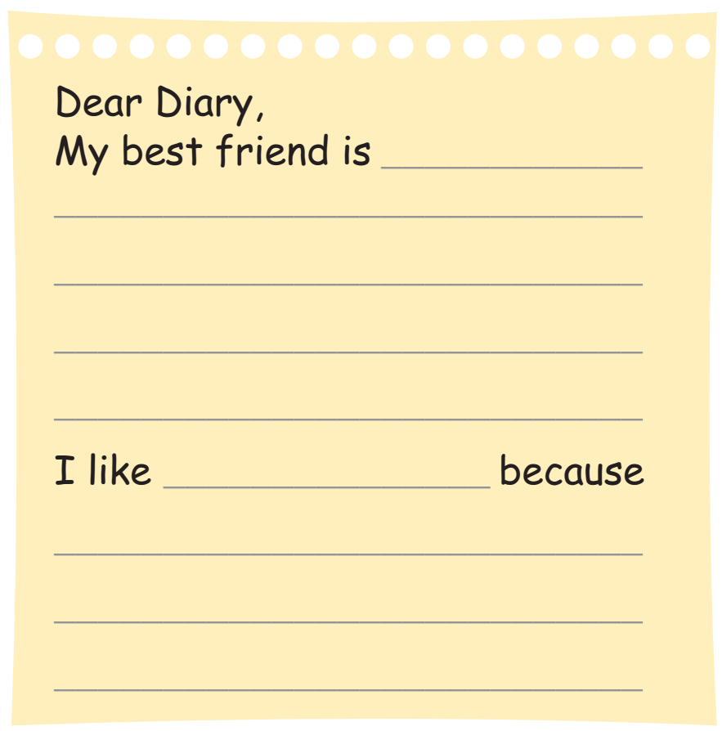
e. Assessment
- Teacher gives corrections and feedback.

4. CONSOLIDATION (2 mins)
a. Wrap-up
- Summarise the main points of the lesson.
b. Homework
- Rewrite the diary entry in the notebook.
- Do exercises in the workbook.

Board Plan

Date of teaching
Unit 3: My friends
Lesson 6: Skills 2
*Warm-up
Game: Jumble words
*Listening
Task 1: Look and answer.
Task 2: ﻿Listen and find out Lan and Chi.
Task 3: Listen again and fill the blanks.

*Writing
Task 4: ﻿Ask and answer.
Task 5: Write a diary entry.

*Homework

UNIT 3: MY FRIENDS
Lesson 7: Looking back and Project

I. OBJECTIVES
By the end of this lesson, Ss will be able to:
1. Knowledge
- Review the vocabulary and grammar of Unit 3
- Apply what they have learnt (vocabulary and grammar) into practice through a project.
2. Competences
- Develop communication skills and creativity
- Develop presentation skill
- Be collaborative and supportive in pair work and teamwork
3. Personal qualities
- Be kind and friendly to other friends
- Be responsible and participate in school activities
- Develop self-study skills

II. MATERIALS
- Grade 6 textbook, Unit 3, Looking back and Project
- Computer connected to the Internet
- Projector / TV
- hoclieu.vn

Assumption
Anticipated difficulties | Solutions
Students may have underdeveloped speaking, writing and co-operating skills when doing the project. | - Encourage students to work in pairs, in groups so that they can help each other.  - Provide feedback and help if necessary.
Some students will excessively talk in the class. | - Define expectation in explicit detail.  - Have excessively talkative students practise.  - Continue to define expectations in small chunks (before every activity).

III. PROCEDURES
1. WARM-UP (5 mins)
a. Objectives:
- To help Ss review the vocabulary of Unit 3
b. Content:
- Brainstorming: adjectives to describe people
c. Expected outcomes:
- Students can recall words used to describe appearance and personalities.
d. Organisation

TEACHER’S ACTIVITIES | STUDENTS’ ACTIVITIES | CONTENTS
- Teacher divides the board, and divides the class into 2 big groups.  - Each group will be assigned a category: APPEARANCE & PERSONALITIES  - Teacher asks students to brainstorm all adjectives related to people’s appearance and personalities.  - The group having the most suitable answers is the winner. | - Students work in 2 big groups to play the game. | - Appearance: tall, short, beautiful, smart, …  - Personalities: confident, careful, clever, funny, …
e. Assessment
- Teacher corrects for students (if needed)

2. ACTIVITY 1: LOOKING BACK (20 mins)
a. Objectives:
- To help Ss revise the vocabulary about body parts, appearance and personality adjectives.
- To help Ss revise the present simple and present continuous.
b. Content:
- Task 1: Choose the correct answer A, B, or C.
- Task 2: Answer questions about your classmates.
- Task 3: Put the verbs in brackets in the present continuous.
- Task 4: Put the verbs in brackets in the present simple or present continuous.
c. Expected outcomes:
- Students can use the learnt vocabulary to complete the tasks successfully.
- Students can recall the use of the present simple and present continuous.
d. Organisation
TEACHER’S ACTIVITIES | STUDENTS’ ACTIVITIES | CONTENTS
Task 1: Choose the correct answer A, B, or C. (3 mins)
- Teacher encourages students to complete the task individually.  - Students exchange their textbook to discuss the reasons why they are choosing the appropriate  adjectives.  - Teacher gives feedback as a class discussion. | - Students do the task individually and then exchange their textbook in pairs to discuss.  - Students correct the answers. | Answer key:  1. B  2. A  3. C  4. A  5. C
Task 2: Answer questions about your classmates. (5 mins)
- Teacher asks students to work in pairs to ask and answer the questions.  - Teacher invites some pairs to ask and answer in front of the class. | - Students work in pairs to do the task and then volunteer to ask and answer in front of the class. | Questions:  1. Who has long hair in your class?  2. Who has a small nose?  3. Who has a round face?  4. Does the classmate next to you have long hair?  5. Does the classmate next to you have big eyes?
Task 3: Put the verbs in brackets in the present continuous. (6 mins)
- Teacher encourages students to complete the task individually.  - Students exchange their textbooks with their partners.  - Teacher gives feedback as a class discussion. | - Students do the task independently.  - Students exchange their textbook to check the answers. | Answer key:  1. are running  2. are talking  3. are not talking / aren’t talking  4. are drawing  5. is not teaching / isn’t teaching
Task 4: Put the verbs in brackets in the present simple or present continuous. (6 mins)
- Teacher encourages students to complete the task individually.  - Students exchange their textbooks with their partners.  - Teacher gives feedback as a class discussion. | - Students do the task independently.  - Students exchange their textbook to check the answers. | Answer key:  1. are you doing - am writing / ’m writing  2. cycles - don’t cycle - walk  3. Is he doing - is reading / ’s reading
e. Assessment
- Teacher corrects students’ answers as a whole class.

3. ACTIVITY 3: PROJECT (16 mins)
a. Objectives:
- To help Ss improve their creativity and teamwork
- To improve their speaking and presentation skills
b. Content:
- Poster presentation
c. Expected outcomes:
- Students are able to present their posters about their friends.
d. Organisation
TEACHER’S ACTIVITIES | STUDENTS’ ACTIVITIES | CONTENTS
My class yearbook  - Ask Ss to read the instructions again (T has already assigned the project since the first lesson of the Unit and checked their progress after each lesson). Let students have some time to check their posters for the final time and make any adjustments if necessary.  - T has some students show their posters and present them to the class.  - Give feedback to students’ presentations. | - Students check their posters again and then volunteer to present. | Suggested outcome:  Students’ posters & presentations
e. Assessment
- Teacher gives corrections and feedback.

4. CONSOLIDATION (4 mins)
a. Wrap-up
- Summarise the main points of the lesson.
b. Homework
- Prepare for the next lesson.
Board Plan

Date of teaching
Unit 1: My friends
Lesson 7: Looking back and Project
*Warm-up
Brainstorming

*Looking back
Task 1: Choose A, B, or C.
Task 2: Answer questions.
Task 3: Put the verbs in the present continuous.
Task 4: Put the verbs in the present simple or present continuous.

*Project
My class yearbook

* Homework

