Date of preparing: ………………………………….
Date of teaching: ………………………………….

Period …
UNIT 1: HOME
Lesson 2 - Part 1 (Page 9) - Vocabulary and Reading

I. OBJECTIVES
By the end of the lesson, Ss will be able to…
1. Knowledge
- know more phrases about doing housework.
- talk about family members and housework.
- use the Present Simple with Wh – questions.
2. Ability
- improve the use of English and Reading skills.
3. Quality
- have positive attitude in English language learning so that they actively participate in all classroom activities.
- love family members and help family with housework.

II. TEACHING AIDS AND LEARNING MATERIALS
Lesson plan, PPT slides, student’s book, workbook, notebook, personal computer (if any), projector/TV, speakers, DCR & DHA on EDUHOME, handouts…
III. PROCEDURES
A. Warm up: (5’)
a) Objective: Introduce the new lesson and set the scene for Ss to acquire new language; get students' attention at the beginning of the class by means of enjoyable and short activities as well as to engage them in the steps that follow.
b) Content: Introducing housework.
c) Product: Ss have general ideas about they are going to study in the lesson.
d) Competence: Collaboration, guessing & reasoning, communication.
e) Organization of the activity:
Teacher’s Activities | Students’ Activities
- Give greetings  - Check attendance  - Option 1: Collocation with “House” and “Home”  - Explain collocation  - Give suggestions and have Ss find collocations with “House” and “Home” (in groups)  - The group that can give all correct answers in the shortest time will be the winner  - Give feedback  - Lead to the new lesson: Housework    - Option 2: Home Challenge  - About 1 week before the lesson starts, T asks Ss to record a very short video clip about what Ss do at home (do housework, cook a dish or do gardening)  - Have Ss collect the video clips of the group members and join them as a clip for the group (about 1 minute)  - Show clips of 4 groups on the screen and choose the best one  - Give feedback and evaluation  Lead to the new lesson | - Greet T  - Work in groups and make right collocations  - Give answers  - Listen  Answer keys  House: housewife, housework, housekeeper  Home: homemade, homework, hometown, homeland  - Make video clips about what Ss do at home  - Join clips, edit and add effects  - Watch and vote

B. New lesson (35’)
- Activities 1: Vocabulary (18’)
a) Objective: Ss know some vocabularies about household chores
b) Content:
- Filling in the blanks, then listen and repeat.
- Talking about housework.
c) Products: Ss can use the language inputs to talk about housework.
d) Competence: Communication, collaboration, presentation, listening, creativity.
e) Organization of the activity:
Teacher’s Activities | Students’ Activities
a. Fill in the blanks. Listen and repeat  - Option 1:  - Demonstrate the activity, using the example in the book  - Have Ss look, read and fill in the blanks – using the words in the box  - Ask Ss to work in pairs to check their answers with their partners  - Check answers as a whole class  - Play the audio (CD1 – Track 08) for Ss to listen and repeat  - Call some Ss to read the phrases again, correct their pronunciation and stress  - Option 2:  - Follow same steps as option 1  - Give Ss an extra activity  - Have Ss close all books  - Use other pictures (different pictures from those in the book) to help Ss remember the new words they have learnt  - Have Ss look at the sentences and pictures, then give names of the household chores  - Remind Ss to use the right form of verbs  - Ask Ss to give answers  - Check answers as a whole class  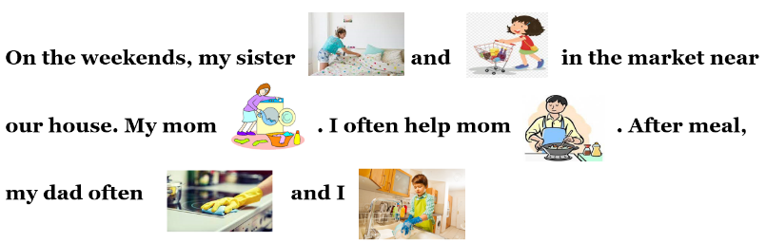  b. Say what housework you do at home  - Option 1:  - Have Ss work with a partner to say what housework they do at home  - Encourage Ss to use more household chores (besides those in the textbook)  - Have some Ss share their ideas with the class  - Give feedback and evaluation  - Option 2:  - Help Ss to make the task easier by providing more phrases about doing housework  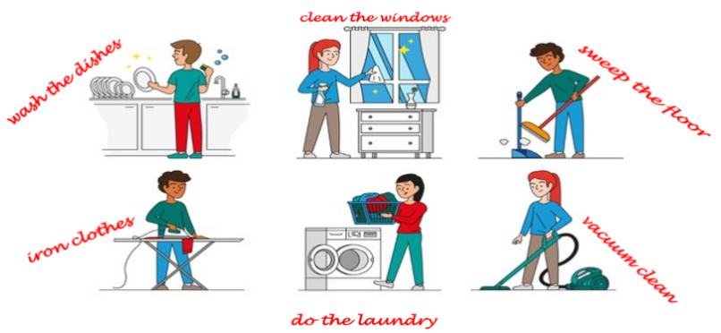  - Then, follow the same steps as option 1 | - Look and listen  - Work in pairs  - Listen and check  - Listen and repeat  - Read  Answer keys  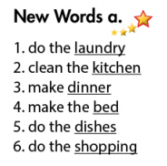  - Close books  - Look and give answers  - Give answers (Say or write on the board)  Answer keys  On the weekends, my sister makes the bed and does the shopping in the market near our house. My mom does the laundry. I often help mom make dinner. After meal, my dad often cleans the kitchen and I do the dishes.  - Work in pairs  - Give answers  - Listen  Suggested answers  Household chores: take out the garbage, sweep the floor, iron clothes, clean the window, vacuum clean, …
- Activity 2: Reading (17’)
a) Objective: Ss can develop their reading skills.
b) Content: Reading a blog and circling the correct answers.
c) Products: Ss apply reading strategies (skimming and scanning, reading for details).
d) Competence: Collaboration, communication, analytical skill, synthesizing skill.
e) Organization of the activity:

Teacher’s Activities | Students’ Activities
Read Ken’s blog about his family and circle the correct answers  - Option 1:  - Help Ss have general ideas about Wh-questions by explain “Who”, “What”  - Have Ss explore all the pictures and the heading  - Have Ss look at the questions and underline the key words in the questions  - Have Ss check the key words with the class  - Have Ss read the blog individually  - Have Ss work in pairs to read the blog again  - Have Ss circle the correct answers  - Remind Ss to use the Present Tense  - Have some Ss share their answers with the class (read), explain for their answers  - Give feedback  - Give feedback and correct Ss’ answers if necessary  - Option 2:  - Ask some questions about Ken:  What is his name?  How old is Ken?  What does he like?  - Explain what a blog is Lead to the reading text  - Have Ss read the questions and guess the answers  - Have Ss read the blog and circle the correct answers – underline the supporting ideas  - Have Ss check answers with their partners  - Call Ss to give answers, explain  - Give feedback and evaluation | - Listen  - Look at the pictures, head…  - Read the questions and underline the key words  - Check key words  - Read  - Circle the correct answers  - Read answers, explain  - Check answers  Answer keys  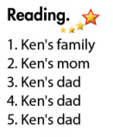  - Answer  - Listen  - Read and do the task  - Work in pairs  - Give answers and explain

C. Consolidation (3’)
* Vocabulary:
Household chores: do the laundry, do the dishes, make the bed, make dinner, do the shopping, clean the kitchen, iron clothes, take out the garbage…
* Question words: What: asking for information about something.
Who: asking what or which person or people (subject).

D. Homework (2’)
- Learn by heart the new words.
- Do exercises in Workbook: Lesson 2 - New words – Part a, b (page 4) and Listening (page 5).
- Prepare: Lesson 2 – Grammar (page 10 – SB).

