|  |  |
| --- | --- |
|  | *Thời gian làm bài: 40 phút (Không kể thời gian giao đề)*  *-------------------------* |

**Họ tên thí sinh: .................................................................**

**Số báo danh: ......................................................................**

**Mã Đề: 008.**

**Câu 1.** What does this sign mean?

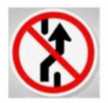

**A.** Slippery road.  **B.** Roundabout ahead

**C.** No parking here.  **D.** Prohibit Changing Lane

**Câu 2.** **Look at the signs. Choose the best answer for the question.**

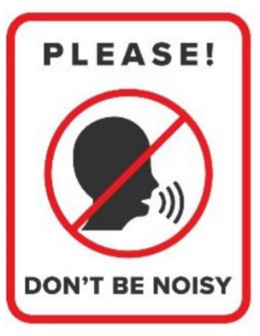

**A.** You must be quiet in this area.  **B.** You don’t have to raise your voice in this area.

**C.** You mustn’t talk in this area.  **D.** You shouldn’t speak to anyone in this area.

**Câu 3.** What is the main offer of this Happy Hour promotion?

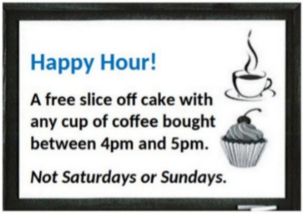

**A.** Half-price cake  **B.** Discounted cupcakes

**C.** A free slice of cake with coffee purchase  **D.** Free coffee

**Câu 4.** When was the sports bag found?

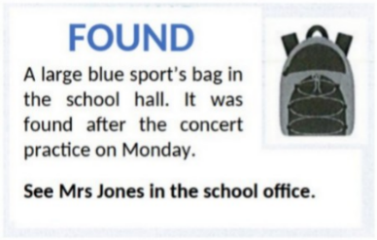

**A.** The next day after the practice  **B.** After the concert practice

**C.** During the concert practice  **D.** Before the concert practice

**Câu 5.** **Look at the signs. Choose the best answer for the question.**

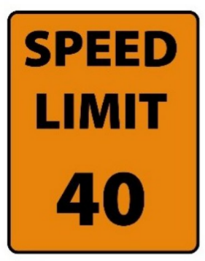

**A.** You cannot drive faster than 40 miles per hour.  **B.** You must drive at 40 miles per hour.

**C.** The minimum speed is 40 miles per hour.  **D.** You can drive 40 miles per hour or more.

**Câu 6.** What caused damage to the library?

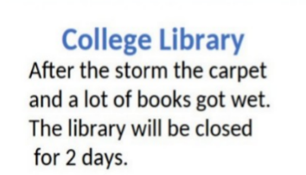

**A.** A fire  **B.** A storm  **C.** Renovation work  **D.** Vandalism

**Câu 7.** **Look at the signs. Choose the best answer for the question.**

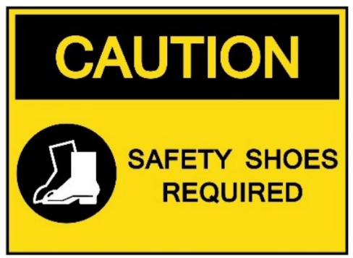

**A.** You are allowed to wear shoes in this area.

**B.** You should wear shoes in this area because of safety.

**C.** You have to wear shoes that can provide protection in this area.

**D.** You have to keep your shoes safe in this area.

**Câu 8.** Which day is the City Zoo closed?

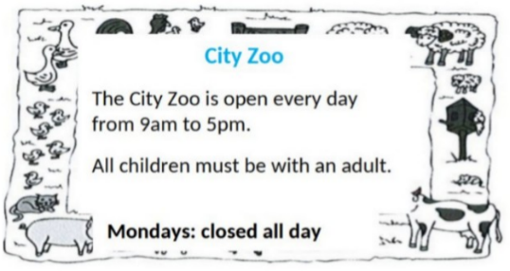

**A.** Monday  **B.** Sunday  **C.** Friday  **D.** Saturday

**Câu 9.** What does this sign mean?

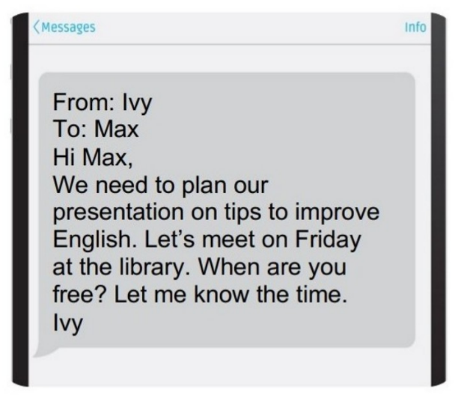

**A.** Ivy wants to remind Max of the project's deadline.

**B.** Ivy wants to know when they will meet to work on the project.

**C.** Ivy wants to thank Max for doing the presentation.

**D.** Ivy wants to find out more about the project from Max.

**Câu 10.** How much ice cream do you need to buy to get the discount?

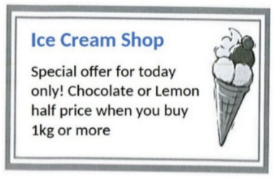

**A.** Exactly 1kg  **B.** 2kg or more  **C.** 500g or more  **D.** 1kg or more

**----HẾT---**