Period
LESSON PLAN
TIẾNG ANH 10 FRIENDS GLOBAL
UNIT 2: ADVENTURE
LESSON 2D: CONTRAST: PAST SIMPLE AND PAST CONTINUOUS
By the end of the lesson, Ss will be able to:
1. Knowledge:
- understand the contrast between past simple and past continuous
- Grammar: past simple and past continuous
- main skills: listening and speaking skills
- sub skills: reading and writing skills
- Use those two tenses properly in exercises and daily conversation.
3. Quality:
- have positive attitude in English language learning so that they can participate enthusiastically in all classroom activities, especially with the topic conducted by the teacher
- know how to distinguish the use of the past simple and the past continuous
II. TEACHER AIDS AND LEARNING MATERIALS:
Lesson plan, PPT slides, student’s book, workbook, notebook, personal computer (if any), projector/TV, speakers, IWB software.
III. PROCEDURES:
A. Warm-up (6’)
a) Objective: Introduce the new lesson and set the scene for Ss to acquire new language; get students' attention at the beginning of the class by means of enjoyable and short activities as well as to engage them in the steps that followed.
b) Content: Task 1 page 26.
c) Outcomes: Students can gain more confidence and interest in the lesson.
d) Competence: communication, collaboration, critical thinking
e) Organisation of the activity:

TEACHER’S ACTIVITIES | STUDENT’S ACTIVITIES | CONTENTS
WARM-UP. T-Ss/ S-S/ Indiv  Activity 1 (4’): Listen and answer the questions.  There are 2 slides with the same pictures describing the story in task 1. The first slide contains music. Teacher can choose freely between these two to excite the class.  - Ask students to listen to the story and answer the questions.  - Play the audio. The pictures will be played automatically.  - Invite some students to share the answers.  - Check the answers.  Activity 2 (2’): Underline all the past simple and past continuous forms in the text.  - Ask students to open the book page 26 and look at the text in task 1.  - Ask them to underline all the past simple and past continuous forms in the text.  - Check the answers.  - Lead to the topic of the lesson. | - Listen carefully to the teacher.  - Listen to the story and answer some questions.  - Volunteer to answer.  - Check the answers with the teacher.  - Open the coursebook page 26.  - Underline.  - Check the answers with the teacher.  - Listen to the teacher. | 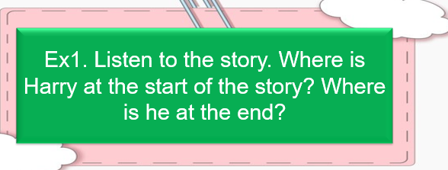  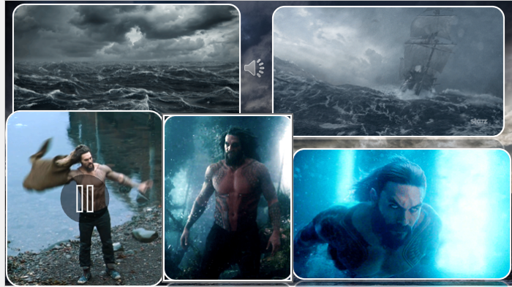  Answers:  He is on the shore at the start.  He is in the sea at the end.  Answers:  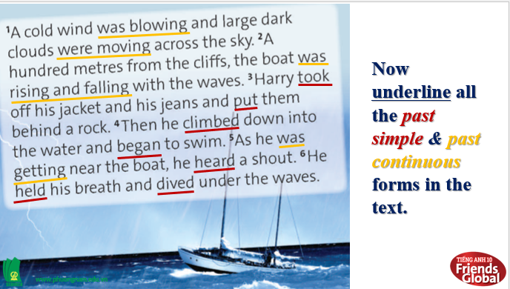

B. New lesson (34’)
- Activity 1: Presentation (10’)
a) Objective: Remind students forms and usages of past simple tense and past continuous tense. Students can distinguish these two tenses.
b) Content:
Listening
Grammar
c) Outcomes: Students can apply the useful language in everyday conversations.
d) Competence: communication, presentation, presentation
e) Organisation of the activity:

TEACHER’S ACTIVITIES | STUDENT’S ACTIVITIES | CONTENTS
PRESENTATION. T-Ss/ S-S/ Indiv.  Activity 1 (4’): Remind forms and usages of past continuous tense and past simple tense.  - Present affirmative, negative, and interrogative forms of these two tenses.  - Highlight the structures.  - Review the usages of each tense and give examples. (Teacher can invite students to make sentences.)  Activity 2 (3’): Distinguish past simple and past continuous.  - Ask students ‘If there are two events in the past, how can we use these two tenses?’.  - If the students can get the answer, praise them. If there isn’t any response, show them how to use.  - Give some examples to clarify.  Activity 3 (3’): Introduce ‘Learn This! Box’.  - Ask students to read it silently and highlight some main points.  - Clarify ways to use past simple and past continuous if there are some events in a past in a sentence. | - Listen carefully to the teacher.  - Take note.  - Raise hand to answer.  - Listen to the teacher and take note. | 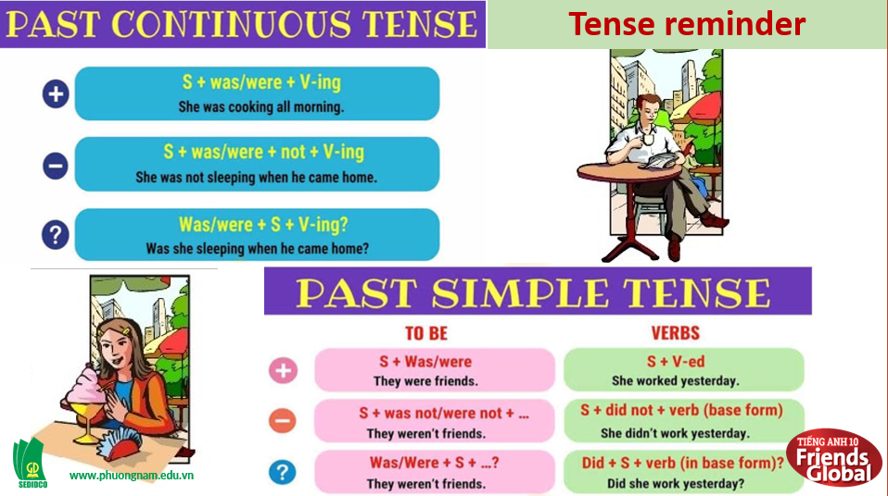  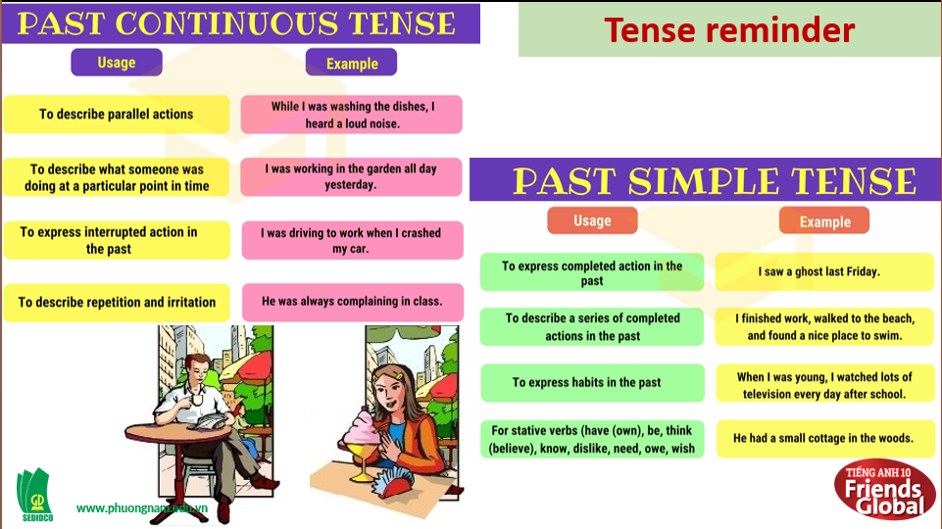  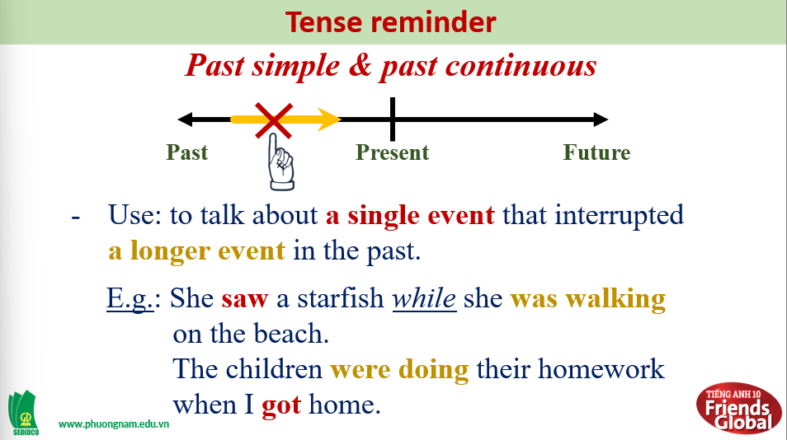  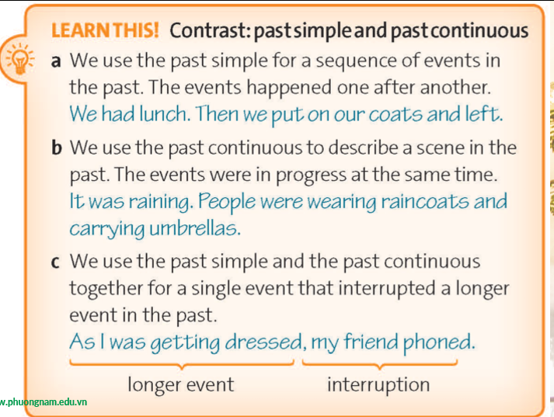
- Activity 2: Practice (19’)
a) Objective: Students know more about past simple tense and some irregular verbs.
b) Content:
Speaking
Grammar
c) Outcomes: Students know how to use past simple and past continuous in everyday conversations.
d) Competence: communication, collaboration, presentation
e) Organisation of the activity:
TEACHER’S ACTIVITIES | STUDENT’S ACTIVITIES | CONTENTS
PRACTICE. T-Ss/ S-S/ Indiv.  Activity 1 (2’): Task 2 page 26.  - Ask students to match sentence 1-6 with rules a-c.  - Check the answers.  Activity 2 (3’): Task 3 page 26. GAME ‘WHALE RESCUE’  - Ask students to complete the sentences using the past continuous or past simple form of the verbs in brackets to rescue the whale in the story.  - With each completed sentence, it will rain, and the sea level will raise to help the poor whale.  - Invite some students to complete the sentences.  - Check the answers.  Activity 3 (4’): Task 4 page 26.  - Ask students to put the sentences from exercise 3 in the correct order to continue the story.  - Play the audio.  - Check the answers.  Activity 4 (2’): Present ‘Look Out!’ box.  - Introduce the box and highlight some main points.  Activity 5 (5’): Write 5 sentences using past simple and past continuous. Use while/ as or when.  - Ask students to make sentences using suggested words on the screen with proper use of tense.  - Yellow words are for activities and red words are for interruptions.  - Invite some students to share their answers.  - Check the answers.  Activity 6 ( 3') : Pair- work. Task 6 page 26.  - Ask students to work in pairs to discuss what happened next in Harry's story. Ask students to use the questions below and sentences from 5 to help.  - Provide some questions for students to prepare the story.  - Invite some pairs to share their ideas. They can use the questions or their own ideas.  - Correct students' pronunciation and grammar. | - Complete the task.  - Check the answers with the teacher.  - Volunteer to do the task.  - Get bonus.  - Check the answers with the teacher.  - Put the sentences in the correct order.  - Listen and check.  - Check the answers with the teacher.  - Look at the box and take note or highlight important things.  - Listen to the teacher carefully and do the task.  - Volunteer to answer.  - Check the answers with the teacher.  - Work in pairs and discuss.  - Create the story.  - Volunteer to answer. | Answers:  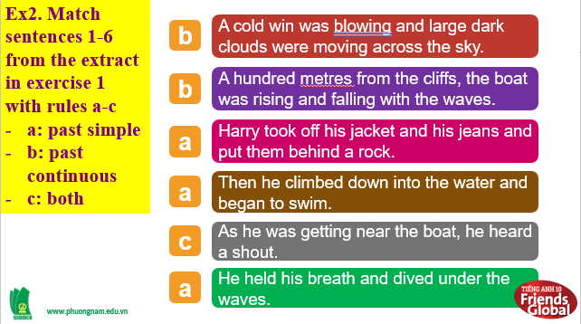  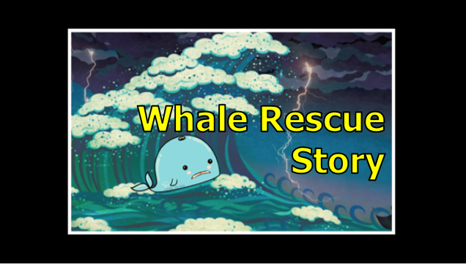  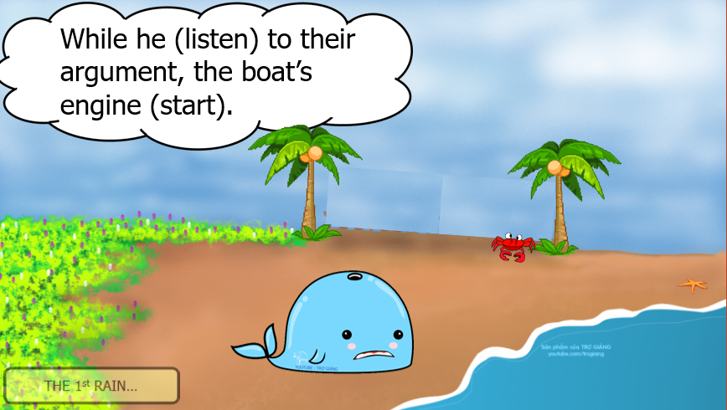  Answers:  1. was listening; started  2. fell; realized; jumped  3. swam; came; climbed; were arguing  4. began; was deciding; heard  Answers:  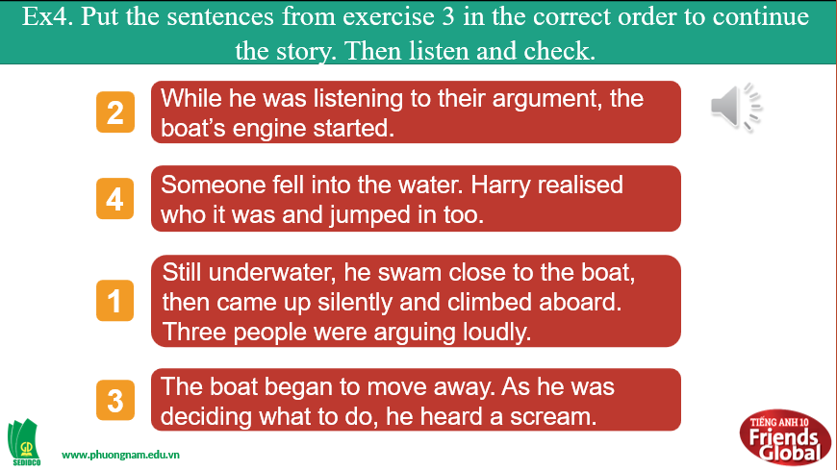  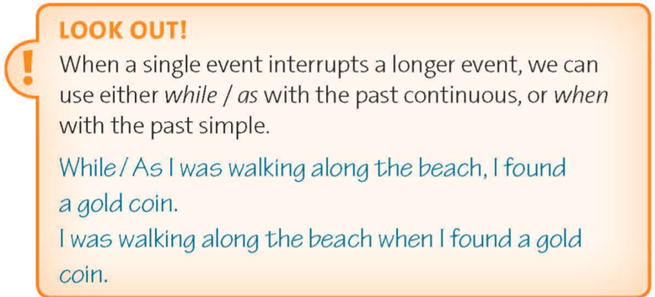  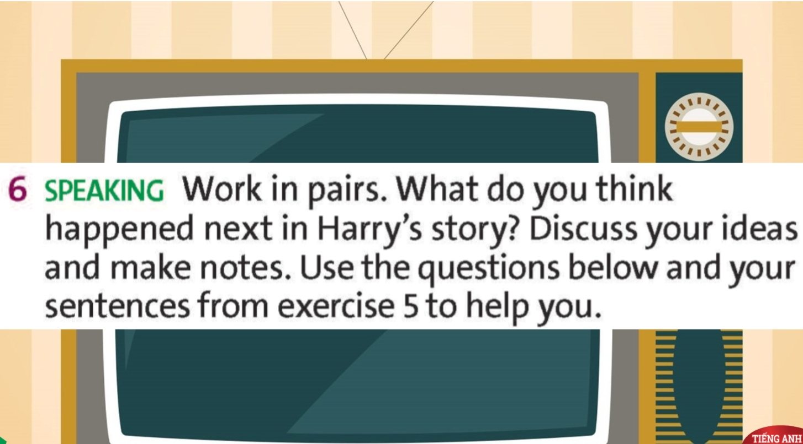  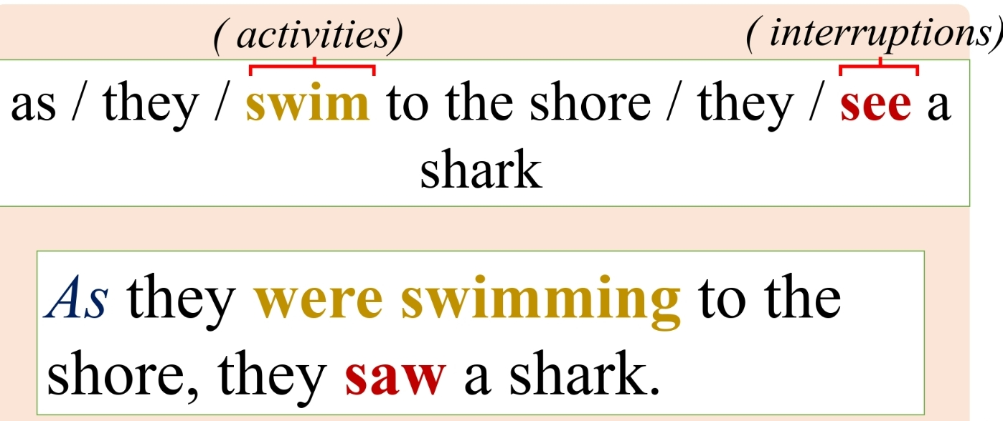  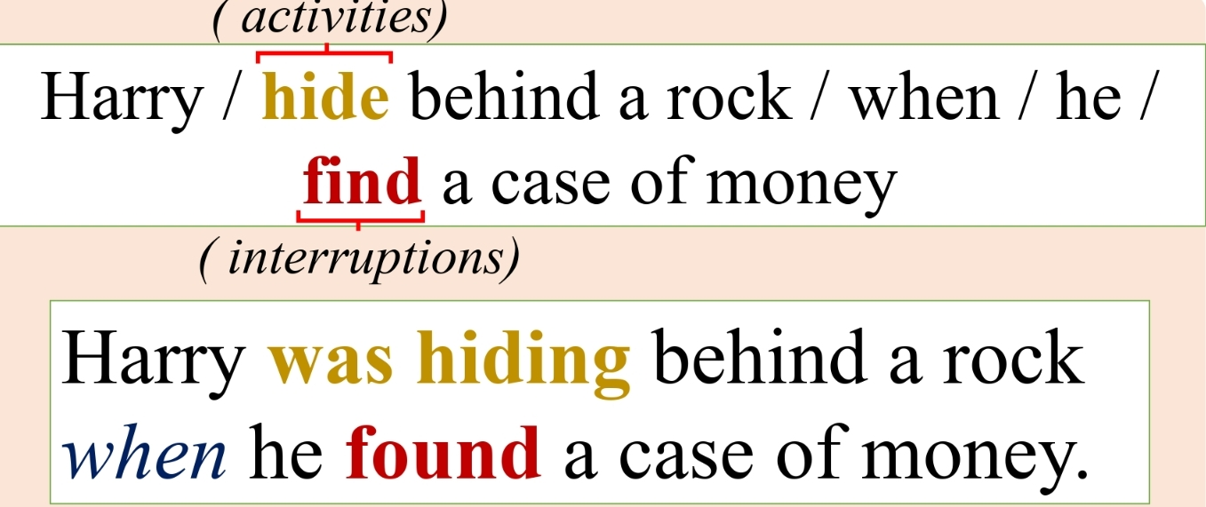  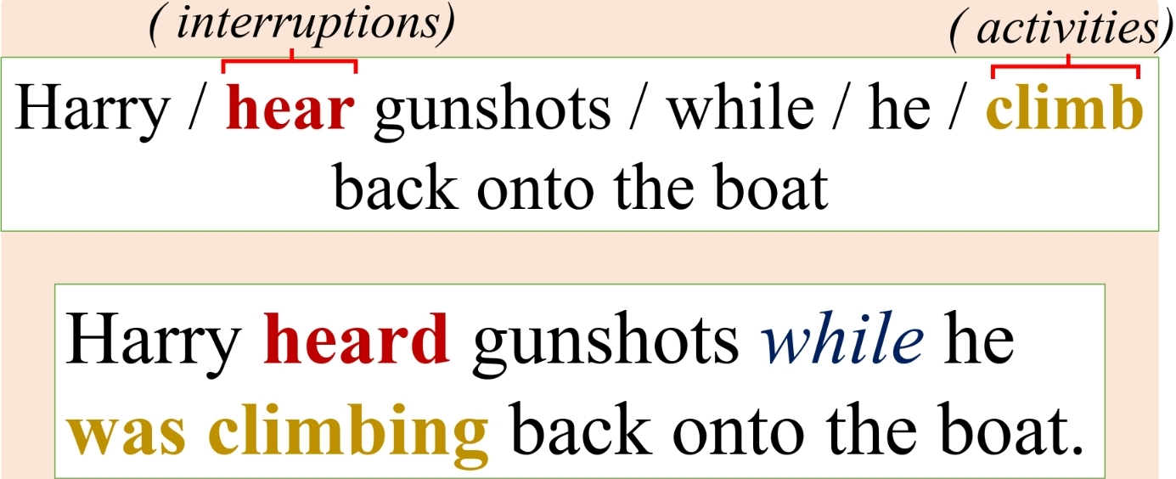  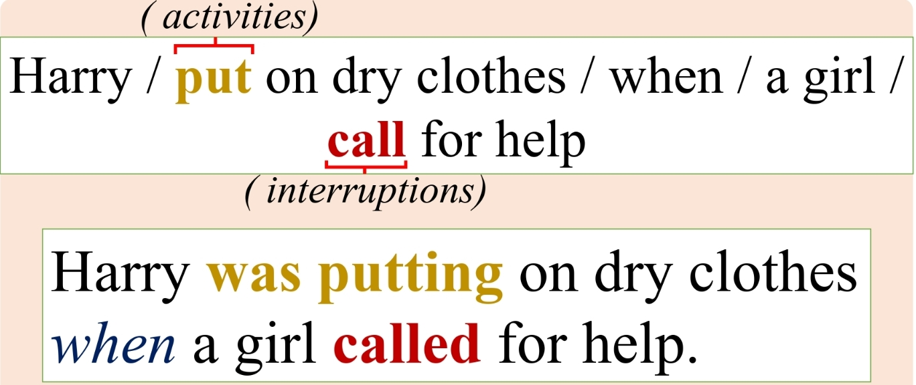  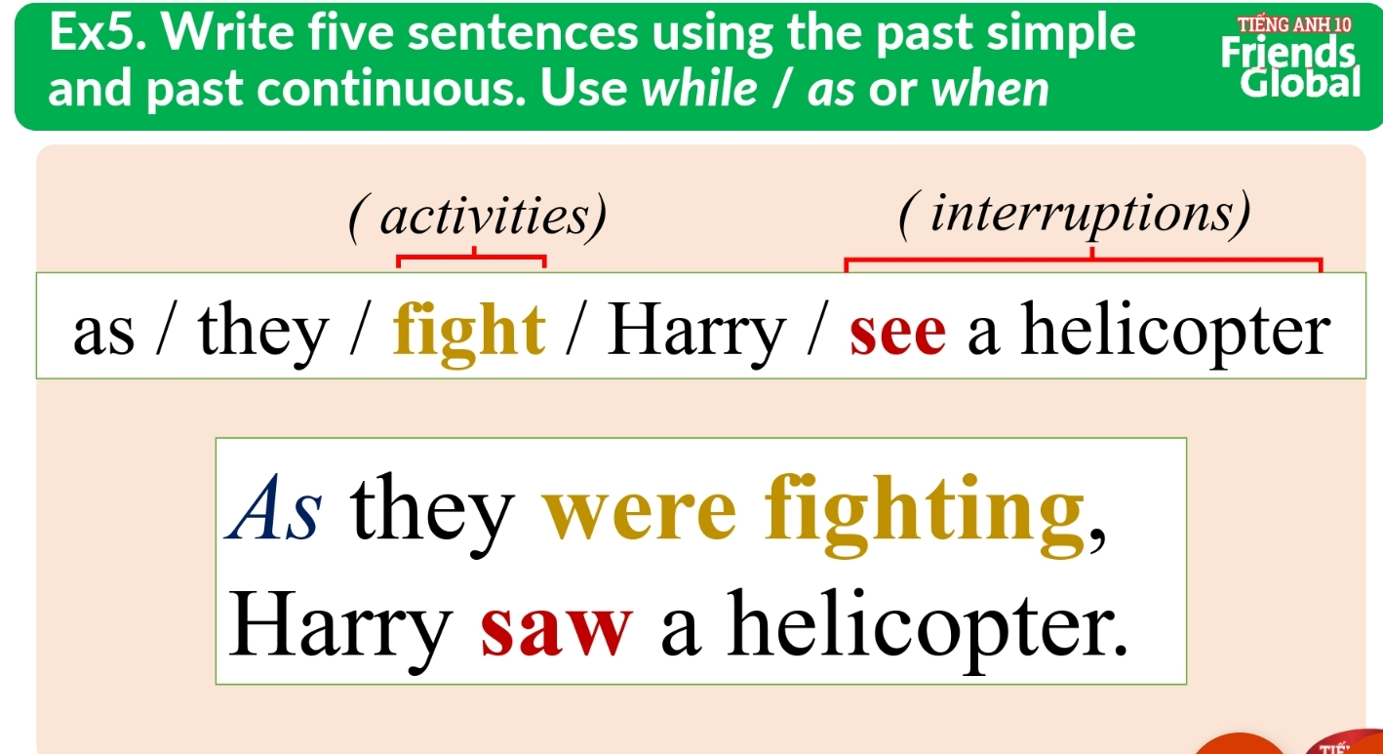  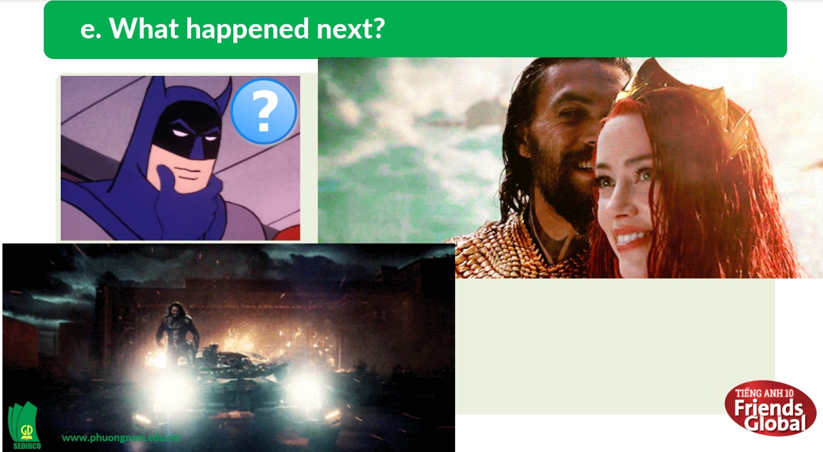  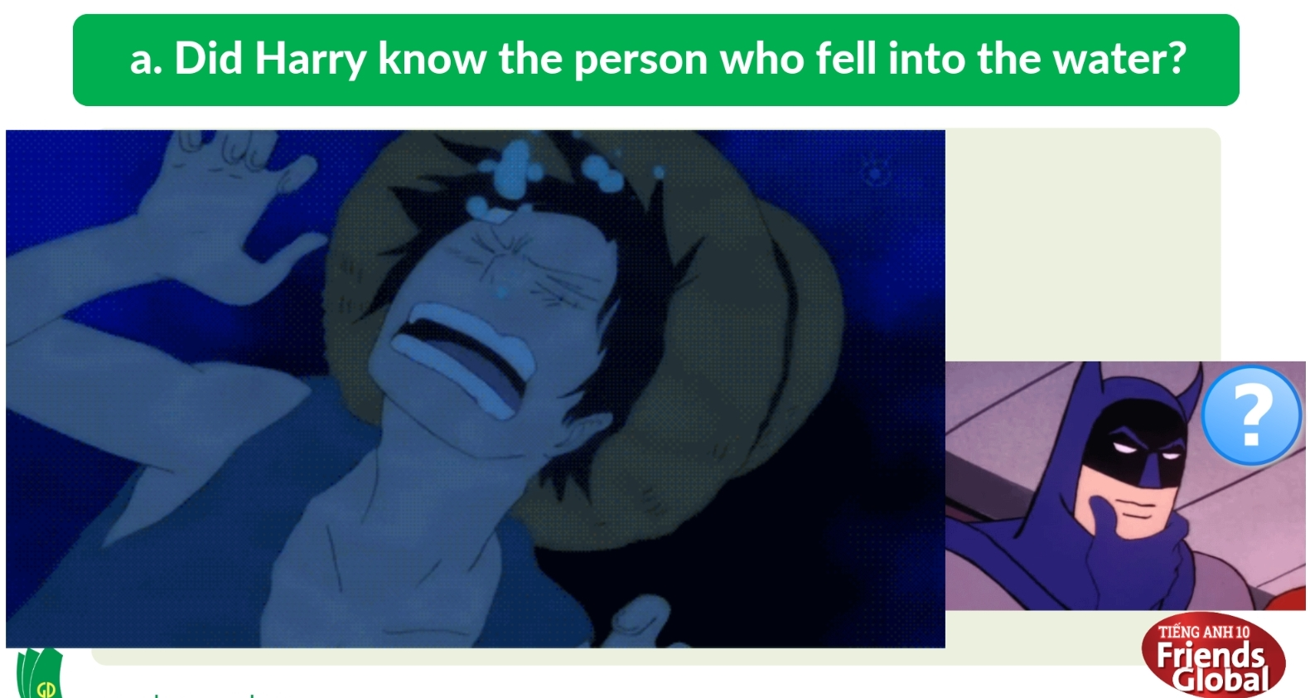

- Activity 3: Outcomes (5’)
a) Objective: Students listen to the story and check how different their ideas to the real story. Communication is also be practiced.
b) Content: Task 7 page 26
c) Outcomes: Ss speak and listen mutually, they can apply the structure of past simple or some adjectives to their conversations.
d) Competence: Presentation, communication, guessing
e) Organisation of the activity:
TEACHER’S ACTIVITIES | STUDENT’S ACTIVITIES | CONTENTS
PRODUCT. T- Ss/ S-S/ Indiv  - Play the recording.  - Ask students to compare the story and their story to see how different they are.  - Invite some students to share some differences.  - Encourage students to talk more. | - Listen and check.  - Compare the stories.  - Volunteer to share their ideas. | 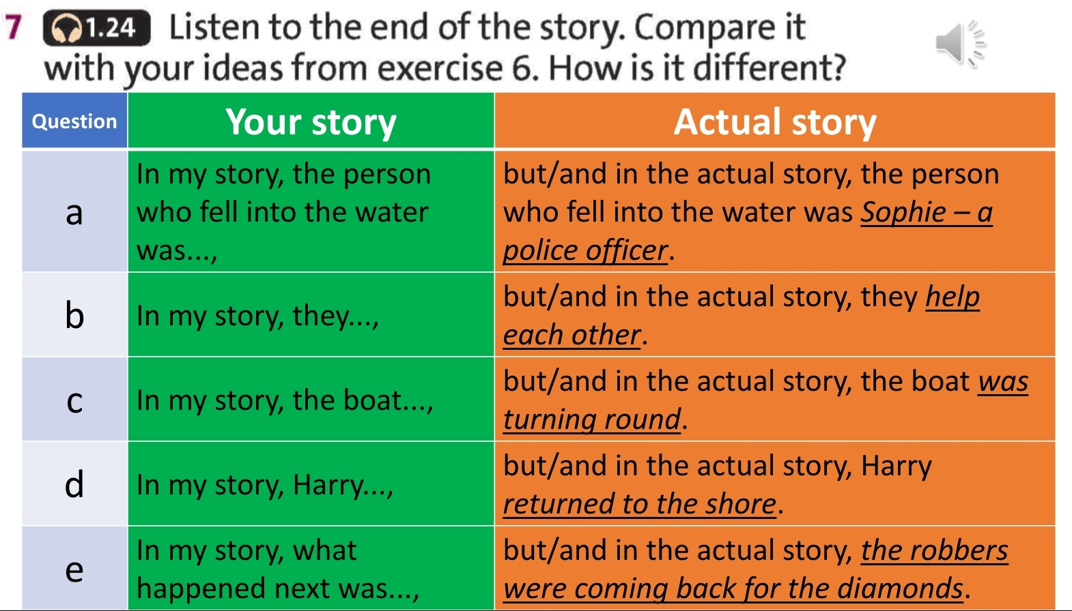
C. Consolidation (3’)
Grammar: the use of past simple and past continuous
D. Homework (2’)
- Learn by heart simple all the structures
- Do exercise
- Prepare: Unit 1 – E-Work skills (page 27 – SB)

