|  |  |
| --- | --- |
| **UBND HUYỆN KINH MÔN**  **PHÒNG GIÁO DỤC VÀ ĐÀO TẠO**  **-------------------------------** | **ĐỀ KIỂM TRA GIỮA HỌC KÌ I**  **NĂM HỌC 2022-2023**  **MÔN: TIẾNG ANH – LỚP 9 (THÍ ĐIỂM)**  Thời gian làm bài: 60 phút |

**A.LISTENING: ( 2 points)**

**Part 1. You will hear five short conversations. You will hear each conversation twice. There is one question for each conversation. Tick the right answer. (1,0pt)**

1. What doesn’t the girl like about her photo?

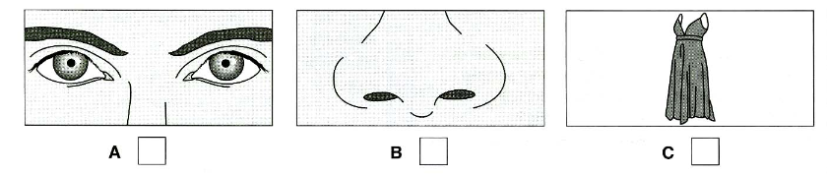

2. Which is the boy’s next lesson?

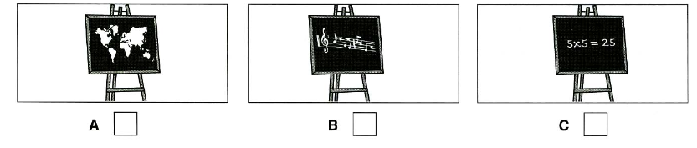

3. What will the woman do first?

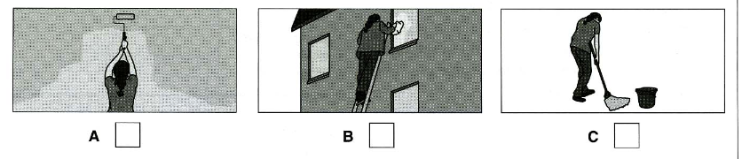

4.What do they need to buy for dinner?

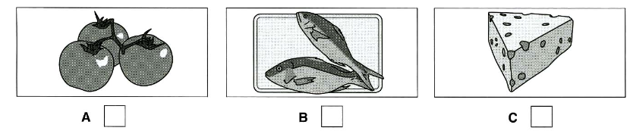

5. What did Joe get for his birthday?

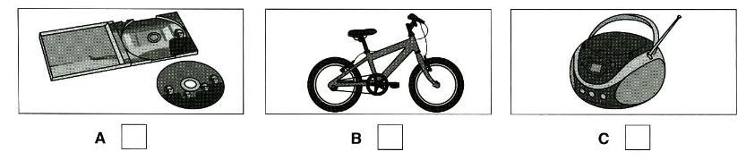

**Part 2. You will hear a man leaving a message. Listen and complete questions( 1,0pt)**

|  |
| --- |
| **Phone Message**  **From: Bike shop**  Colour of bike: 6. ........................  Bike costs: 7. £ ....................  Shop has also got: 8. Bicycle .............................  Come tonight before: 9. ................................ P.M  Address to go to: 10. King Street ............................... |

**B. Language:( 3 points)**

**.Choose the best option to complete each sentence. Circle A, B or C.**

|  |  |  |
| --- | --- | --- |
| 1. Our schools have put various kinds of _______ on us. | | |
| A. homework | B. pressures | C. difficulties |
| 2. We feel ______ to have a long summer holiday after a hard year of work. | | |
| A. delighted | B. stressful | C. embarrassed |
| 3. During adolescence, teens experience both emotional and _____ changes. | | |
| A. physical | B. spiritual | C. social |
| 4. Many teens try to work hard to meet parents’ ______. | | |
| A. hope | B. expectation | C. belief |
| 5. Cognitive skills enable teen to _____ better and be more self-disciplined. | | |
| A. emphasise | B. focus | C. concentrate |
| 6. ______ I warned her about the quality of the product, she bought it as a souvenir. | | |
| A. However | B. When | C. Although |
| 7. We travelled to a craft village ______ we had spent two hours in the gallery. | | |
| A. before | B. after | C. while |

|  |  |  |
| --- | --- | --- |
| 8. Transportation systems in big cities are often ___________ those in the countryside. | | |
| A. more reliable | B. more reliably than | C. more reliable than |
| 9. I can’t put up ___________ this anymore! You keep making so much noise! | | |
| A. about | B. on | C. with |
| 10. This building has been ___________ because it was no longer safe for people. | | |
| A. pulled down | B. pulling down | C. pull down |

**C. READING:( 2 points)**

**Part 1. Circle the correct answer A, B or C for each gap in the passage. (1,0 point)**

My mother came from Baffin Island. She used to live in an igloo: a domed house (1)______ from blocks of ice. The house had only one room for all the generations: grandparents, parents, brothers, unmarried sisters, and sometimes other relatives. Everyone worked together to survive the Arctic (2)______. Men went out hunting (3)______ women stayed at home making clothes and preparing food. When they had to travel far, they (4)______ on dogsleds. At night they used to entertain themselves by telling and (5)______ out stories. They danced to drum music ,too

*Akycha from Canada*

1. A. build B. built C. building

2. A. spring B. summer C. winter

3. A. while B. during C. before

4. A. walked B. rode C. drove

5. A. going B. knocking C. acting

**Part 2. Circle the correct answer A,B,C and D that best fit the question below.( 1.0 point)**

Recently, my grandparents often recall how difficult their lives were when they were young, claiming that my generation has much easier lives than they had. I agree with them. In fact, life today is much more comfortable and easier than it was in my grandparents’ youth for some reasons.

First, technology has made modern-day life much more comfortable than in the past. During my grandparents’ time, life was rough and hard because all the work was done without any modern tools, so they had to do their laundry by hand, walked from one place to another. Furthermore, there was limited in entertainment choices in the past. They could at best listen to the radio or perhaps watch a black-and-white movie for pleasure.

In addition, people today have more leisure time than they did before. People no longer have to work very long hours like my grandparents did. Since my grandparents were farmers, they had to work in the rice field all day long even without resting on weekends. In contrast, many people today, including my parents, simply work from nine to five on weekdays and take weekends off. They therefore have much free time than my grandparents did, so they can spend more time on leisure activities. They go to the movies, go to the gym, or take trips. All these activities have positive affect on their quality of living.

In conclusion, people today have more comfortable and easier lives than in the past.

1. Life in the past was …….. than it is now.

1. more boring B. happier C. more comfortable

2.People used to move from one place to another ……….

1. by bike B. by motorbike C. on foot

3.There are …….. kinds of entertainment now than before.

1. more B. less C. much

4.People in the past …………. have weekends off.

1. used to B. didn’t use to C. needed

5.What do people today do to relax? – They ………..

1. go camping B. go to the gym or take trips C. both A and B

**D.WRITING (30 pts)**

**Part 1. Choose the underlined word or phrase in each sentence below that needs correcting (1.0 point).**

1. When he came, I watched a football match on TV.

A B C D

2. When Andrew saw the question, he was knowing the answer immediately.

A B C D

3. Mai has stayed on her uncle's farm for last week.

A B C D

4. I'm looking forward to hear from you.

A B C D

5. They asked me don’t talk during the discussion

A B C D

**Part 2 . Rewrite the following sentences in such a way that they stay the same meanings. (1.0 pt)**

1. I don’t know where my wallet is.

-> I wish …. .……………………………………………

2. Ancient people thought that the stars would fall on them

-> It ……………………………………..……………………

3. Teacher says that no student in the school is noisier than I am.

-> The teacher says that ……………………………

4.What about seeing Trang An, a natural wonder of our area

-> He suggested.............................................................................................

5. “Peter, do you prefer tea or coffee?” she said

-> She asked Peter …………………………………………………

**Part 3. Write a passage (about 100 – 120 words) about a wonder of Viet Nam (1.0 point)**

**Your passage may include:**

* What is the name of wonder?
* Where is it?
* What is it famous for?
* What can you do when you visit it?
* How do you feel about it?

Begin:

.................................................................................................................................................................................................................................................................................................................................................................................................................................................................................................................................................................................................................................................................................................................................

**The end.**

**ANSWER KEY ( 9 thí điểm )**

1. **LISTENING ( 20 points)**

**Part 1*.* 5 x 2 = 10 pts**

|  |  |  |  |  |
| --- | --- | --- | --- | --- |
| 1. B | 2. C | 3. C | 4. A | 5. C |

**Part 2*.* 5 x 2 = 10 pts**

|  |  |  |  |  |
| --- | --- | --- | --- | --- |
| 1.blue | 2. 110.(00)/ one hundred (and) ten (pounds) | 3. (the) (bicycle) light(s) | 4. 6.45/18.45 | 5. 22/ twenty (-) two (King Street) |
| 1. **Language**   **(10 x 3 = 30 pts)** |  |  |  |  |

1. B 2. A 3. A 4. B 5. C 6. C 7. B 8. C 9. C 10. A

1. **READING: ( 20 points)**

**Part 1. 5 x 02 = 10pts**

1. B 2. C 3. A 4. B 5. C

**Part 2. 5 x 2 = 10 pts**

**1.A 2.C 3. A 4. B 5. B**

1. **WRITING: ( 30 points)**

**Part 1: (5 x 2= 10 point).**

1. B 2. C 3. D 4. D 5. D

**Part 2. 5 x 2 = 10 pt**

1-> I wish I knew where my name was.

2-> It was thought that the stars would fall on them.

3.-> The teacher says that I am the noisiest in the school.

4. -> He suggested seeing Trang An, a natural wonder of our area.

5. -> She asked Peter if he prefered tea or coffee.

**Part 3. (10pt)**

**1. Form:**

* *Correct form of a paragrpah (1 point)*

**2. Task fulfillment:**

* *Task complete with relevant information (4 points)*
* *Well- organized (3 points)*

**3. Language:**

* *Accurate grammar (3 points )*
* *Appropriate vocabulary (2 points )*
* *Correct spelling and punctuation (2 points )*