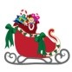

1
2
-to find out solve the puzzle!
1: The first letter in
4: The seventh letter of the alphabet.
8 + 12 + 19: First letter of this illustration.
3

5: First letter of the alphabet.
4
3 + 7 +13+ 24: First letter of the language used in this task.

5
6
6: First letter of this illustration.

7
2: The first letter of this illustration.
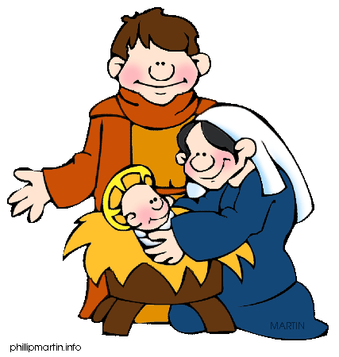
8
I
9
14: The first letter of these Christmas things.
10
25: Second letter of this illustration.
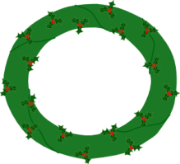
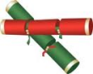
16 + 22: The third letter of this word.
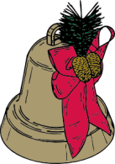
11
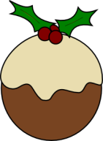

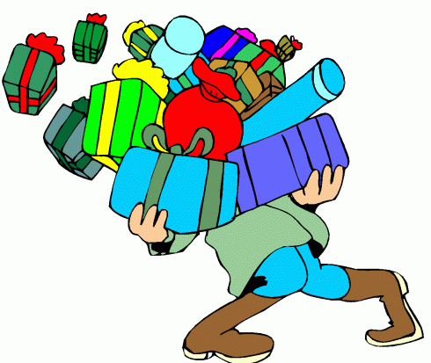

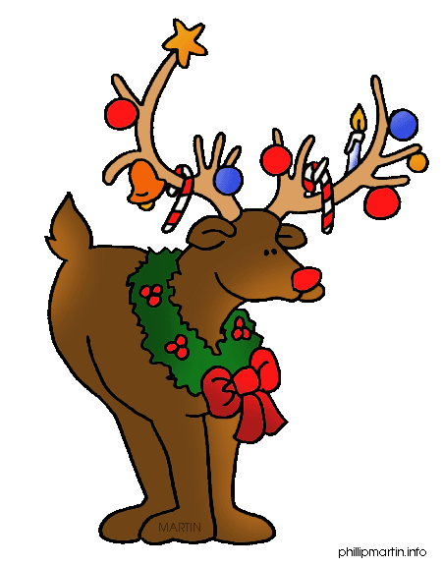

12
13
17
16
15
14
25
18
19
20
21
22
23
24
10: First letter of this Christmas stuff.
17 + 23: The third letter of this word.
11: The seventh letter of the things the man carries in the picture.
15 + 20: Letter number 4 in this word.
18: Letter number four in this thing we all want for Christmas.
21: Fourth letter in the name of this reindeer.

