Họ tên thí sinh: .................................................................
Số báo danh: ......................................................................
Mã Đề: 015.
Câu 1. What is the offer for the swim class?
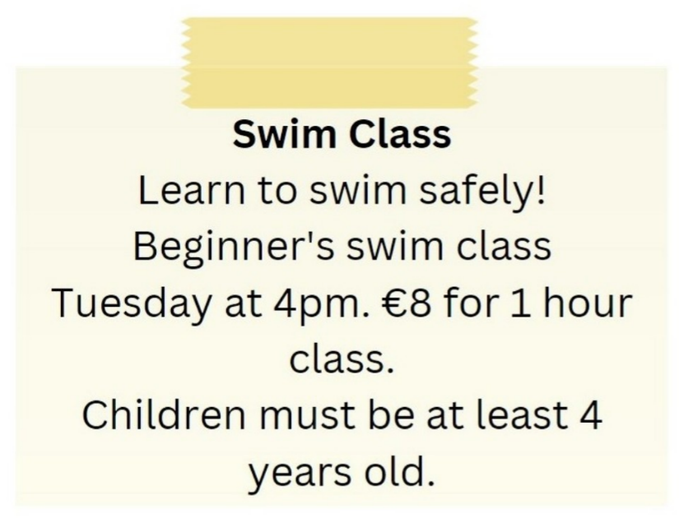
A. Beginner's swim class on Tuesday at 5pm for €10
B. Advanced swim class on Tuesday at 4pm for €8
C. Beginner's swim class on Wednesday at 4pm for €8
D. Beginner's swim class on Tuesday at 4pm for €8
Câu 2. Who is Andrew planning to go to the cinema with?
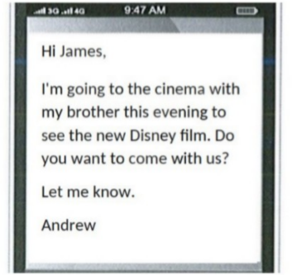
A. James B. Alone C. His parents D. His brother
Câu 3. What does this sign mean?
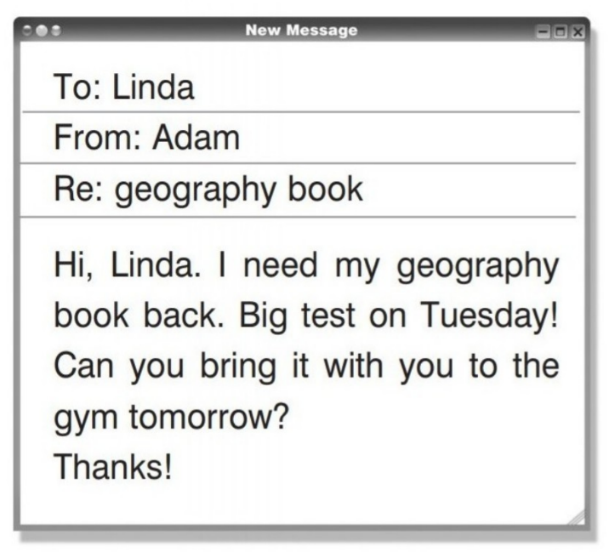
A. Linda wants to study in the fitness center. B. Adam requests to take Linda's book.
C. On Tuesday, Adam has a geography exam. D. The book belongs to Linda.
Câu 4. What does this sign mean?
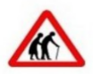
A. Be cautious as elderly people may be crossing the road.
B. Be careless as elderly people may be crossing the road.
C. They are wearing traditional clothing.
D. There are two old people here.
Câu 5. Which of the following is NOT mentioned as available at the Indoor Market?
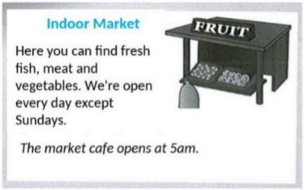
A. Vegetables B. Dairy products C. Meat D. Fresh fish
Câu 6. What is true about the New Zealand advertisement?
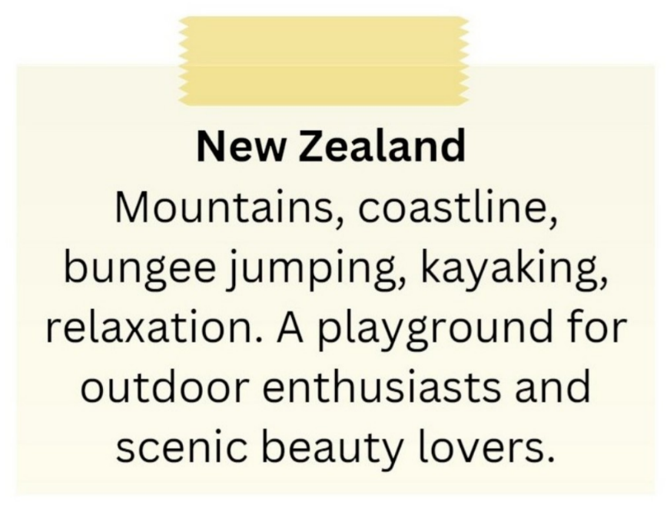
A. It primarily appeals to relaxation enthusiasts.
B. It is not suitable for outdoor enthusiasts.
C. It highlights mountains, coastline, bungee jumping, and kayaking.
D. It is a destination for indoor activities and cultural experiences.
Câu 7. What should visitors do if the gate is closed?
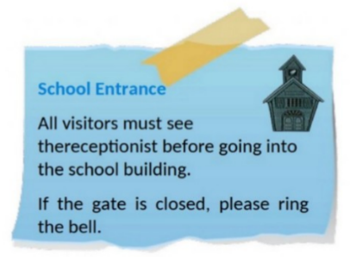
A. Wait for someone to open it B. Come back later
C. Ring the bell D. Call the school office
Câu 8. What can you see at the circus?

A. Only acrobats B. Only wild animals
C. Only funny clowns D. Wild animals and funny clowns
Câu 9. Who should students contact if they have lost their phone?
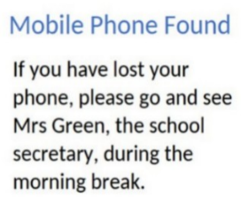
A. Their teacher B. The janitor C. Mrs Green D. The principal
Câu 10. Who can participate in this cycle ride?
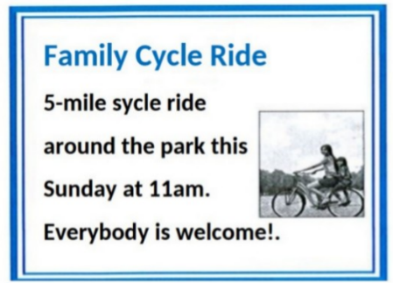
A. Only families with children B. Anyone who wants to join
C. Only park members D. Only experienced cyclists
----HẾT---

