|  |  |  |
| --- | --- | --- |
| **Name:.............................**  **........................................**  **........................................**  **Class: .............................** | **ĐỀ KIỂM TRA GIỮA HỌC KỲ I NĂM HỌC 2022 - 2023 MÔN: Tiếng Anh 6  Thời gian làm bài: 60 phút Đề gồm 04 trang** | **Mã đề 6.1.14** |

**A. LISTENING**

***I. Listen and and choose the best answer. (1.0pt)***

1. What does Daisy want for supper? 2. What did Sally get for her birthday?

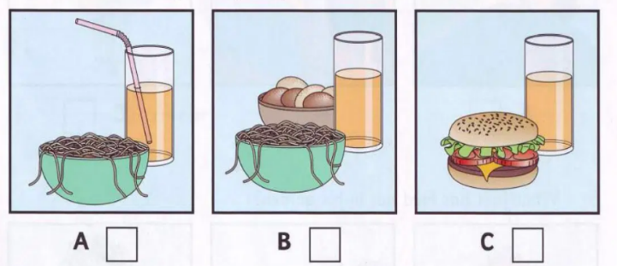 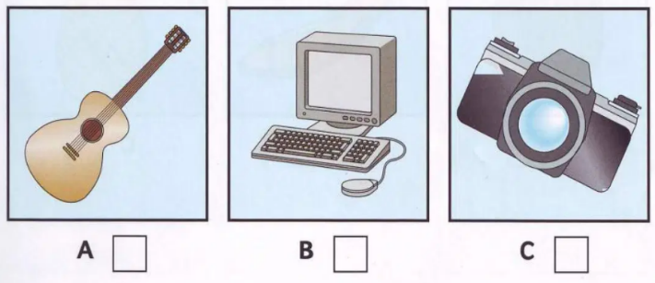

3. When did Peter go at the weekend? 4. What was the matter with Mary? 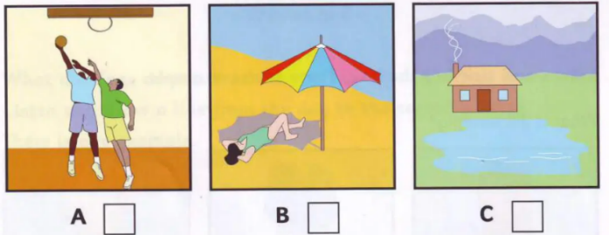 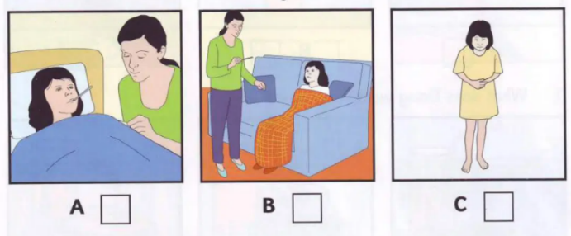

5. What fruit has Fred got in his garden?

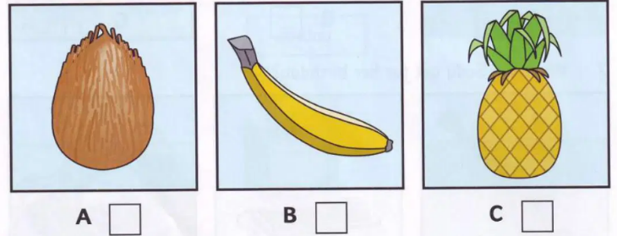

## *II. Listen and write a name or number. There are two examples. (1.0pt)*

**Sports centre**

0. Boy’s age: *11*

1. Favourite sport: ………………………….

2. Lives in: ……………………Street

3. Comes to sports centre by: ………………………....

4. Comes to sports centre after: ………………………….

5. Often buys some: ………………………….

**B. GRAMMAR – VOCABULARY – LANGUAGE FUNCTION**

***Circle the letter A, B or C before the best option to complete the sentences. (3.0pts)***

1. **Mom**: *“What does your best friend look like, Jane?”*

**Jane**: *“ ________________________________”*

A. She’s very kind and creative.

B. She’s tall and thin.

C. She likes playing the guitar.

2. Choose the word that has the **underlined** part pronounced differently from the others:

A. sm**ar**t B. M**o**nday C. s**u**bject

3. **Ms. Lan**: *“This is our new classmate, Peter.”*

**Students**: *“_______________”*

A. Nice to meet you. B. You are so funny. C. Let’s play football.

4. There are so many new words. Can I use a ________ to help me?

A. calculator B. ruler C. dictionary

5. My best friend is very _________. He plays football and basketball very well.

A. smart B. sporty C. funny

6. The vase is _________ the book and the glasses.

A. on B. between C. behind

7. **Kim**: *“How about going to the park?”*

**Linda**: *“ ______________”*

A. Not at all. B. I don’t like. C. Great idea.

8. They live __________the city.

A. in                    B. at                            C. on

9. What are you doing this afternoon? – I don’t know but I’d like to _______ karate.

A. play B. do C. go

10. Kate and Jenny are in their ___________ room?

A. living B. live C. lives

11. What time ______ Phuong go to school?

A. does B. do C. are

12. There ____ a big garden and four rooms.

A. are                            B. is                C. am

13. Be quiet! The baby ______________.

A. is sleep                  B. sleep C. is sleeping

14. This is ___________ calculator.

A. Tony B. of Tony C. Tony’s

15. The girls are __________ rope in the playground now.

A. skipping B. skip C. skips

**C. READING**

***I. Read the passage and decide whether the statements are T (True) or F (False). (1.5pts)***

My name is Emma. I am a student at San Ceferino school. I think it is an interesting school because it is not a regular school. The school is not modern, it is an old, big school. There is a big classroom with a computer for each student. In my school, we have English, Math and Science classes everyday, but we only have Art and Music classes on Friday. We also have computer classes on Tuesday and Thursday. My favourite subject is Science. Another interesting thing about my school is that there is a pet animal in the school. It is a dog, we call it “Antonio”. All my friends and I like my school and Antonio.

1. Emma is a teacher.

2. The school is boring.

3. There are many computers in the school.

4. There is Art class on Thursday.

5. Antonio is a dog’s name.

***II. Read the passage and choose the correct answer. (1.5pts)***

My best friend is Jennifer. She lives in Singapore, next to Malaysia. She is thirteen, two years older than me. She has a younger brother, David. She likes music, swimming and reading books but she doesn’t like playing computer games. She is very friendly and helpful. She is tall with long blonde hair and blue eyes. We write emails to each other every week. She says that she is going to visit Viet Nam this summer with her parents and her brother. I will take them to my house and we will visit some natural wonders of Viet Nam such as Ha Long Bay. I am looking forward to that time.

1. Where is Jennifer from?

A. Singapore B. Viet Nam C. Malaysia

2. How old is Jennifer?

A. Eleven B. Twelve C. Thirteen

3. What is she like?

A. Music, swimming and reading.

B. Friendly and helpful.

C. Tall with long blonde hair and blue eyes.

4. How many people are there in her family?

A. Four B. Three C. Five

5. Which sentence is NOT true about Jennifer?

A. She likes swimming.

B. She likes playing computer games.

C. She will visit Viet Nam this summer.

**D. WRITING**

***I. Rewrite the sentences without changing the meaning. (1.0pt)***

1. I like the bedroom most.

My favourite room is ……………………………………………………………………….

2. My house is behind the park.

The park is………………………………………………………………………………….

3. My class has 36 students.

There are……………………………………………………………………….....................

4. He has short and black hair.

His hair is……………………………………………………………………….....................

5. How about playing badminton this afternoon?

Let’s ………………………………………………………………………...........................

***II. Write a paragraph (50-70 words) to describe your house. (1.0pt)***

**Suggestions:**

*Where do you live?*

*What is your house?*

*How is your house?*

*How many rooms are there?*

*What is your favorite room?*

*What are there in that room?*

*What do you often do in this room?*

**_____The end_____**