

**PART 2: VOCABULARY**

|  |  |  |  |
| --- | --- | --- | --- |
| ENGLISH | TYPE | PRONUNCIATION | VIETNAMESE |
| **biology** | (n) | /baɪˈɒlədʒi/ | Môn Sinh học |
| **geography** | (n) | **/** dʒiˈɒɡrəfi/ | Môn Địa lý |
| **history** | (n) | **/** ˈhɪstri/ | Môn Lịch sử |
| **I.T(information technology)** | (n) | **/**aɪ’ti:**/**(/ɪnfəˌmeɪʃən tekˈnɒlədʒi/) | Môn Tin học |
| **literature** | (n) | **/** ˈlɪt.rə.tʃər/ | Môn Văn học |
| **music** | (n) | **/** ˈmjuː.zɪk/ | Môn Âm nhạc |
| **P.E(physical education)** | (n) | **/**piːiː**/**(**/**ˌfɪz.ɪ.kəl ed.jʊˈkeɪ.ʃən/) | Môn Thể dục |
| **physics** | (n) | **/**ˈfɪzɪks/ | Môn Vật lý |
| **act** | (v) | **/** ækt/ | Diễn xuất |
| **activity** | (n) | **/** ækˈtɪvəti/ | Hoạt động |
| **arts and crafts** | (n) | **/** ˌɑːts ən ˈkrɑːfts/ | Thủ công mỹ nghệ |
| **drama club** | (n) | **/** ˈdrɑː.mə klʌb/ | Câu lạc bộ kịch |
| **indoor** | (adj) | **/** ˌɪnˈdɔːr/ | Trong nhà |
| **outdoor** | (adj) | **/** ˈaʊtˌdɔːr/ | Ngoài trời |
| **sign up** | (v) | **/** saɪn ʌp/ | Đăng ký |
| **adventure** | (n) | **/** ədˈventʃər/ | Cuộc phiêu lưu |
| **author** | (n) | **/** ˈɔːθər/ | Tác giả |
| **fantasy** | (n) | **/**ˈfæntəsi/ | Kỳ ảo |
| **mystery** | (n) | **/** ˈmɪstəri/ | Bí ẩn |
| **novel** | (n) | **/** ˈnɒvəl/ | Tiểu thuyết |
| **peaceful** | (adj) | /ˈpiːsfl/ | Yên bình/ thanh bình |
| **beautiful** | (adj) | /ˈbjuːtɪfl/ | Đẹp |
| **capital** | (n) | /ˈkæpɪtl/ | Thủ đô |
| **secret** | (n) | /ˈsiːkrət/ | Bí mật |
| **event** | (n) | /ɪˈvent/ | Sự kiện |
| **strange** | (adj) | /streɪndʒ/ | Lạ |

**Task 1. Look at the pictures and write school subiects.**

geography science maths art biology English

literature history physics PE (physical education)

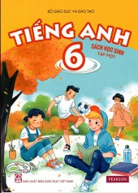 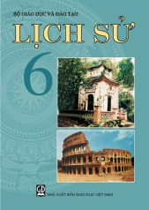  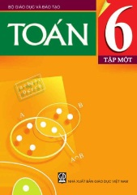 

1.*English* 2. 3. 4. 5.

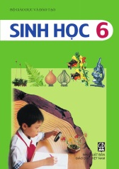   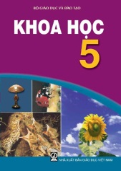 

6. 7. 8. 9. 10.

**Task 2. *Read the sentences. Circle the correct answers.***

5…………………

8…………………

7…………………

6…………………

1. I like\_\_\_\_\_\_\_\_\_\_ because I like reading stories.  
A. literature B. math C. physics D. biology

2. I like to study plants and how they grow. I like\_\_\_\_\_\_\_\_\_\_.

A. I.T B. biology C. history D. math

3. I like computers. That's why I like\_\_\_\_\_\_\_\_\_\_.  
A. I.T B. P.E C. history D. physics  
4. I love to learn about mountains and rivers. I like\_\_\_\_\_\_\_\_\_\_.  
A. I.T B. physics C. English D. geography  
5. I don't like running and playing sports. I don't like\_\_\_\_\_\_\_\_\_\_.  
A. literature B. P.E C. math D. history

6. Studying helps me learn about countries around the\_\_\_\_\_\_\_\_\_\_ world and famous people in the past.  
A. music B. history C. biology D. math

7. I love to learn how light, heat, and sound work. I love\_\_\_\_\_\_\_\_\_\_.  
A. geography B. biology C. physics D. music

8. My brother love playing tennis. He usuall go to the indoor sports\_\_\_\_\_\_\_\_ at school.

A. park B. pool C.club D.class

9. Jonh like acting a lot, so he signs up for the school\_\_\_\_\_\_\_\_\_\_ club.

A .arts and craft B.drama C. music D.dance

10. I don’t like playing\_\_\_\_\_\_\_ such as biking and running.

A. acting B. table tennis C. outdoor D. indoor

**Task 3. Read the clue and write the names of the subjects:**

1. This subject help you learn about countries and people in the past. \_\_\_\_\_\_\_\_\_\_\_\_\_
2. You learn about the location of the countries, cities, rivers and mountains in this subject. \_\_\_\_\_\_\_\_\_\_\_\_\_\_\_\_\_
3. You learn how to sing songs and play guitar, piano, … when you take this lesson. \_\_\_\_\_\_\_\_\_\_\_\_\_\_\_\_
4. Students run, do exercise and play sports in this subject. \_\_\_\_\_\_\_\_\_\_\_
5. In this subject you read stories and write essays. \_\_\_\_\_\_\_\_\_\_\_\_\_\_\_
6. In this subject you study computers and how to use them. \_\_\_\_\_\_\_\_\_\_\_\_\_\_
7. This is a science that plants and animals. \_\_\_\_\_\_\_\_\_\_\_\_\_\_
8. This is a science that studies light, heat, sound and other forms of energy. \_\_\_\_\_\_\_\_\_\_\_\_\_\_\_

**Task 4. Fill in the blanks using the words in the box.**

|  |  |  |  |  |  |  |  |  |  |  |  |  |
| --- | --- | --- | --- | --- | --- | --- | --- | --- | --- | --- | --- | --- |
| **sign up** | | **drama club** | | **arts and crafts** | | **indoor activities** | | | **indoor activities** | | | **act** |
| **sign up** | **history** | | **arts and crafts** | | **fantasy** | | **novel** | **geography** | | **drama club** | **literature** | |

**1.** Why don't you\_\_\_\_\_\_\_\_\_\_\_\_\_\_ for a book club?  
**2.** Chris wants to be an actor. He's learning how to\_\_\_\_\_\_\_\_\_\_\_\_\_\_ at school.  
**3.** Jane likes acting. She joined the\_\_\_\_\_\_\_\_\_\_\_\_\_\_ at school.  
**4.** Some students love doing\_\_\_\_\_\_\_\_\_\_\_\_\_\_ because they can make pretty things from paper.  
**5.** Volleyball and table tennis are\_\_\_\_\_\_\_\_\_\_\_\_\_\_. We often play them in the sports center.  
**6.** Many students like playing soccer and tennis. They're \_\_\_\_\_\_\_\_\_\_\_\_\_\_.

**7.** My favorite subject is\_\_\_\_\_\_\_\_\_\_\_\_\_\_ I like learning about people in the past.

**8.** Harry Potter is a famous\_\_\_\_\_\_\_\_\_\_\_\_\_\_ series. Many people love the magical world in the books.

**9.** There are many\_\_\_\_\_\_\_\_\_\_\_\_\_\_ projects before the holidays. You can learn how to make beautiful cards and decorations.

**10.** Her first\_\_\_\_\_\_\_\_\_\_\_\_\_\_ is about her childhood in the south of India. Many people, especially girls and women, love it because they can see themselves in her story.

**11.** Why don't you\_\_\_\_\_\_\_\_\_\_\_\_\_\_ for an outdoor activity? Being outdoors is great for your health.

**12.** Matt doesn't like\_\_\_\_\_\_\_\_\_\_\_\_\_\_. He thinks all the books he has to read in the class are boring.  
**13.** We learn about different countries in\_\_\_\_\_\_\_\_\_\_\_\_\_\_ class.

**14.** The\_\_\_\_\_\_\_\_\_\_\_\_\_\_ is looking for actors for their new play.

**Task 5. Unscramble the letters to make meaningful word.**

**.**

1. ligbyoo 5.imsuc

2. ryshiot 6.pihcyss

3. georyhgap 7. T.I

4. ertltiuare 8. E.P

9. tyerysm 12. fihet

10. ceetidtv 13. ceul

11. saetl 14. vosel



**PART 3: GRAMMAR**

1. **Tính từ sở hữu (Possessive adjective)**

Tính từ sở hữu thể hiện tính chất sở hữu của người hoặc vật với danh từ đi sau nó. Tính từ sở hữu tùy thuộc chủ sở hữu.

Các tính từ sở hữu cùng với các đại từ nhân xưng (personal pronouns) tương quan như sau:

|  |  |
| --- | --- |
| **Đại từ nhân xưng** | **Tính từ sở hữu** |
| I | My |
| You | Your |
| He | His |
| She | Her |
| It | Its |
| We | Our |
| They | Their |

Các tính từ sở hữu luôn đi trước danh từ mà nó sở hữu và các danh từ này không có mạo từ đi theo.

My mother (Mẹ của tôi), his work (công việc của anh ta), our office (cơ quan của chúng tôi), your good friend (người bạn tốt của bạn)

* He sees his grandmother: Anh ấy thăm bà.
* He sees his grandparents: Anh ấy thăm ông bà.

### **Đại từ sở hữu (Possessive Pronouns)**

Đại từ sở hữu là từ chỉ sự sở hữu của người hoặc vật với người hoặc một sự vật khác. Đại từ sở hữu được sử dụng để thay thế cho tính từ sở hữu theo sau để tránh lặp lại. (Đại từ sở hữu = Tính từ sở hữu + Danh từ).

*Eg: This is my pen and that is****yours****. (yours = your pen)*

*Her shirt is new, and* ***mine*** *is old. (mine = my shirt)*

*Tim is a friend of****mine****.*

**Bảng liệt kê đại từ nhân xưng chủ ngữ, tính từ sở hữu và đại từ sở hữu**

|  |  |  |  |
| --- | --- | --- | --- |
| **Đại từ nhân xưng chủ ngữ** | **Tính từ sở hữu** | **Đại từ sở hữu** | **Nghĩa** |
| I | my | **mine** | *của tôi* |
| you | your | **yours** | *của bạn/các bạn* |
| we | our | **ours** | *của chúng tôi* |
| they | their | **theirs** | *của họ* |
| he | his | **his** | *của anh ấy* |
| she | her | **hers** | *của cô ấy* |
| it | its | **its** | *của nó* |

**II. Using “and”/ “or” for listing: Sử dụng and hoặc or để liệt kê.**

***1. We use “and” to join two or more nouns in a positive sentence***

**I like English and music.**

**I like English, math and music.**

***2. We use “or” to join two or more nouns in a negative sentence: sử dụng or đrr nối hai hoặc nhiều danh từ trong câu phủ định.***

**I don’t like English or music.**

**I don’t like English, math or music.**

**III. Using “like” to talk about school activities**

***1. We use “like + verb-ing”: đọng từ sau like luôn sử dụng ở dạng đuôi ING để nói về các hoạt động tại trường học.***

**I like doing outdoor activities.**

**I like speaking English.**

**2. Verbs of *liking* + V-ing**

Chúng ta sử dụng động từ dạng V-ing đằng sau những động từ chỉ sự thích/ ghét sau.

|  |  |
| --- | --- |
| **Thích** | **Ghét** |
| like | hate |
| love | dislike |
| enjoy |  |

*Ví dụ:*

He likes playing sports at recess.

She hates working overtime.

**Task 1. Complete the table:**

|  |  |  |
| --- | --- | --- |
| **Verb** | **Verb-ing** | **Meaning** |
| **1.** sing |  |  |
| **2.** draw |  |  |
| **3.** cut |  |  |
| **4.** read |  |  |
| **5.** dance |  |  |
| **6.** get |  |  |
| **7.** act |  |  |
| **8.** paint |  |  |
| **9.** sign |  |  |
| **10.** listen |  |  |
| **11.** swim |  |  |
| **12.** read |  |  |
| **13.** happen |  |  |
| **14.** play |  |  |
| **15.** join |  |  |

**Task 2.Read the sentences. Underline the correct words.**

1. Have you got \_\_\_\_\_\_\_\_\_ pen, or would you like to borrow \_\_\_\_\_\_\_\_\_?

A. your – mine B. yours – my C. yours – mine

2. Jane’s voice is good. \_\_\_\_\_\_\_\_\_ is good, too.

A. I B. my C. mine

3. \_\_\_\_\_\_\_\_\_ cat is adorable. \_\_\_\_\_\_\_\_\_ is adorable too.

A. Your – My B. Your – Mine C. Yours – Mine

4. My face looks like \_\_\_\_\_\_\_\_\_ face.

A. she B.her C. hers

5. It’s not \_\_\_\_\_\_\_\_\_ fault. It’s\_\_\_\_\_\_\_\_\_.

A. your – mine B. yours – mine C. your – my

6. Jim’s car was parked here. \_\_\_\_\_\_\_\_\_ parked \_\_\_\_\_\_\_\_\_ car here too.

A. I – mine B. I – my C. my – mine

7. I know Louis is \_\_\_\_\_\_\_\_\_ friend. He’s also a friend of \_\_\_\_\_\_\_\_\_.

A. your – my B. your – I C. your – mine

8. I lost my pencil. Can I have one of \_\_\_\_\_\_\_\_\_?

A. your B. you C. yours

9. This is not \_\_\_\_\_\_\_\_\_ car. \_\_\_\_\_\_\_\_\_ is black.

A. my – My B. my – Mine C.my – I

10. Has the cat had \_\_\_\_\_\_\_\_\_ food?

A. its B. it C.him

**Task 3. Underline the correct words.**

**1.** I like art, English, ***and/or*** music.  
**2.** What's your favorite subject? ***Mine/ Yours*** is biology.  
**3.** Do you like ***play/playing*** sports?  
**4.** The book's ***by/on*** Harper Lee.  
**5.** I think the book ***is/are*** very exciting.  
**6.** I like ***dancing/danceing***. I want to sign up for a dance class.  
**7.** Do you know where my bag is?  
Hmm, is that ***mine/yours***?  
**8.** I don't like ***draw/drawing.***

**Task 4. Complete the sentences, using the *-ing* form of the verbs in the box.**

**tidy fly take watch cook make wait read play go**

1. Do you fancy \_\_\_\_\_\_\_\_\_\_\_\_\_ out this evening?

2. I like \_\_\_\_\_\_\_\_\_\_\_\_\_ tennis at the weekend.

3. Jim enjoys \_\_\_\_\_\_\_\_\_\_\_\_\_ photos of himself and his friends.

4. Ann’s father doesn’t like \_\_\_\_\_\_\_\_\_\_\_\_\_ ice hockey on TV.

5. My mother hates \_\_\_\_\_\_\_\_\_\_\_\_\_, so we eat out every often.

6. Do you like \_\_\_\_\_\_\_\_\_\_\_\_\_ pottery?

7. She dislikes \_\_\_\_\_\_\_\_\_\_\_\_\_ her room every day.

8. My niece loves \_\_\_\_\_\_\_\_\_\_\_\_\_ adventure books.

9. I can’t stand \_\_\_\_\_\_\_\_\_\_\_\_\_ for buses in the rain.

10. They detest \_\_\_\_\_\_\_\_\_\_\_\_\_, so they usually travel by train or coach.



**LISTENING**

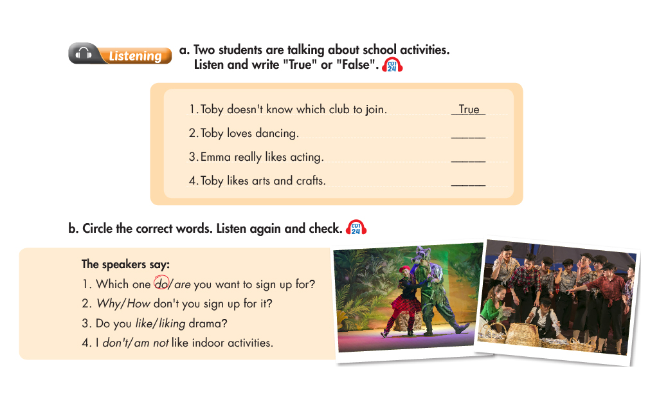



**SPEAKING**

**Task 1. Match the questions and answers. Then practice.**

|  |  |  |
| --- | --- | --- |
| 1. Why don’t you join the tennis club? | 1- | 1. Oh. I really like reading book. |
| 1. Do you like doing art and craft? | 2- | 1. I like English and Math |
| 1. Which club do you want to sign up for? | 3- | 1. Let me see. |
| 1. Great. Why don’t you sign up for it? | 4- | 1. My favourite subject is Math. |
| 1. How about a book club? | 5- | 1. I don’t like physic and art. |
| 1. What subject do you like? | 6- | 1. Hmm. I don’t know. |
| 1. What’s your favourite subject? | 4- | 1. Yes, I do. Art is my favourite subject. |
| 1. What subject don’t you like? | 8- | 1. Because I don’t like outdoor activities |

**Task 2. Answer the questions.**

|  |  |  |
| --- | --- | --- |
| 1. What subject do you like? |  | ……………………………………… |
| 1. What’s your favourite subject? |  | ……………………………………… |
| 1. What subject don’t you like? |  | ……………………………………… |
| 1. Why don’t you like I.T? Computers are useful. |  | ………………………………………  ……………………………………… |
| 1. Which school club do you sign up for? |  | ……………………………………… |
| 1. Do you like science? |  | ……………………………………… |
| 1. Which activity do you want to join? Outdoor or indoor activity. |  | ……………………………………… |
| 1. Do you like doing art and craft? |  | ………………………………………  ……………………………………… |



**READING**

**Task 1. Read and answer the questions.**

|  |  |
| --- | --- |
| cute-girl-go-school-cartoon_33070-2105 | Hi, I’m Linda. I’m in the sixth grade. Today is my first day at secondary school. In the morning I put on my new uniform and get my new bag.  My best friend and I walk to school together. We are both very nervous and excited. When we get school, we are shown into our classroom with our new teacher. It is quite scary because I don’t know most of the children. Then we go to our first lesson. We have lots of different subjects and the lessons are really fun. My favourite subjects are art and English.  I really like my new school, all my teacher are lovely, the lessons are really interesting and I enjoy my first day. I can’t wait to go back tomorrow! |

1. What grade is Linda in?

2. Who does she go to school with?

3. How does they go to school?

4. Why does Linda feel scary?

5. What are her favourite subjects?

6. Does she enjoy her first day at school?

**Task Task 2. *Read the school newsletter and answer the questions***

**School Clubs**

We have lots of fun clubs at our school. If you like outdoor activities, the Soccer Club meets at 4 p.m. every Tuesday, with the Tennis Club at the same time on Thursdays. For indoor activities, the Board Games Club starts next week. It is popular so please sign up on the noticeboard. The Book Club welcomes anyone who likes reading. You don't need to sign up but please bring your own copy of The Secret Garden with you to the Library at 4 p.m. on Wednesday. Our Arts and Crafts Club is for people who like making things. The cost is $20 per term for materials.

**1.** Which club is on Tuesdays?

**……………………………………………………………………………………………**

**2.** Which club wants you to sign up on the noticeboard?

**……………………………………………………………………………………………**

**3.** Which club wants you to take something with you?

**……………………………………………………………………………………………**

**4.** Which club needs money?

**……………………………………………………………………………………………**

**Task Task 3. Reading Read the book review and write T "True" or F "False" for each sentence.**

**My Favorite Novel**

Thành Nguyễn, November 18

My favorite book is Yellow Flowers on the Green Grass (Tôi Thấy Hoa Vàng Trên Cỏ Xanh). It's an interesting novel. The author of the book is Nguyễn Nhật Ánh. The book is about Thiều and the people around him. I like the book because it shows us many beautiful things in Thiêu's village. It is a peaceful village with green grass, trees, wind, and yellow flowers. Some parts of the story are very sad. I cried a lot when I thought Thiều's brother, Tường, cannot walk again. I really like this book. I think you should read it.

|  |  |
| --- | --- |
| **Sentences** | **True/ False** |
| **1.** Yellow Flowers on the Green Grass is by Nguyễn Nhật Ánh. |  |
| **2.** The writer thinks the book is boring. |  |
| **3.** The story is about three girls as they grow up. |  |
| **4.** In the story, Tường lives in a big city. |  |
| **5.** Some parts of the story are sad. |  |
| **6.** The writer likes this story. |  |



**WRITING**

**Task 1. Complete the second sentence so that it has the same meaning as the first.**

1. What is your favorite subject?

→ What subject

2. There are 35 students in my class.

→ My class

3. Mai live near her school.

→ Mai’s house isn’t

4. Mary plays the piano very well.

→ Mary is good

5. Do you like physics?

→ Are you interested

6. The school has a computer room and a library.

→ There

**Task 2. Put the words in order to make a sentence.**

1. secondary/ first/ your/ at/ school/ is/ how/ week?

2. lessons/ many/ have/ on/ how/ you/ do/ Friday?

3. art/ creative/ are/ drawings/ students/ the/ some/ doing/ in/ club

4. school/ at/ English/ we/ have/ classes/ don’t/ today

5. homework/ you/ doing/ maths/ are/ your?

6. children/ first/ on/ most/ school/ excited/ are/ day/ of/ the

**Ta Task 3. Write 6 sentences about your school.**

1. School’s name:

2. School’s address:

3. Number of pupils:

4. Number of teachers:

5. Uniform colour:

6. Favourite activity:



**

