|  |  |
| --- | --- |
|  | *Thời gian làm bài: 40 phút (Không kể thời gian giao đề)*  *-------------------------* |

**Họ tên thí sinh: .................................................................**

**Số báo danh: ......................................................................**

**Mã Đề: 006.**

**Câu 1.** What special offer is available at the new fast food restaurant?

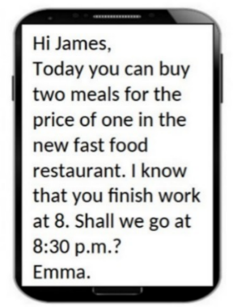

**A.** Buy one get one free dessert  **B.** Free drinks with every meal

**C.** 50% off all menu items  **D.** Two meals for the price of one

**Câu 2.** **Look at the signs. Choose the best answer for the question.**

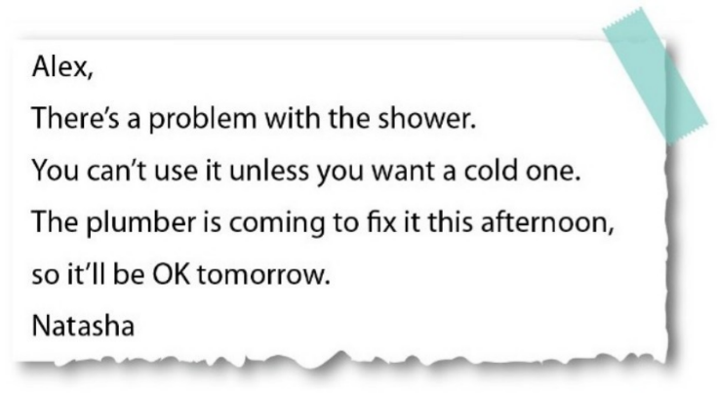

**A.** Alex can’t take a shower until tomorrow.

**B.** The plumber will repair the shower tomorrow.

**C.** It is impossible to have a hot shower this morning.

**D.** Alex prefers taking a cold shower today.

**Câu 3.** How long does the reading competition last?

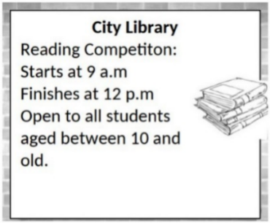

**A.** 2 hours  **B.** 3 hours  **C.** 4 hours  **D.** 5 hours

**Câu 4.** What are the new students instructed to do?

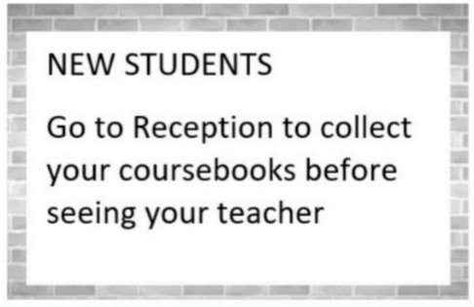

**A.** See their teacher before going to Reception  **B.** Go to Reception to collect their coursebooks

**C.** Go to their teacher first  **D.** Collect their coursebooks from their teacher

**Câu 5.** "What activity is the person inviting their friend to do?"

Hey friend! I hope you're having a good day. I wanted to see if you're up for watching a film this weekend. I heard that a new blockbuster just came out and it's supposed to be really good. Let me know if you're free and we can catch it together.

**A.** Watch a film  **B.** Go to a museum  **C.** Read a book  **D.** Attend a play

**Câu 6.** **Look at the signs. Choose the best answer for the question.**

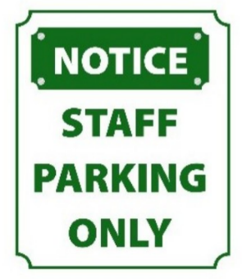

**A.** No one is allowed to park in this area.

**B.** Only people who work here can park in this area.

**C.** You have to contact the staff if you want to park in this area.

**D.** This parking area is for everyone.

**Câu 7.** What is true about this notice?

Library Opening Notice:

Book lovers rejoice! Our local library is finally opening its doors after months of renovation. Join us on Saturday, June 19th, for the grand opening celebration. We will have book signings, story readings, and a special surprise for our first 50 visitors. Don't miss out on this exciting event!

**A.** There will be no book signings.

**B.** The grand opening celebration is on Sunday, June 19th.

**C.** The local library is opening after months of being closed.

**D.** The first 100 visitors will receive a special surprise.

**Câu 8.** What does Rachel offer to do?

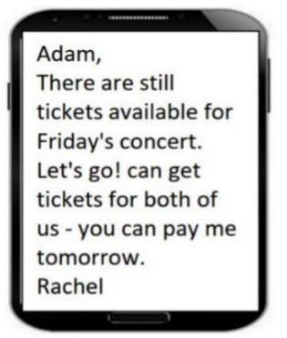

**A.** Get tickets for both of them  **B.** Reserve tickets for Adam

**C.** Pay for both tickets  **D.** Buy tickets for Adam

**Câu 9.** What does Paul request from Alice in his message?

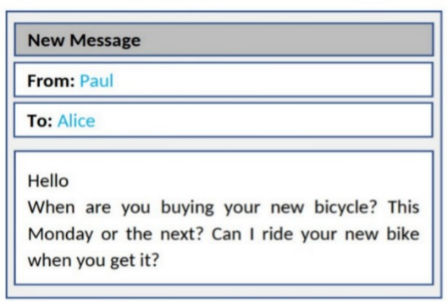

**A.** To try out her new bicycle when she gets it  **B.** To teach him how to ride a bicycle

**C.** To borrow money for a bicycle  **D.** To go bicycle shopping together

**Câu 10.** **Look at the signs. Choose the best answer for the question.**



**A.** You can only buy apples today.

**B.** You can buy cheaper apples after 6 p.m.

**C.** Today you can buy apples at a cheaper price before 6 p.m.

**D.** You can’t buy any apples before 6 p.m.

**----HẾT---**