
PART 2: VOCABULARY

ENGLISH | TYPE | PRONUNCIATION | VIETNAMESE
blond | (adj) | /blɒnd/ | (Tóc) vàng
blue | (adj) | /bluː/ | Màu xanh dương
brown | (adj) | /braʊn/ | Màu nâu
glasses | (adj) | /ɡlæsiz/ | Mắt kính
long | (n) | /lɔŋ/ | Dài
red | (adj) | /red/ | Màu đỏ
short | (adj) | /ʃɔːrt/ | Ngắn, thấp
slim | (adj) | /slɪm/ | Thon thả, gầy
tall | (adj) | /tɔːl/ | Cao
badminton | (n) | /ˈbædmɪntən/ | Cầu lông
barbecue | (n) | /ˈbaːrbikjuː/ | Tiệc nướng ngoài trời
beach | (n) | /biːtʃ/ | Bãi biển
cake | (n) | /keik/ | Bánh ngọt
mall | (n) | /mɔ:l/ | Trung tâm thương mại
movie | (n) | /ˈmuːvi/ | Phim điện ảnh
party | (n) | /ˈpɑːrti/ | Bữa tiệc
pizza | (n) | /ˈpiːtsə/ | Bánh pi-za
swimming | (n) | /ˈswɪmɪŋ/ | Việc bơi lội
TV | (n) | /ˌtiː ˈviː/ | Ti vi
video game | (n) | /ˈvɪdiəʊ ɡeɪm/ | Trò chơi điện tử
friendly | (adj) | /ˈfrendli/ | Thân thiện
funny | (adj) | /ˈfʌni/ | Buồn cười, vui nhộn
helpful | (adj) | /ˈhelpfl/ | Có ích
kind | (adj) | /kaɪnd/ | Tử tế
lazy | (adj) | /ˈleɪzi/ | Lười biếng
selfish | (adj) | /ˈselfɪʃ/ | Ích kỷ
housework | (n) | /ˈhaʊswɜːrk/ | Công việc nhà
character | (n) | /ˈkærəktər/ | Nhân vật/ Tính cách
schoolwork | (n) | /ˈskuːlwɜːrk/ | Bài tập về nhà
expression | (n) | /ɪkˈspreʃn/ | Thành ngữ
shuttlecock | (n) | /ˈʃʌtlkɑːk/ | Quả cầu
Task 1. Fill in each blank to find names of parts of the body.

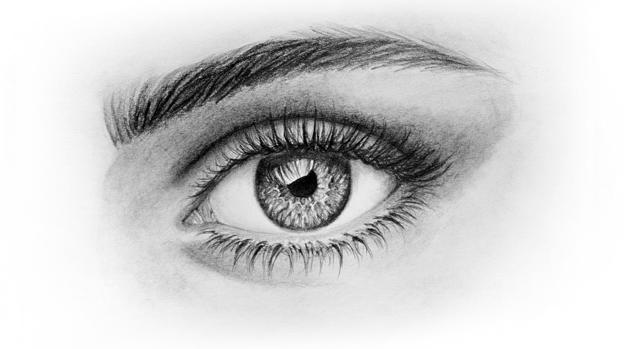  _y_ | 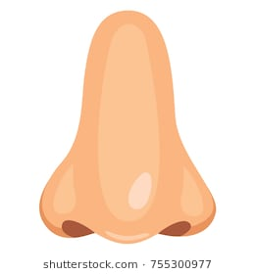  n_s_ |   m_ _th | 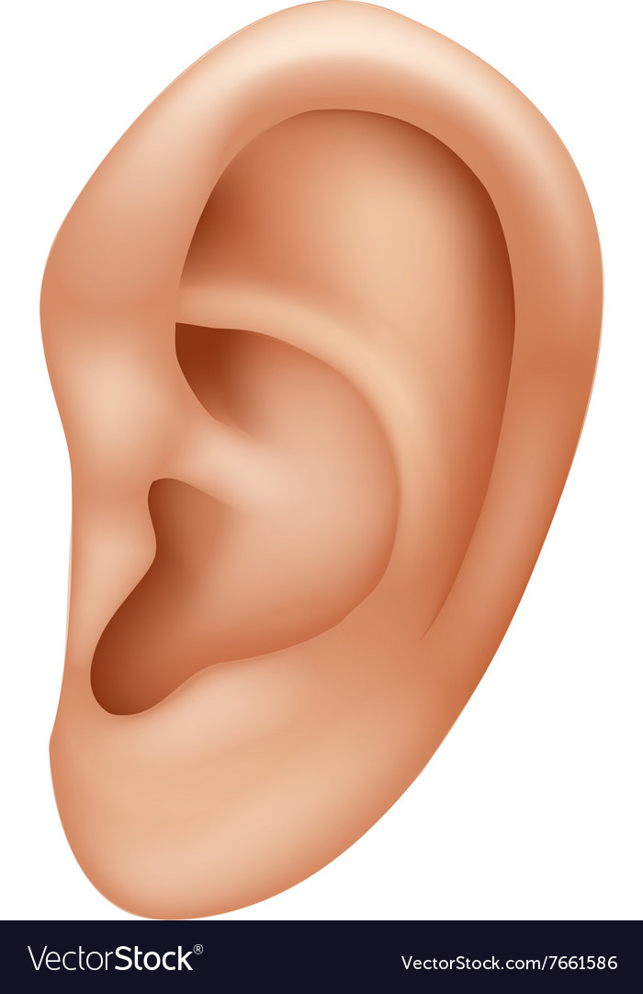  e_r | 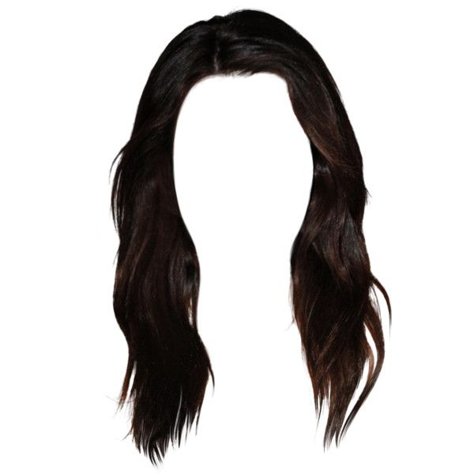  h_ _r
  t_ _t_ | 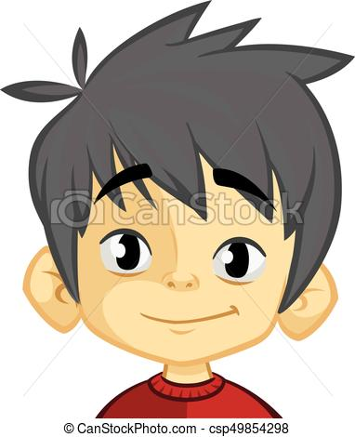  _ac_ | 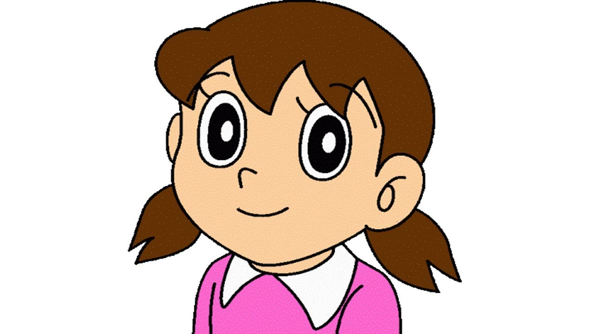  h_ _d | 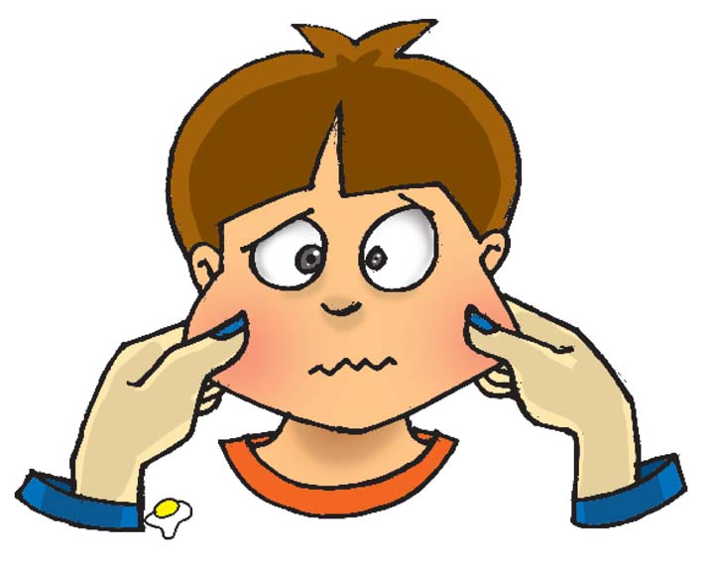  _h_e_s | 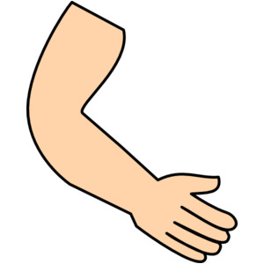  _r_
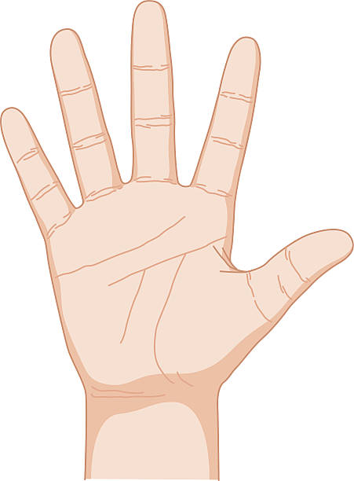  _a_d | 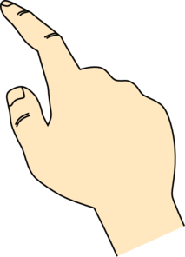  f_n_e |   _lb_w | 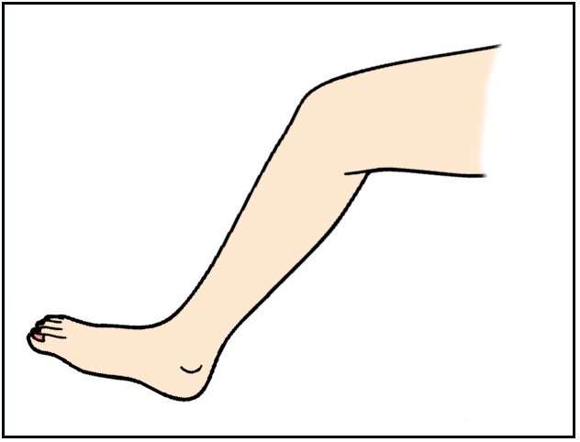  _e_ | 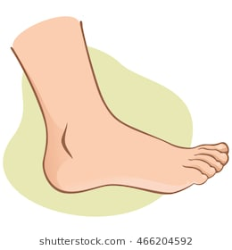  f_ _ t
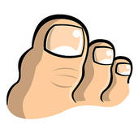  _o_s | 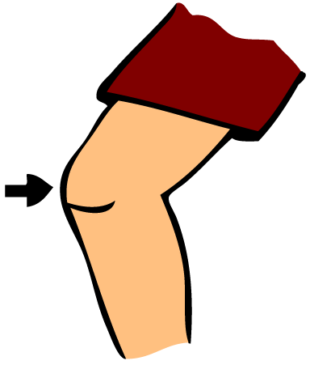  _n_e | 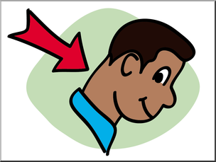  n_ _k |   b_c_ | 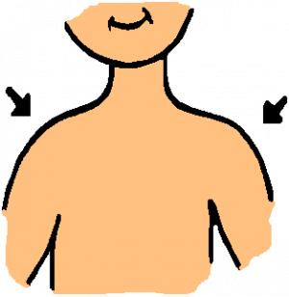  s_o_l_ _rs

Task 2. Choose a suitable adjective for each picture below

friendly | talkative | kind | boring | fun
confident | fat | shy | hard-working | creative

  _________________ | 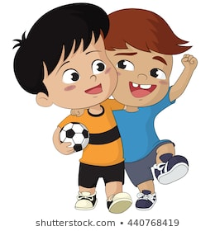  ________________ | 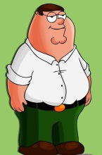  ________________ |   ________________ |   ________________
  _________________ | 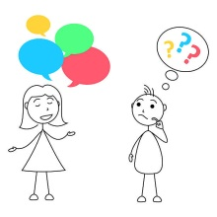  _________________ |   ________________ |   ________________ | 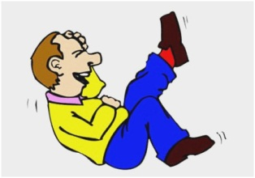  _________________
Task 3. Read and circle the right adjectives.

1. Donata is very friendly/ rude. She has a lot of friends.
2. Mona is very reliable/ creative. She always has new ideas.
3. Ann is a bit interesting/ boring. She never has anything interesting to say.
4. Jully is very funny/ shy. She likes telling jokes.
5. Anna is very serious/sensitive. She cries quickly whenever she watches a romance movie.
6. Lucy is very outgoing/ generous. She likes meeting and talking to people.
7. Joana is very hard-working/ lazy. She never helps with the housework.
8. Jane is very nervous/ impatient. She becomes annoyed if she has to wait for something or someone.
9. Mathew is very active/ helpful. He likes to play sport or do physical things.
10. Helen is a quiet/ curious person. She isn’t very talkative.
Task 4. Fill in each blank with the correct adjective from the box.

kind boring shy funny clever
friendly talkative creative confident hard-working
1. He’s a little bit . He likes to talk a lot.
2. She always has a smile with everyone.
3. Everyone is to me. They often help me when I need.
4. It is to sit on the plane with nothing to read.
5. She is very . She writes poetry and paints.
6. It’s a really film; everyone laughs a lot.
7. Children are often at school and he always gets good marks.
8. He is often of people they don’t know.
9. The teacher wants the students to feel about asking questions when they don’t understand.
10. I’m not very at Math. I often make mistakes in calculations.
Task 5. Read the definitions and complete the blanks with given letter.

1. This kind of person thinks about other people all the time. ___Kind_____
2. This is a big building with a lot of shops, restaurants, and cafes. M_________
3. People often have one for their birthday. P__________
4. This is a sport we play with a racket and a shuttlecock. B__________
5. This is when someone's color hair is yellow. B__________
6. This kind of person doesn't like doing housework or schoolwork. L__________
7. People wear these on their eyes to help them see. G__________
8. People only think about themselves. S_________
9. People make their friends laugh. F__________
10. People love talking to their friends. F__________
11. People are very nice to people and animals. K__________
12. People help other people by doing something or giving advice. H__________
13. People don't want to work. L__________
Task 6. Fill in the blanks using the phrases in the box.

watch TV | have a barbecue | make a cake | have a party
watch a movie | play video games | play badminton | go swimming
go shopping | make a pizza | go to the beach | go to the mall

- I want to go shopping to buy some winter clothes.
2. Let's__________. I want to go shopping and there's a great restaurant there, too.
3. It's a beautiful day! Let's__________ and swim in the sea.
4. She's going to__________. It's going to have cheese and tomato on it.
5. Let's__________ at the movie theater.
6. I usually__________ with my friends at school. I can hit the shuttlecock really hard.
7. My sister and I always__________ after dinner. We really like cartoons.
8. I like to__________ with my friends. My mom only lets me play after I finish my homework.
9. I have milk, flour, eggs, and sugar. Let's__________.
10. He's going to__________ for his birthday. I need to get him a gift.
11. It's a lovely day. Let's__________ in the garden. It will be delicious!
12. I like to__________ at the beach when it's sunny.


PART 3: GRAMMAR

1.Present continuous (Thì hiện tại tiếp diễn)
a. Form
(+) | I + am + V-ing.  You, we, they + are + V-ing.  He, she, it + is + V-ing.
(-) | I am not + V-ing.  You, we, they + aren’t + V-ing.  He, she, it + isn’t + V-ing.
(?) | Am + I + V-ing?  Are + you, we, they + V-ing?  Is + he, she, it + V-ing?
b. Usage
- Thì hiện tại tiếp diễn diễn tả một hành động đang diễn ra tại thời điểm nói.
VD: My mother is cooking in the kitchen now. (Hiện tại mẹ tôi đang nấu ăntrong bếp.)
❖ Thì hiện tại tiếp diễn diễn tả một hành động hoặc sự việc đang diễn ra xung quanh thời điểm nói.
VD: Linda is quite busy these days. She’s doing the English project for her school. (Linda is in a restaurant with her friend now.)
(Linda dạo này rất bận. Cô ấy đang làm dự án tiếng Anh cho trường của cô ấy.) (Hiện tại Linda đang ngồi trong nhà hàng với bạn cô ấy.)
- Thì hiện tại tiếp diễn có thể diễn tả một hành động sắp xảy ra trong tương lai gần (điều này đã được lên kế hoạch).
VD: He is going to Paris. (Anh ấy định đi Paris.)
- Thì hiện tại tiếp diễn diễn tả một hành động thường xuyên xảy ra lặp đi lặp lại gây sự bực mình hay khó chịu cho người nói. Cách dùng này được dùng với trạng từ “always, continually”.
VD: Tony is careless. He is always losing his keys. (Tom thì bất cẩn.Anh lấy luôn làm mất chìa khoá.)
c. Signals
Các trạng từ hay gặp: now, at the present, at the moment, at this time(bây giờ, lúc này)
Các động từ: Look! (Nhìn kìa), Listen(Nghe này); Becareful!(Cẩn thận);Hurry up! (Nhanh lên)
d. How to add“ing” after verbs
- Thông thường nhất, ta thêm đuôi -ing vào sau các động từ.
readreading go going
- Khi động từ kết thúc bằng “e”, ta bỏ “e” trước khi thêm “ing”.
havehaving make making
❖ Khi động từ kết thúc bằng “ee”, ta thêm ing mà không bỏ “e”.
seeseeing agree agreeing
❖ Khi động từ kết thúc bằng “ie” ta đổi “ie”->“y” rồi thèm “ing”.
lielying die dying
❖ Khi âm tiết cuối của động từ mang trọng âm và có chứa 1 nguyên âm + 1 phụ âm, ta gấp đôi phụ âm cuối rồi thêm “ing”.
runrunning permit permitting
e. Note
Chúng ta không dùng thì hiện tại tiếp diễn với các động từ thuộc về nhận thức, tri giác hoặc sự sở hữu như: be, see, hear, understand, know, like, want, feel, smell, remember, forget,...Tasử dụng thì hiện tại đơn thay vì hiện tại tiếp diễn trong các trường hợp này.
Example
False: She is being happy.
Correct: She is happy.
2. MỘT SỐ ĐỘNG TỪ KHÔNG chia ở thì hiện tại tiếp diễn:
1. Want  2. Like  3. Love  4. Prefer  5. Need  6. Believe  7. Contain  8. Taste | 9. Suppose  10. Remember  11. Realize  12. Understand  13. Depend  14. Seem  15. Know  16. Belong | 17. Hope  18. Forget  19. Hate  20. Wish  21. Mean  22. Lack  23. Appear  24. Sound
Task 1.Verbs form:

I. Complete the sentences with forms of be or have.
1. She ____________ long blond hair.
2. He ____________ green eyes. They look so nice.
3. He ____________ short blond hair.
4. His eyes ____________ black and quite large.
5. Her eyes’ color ____________ green. It is brown.
6. She ____________ in good-shape. She is a little thin.
7. (she) ____________ straight black hair? - Yes.
8. My uncle ____________ medium-height. He is just a little taller than me.
9. What (John) ____________ on his nose? - Glasses. He is reading a book.
10. (Mai) ____________ short black hair or long brown hair?
11. His mouth is small and he ____________ green eyes.
12. George ____________ short hair like most of men. His hair is quite long and smooth.
13. Miranda’s parents have brown eyes, but she doesn’t. Her eyes ____________ blue.
14. Which is his complexion’s color? (it) ____________ tanned?
15. My grandfather ____________ a moustache. He has got a beard.
II. Read the text then give the correct form of verb.
It (0. be) is Sunday evening and my friends and I (1. be) __________ Jane’s birthday party. Jane (2. wear) ___________a beautiful long dress and (3. stand) _____ next to her boyfriend. Some guests (4. drink) ______wine or beer in the corner of the room. Some of her relatives (5. dance) ______ in the middle of the room. Most people (6.sit) __________on chairs, (7. enjoy) ________ foods and (8. chat) _______with one another. We often (9. go) ________ to our friends’ birthday parties. We always (10. dress) ________ well and (11. travel) _________by taxi. Parties never (12. make) ________us bored because we like.
III. Underline the correct words.
1. Are/ Am you wearing brown pants?
2. He are/ is wearing green shorts.
3. They are/ is wearing blue T-shirts.
4. I am/are wears/ wearing sneakers.
5. You am/ are wearing glasses.
6. Are/ Is they wearing black caps?
7. What does/ is she wearing?
8. Hey, Frank, what are you do/ doing on Saturday afternoon?
9. What's Hermione like/do?
10. Is/ Are she wearing glasses?
11. I'm not/ don't having a party this Saturday. It's next week.
12. What does/ is Spiderman do?
13. Is she having/ have a barbeque tonight?
Task 3. Choose the underlined word or phrase (marked A, B, C or D) that needs correcting

1. My sister is very seriously and hard-working in her study.
A B C D
2. Ride a bike at the weekend is my best friend's hobby.
A B C D
3. She is very cared, so she always helps her mother do the housework.
A B C D
4. My friend has a short brown hair and an oval face.
A B C D
5. Because Nga is very keen on the school's singing competition, she is taking part
A B C
on it tomorrow.
D
6. I have an important maths exam tomorrow afternoon, so I do a lot of maths
A B C exercises at home this evening.
D
7. We have a lot of assignments to do. Therefore, we are going to the cinema
A B C
with you tonight.
D
8. I have new pencil, a pencil sharpener and a pencil case.
A B C D
9. The painting competition will start at his school on the 17th of October.
A B C D
10. She usually plays the piano every Monday evening, but today she watch cartoons
A B C D
with her younger sister.
11. There are a table, four chairs, two pictures and a vase in the living room.
A B C D
12. There aren't a lot of posters in the wall in his bedroom.
A B C D
13. My dog has a long tail, big eyes and a yellow fur.
A B C D
14. She has a birthday party with a big birthday cake and a lot of candles at home
A B C D
at present.
15. She is short hair and big eyes
A B C D


LISTENING

Task 2. Listen and decide if the statements below are true (T) or false (F).

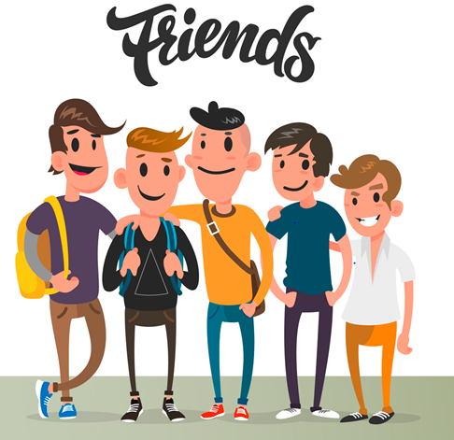 | - Sam has more than 4 best friends  ………………………  - Tom is tall, but Henry is short.  ………………………  3. Henry doesn’t help Sam study.  ………………………  - Lars is talkative.  ………………………  5. Daisy sings well.  ………………………
Task 3. Listen again and fill in the blanks.

1. Tom is funny because he can tell good …………………
2. Henry looks like a …………………
3. Daisy is a winner of the school’s …………………competition.

SPEAKING

Task 1. Match the questions and answers. Then practice.

1. What are you doing this weekend? |  | - They are dark brown.
2. What does your English teacher look like? |  | - . It’s Sandra. She is my new friend
3. What is Mary like? |  | - I’m visiting my grandparents
4. Can you help me with my homework, please? |  | - She’s slim and has long blond hair and blue eyes.
5. Where are the kids? |  | - Sound great! I’d be happy to
6. Would you like to join our party on Sunday? |  | - They are playing in the playground
7. What colour are his eyes? |  | - She’s kind, active and sensitive
8. Who is that girl? |  | - . Sorry, I can’t. I’m busy

Task 2. Answer the questions.

- Do you have a best friend? |  | - ……………………………………..
- What color hair does she/he have? |  | - ……………………………………..
- What does she /he look like? |  | - ……………………………………..
- Is she beautiful/he handsome? |  | - ……………………………………..
- What colour are her/his eyes? |  | - ……………………………………..
- Does he/she wear glasses? |  | - ……………………………………..  ……………………………………..
- Why do you like her/him? |  | - ……………………………………..
- Can you introduce me to her/him? |  | - ………………………………………..  ……………………………………..


READING

Task 1. Read and choose the correct answer (A, B, or C).

MY WEEKEND

A. I'm Alex. I often go shopping with my mom on the weekends. We usually go to the supermarket near my house to buy food. When we go home, she sometimes teaches me how to cook. I want to be a good cook like my mom.

B. My name's Will. I always ride my bike to band practice on Saturday mornings. We practice for about two hours, then I go home and play with my younger brother. He doesn't like going out and meeting new people. We often play video games together instead.

C. My name's Oscar. I like to sleep in on the weekends. I sleep until 9 a.m. and then I
sometimes go swimming with my brother. On Saturday nights, I often stay up late to watch a movie or read a book.

1. Who plays music on the weekends? __________
2. Who doesn't go to bed early on Saturdays? __________
3. Who helps with chores on the weekends? __________
4. Who wants to learn how to make delicious food? __________
5. Who has a shy brother? __________
6. Who goes out for two hours every Saturday? __________
Task 2: Complete the passage with the correct verbs


This _________ my best friend. Her name _________ Laura. She _________ twelve years old and she _________ in Bristol, England.
Laura _________ very pretty. She _________ straight brown hair and dark brown eyes. Her nose _________ straight and her lips _________ rather thin. Laura _________ medium height, slim and very fit because she learns to dance and she _________ very well.
Laura _________ very friendly and confident and she _________ a great sense of humour. I like being with her because she makes me feel happy and comfortable!
Task 3: Read the text. Choose the best word (A, B, or C) for each space.

MY NEW FRIEND
Kim is a new girl in my class. We're friends now. Kim is tall with (1)__________ blond hair and blue eyes. We (2)__________ badminton together after school. At school, she always wears a uniform but today is Saturday so she is (3)__________ a yellow T-shirt and pink sneakers. I think Kim is very funny and kind, and she thinks (4)__________ other people. We are going shopping at the mall this afternoon because she's (5)__________ a party tonight. After that, we are making pizza for the party and watching TV. Tomorrow we are (6)__________ swimming at the beach.
1. A. tall B. slim C. fat C. long
2. A. play B. to play C. playing D. plays
3. A. wear B. wears C. wearing D. to wear
4. A. about B. to C. for D. in
5. A. working B. making C. doing D. having
6. A. playing B. going C. doing D. joining


WRITING

Task 1. Unscramble the sentences

1. he/ look/ What/ does/ like? →……………………………………………………….
2. tall/ and hair./ has/ black/ He’s →……………………………………………………….
3. he/ glasses?/ white/ Is/ wearing →……………………………………………………….
is./ Yes,/ he
→……………………………………………………….
4. wearing?/ she/ is/ What →……………………………………………………….
wearing/ a/ dress./ blue/ She/ is
→……………………………………………………….
5. your/ Is/ friend/ a girl/ boy? a/ or →……………………………………………………….
friend/ My/ girl./ is/ a →……………………………………………………….
6. you/ What/doing/are/on/Friday? →……………………………………………………….
7. I’m /soccer/Jonh/ playing /with →……………………………………………………….
8. going/beach/ I/m/ to/ Saturday/ family/with/ the/my/on? →……………………………………………………….
9. your/ like/ is/ father/ What ?
→……………………………………………………….
Funny/ He/ and/ generous →……………………………………………………….
10.your/ character / Who’s / a movie/ favourite/ from/or/comic book?
→……………………………………………………….
Harry Potter/ I/ like
→……………………………………………………….
Ta Task 3. Write 6 sentences about your best friend.

………………………………………………….
………………………………………………….
………………………………………………….
………………………………………………….
………………………………………………….
………………………………………………….
………………………………………………….
………………………………………………….
………………………………………………….



