Thời gian làm bài: 40 phút (Không kể thời gian giao đề)
-------------------------
Họ tên thí sinh: .................................................................
Số báo danh: ......................................................................
Mã Đề: 008.
Câu 1. What does this sign mean?
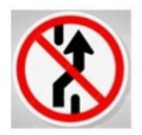
A. Slippery road. B. Roundabout ahead
C. No parking here. D. Prohibit Changing Lane
Câu 2. Look at the signs. Choose the best answer for the question.
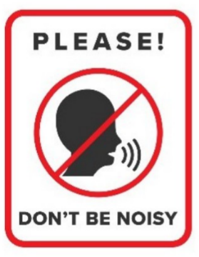
A. You must be quiet in this area. B. You don’t have to raise your voice in this area.
C. You mustn’t talk in this area. D. You shouldn’t speak to anyone in this area.
Câu 3. What is the main offer of this Happy Hour promotion?
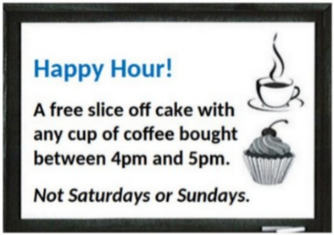
A. Half-price cake B. Discounted cupcakes
C. A free slice of cake with coffee purchase D. Free coffee
Câu 4. When was the sports bag found?
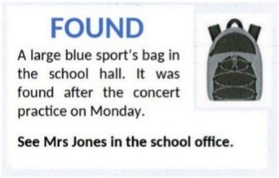
A. The next day after the practice B. After the concert practice
C. During the concert practice D. Before the concert practice
Câu 5. Look at the signs. Choose the best answer for the question.
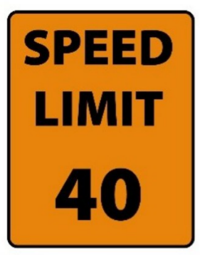
A. You cannot drive faster than 40 miles per hour. B. You must drive at 40 miles per hour.
C. The minimum speed is 40 miles per hour. D. You can drive 40 miles per hour or more.
Câu 6. What caused damage to the library?
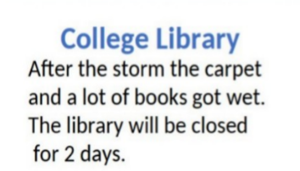
A. A fire B. A storm C. Renovation work D. Vandalism
Câu 7. Look at the signs. Choose the best answer for the question.
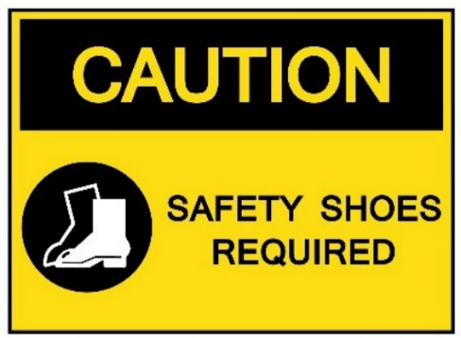
A. You are allowed to wear shoes in this area.
B. You should wear shoes in this area because of safety.
C. You have to wear shoes that can provide protection in this area.
D. You have to keep your shoes safe in this area.
Câu 8. Which day is the City Zoo closed?
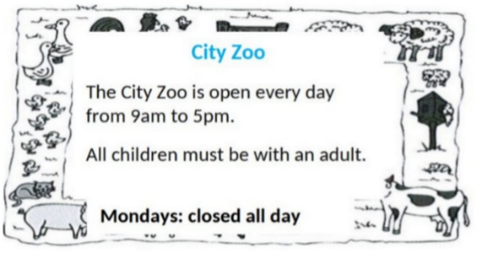
A. Monday B. Sunday C. Friday D. Saturday
Câu 9. What does this sign mean?
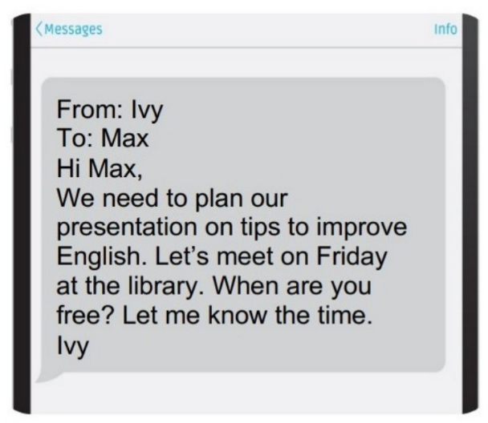
A. Ivy wants to remind Max of the project's deadline.
B. Ivy wants to know when they will meet to work on the project.
C. Ivy wants to thank Max for doing the presentation.
D. Ivy wants to find out more about the project from Max.
Câu 10. How much ice cream do you need to buy to get the discount?
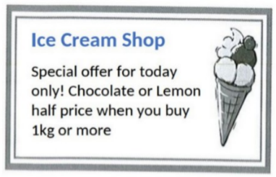
A. Exactly 1kg B. 2kg or more C. 500g or more D. 1kg or more
----HẾT---

