|  |  |  |
| --- | --- | --- |
| PHÒNG GIÁO DỤC VÀ ĐÀO TẠO……. ĐỀ CHÍNH THỨC | ĐỀ KIỂM TRA __________ Năm học: 20__ - 20__ Tiếng Anh - Lớp 7 Thời gian làm bài: 60 phút | |
| Trường: ________________________ Họ tên: _______________________ Lớp: _____________ | Điểm | Nhận xét của giáo viên |

|  |  |  |
| --- | --- | --- |
|  | **Tiếng Anh 7 i-Learn Smart World - Unit 5.1 Time allotted: 60** | Mã đề: a |

|  |  |
| --- | --- |
| **PART 1** | **Pronunciation (4 questions)** |

**Choose the word whose underlined part is pronounced differently.**

1. A. bunch B. butter C. sugar D. cupboard

2. A. cans B. eggs C. bags D. sticks

**Choose the word that has a different stressed syllable from the rest.**

3. A. garlic B. dessert C. lemon D. carton

4. A. spaghetti B. grocery C. vegetable D. tablespoon

|  |  |
| --- | --- |
| **PART 2** | **Vocabulary and Grammar (12 questions)** |

**Choose the best option (A, B, C or D) to complete each of the following questions.**

5. The chef ______________ the potatoes in oil in a pan.

A. fries B. grills C. chops D. roasts

6. There’s ______________ apple and ______________ honey on the table.

A. an/ a B. some/ some C. an/ some D. an/ the

7. She was thirsty, so she bought a ______________ of soda.

A. jar B. can C. bag D. stick

8. I gave Chloe a ______________ of chocolates to say thank you. She helped me a lot with my assignment.

A. bottle B. bag C. parcel D. box

9. Steve puts only a ______________ of sugar on his coffee. He says too much sugar is not good for his health.

A. teaspoon B. gram C. tablespoon D. liter

10. My mum bought ______________ bunch of bananas this morning. She used half of ______________ bananas to make banana muffins.

A. the/ the B. some/ some C. a/ the D. the/ some

11. I like mixing ______________ fruit with yoghurt to have a nice, healthy dessert.

A. a B. some C. many D. much

12. I always bring a ______________ of water when I go to the gym.

A. glass B. box C. stick D. bottle

13. I don’t like ______________ food because it has a strong hot taste.

A. crunchy B. spicy C. sweet D. sour

14. Student A: “How much butter do we need?”  
Student B: “______________”

A. Maybe one or two. B. About 100 g. C. Not many. D. A bunch.

**Choose the best option (A, B, C or D) to complete each of the following questions.**

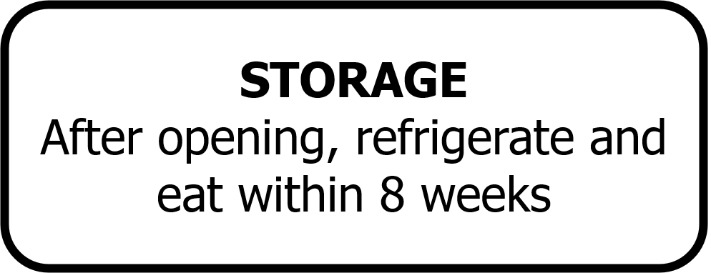

15. Read the notice and choose the correct statement.

A. You have to put it in the fridge after you open it. B. It is enough to eat in 8 weeks. C. You have to keep it cold in 8 weeks. D. You need to open the refrigerator in 8 weeks.

**Choose the best option (A, B, C or D) to complete each of the following questions.**

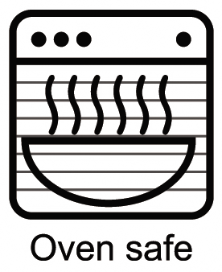

16. What does this sign mean?

A. It’s safe to buy a microwave oven. B. You need to use the microwave oven safely.

C. You can heat up this container in the microwave oven. D. There is a container for this microwave oven.

|  |  |
| --- | --- |
| **PART 3** | **Word Formation (6 questions)** |

**Write the correct form of the words in brackets. (6 questions)**

My sister, Sonya, is a food lover. She often eats (HEALTH) (17)_healthy__________ food, such as rice, vegetables, fruit, and fish. She hardly ever eats (FRY) (18)_fried___ food because it is high in fat, calories and salt. She likes trying (USUALLY) (19)_unusual____ dishes when she travels. She thinks it’s (INTEREST) (20)_interesting__ to eat local food and learn more about the cultures. Last year, she ate tarantula in Cambodia. Tarantulas are spiders living underground. They deep-fry tarantulas in oil until they are crispy. Sonya thought tarantula was a (TASTE) (21)__tasty___ snack. Two years ago in Germany, she tried Limburger cheese – one of the world’s stinkiest cheese. She said it was delicious but really (SMELL) (22)__smelly__.

|  |  |
| --- | --- |
| **PART 4** | **Reading (10 questions)** |

**Read the following passage. For each statement, write SP for silkworm pupae and ST for stinky tofu. (5 questions)**

Many people consider Asia as a food heaven with attractive and delicious dishes. However, there is also some really strange food that not everyone is brave enough to try.  
Silkworm pupae (con nhộng) in Vietnam  
Many villages in the north of Vietnam are famous for raising silkworms (con tằm) and harvest cocoons to make silk. Therefore, silkworm pupae are very popular in the local markets. First, people wash the pupae, dry and mix them with salt. Then, they fry pupae with oil and fish sauce. They also cut lemon leaves into tiny strips and mix them with fried pupae to add more taste to the dish. The pupae’s outer shell is crunchy while the inside is soft and juicy. It also contains lots of protein.  
Stinky tofu in China  
Stinky tofu is a kind of fermented tofu. It has a strong unpleasant smell. Some people say it smells like garbage or wet socks. It’s a popular street food in China, Taiwan or Hongkong. People usually buy it at night markets or roadside stalls, rather than in restaurants. Traditionally, it is made from fermented milk, vegetables, meat and Chinese herbs. People can cook stinky tofu in different ways. The most common way is to deep-fry it and then add garlic, soy sauce and chili sauce. It’s crispy on the outside, but still hot and smooth on the inside. People serve it with cucumber and pickled cabbage.  
People rarely sell it in restaurants. (23)___________  
It is served with lemon leaves. (24)___________   
Its ingredients include meat and herbs. (25)___________   
There is a variety of ways to cook this dish. (26)___________   
It is high in protein. (27)___________

23. ST 24. SW 25. ST 26. ST 27. SW

**Read the online post. For questions, choose the correct option that best suits each blank. (5 questions)**

Hi Julie,   
Jack fell off the ladder while he was fixing the roof this afternoon. He hurt his head, so I need (28)___________ in the hospital with him tonight. Can you take care of the children? They love spending time with their auntie. I’ll be home tomorrow. There’s enough food for you all. I bought some chicken and a lettuce this morning. I put (29)___________ in the fridge. There are some onions, potatoes, gingers and a (30)___________ of rice in the bottom cupboard next to the fridge. You can use them to make chicken curry if you like. There are two cans of tuna in the cupboard above the oven, in case you want to make tuna salad. I also bought a tub of vanilla ice cream. You can have (31)___________ of the ice cream for dessert after dinner. Don’t let the children eat too much, or they may have a stomachache. Unfortunately, there is (32)___________ milk left. Can you buy two bottles of milk on your way here? Call me if you have any problems or questions.   
See you soon,   
Susan

(28) A. stay B. staying C. to stay D. to staying

(29) A. it B. them C. some D. many

(30) A. bag B. can C. jar D. carton

(31) A. little B. a lot C. much D. some

(32) A. some B. much C. not D. no

|  |  |
| --- | --- |
| **PART 5** | **Writing (8 questions)** |

**Put the words in the correct order to make correct sentences.**

33. Keywords: milk/breakfast. /Emma/a/for/had/of/sandwich/and/a carton

→ .......................................

34. Keywords: top cupboard./some/are/of/There/box/and/a/spaghetti/cans/tuna/of/in/the

→ .......................................

**Rewrite the following sentences without changing their meaning. Use the given word(s) if any.**

35. We don’t have many eggs in the fridge. (FEW)

→ There___________

36. I have a little money, just enough to buy a cup of coffee.

→ I don’t___________

**Use the given words or phrases to make complete sentences.**

37. How/ glasses/ milk/ you/ drink/ day?

→ How___________

38. We/ need/ buy/ carton/ eggs/ and/ a kilogram/ meat.

→ We___________

39. There/ big bag/ rice/ bottom cupboard/ next/ the sink.

→ ___________

40. Please put/ butter/ the fridge/ and/ cooking oil/ top cupboard.

→ ___________

33. Emma had a sandwich and a carton of milk for breakfast./Emma had a carton of milk and a sandwich for breakfast.

34. There are some cans of tuna and a box of spaghetti in the top cupboard.

35. There are a few eggs in the fridge./There are few eggs in the fridge.

36. I don’t have much money, just enough to buy a cup of coffee.

37. How many glasses of milk do you drink a day?

38. We need to buy a carton of eggs and a kilogram of meat.

39. There is a big bag of rice in the bottom cupboard next to the sink.

40. Please put the butter in the fridge and the cooking oil in the top cupboard.

|  |  |
| --- | --- |
| **PART 6** | **Listening (10 questions)** |

**You will listen to a tour guide talking about a traditional dish. Decide whether the following statements are True (T) or False (F). (5 questions)**

**Answers** **True** **False**

41. Bamboo worms is a famous dish in Hà Giang. **◯** **◯**

42. The best time to eat it is between September and October because the worms are crunchy. **◯** **◯**

43. The chef adds some sugar to the worms. **◯** **◯**

44. People can fry worms with herbs or steam them. **◯** **◯**

45. The worms taste like corn or butter. **◯** **◯**

**You will listen to a cookery show. Complete the recipe with NO MORE THAN TWO WORDS AND/OR A NUMBER for each blank. (5 questions)**

**FRUIT PANCAKES   
   
Ingredients:**- Some fruit (bananas or strawberries)   
- (46)___________ of flour   
- 400 ml of milk   
- 40 g of (47)___________   
- 2 eggs   
- (48)___________ of sugar   
- One teaspoon of salt   
- Some oil   
   
**Instructions:**    
- Chop the fruit   
- Melt the butter   
- (49)___________ the flour, milk, eggs and salt together   
- Put some oil into a pan   
- Put some of the mixture into the pan, make a pancake and (50)___________ it on both sides   
- Take out the pancake   
- Put fruit on top of the pancake

46. 200 g/200 grams

47. butter

48. 4 tablespoons/four tablespoons

49. Mix

50. fry

**---THE END---**