Mã đề 9.1.9
DEMO ĐỀ KIỂM TRA GIỮA KỲ 1
MÔN: TIẾNG ANH 9 – THỜI GIAN LÀM BÀI: 60 PHÚT
NĂM HỌC : 2022- 2023
A – LISTENING :
I/ Listen and tick. (1.0pt)
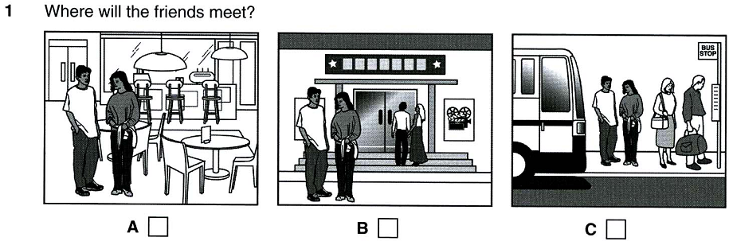
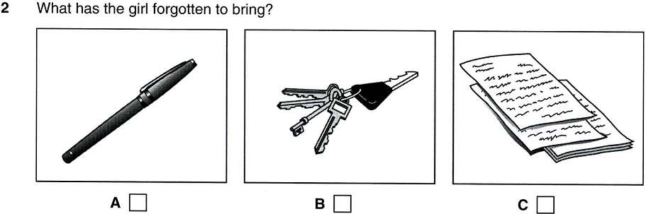
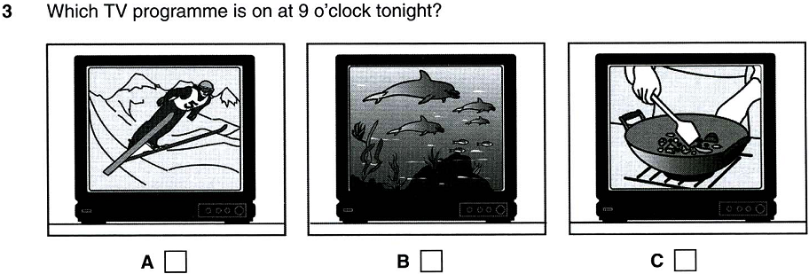
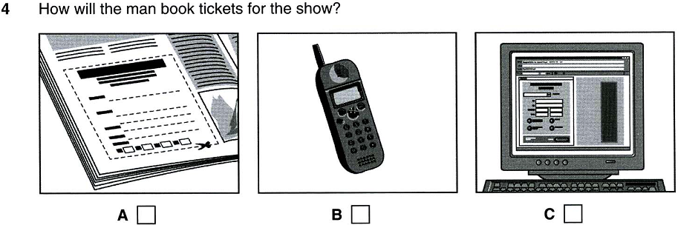
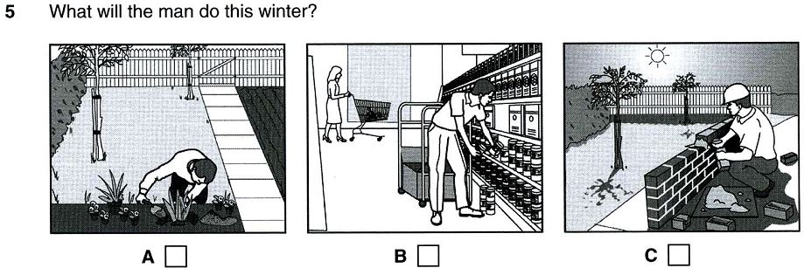
II/ Listen and choose. You will hear a news reporter caller Angela Bond, talking on the radio about her job. (1.0pt)
6. Where is Angela working at the moment?
A. Britain | B. the USA | C. Asia | D. France
7. Angela likes her job because she
A. loves being in dangerous situation.  C. enjoys watching important events happen. | B. never knows where she’ll go next.  D. has experience
8. What did Angela bring home from Hong Kong?
A. pictures | B. carpets | C. furniture | D. glasses
9. What time does Angela’s working day begin?
A. 8.30 am | B. 6.30 pm | C. 10.00 am | D.9.30 pm
10. Where did Angela meet her boyfriend?
A. at her sister’s house | B. at university | C. in Hong Kong | D. at her friend’s house
B- LANGUAGE :( 2.5pts)
I. Mark the letter A, B, C or D to indicate the word whose underlined part differs from the other three in pronunciation in each of the following questions.(0,4 pt)
1. A. culture B. popular C. regular D. fabulous
2. A. conflict B. forbidden C. reliable D. determine
II. Mark the letter A, B, C or D to indicate the correct answer to each of the following question.(1,6pt)
3. In 1990, due to the change of the economic situation, Dong Ho paintings were difficult to sell and many__________ quit their job.
A. craftsmanship B. craft unions C. craftsmen D. crafts
4. Making rice paper__________ jobs and income for many locals, and helps many families out of poverty and become well-off.
A. keeps B. gets C. applies for D. creates
5. Since changing the way of production, many craftsmen have voluntarily joined together to form__________.
A. cooperates B. cooperation C. cooperatives D. cooperative
6. How are you_________ on with your work? - It is OK
A. calling B. getting C. playing D. looking
7.It gets__________ to understand what the professor has explained.
A. the more difficult B. more difficult than
C. difficult more and more D. more and more difficult
8. Nowadays, Tan Chau artisans can produce silk of multiple colours__________ they can meet customers' demands.
A. so B. so that C. but D. in order
9. My teacher told me that I attend the math course for the higher level programme that I for.
A. can’t – apply B. couldn’t – apply
C. can’t – applied D. couldn’t – had applied
10. Marigold wondered Kevin and Ruth would be at the party.
A. that B. whether C. if D. B & C
C- READING :
I. Choose the correct answer for each gap to complete the following passage.(1.5pts)
New Orleans is a city in the southern part of the US. It is (1) _______ for it sold-fashioned streets and buildings and jazz music. It used to (2) ____________ millions of tourists every year. But all of this have changed in August of 2005.
A nasty hurricane named Katrina hit the southern part of the US. New Orleans suffered the most damage (3) __________ the storm. New Orleans is a city but built (4)________sea level, so it has levees-walls built to keep sea from flowing into land. However, Katrina destroyed these levees and the city eventually is flooded.
More than 100 people were dead and the city was totally destroyed. Houses were gone, buildings were ruined, and cars were damaged. Experts (5) ________ that it will cost more than 26 billion dollars to rebuild the city.
1. A. good B. famous C. lovely D. beautiful
2. A. absord B. keep C. attract D. call
3. A. with B. at C. of D. from
4. A. below B. under C. on D. at
5. A says B. sayed C. say D. said
II. Read the following passage and mark the letter A, B, C, or D to indicate the correct answer to each of the questions.(1.5pts)
In the earliest times children got their education directly from parents and other adults. They learned mainly skills for survival. Adults passed down this knowledge through spoken language. Eventually cultures around the world began inventing writing. As societies developed they set up schools to teach reading, writing, maths and other subjects.
The first schools were usually just for boys. Most of the students came from rich and powerful families. Often the purpose of their education was religious training. In many cultures the religious leaders formed the highest level of society. Some schools had other purposes as well. Many schools focused on military training. Sometimes youths attended special schools to learn the art of public speaking. These skills were meant to help them become future leaders.
Most girls received their education at home. They learned cooking, sewing and other useful skills. Over time education became available to more people, not just the rich and powerful. The governments of some countries set up public systems of education in the 1800s. More schools opened to girls.
During the 1900s marks, or grades, became a new measure of learning. Testing became a regular part of formal education. As education became more important to people, teachers' colleges opened. The requirements for becoming a teacher became stricter. Teaching became a highly respected profession.
1. In the earliest times, children learned mainly skills so that they could________.
A. continue to exist B. pass this knowledge down
C. invent writing D. make societies develop
2. The word “they” in the passage refers to________.
A. cultures B. societies C. schools D. subjects
3. Which of the following is NOT true according to the passage?
A. The first schools were usually just for boys from rich and powerful families.
B. Art of public speaking was one of the skills that help youths become future leaders.
C. During the 1900s, testing became a regular part of formal education.
D. In the earliest times, knowledge was passed down through written records.
4. The phrase “set up” in the passage could be best replaced by________.
A. made B. based C. founded D. built
5. The best title for the passage could be________.
A. Education in the Earliest Times B. The Development of Education
C. Education in Modern Times D. Testing - a Regular Part of Education

D: WRITING :

I. Mark the letter A, B, C or D on your answer sheet to indicate the underlined part that needs correction in each of the following questions. (0.5pt)
1. I asked him how far was it to the station if I went there by taxi.
A B C D
2. In spite of John came to the show late due to the heavy rain, he could see the main part of the show.
A B C D
II. Rewrite the second sentences in such other ways that the meanings stay unchanged with the first ones. (1.0 point)
1. She went to bed early because of her sickness.
Because………………………………………………………………………………….
2. "You should drink more water a day", the doctor said to the patient.
The doctor advised………………………………………………………………………
3. "I think we should take a shower instead of a bath", I said
I suggested………………………………………………………………………………
4. I have never listened to ghost stories before.
This is……………………………………………………………………………………
5. She sings better than anybody else in the class.
She is……………………………………………………………………………………

III. Reorder the words to make a meaningful sentence.(1.0pt)

1. it/an/is/ important/ keep/in/ calm/to/ emergency.
……………………………………………………………………………………
2. my father / to / The doctor / give up / told / smoking /.
……………………………………………………………………………………
3. there/ four/ wish/ seasons/ in/ I/ my/ were/ area.
……………………………………………………………………………………
4. if/ I/ would/ you, I/for/ call/ the helpline/ help/were/.
……………………………………………………………………………………
5. she/ to/wondered/ whether/was/ tell/ her/ best friend/ what/ she/ thinking.
……………………………………………………………………………………

THE END

ĐÁP ÁN ĐỀ KIỂM TRA GIỮA KÌ I MÔN TIẾNG ANH 9
NĂM HỌC 2022-2023
ĐỀ BÀI | ĐÁP ÁN/BIỂU ĐIỂM
A. LISTENING | - (1.0 point)  1. A 2. A 3. 4. B 5. A  - (1.0 point)  1. A 2. C 3. C 4. A 5. A
B- LANGUADE | 10 x 0,25 =2,5pts)  1.A. 6. B.  2. C. 7. D.  3. C. 8. B.  4. D. 9. D.  5. C. 10.D.
C. READING : | I. (5 x 0,3 =1,5pts)  1. B 2. C 3. D 4. A 5. C  II. :(5 x 0,3 =1,5pts)  1. A 2. A 3. D 4.C . 5. B
D. WRITING : | I :(2 x 0,25 =0,5pt)  1. B 2. C  II. :(5x 0,2 =1,0pt)  1. Because she was sick, she went to bed early  2. The doctor advised the patient to drink more water a day  3. I suggested taking a shower instead of a bat.  4. This is the first time I have ever listened to the ghost stories  5. She is the best singer in the class.  III. :(5x 0,2 =1,0pt)  1. It is important to keep calm in an emergency.  2.The doctor told my father to give up smoking.  3.I wish there were four seasons in my area.  4. If I were you, I would call the helpline for help.  5. She wondered whether to tell her best friend what she was thinking.

