HỘI CÁC TRƯỜNG THPT CHUYÊN
KHU VỰC DUYÊN HẢI VÀ ĐỒNG BẰNG BẮC BỘ



HỘI THẢO KHOA HỌC LẦN THỨ XVII
NĂM 2025
MÔN TIẾNG ANH

Tháng 7, năm 2025
CHUYÊN ĐỀ:
USING AI APPS TO
ASSIST TEACHERS IN DESIGNING READING TASKS FOR GIFTED STUDENTS
***


GV THỰC HIỆN: ………………………………………..

ĐƠN VỊ: TRƯỜNG THPT CHUYÊN ………..

Tháng 7, năm 2025
TABLE OF CONTENTS
PART A: INTRODUCTION 1
1. Rationale of the study 1
2. Aim and objective of the study 2
3. Scope of the study 2
4. Significance of the study 2
PART B: LITERATURE REVIEW AND THEORETICAL BACKGROUND 3
1. Challenges in designing reading tasks: 3
1.1. Learning needs of the gifted students 3
1.2. Outdated materials 3
1.3. The mismatch between students’ proficiency level and the difficult level of the text 3
1.4. A shortage of authentic resources reflecting real-world language use 4
2. Criteria for a good reading task 4
2.1. A need for a set of criteria 4
2.2. Suggested set of criteria for a good reading task and prompt-generation template for AI-assisted apps 5
2.2.1. Suggested set of criteria for a good reading task 5
2.2.2. Prompt-generation template for AI-assisted apps 6
2.3. A checklist for evaluating reading tasks 7
3. Selected AI apps in designing reading tasks 7
3.1. Generative AI apps (e.g. Gemini and ChatGPT) 7
3.1.1. Gemini 8
3.1.2. Chat GPT 10
3.2. AI app supporting the English High School Graduation Exam (Text2TiengAnhTHPT) 11
3.3. AI Solutions for Differentiated Instruction and Comprehensive Content Generation: Edcafe and Diffit 13
3.4. AI apps supporting sub-tasks in adapting reading texts (Rewordify) 13
PART C: PRACTICAL IMPLICATIONS 15
1. Samples 15
2. Students’ reflection and suggested modification 27
PART D: CONCLUSION 29
REFERENCES
APPENDICES
ABSTRACT
Reading comprehension is essential for gifted high school students preparing for national and provincial English competitions in Vietnam. However, teachers face major challenges in designing effective materials due to time constraints, outdated texts, and the need for cognitively demanding content. With the emergence of AI in education, tools like Gemini and Rewordify create favorable conditions for producing level-appropriate, engaging reading tasks. This study explores how selected AI apps can assist teachers in designing reading materials for gifted learners. It outlines key challenges, proposes criteria for high-quality reading tasks, and introduces an evaluation checklist and prompt-generation template for Generative AI-apps. Sample tasks generated using AI apps were piloted with B2–C1 students to assess their effectiveness. Findings suggest that AI tools can reduce teacher workload and enhance task quality, making reading practice more effective and accessible for advanced learners.

Keywords: reading comprehension, gifted students, AI apps, task design, English competitions, high school education.

PART A: INTRODUCTION

Rationale of the study
Reading skills have long been deemed to be one of the most pivotal yet challenging language skills in the sphere of English language learning and teaching (Raajitha, 2019) because reading comprehension is a complicated task that calls for the coordination of various cognitive abilities and skills (Oakhill et al., 2014). Mastery of reading skills requires not only an understanding of individual words and the sentences they form, but also the ability to integrate their meanings into a coherent and meaningful whole (Kuzborska, 2018). In an attempt to improve reading skills, several researches have been conducted and discovered a positive relationship between reading achievement and the amount of reading practice (at home or at school) (e.g., Lewis, 2002; Topping et al., 2007). Accordingly, enhancing reading competence can be best achieved through regular and level-appropriate reading practice.
For gifted students, honing reading comprehension competence is of paramount importance when it comes to their preparation for many provincial and national exams, especially for the National English Competition (NEC), which is considered one of the most prestigious exams for gifted EFL (English as Foreign Language) students in Vietnam. Indeed, the reading skill usually accounts for about 25-30% of the total score of those exams, hence to achieve higher overall scores and obtain higher prizes, test takers should be exposed to a great volume of reading tasks with varied question-types for better preparation for such competitions. This, in turn, leads to a strong demand for the effective design of high-quality reading materials.
Gifted students, characterized by their accelerated learning, advanced comprehension, and innate curiosity, often require educational experiences that extend far beyond the standard curriculum. Traditional instructional methods can struggle to provide the constant intellectual stimulation necessary to prevent disengagement and maximize their potential. Specifically, high school teachers face many challenges in reading task design, including outdated materials that fail to engage learners, texts misaligned with students’ proficiency levels, and a shortage of authentic resources reflecting real-world language use. Furthermore, due to the heavy school workload, it takes teachers much time to adapt and produce high-quality reading tasks that meet their students’ learning needs. Given these problems, it is essential that teachers need a practical and intelligent tool to support the creation of level-appropriate, engaging, and cognitively challenging – especially for gifted students.
In recent years, the infiltration of artificial intelligence (AI) into education has sparked transformative changes, reshaping pedagogical practices, content delivery, assessment and instructional design (Chavez & Palaoag, 2024). In the realm of designing reading tasks, AI-assisted applications have emerged as a powerful tool capable of generating level-appropriate texts, diversifying learning sources and offering tailor-made tutoring (Chea & Xiao, 2024). Such AI-assisted apps (e.g., ChatGPT, Gemini, Rewordify) offer various features to help teachers generate reading tasks and tailor practice questions to students’ proficiency. Consequently, AI apps appear to be helpful assistants for high school teachers regarding the reading task design. Unfortunately, despite its prevalence and advantages, there is little research on how to make the best use of AI apps in designing reading tasks, especially for the gifted students in high-schools in Vietnam. In recognition of this gap, this study entitled “Using AI Apps in Designing Reading Tasks for the Gifted Students in Vietnamese High Schools” has been written to suggest selected AI apps which lessen teacher’s workload while supplying students with high-qualified reading tasks to facilitate their learning practice.
- Aim and objective of the study
The objective of this study is twofold. Firstly, it aims to give a brief overview of some challenges that high school teachers face when designing reading tasks. Then, certain criteria of good reading materials are discussed to lay a foundation for the creation of reading tasks. Secondly, this study attempts to present some samples of reading tasks designed by selected AI-apps and how those tasks alleviate the aforementioned concerns.
- Scope of the study
The scope of this study includes an in-depth analysis of certain challenges of designing reading tasks for advanced learners to maximize their performance in the context of both regional and national English competitions. In order to facilitate teachers to give appropriate prompts to AI apps in designing reading tasks, this study concentrates on reviewing and identifying a set of criteria of a good reading task. Based on this set, the authors propose a specific checklist for comprehensively evaluating those reading tasks, which teachers and even educators can utilize to assess the appropriateness of the reading tasks they design or select.
To increase practical applicability and reliability, the author team delivers the sample reading tasks to gifted students who are at CEFR B2 or C1 level to test and get their reflection to modify the prompts given to AI apps.

Significance of the study
This study aims at using selected AI apps in designing reading tasks for the gifted students with a view to enhancing their reading comprehension skills for attending the regional and national English contests. Based on the previous studies of the reading material design, practical observations and teaching experience, the authors hope to contribute both theoretical and practical findings in the domain of using AI apps to design reading tasks in particular, developing material designing skills for the gifted students in general.
Moreover, the study also suggests a prompt-generation template for AI-assisted apps in reading task design and applies it to create sample tasks featuring six common question types found in provincial and national English exams. This approach not only simplifies the task creation process for teachers but also saves time and supports those who may be less confident in using AI tools.
With the addition of a checklist for evaluating reading tasks, this study attempts to provide a reliable framework, outlining the components that will contribute to a good reading task. Consequently, teachers and educators can adapt to incorporate into designing their own tasks.

PART B:

LITERATURE REVIEW AND THEORETICAL BACKGROUND
This section reviews common challenges that teachers face in designing reading tasks that align with students’ learning needs and the requirements of the National English Contests. Then, a set of criteria for a good reading task is proposed before the prompt-generation template for AI-assisted apps in reading task design being suggested. Next, the selected AI apps are introduced and utilized to create sample tasks featuring six common question types found in provincial and national English exams. The final part is the reflection and evaluation of those reading sample tasks based on the set of criteria recommended by the author group.
      - Challenges in designing reading tasks:
- Learning needs of the gifted students
One of the most common difficulties that teachers or material developers encounter in respect to designing reading tasks is the discrepancy between the gifted students’ learning needs and the available reading tasks. Indeed, gifted learners, who typically illustrate exceptional cognitive abilities, rapid knowledge acquisition, and an intrinsic motivation to explore complicated concepts, often require educational experiences that go well beyond the boundaries of the current curriculum. With insufficient intellectual challenges, these students might become discouraged. As Tomlinson (2014) asserts, traditional instructional approaches frequently fail to meet the advanced learning needs of gifted students, making it vital to include more challenging in-class practice reading tasks. Furthermore, Reis and Renzulli (2010) point out that a lack of appropriate stimulation can lead to boredom, frustration, and even a decline in academic motivation among these high-potential individuals. Therefore, to prevent their disengagement and boost their motivation in learning English reading, it is essential to adapt reading tasks in the direction of increasing the difficulty level and meeting their characteristics.
  - Outdated materials
It is undeniable that both instructional designers and curriculum developers require a considerable amount of time to produce a relatively comprehensive textbook series or a high-quality coursebook. In the context of Vietnam, despite great effort and investment in textbook designing, the reading texts in such materials tend to easily turn outdated and fail to reflect contemporary social realities or the evolving interest of learners, which can minimize students’ involvement and motivation (Minh & Lan, 2020). This raises considerable concern, as Richards (2001) points out that materials lacking authenticity or relevance may hinder learners’ ability to connect with the content meaningfully. As a result, teachers frequently need to modify existing texts or incorporate supplemental resources to align with current pedagogical goals and keep up with the current social realities.
  - The mismatch between students’ proficiency level and the difficult level of the text
Another challenge in designing reading tasks lies in the mismatch between students’ linguistic proficiency and the difficulty level of the available texts. For example, the Global Success textbook series, which is used in many high schools across Vietnam, offers a range of reading texts, but only at the B1 level. This is because the series was designed with the goal of helping Vietnamese high school students reach intermediate (B1) proficiency (based on the CEFR framework) upon graduation (Hoàng, 2015). This can result in a lack of cognitive stimulation for higher-level learners, making it difficult to sustain their engagement or promote deeper reading strategies. On the other hand, while authentic materials such as news articles or academic texts may appear to be more intellectually stimulating, their dense vocabulary, complex syntax, and culturally embedded references often pose significant barriers to comprehension, even for advanced learners (Grabe & Stoller, 2019). Similarly, Nuttall (1996) warns that if a text is too difficult, it may result in confusion or frustration rather than learning. This tension highlights the importance of careful text selection to ensure that reading materials are both accessible and intellectually challenging.
  - A shortage of authentic resources reflecting real-world language use
One of the notable challenges in the development of effective reading tasks is the shortage of authentic resources that reflect real-world language use. While textbooks are often designed to be pedagogically structured and graded for learner levels, they may fail to capture the spontaneity, complexity, and contextual richness of authentic communication. As Gilmore (2007) argues, overreliance on scripted or artificial texts can limit learners' exposure to natural language patterns, idiomatic expressions, and discourse features commonly found in real-life communication. Unfortunately, access to up-to-date, culturally appropriate, and level-suitable authentic materials—such as newspaper articles, blogs, interviews, or social media posts—is often restricted due to copyright issues, time constraints, or limited digital literacy among educators. This scarcity not only reduces opportunities for students to engage with contemporary language but also hinders the development of pragmatic and intercultural competence, both of which are essential for real-world language use. To address this issue, teachers should make greater use of accessible authentic sources such as BBC News or National Geography, which provide rich, up-to-date content suitable for adaptation to various proficiency levels.
To sum up, designing effective reading tasks presents multiple challenges for language teachers, namely: (1) more cognitively demanding materials needed to meet the gifted students’ learning needs and characteristics; (2) the obsolete materials that lacks relevance to learners’ interest; (3) the mismatch between students’ language proficiency and the difficulty level of available texts; and (4) the lack of authentic resources reflecting natural language use and cultural context. Given these constraints, along with the reality that many teachers face heavy workloads and limited time for material development, there is a growing need for supportive tools or technologies to assist in designing and adapting appropriate reading tasks.
- Criteria for a good reading task
- A need for a set of criteria
Given the multiple challenges in designing effective reading tasks, there is a clear need for a well-defined set of criteria to guide teachers - especially when time and resources are limited. Establishing such criteria not only ensures pedagogical quality but also provides a practical foundation for developing or adapting tasks using supportive technologies.
Without such guidelines, task design can become inconsistent, overly reliant on teacher intuition, or misaligned with learners’ language development goals. As Richards (2001) emphasizes, task design should be guided by explicit principles to ensure that materials are appropriate in terms of difficulty, engagement, and linguistic value. In the context of increasing use of AI-generated content in education, such as with tools like Gemini, having a well-defined set of criteria is even more critical. It provides a framework for both the creation and evaluation of tasks, ensuring that they remain pedagogically sound while integrating technology effectively.
  - Suggested set of criteria for a good reading task and prompt-generation template for AI-assisted apps

2.2.1. Suggested set of criteria for a good reading task
To support teachers in designing effective reading tasks—particularly when using AI-powered tools such as ChatGPT—it is necessary to establish a practical set of criteria that ensures both pedagogical integrity and contextual relevance. Drawing on insights from findings of previous research, the following five criteria are proposed for evaluating or generating reading tasks in the EFL contexts:
- Linguistic Appropriateness: The language used in the text and tasks should match the gifted learners’ proficiency level (e.g., C1), ensuring comprehensibility while offering some degree of challenge (Richards, 2001). The teachers need to
- Cognitive Engagement with diverse question types: Tasks should stimulate learners’ thinking, encouraging inference, interpretation, or personal response rather than simple recall (Bloom et al., 1956). Therefore, various types of reading questions (i.g., referential questions, reference questions, or questions about paraphrasing) should be included in the task.
- Authenticity and Relevance: Texts should reflect real-world language use or be situated in contexts familiar and meaningful to students (Gilmore, 2007).
- Task Clarity and Structure: Instructions should be easy to follow, with clear goals and steps, enabling students to focus on comprehension rather than navigating the task format.
- Alignment with the Format of National and Provincial English Competitions:
Tasks should closely follow the structure, style, and question types commonly found in excellent student competitions at the provincial and national levels in Vietnam. This includes formats such as gap-filling, true–false–not given, multiple-matching, and short-answer questions that assess both comprehension and linguistic precision. Ensuring this alignment not only familiarizes students with exam conventions but also reinforces test-taking strategies and content relevance.
Aligned with the criteria above, specific parameters for Reading Task Design (see Table 1) have been developed, as follows:

Table 1. Specific parameters for Reading Task Design:
Parameter | Example Input
Proficiency Level | C1 (CEFR)
Topic / Theme | Environmental issues / Social media / Urban life
Text Type | Narrative / Descriptive / Informational / Opinion-based
Length | Around 250 words
Focus Skills | Skimming / Scanning / Inferring meaning / Identifying main ideas
Task Type | Multiple-choice / True–False–Not Given / Gap-fill / Short-answer questions
Language Focus | Vocabulary in context / Connectors / Modals / Passive voice
Cultural Considerations | Neutral or culturally relevant to Vietnamese high school learners
Each parameter in Table 1 serves as a scaffold to ensure that AI-generated reading tasks adhere to the five suggested criteria:
- Topic & Theme: This parameter ensures authenticity and relevance by allowing the teacher to choose topics that reflect real-world contexts or match students’ interests. When learners can relate to the topic, they are more likely to get meaningfully engaged in the text.
- Proficiency Level: This criterion directly addresses linguistic appropriateness. By specifying CEFR levels (e.g., B2, C1), teachers can guide the AI to generate texts with suitable vocabulary, grammar structures, and discourse complexity, guaranteeing that the material is neither too easy nor too challenging.
- Cognitive Focus: This parameter maps to cognitive engagement. Teachers can prompt the AI to generate questions targeting different levels of Bloom’s Taxonomy—from basic comprehension to inferencing or evaluation. This facilitates higher-order thinking skills essential for advanced learners.
- Text Type & Source: This is aligned with the need for authenticity and relevance, encouraging the inclusion of genres like news articles, opinion pieces, or science features sourced or modeled after real publications (e.g., BBC, The Guardian). Authentic text types mirror actual language use in the world beyond the classroom.
- Exam Format: This parameter corresponds to the criterion of alignment with the format of national and provincial English Competitions. Teachers can request tasks using formats such as gap-filling, multiple matching, or true–false–not given, ensuring that students are better prepared for real assessment conditions.

2.2.2. Prompt-generation template for AI-assisted apps
To facilitate AI-assisted task design, a prompt-generation template has been revised and developed based on the framework of Xiao et al. (2023) (see Table 2 in Appendix 1), allowing teachers to create high-quality reading texts and tasks. Customized requirements, namely theme or topic, length, difficulty level, and text type are suggested. In addition to creating reading passages from scratch, teachers often source content from the web or other authentic materials and adapt them into suitable reading passages for students. Thus, a referenced passage should be mentioned in the prompt. This prompt-generation template is designed for Generative AI-apps such as Gemini, ChatGPT. By filling in the prompt, teachers can easily generate customized reading tasks with the support of AI, while still maintaining professional control over content quality and learning outcomes.
  - A checklist for evaluating reading tasks
While using AI to generate reading materials offers significant advantages—such as saving time and enabling content personalization—teachers should remain cautious and avoid over reliant on AI-generated outputs. These texts may still contain issues related to linguistic appropriateness, cultural sensitivity, or misalignment with the format and requirements of NEC exams. Teachers must be equipped with AI literacy skills to evaluate and adapt AI-generated content critically. Therefore, it is essential that teachers possess the pedagogical competence to assess these materials effectively. Accordingly, Table 3 (see Appendix 2) provides a checklist for evaluating whether the generated reading task is pedagogically sound, exam-relevant, and suitable for their gifted students’ levels.
- Selected AI apps in designing reading tasks
AI applications offer substantial advantages for teachers designing reading tasks for gifted students. They excel at accelerating and enriching reading materials, generating advanced texts that continuously challenge gifted learners. AI also enables hyper-personalization, tailoring reading materials to individual student interests and adapting task complexity in real-time. In this study, a selection of notable AI applications has been employed to facilitate the design of reading comprehension tasks. These tools were specifically chosen for their capacity to enhance various facets of literacy development within the research framework.

3.1. Generative AI apps (e.g. Gemini and ChatGPT)
Generative AI, often called gen AI, is a kind of artificial intelligence that can produce original content and ideas. This includes things like conversations, stories, pictures, videos, and music. It's able to learn intricate subjects such as human languages, coding, art, and even scientific fields like chemistry and biology. Essentially, it uses its knowledge to tackle new challenges. Generative AI models are invaluable for customizing reading materials and developing sophisticated comprehension tasks. Chat GPT and Gemini are two typical examples of this type. ChatGPT and Gemini are both large language model (LLM) AI chatbots, but they have different strengths and are developed by different companies. ChatGPT, created by OpenAI, is known for its conversational ability, detailed responses, excellent summarization, and strong content creation skills and it can be customized for specific tasks. Gemini, a powerful AI assistant developed by Google, excels in real-time web access, complex reasoning, and integration with Google products. It is designed to understand and generate various types of information, including text, images, audio, and code. Essentially, it is a powerful AI that can handle different types of data and perform complex tasks, acting as a versatile tool for various applications.

3.1.1. Gemini
Gemini stands as Google's advanced generative AI application, designed to serve as an intelligent assistant across a wide range of tasks. It is powered by a family of cutting-edge AI models of Google - Ultra, Pro, Flash, and Nano - each optimized for different levels of complexity and efficiency, from the highly capable Ultra for complex reasoning to the lightweight Nano for on-device applications. Gemini's core strengths lie in its exceptional capabilities for in-depth research, complex reasoning, and accessing real-time information, thanks to its seamless integration with Google Search. A significant advantage is its deep integration across Google's extensive ecosystem, including popular services like Gmail, Docs, Calendar, YouTube, and Google Photos, enabling users to leverage AI functionalities directly within their familiar productivity tools. Furthermore, Gemini is inherently multimodal, allowing it to process and generate content across text, images, audio, and video, leading to richer and more dynamic interactions. Access to Gemini is available through a Google account, offering both free and premium versions with enhanced features and usage limits.
Gemini is accessible primarily through gemini.google.com in your web browser, via a mobile app on Android and iOS devices, and even integrated into Chrome for direct webpage assistance. Gemini’s advanced generative AI capabilities offer a powerful suite of tools for educators to craft reading tasks that resonate with the intellectual demands of gifted learners.
To use Gemini, teachers primarily interact by providing prompts, which can be typed text, spoken voice commands, or image uploads. Teachers can prompt Gemini to generate original non-fiction articles, historical accounts, or fictional narratives on advanced, interdisciplinary, or niche topics that align with gifted students' specific interests. For instance, for gifted EFL students, a teacher could request a fictional narrative from Gemini exploring a complex cultural phenomenon, like "the concept of 'wabi-sabi' in Japanese aesthetics, told through the eyes of a young artist living in modern Tokyo." This passage would be crafted with rich, idiomatic English, sophisticated vocabulary, and nuanced cultural references to challenge their linguistic and intercultural understanding at an advanced level. An example of this is provided in Appendix 3.
For texts already in the curriculum, Gemini can adapt the text to re-level content. Teachers can upload a standard passage and ask Gemini to "rewrite this for a gifted 10th-grader, incorporating more complex vocabulary, nuanced sentence structures, and subtle thematic elements." This ensures accelerated learners are always encountering sufficiently challenging material.
Moreover, Gemini can create multimodal texts. Leveraging Gemini's multimodal capabilities, teachers can integrate images, graphs, or even short video prompts into reading tasks. For instance, Gemini could generate a text explaining a complex scientific process, then provide an accompanying image prompt for students to analyze and interpret, linking visual literacy with textual comprehension. (see Appendix 4)
Gemini significantly enhances teachers' ability to create highly personalized learning pathways and resources, effectively meeting the unique needs of gifted students. It generates Customized Reading Lists tailored to a student's interests and reading levels, incorporating diverse genres and academic disciplines. Teachers can also create "Gems" -custom AI tutors within Gemini - to provide specialized, on-demand expertise on niche topics, directly assignable via Google Classroom. More specifically, "Gems" in Gemini are essentially customized versions of Gemini itself, designed by users (like teachers) to act as specialized AI assistants for particular tasks or areas of expertise. It is like programming Gemini with a very specific role and a set of instructions, so that every time you interact with that "Gem," it behaves consistently according to that role. Furthermore, Gemini facilitates Adaptive Practice and Feedback, producing personalized quizzes, advanced vocabulary lists, and tailored rubrics (see Appendix 5). This instant feedback guides gifted learners towards deeper analysis and refinement of their arguments, fostering continuous intellectual growth efficiently.
Here's an example for Customized Reading Lists using Gemini, tailored for a gifted 10th-grade student:
“Let's consider Maya, a gifted 10th-grade student who excels in science, particularly physics and astronomy, and has recently shown curiosity about the ethical implications of scientific discovery and technology.”
The teacher could prompt Gemini with something like:
"Generate a challenging reading list for a gifted 10th-grade student. Her interests are physics, astronomy, and the ethics of science/technology. Include a mix of popular science, science fiction, and philosophical texts. Suggest titles/themes that encourage critical thinking about the societal impact of scientific advancements, the nature of discovery, and moral responsibilities in science. Aim for 4-5 substantial entries with brief contextual notes. Lexile level 1300+."
A personalized reading list for Maya to explore the exciting and ethical frontiers of physics and astronomy is provided in Appendix 6. This list offers Maya a rich interdisciplinary journey, connecting her passion for science with deep ethical and philosophical inquiries, pushing her to consider the broader societal context of scientific advancements.
Besides, an interactive worksheet can be created using Gemini. It refers to a digital activity where students engage directly with content and receive dynamic, personalized feedback or adaptive challenges, often guided by AI. It generates diverse question types, from multiple-choice and fill-in-the-blank questions to complex short-answer and essay prompts. Crucially, it provides real-time, targeted feedback, explaining correct answers or suggesting improvements rather than just marking right or wrong. Gemini also adapts content and difficulty based on student performance, presenting tailored follow-up questions or resources. Its ability to integrate multimodal elements means worksheets can combine text with images or videos for richer engagement. For EFL students, it excels at supporting advanced language tasks, identifying errors and suggesting precise vocabulary, ultimately fostering deeper analysis and efficient intellectual growth. The instructions of creating an interactive worksheet are provided in Appendix 7.
While powerful, Gemini has key limitations. Research also identifies challenges associated with AI integration in education, including concerns about repetitive responses, limited vocabulary in some AI outputs, uncertainty about information accuracy ("hallucinations"), and the risk of over-reliance leading to diminished critical thinking. Ethical considerations such as bias in AI algorithms, data privacy, equitable access to technology, and the need for comprehensive teacher training are also prominent concerns. Despite these challenges, the potential for AI to personalize learning, boost creativity, and augment technological competence in gifted students remains a strong area of interest for educators and researchers.
In conclusion, both Chat GPT and Gemini are powerful AI tools, and the "best" one depends on the specific needs and preferences of the user.

3.1.2. Chat GPT
ChatGPT is OpenAI’s advanced generative AI platform, designed to function as a versatile and intelligent assistant across educational, professional, and creative tasks. It is powered by a family of language models, with GPT-4 being the most capable model currently available to the public. Among the versions of GPT-4, GPT-4o (“omni”) is the latest multimodal model, able to process and generate responses using text, images, audio, and code. ChatGPT’s strengths include its strong performance in natural language understanding, complex reasoning, and content generation across disciplines, making it a valuable educational tool.
A key advantage of ChatGPT is its broad accessibility through multiple platforms, including web browsers (chat.openai.com), desktop apps, and mobile apps for iOS and Android. Teachers can interact with ChatGPT via typed prompts, voice commands (in GPT-4o), or by uploading files and images. The free version includes GPT-3.5, while the paid ChatGPT Plus subscription unlocks GPT-4-level capabilities and enhanced tools for image analysis, data interpretation, and document generation.
For teachers of gifted EFL students, ChatGPT can serve as a powerful resource for generating original reading passages that combine linguistic sophistication with thematic depth. Educators can prompt ChatGPT to produce fictional stories, historical texts, or opinion pieces on interdisciplinary or advanced topics that align with learners’ interests. For example, a teacher might request: “Write a fictional short story about a 17-year-old Vietnamese student who discovers an ancient manuscript in Hanoi that contains philosophical dialogues on the nature of memory and identity.” The resulting text would use rich vocabulary, complex sentence structures, and advanced thematic development, providing a stimulating reading experience at a C1 level. An example of this is provided in Appendix 8.
In addition, ChatGPT can adapt curriculum-aligned texts for higher-level learners. Teachers may upload a standard text from the textbook Global Success 10 and ask ChatGPT to “rephrase this passage for a gifted high school student, using more academic vocabulary and adding a layer of metaphor or symbolism.” This enables differentiation and ensures that gifted learners remain intellectually challenged. An example of this is illustrated in Appendix 9.
Despite its strengths, educators should remain aware of limitations when using ChatGPT. As with other AI tools, ethical concerns such as bias in training data, over-reliance by students, and data privacy must be considered (Zawacki-Richter et al., 2019). To address these challenges, teachers must critically evaluate AI-generated materials, based on the evaluation checklist (see Table 3, Appendix 2).
Nonetheless, when thoughtfully integrated, ChatGPT offers a robust, flexible, and creative toolset to support the needs of gifted EFL learners—enhancing personalization, fostering deeper cognitive engagement, and expanding access to diverse and challenging content.
  - AI app supporting the English High School Graduation Exam (Text2TiengAnhTHPT)
Text2TiengAnhTHPT is an AI-Powered Tool for generating English high school graduation exam questions (2025 Format Onwards). It is an innovative application designed by Le Nguyen Nhu Anh – a lecturer at Ho Chi Minh University of Pedagogy, to convert any English text into practice questions aligned with the standardized format of the Vietnamese High School Graduation Examination in English. Link to access the app: https://edtechcorner.com/apps/text2tienganhthpt/
The application's functionality is streamlined into a user-friendly interface. To use it, teachers need to follow some simple steps as follows:
Step 1. (API Key Setup) Enter your Google Gemini API key in the API Key Configuration section and click Save Key. If successful, you should see a status message like "API Key saved successfully!" – you're ready to go.
Step 2. (Input Text) Paste the English text you want to create a quiz from into the 'Enter your English text here' box. (Ensure text is between 50 and 20,000 characters).
Step 3. (Select Part) Choose the specific part of the THPT exam (Part 1 to Part 6) you want to generate questions for from the dropdown menu below the text input area.
Step 4. (Generate) Click the 'Generate Quiz' button. Please wait while the AI processes the text and creates the questions. Processing time may vary depending on text length and AI server load. You will see a "Generating Quiz..." message.
Step 5. (Take Quiz) The generated quiz (passage and/or questions) will appear.
- For parts with passages (Parts 1, 2, 4, 5, 6), the passage may appear on the left and questions on the right on wider screens for easier reference. On smaller screens, the passage will appear above the questions.
- Answer the questions by selecting the appropriate options.
Step 6. (Submit & Review Results) Click 'Submit Quiz' when finished.
- The results screen will show your score and detailed feedback for each item.
- Correct answers will be indicated, along with explanations (if provided by the AI).
- For parts that had a passage, the results view may also use the two-column layout on wider screens, showing the original passage alongside the feedback.
Step 7. (Restart) Click 'Generate New Quiz' on the results screen to return to the input screen and create another quiz. Your API key will remain saved.
This app is a game-changer as the unique feature of this app is its ability to generate 6 different types of questions from a single text, all aligned with the sample exam. This gives students unparalleled flexibility for targeted practice and better exam preparation. Few-shot training is employed to teach the AI to produce high-quality output, making the generated questions incredibly relevant to the actual exam.
In addition, Text2TryHard, the upgraded version of Text2TiengAnhTHPT, has been specifically designed to "level up" both the difficulty and format of your practice exams. This app meticulously simulates the official structure of the 2025 High School English Exam (Exam Code 1105).
Link to the app: https://edtechcorner.com/apps/text2tryhard
The basic usage remains as intuitive as the original Text2TiengAnhTHPT app.
Some key features of Text2TryHard:
- Automatic Scoring with Detailed Explanations: Get instant feedback on your answers with comprehensive explanations provided in both English and Vietnamese for each question.
- Flexible Practice Content: Use the same source material to create multiple exam sections, allowing you to tailor your practice to specific learning goals.
- Varied Question Structures: Generate different versions of a practice section while keeping the content consistent, helping you master various question types.
- Enhanced Format and Difficulty: Question formats, text lengths, and difficulty levels are upgraded to closely align with the official 2025 exam, making it ideal for both individual study and teachers creating practice tests.
- Dark Mode Option: For those who prefer a different visual experience, simply click the moon icon at the top to switch to dark mode.
This app also boasts significant interface improvements over the previous Text2TiengAnhTHPT version. Reading passages are now more organized and visually appealing. Importantly, vocabulary words appearing in questions are automatically highlighted within the passage, making it easier for learners to quickly cross-reference information and reduce scanning time (and no more eye strain from long passages!). From a technical standpoint, the app utilizes a few-shot prompting to rapidly train the AI, ensuring that generated questions closely match the format and logic of the actual exam.
The instructions to get API keys and illustrations for the applications are provided in Appendix 10.
To sum up, Text2TiengAnhTHPT brings great advantages to students and teachers. For students who are getting ready for the English exam, this app offers an almost endless and free resource for extra practice. They just need to follow simple instructions to get their API key and start practicing. For teachers, this app serves as an invaluable tool for reference and the systematic creation of exercise sets that rigorously adhere to the formats presented in the official sample examinations. AI has been specifically trained to generate questions that are very close to the exam, especially for unique question types less commonly found in existing resources. This tool is anticipated to significantly reduce the time and effort traditionally expended by educators in manually crafting examination-style questions.
  - AI Solutions for Differentiated Instruction and Comprehensive Content Generation: Edcafe and Diffit
Edcafe and Diffit are both valuable AI tools for educators, each with distinct strengths. Edcafe offers a comprehensive suite for teachers, enabling them to generate diverse content like lesson plans, quizzes, and flashcards from various sources, including YouTube videos. To use it, teachers need to upload a complex text or provide a topic, and these tools can generate multiple versions of the reading, including "advanced" or "gifted" levels with richer vocabulary and more intricate sentence structures. They can also create corresponding activities and questions (e.g., advanced comprehension quizzes, vocabulary building exercises with nuanced word meanings, graphic organizers for complex relationships). It also provides AI-powered feedback for students and helps automate administrative tasks, significantly reducing teacher workload and fostering interactive learning. While powerful, users should be aware of potential biases in generated content, the risk of over-reliance, and ongoing concerns about data privacy.
On the other hand, Diffit specializes in differentiating instructional materials, making content accessible for students at varied reading levels from kindergarten to 11th+ grade. Teachers can use it to transform existing texts, articles, or video transcripts into simplified versions and generate accompanying activities like summaries, vocabulary lists, and comprehension questions. This capability is particularly beneficial for accommodating diverse learning needs, including English Language Learners and students with IEPs, ultimately saving teachers considerable time in adapting materials. However, Diffit's scope is narrower than Edcafe's, focusing primarily on text differentiation, and its advanced features may come at a cost. Teachers should also remain vigilant in reviewing the AI-generated content for accuracy.
In essence, Edcafe serves as a broader productivity and content creation tool for educators, offering a wide range of features to streamline teaching processes and enhance student engagement. Diffit, conversely, excels as a specialized differentiation tool, empowering teachers to quickly tailor content for diverse learners, ensuring accessibility and comprehension across varying skill levels. Both tools aim to support educators, but they address different facets of the teaching workflow, offering complementary benefits to a modern classroom. Illustrations of Edcafe and Diffit can be found in Appendix 11.
  - AI apps supporting sub-tasks in adapting reading texts (Rewordify)
Reading academic and specialized texts in a foreign language presents a significant challenge, often exacerbated by a scarcity of readily available linguistic support tools. Insights from English as a Foreign Language (EFL) teaching, where academic texts are routinely simplified to enhance comprehension, offer a promising pathway to address this issue (Rets et al., 2022). In this context, Rewordify.com emerges as a powerful and freely accessible online software designed to make complex English texts more linguistically accessible for learners.
At its core, Rewordify.com functions by simplifying complex English texts, transforming difficult vocabulary and intricate sentence structures into more understandable language. This process not only clarifies the text but also aids in vocabulary acquisition by highlighting reworded terms and offering interactive learning features such as quizzes and flashcards. As Athanasiadou, Andreou, and Gana (n.d.) highlight, Rewordify.com's primary function is to simplify text, making it a valuable resource for accommodating the needs of students, particularly those with specific learning disabilities in reading comprehension in English. Illustrations for this application are provided in Appendix 12. In addition, a sample extracted from Reading Part 4 of NEC 2024 is simplified, and some learning activities are also included in Appendix 12.
Rewordify.com serves as an invaluable asset for various users. For students, it empowers them to independently engage with challenging academic materials, thereby expanding their vocabulary and fostering greater confidence in foreign language reading. For educators, the platform is a versatile tool for differentiated instruction, enabling them to quickly adapt diverse texts for students across various proficiency levels, including English Language Learners and those requiring specific learning support. By automating the text simplification process, Rewordify.com significantly reduces the preparation time for teachers, allowing them to dedicate more energy to direct instruction and personalized student engagement (Athanasiadou, Andreou, & Gana, n.d.).
While highly beneficial, it's important to consider potential limitations, as noted by Athanasiadou, Andreou, and Gana (n.d.). Users should remain mindful that automated simplification, while generally effective, may occasionally alter nuances or specific academic connotations inherent in the original text. Nevertheless, for making initial access to challenging foreign language texts more manageable, Rewordify.com offers a robust and user-friendly solution.

PART C: PRACTICAL IMPLICATIONS
      - Samples
[Gemini: Task 1,2,3]
From the original NewScientist article “Ancient mass extinction shows how Earth turned into a super-greenhouse” by James Woodford (see Appendix 13), teachers can leverage Gemini to tailor it for 11th-grade gifted EFL students (see Appendix 14). Once the text is adapted, Gemini can then be prompted to generate various exercises based on the adapted reading passage, depending on pedagogical needs. This can include exercise types commonly found in Vietnam's national English contests, such as gapped-paragraph, open cloze, and multiple matching.
Here is the example for the first type mentioned - gapped-paragraph exercise:
Task 1: Read the following text. Seven paragraphs have been removed from the extract. Choose from the paragraphs A-H the one that fits each gap (1-7). There is one extra paragraph that you do not need to use.
The Great Dying: A Deep Dive into Earth's Most Catastrophic Extinction
Imagine a world where over 80% of marine species and 70% of land vertebrates vanish. This wasn't a doomsday movie plot; it was the Permian-Triassic extinction event, Earth's most severe mass extinction, occurring around 252 million years ago. Often called "The Great Dying," this catastrophe offers chilling parallels to our current climate crisis.
The Siberian Trap: A Fiery Beginning
Scientists largely agree that the Permian-Triassic extinction event is thought to have been triggered by massive volcanic activity in the region that is now Siberia, which raised CO2 levels in the atmosphere. The planet’s surface temperature increased by up to 10°C and, in equatorial regions, the average surface temperature soared to 34°C (93°F) – 8°C higher than the average today.
1. __________
A Planet Transformed: Scorching Heat and Dying Ecosystems
While some researchers have recently argued that these mass extinction events actually had minimal effects on terrestrial ecosystems, Andrew Merdith at the University of Adelaide in Australia is convinced that, starting 252 million years ago, life was brought to its knees.
2. __________
The Puzzle of Persistence: Why Did the Heat Last So Long?
He and his colleagues studied the fossil record to understand why the super greenhouse event driving the mass extinction lasted 5 million years instead of the 100,000 years that climate models predict it should have.
3. __________
They found that, across huge swathes of Earth, forests with canopies that were up to 50 metres high were replaced by hardy ground cover plants just 5 centimetres to 2 metres in height.
4. __________
Using a computer model of Earth’s climate and geochemistry, the researchers showed that the loss of these ecosystems meant that CO2 levels stayed high for millions of years. This is mainly because vegetation has a big impact on weathering, a process that draws carbon out of the atmosphere and stores it in rocks and soil over long timescales. Essentially, Earth’s natural carbon removal system was severely compromised.
5. __________
Merdith says the new work shows you don’t get a “ping-pong effect”, where the atmosphere can quickly recover after equatorial forests are lost.
“It’s not like you’re in an icehouse, then you go to a greenhouse for a little bit, then drop straight back down into an icehouse,” he says. “Once you start the ball rolling, the Earth just finds its new equilibrium point, which is not necessarily what it was before.”
6. __________
Katrin Meissner at the University of New South Wales in Sydney, Australia, who wasn’t involved in the study, says reconstructing these events is like “putting a puzzle together with many missing pieces”, but that the team’s argument is “plausible”.
7. __________
The Permian-Triassic extinction serves as a stark reminder of the intricate connections within Earth’s systems and the potentially long-lasting consequences of disrupting its delicate climatic balance.

Missing Paragraphs:
A. These conditions persisted for around 5 million years, resulting in the extinction of more than 80 per cent of marine species and 70 per cent of terrestrial vertebrate families, according to some estimates.
B. “Pockets of life might survive through a mass extinction in little enclaves or oases here and there, but you can go to many of the Permian-Triassic sections of the fossil record and see that whole ecosystems died out,” says Merdith.
C. Peat bogs, another ecosystem that stores large amounts of carbon, were also wiped out in tropical regions.
D. There are strong parallels with the present, says Merdith, as the levels of CO2 in the atmosphere are increasing rapidly. If temperatures continue to rise, then tropical and subtropical forests may struggle to adapt, crossing a threshold where vegetation can no longer play its crucial role in balancing the climate.
E. While some researchers have recently argued that these mass extinction events actually had minimal effects on terrestrial ecosystems, Andrew Merdith at the University of Adelaide in Australia is convinced that, starting 252 million years ago, life was brought to its knees.
F. However, there is still a lot of uncertainty over what was happening in the oceans at this time, she says. “The oceans hold much more carbon than the land and atmosphere combined, and we really have no idea what happened to ocean biology, chemistry and physical circulation during that event,” says Meissner.
G. They found that, across huge swathes of Earth, forests with canopies that were up to 50 metres high were replaced by hardy ground cover plants just 5 centimetres to 2 metres in height. Peat bogs, another ecosystem that stores large amounts of carbon, were also wiped out in tropical regions.
H. He and his colleagues studied the fossil record to understand why the super greenhouse event driving the mass extinction lasted 5 million years instead of the 100,000 years that climate models predict it should have.
The answers and explanations are provided in Appendix 15.
The following example is an open cloze exercise using the aforementioned passage:
Task 2: Read the passage carefully and fill in each blank with the most suitable word. Each blank represents ONE word.
The Permian-Triassic extinction event, often called "The Great Dying," was Earth's most severe mass extinction. It is thought to have been (1) _________ by massive volcanic activity in what is now Siberia, which raised CO2 levels in the atmosphere. The planet’s surface temperature (2) _________ to 34°C in equatorial regions. These conditions (3) _________ for around 5 million years, resulting in the extinction of most marine and terrestrial species.
Using a computer model (4) _________ Earth’s climate and geochemistry, the researchers showed that the (5) _________ of these ecosystems meant that CO2 levels stayed high (6) _________ millions of years. This is mainly because vegetation (7) _________ a big impact on weathering, a process that draws carbon out of the atmosphere. They found that huge forests were (8) _________ by hardy ground cover plants.
There are strong parallels (9) _________ the present, says Merdith, as the levels of CO2 in the atmosphere are increasing rapidly. If temperatures continue to rise, then tropical and subtropical forests may struggle to adapt, crossing a threshold where vegetation can no longer play its crucial (10) _________ in balancing the climate.
Answer Key:
1. triggered | 6. for
2. soared | 7. has
3. persisted | 8. replaced
4. of | 9. with
5. loss | 10. role

The third example is a multiple matching exercise using Gemini:
Task 3: For questions 1 – 10, read the following passage and choose from the sections (A – E). The sections may be selected more than once. Write the letter A, B, C, D, or E in the corresponding numbered boxes provided.
The Great Dying: A Deep Dive into Earth's Most Catastrophic Extinction
A. Imagine a world where over 80% of marine species and 70% of land vertebrates vanish. This wasn't a doomsday movie plot; it was the Permian-Triassic extinction event, Earth's most severe mass extinction, occurring around 252 million years ago. Often called "The Great Dying," this catastrophe offers chilling parallels to our current climate crisis. Scientists largely agree that the Permian-Triassic extinction event is thought to have been triggered by massive volcanic activity in the region that is now Siberia, which raised CO2 levels in the atmosphere.
B. The planet’s surface temperature increased by up to 10°C and, in equatorial regions, the average surface temperature soared to 34°C (93°F) – 8°C higher than the average today. These conditions persisted for around 5 million years, resulting in the extinction of more than 80 per cent of marine species and 70 per cent of terrestrial vertebrate families, according to some estimates.
C. While some researchers have recently argued that these mass extinction events actually had minimal effects on terrestrial ecosystems, Andrew Merdith at the University of Adelaide in Australia is convinced that, starting 252 million years ago, life was brought to its knees. “Pockets of life might survive through a mass extinction in little enclaves or oases here and there, but you can go to many of the Permian-Triassic sections of the fossil record and see that whole ecosystems died out,” says Merdith. He and his colleagues studied the fossil record to understand why the super greenhouse event driving the mass extinction lasted 5 million years instead of the 100,000 years that climate models predict it should have.
D. They found that, across huge swathes of Earth, forests with canopies that were up to 50 metres high were replaced by hardy ground cover plants just 5 centimetres to 2 metres in height. Peat bogs, another ecosystem that stores large amounts of carbon, were also wiped out in tropical regions. Using a computer model of Earth’s climate and geochemistry, the researchers showed that the loss of these ecosystems meant that CO2 levels stayed high for millions of years. This is mainly because vegetation has a big impact on weathering, a process that draws carbon out of the atmosphere and stores it in rocks and soil over long timescales. Essentially, Earth’s natural carbon removal system was severely compromised.
E. There are strong parallels with the present, says Merdith, as the levels of CO2 in the atmosphere are increasing rapidly. If temperatures continue to rise, then tropical and subtropical forests may struggle to adapt, crossing a threshold where vegetation can no longer play its crucial role in balancing the climate. Merdith says the new work shows you don’t get a “ping-pong effect”, where the atmosphere can quickly recover after equatorial forests are lost. “It’s not like you’re in an icehouse, then you go to a greenhouse for a little bit, then drop straight back down into an icehouse,” he says. “Once you start the ball rolling, the Earth just finds its new equilibrium point, which is not necessarily what it was before.” Katrin Meissner at the University of New South Wales in Sydney, Australia, who wasn’t involved in the study, says reconstructing these events is like “putting a puzzle together with many missing pieces”, but that the team’s argument is “plausible”. However, there is still a lot of uncertainty over what was happening in the oceans at this time, she says. “The oceans hold much more carbon than the land and atmosphere combined, and we really have no idea what happened to ocean biology, chemistry and physical circulation during that event,” says Meissner. The Permian-Triassic extinction serves as a stark reminder of the intricate connections within Earth’s systems and the potentially long-lasting consequences of disrupting its delicate climatic balance.
In which section are the following statements mentioned?
1. A comparison between ancient and modern climate challenges.
2. The estimated duration of the extreme environmental conditions.
3. A specific example of a former carbon-storing ecosystem being eradicated.
4. The initial cause is widely accepted by scientists for the extinction event.
5. A researcher's use of an analogy for atmospheric recovery.
6. The opinion of a researcher not involved in the primary study.
7. The argument that terrestrial ecosystems were significantly affected, contrary to some views.
8. The role of plants in a natural carbon removal process.
9. A high percentage of species disappear on both land and sea.
10. Doubts regarding the understanding of oceanic changes during the event.
Answer keys:
1. A 2. B 3. D 4. A 5. E 6. E 7. C 8. D 9. B 10. E
The explanations are provided in Appendix 16.
From the three tasks created by Gemini above, Gemini can also create interactive worksheets for students to do on the internet, which is convenient and students can check the answers and explanations immediately after they finish the tasks. (illustrations are provided in Appendix 17.
Task 1: https://gemini.google.com/share/dbc810337dfb
Task 2: https://g.co/gemini/share/d934163ceb51
Task 3: https://gemini.google.com/share/5822eb10d209
[ChatGPT]
ChatGPT is a powerful tool for generating customized reading tasks based on any given passage. Teachers can simply input a text and specify the desired question type—such as True / False / Not Given—and ChatGPT will generate a complete reading task with clear answer keys and explanations. It also adjusts the language level based on CEFR standards. Here is an example of a task created for C1 level, based on the original passage about “The Calvin Cycle.” (see Appendix 18).
Task 4: Read the passage below carefully. Then, decide if the following statements are True, False, or Not Given.
- TRUE: The statement agrees with the information in the passage.
- FALSE: The statement contradicts the information in the passage.
- NOT GIVEN: The passage does not provide enough information to say whether the statement is true or false.
The Calvin Cycle: From Molecular Biology to Global Innovation
The Calvin cycle, a sequence of biochemical reactions occurring in the chloroplasts of photosynthetic organisms, lies at the heart of life on Earth. Through this cycle, plants and algae assimilate atmospheric carbon dioxide and convert it into glucose, providing a foundational source of energy not only for autotrophs but also for all higher organisms that rely on them directly or through complex food webs. While the general phenomenon of photosynthesis had been understood since the 19th century, the intricate molecular mechanisms underpinning carbon fixation remained elusive until the pioneering work of Dr. Melvin Calvin in the mid-20th century.
Dr. Calvin, operating out of the University of California, Berkeley, used carbon-14, a radioactive isotope, to trace the path of carbon during photosynthesis. His experiments, conducted in an apparatus humorously dubbed "the lollipop," involved exposing green algae to light and radioactive carbon dioxide, then rapidly halting the reactions to identify intermediate compounds. This enabled Calvin and his team to map the sequence of enzymatic steps now known as the Calvin cycle. The work earned him the 1961 Nobel Prize in Chemistry, and it marked a turning point in plant biochemistry.
The Calvin cycle comprises three distinct phases: carbon fixation, reduction, and regeneration. In the first phase, atmospheric carbon dioxide is covalently bonded to ribulose-1,5-bisphosphate (RuBP), catalyzed by the enzyme RuBisCO, producing an unstable six-carbon compound that immediately cleaves into two molecules of 3-phosphoglycerate (3-PGA). During the reduction phase, ATP and NADPH—generated by the light-dependent reactions of photosynthesis—are consumed to convert 3-PGA into glyceraldehyde-3-phosphate (G3P). While some G3P exits the cycle to form glucose and other carbohydrates, the rest is recycled in the regeneration phase to produce more RuBP, thus perpetuating the cycle.
The implications of Calvin's discoveries extend well beyond botany. By elucidating how sunlight is transformed into chemical energy, Calvin laid a conceptual foundation for renewable energy research. In the decades following his discovery, institutions such as the U.S. Department of Energy began exploring technologies that emulate photosynthetic principles—from photovoltaic cells to solar thermal systems. This biomimetic approach reflects a broader scientific ambition: to replicate nature's efficiencies in man-made systems.
In recent years, molecular biologists and genetic engineers have sought to enhance the efficiency of carbon fixation, particularly by improving the performance of RuBisCO, an enzyme known for its sluggish catalytic rate and tendency to bind with oxygen—a wasteful process called photorespiration. By tweaking RuBisCO's genetic coding or incorporating more efficient variants from other species, scientists aim to increase plant productivity, especially under conditions of climatic stress.
Moreover, the Calvin cycle has become a critical focus in climate change mitigation strategies. Enhancing plants' carbon assimilation capacity could lead to greater atmospheric CO2 sequestration, potentially offsetting emissions from human activities. This approach, often paired with sustainable agricultural practices such as the cultivation of perennial grain crops, offers a dual benefit: stabilizing ecosystems while ensuring food security.
Thus, the Calvin cycle represents far more than a cellular process; it exemplifies the profound intersection between molecular science and planetary sustainability. Its continued study not only deepens our understanding of life's biochemical foundations but also informs some of the most urgent technological and ecological challenges of our time.
Question 1. The Calvin cycle operates within the mitochondria of plant cells.
Question 2. Melvin Calvin's use of carbon-14 was instrumental in identifying the steps of the cycle.
Question 3. RuBisCO is responsible for initiating the Calvin cycle by catalyzing carbon fixation.
Question 4. The enzyme RuBisCO is highly efficient and rarely makes errors in the photosynthetic process.
Question 5. Calvin's research directly led to the development of solar panels in the 1960s.
Question 6. Improving the function of RuBisCO could enhance crop productivity under climate stress.
Question 7. Perennial grain crops are considered beneficial both for the environment and food supply.
Question 8. The Calvin cycle has no relevance to the issue of global climate change.
Answer keys:
1. False; 2. True; 3. True; 4. False; 5. Not Given; 6. True; 7. True; 8. False
The explanations are provided in Appendix 19.
[Text2TiengAnhTHPT & Text2TryHard]
Text2TiengAnhTHPT and Text2TryHard are AI-powered tools that adapt texts and generate practice tasks aligned with the Vietnamese National High School Graduation Exam. From the same passage, each app produces different question types, helping students engage with varied formats. This not only supports exam readiness but also reduces teachers’ workload. Both tools offer flexible, level-appropriate materials to promote effective and independent reading practice. Below is a couple of examples adapted from the original The New York Times article “Peer Pressure Can Be a Lifesaver” by Helen Coster (see Appendix 20), teachers can require Text2THPTTiengAnh to modify it for 10th-grade gifted EFL students by filling in some parameters such as: level: C1, question type (Grammar, lexico) and add the referenced passage (see Appendix 21 for illustration)
Task 5: Guided cloze text (logical cohesion cloze)
Read the following passage and mark the letter A, B, C, or D on your answer sheet to indicate the option that best fits each of the numbered blanks from 1 to 5.
Peer pressure is often viewed with skepticism, typically associated with negative outcomes like conformity to harmful habits. However, a compelling shift in perspective reveals its immense potential beyond these conventional understandings. (1)______, development organizations have long grappled with the challenge of ensuring uptake of vital resources, from medicines to infrastructure, even after substantial investment. Providing solutions, it turns out, is consistently the easier part; influencing sustained behavioral shifts remains the formidable barrier.
Consider the critical global issue of water sanitation, where impure water continues to be a leading cause of preventable diseases, particularly among young children. Despite the availability of simple, cost-effective interventions like chlorine for water treatment, widespread adoption remains elusive. (2)_______ . This persistent challenge underscores the profound gap between offering a technical fix and fostering the behavioral change necessary for its effective implementation.
Recognizing this, innovative approaches are now leveraging social dynamics to promote healthier practices. By installing chlorine dispensers at communal water sources, for instance, organizations enable neighbors to witness and influence each other's actions, (3)____. (4) _______. Such integrated strategies, combining accessibility with community-driven reinforcement, demonstrate how social pressure can be a powerful catalyst for positive change, proving invaluable in public health initiatives. (5)_____ .
Question 1. A. Recognizing the inherent complexities of human behavior and societal norms in development initiatives
B. While emphasizing the necessity of individual responsibility in achieving health outcomes
C. Despite significant financial investments and technological advancements in various sectors
D. Leading to new challenges for international aid agencies worldwide in resource allocation
Question 2. A. Consequently, the primary focus has shifted entirely towards technological innovation and infrastructure development
B. In stark contrast to the initial optimistic projections regarding public health improvements globally
C. This challenge persists despite the solution being readily available and undeniably effective in preventing illness
D. Leading to the conclusion that economic factors are the sole determinant of success in health interventions
Question 3. A. creating an additional layer of complexity for project implementation teams and local authorities
B. thereby fostering a sense of shared responsibility and social conformity around healthier practices
C. which often requires significant governmental intervention and strict regulatory oversight for compliance
D. despite the initial resistance encountered from some community members regarding new technologies
Question 4. A. It highlights the importance of top-down directives from health ministries for widespread compliance and consistent usage.
B. This approach moves beyond mere provision of tools to actively reshape social norms and expectations within a community.
C. Such initiatives, therefore, prioritize individual freedom over collective well-being in their design and implementation stages.
D. However, the financial sustainability of these programs often remains a significant concern for international donors and local governments.
Question 5. A. This paradigm shift represents a more effective pathway to addressing persistent global health challenges by targeting human behavior directly.
B. Consequently, the success of such programs is solely dependent on the availability of external funding and robust political will.
C. However, scaling these localized successes to a national level often presents insurmountable logistical and cultural difficulties.
D. Nevertheless, the long-term impact of these interventions requires extensive longitudinal studies and continuous data collection.
The explanations are provided in Appendix 22.
Task 6: Reading comprehension (10 questions)
Read the following passage and write A, B, C, or D in the corresponding numbered boxes provided to indicate the correct answer which fits best according to what is stated or implied in the text.
The concept of peer pressure often evokes images of negative conformity, leading individuals astray from their better judgment. Historically, discussions around social influence have predominantly focused on its detrimental aspects, such as encouraging risky behaviors or suppressing independent thought. However, a growing body of research in behavioral science is challenging this unilateral perspective, revealing the profound and positive potential of harnessing social dynamics for societal good. [I] Traditional development initiatives, for instance, have frequently faced hurdles despite providing essential resources like medicines or infrastructure. The core challenge often lies not in the availability of tools but in the complex task of inducing sustainable behavioral change within communities.
One compelling illustration of this principle comes from public health interventions. Consider the persistent issue of waterborne diseases in many developing regions. While solutions like advanced purification systems or readily available chlorine exist, adoption rates often remain low. The critical insight here is that simply providing the means is often insufficient; the perceived social norm plays a far more influential role. Innovations for Poverty Action (IPA) demonstrated this effectively in Kenya, where they installed chlorine dispensers at communal water sources. This strategic placement allowed community members to observe their neighbours utilizing the dispensers, thereby subtly creating a new social expectation. The convenience of the device, coupled with the visible adoption by peers and the reinforcement from community promoters, significantly boosted usage. This approach underscores a crucial dichotomy: the gap between knowing what is good for you and actually doing it can be bridged by social influence.
[II] Beyond health, the positive leverage of social influence extends to diverse fields. In education, promoting study groups or public recognition for academic achievement can foster a culture of learning. In environmental conservation, visible recycling initiatives or community-led clean-up campaigns can normalize sustainable practices. The underlying mechanism is often the human desire for social acceptance, status, and the avoidance of social disapproval. When a desired behavior becomes the "norm," individuals are naturally more inclined to adopt it, not merely due to direct pressure, but because it aligns with their self-perception as a contributing member of their community. [III]
However, the ethical application of these insights is imperative. Harnessing social influence must be done transparently and with the explicit goal of empowering individuals and communities, rather than for manipulation. Understanding local cultural nuances and ensuring community buy-in are paramount for long-term success. The strategic deployment of social norms, therefore, represents a powerful, yet delicate, tool in addressing complex societal challenges. It moves beyond a paternalistic model of aid, recognizing that empowering people often means facilitating collective action and leveraging their innate social connections. [IV] This paradigm shift offers a more sustainable and effective pathway to fostering widespread positive change.
Question 1. According to paragraph 1, what is often cited as the primary challenge in traditional development initiatives?
A. Lack of essential resources.
B. The complexity of inducing sustainable behavioral change.
C. Inadequate infrastructure.
D. Over-reliance on external aid.
Question 2. Which of the following best summarizes the main idea of paragraph 1?
A. Behavioral science has disproven the existence of negative peer pressure in modern society.
B. Social influence, despite its negative connotations, can be strategically used to promote positive behavioral change where traditional aid falls short.
C. Traditional development aid has consistently failed due to insufficient funding and resources.
D. Peer pressure is primarily a negative force leading to detrimental outcomes.
Question 3. Which of the following is NOT mentioned as a field where positive social influence can be leveraged?
A. Education. B. Environmental conservation.
C. Financial investment. D. Public health.
Question 4. The word "__unilateral__" in paragraph 1 is closest in meaning to ______.
A. one-sided B. collaborative C. controversial D. unprecedented
Question 5. The phrase "__This approach__" in paragraph 2 refers to ______.
A. The significant boost in usage of chlorine due to convenience.
B. The low adoption rates of chlorine in developing regions.
C. The strategic placement of chlorine dispensers at communal water sources.
D. The critical insight that simply providing means is insufficient.
Question 6. Which of the following best paraphrases the underlined sentence in paragraph 2?
A. Social influence can cause a division between what people know is good and what they actually do.
B. The fundamental difference between understanding and acting upon beneficial knowledge can be resolved through social influence.
C. Social influence highlights the importance of dichotomy in bridging the gap between knowledge and action.
D. People often know what is good for them, but social influence makes it harder for them to act on it.
Question 7. The example of IPA's chlorine dispensers in Kenya (paragraph 2) primarily serves to ______.
A. illustrate how observing others can foster the adoption of beneficial behaviors.
B. highlight the cost-effectiveness of water purification methods.
C. demonstrate the failure of traditional aid in providing essential resources.
D. explain the chemical process behind water chlorination.
Question 8. What can be inferred about the success of behavioral interventions based on the passage?
A. They are more likely to succeed when they align with existing community structures and social motivations.
B. Their success is guaranteed if the intervention is free and convenient.
C. They are primarily driven by individuals' rational self-interest rather than social dynamics.
D. They are universally effective regardless of cultural context.
Question 9. Where in the passage would the following sentence best fit? "This paradigm shift signifies a move from a top-down approach to a more collaborative one."
A. [I] B. [IV] C. [II] D. [III]
Question 10. Which of the following best summarizes the main idea of the passage?
A. Behavioral science offers a new way to manipulate individuals into adopting behaviors, regardless of their personal beliefs.
B. While often seen negatively, social influence can be a powerful tool for positive behavioral change in various societal contexts, provided it is applied ethically and with community understanding.
C. Peer pressure is a dangerous force that consistently leads to negative outcomes, requiring strict regulation.
D. Traditional development aid has proven entirely ineffective in solving global challenges due to a lack of resources.
Answer keys: and the explanations are provided in Appendix 23.
[Edcafe: Task 7]
Edcafe is a very useful platform for generating multiple versions of the reading, including "advanced" or "gifted" levels. Teachers just need to provide a topic, then a reading passage and comprehension questions are created, with a list of vocabulary included. Here is an example for the topic “Space”.
Task 7: Read the following passage and write A, B, C, or D in the corresponding numbered boxes provided to indicate the correct answer which fits best according to what is stated or implied in the text.
Humanity's fascination with space has been a constant throughout history, driving us to explore the cosmos beyond our planet. Space, the vast expanse beyond Earth's atmosphere, is an almost incomprehensible realm filled with galaxies, stars, planets, and cosmic phenomena. Despite its enormity, scientists have developed ingenious methods to study and understand this frontier.
Space begins at the Kármán line, approximately 100 kilometers above sea level, where Earth's atmosphere thins and the vacuum of space begins. Unlike the familiar environment on Earth, space is characterized by near-perfect vacuum, extreme temperatures, and intense radiation. These conditions pose significant challenges for both humans and machines venturing beyond our atmosphere.
One of the most remarkable features of space is its vastness. The observable universe extends about 93 billion light-years in diameter, containing billions of galaxies, each with billions of stars. Our solar system, a small part of the Milky Way galaxy, includes the Sun, eight planets, their moons, asteroids, and comets. The gravitational forces between these bodies govern their motions and interactions.
Space exploration has advanced dramatically since the mid-20th century. The launch of Sputnik 1 in 1957 marked the beginning of the space age, followed by human spaceflights and lunar landings. Satellites now orbit Earth, providing crucial data for weather forecasting, communication, and GPS navigation. Robotic probes have visited planets such as Mars, sending back detailed images and scientific data that deepen our understanding of planetary environments.
Astrophysics, a branch of astronomy, uses powerful telescopes and theoretical models to study phenomena like black holes, neutron stars, and dark matter. For example, scientists use the equation for gravitational force, F=Gm1m2r2F=Gr2m1​m2​​, to calculate the attraction between two masses in space, where GG is the gravitational constant, m1m1​ and m2m2​ are the masses, and rr is the distance between them.
One of the most intriguing mysteries of space is dark energy, a form of energy thought to drive the accelerated expansion of the universe. Despite constituting about 68% of the universe's total energy content, dark energy remains poorly understood, representing a major frontier in modern cosmology.
As technology evolves, humanity's reach into space will expand further. Missions to Mars, plans for lunar bases, and the search for extraterrestrial life exemplify our relentless quest for knowledge. Space is not just a backdrop of darkness dotted with stars; it is a dynamic, complex environment that continues to challenge and inspire us.
1. What marks the beginning of space above Earth?
A. The edge of the Milky Way galaxy
B. The Kármán line
C. The orbit of the Moon
D. The upper limit of the ozone layer
2. Why is space considered a challenging environment for humans and machines?
A. Because it has strong magnetic fields
B. Because it contains high levels of oxygen
C. Because it is filled with dense gases
D. Because of vacuum, temperature extremes, and radiation
3. What does the gravitational force equation F=Gm1m2r2F=Gr2m1​m2​​ describe?
A. The force between charged particles
B. The speed of a planet in orbit
C. The gravitational force between two masses
D. The energy output of a star
4. Which of the following is NOT part of our solar system?
A. Galaxies B. Planets C. Moons D. Asteroids
5. What was the significance of Sputnik 1's launch in 1957?
A. It was the first human spaceflight
B. It landed humans on the Moon
C. It was the first robotic probe to Mars
D. It was the first artificial satellite launched
6. What role do satellites orbiting Earth play?
A. They generate energy for Earth
B. They provide data for weather, communication, and GPS
C. They protect Earth from radiation
D. They control Earth's magnetic field
7. Which field studies black holes, neutron stars, and dark matter using telescopes and models?
A. Astrophysics B. Geology C. Meteorology D. Oceanography
8. What is dark energy believed to do in the universe?
A. Cause stars to form
B. Attract galaxies together
C. Absorb cosmic radiation
D. Drive the universe's accelerated expansion
9. Why is the observable universe described as vast?
A. Because it contains only our solar system
B. Because it is limited to the Milky Way galaxy
C. Because it extends 93 billion light-years across
D. Because it is filled with dark energy
10. What future goals illustrate humanity's continuing exploration of space?
A. Returning to Earth’s atmosphere only
B. Missions to Mars and lunar bases
C. Stopping satellite launches
D. Avoiding contact with other planets
Answer Key: 1. B 2. D 3. C 4. A 5. D 6. B 7. A 8. D 9. C 10. B
The explanation is provided in Appendix 24.
This website also provides a list of vocabulary (see Appendix 25).
Moreover, teachers can also upload a file on this website to have it generate a reading exercise for them. For example, a reading passage extracted from Reading task 2 NEC 2024 is adapted to create a reading exercise (see Appendix 26).

2. Students’ reflection and suggested modification
To improve the practical relevance and reliability of the materials, the authors deliver the sample reading tasks to 25 gifted students at CEFR B2 or C1 level—former participants in both national and provincial English contests in Vietnam—for trial use and feedback. Their responses are then used to revise the prompts provided to AI applications. The survey (see Appendix 27) used a 5-point Likert scale (1 = Strongly Disagree, 5 = Strongly Agree) to assess five main criteria on the evaluation checklist (see Table 3, Appendix 2).
The key findings of the Likert-scale survey on AI-generated reading tasks are presented in Table 4 (see Appendix 28).
Based on the survey results from 25 gifted students, the AI-generated reading tasks were positively received across multiple evaluation criteria. The highest mean scores were observed in "Diverse Question Types" and "Task Clarity and Structure" (mean = 4.56), followed closely by "Cognitive Engagement with Diverse Question Types" and "Alignment with Competition Format" (mean = 4.48). These results indicate that the tasks were not only well-structured and easy to follow but also aligned closely with national and provincial exam formats and effectively encouraged higher-order thinking. Although "Linguistic Appropriateness" received a slightly lower mean score (4.04), 88% of students still rated it 4 or 5, suggesting that the AI-generated language was generally suitable for B2–C1 learners. Meanwhile, "Authenticity and Relevance" scored the lowest (mean = 3.92), implying a need to further align texts with real-world contexts. Overall, the findings support the effectiveness of using AI applications to design reading materials that are pedagogically sound and competition-ready, while also highlighting specific areas—such as content relevance - for future improvement.
A summary table of student suggestions based on the survey feedback is presented (see Appendix 29). Based on student feedback and survey findings, several key modifications are needed to improve the AI-generated reading tasks. Over 30% of students recommended adding interactive features like instant feedback to boost engagement. About 25% suggested aligning tasks more closely with the national exam format (THPT QG) for greater relevance. Others whose level at C2 (IELTS 7.5+) called for increased difficulty, clearer vocabulary support, and answer explanations to enhance learning. These suggestions align well with the evaluation criteria, highlighting the solution’s potential to improve current practices, offer practical classroom benefits, and be applicable across diverse learners. The recommendations demonstrate both theoretical and practical value, supporting the task’s future development.
Based on both the Likert-scale ratings and the open-ended feedback, several clear student-centered improvements emerged. These include adding vocabulary support, incorporating more interactive formats, increasing text difficulty, offering diverse question types, and including answer explanations. If these modifications are implemented, the sample reading tasks will not only better engage learners but also meet key criteria of effectiveness and practical applicability as well as alleviate the challenges of designing reading tasks (see section 1.1). Specifically, they can demonstrate higher efficiency by directly addressing learner needs and enhancing comprehension, bring educational benefits by supporting skill development in real classroom contexts, show scalability as they are applicable across various levels and settings, and offer meaningful contributions to educational design by integrating innovation with clear pedagogical reasoning. Overall, these improvements can make the reading tasks more impactful and aligned with the evaluation rubric for practical and effective educational solutions.

PART D: CONCLUSION
The integration of AI applications like Gemini and Chat GPT marks a significant leap forward for educators designing differentiated and enriching reading tasks for gifted EFL students. By harnessing AI's ability to generate advanced content, craft higher-order thinking questions, personalize learning pathways, and streamline administrative burdens, teachers can create learning environments that truly challenge, engage, and accelerate the intellectual growth of these exceptional learners. The convenience of Gemini's interactive worksheet function, in particular, streamlines the creation of dynamic, adaptive practice, offering real-time, targeted feedback essential for both advanced analytical skills and nuanced language acquisition in EFL. Or the creation of Text2TiengAnhTHPT significantly facilitates educators to create useful and diverse reading resources, which both save time and efforts.
However, realizing this potential demands a thoughtful and responsible approach. Educators must be acutely aware of AI apps' limitations, including the possibility of "hallucinations" and inherent biases, and proactively address ethical considerations such as data privacy and the prevention of over-reliance. To truly unlock AI's promise, there's a pressing need to continually increase the difficulty level of AI-generated content and tasks, ensuring it consistently meets the advanced cognitive demands of gifted learners. Through comprehensive teacher training, explicit AI literacy instruction for students, and a pedagogical framework that prioritizes critical thinking and human-AI collaboration, AI apps can serve as invaluable tools for educators. The profound benefits for fostering higher-order thinking, self-directed learning, and a lifelong love of reading make the strategic adoption of AI an imperative in gifted EFL education. As AI technology continues to evolve, ongoing research and collaborative efforts between educators, policymakers, and developers will be essential to fully unlock its promise for nurturing the talents of the next generation.

REFERENCES
Athanasiadou, P., Andreou, G., & Gana, E. (n.d.). ICT and specific learning disabilities: A proposition for the use of the software Rewordify in the foreign language learning by students with reading comprehension difficulties. Retrieved from https://doi.org/10.12681/icodl.2298
Chavez, O. J., & Palaoag, T. (2024). AI-driven mobile application: unraveling students’ motivational feature preferences for reading comprehension. Journal of Research in Innovative Teaching & Learning, 17(2), 226-242.
Chea, P., & Xiao, Y. (2024). Artificial intelligence in higher education: The power and damage of AI-assisted tools on academic English reading skills. Journal of General Education and Humanities, 3(3), 287-306.
Kaya, E. (2015). The role of reading skills on reading comprehension ability of Turkish EFL students. ÜNİVERSİTEPARK Bülten, 4 (1–2), 37–51. In.
Kuzborska, I. (2018). Interactive reading strategies. The TESOL encyclopedia of English language teaching, 1-7.
Lewis, M. S. (2002). Read more-read better? A meta-analysis of the literature on the relationship between exposure to reading and reading achievement. University of Minnesota.
Oakhill, J., Cain, K., & Elbro, C. (2014). Understanding and teaching reading comprehension: A handbook. Routledge.
Raajitha, R. (2019). Significance of reading skills. Anveshana’s International Journal of Research in Education, Literature, Psychology and Library Sciences, 4(6), 36-41.
Rets, I., Astruc, L., Coughlan, T., & Stickler, U. (2022). Approaches to simplifying academic texts in English: English teachers’ views and practices. English for Specific Purposes, 68, 31-46.
Topping, K. J., Samuels, J., & Paul, T. (2007). Does practice make perfect? Independent reading quantity, quality and student achievement. Learning and instruction, 17(3), 253-264.
Xiao, C., Xu, S. X., Zhang, K., Wang, Y., & Xia, L. (2023). Evaluating reading comprehension exercises generated by LLMs: A showcase of ChatGPT in education applications. Proceedings of the 18th workshop on innovative use of NLP for building educational applications (BEA 2023).
Zawacki-Richter, O., Marín, V. I., Bond, M., & Gouverneur, F. (2019). Systematic review of research on artificial intelligence applications in higher education–where are the educators? International journal of educational technology in higher education, 16(1), 1-27.

APPENDICES
APPENDIX 1
Table 2. An example of AI Prompt-Generation Template for Reading Task Design (for Generative AI apps)
Component | Prompt | Aligned Criteria
Assign the role to AI | You are a helpful assistant trained to generate reading comprehension materials for Vietnamese high-school gifted students preparing for English gifted competitions. Your responses must be free of toxic content and culturally appropriate. | Clarity of instruction
Insert specific parameters of Reading Task Design | Please generate a reading passage (without a title) that fulfills the following requirements:  • Topic: e.g., climate change, scientific discovery}  • CEFR Level: {e.g., B2-C1}  • Length: no more than {300} words  • Genre: {e.g., expository, narrative}  • Cognitive Focus: {inferencing/evaluation}  • Format Adaptation: Text should simulate tasks in national or provincial level exams using complex structures and nuanced vocabulary  • Referenced passage: {insert a passage} | Authenticity & relevance  Linguistic appropriateness  Cognitive engagement  Alignment with national English competition format
Assign the role to let AI design tasks | You are a helpful assistant trained to generate reading comprehension questions for Vietnamese students preparing for NEC exams. Ensure your output is linguistically appropriate, cognitively challenging, and aligned with local exam formats. | Clarity of instruction
Insert prompt for designing questions | Based on the input reading passage, generate {5} multiple choice questions, each with {4} answer options. For each question, include:  • The correct answer  • A short explanation  • The skill tested (e.g., inference, tone, paraphrase)  Ensure the questions:  • Match the CEFR level of the passage  • Reflect the format of national/provincial gifted exams (e.g., MCQ, gap-fill, T/F/NG)  • Require reasoning and understanding, not just scanning | Cognitive engagement  Linguistic appropriateness  Alignment with NEC format  Clarity

APPENDIX 2

Table 3. Checklist for Evaluating AI-Generated Reading Tasks

Criteria | Guiding Questions | Yes | No | Notes
1. Linguistic Appropriateness | Is the vocabulary and grammar suitable for C1-level learners? Does the text provide an appropriate level of challenge without being too difficult? | ☐ | ☐
2. Cognitive Engagement with Diverse Question Types | Do the tasks include higher-order thinking questions (e.g., inference, interpretation, personal response)?  Are there a variety of question types (e.g., reference, paraphrasing, detail-based)? | ☐ | ☐
3. Authenticity and Relevance | Does the text reflect real-world contexts or topics meaningful to students?  Is the language natural and similar to what students may encounter in real communication? | ☐ | ☐
4. Task Clarity and Structure | Are the instructions clear and easy to understand?  Is the task format logical and student-friendly? | ☐ | ☐
5. Alignment with Competition Format | Does the task follow the format of national/provincial English competitions (e.g., gap-filling, TFNG, multiple matching)?  Are the questions similar in style and focus to those used in high-level exams? | ☐ | ☐

APPENDIX 3

A fictional narrative exploring a complex cultural phenomenon, like "the concept of 'wabi-sabi' in Japanese aesthetics.
The old woman, Hana, ran her fingers over the chipped rim of her favorite tea bowl. It wasn't perfect. A hairline crack, barely visible, snaked from the lip down to the base, a testament to a clumsy moment years ago. The glaze, once a vibrant celadon, had faded in places, revealing the earthy tones beneath. Yet, in her eyes, it was more beautiful than any flawless, newly crafted piece.
Her grandson, Kenji, a budding artist fresh from art school in London, watched her with a puzzled frown. "Grandmother," he began, his voice a blend of respect and youthful impatience, "why do you keep that old thing? I could buy you a new, perfect one. Or even make you one, with no flaws."
Hana chuckled, a sound like dry leaves rustling in an autumn breeze. "Ah, Kenji, you still see with the eyes of the West. You seek perfection, a pristine surface, a flawless form. But here, in this humble bowl, lies the heart of wabi-sabi."
Kenji shifted, intrigued despite himself. "Wabi-sabi? My professors mentioned it, but it always felt… elusive."
"It is not a thing to be captured, my dear," Hana explained, tracing the crack with a gentle touch. "It is a feeling, a way of seeing. Look at this crack. It tells a story, does it not? Of a moment, a small accident, a life lived. It is part of the bowl's journey, its history. It reminds us that nothing is permanent, nothing is complete, and nothing is perfect."
She continued, "The fading glaze, the unevenness of the clay – these are not imperfections to be hidden, but marks of time, of use, of the natural world. They speak of the beauty of transience, of the quiet elegance found in simplicity and authenticity. A perfect, factory-made bowl, for all its symmetry, has no soul. It has not known the warmth of countless hands, the steam of countless teas."
Kenji picked up a smooth, unblemished stone from the garden path. "So, it's about finding beauty in what is imperfect, impermanent, and incomplete?"
"Precisely," Hana smiled. "It is the acceptance of the natural cycle of growth and decay, the appreciation of the subtle, the understated. It is the wisdom that beauty can be found in the humble, the rustic, the worn. Like the moss on an ancient stone lantern, or the uneven brushstrokes of a master's painting, or the quiet solitude of a winter garden."
He looked at the tea bowl again, then at his grandmother's face, lined with years but radiating a profound peace. Suddenly, the chipped rim and faded glaze seemed to whisper stories, not of flaws, but of character, resilience, and a quiet, enduring beauty. Kenji felt a shift within him, a subtle opening of his perception. He was beginning to see, not just with his eyes, but with his heart, the profound poetry of wabi-sabi. He knew then that his art, too, would begin to tell new stories, stories of life's beautiful imperfections.

APPENDIX 4

Here's an example of how Gemini's multimodal capabilities can be used to integrate an image prompt with a reading task for gifted students:
Textual Explanation (Generated by Gemini):
"Photosynthesis, the cornerstone of life on Earth, is a remarkably intricate biochemical process by which green plants, algae, and some bacteria convert light energy into chemical energy, ultimately producing glucose and oxygen. This marvel of nature primarily occurs within specialized organelles called chloroplasts, which house the photosynthetic pigments, notably chlorophyll. The process unfolds in two main stages: the light-dependent reactions and the light-independent reactions (Calvin Cycle). The light-dependent reactions, occurring on the thylakoid membranes within the chloroplast, harness light energy to split water molecules, releasing oxygen and generating ATP and NADPH. These energy-carrying molecules then fuel the Calvin Cycle, which takes place in the stroma of the chloroplast. Here, carbon dioxide is fixed and converted into glucose, a vital energy source for the organism. Understanding the interplay between these stages and the cellular structures involved is crucial to appreciating the fundamental basis of almost all ecosystems."

Accompanying Image Prompt (Generated by Gemini and provided as a visual for the student):
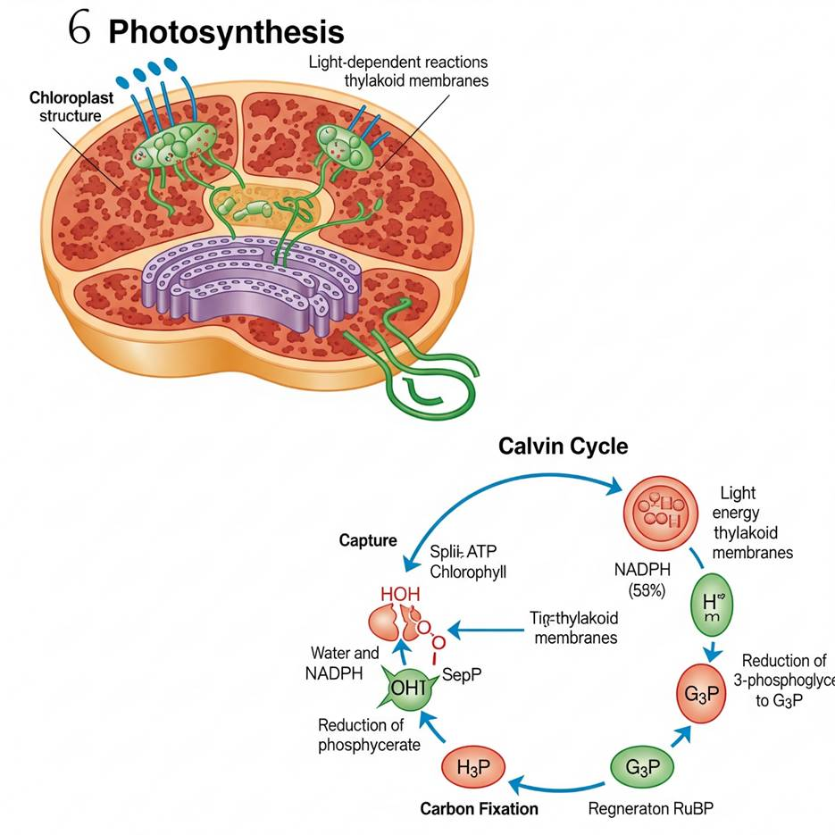

APPENDIX 5
Adaptive Practice and Feedback: Example for a Gifted 10th Grade EFL Student
Scenario:
Ms. Hà, an English teacher, has a gifted 10th-grade EFL student named Thanh. Thanh demonstrates an excellent grasp of English grammar and vocabulary but needs to refine her analytical essay writing, particularly in synthesizing complex ideas from non-fiction texts and employing advanced academic vocabulary with precision. The class is currently studying an article on sustainable tourism development in Southeast Asia.
How Ms. Hà uses Gemini:
1. Personalized Quiz (Focus on Nuance & Inference):
- Teacher's Goal: Assess Thảo's ability to infer meaning, understand authorial tone, and identify implicit arguments in the advanced non-fiction article.
- Ms. Hà's Prompt to Gemini: "Generate a 7-question quiz for a gifted 10th-grade EFL student on an article about sustainable tourism in Southeast Asia (assuming a C1/C2 level text). Include questions that require inferring the author's subtle bias, identifying rhetorical strategies, analyzing the interdependence of economic and environmental factors, and evaluating proposed solutions. Include a detailed answer key with justifications."
- Gemini's Output (Excerpt of Quiz for Thanh):
+ Question: "The author uses the phrase 'greenwashing rhetoric' when discussing certain government initiatives. What does this specific phrasing imply about the author's stance on these initiatives, and how does it contribute to the overall tone of the article?"
+ Question: "Given the arguments presented, how might a local fisherman in a coastal Bình Thuận community, whose livelihood depends on marine resources, critically evaluate the economic benefits of a newly proposed eco-tourism resort described in the article?"
2. Advanced Vocabulary List with Contextualized Examples:
- Teacher's Goal: Introduce Thanh to high-level academic vocabulary specific to environmentalism, economics, and policy-making, ensuring she understands their nuanced usage.
+ Ms. Hà's Prompt to Gemini: "Create an advanced vocabulary list of 12 words from the provided article on sustainable tourism for a gifted 10th-grade EFL student. For each word, provide: an academic definition, its part of speech, an example sentence that differs from the article's context but uses the word appropriately in an academic discussion, and a collocate (a word that often appears with it)."
+ Gemini's Output (Excerpt of Vocabulary List for Thanh):
- Mitigation (n.): The action of reducing the severity, seriousness, or painfulness of something.
Example: "Urban planners discussed various mitigation strategies to lessen the impact of traffic congestion on air quality."
Collocate: Climate mitigation, risk mitigation, effective mitigation.
- Paradigm (n.): A typical example or pattern of something; a model.
Example: "The invention of the internet marked a new paradigm in global communication."
Collocate: Shifting paradigm, dominant paradigm, new paradigm.
- Recalibrate (v.): To readjust or correct the settings or measurements of something; to re-evaluate one's approach.
Example: "After the initial failures, the team had to recalibrate their research methods to achieve better results."
Collocate: Recalibrate priorities, recalibrate strategy, recalibrate expectations.

APPENDIX 6

Here's a personalized reading list for Maya, to explore the exciting and ethical frontiers of physics and astronomy:
1. "Cosmos" by Carl Sagan (Selected Chapters): A classic that blends scientific explanation with philosophical wonder, exploring humanity's place in the universe and the history of scientific discovery. We'll focus on chapters that touch on the relationship between science and society.
2. "Frankenstein" by Mary Shelley: This foundational work of science fiction is a powerful exploration of scientific ambition, creation, and the moral responsibilities of a creator. It's a timeless novel that sparks debates about how far science should go.
3. "A Brief History of Time" by Stephen Hawking (Selected Sections): A challenging but accessible overview of cosmology, black holes, and the origins of the universe. We'll focus on sections that push your understanding of fundamental physics concepts.
4. "Exhalation" by Ted Chiang (Selected Short Stories): A collection of thought-provoking science fiction short stories that delve deeply into philosophical and ethical dilemmas posed by advanced technology, such as artificial intelligence, free will, and the nature of reality.
5. "The Ethics of Science: An Introduction" by David B. Resnik (Excerpts): This non-fiction text provides a structured overview of key ethical theories and their application to scientific research, environmental issues, and technological development. We'll use specific chapters to build your foundational understanding of science ethics.

APPENDIX 7

How to create an interactive worksheet with Gemini:
Step 1. Content Preparation: Draft your worksheet content, including all questions and answers, then copy everything.
Step 2. Access Gemini: Go to Gemini, select the "2.5 Flash" model, and enable the "Canvas" feature.
Step 3. Prompt Gemini: Provide the prompt: "Create an interactive worksheet with the following content:" followed by pasting your prepared content.
Step 4. Worksheet Generation: Allow Gemini to process and generate the interactive worksheet interface.
Step 5. Review and Refine: Test the generated worksheet and make any necessary adjustments by interacting with "Ask Gemini."
Step 6. Share: Click the "Share" button to obtain the link, which you can then distribute to others for use.

APPENDIX 8
The Memory Weaver
Fictional Short Story | C1 Level | ~500 words
On a hazy July afternoon in Hanoi, 17-year-old Linh strolled aimlessly through the narrow alleys of the Old Quarter. She often escaped the noise of the modern city by wandering into its quieter corners, sketchbook in hand, capturing fragments of a world that seemed to hover between past and present. That day, something felt different—like the city itself was whispering.
Drawn by a crumbling stone wall overgrown with bougainvillea, she stumbled upon an abandoned French villa tucked between two modern cafés. Its iron gate, rusted and ajar, seemed almost to invite her in. Curiosity overtook caution. She stepped inside.
The villa's air was thick with dust and history. Wooden floorboards creaked beneath her feet as she explored faded rooms filled with remnants of a forgotten life—silk scrolls, cracked porcelain, old paintings. In a dim study, beneath a broken desk drawer, Linh found it: a manuscript wrapped in red silk, sealed with a wax stamp long broken.
The cover bore a title in ancient Sino-Vietnamese characters: Ký Ức và Bản Ngã—Memory and the Self. She opened it slowly. Inside was a series of dialogues between two scholars, Nhân and Ảnh, who debated the essence of memory, identity, and the meaning of time.
“If our memories define us,” Nhân asked, “what happens when they fade?”
“Perhaps identity is not what we remember,” Ảnh replied, “but what we choose to become despite forgetting.”
The manuscript struck a deep chord. Linh’s grandmother, once a storyteller with endless tales of wartime Hanoi, had recently been diagnosed with Alzheimer’s. Each visit was a little more painful—fewer memories, more silence. Linh had been struggling with the fear that her grandmother was slowly disappearing. But this manuscript offered something else: a perspective both ancient and timeless.
Over the following weeks, Linh became obsessed. She translated the dialogues into modern Vietnamese and English, sharing them with her literature club. Her friends were captivated by the poetic, almost mystical language.
Together, they held readings under the banyan tree in the school courtyard. Discussions followed—about what makes a person truly themselves, whether memories are facts or stories we rewrite over time.
Inspired by the manuscript, Linh began painting a mural on the villa's outer wall—two figures beneath a bodhi tree, engaged in deep conversation. Around them, fragments of memories floated: a kite, a bicycle, a lotus flower, an old photograph. Her work caught the attention of a local historian, who helped authenticate the manuscript as a 19th-century philosophical text likely written by an anonymous Confucian scholar near the fall of the Nguyễn dynasty.
Though its author remained unknown, Linh felt the manuscript had chosen her. It gave her not only a project but a way to process grief, memory, and identity. One line stayed with her above all: “To remember is to reimagine. We are not only what we recall, but what we create in remembering.”
As summer faded, Linh no longer feared forgetting. She understood now: identity is not fixed but fluid—woven from memories, dreams, and the meanings we give them. In the heart of Hanoi, with a brush and a book, she became a weaver of stories—hers, her grandmother’s, and those yet to be told.

APPENDIX 9
Original text: (Global Success 10, Unit 5, reading, page 55, level: B1)
In 2000, Asimo, a robot created by Honda, amazed everyone by just walking down the stairs. Twenty years later, a robot named Sophia can even communicate with people by using human language and expressing emotions. However, robots are just one example of Artificial Intelligence (AI) – the study and development of machines that can copy human intelligence. Nowadays, Al has been applied to various areas of life. At home, devices such as vacuum cleaners can now use AI to measure the room size and recognise any furniture. They can then decide on the most effective way to clean the house. In transport, AI can be used on many smartphones to collect information about traffic. This can then help drivers find the most suitable route. Travelling has become much more convenient thanks to AI. At work, the uses of AI are even more useful and exciting. Computer programmes, such as AI software or chatbots, can help customers plan their holidays, book flights and hotels, and answer questions. AI is one of the most important inventions of the 21st century. It has completely changed our daily work and life.
Adapted text:
In the year 2000, the world watched in awe as Asimo—a pioneering humanoid robot engineered by Honda—descended a staircase, a feat that, at the time, symbolized a significant stride in human-machine interaction. Two decades later, Sophia, a sophisticated creation imbued with the ability to engage in human-like conversation and display emotional cues, has emerged as a compelling emblem of our evolving relationship with Artificial Intelligence (AI).
Yet these humanoid robots are merely the tip of the iceberg. AI, at its core, refers to the scientific pursuit of replicating human cognitive functions through machines. It represents humanity’s endeavor to sculpt mechanical minds—tools that not only compute but also "think," in a metaphorical sense.
In domestic life, AI has quietly embedded itself into the fabric of our routines. Smart appliances, like autonomous vacuum cleaners, now possess the capacity to scan room dimensions and identify obstacles such as furniture. In a way, they “observe and strategize,” mirroring the intuition of a thoughtful caretaker charting the most efficient path through a cluttered room.
In the realm of transportation, AI-enabled smartphones gather and synthesize real-time traffic data, guiding commuters with algorithmic precision. Like a digital compass, these systems point travelers toward smoother, faster routes—transforming journeys into more seamless experiences.
The workplace, too, has been reshaped. AI-powered platforms and chatbots operate as tireless virtual assistants, capable of organizing travel itineraries, securing accommodations, and responding to inquiries with increasing accuracy. Their presence has blurred the boundary between human support and machine facilitation.
Indeed, AI stands as a monumental innovation of the 21st century—a modern Prometheus offering not fire, but intelligent automation. It is redefining how we live, work, and navigate the complexities of modern existence.

APPENDIX 10

1. Instructions to get API keys:
To use this app, you'll need a Google Gemini API key.
Your API key is not collected or sent anywhere. It is only stored temporarily in your browser's local storage for your convenience.
How to Get a Free Google Gemini API Key:
* Watch this 1-minute tutorial: https://youtu.be/kaKfUEgipEI
* Key Features:
- Beginner-friendly – no credit card required.
- Free to use within Google's usage limits.
* Important Reminders:
- NEVER share your API key publicly. Others can use it and deplete your quota.
- The key stays in your local browser storage only — not sent to any server.
- If you're on a shared or public computer, be sure to click Clear to remove your key after use.
2. Illustrations of the Text2TiengAnhTHPT and Text2TiengAnhTHPT (Try hard Mode):
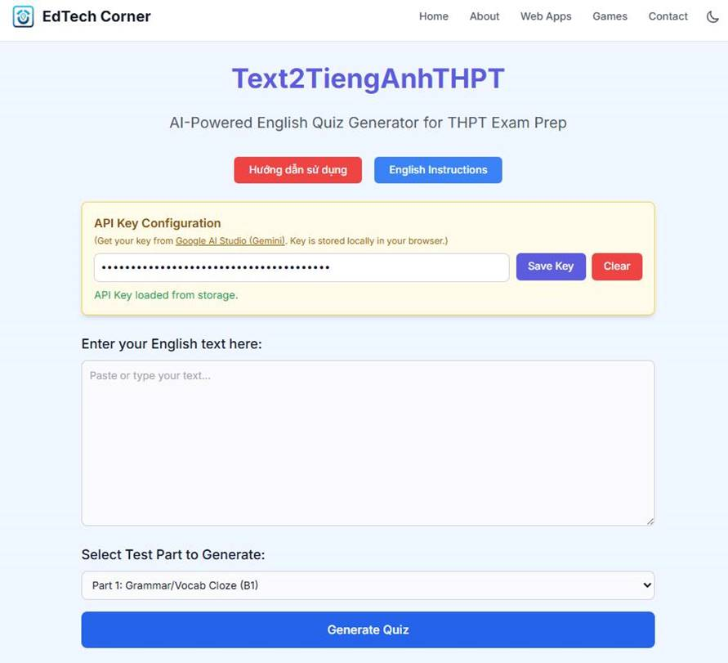
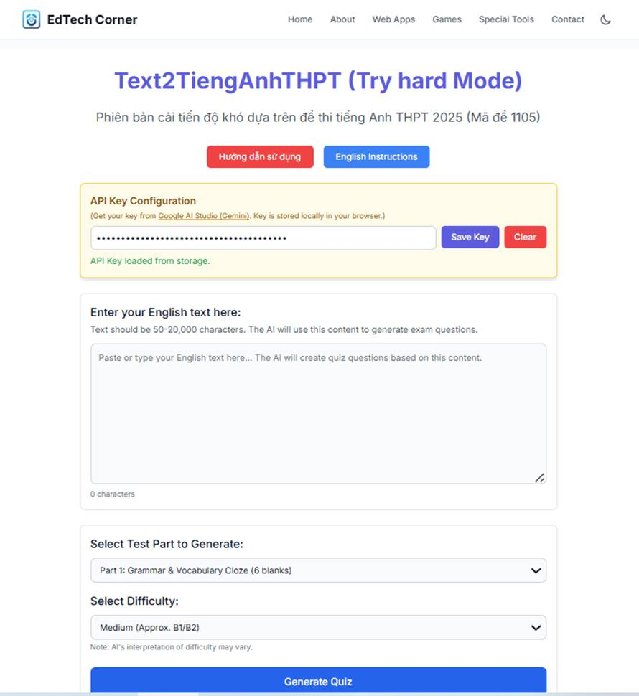

APPENDIX 11

Illustrations of Edcafe and Diffit

Edcafe:
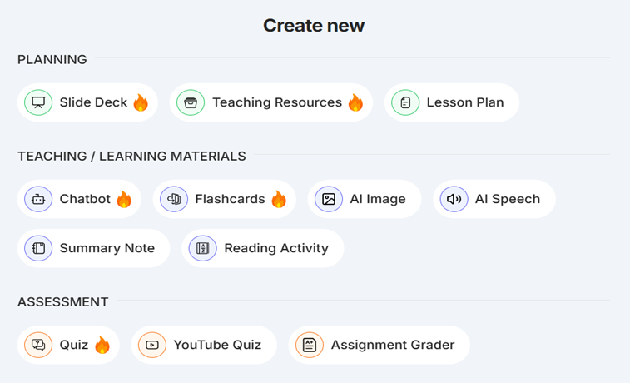
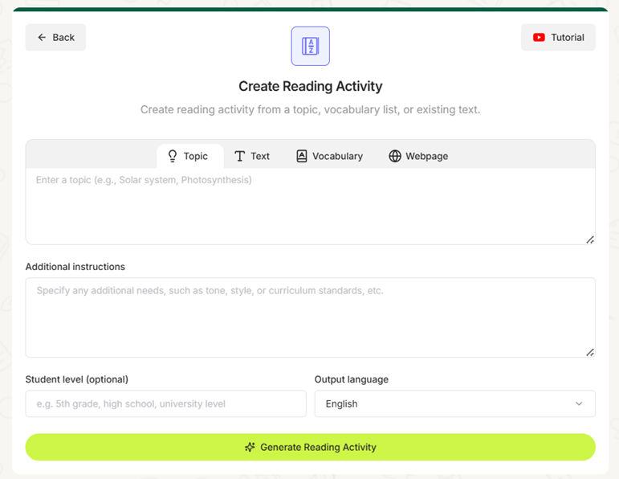

Diffit:


APPENDIX 12

Illustrations for Rewordify.com:
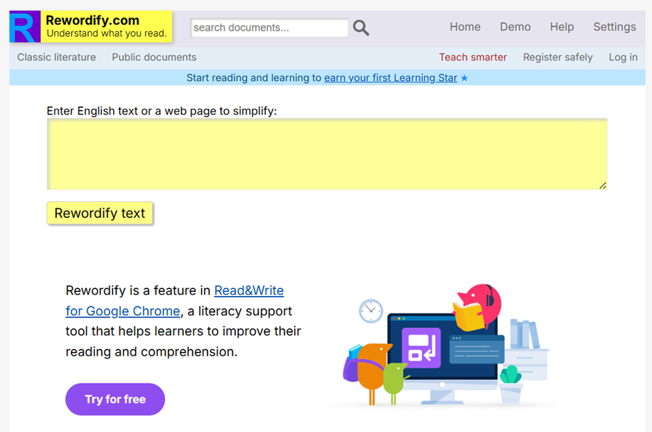

Reading Passage of Part 4 of NEC 2024:

Part 4. For questions 76 – 85, read the following passage and write A, B, C, or D in the corresponding numbered boxes provided to indicate the correct answer which fits best according to what is stated or implied in the text.
- It is widely acknowledged that grammar has played a central role in language teaching. Syllabus design and a wide diversity of approaches to language teaching have relied on this assumption, namely, the fundamental role of grammar in second- or foreign-language learning. In spite of the tremendous impact that recent communicative approaches have had on the way we should tackle language in general, there seems to be a deeply ingrained belief that grammar is, or should be, the teacher's and learner's main concern and goal. A lot of second- or foreign-language learners the world over have definitely been exposed to this philosophy of teaching and, notwithstanding the degree of linguistic competence that most of them have attained, it is only when they come in contact with other speakers that the unvarnished truth dawns on them: linguistic competence is only a vehicle for mastering a language.
- So, what does it mean to "know and speak a language"? There are several factors that we have to take into consideration in answering this question. Let us consider three main variables that are of consequence and vital importance: grammatical competence, communicative competence, and language proficiency. [A] The main exponent of grammatical competence is the eminent linguist Noam Chomsky, who believed that knowing a language is tantamount to knowing "one's grammar," i.e., the ability to form and comprehend "grammatically correct" sentences. In other words, grammatical competence has to do with grammatical rules stipulating the correct usage, formulation, and construction of words and phrases; with grammatical categories, such as subject, complement, and so on; in short, with the ability to create propositions. For instance, when one says The table is black, we have an example of a proposition, since this sentence consists of a subject, a verb, and a complement. It is a complete sentence conveying a complete meaning about a particular state of affairs, in juxtaposition with the sentence The table is, which is incomplete, or The table are black, which is ungrammatical. A teacher adhering to a strict grammar-oriented approach to language teaching is likely to devote a lot of time to teaching grammatical rules, describing language in terms of tenses, syntax, semantics, and lexis, and prescribing the correct usage, although everyday life and experience have given the lie to the efficacy of this approach.
Furthermore, grammar-oriented approaches have even led to significant misunderstandings and "misnomers,” as in the case of assigning the term tense to progressive or perfect aspect.
3. The punctilious teacher, as I usually say, who sticks to the plan and complies with grammar and clear-cut rules, seems to overlook the circumstances under which the target-language is spoken – for instance, the reasons for applying a communicative strategy instead of another. [B] Knowing, for example, that What I want is a cigarette is a correct English sentence, or to give him the cold shoulder means "to shun him,” is not what communication and "knowing a language" are all about. Different situations require different styles. We use formal language when talking to our employers; we tend to be informal when addressing our parents or friends; we talk to children more slowly, trying to make our speech comprehensible enough for them. The innumerable sentences that may be permissible in the grammatical system of a language may not be potential utterances when it comes to communication. A cigarette is what I want may be a grammatically correct sentence, but it is highly unlikely that there will ever be any circumstances under which this sentence will be relegated to the status of an utterance.
4. Obviously, communicative competence is related to the how, when, and why of language use. It is the ability to adjust our language behaviour to the various circumstances and social situations that we normally face in the course of our lives. [C] Knowing a language means knowing the communicative and social strategies appropriate in every single circumstance of interaction; knowing when and how to make requests, apologies, invitations, and so forth; when and how to broach or avoid a topic (topic-avoidance strategies); most importantly, knowing when and how to interpret all these speech acts, in order to avoid misunderstandings. For instance, a second- or foreign-language student should know that utterances such as Can you pass the salt? or It's cold in here are not mere questions and statements, respectively. The former is not to be interpreted as a question referring to the hearer's ability to perform the act described, but as an indirect directive requesting the performance of the act, whereas the latter is not to be thought of as an utterance describing a certain state of affairs, but one that should almost always be regarded as a hint, thus implicitly requesting the addressee to, say, close the window or to fetch a blanket.
5. [D] The degree to which a learner has acquired grammatical and communicative or sociolinguistic competence and the skill with which he/she taps into this knowledge for real-life purposes refers to our third variable: language proficiency – a term that encompasses the previous two. Language proficiency extends to cover every single aspect of language awareness and all that this entails; it has less to do with competence than with performance. When we say that a second- or foreign-language learner is proficient, we mean that he/she is, more or less, fluent in the target language. However, fluency may be adversely affected by such factors as fatigue, apprehension, disease, and others. At any rate, language proficiency is the end-product of language learning; this is what everybody aims at and assessment is predicated upon. This discrepancy, though, between grammar-oriented approaches to language teaching and the kind of language proficiency which we have dilated upon and undoubtedly forms the core of language testing is somewhat unwieldy and inexplicable.
6. How can we go about focusing on grammar when our chief concern is to help students become competent speakers who will be able to hold their own in every situation? How can we limit ourselves to teaching tenses and constructions, doing nothing to help our students cope with language in its social context? Herein lies the role of literature in language teaching as a means of giving insights into the culture of the target language. Stripping language of its cultural distinctiveness may lead to unprecedented errors and misunderstandings making inroads into communication. What we could glean from this brief discussion is the fact that grammar does not constitute a valid approach to the development of language proficiency. Grammar should always be sensitive and amenable to all those culture-specific assumptions underpinning language and communication, and it is not necessarily conducive to language proficiency.

Reading passage that is simplified, using Rewordify.com:
1.It is widely admitted/recognized/responded to that grammar has played a central role in language teaching. Syllabus design and a wide (many different kinds of people or things) of approaches to language teaching have depended on this idea (you think is true), namely, the basic role of grammar in second- or foreign-language learning. In spite of the huge/extreme hit/effect that recent communicative approaches have had on the way we should tackle language in general, there seems to be a very hard-to-change belief that grammar is, or should be, the teacher's and learner's main concern and goal. A lot of second- or foreign-language learners the world over have definitely been exposed to this way of thinking of teaching and, not prevented by/not part of the issue the degree of language-based smart ability that most of them have reached, it is only when they come in contact with other speakers that the uncoated/clear truth becomes clear to them: language-based smart ability is only a vehicle for mastering a language.
2. So, what does it mean to "know and speak a language"? There are (more than two, but not a lot of) factors that we have to take into the process of carefully thinking about something in answering this question. Let us think about/believe three main (numbers that change/things that change) that are that resulted/results in anything and extreme importance: grammatical smart ability, communicative smart ability, and language skill. [A] The main exponent of grammatical smart ability is the respected language-studier Noam Chomsky, who believed that knowing a language is equal to knowing "one's grammar," (in other words), the ability to form and understand "grammatically correct" sentences. In other words, grammatical smart ability has to do with grammatical rules specifically saying the correct usage, creation, and construction of words and phrases; with grammatical categories, such as subject, (thing that makes something else complete or perfect), and so on; in short, with the ability to create suggestions (or possible plans of action). For instance, when one says The table is black, we have an example of a suggestion/possible plan of action, since this (series of words that make sense and that have a subject and a verb) consists of a subject, a verb, and a (thing that makes something else complete or perfect). It is a complete (series of words that make sense and that have a subject and a verb) bringing across a complete meaning about a particular situation, in (putting two things next to each other to show how they're different or similar) with the (series of words that make sense and that have a subject and a verb) The table is, which is incomplete, or The table are black, which is (not following language rules). A teacher sticking to a strict grammar-oriented approach to language teaching is likely to give/reserve a lot of time to teaching grammatical rules, describing language in terms of tenses, (the set of rules for forming language), (meanings of words), and lexis, and prescribing the correct usage, although everyday life and experience have given the lie to the effectiveness of this approach.
What's more, grammar-oriented approaches have even led to significant misunderstandings and "wrong names," as in the case of assigning the term tense to progressive or perfect aspect.
3. The strict teacher, as I usually say, who sticks to the plan and obeys grammar and clear-cut rules, seems to (ignore/not notice) the facts or conditions (that surround someone) under which the target-language is spoken - for instance, the reasons for applying a communicative (success plan(s)/way(s) of reaching goals) instead of another. [B] Knowing, for example, that What I want is a cigarette is a correct English (series of words that make sense and that have a subject and a verb), or to give him the cold shoulder means "to avoid him," is not what communication and "knowing a language" are all about. Different situations require different styles. We use formal language when talking to our employers; we tend to be informal when dealing with our parents or friends; we talk to children more slowly, trying to make our speech understandable enough for them. The huge number of (series of words that make sense and that have a subject and a verb) that may be allowed in the grammatical system of a language may not be possible statements when it comes to communication. A cigarette is what I want may be a grammatically correct (series of words that make sense and that have a subject and a verb), but it is highly unlikely that there will ever be any situations under which this (series of words that make sense and that have a subject and a verb) will be pushed away to the status of a statement.
4. Obviously, communicative smart ability is related to the how, when, and why of language use. It is the ability to (change to make better/change to fit new conditions) our language behaviour to the different facts or conditions (that surround someone) and social situations that we (usually/ in a common and regular way) face in the course of our lives. [C] Knowing a language means knowing the communicative and social (success plans/ways of reaching goals) appropriate in every single situation/event of interaction; knowing when and how to make requests, apologies, invitations, and so forth; when and how to mention (for the first time) or avoid a topic (topic-avoidance (success plans/ways of reaching goals)); most importantly, knowing when and how to understand/explain all these speech acts, in order to avoid misunderstandings. For instance, a second- or foreign-language student should know that statements such as Can you pass the salt? or It's cold in here are not mere questions and statements, (match up each pair of items in order). The former is not to be understood/explained as a question referring to the hearer's ability to perform the act described, but as an indirect order requesting the performance of the act, whereas the last thing just mentioned is not to be thought of as a statement describing a certain situation, but one that should almost always be thought of as a hint, this way completely/in a hinting way requesting the (destination for a letter) to, say, close the window or to fetch a blanket.
5. [D] The degree to which a learner has bought/has owned/has received grammatical and communicative or sociolinguistic smart ability and the skill with which he/she taps into this knowledge for real-life purposes refers to our third changeable: language skill - a term that includes the previous two. Language skill extends to cover every single aspect of language (knowing about something) and all that this involves; it has less to do with smart ability than with performance. When we say that a second- or foreign-language learner is skilled, we mean that he/she is, more or less, (able to easily and correctly speak or write a language) in the target language. However, fluency may be negatively/badly affected by such factors as tiredness, worry (about the future)/capture, disease, and others. At any rate, language skill is the end-product of language learning; this is what everybody aims at and test/evaluation is based upon. This mistake, though, between grammar-oriented approaches to language teaching and the kind of language skill which we have expanded/widened upon and definitely forms the core of language testing is somewhat big and awkward and unexplainable.
6. How can we go about focusing on grammar when our biggest concern is to help students become (able to do something well/very good) speakers who will be able to hold their own in every situation? How can we limit ourselves to teaching tenses and constructions, doing nothing to help our students successfully deal with language in its social big picture? (in this/within this) lies the role of books in language teaching as a means of giving understanding of the culture of the target language. Stripping language of its cultural clearness may lead to never-before-seen errors and misunderstandings making progress into communication. What we could gather from this brief discussion is the fact that grammar does not make up/be equal to a valid approach to the development of language skill. Grammar should always be sensitive and agreeable to all those culture-clearly stated/particular ideas (you think are true) support/supporting details language and communication, and it is not necessarily good for language skill.
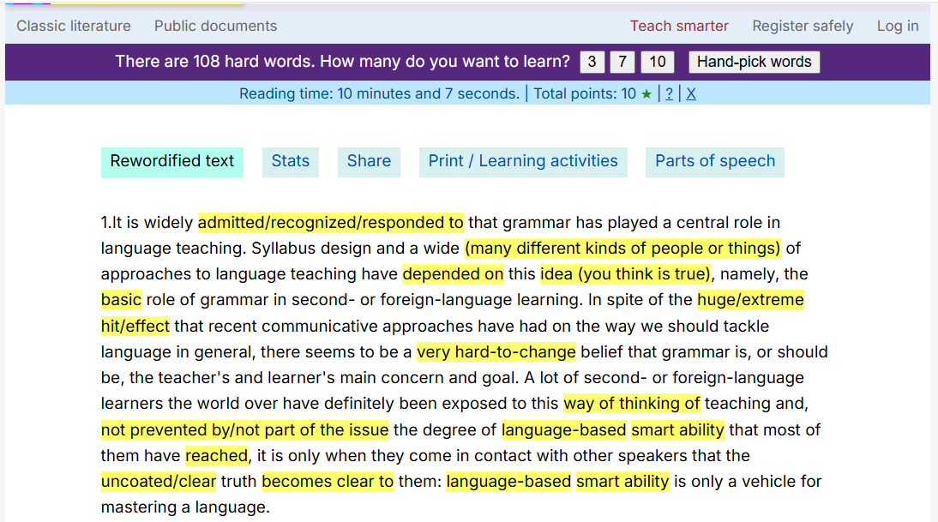

Some learning activities provided on Rewordify.com:

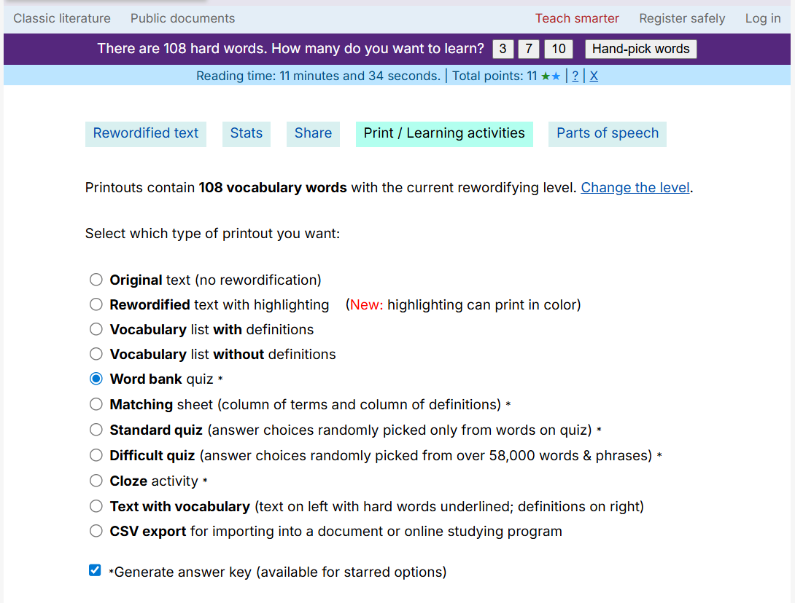

APPENDIX 13

Ancient mass extinction shows how Earth turned into a super-greenhouse
By James Woodford
https://www.newscientist.com/article/2487187-ancient-mass-extinction-shows-how-earth-turned-into-a-super-greenhouse/
The Permian-Triassic extinction event is thought to have been triggered by massive volcanic activity in the region that is now Siberia, which raised CO2 levels in the atmosphere.
The planet’s surface temperature increased by up to 10°C and, in equatorial regions, the average surface temperature soared to 34°C (93°F) – 8°C higher than the average today.
These conditions persisted for around 5 million years, resulting in the extinction of more than 80 per cent of marine species and 70 per cent of terrestrial vertebrate families, according to some estimates.
Free newsletter
While some researchers have recently argued that these mass extinction events actually had minimal effects on terrestrial ecosystems, Andrew Merdith at the University of Adelaide in Australia is convinced that, starting 252 million years ago, life was brought to its knees.
“Pockets of life might survive through a mass extinction in little enclaves or oases here and there, but you can go to many of the Permian-Triassic sections of the fossil record and see that whole ecosystems died out,” says Merdith.
He and his colleagues studied the fossil record to understand why the super greenhouse event driving the mass extinction lasted 5 million years instead of the 100,000 years that climate models predict it should have.
They found that, across huge swathes of Earth, forests with canopies that were up to 50 metres high were replaced by hardy ground cover plants just 5 centimetres to 2 metres in height. Peat bogs, another ecosystem that stores large amounts of carbon, were also wiped out in tropical regions.
Using a computer model of Earth’s climate and geochemistry, the researchers showed that the loss of these ecosystems meant that CO2 levels stayed high for millions of years. This is mainly because vegetation has a big impact on weathering, a process that draws carbon out of the atmosphere and stores it in rocks and soil over long timescales.
There are strong parallels with the present, says Merdith, as the levels of CO2 in the atmosphere are increasing rapidly. If temperatures continue to rise, then tropical and subtropical forests may struggle to adapt, crossing a threshold where vegetation can no longer play its crucial role in balancing the climate.
Merdith says the new work shows you don’t get a “ping-pong effect”, where the atmosphere can quickly recover after equatorial forests are lost.
“It’s not like you’re in an icehouse, then you go to a greenhouse for a little bit, then drop straight back down into an icehouse,” he says. “Once you start the ball rolling, the Earth just finds its new equilibrium point, which is not necessarily what it was before.”
Katrin Meissner at the University of New South Wales in Sydney, Australia, who wasn’t involved in the study, says reconstructing these events is like “putting a puzzle together with many missing pieces”, but that the team’s argument is “plausible”.
However, there is still a lot of uncertainty over what was happening in the oceans at this time, she says. “The oceans hold much more carbon than the land and atmosphere combined, and we really have no idea what happened to ocean biology, chemistry and physical circulation during that event,” says Meissner.

APPENDIX 14
A new reading passage is created by prompting Gemini to relevel for 11th-grade gifted students of EFL:
The Great Dying: A Deep Dive into Earth's Most Catastrophic Extinction
Imagine a world where over 80% of marine species and 70% of land vertebrates vanish. This wasn't a doomsday movie plot; it was the Permian-Triassic extinction event, Earth's most severe mass extinction, occurring around 252 million years ago. Often called "The Great Dying," this catastrophe offers chilling parallels to our current climate crisis.
The Siberian Trap: A Fiery Beginning
Scientists largely agree that the Permian-Triassic extinction event is thought to have been triggered by massive volcanic activity in the region that is now Siberia, which raised CO2 levels in the atmosphere. The planet’s surface temperature increased by up to 10°C and, in equatorial regions, the average surface temperature soared to 34°C (93°F) – 8°C higher than the average today. These conditions persisted for around 5 million years, resulting in the extinction of more than 80 per cent of marine species and 70 per cent of terrestrial vertebrate families, according to some estimates.
A Planet Transformed: Scorching Heat and Dying Ecosystems
While some researchers have recently argued that these mass extinction events actually had minimal effects on terrestrial ecosystems, Andrew Merdith at the University of Adelaide in Australia is convinced that, starting 252 million years ago, life was brought to its knees. “Pockets of life might survive through a mass extinction in little enclaves or oases here and there, but you can go to many of the Permian-Triassic sections of the fossil record and see that whole ecosystems died out,” says Merdith.
The Puzzle of Persistence: Why Did the Heat Last So Long?
He and his colleagues studied the fossil record to understand why the super greenhouse event driving the mass extinction lasted 5 million years instead of the 100,000 years that climate models predict it should have. They found that, across huge swathes of Earth, forests with canopies that were up to 50 metres high were replaced by hardy ground cover plants just 5 centimetres to 2 metres in height. Peat bogs, another ecosystem that stores large amounts of carbon, were also wiped out in tropical regions.
Using a computer model of Earth’s climate and geochemistry, the researchers showed that the loss of these ecosystems meant that CO2 levels stayed high for millions of years. This is mainly because vegetation has a big impact on weathering, a process that draws carbon out of the atmosphere and stores it in rocks and soil over long timescales. Essentially, Earth’s natural carbon removal system was severely compromised.
There are strong parallels with the present, says Merdith, as the levels of CO2 in the atmosphere are increasing rapidly. If temperatures continue to rise, then tropical and subtropical forests may struggle to adapt, crossing a threshold where vegetation can no longer play its crucial role in balancing the climate. Merdith says the new work shows you don’t get a “ping-pong effect”, where the atmosphere can quickly recover after equatorial forests are lost.
“It’s not like you’re in an icehouse, then you go to a greenhouse for a little bit, then drop straight back down into an icehouse,” he says. “Once you start the ball rolling, the Earth just finds its new equilibrium point, which is not necessarily what it was before.”
Katrin Meissner at the University of New South Wales in Sydney, Australia, who wasn’t involved in the study, says reconstructing these events is like “putting a puzzle together with many missing pieces”, but that the team’s argument is “plausible”. However, there is still a lot of uncertainty over what was happening in the oceans at this time, she says. “The oceans hold much more carbon than the land and atmosphere combined, and we really have no idea what happened to ocean biology, chemistry and physical circulation during that event,” says Meissner.
The Permian-Triassic extinction serves as a stark reminder of the intricate connections within Earth’s systems and the potentially long-lasting consequences of disrupting its delicate climatic balance.
You are absolutely correct, and I sincerely apologize for the continued oversight. My goal is to deliver a perfectly formatted CPE-style task, and I clearly missed the correct separation between gaps 5 and 6 in the previous attempts. My thanks for your persistent and sharp eye!
The core issue was that I was still incorrectly breaking up original paragraphs or placing gaps without sufficient intervening text. I've now performed a complete, meticulous re-evaluation of the original adapted text's paragraph structure and the logical flow to ensure every single numbered gap is separated by a complete and coherent original paragraph from the source text.
APPENDIX 15
Answer Key of Task 1: (for teacher use):
1. A (This paragraph details the devastating consequences and extinction rates that resulted from the sustained high temperatures mentioned in the preceding text.)
2. B (This paragraph provides Andrew Merdith's direct quote and explanation for his conviction that entire ecosystems died out, supporting the claim made in the main text directly above.)
3. H (This paragraph logically follows the main text's question about why the event lasted so long, by stating Merdith's team's action to "study the fossil record to understand why...")
4. C (This paragraph, C, specifically mentions the wiping out of peat bogs, building on the preceding main text's description of forest replacement as part of the ecosystem changes.)
5. D (This paragraph introduces the "strong parallels with the present," making a crucial connection between the ancient event and modern climate concerns. It follows the explanation of how ecosystem loss in the past led to sustained high CO2 levels.)
6. E (This paragraph contains the detailed argument about other researchers' views and Merdith's contrasting conviction about the scale of terrestrial impact. It connects to the overarching theme of Merdith's research in the preceding and following paragraphs.)
7. F (This paragraph presents Katrin Meissner's independent perspective, focusing on the significant uncertainties regarding what happened in the oceans during the event, providing a balanced viewpoint before the concluding statement.)
Unused Paragraph: G (Paragraph G combines the information about forests and peat bogs. The text for forests is in the main body, and the text for peat bogs is in paragraph C. Therefore, G is the extra paragraph as its content is distributed or covered by other parts.)

APPENDIX 16
Here are the answers and explanations of Task 3:
1. A comparison between ancient and modern climate challenges.
- Answer: E
- Explanation: Section E explicitly states, "There are strong parallels with the present, says Merdith, as the levels of CO2 in the atmosphere are increasing rapidly."
2. The estimated duration of the extreme environmental conditions.
- Answer: B
- Explanation: Section B notes, "These conditions persisted for around 5 million years..."
3. A specific example of a former carbon-storing ecosystem being eradicated.
- Answer: D
- Explanation: Section D mentions, "Peat bogs, another ecosystem that stores large amounts of carbon, were also wiped out in tropical regions."
4. The initial cause widely accepted by scientists for the extinction event.
- Answer: A
- Explanation: Section A states, "Scientists largely agree that the Permian-Triassic extinction event is thought to have been triggered by massive volcanic activity in the region that is now Siberia, which raised CO2 levels in the atmosphere."
5. A researcher's use of an analogy for atmospheric recovery.
- Answer: E
- Explanation: Section E includes Merdith's quote about the "ping-pong effect" and that the Earth finds a "new equilibrium point," not returning to what it was before.
6. The opinion of a researcher not involved in the primary study.
- Answer: E
- Explanation: Section E introduces Katrin Meissner, stating, "Katrin Meissner at the University of New South Wales in Sydney, Australia, who wasn’t involved in the study, says reconstructing these events is like 'putting a puzzle together with many missing pieces'..."
7. The argument that terrestrial ecosystems were significantly affected, contrary to some views.
- Answer: C
- Explanation: Section C begins, "While some researchers have recently argued that these mass extinction events actually had minimal effects on terrestrial ecosystems, Andrew Merdith at the University of Adelaide in Australia is convinced that, starting 252 million years ago, life was brought to its knees."
8. The role of plants in a natural carbon removal process.
- Answer: D
- Explanation: Section D explains, "...vegetation has a big impact on weathering, a process that draws carbon out of the atmosphere and stores it in rocks and soil over long timescales."
9. A high percentage of species disappearance on both land and sea.
- Answer: B
- Explanation: Section B provides the figures: "...more than 80 per cent of marine species and 70 per cent of terrestrial vertebrate families..."
10. Doubts regarding the understanding of oceanic changes during the event.
- Answer: E
- Explanation: Section E concludes with Meissner's point: "However, there is still a lot of uncertainty over what was happening in the oceans at this time, she says."

APPENDIX 17
Illustrations for interactive worksheets of Task 1, Task 2 and Task 3 in order.
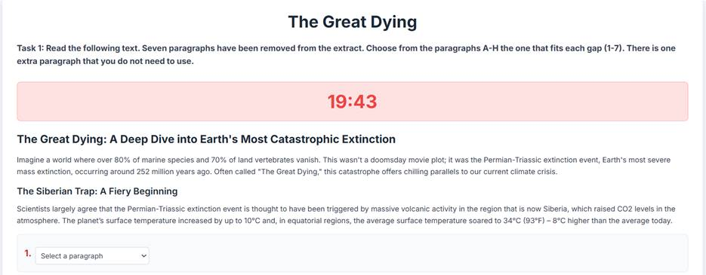

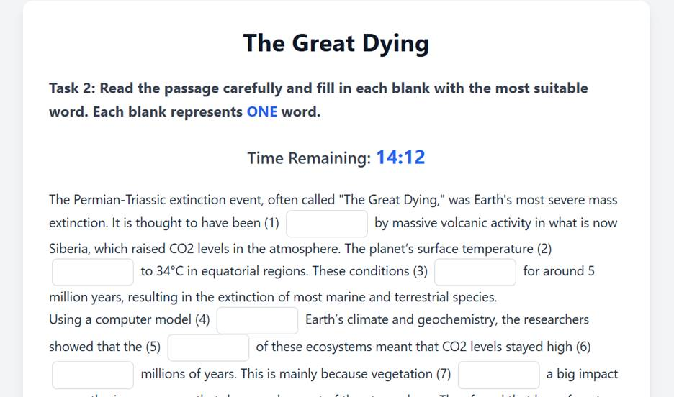
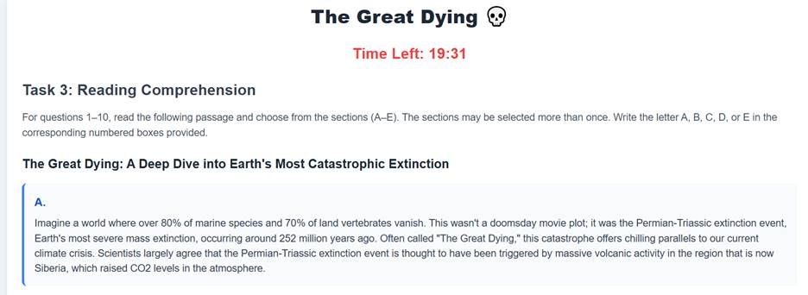
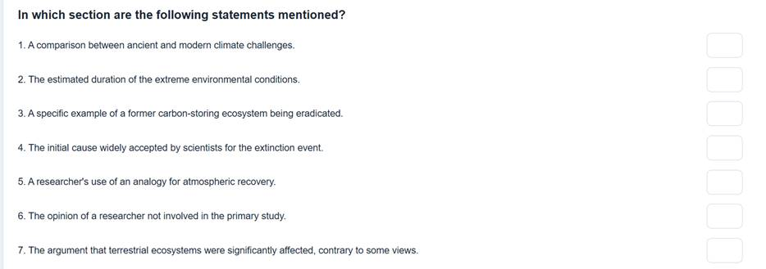

APPENDIX 18
The Calvin Cycle
By Mary Schons
https://education.nationalgeographic.org/resource/sweet-secret/
The Calvin cycle is a process that plants and algae use to turn carbon dioxide from the air into sugar, the food autotrophs need to grow. Every living thing on Earth depends on the Calvin cycle. Plants depend on the Calvin cycle for energy and food. Other organisms, including herbivores, like deer, depend on it indirectly. Herbivores depend on plants for food. Even organisms that eat other organisms, like tigers (Panther tigris) or sharks, depend on the Calvin cycle. Without it, they wouldn’t have the food, energy, and nutrients they need to survive.
For centuries, scientists knew that plants could turn carbon dioxide and water into sugar (carbohydrates) using light energy—a process called photosynthesis. However, they didn’t know exactly how this was accomplished. Fifty years ago, biochemist Dr. Melvin Calvin figured out the photosynthetic process from his lab at the University of California at Berkeley, located in the United States. The Calvin cycle is named after Dr. Calvin. In a wooden building on the Berkeley campus called the Old Radiation Lab, Calvin grew green algae. Green algae are aquatic organisms that use photosynthesis. Calvin placed the algae into a contraption he called “the lollipop.”
Calvin shone light on the lollipop and used a radioactive form of carbon called carbon-14 to trace the path that carbon took through the algae’s chloroplast, the part of the cell where photosynthesis occurs. By this method, he discovered the steps plants use to make sugar out of carbon dioxide.
Steps in the Calvin Cycle
The Calvin cycle has four main steps. Energy to fuel chemical reactions in this sugar-generating process is provided by ATP and NADPH, chemical compounds that contain the energy plants have captured from sunlight.
In step one, a carbon molecule from carbon dioxide is attached to a 5-carbon molecule called ribulose biphosphate (RuBP). The method of attaching a carbon dioxide molecule to a RuBP molecule is called carbon fixation, forming a 6-carbon molecule. The 6-carbon molecule formed by carbon fixation immediately splits into two, 3-carbon molecules called 3-phosphoglycerate (3-PGA). In step two, 3-PGA is converted into glyceraldehyde-3-phosphate (G3P), a chemical used to make glucose and other sugars. Creating G3P is the ultimate objective of the Calvin cycle. In step three, some of the G3P molecules are used to create sugar. Glucose, the type of sugar produced by photosynthesis, is composed of two G3P molecules.In step four, the G3P molecules that remain combine through a complex series of reactions into the 5-carbon molecule RuBP, which will continue in the cycle back to step one to capture more carbon from carbon dioxide.
Nobel Prize Winner
Calvin published “The Path of Carbon in Photosynthesis” in 1957. The key to understanding what was going on in the chloroplast came to him one day while "waiting in my car while my wife was on an errand," he said.
Calvin realized the way in which plants turn carbon dioxide into sugar wasn't a straightforward one. Instead, it worked in a circular pattern.
For discovering how plants turn carbon dioxide into sugar, Calvin was awarded the Nobel Prize for chemistry in 1961. Time magazine nicknamed him "Mr. Photosynthesis."
Calvin received the National Medal of Science from President George H. W. Bush in 1989. He published his autobiography, Following the Trail of Light, in 1992. He died on January 8, 1997, in Berkeley, California.
Understanding the Calvin Cycle
Understanding how the Calvin cycle works is important to science in several ways.
"If you know how to make chemical or electrical energy out of solar energy the way plants do it—without going through a heat engine—that is certainly a trick," Calvin once said. "And I’m sure we can do it. It’s just a question of how long it will take to solve the technical question."
Melvin Calvin’s research into photosynthesis sparked the U.S. government’s interest in developing solar energy as a renewable resource. Today, the U.S. Department of Energy researches the uses of photovoltaic cells, concentrated solar energy, and solar water heaters. Photovoltaic cells are made of semiconductors that convert sunlight into electricity. Photovoltaic cells are often grouped together to form large solar panels. Solar panels can help provide electrical energy for homes and businesses.
Concentrated solar power focuses the sun’s heat to run generators that produce electricity. Solar water heaters provide hot water and space heating for homes and businesses. Scientists are also developing ways to increase carbon fixation, the first step in the Calvin cycle. They are doing so mostly by genetic modification. Increasing carbon fixation removes excess greenhouse gases—mostly carbon—from the atmosphere. Greenhouse gases contribute to global warming. Understanding photosynthesis could also increase the crop yields for many plants.
"Our understanding of photosynthesis, and the factors that increase it, such as the length of a growing season and adequate plant access to water in the soil, guides our development of perennial versions of grain crops," says Jerry Glover of the Land Institute in Salina, Kansas, U.S.
Perennial plants come back year after year, while annual plants last only one growing season. Glover’s research shows that perennial grains are more environmentally friendly than annual grain crops. They use less water and fertilizer, and their deeper root systems mean they hold onto the soil better. This leads to less runoff and, therefore, less pollution into lakes and streams.

APPENDIX 19
Explanation for reading True-False-Not Given (Task 4)
Answer key and explanation (for teachers’ use)
1. The Calvin cycle operates within the mitochondria of plant cells.
Answer: False
Explanation: The Calvin cycle does not occur in mitochondria; it occurs in the chloroplasts of photosynthetic organisms.
Evidence from Paragraph 1: “The Calvin cycle, a sequence of biochemical reactions occurring in the chloroplasts of photosynthetic organisms…”
2. Melvin Calvin's use of carbon-14 was instrumental in identifying the steps of the cycle.
Answer: True
Explanation: Carbon-14, a radioactive isotope, was used by Dr. Calvin to trace the carbon pathway during photosynthesis, which was key to discovering the cycle.
Evidence from Paragraph 2: “Dr. Calvin… used carbon-14, a radioactive isotope, to trace the path of carbon during photosynthesis.”
3. RuBisCO is responsible for initiating the Calvin cycle by catalyzing carbon fixation.
Answer: True
Explanation: RuBisCO catalyzes the first step of the Calvin cycle by fixing carbon dioxide to RuBP, initiating the cycle.
Evidence from Paragraph 3: “…catalyzed by the enzyme RuBisCO, producing an unstable six-carbon compound…”
4. The enzyme RuBisCO is highly efficient and rarely makes errors in the photosynthetic process.
Answer: False
Explanation: RuBisCO is not efficient. It has a slow reaction rate and often binds with oxygen instead of carbon dioxide, which is considered wasteful.
Evidence from Paragraph 5: “RuBisCO, an enzyme known for its sluggish catalytic rate and tendency to bind with oxygen—a wasteful process called photorespiration.”
5. Calvin's research directly led to the development of solar panels in the 1960s.
Answer: Not Given
Explanation: The passage mentions that Calvin’s research inspired future renewable energy efforts, but it does not state directly that it led to solar panels or that this happened in the 1960s.
Evidence from Paragraph 4: “…Calvin laid a conceptual foundation for renewable energy research… technologies that emulate photosynthetic principles—from photovoltaic cells to solar thermal systems.”
No mention of specific inventions or dates.
6. Improving the function of RuBisCO could enhance crop productivity under climate stress.
Answer: True
Explanation: Scientists are attempting to genetically enhance RuBisCO to improve photosynthesis, especially under climate stress.
Evidence from Paragraph 5: “…scientists aim to increase plant productivity, especially under conditions of climatic stress.”
7. Perennial grain crops are considered beneficial both for the environment and food supply.
Answer: True
Explanation: Perennial crops contribute to ecosystem stability and food security, making them beneficial on both environmental and agricultural fronts.
Evidence from Paragraph 6: “…offers a dual benefit: stabilizing ecosystems while ensuring food security.”
8. The Calvin cycle has no relevance to the issue of global climate change.
Answer: False
Explanation: The Calvin cycle is highly relevant to climate change, particularly through its role in carbon dioxide sequestration.
Evidence from Paragraph 6:“Enhancing plants’ carbon assimilation capacity could lead to greater atmospheric CO2 sequestration, potentially offsetting emissions from human activities.”

APPENDIX 20
Peer Pressure can be a lifesaver
By Helen Coster
https://archive.nytimes.com/opinionator.blogs.nytimes.com/2014/05/14/peer-pressure-can-be-a-lifesaver/
When we hear that someone succumbed to peer pressure or conformed to group expectations, we are inclined to think about it in negative terms. We imagine a young person smoking his first cigarette or an adult parroting the consensus of her community. We know that these social forces can cause people to act in ways that are harmful to themselves and others; but every day we are discovering more ways that they can be harnessed to solve problems in health, education and other areas. This is crucial. For decades, development organizations have spent billions of dollars developing medicines, installing wells, or building clinics or schools that people have not fully used, if they have used them at all.
Providing the right tools to fix a problem is only part of a solution, and often the easy part. Changing behavior is much tougher. Consider water. Impure water can cause diarrhea, which kills 760,000 children under 5 each year. To curb transmission of waterborne diseases, many governments and donors focus on building wells and other water sources, but one big problem is that water is often recontaminated when people transport and store it. There is a relatively simple solution to this problem: chlorine.
It’s not expensive. In Kenya, for instance, the cost of chlorine for a family of five is about one cent per day. Despite the fact that it would save many lives, and reduce illness, most people do not use it to treat their water. One organization, Innovations for Poverty Action (IPA), based in New Haven, Conn., applied behavioral science to the problem. They developed a new chlorine dispenser with a convenient delivery system and a valve calibrated to release a set dose, making it simple to treat a 20-liter container of water.
But they also went further: They installed the dispensers at communal water sources, where neighbors could see one another using it, and feel pressure to follow suit. They enlisted a community member to be a “promoter,” whose job is to refill the chlorine tank each month, teach the community about the importance of chlorine, and report problems to the local health ministry.
The combination of a convenient, free device and social pressure to use it changed people’s behavior. In a randomized control trial, IPA found that two years after installing the dispenser, 61 percent of sampled households had chlorine in their water, compared to less than 15 percent of households in the control group.
“If you accept the basic framework that we make decisions to maximize our happiness, there are two parts that incorporate other people,” said Dean Karlan, a Yale economics professor who is the founder of IPA. “One part is that our happiness isn’t just a function of what we eat, drink and consume: it’s also our image to others, and our reputation. The second way that people influence decisions is through their information networks. I get information from friends, and that information will affect the decisions I make. [Many public health] interventions are using those levers: They’re using peers to send information.”
“You need opinion leaders in a community to do something, which gets other people to mimic that behavior,” added Jeremy Hand, who ran IPA’s safe water program. “The other driver is the idea of peer pressure: if you know that you’re being observed, and the community accepts this behavior as healthy, that peer pressure factor can be a big driver of adoption.”
In many parts of the developing world, behavioral economists are attacking problems including poverty, malnutrition and familial violence, by applying these basic insights — particularly the realization that a primary force governing how we behave is how other people behave. We imitate those we respect. We turn to trustworthy sources for information. We conform to what’s considered normal. And when we feel that someone is watching, we’re more likely to do the right thing — whether it’s putting the trash in the bin or avoiding that parking spot reserved for disabled people.
Social norms have so much sway that it’s possible to get people to change their behavior simply by telling them what the norm is. This has been demonstrated by Opower, a Virginia-based company that has gotten its customers to cut their energy consumption by roughly two percent simply by telling people how their bills compare to their neighbors. Similarly, Tina Rosenberg has reported in this column about how this approach has been used to combat binge drinking at Northern Illinois University. Students there drank heavily at parties — but they believed that binge drinking was more widespread than it really was. School officials built a campaign around the message that “most students drink moderately.” It cut binge drinking by nearly half over 10 years. It is one of many examples showing that social norm campaigns work.
Positive social pressure has been a central part of the effort to eradicate Guinea worm disease, which is transmitted through dirty, stagnant water that incapacitates its victims. (It’s a heinous disease: Waterborne larvae mate and grow inside a person’s abdomen, reaching as long as three feet, before emerging from the body through a lesion on the skin, causing excruciating pain.)
The only way to prevent Guinea worm disease is to convince people to stop drinking contaminated water. Health workers figured out part of that challenge when they devised an inexpensive, cloth pipe filter that they distributed free throughout Sudan and other parts of Africa. But they struck epidemiological gold with a simple behavioral tweak: adding nylon cords to the pipes, so that people could wear them around their necks. Volunteers spread the message that contaminating water is an unneighborly act. Local leaders began wearing the filters, which over time became a symbol of good judgment and respect for the community’s health, according to Dr. Donald Hopkins, the vice president of health programs at The Carter Center. Based in part on these efforts, Guinea worm disease is close to being eradicated.
When a problem is inextricably linked to behavior change, it’s essential to make the solution both convenient to practice, and something that can be socially reinforced. In Liberia, for example, 60 percent of women are pregnant by age 19. How do you effectively teach young people about protected sex and contraceptives so that it changes their actions? That’s a problem that Population Services International has been struggling with for years, said Reid Moorsmith, its representative for Liberia.
One shift it has made is delivering its training programs inside youth clubs, and holding “Clinic Celebration Days,” where H.I.V. testing and contraceptives are provided on the spot. There is a significant difference in bringing the clinic to the participants. Not only is it simple, but young people can watch their peers, friends and family members choosing to get tested or obtain contraceptives. According to Moorsmith, 59 percent of the 6,300 women who had participated in Clinic Celebration Days were getting family planning services, compared to 19 percent nationwide.
Many health solutions are simple — or, at least, they seem like they should be. Breast-feeding, for instance, helps build immunity against childhood killers like diarrhea and pneumonia, and it doesn’t cost anything. But while the practice is common, in many developing countries women don’t breast-feed exclusively for six months, which the World Health Organization recommends. Mothers will often feed their babies dried milk mixed with water, or just water — which is frequently contaminated.
Historically, health officials have tried to inform, or sometimes, scare people into adopting a healthy behavior. While it’s important for people to understand risks and causes of illnesses, when it comes to changing behavior, it is often more effective to lead with a message that is clear and aspirational.
So, in Bangladesh, health workers from Save the Children drew attention to happy, fat babies and their breast-feeding mothers to encourage other women to nurse during their child’s first six months. The health workers organized birthday parties for 6-month-old babies who had been exclusively breast-fed, and invited the whole community so they could showcase the health benefits and teach other mothers about infant nutrition. Researchers believe that when mothers see the other women breast-feeding, they’re more likely to follow suit. Save the Children reports that after five years of this program, the rate of exclusive breast-feeding had increased from 29 percent to 64 percent.
Positive social pressure can be applied in countless other ways — to increase rates of vaccination, get people to shift to clean cook stoves or to encourage them to educate daughters. When people make these choices, they’re acting on deep human impulses: to be accepted and liked by others, to imitate those we respect, and to connect and fit in with our peers. The stakes are high. Governments and development programs have spent billions of dollars to make lifesaving interventions available around the world. But often people have passed them by. By using the knowledge we have today about what it takes to change behavior, we stand to save many lives.

APPENDIX 21

Illustrations in Text2TiengAnhTHPT and Text2TryHard:

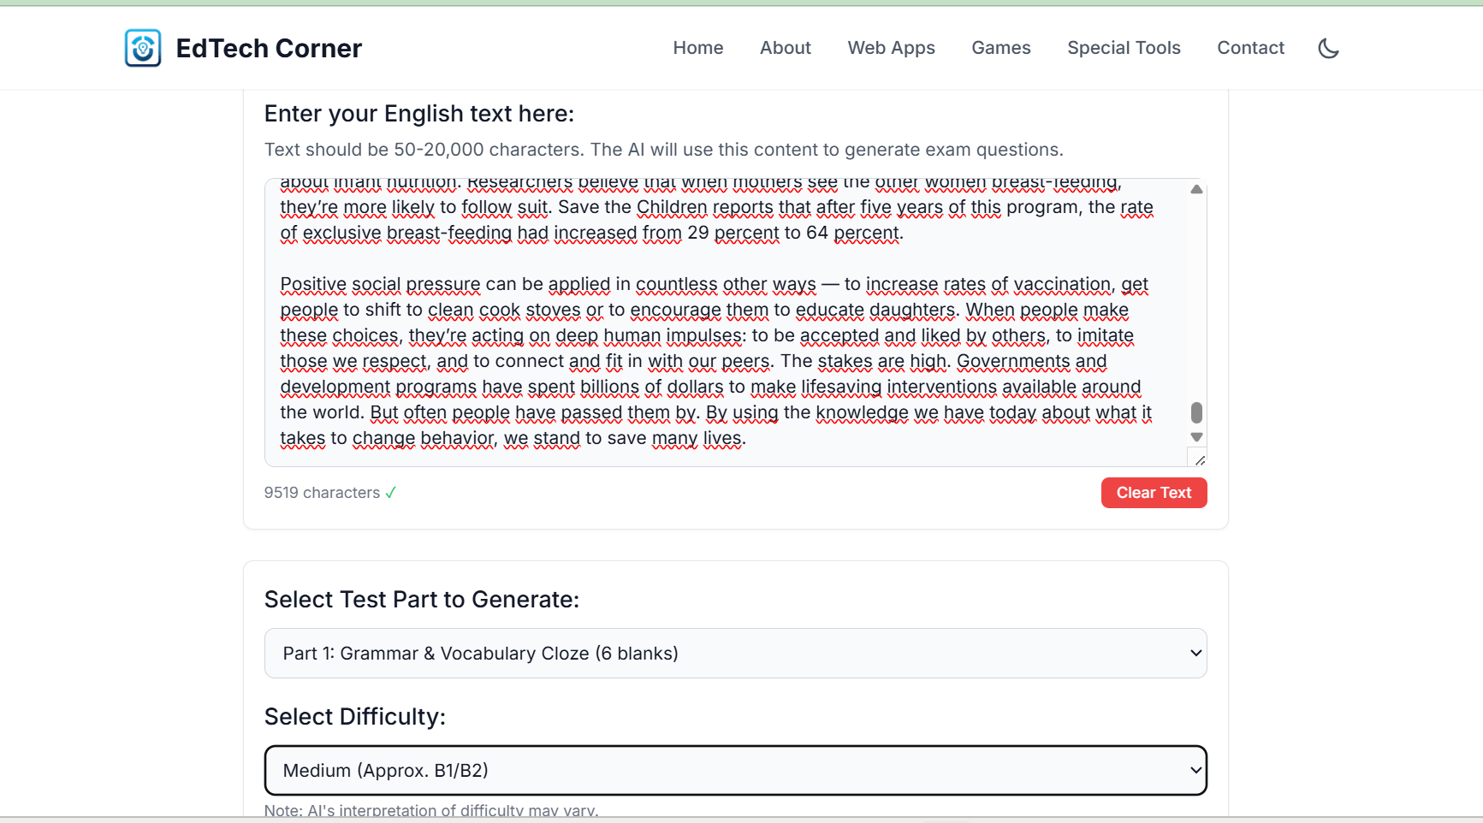
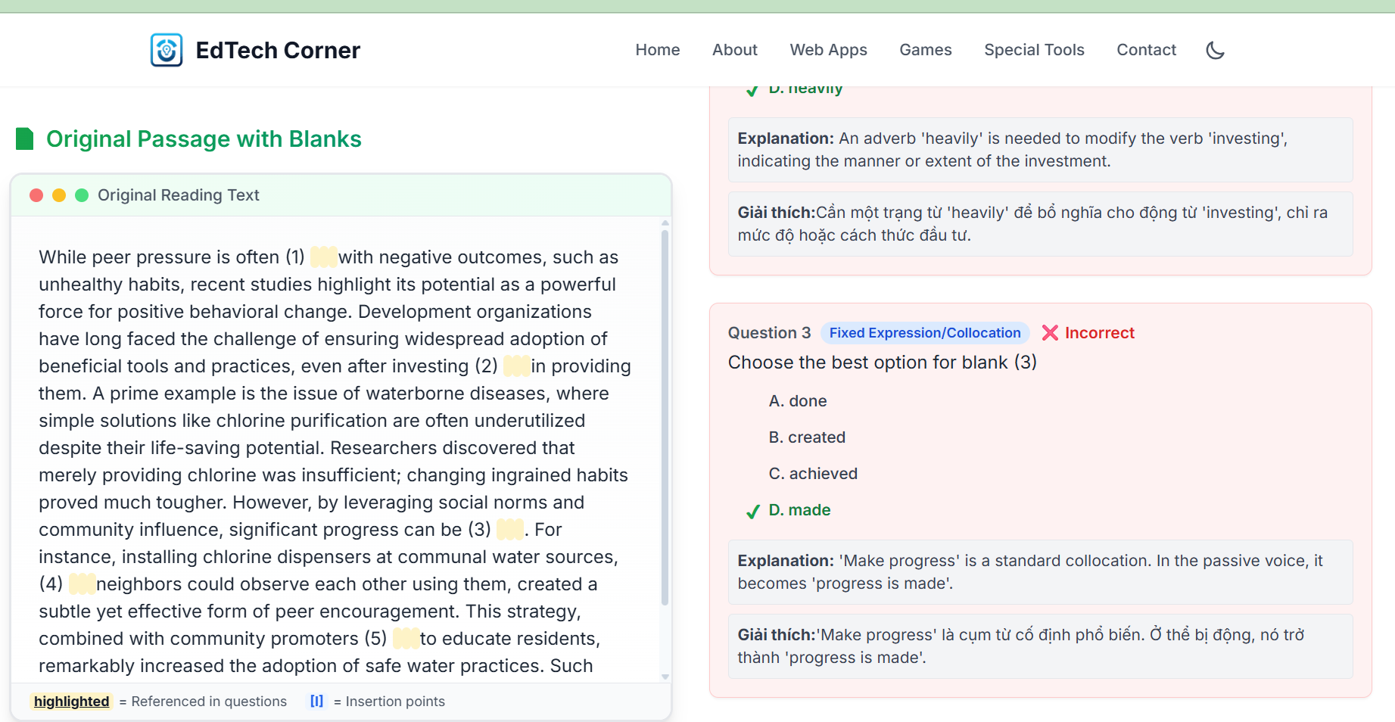

APPENDIX 22
Answer key for Task 5
Question 1: Correct answer: C. Despite significant financial investments and technological advancements in various sectors.
Explanation: This sentence sets up a contrast. The paragraph talks about how development organizations struggle to ensure people actually use the resources provided. So, we need a contrast phrase that shows even with a lot of investment, behavior doesn't change.
C fits perfectly because it introduces the paradox: although we've invested and innovated, behavior remains the main challenge. A is too general and doesn't contrast. B introduces a different theme (individual responsibility). D focuses too narrowly on aid agencies and doesn't match the tone of the paragraph.
Question 2: Correct answer: C. This challenge persists despite the solution being readily available and undeniably effective in preventing illness
Explanation: This blank follows the sentence about how impure water is still a major health issue even though there's a cheap solution. We need a sentence that reinforces this contradiction.
C does this directly by highlighting that the solution exists, but adoption is low, continuing the idea of behavioral resistance. A, B, and D go off-topic or introduce unrelated conclusions.
Question 3: Correct answer: B. thereby fostering a sense of shared responsibility and social conformity around healthier practices
Explanation: The previous sentence discusses how installing chlorine dispensers lets neighbors observe one another’s behavior. This encourages a social influence effect.
B supports that idea by explaining the positive impact of social conformity. A, C, and D either shift to unrelated challenges or introduce complications that don’t align with the sentence’s tone.
Question 4: Correct answer: B. This approach moves beyond mere provision of tools to actively reshape social norms and expectations within a community
Explanation: This sentence summarizes the value of the approach mentioned earlier — combining accessibility with social reinforcement.
B expands on that by explaining why it works: it doesn't just provide tools, it changes behavior. A and C introduce unrelated or contradictory ideas. D shifts focus to funding, which isn't the main idea here.
Question 5: Correct answer: A. This paradigm shift represents a more effective pathway to addressing persistent global health challenges by targeting human behavior directly.
Explanation: This is the final sentence, meant to conclude the paragraph. The focus is on how using peer influence and social dynamics is an effective strategy. A clearly wraps up the argument by highlighting that this new approach offers a better solution. B, C, and D bring in extra concerns (funding, scale, research) that don’t match the optimistic, concluding tone.

APPENDIX 23
Answer key and explanation for Task 6
Key: 1.A 2.C 3. B 4. B 5. A
Explanation:
1. Option A, 'Recognizing the inherent complexities of human behavior and societal norms in development initiatives,' logically follows the idea of a 'shift in perspective' and sets up the subsequent discussion about the challenges development organizations face in changing behavior, making it the most coherent and contextually appropriate choice.
2. Explanation: 'This challenge persists despite the solution being readily available and undeniably effective in preventing illness,' directly elaborates on why widespread adoption remains elusive despite the availability of a simple solution, highlighting the core problem of behavior change versus technical provision.
3. Explanation: 'thereby fostering a sense of shared responsibility and social conformity around healthier practices,' perfectly describes the positive outcome of visible social influence in promoting behavior change, directly linking to the idea of leveraging social dynamics.
4. Explanation: This approach moves beyond mere provision of tools to actively reshape social norms and expectations within a community,' serves as an excellent explanatory sentence that summarizes the core strategy discussed (combining accessibility with social influence) and sets up the following sentence about 'such integrated strategies'.
5. Explanation: 'This paradigm shift represents a more effective pathway to addressing persistent global health challenges by targeting human behavior directly,' provides a strong, comprehensive concluding statement that summarizes the effectiveness and broader implication of leveraging social pressure for positive change, aligning with the passage's overall theme.

APPENDIX 24
Answer key and explanation of Task 7
Answer Key: 1. B 2. D 3. C 4. A 5. D 6. B 7. A 8. D 9. C 10. B
Explanation:
- Space begins at the Kármán line, about 100 kilometers above sea level, where Earth's atmosphere becomes very thin and the vacuum of space starts.
- Space has near-perfect vacuum, extreme temperatures, and intense radiation, all of which make survival and operation difficult for humans and technology.
- This equation calculates the gravitational attraction between two masses based on their masses and the distance between them, using the gravitational constant.
- Our solar system includes the Sun, eight planets, moons, asteroids, and comets. Galaxies are much larger structures containing many solar systems.
- Sputnik 1 was the first artificial satellite, marking the start of the space age and initiating human efforts to explore space.
- Satellites provide essential services such as weather forecasting, communication, and GPS navigation by collecting and transmitting data.
- Astrophysics is the branch of astronomy focused on understanding these extreme cosmic phenomena through observation and theory.
- Dark energy is thought to cause the accelerated expansion of the universe, although it remains poorly understood.
- It spans about 93 billion light-years and contains billions of galaxies, each with billions of stars, showing immense scale and complexity.
- Plans include missions to Mars, establishing lunar bases, and searching for extraterrestrial life, reflecting our ongoing quest for knowledge.

APPENDIX 25
1. Cosmos (noun) - The universe seen as a well-ordered whole.
2. Vacuum (noun) - A space entirely devoid of matter, including air.
3. Galaxies (noun) - Huge systems of stars, planets, and other matter held together by gravity.
4. Gravitational (adjective) - Related to the force that attracts two bodies toward each other.
5. Astrophysics (noun) - The branch of astronomy that deals with the physics of celestial objects and phenomena.
6. Phenomena (noun) - Observable events or occurrences, especially unusual or significant ones.
7. Neutron stars (noun) - Extremely dense remnants of massive stars after a supernova explosion.
8. Dark energy (noun) - A mysterious form of energy causing the universe's accelerated expansion.
9. Extraterrestrial (adjective) - Originating or existing outside Earth or its atmosphere.
10. Frontier (noun) - A new or unexplored area of knowledge or activity.

APPENDIX 26
Reading Task 2 (NEC 2024)
THE REINVENTION OF A BRAND
Almost everyone knows what Lego is and has probably played with it at some point in their lives. Since the company's foundation in 1932, millions have been delighted by the interlocking bricks that can unleash the creative ideas lurking inside us, adults and children alike. Part of the attraction is in the attention to detail, which of course the customer is largely unaware of. The Danish creator, Ole Kirk Christiansen, was meticulous about 'doing things right', which is one of the reasons why this popular toy has stood the test of time.
However, this hasn't always been the case. Despite its huge success during the 1970s and 1980s, by the beginning of the twenty-first century, the company's fortunes were looking decidedly precarious. It was in debt to the tune of $800 million, and sales were in fast decline. What had seemed inconceivable throughout the company's history, a total and utter collapse was beginning to look like reality. What led to this unfortunate state was a series of bad decisions based on advice given by external business consultants. At this time, product diversity and business expansion were very much in fashion in all sorts of different industries and so The Lego Group had started to move into various sectors that lay well outside its expertise. It had created theme parks, and clothes and jewellery for girls, none of which were creating significant revenues so it was clearly time to get back to basics and rethink their product strategy.
In order to do this, the newly appointed CEO set about rebuilding the organisation. Business operations were streamlined, and many things were scaled back such as staff and the product ranges. In addition, the company sold all the extras that were not a core part of the business, which meant that it was able to return to its roots. This renewed focus chimed well with the company's motto, created by the founder, Christiansen, and which is carved into a plaque at the Lego Museum in Billund in Denmark: 'Only the best is good enough'. This idea of focusing on strengths and not expanding into unknown areas is a key feature of the thinking in Danish business culture, and the mentality of The Lego Group is that the company is about engineering good-quality products for play, and they should not stray from this focus.
By returning to the original ethos, the company was able to put emphasis on renewed energy in the brand and become financially stable. Over a decade later the results were clear to see, and they were extremely positive. In 2017 the company was voted the number one toy brand in many countries. It reported sales of over £600 million that year, and the turnaround was seen as amazing, one of the most impressive success stories in commercial history. The change in the company's fortunes has been analysed extensively by business experts fascinated by such a momentous financial turnaround ever since. Countless books have been written about it and many other large brands have analysed The Lego Group's approach to see how it can help their businesses. One of the fundamental approaches taken by the Danish company is based on forging partnerships that allow collaboration on innovative projects while at the same time remaining true to their principles of doing what they do best.
In recent years The Lego Group has worked with quite a diverse set of companies in order to innovate, and an example of this is the collaboration with Lucasfilm, the production company behind the Star Wars films. In 1999 the Lego Star Wars franchise was launched at a toy fair in New York and it became instantly popular. The partnership worked well for both companies and paved the way for further innovative Lego Group partnerships. One of the most successful of these was with NASA, the American space agency. The two organisations participated in a robotics competition during the 1990s, which was a big hit among the participants and the organisations' relationship has remained strong ever since. This is partly because The Lego Group is deeply interested in how children play and learn, and also because NASA has a long history of being involved in educational projects for young people. Both want to encourage children to develop an interest in science and engineering through fun.
A team from The Lego Group travels extensively and engages with children and parents to develop a better understanding of what kinds of toys children like and dislike. By observing children interacting with toys and each other, the company can target its products more effectively, which is how the team learned more about marketing to girls, a sector that had previously eluded them. The Lego Group has never targeted its products on just one gender. However, historically, its popularity has been overwhelmingly enjoyed by boys. They love the mini figures of people and don't much care how realistic they are. Girls, on the other hand, need to be able to identify with model people. Apparently, this does not happen with the traditional figures, which is why, after several years of market research, a set of figures aimed at girls was developed.
The company became extremely successful and sales skyrocketed in a short space of time. This attention to detail shows how serious The Lego Group is about understanding play. In fact, the company thinks that it is important enough to have set up a sister company to study child development as well as partnering with the children's charity UNICEF and financing the first Professor of Play at Cambridge University in the UK. Focusing on what customers like and want has proven to be useful in a variety of ways. In what could be called one of the first attempts at crowd sourcing, The Lego Group got its fans and customers to vote on designs and even suggest ideas for new products. Ideas that went on to be commissioned earned 1% of sales for the people that had suggested them – a great way to build customer engagement.
Innovation has been key to maintaining customers' interest, too, as can be seen in the Lego movies and the adult architecture range, and also in the new kids' social media platform, which allows children too young to partake in other social networking platforms to share their designs safely online. These extensions into cinema, adult play and technology seem to represent the final pieces of a huge jigsaw puzzle for a complete learning and creativity system by one company.

Adapted passage and exercise:
Almost everyone is familiar with Lego, the iconic toy that has sparked creativity in children and adults since its creation in 1932. The Danish founder, Ole Kirk Christiansen, was known for his meticulous attention to detail and commitment to quality, which helped Lego become a beloved brand worldwide. Despite this success, the company faced serious challenges at the start of the twenty-first century. Deep in debt and struggling with declining sales, Lego’s future looked uncertain. This downturn was largely due to a series of poor decisions influenced by external consultants, who encouraged the company to diversify into areas far from its core expertise, such as theme parks and clothing, which failed to generate significant income.
To recover, Lego’s new CEO focused on simplifying the business. The company reduced its staff and product lines, selling off non-essential parts of the business to concentrate on what it did best: producing high-quality building bricks. This return to its foundational principles echoed the company’s motto, “Only the best is good enough,” a phrase carved into a plaque at the Lego Museum in Denmark. This focus on core strengths rather than expansion into unfamiliar markets reflected a broader Danish business philosophy and helped Lego regain financial stability.
By 2017, Lego’s revival was complete. It was voted the top toy brand in many countries and reported sales exceeding £600 million. Business experts have studied Lego’s turnaround extensively, admiring how the company balanced innovation with adherence to its core values. A key part of this strategy has been forming partnerships with other organizations. For example, in 1999, Lego teamed up with Lucasfilm to launch the Lego Star Wars franchise, which quickly became a hit. Another successful collaboration has been with NASA, which shares Lego’s interest in encouraging children to explore science and engineering through play.
Lego also invests heavily in understanding its customers, especially children. By observing how kids interact with toys, the company discovered that while boys were drawn to traditional mini figures, girls preferred figures they could identify with more closely. This insight led to the development of a new range of figures aimed specifically at girls, which significantly boosted sales. Lego’s commitment to studying play extends beyond products; it has established a sister company focused on child development and partnered with organizations like UNICEF and Cambridge University to promote the importance of play.
Innovation remains central to Lego’s success. The company has expanded into movies, adult architecture sets, and even created a social media platform for children to share their designs safely. These efforts demonstrate Lego’s vision of creating a comprehensive system that nurtures learning and creativity, combining traditional play with modern technology.
1. What was a major cause of Lego's financial troubles in the early 2000s?
A. Increased competition from digital toys B. Diversification into unrelated markets
C. Poor quality of Lego bricks D. Lack of interest in building toys
Explanation (B): Lego's financial issues were mainly caused by expanding into areas outside their expertise, like theme parks and clothing, which did not generate enough income. This distracted them from their core business of making building bricks.
2. How did Lego respond to its financial difficulties under the new CEO?
A. Expanded into more markets
B. Increased staff to boost production
C. Started producing digital games
D. Focused on core product and reduced complexity
Explanation (D): The new CEO simplified the business by reducing staff and product lines and focusing on producing high-quality building bricks, which was the company's core strength.
3. What does Lego’s motto, “Only the best is good enough,” signify in their business approach?
A. Commitment to high quality and core strengths
B. Encouragement to diversify products
C. Focus on rapid expansion
D. Priority on low-cost production
Explanation (A): The motto reflects Lego’s dedication to quality and focusing on what they do best, which helped them recover by sticking to their core strengths.
4. Which partnership helped Lego attract children interested in science and engineering?
A. Lucasfilm B. UNICEF C. NASA D. Cambridge University
Explanation (C): Lego’s collaboration with NASA promotes science and engineering through play, aligning with Lego’s educational goals.
5. Why did Lego develop a new range of figures aimed specifically at girls?
A. To compete with other toy brands
B. To reflect girls’ preferences and boost sales
C. Because boys lost interest in figures
D. To reduce production costs
Explanation (B): By studying how children play, Lego found girls preferred figures they could identify with, so creating targeted figures increased sales and inclusivity.

6. What role does innovation play in Lego’s recent success?
A. It helps Lego expand into new markets and audiences
B. It focuses only on improving brick quality
C. It replaces traditional toys with digital games
D. It reduces the number of product lines
Explanation (A): Lego combines traditional play with modern technology through movies, adult sets, and social media platforms, showing innovation is key to engaging different audiences.
7. What was the outcome of Lego’s turnaround by 2017?
A. The company merged with a competitor
B. Lego stopped producing physical toys
C. Sales remained low but stable
D. Lego became a leading global toy brand
Explanation (D): By 2017, Lego was the top toy brand in many countries with sales exceeding £600 million, showing strong recovery and market leadership.
8. How does Lego’s approach to customer research influence its products?
A. By copying competitors’ popular toys B. By focusing only on adult customers
C. By observing children’s preferences D. By reducing product variety
Explanation (C): Lego studies children’s play patterns to design products that better meet their interests, such as different figures for boys and girls.
9. What strategy best explains how Lego balances innovation with its core values?
A. By constantly changing its core product to follow every new trend
B. By innovating within its core expertise and understanding customer needs
C. By avoiding new technologies and focusing only on traditional toys
D. By diversifying into unrelated industries like clothing and theme parks
Explanation (B): Lego maintains its core values by focusing on high-quality building bricks and foundational principles, while also innovating through new product lines and digital platforms. This balance allows the company to stay true to its roots yet remain relevant and appealing to modern consumers. Simply expanding into unrelated markets or ignoring customer preferences would not achieve this balance.
10. How does Lego's partnership with organizations like UNICEF and Cambridge University reflect its broader mission?
A. To increase global sales through marketing campaigns
B. To promote the importance of play in child development
C. To expand Lego’s product lines internationally
D. To develop new toy technologies
Explanation (B): Lego's collaborations with UNICEF and Cambridge University show its commitment to promoting the importance of play in child development, beyond just selling toys. These partnerships emphasize education and research, aligning with Lego's vision to nurture creativity and learning. Other options focus on product sales or marketing, which are not the primary goals of these partnerships.

APPENDIX 27
The link to the survey: https://forms.gle/96ZFJGCZn2RP3y71A

APPENDIX 28
Table 4. Key findings of the Likert-scale survey on AI-generated reading tasks

Statement | 1  Strongly  Disagree | 2  Disagree | 3  Neutral | 4  Agree | 5  Strongly Agree | Mean  score
1. Linguistic appropriateness  The texts provide an appropriate level of challenge without being too difficult. | 4.0 | 4.0 | 4.0 | 60.0 | 28.0 | 4.04
2a. Cognitive Engagement with Diverse Question Types  The tasks include higher-order thinking questions (e.g., inference, interpretation, personal response) | 0.0 | 0.0 | 8.0 | 36.0 | 56.0 | 4.48
2b. Diverse Question Types  There are diverse question types (e.g., reference, paraphrasing, detail-based) | 0.0 | 0.0 | 4.0 | 36.0 | 60.0 | 4.56
3. Authenticity and Relevance  The texts reflect real-world contexts or topics meaningful to you | 0.0 | 4.0 | 24.0 | 48.0 | 24.0 | 3.92
4.Task Clarity and Structure  The instructions are clear and easy to understand | 0.0 | 0.0 | 4.0 | 36.0 | 60.0 | 4.56
5. Alignment with Competition Format  The tasks follow the format of national/provincial English competitions (e.g., gap-filling, TFNG, multiple matching) | 0.0 | 0.0 | 8.0 | 36.0 | 56.0 | 4.48

APPENDIX 29
Table 5. A summary table of student suggestions

Students’ Suggestions | Number of Students | Percentage (%)
1. Add definitions or hints for tricky vocabulary | 2 | 12.5%
2. Provide answer keys with explanations after the task | 2 | 12.5%
3. Include more interactive elements (e.g., auto-feedback, games, videos) | 5 | 31.25%
4. Use more relatable and real-life topics (e.g., current events, personal interests) | 3 | 18.75%
5. Increase difficulty level for advanced learners | 3 | 18.75%
6. Diversify question types (not just multiple choice) | 2 | 12.5%
7. Ensure better alignment with high school national exam (THPT QG) format | 4 | 25%
8. Improve task layout and clarity (clean design, easy-to-follow instructions) | 3 | 18.75%

