ĐỀ MINH HỌA SỐ 05
KỲ THI TỐT NGHIỆP TRUNG HỌC PHỔ THÔNG NĂM 2025
(Đề thi có 08 trang)
Môn thi: TIẾNG ANH
Thời gian làm bài: 50 phút, không kể thời gian phát đề
Read the following advertisement and mark the letter A, B, C or D on your answer sheet to indicate the option that best fits each of the numbered blanks from 1 to 6.
💖 FIND YOUR PERFECT MATCH ONLINE! 💖
Ready to fall in love? Join our (1) ____ that is designed for those who are serious about finding a genuine connection. Signing up means meeting like-minded individuals (2) ____ about building a meaningful relationship. We help you (3) ____ arrangements for memorable dates, so you can focus on what truly matters. Express your true self in a welcoming and secure environment and build a lasting (4) ____ with someone who understands you. Our platform offers personalized matching, ensuring you meet the right person. If you don't mind (5) ____, the first step, start your journey today and discover what love truly means. We promise to help you find that special someone you can truly believe in—someone you feel you truly belong (6) ____ and who is ready to build a genuine relationship with you.
📧 Contact us now: support@yourdatingprogram.com 📞 +123-456-7890
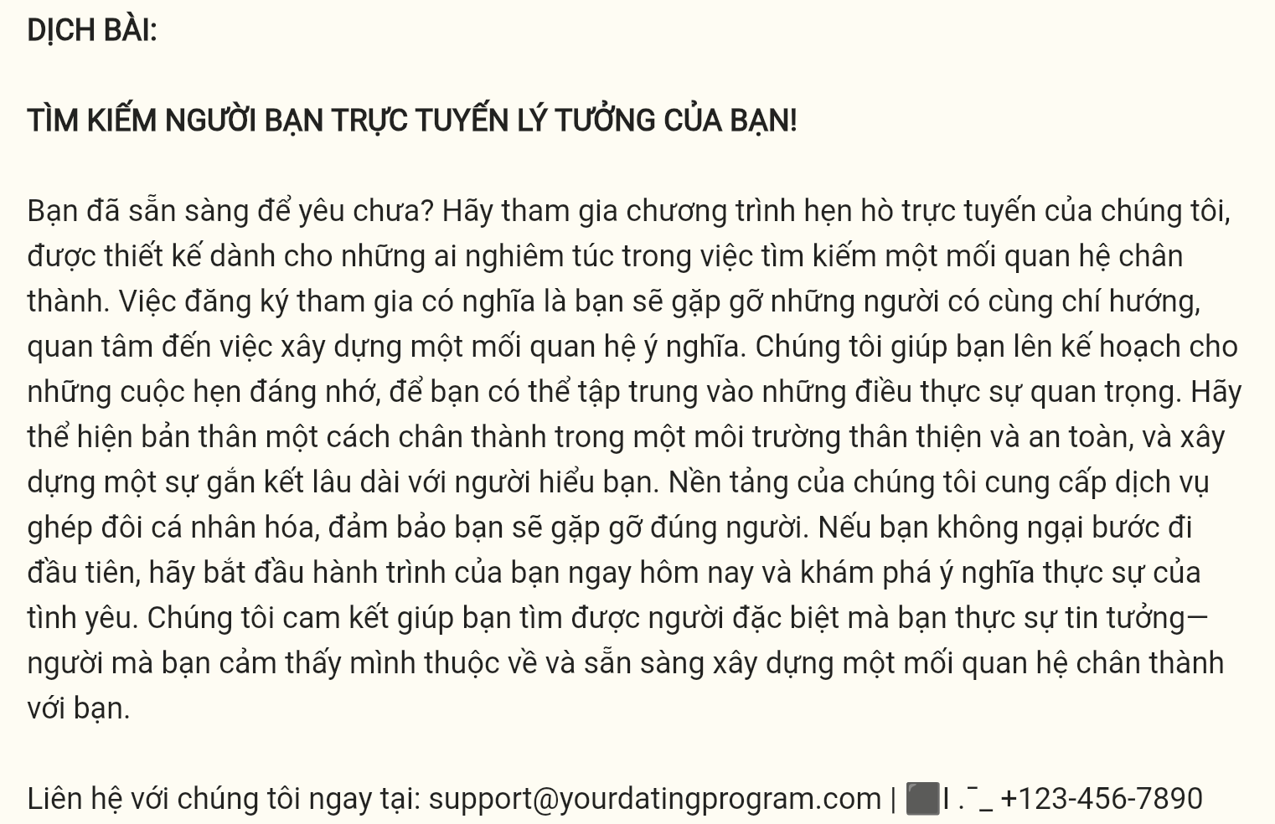
Question 1 [696924]: A. dating online program B. online dating program
C. program dating online D. online program dating
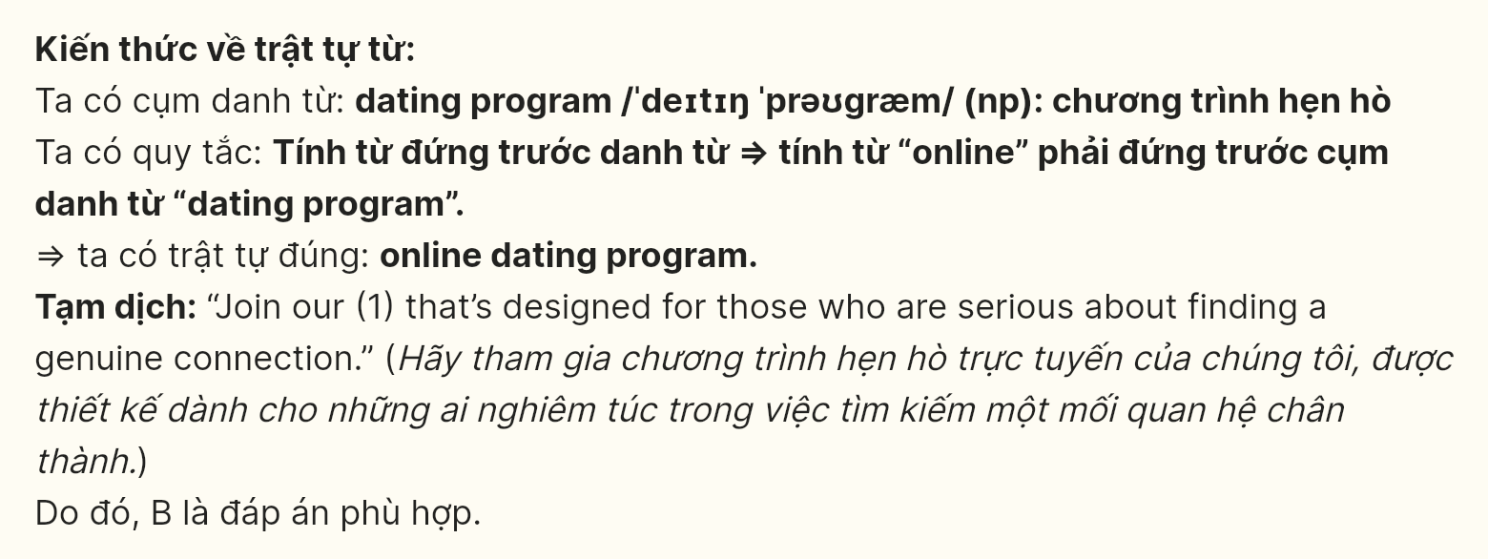
Question 2 [696925]: A. who cared B. are caring C. cared D. caring
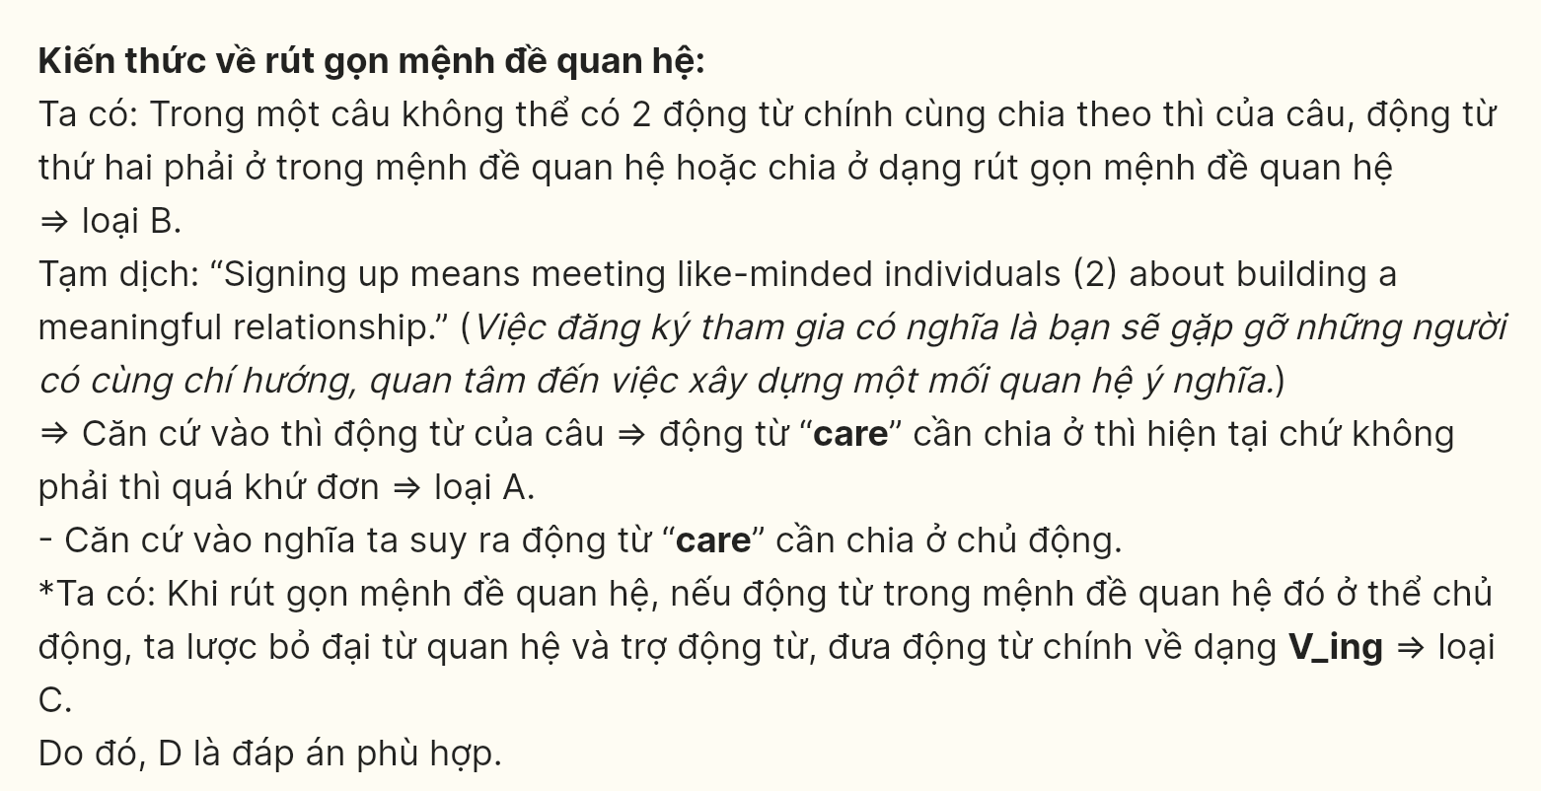
Question 3 [696926]: A. make B. take C. keep D. do
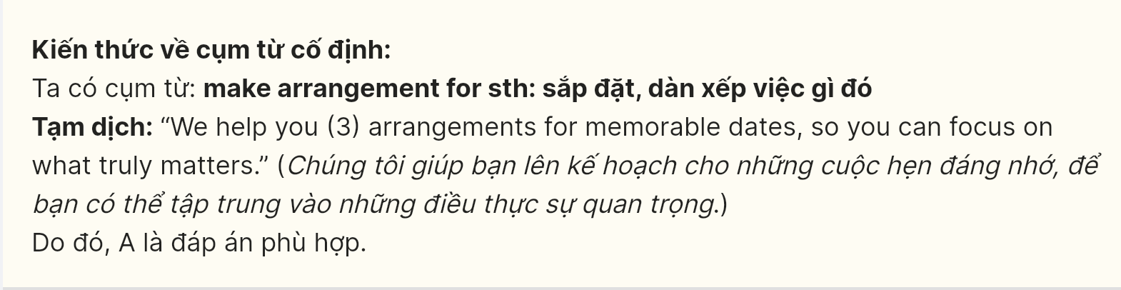
Question 4 [696927]: A. connect B. connection C. connected D. connective
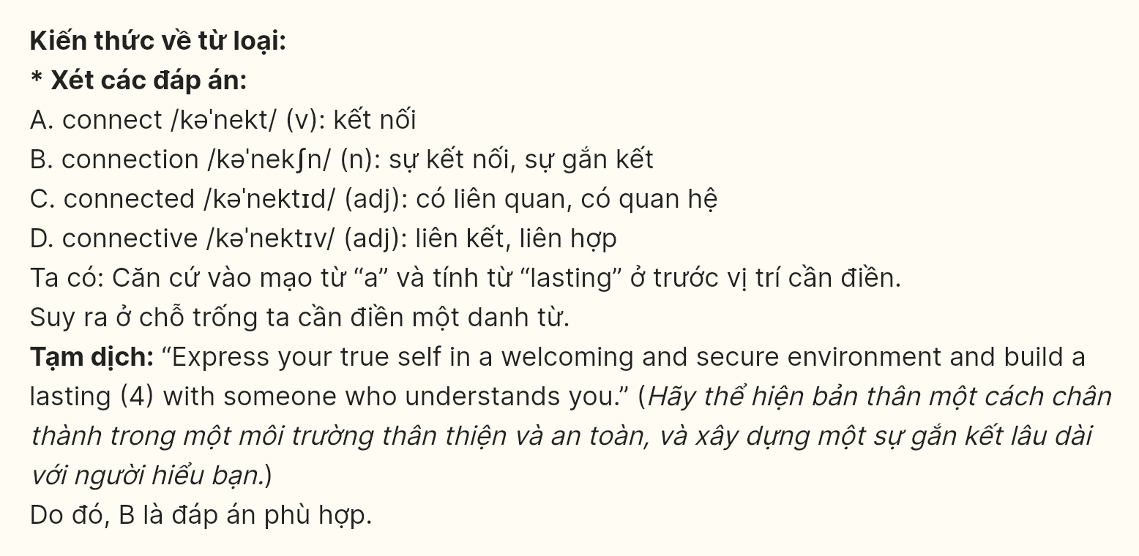
Question 5 [696928]: A. to take B. taking C. taking D. take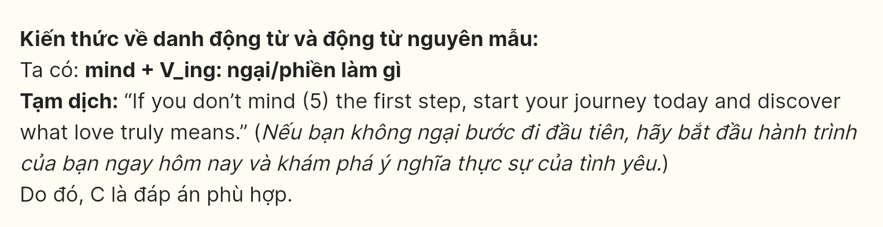
Question 6 [696929]: A. to B. for C. with D. in
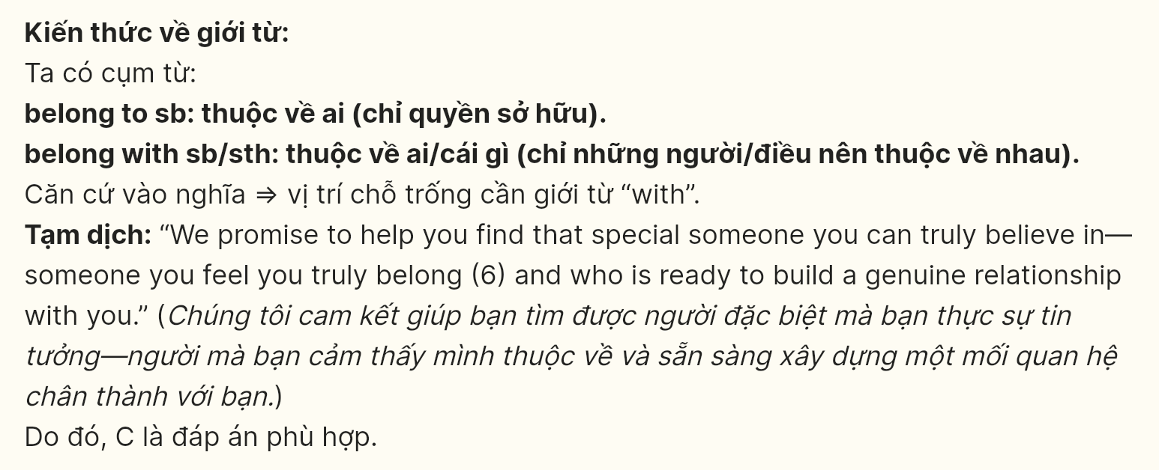
Read the following leaflet and mark the letter A, B, C or D on your answer sheet to indicate the option that best fits each of the numbered blanks from 7 to 12.
📘 Online Learning During the COVID-19 Pandemic: A New Way to Learn!
Embrace the future of education from the comfort of home
What is Online Learning?
Online learning has quickly (7) ____ as a preferred method of education during the COVID-19 pandemic, allowing students to carry on with their studies safely from home. It makes use of (8) ____ essential digital tools and platforms to deliver lessons, making studying much more flexible and accessible anytime, anywhere.
📘 Benefits of Online Learning
- Flexible Schedule: You can learn when it (9) ____ you best. This gives you the chance to balance study time with breaks. It’s perfect for managing your time efficiently.
- Safe Learning Environment: Learning from home helps you avoid (10) ____ to the virus. It ensures that you stay safe while continuing your education.
- Access to a Variety of Resources: You can dive into (11) ____ lessons for better understanding. There are plenty of videos to watch and learn from. (12) ____ online quizzes help test your knowledge regularly.
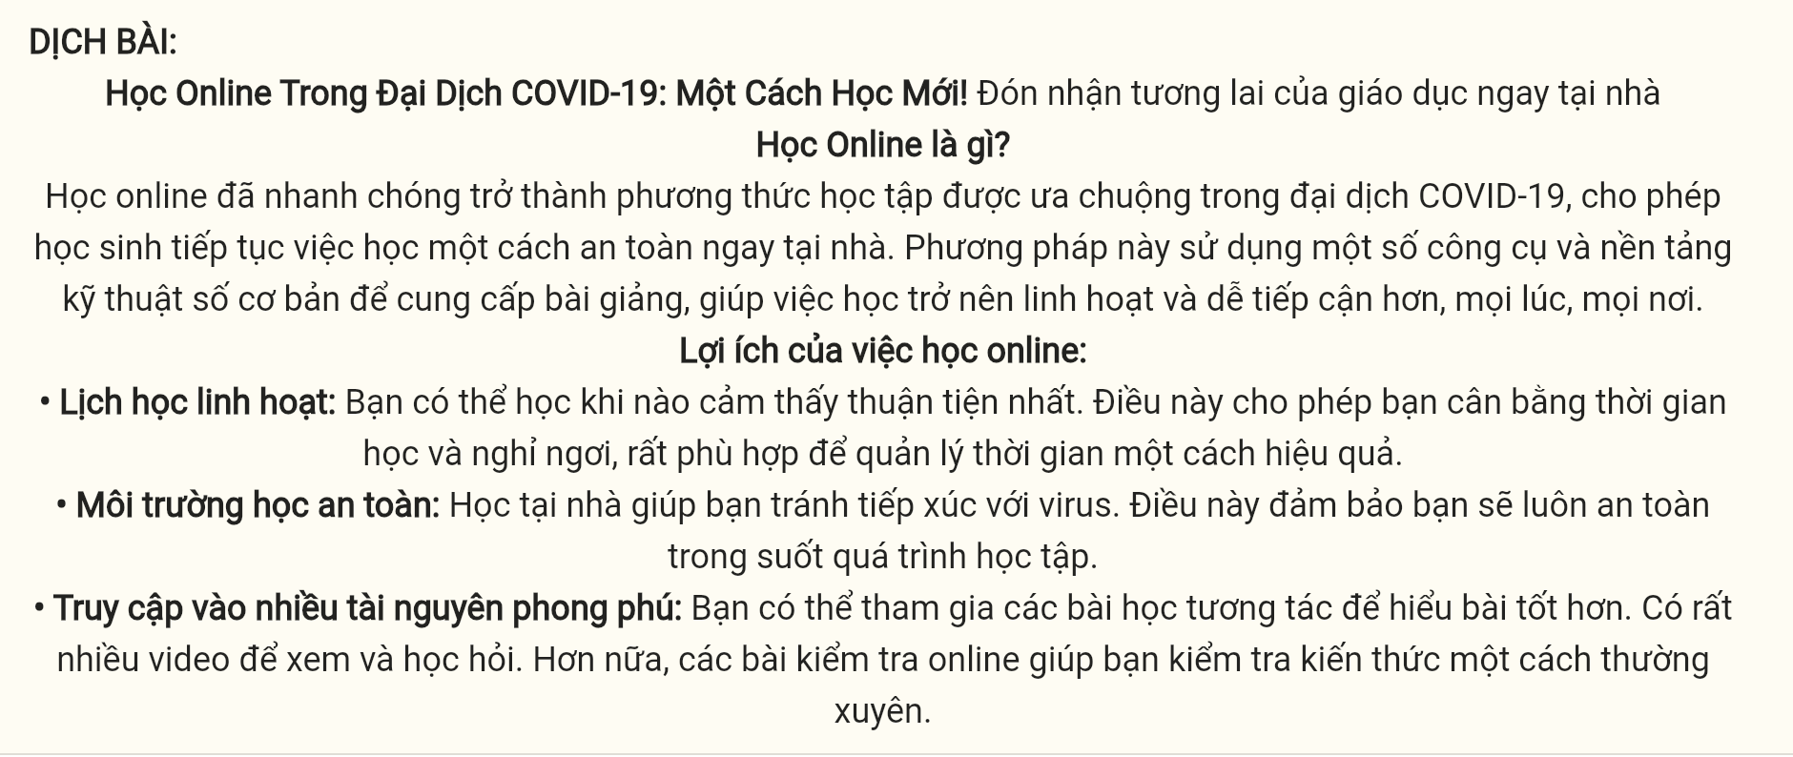
Question 7 [696930]: A. caught on B. brought up C. carried on D. broke out
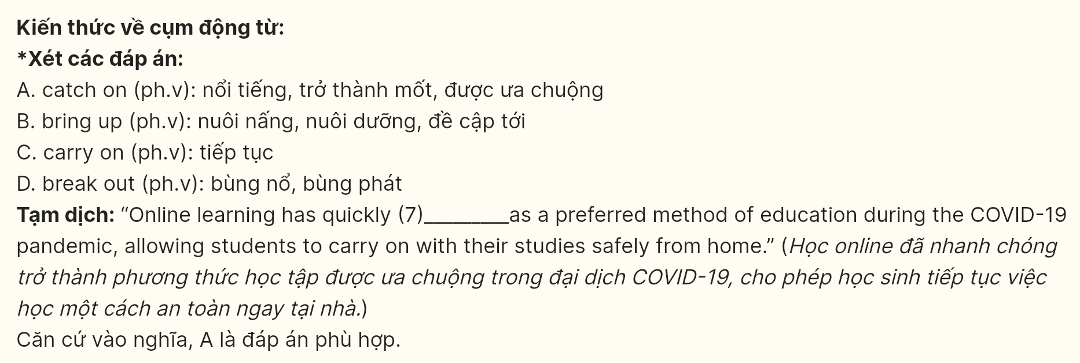
Question 8 [696931]: A. a little B. much C. a few D. all
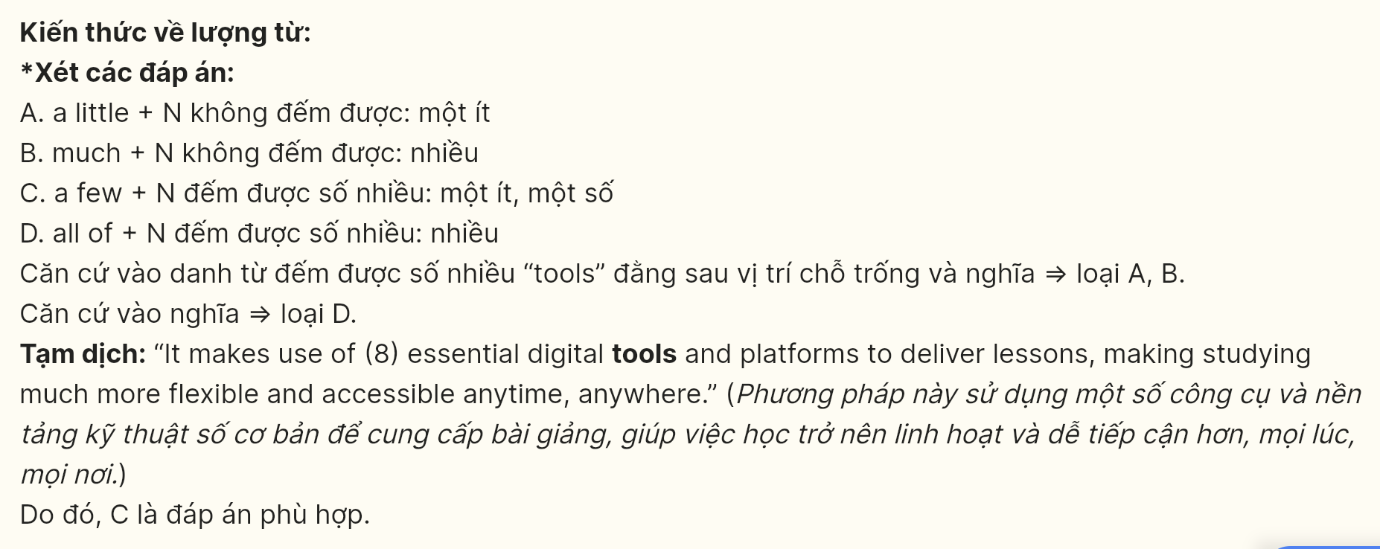
Question 9 [696932]: A. fits B. suits C. reaches D. takes
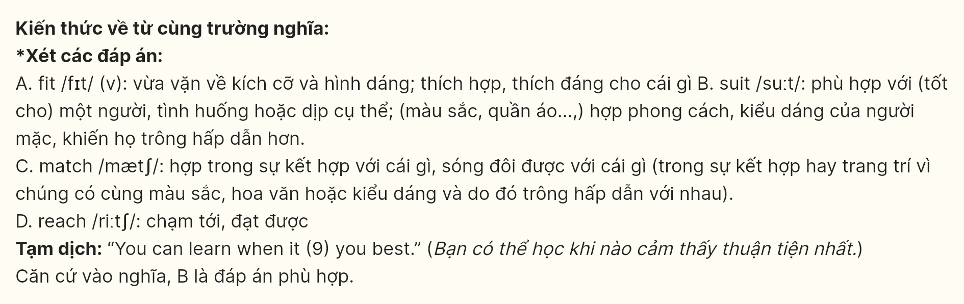
Question 10 [696933]: A. likelihood B. condition C. guarantee D. exposure
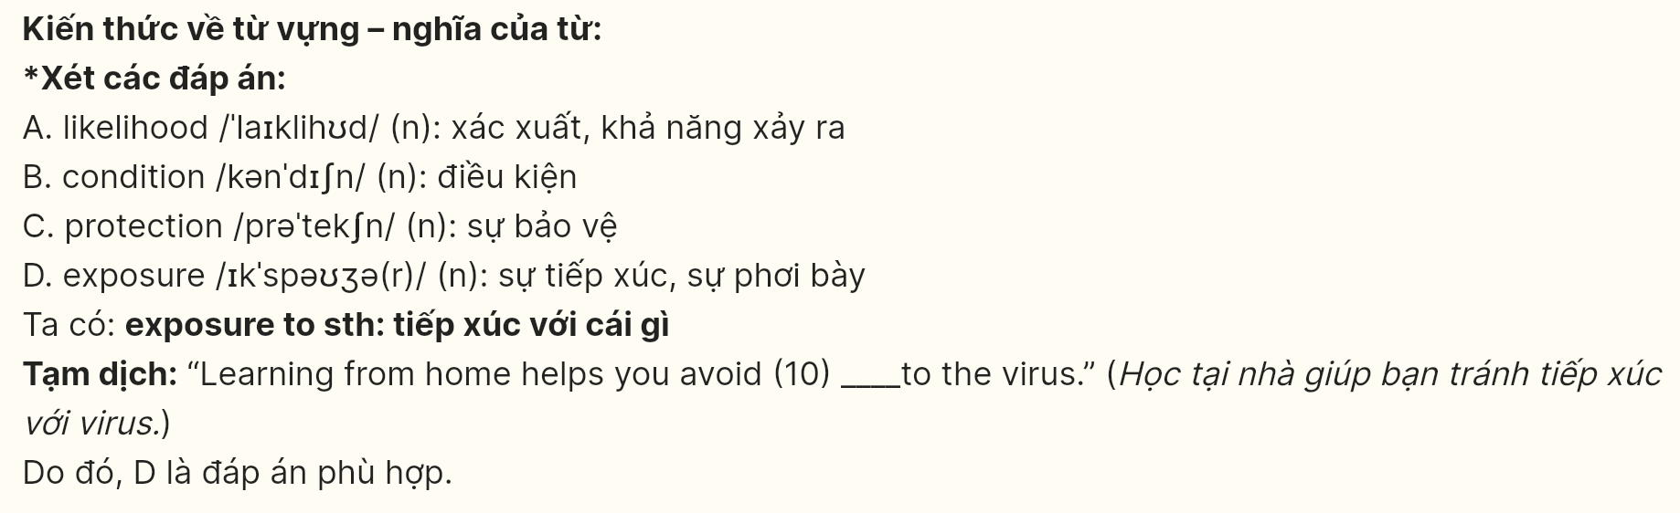
Question 11 [696934]: A. preventive B. alternative C. interactive D. impressive
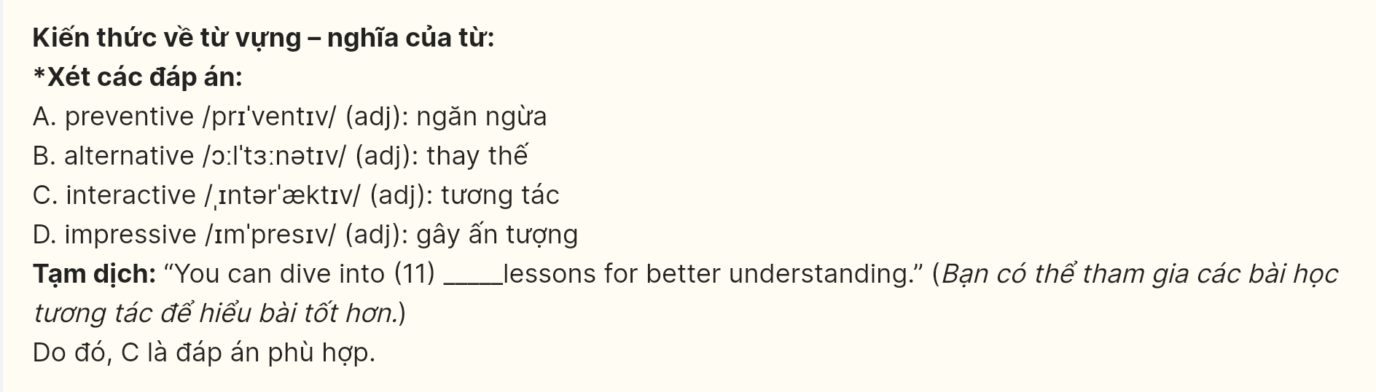
Question 12 [696935]: A. Therefore B. Furthermore C. Nevertheless D. In contrast
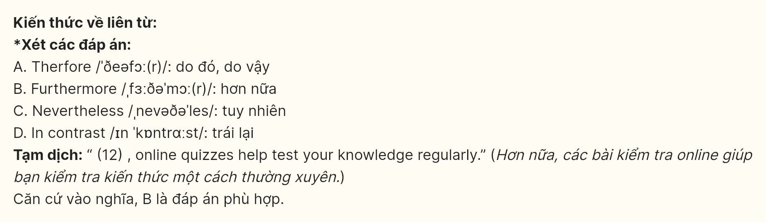
Mark the letter A, B, C or D on your answer sheet to indicate the best arrangement of utterances or sentences to make a meaningful exchange or text in each of the following questions from 13 to 17.
Question 13 [696936]:
a. Emma: Oh, hey David! I’m searching for a good mystery novel.
b. David: Hi, Emma! I didn’t expect to see you here. What are you looking for?
c. David: You should try the latest one by John Grisham. It’s a real page-turner!
A. c-a-b B. a-b-c C. b-a-c D. a-c-b
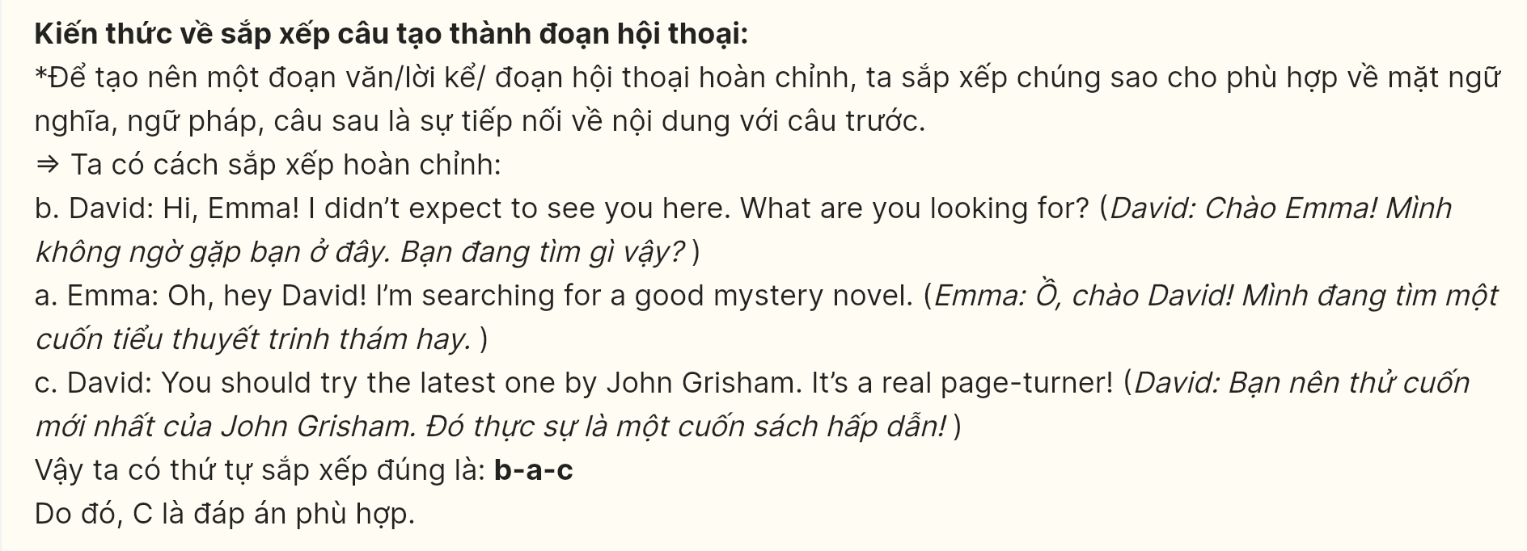
Question 14 [696937]:
a. Lucas: Why photography?
b. Isabella: It allows me to capture beautiful moments and be creative.
c. Lucas: What new skill are you planning to learn this year?
d. Lucas: The equipment can be quite expensive. Are you ready for that investment?
e. Isabella: I’m going to start learning photography.
A. c-e-a-b-d B. c-b-d-e-a C. d-b-a-e-c D. d-e-a-b-c
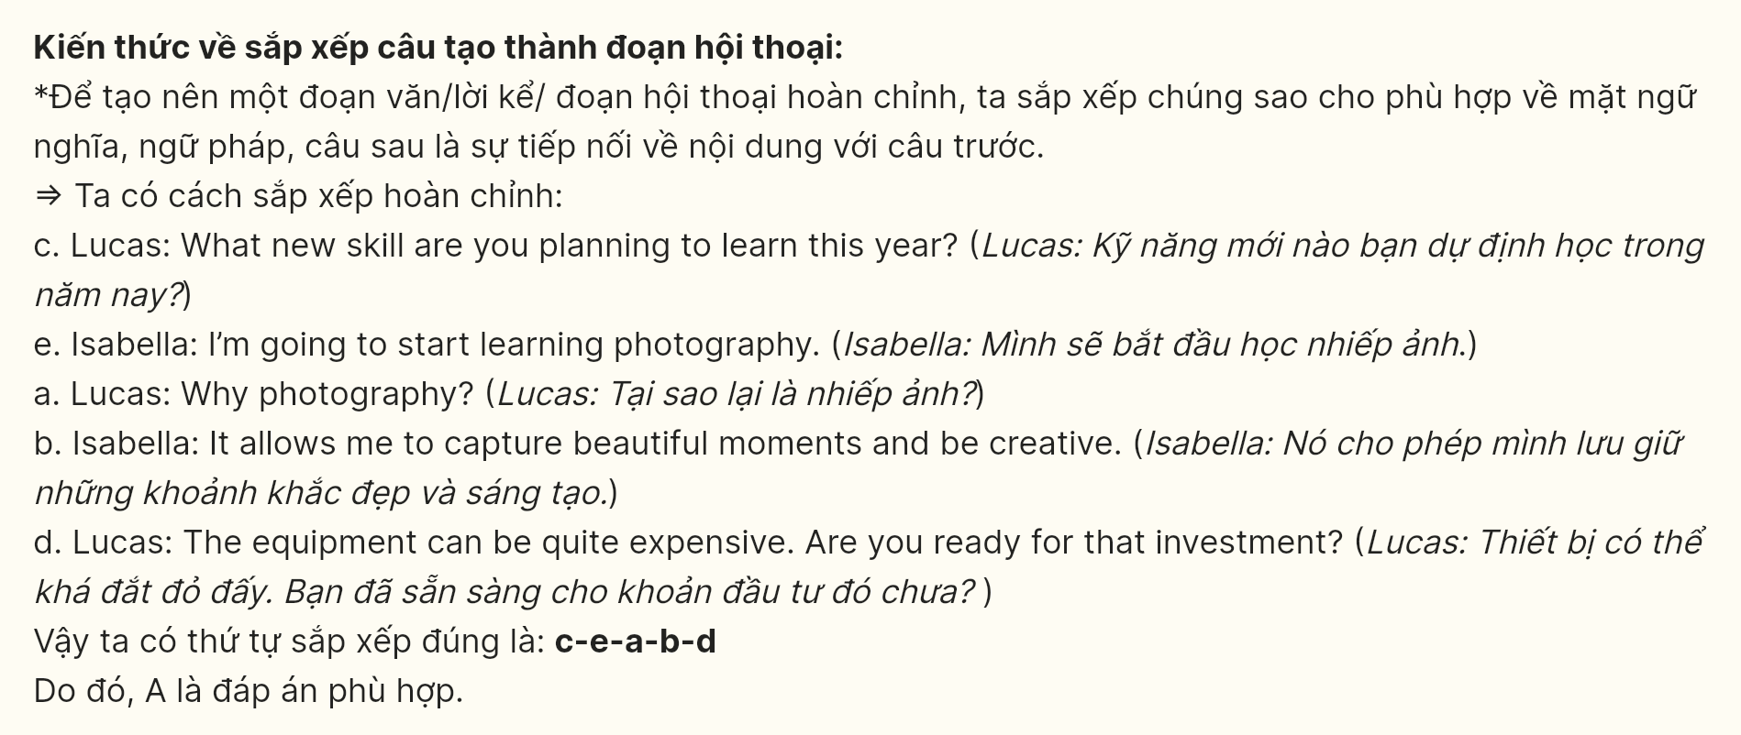
Question 15 [696938]:
Hello Sam,
a. I’ve got so many stories and memories to share with you from this trip.
b. The café you recommended had such a wonderful atmosphere, and the pastries were absolutely delicious.
c. I explored some hidden spots in the city, captured tons of photos, and had a great time wandering through the quaint streets.
d. Thanks so much for your travel tips for Paris.
e. Let’s meet up soon so I can show you all the photos and hear about your latest adventures.
See you soon, Max.
- e-a-c-b-d B. b-a-e-d-c C. c-d-e-c-a D. d-b-c-a-e
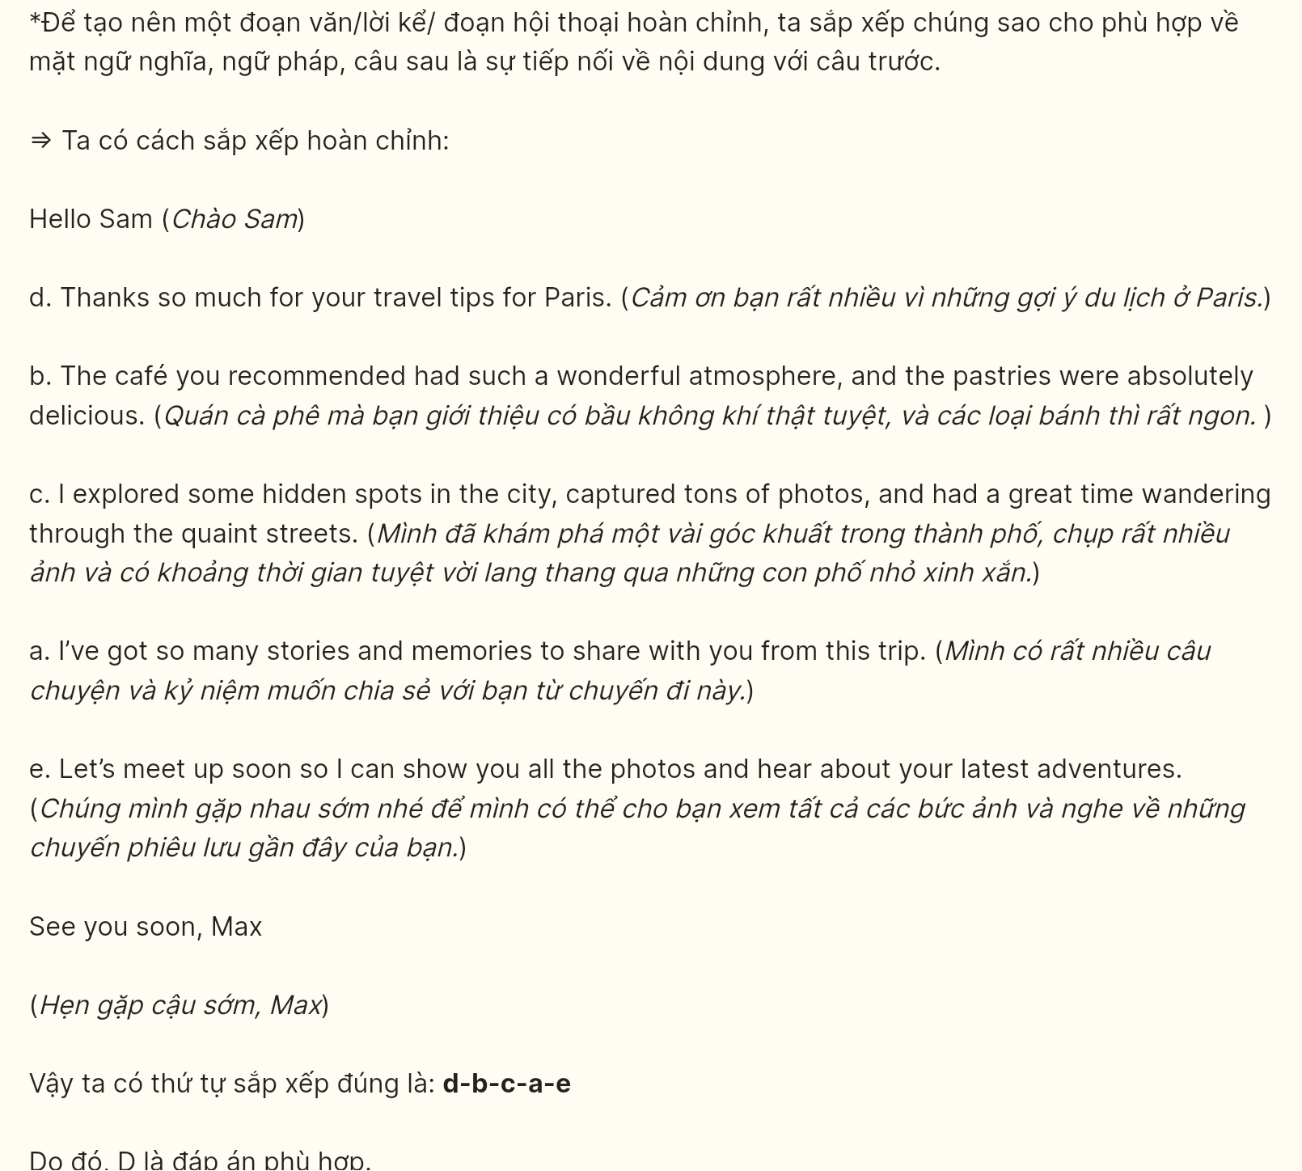
Question 16 [696939]:
a. Running a small business requires long hours and constant dedication, but seeing the positive feedback from customers makes it all worthwhile.
b. Launching my own online bakery was a dream I had for years, and in 2024, I finally took the leap.
c. There have been tough days, especially during peak seasons, but I’ve learned to handle stress and adapt quickly.
d. In the end, building something from scratch and watching it grow has been one of the most satisfying experiences of my life.
e. From designing the website to experimenting with unique recipes, I’ve put my heart and soul into every aspect of the business.
A. a-c-e-b-d B. b-e-a-c-d C. e-c-b-a-d D. c-e-b-a-d
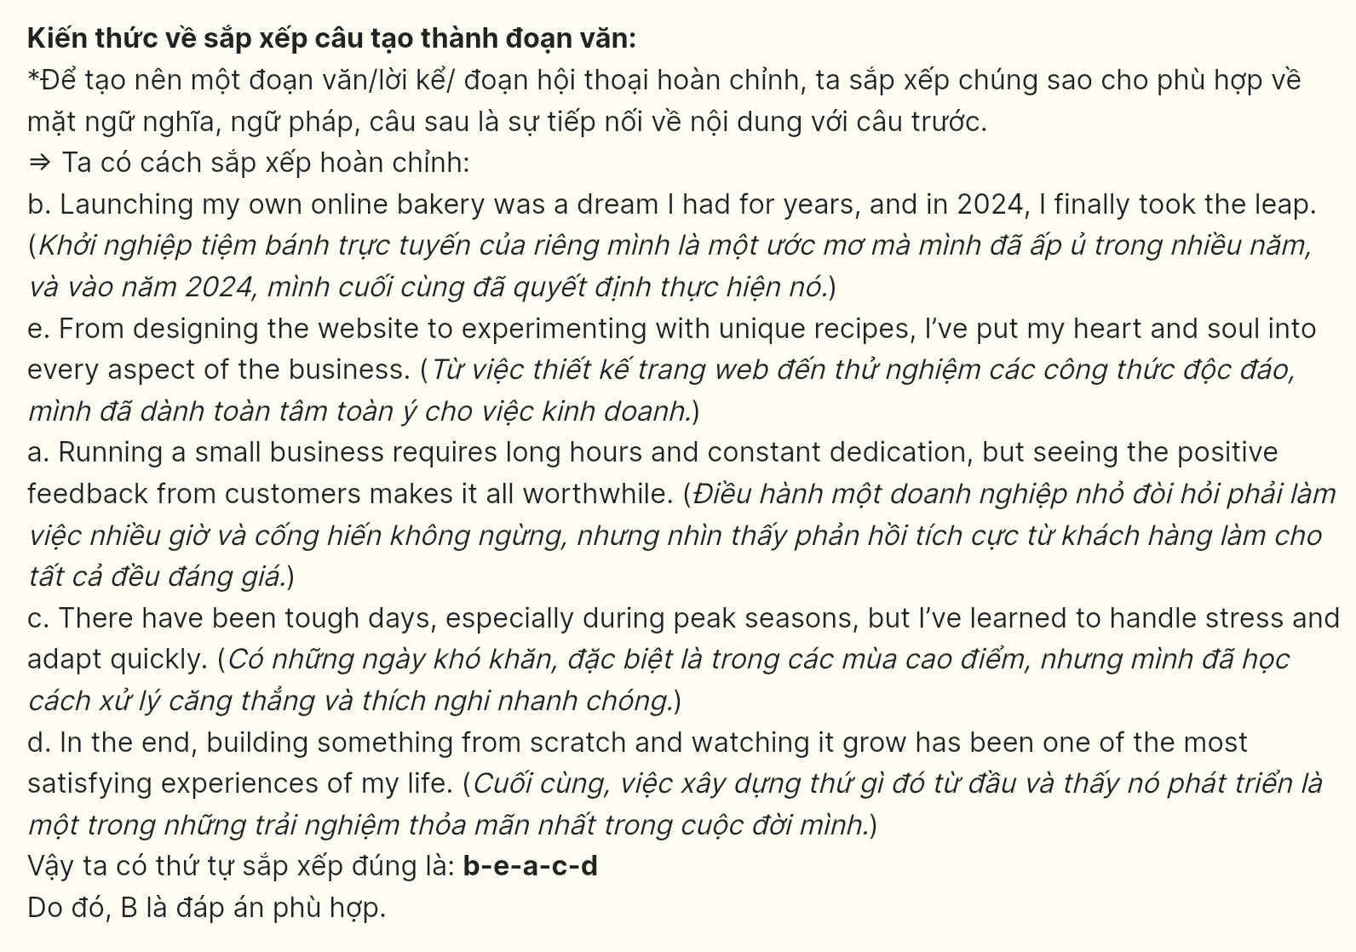
Question 17 [696940]:
a. City dwellers have started growing their own vegetables and herbs on balconies, rooftops, and community gardens.
b. As more people participate, local food networks have strengthened, reducing the reliance on imported goods.
c. Urban gardening has seen a significant rise in popularity in recent years.
d. This trend not only provides access to fresh produce but also promotes a greener urban environment.
e. However, the high cost of materials and supplies can be a barrier for some gardeners.
- C-a-d-b-e B. c-b-e-d-a C. c-e-d-a-b D. c-d-e-a-b
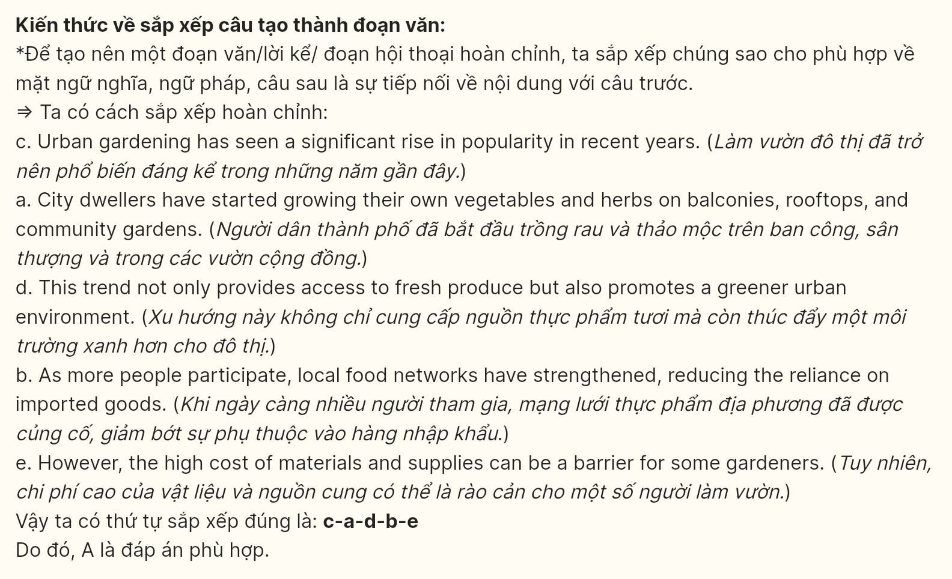
Read the following passage and mark the letter A, B, C or D on your answer sheet to indicate the option that best fits each of the numbered blanks from 18 to 22.
The World Health Organization, which is a specialized agency of the United Nations, (18) ____. It focuses on improving access to healthcare, especially in underdeveloped regions, ensuring that no one is left behind. Through its global health initiatives, the WHO has helped reduce the spread of diseases like tuberculosis and HIV. Additionally, it plays a key role in coordinating international responses to health emergencies, such as epidemics and pandemics.
WHO is responsible for coordinating international health efforts and providing support to countries in need. It works with governments and organizations to develop policies and strategies aimed at improving public health. WHO has a network of experts (19) ____. The organization also assists in the training of healthcare professionals globally, ensuring that health systems are equipped to respond to emerging threats.
One of WHO’s key roles is to provide emergency response during health crises. (20) ____. In addition, WHO monitors global health trends to predict and prevent future outbreaks. The organization also collaborates with governments and health experts to develop early warning systems and response strategies.
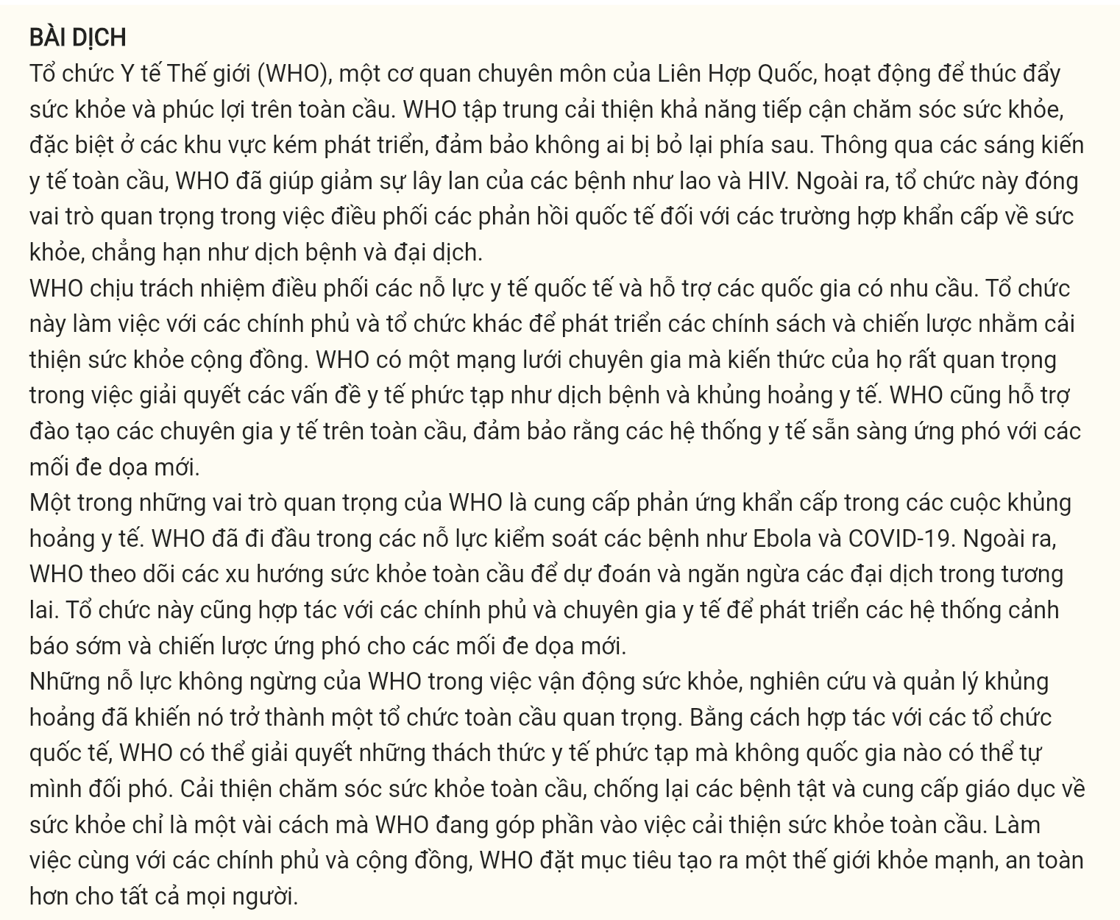
Question 18 [696941]:
A. that works to promote health and well-being across the globe
B. in which health and well-being across the globe are promoted
C. working to promote health and well-being across the globe
D. works to promote health and well-being across the globe
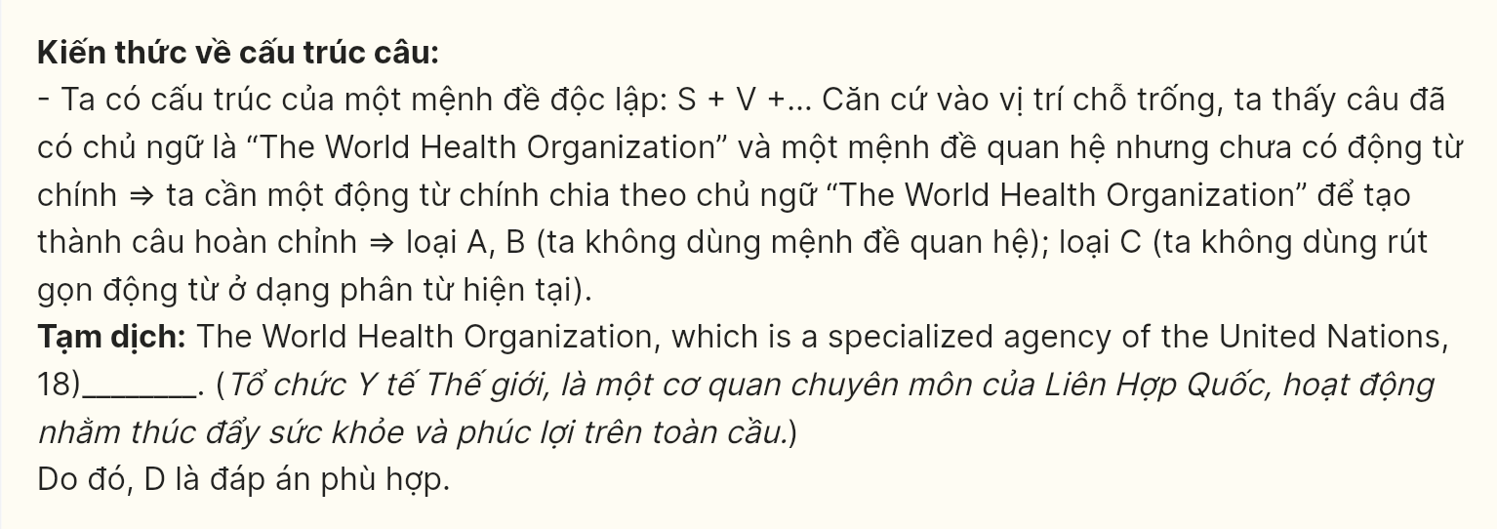
Question 19 [696942]:
A. whose knowledge is crucial in dealing with complex health issues such as epidemics and health crises
B. specialize in dealing with complex health issues such as epidemics and health crises
C. work on finding solutions to complex health issues such as epidemics and health crises
D. of which the knowledge in dealing with complex health issues such as epidemics and health crises
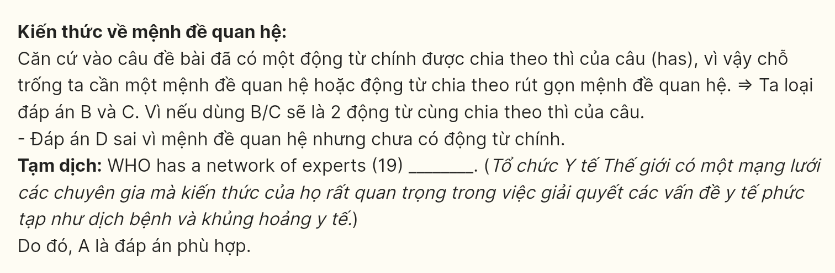
Question 20 [696943]:
A. It has been at the forefront of efforts to control diseases such as Ebola and COVID-19
B. Controlling diseases such as Ebola and COVID-19, people appreciate its enormous efforts
C. Efforts to control diseases such as Ebola and COVID-19 lead to the foundation of the organization
D. Experts working for the organization have helped to control diseases such as Ebola and COVID-19
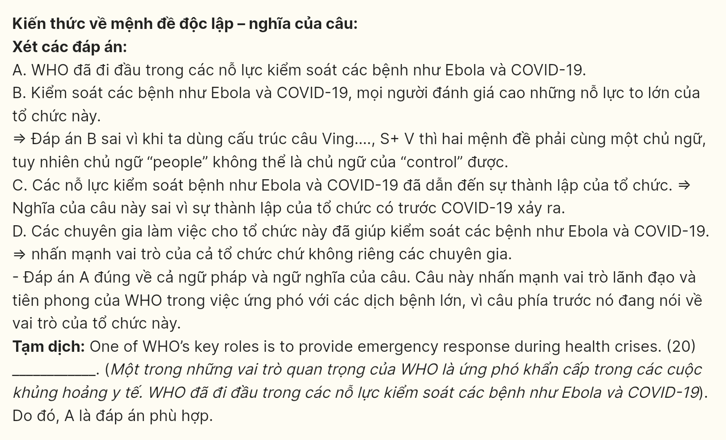
Question 21 [696944]:
A. Addressing complex health challenges that no single nation can tackle alone, international organizations are collaborating with the WHO
B. To address complex health challenges that no single nation can tackle alone, it competes with international organizations
C. By collaborating with international organizations, it can address complex health challenges that no single nation can tackle alone
D. Apart from collaborating with international organizations, it can solve complex health challenges that no single nation can tackle alone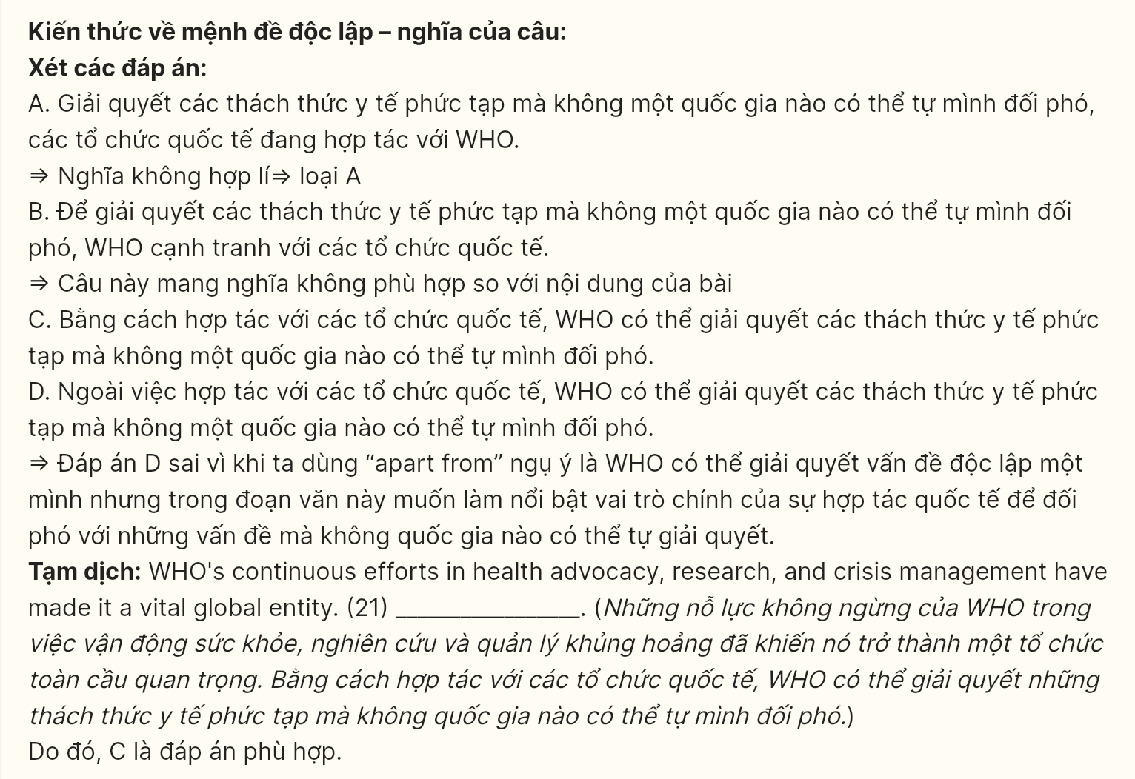
Question 22 [696945]:
A. Everyone can live in a healthier and safer world
B. WHO aims to create a healthier, safer world for everyone
C. Its citizens can enjoy a healthier and safer world
D. Researchers can provide residents with a healthier and safer world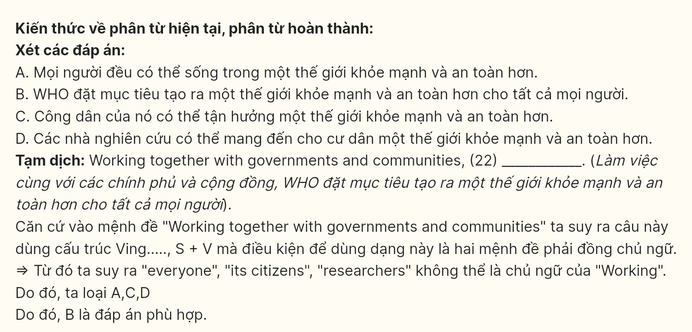
Read the following passage and mark the letter A, B, C, or D on your answer sheet to indicate the best answer to each of the following questions from 23 to 30.
In the digital age, the role of newspapers has evolved significantly. Traditionally, newspapers were the primary source of information, providing news, opinion pieces, and advertisements to a wide audience. However, with the rise of the internet and social media, the newspaper industry has had to adapt to new technologies and changing consumer habits. Many people now turn to online platforms for instant access to news, which has led to a decline in print subscriptions.
Despite the challenges posed by digital media, newspapers continue to play a crucial role in society. They provide in-depth analysis, investigative journalism, and local coverage that is often not available through digital-only platforms. Print newspapers still hold significant credibility among many readers, especially older generations who value the physical format. They are also important in reaching audiences in areas with limited internet access, ensuring that all communities stay informed.
Moreover, newspapers have adapted by embracing digital platforms to reach a broader audience. Many major newspapers now have online versions, offering news articles, multimedia content, and interactive features. This shift has allowed newspapers to maintain their relevance and remain competitive in the digital landscape. The move to digital has also led to the rise of subscription-based models, where readers pay for premium content, creating new revenue streams for traditional media outlets.
However, the digital transformation has not been without its challenges. Newspapers face increasing competition from social media platforms, blogs, and online news outlets, which often provide quicker updates and attract younger audiences. Additionally, the rise of fake news and misinformation on digital platforms has made it more difficult for traditional newspapers to maintain their position as trusted sources of information. Despite these challenges, newspapers continue to play a vital role in providing accurate and reliable news in an ever-changing media landscape.
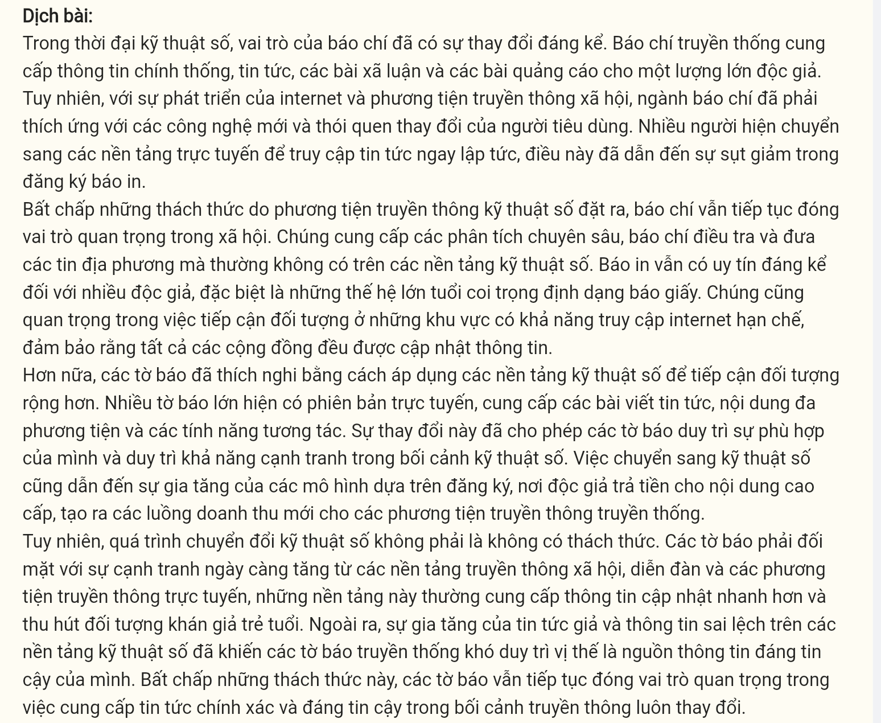
Question 23 [696946]: Which of the following is NOT mentioned as a traditional role of newspapers?
A. Providing news B. Providing opinion pieces
C. Providing advertisements D. Providing real-time news updates
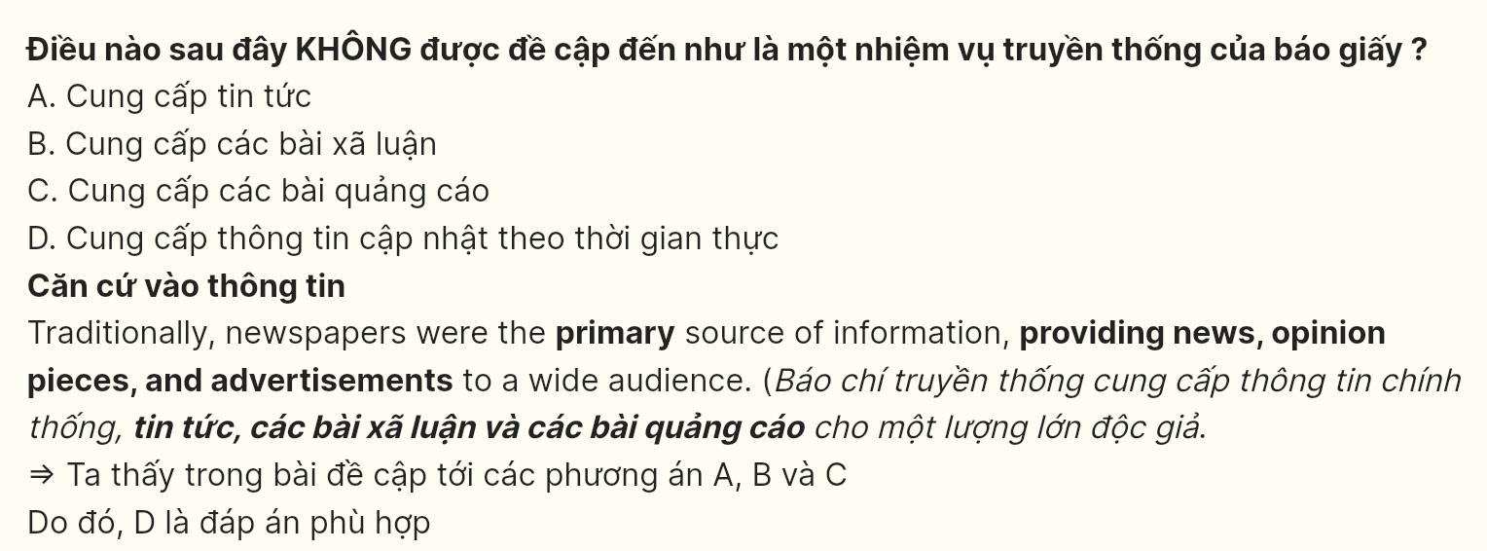

Question 24 [696947]: The word instant in paragraph 1 is OPPOSITE in meaning to ______
A. immediate B. constant C. sudden D. gradual
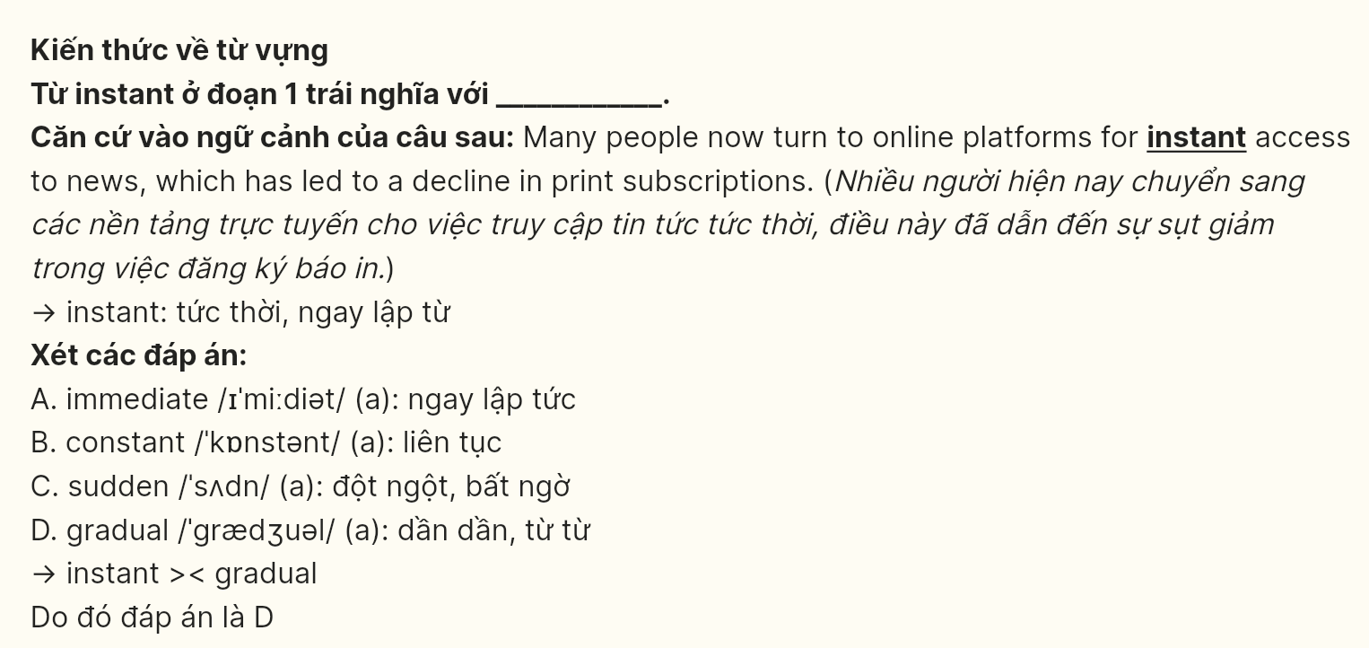
Question 25 [696948]: The word They in paragraph 2 refers to ______
A. Print newspapers B. Readers C. Older generations D. Audiences
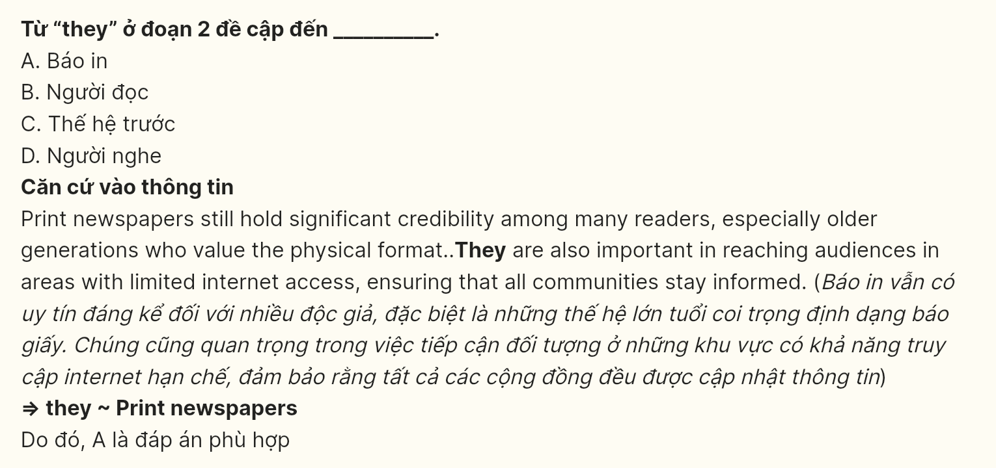
Question 26 [696949]: The word trusted in paragraph 4 could best be replaced by ______
A. dependent B. incredible C. reliable D. suspicious
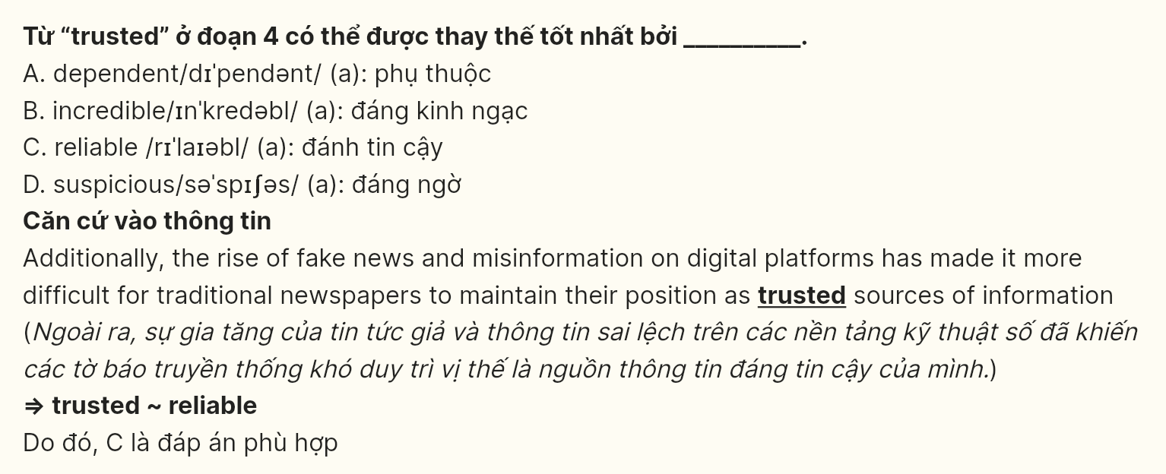
Question 27 [696950]: Which of the following best paraphrases the underlined sentence in paragraph 3?
A. Which of the following best paraphrases the underlined sentence in paragraph 3? (Lỗi sai từ file sách)
B. The shift has allowed newspapers to become less relevant and less competitive in the digital world.
C. This adjustment has helped newspapers assert their dominance and compete in the digital era.
D. This change has enabled newspapers to stay relevant and stay competitive in the digital age.
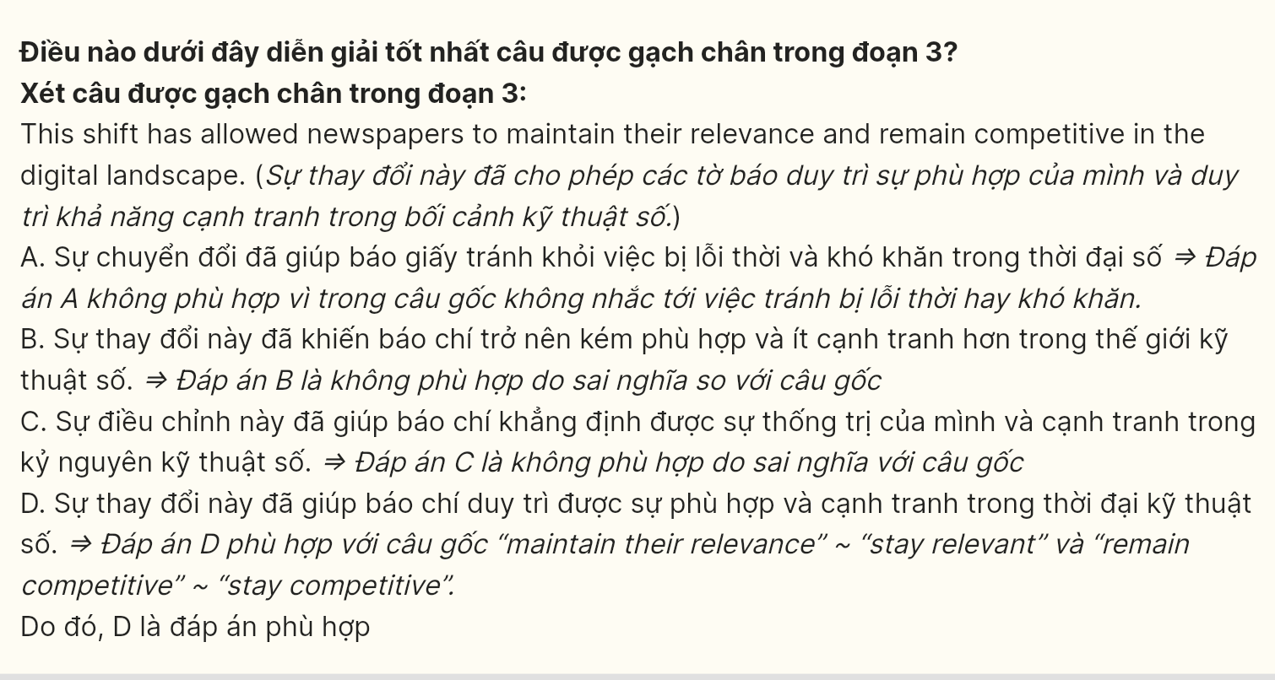
Question 28 [696951]: Which of the following is TRUE according to the passage?
A. Print newspapers are only used by older generations now.
B. The shift to digital platforms has created new revenue opportunities for newspapers.
C. The rise of digital media has completely replaced the role of print newspapers.
D. Fake news and misinformation are not issues for traditional newspapers.
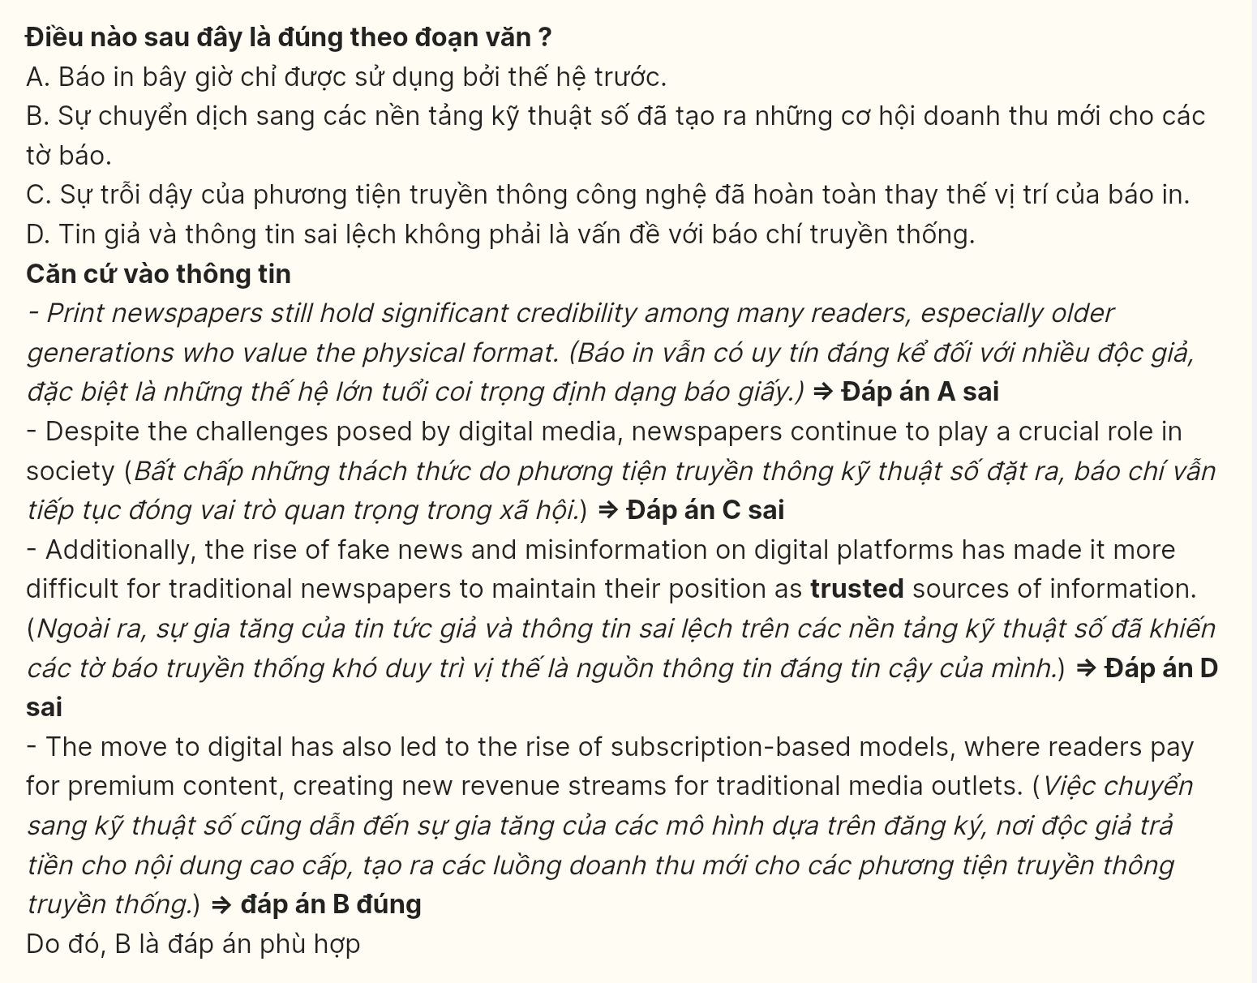
Question 29 [696952]: In which paragraph does the writer mention a causal relationship in which one factor has led to a decrease in another?
A. Paragraph 1 B. Paragraph 2 C. Paragraph 3 D. Paragraph 4
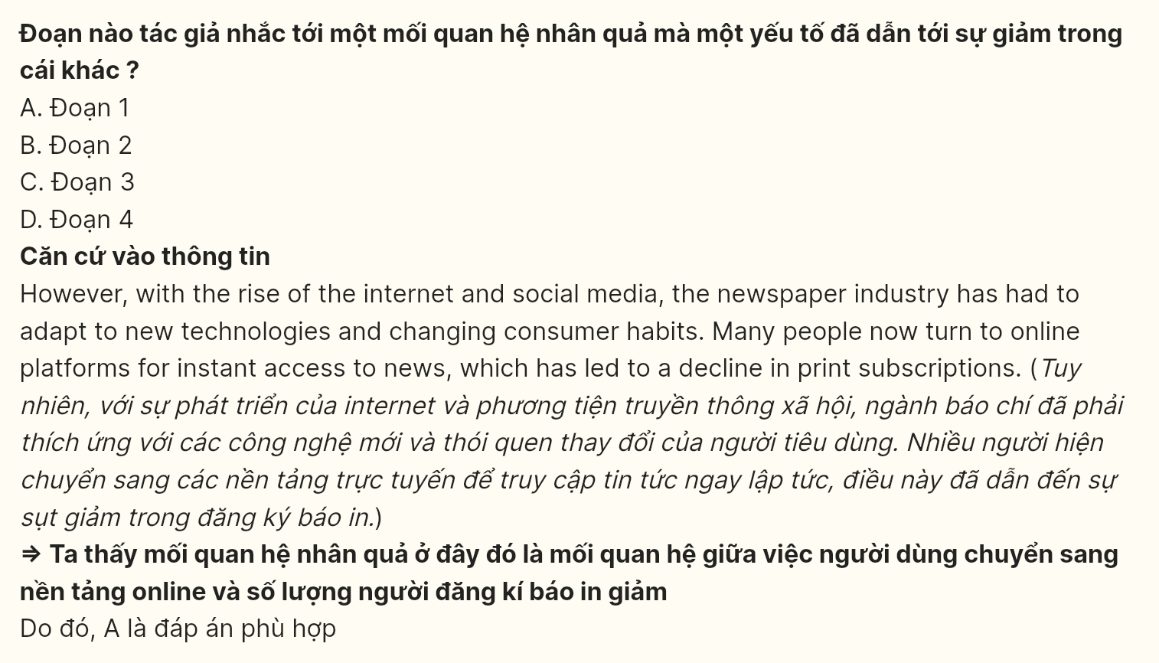
Question 30 [696953]: In which paragraph does the writer discuss the challenges newspapers face in maintaining their credibility in a changing media environment?
A. Paragraph 1 B. Paragraph 2 C. Paragraph 3 D. Paragraph 4
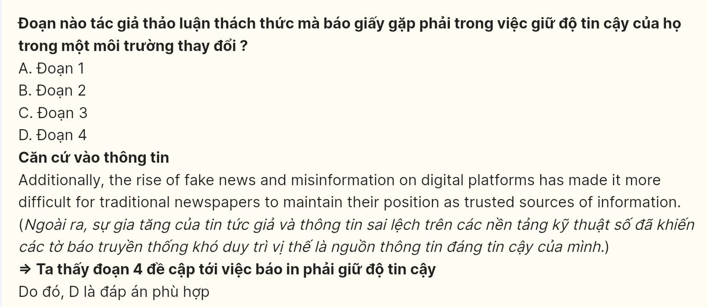
Read the following passage and mark the letter A, B, C or D on your answer sheet to indicate the best answer to each of the following questions from 31 to 40.
[I] The generation gap refers to the differences in attitudes, values, and beliefs between older and younger generations. [II] With rapid advancements in technology and shifting societal norms, the generation gap has become more apparent. [III] As younger generations grow up with modern technology and global connectivity, they frequently experience a world vastly different from that of their parents and grandparents. [IV]
One of the key reasons behind the generation gap is the rapid pace of technological change. Older generations, who grew up in a world without the internet, smartphones, or social media, often find it difficult to relate to the digital lifestyles of younger people. On the other hand, younger generations have been exposed to technology from a young age, shaping their values and communication styles. Additionally, differences in social values, such as views on work, family, and personal freedom, also contribute to the gap. These differing experiences create misunderstandings and a lack of common ground between generations.
The consequences of the generation gap can be significant, especially in family dynamics and workplaces. In families, the divide can lead to conflicts between parents and children, as each generation struggles to understand the other's worldview. In the workplace, generational differences may affect teamwork, communication, and productivity.
Younger employees may prioritize flexibility and innovation, while older generations may value stability and traditional work ethics. These differences can lead to friction, decreased collaboration, and a sense of alienation among coworkers.
To bridge the generation gap, open communication and mutual understanding are essential. Both older and younger generations need to be open to learning from each other and appreciating different perspectives. For instance, older generations can offer wisdom and experience, while younger generations can share their knowledge of technology and new trends. Encouraging intergenerational dialogue through family discussions, mentoring programs, or team-building activities in the workplace can help foster respect and collaboration. By recognizing and embracing their differences, both generations can work together to create a more harmonious society.
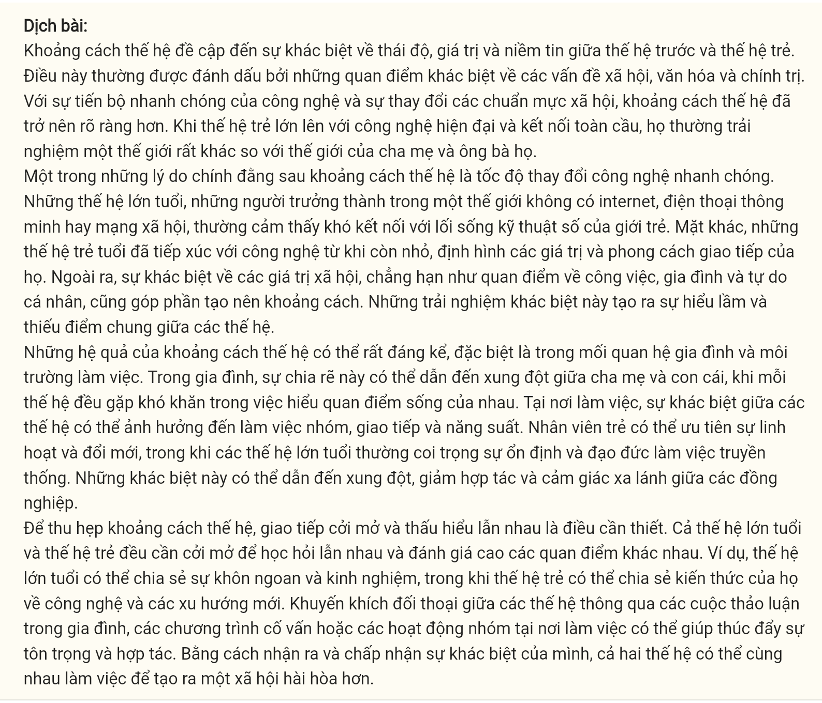
Question 31 [696954]: Where in paragraph 1 does the following sentence best fit?
It is often marked by distinct perspectives on social, cultural, and political issues.
A. [I] B. [II] C. [III] D. [IV]
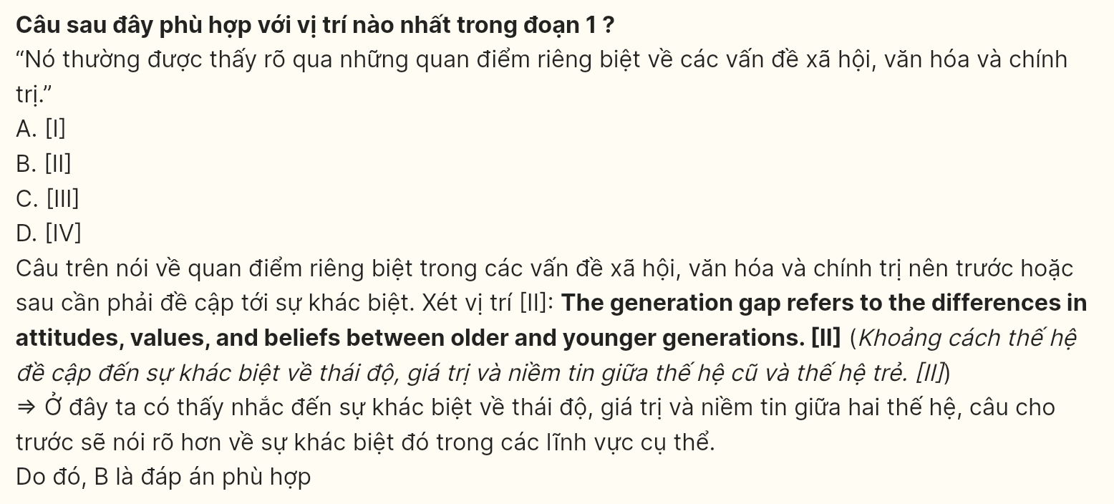
Question 32 [696955]: The word apparent in paragraph 1 could be best replaced by _______.
A. improbable B. questionable C. obvious D. uncertain
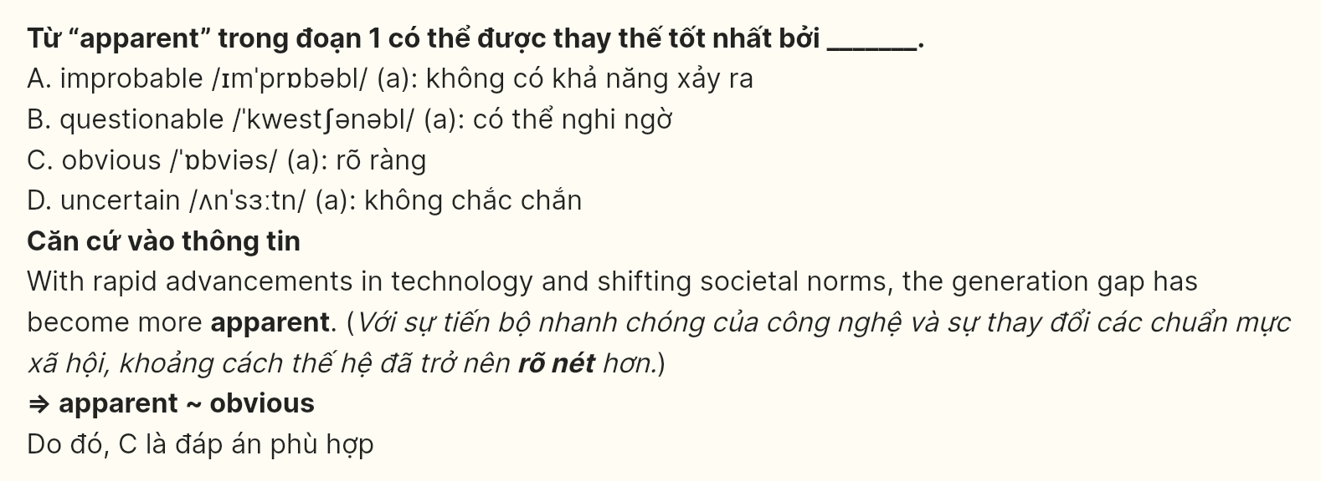
Question 33 [696956]: The word their in paragraph 2 refers to _______.
A. smartphones B. older generations C. communication styles D. younger generations
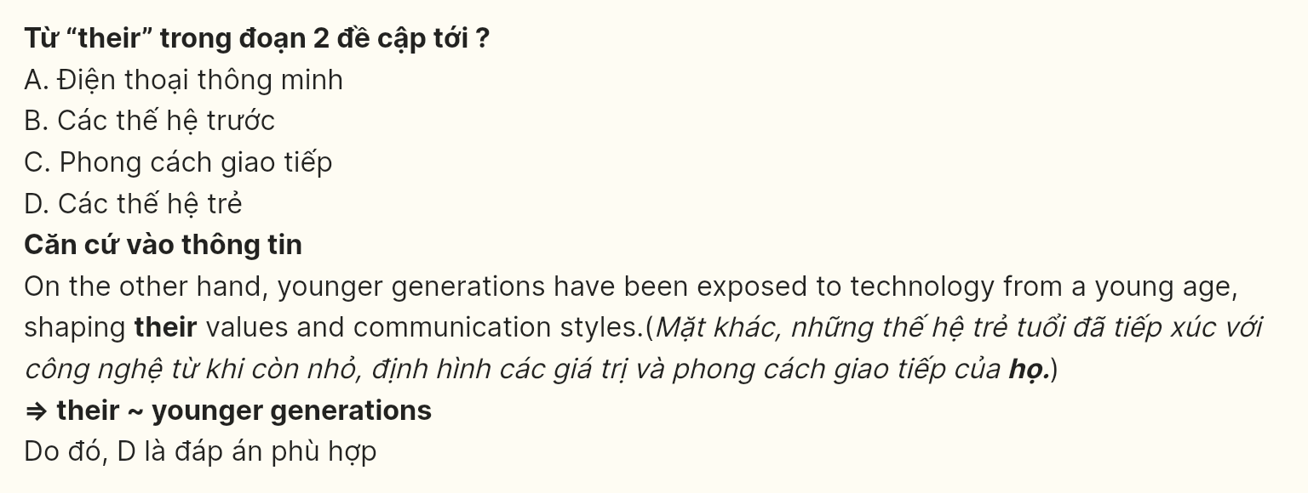
Question 34 [696957]: According to paragraph 2, which of the following is NOT mentioned as a cause of the generation gap?
A. The rapid pace of technological change
B. Differences in social values regarding work and family
C. Younger generations’ exposure to new technologies
D. The influence of teachers and peers at school
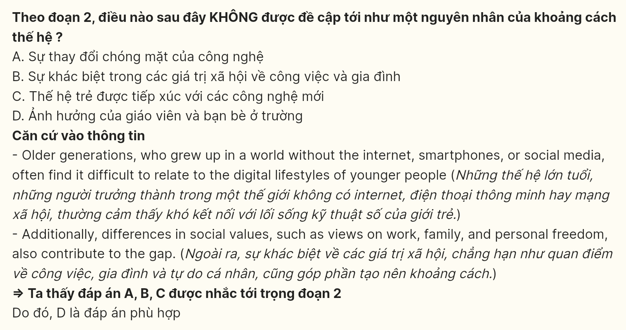
Question 35 [696958]: Which of the following best summarizes paragraph 3?
A. The generation gap affects families and workplaces, leading to misunderstandings and conflicts.
B. Younger generations prioritize work flexibility, while older generations favor traditional values.
C. Most families suffer from misunderstandings due to different generational views.
D. Workplace communication improves when employees embrace new technologies and ideas.
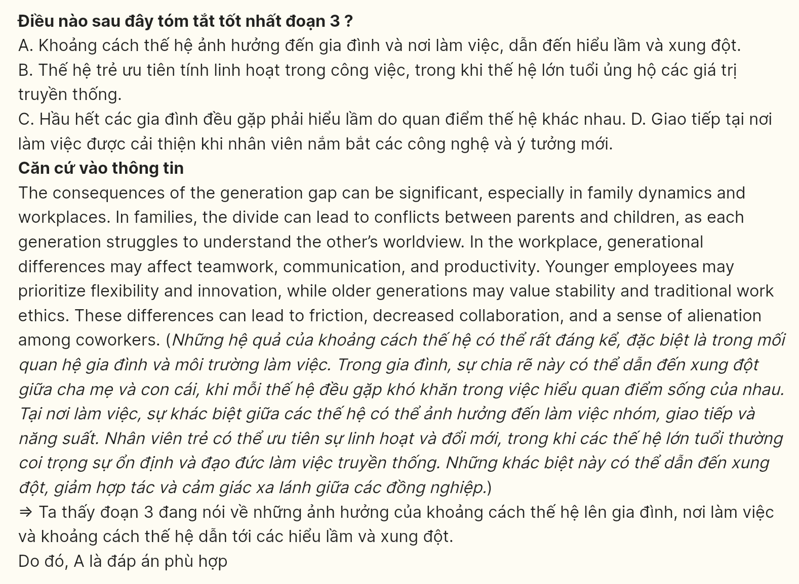
Question 36 [696959]: The word prioritize in paragraph 3 is OPPOSITE in meaning to _______.
A. emphasize B. regard C. overlook D. exaggerate
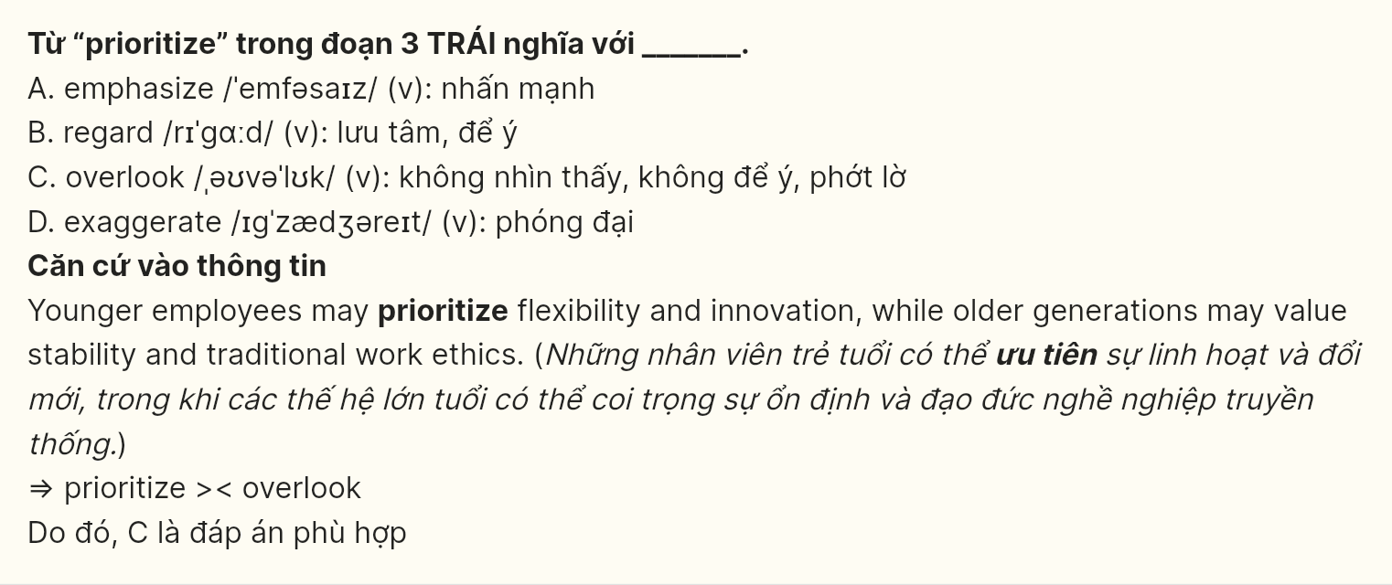
Question 37 [696960]: Which of the following is TRUE according to the passage?
A. Younger generations fully reject the values and perspectives of older generations.
B. The generation gap is mainly caused by differences in economic circumstances between generations.
C. The generation gap can be addressed by encouraging open communication and mutual respect.
D. Older generations are more open to flexible work environments than younger generations.
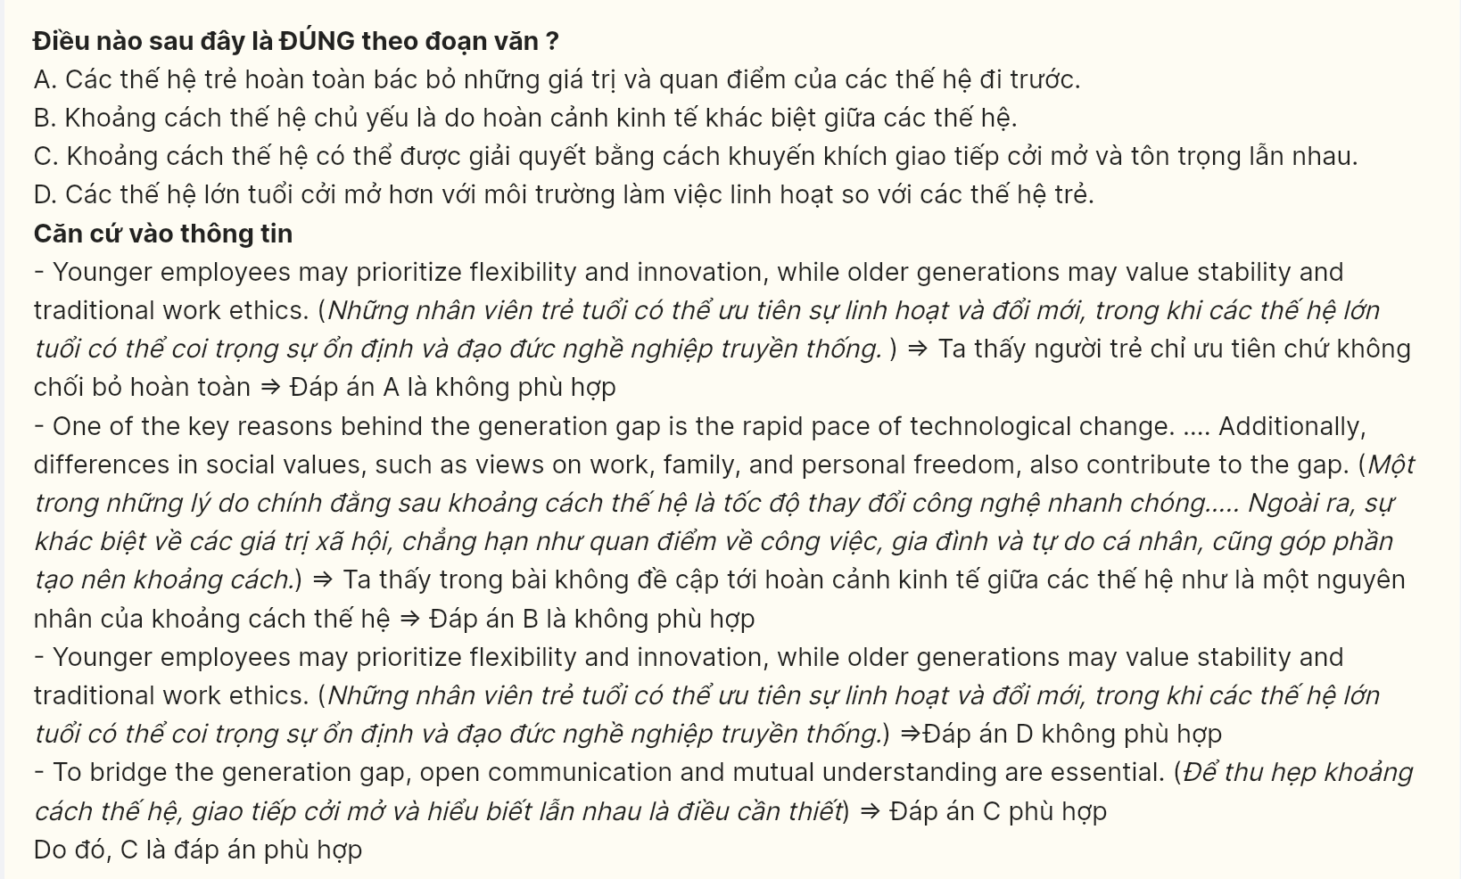
Question 38 [696961]: Which of the following best paraphrases the underlined sentence in paragraph 4?
A. By recognizing and respecting their differences, both generations can work separately to build a stronger society.
B. By acknowledging and accepting their differences, both generations can collaborate to build a more harmonious society.
C. By embracing their similarities and overlooking their differences, both generations can unite for a common cause.
D. By accepting their differences and working together, both generations can create a more peaceful community.
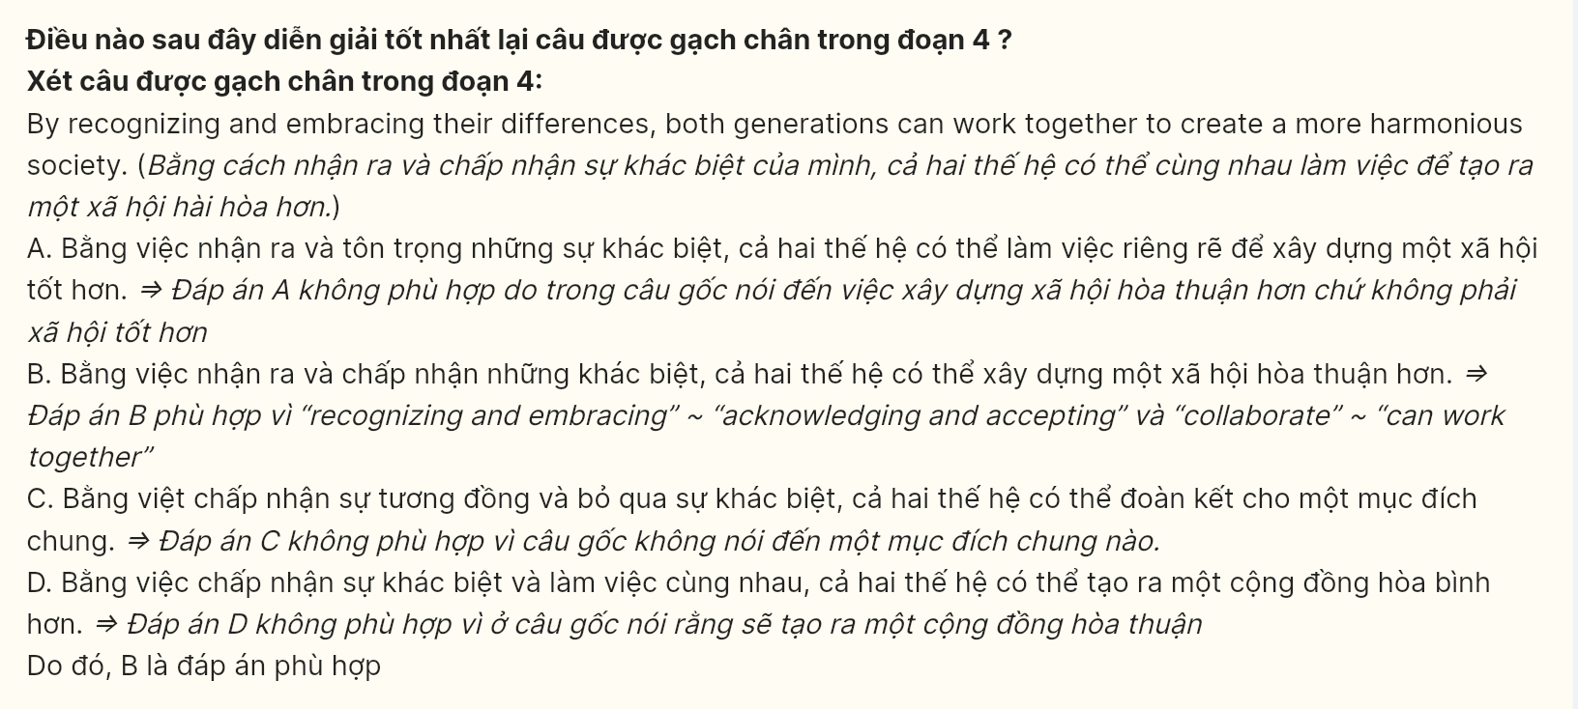
Question 39 [696962]: Which of the following can be inferred from the passage?
A. Younger generations are more likely to maintain traditional values compared to older generations.
B. Technology has had no significant impact on how younger and older generations interact.
C. The differences in values between generations are likely to continue growing as technology advances.
D. Older generations are more likely to embrace global connectivity than younger generations.
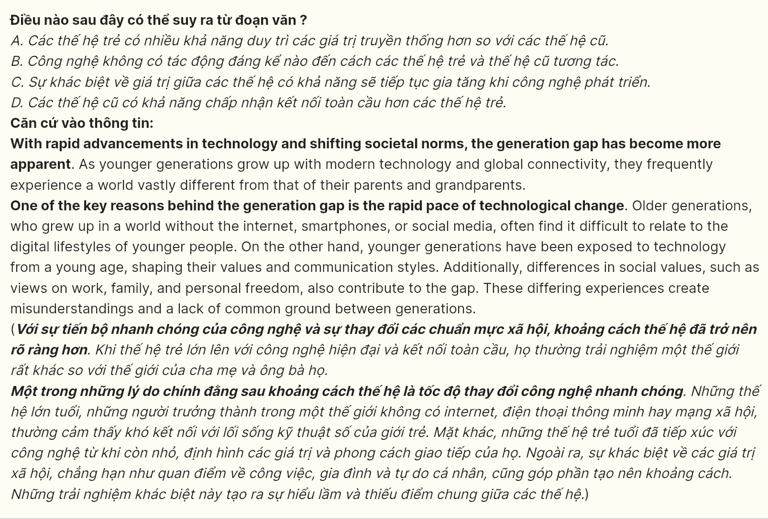
Question 40 [696963]: Which of the following best summarizes the passage?
A. The generation gap is mainly caused by technological advancements, which have changed communication styles, and older generations must learn to adapt to these new ways of connecting.
B. The generation gap arises from differences in values, experiences, and technology use, often causing misunderstandings and bridging this gap requires open communication and mutual respect.
C. The generation gap is a complex issue influenced by social, cultural, and technological changes, but it can be resolved by improving understanding between generations.
D. The generation gap is primarily seen in the workplace, where younger generations seek innovation and flexibility while older generations value tradition and stability, leading to conflict.
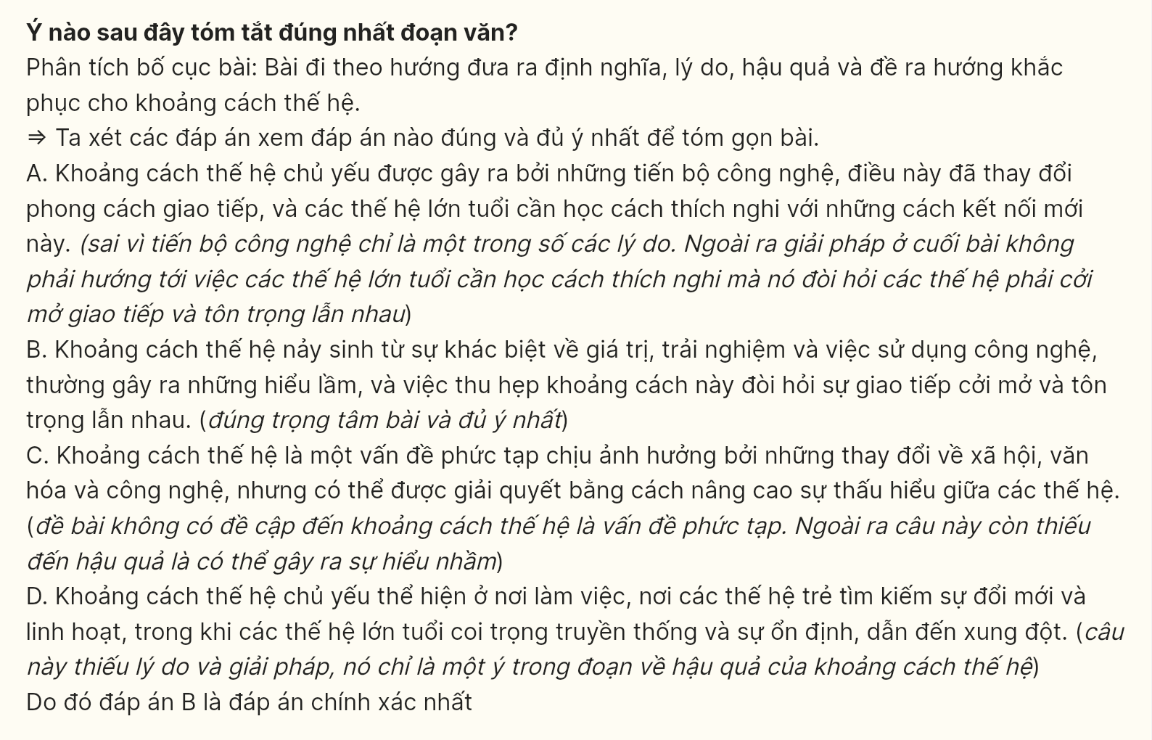
----- THE END -----

