Mã đề 9.1.41
ĐỀ KIỂM TRA CUỐI KỲ I NĂM HỌC: 2021-2022
MÔN: TIẾNG ANH LỚP 9
Thời gian làm bài: 60 phút
SECTION A: LISTENING (2 point)
Task1: Listen to the dialogues and choose the best answer (1 point)
1.Where does her brother work? ( nhận biết)  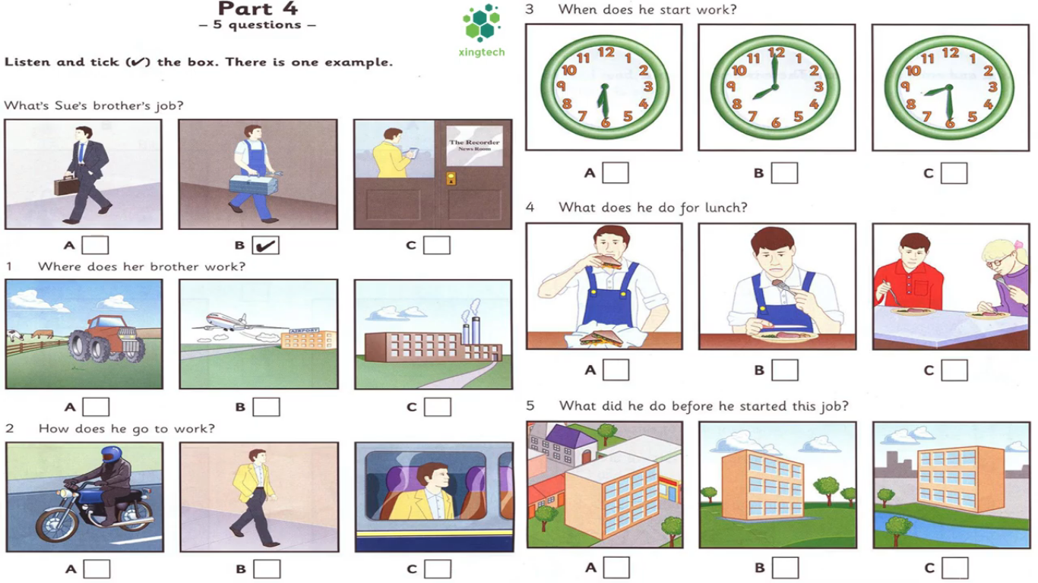 | 2.How often does he go to work? ( nhận biết)
3.When does he start work? ( nhận biết) | 4.What does he do for lunch? ( Thông hiểu)
5.What did he do before he started this job?
( Thông hiểu)

Task 2: Listen to a conversation and decide if the statements are true (T) or false (F). (1 point)
1. Sarah is a teacher. …………………….. …………………….. ( Thông hiểu)
2. She usually arrives at work at nine o ’clock. …………………… ( Nhận biết)
3. Sarah always have lunch at school. …………………….. ( Thông hiểu)
4. She often has work to do in the evening. …………………….. ( Nhận biết)
5. She will saty at home this weekend. ……………………..… ( Nhận biết)
SECTION B: LANGUAGE (2 POINTS)
I. Choose the best option (A, B, C or D) to complete these sentences. (2 point)
1. She turned _________ the new job in New York because she didn't want to leave her hometown. ( TV) (THÔNG HIỂU)
A. on B. down C. off D. up
2. Minh wondered how............. social skills (NP) NHẬN BIẾT
A. to develop B. developing C. develop D. develops
3. People in the past used to ……………. on the farm (NP) NHẬN BIẾT
A. work B. made C. worked D. making
4. We wish we ...............visiting Ha Long Bay now ? (NP)(THÔNG HIỂU)
A. are B. were C. will be D. would
5. It is ............that Ha Long Bay is one of the most unique wonders in the world. (NP) THÔNG HIỂU
A. say B. said C. talked D. think
6. They suggested ................traditional games after school (NP) (NHẬN BIẾT)
A. plays B. playing C. have D. to have
7. Before going to bed, I ...................... a movie about Ho Chi Minh President (NP) (NHẬN BIẾT)
A. see B. saw C. had seen D. seen
8. It is interesting .............by flyover (NP) (NHẬN BIẾT)
A. to travel B. going C. to walk D. moved
9. Extended family has more than two.............. living together. (TV)(THÔNG HIỂU)
A. people B. generations C. family D. adults
10. Recognising and controlling your feelings are .................. skills (TV)(THÔNG HIỂU
A. emotion control B. self – care C. cognitive D. housekeeping
SECTION 3: READING (2 POINTS)
I. Read the passage and then choose the correct answer to each question. (1 point)
If you love and want to learn about the ....(1)..... of the dynasties, The Complex of Hue Monuments is a place not to be missed. Hue Monuments .......(2).... along the banks of the Huong River in Hue city and some neighboring areas. This is the capital, .....(3).....the reign of 9 kings of the Nguyen dynasty from 1802 to 1945 were . That is why Hue Monuments is bold in culture and history.With ancient architecture, Hue Monuments has an ancient and solemn look. But ..(4)...... its location next to the Huong River, Hue Monuments is also poetic and rustic.With that beauty, in 1993, UNESCO recognized The Complex of Hue Monuments as a world cultural heritage, affirming the global value of Hue Monuments.Hue Imperial City has a beauty that is both solemn and poetic. It is a suitable place for people ...(5).... about an old culture while enjoying the beauty of ancient architecture
- A.culture B. cultural C. historic D. traditional (NHẬN BIẾT)
- A. build B. was built C. is built D. built THÔNG HIỂU)
- A. what B. where C. who D. which(NHẬN BIẾT)
- A. because B. because of C. so D. although THÔNG HIỂU)
- A. learn B. learning C. to learn D. learns (NHẬN BIẾT)
II. Read the passage and choose the correct answer for each question (1 point)
The stress and pressure from school, family and friends has made depression increasingly common in teenagers. According to recent study, one in eight teenagers has had some experience with pressure. Depression's symptoms like anxiety, tiredness, and lack of focus can deeply affect teenagers' social life and academic performance. Medication and therapy are two methods typically used to combat depression. These methods are proven to be effective among many teenagers. However, without the support from parents and friends, depression cannot be easily treated. Even when teens manage to get over their condition, parents need to talk to their children and create an environment where their children can talk freely to them. These steps are necessary in order to prevent teenagers from falling into depression again.
1.What is the main idea of the passage (THÔNG HIỂU)
A. The stress and pressure from school
B. The methods typically used to combat depression
C. the support from parents and friends
D. The causes and methods used to combat depression
2. What are depression's symptoms? (NHẬN BIẾT)
A. Anxiety, tiredness, angry. B. Sadness, tiredness, lack of focus.
C. Anxiety, tiredness, lack of focus. D.Sadness, lack of focus
3. What are methods proven to be effective among many teenagers? (NHẬN BIẾT)
A. Medication and entertainment. B. Relaxation and therapy.
C. Medication. D.Medication and therapy
4. Which of the following word(s) is closest in meaning to the word “ support” in the passage? ( THÔNG HIỂU)
A. assistance B. kindness C. responsibility D. provide
5. Which sentence is not true according to the passage? (THÔNG HIỂU)
A. One in eight teenagers has had some experience with pressure
B. Parents should talk to their children and create an environment where their children can talk freely to them.
C. Medication and therapy are methods are proven to be effective among many teenagers
D. The stress and pressure from school hasn’t made depression increasingly common in teenagers
SECTION D: WRITING (2 POINTS)
I. Rewrite the following sentences as directed ( using the suggested words) so that the meanings stay the same. (1 pt)
1. People think that our environment will be more and more polluted. (VẬN DỤNG)
It is
2. They wondered “ What should we do to solve this problem” . (VẬN DỤNG)
They wonndered ..........................................................................................................
3.Improving life skills is very necessary for teenagers (VẬN DỤNG)
It is …………………………………………………………………………….
4. We don’t have enough time to visit your hometown. (VẬN DỤNG)
We wish .......................................................................................
5.My grandparents often went to school on foot. (VẬN DỤNG)
My grandparents...................................................................................
III. Write a passage describing a wonder of Vietnam based on the suggested questions. (1 pts)
- What is the name of the wonder? Where is it? (VẬN DỤNG)
- What is it famous for? (VẬN DỤNG CAO)
- What activities can we do there? (VẬN DỤNG CAO)
- How do you feel about that wonder? (VẬN DỤNG CAO)
- What should you do to introduce it to all people in the world? (VẬN DỤNG CAO)

KEY
SECTION A: LISTENING (2 point)
Task1: Listen to the dialogues and choose the best answer (0,2 x 5 =1 point)
1.C 2.A 3.B 4.A 5.C
Task 2: Listen to Mira talking about her neighborhood. Tick T (True) or F (False). You will listen twice (0,2 x 5 =1 point)
1. T 2. F 3. T 4. T 5. F
SECTION B: LANGUAGE (2 POINTS)
II. Choose the best option (A, B, C or D) to complete these sentences. (0,2x 10 =2 points)
1. B | 3. A | 5. B | 7. C | 9.B
2. A | 4. B | 6. B | 8.A | 10.A
SECTION 3: READING (2 POINTS)
I. Read the passage and then choose the correct answer to each question. (0,2 x 5 =1 point)
1. A 2. B 3. B 4. B 5. C
II. Read the passage and choose the correct answer for each question (0,2 x 5 =1 point)
1. D 2. C 3. D 4. A 5. D
SECTION D: WRITING (2 POINTS)
I. Rewrite the following sentences as directed ( using the suggested words) so that the meanings stay the same. (0,2 x 5= 1 pt)
1. People think that our environment will be more and more polluted.
It is thought that our environment will be more and more polluted.
2. They wondered “ What should we do to solve this problem” .
They wonndered what to do to solve that problem
3.Improving life skills is very necessary for teenagers
It is necessary for teenagers to improving life skills
4. We don’t have enough time to visit your hometown.
We wish we had enough time to visit your hometown
5.My grandparents often went to school on foot.
My grandparents used to go to school on foot.
II. Write a passage describing a wonder of Vietnam based on the suggested questions. (1 pts)
- What is the name of the wonder? Where is it? (0,2ps)
- What is it famous for? (0,2ps)
- What activities can we do there? (0,2ps)
- How do you feel about that wonder? (0,2ps)
- What should you do to introduce it to all people in the world? (0,2ps)
( - 0,1p/ each spelling mistake; No point/ each senence with wrong verb form)

