|  |  |
| --- | --- |
| **Mã đề 7.1.11**  **Họ và tên:**......................................  **Lớp:**........................................... | **ĐỀ KIỂM TRA ĐÁNH GIÁ CUỐI HỌC KỲ I**  **Năm học 2022 - 2023**  **Môn: TIẾNG ANH - Lớp 7**  (Thời gian làm bài 60 phút)  (Đề này gồm có 40 câu, 06 trang) |

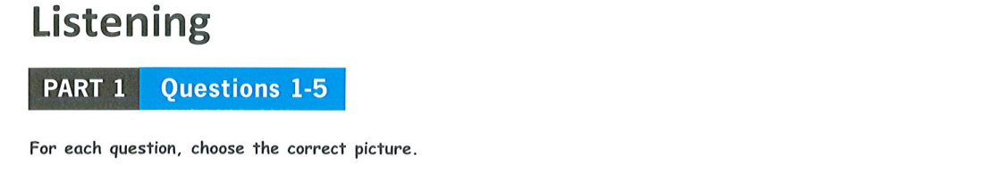

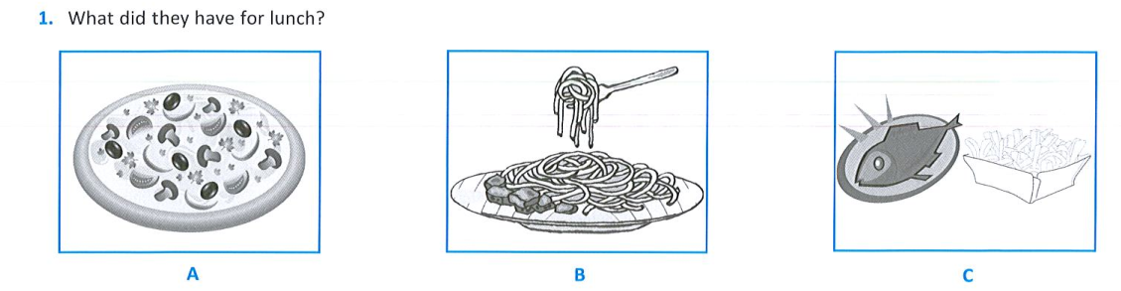

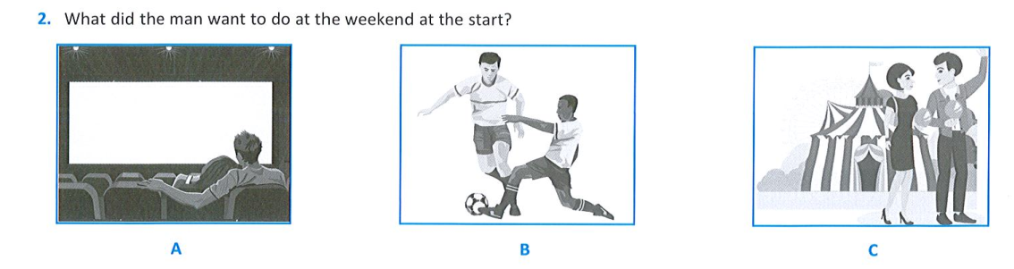

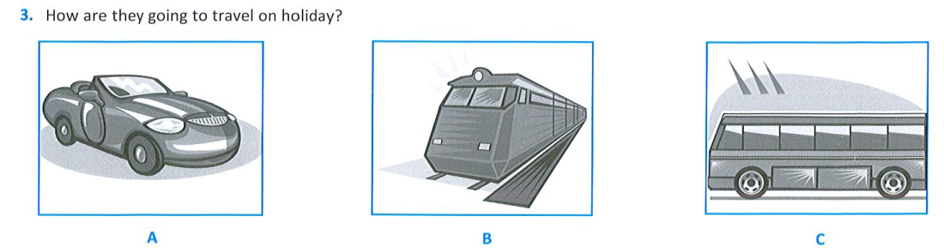

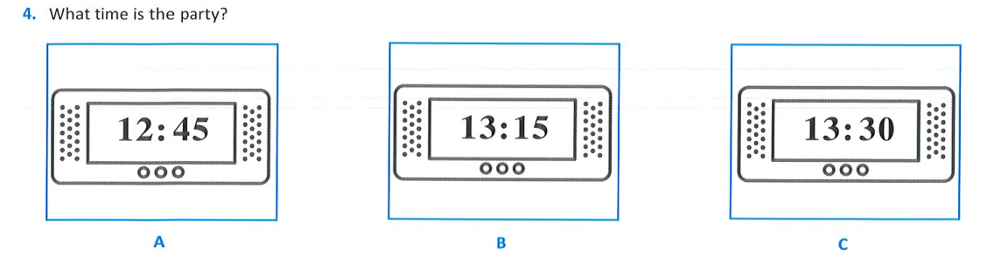

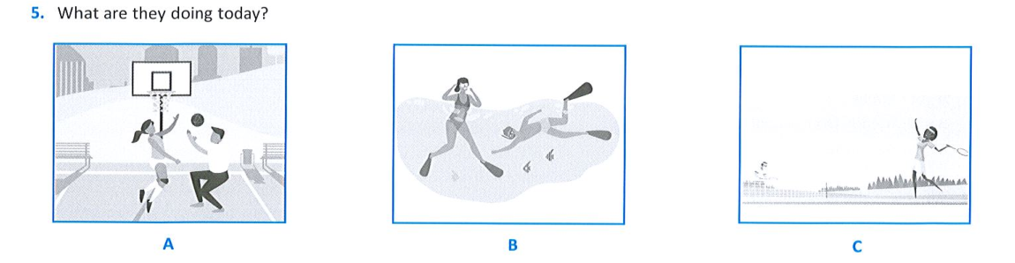

i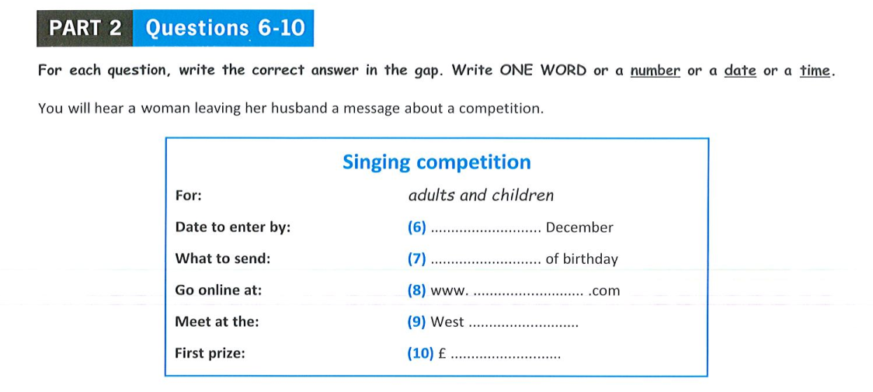

**II. LANGUAGE**

11. **Find the word which has a different sound in the part underlined** (thông hiểu)

A. earn B. first C. stir D. future

12. **Find the word which has a different sound in the part underlined** (thông hiểu)

A. January B. encourage C. ginger D. goodbye

13. Cakes in Viet Nam are normally made…………. butter, eggs and flour. (nhận biết)

A. by B. with C. of D. for

14. She has the same hobbies ………………. me. (nhận biết)

A. from B. as C. on D. of

15. My father’s hobby is playing tennis. He …. it three times a week. (nhận biết)

A. play B. plays C. playing D. to play

16. The neighbourhood was cleaned up this morning, …………… there is no rubbish now. (vận dụng)

A. although B. so C. but D. and

17. I’m interested in his paintings ……………. he is very creative in colours. (vận dụng)

A. because B. so C. although D. and

18. **Find mistake**: Her hobbies are different to mine. (thông hiểu)

A B C D

19. **Find mistake**: He loves skating and so do his brother. (thông hiểu)

A B C D

20. My sisterlikes beef. It’s her favorite ……………. (thông hiểu)

A. meat B. drink C. vegetable D. fruit

**III. Reading**

1. **Read the passage and circle T(True) or F (False)**

People drink a lot of tea. There are many kinds of tea. There is black tea. There is red tea. There is yellow tea. People drink a lot of tea in China. Some people drink it because it is good for them. It makes them healthy. Many people drink it because it tastes very good. It is delicious. People drink a lot of green tea in Japan and in Korea, too. In Viet Nam, some people especially old people like green tea. They buy green tea leaves in the market, wash them in the water and then boil them with water. People drink it when it is cold or even hot.

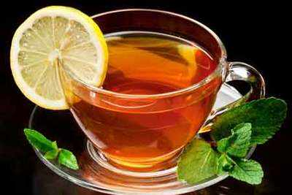 21. People drink a lot of tea. T/F (nhận biết)

22. Chinese people don’t drink tea. T/ F (thông hiểu)

23. They drink tea because it is harmful for their health. T/ F (thông hiểu)

24. Japanese and Korean both drink tea. T/ F (thông hiểu)

25. Green tea leaves are bought from the market. T/ F (thông hiểu)

**Read the letter and choose the besst option**

Charlie Chaplin was an English actor, director, producer, and composer. He is known as the most creative person of the silent-film era. Charlie Chaplin’s portrayal of the tramp won the hearts of people all over the world. Chaplin was born in London on the 16th of April, 1889. He spent his childhood in poverty and hardship. In 1910 he began to perform pantomime in the United States. He first appeared on screen in 1914. He created his world-famous character, the Tramp, and he played this classic role in more than 70 films during his career. He also composed background music for most of his films. In 1972 Chaplin received an Honorary Academy Award for 'the incalculable effect he has had in making motion pictures the art form of this century'. Chaplin died on the 25th of December, 1977, at his home in Switzerland.

**26. In 1910 he began to perform pantomime in …………(**Thông hiểu)

A. the US B. London C. Switzerland D. England

**27. When did he start appearing in films?** ( Thông hiểu)

A. In 1910 B. In 1914 C. In 1972 D. In 1977

**28. In about how many films did he play the *Tramp*?** ( Thông hiểu)

A. Seventy B. Seventeen C. Twenty-five D. Seven

**29. Charlie Chaplin is very famous for …………………...(**Thông hiểu)

A. his stage performance

B. his background music

C. his character “the Tramp”

D. the silent-film era.

**30. Which of the following is NOT true?** (Thông hiểu)

A. Charlie Chaplin was an English artist.

B. He played classical music.

C. He received an award in 1972.

D. He is a composer.

**IV. WRITING**

1. **Make meaningful sentences based on the words given below.**

31. No/ dishes/ Vietnam/ as/ famous/ Pho. ( vận dụng)

………………………………………….

32. Her/ cooking style/ much/ different/ mine. (vận dụng)

……………………………………………………

33. as/ what/ same/ I/ do / everyday/ the/ is/ today. (vận dụng)

……………………………………………………..

34. I began to play the trumpet when I was 12 years old. (vận dụng)

→ (since)

35. I thought the play would be interesting, but it was not really. (vận dụng)

→ (as)

1. **Write a short paragraph (80 - 100 words) about your hobby (1.5 pts):**

**(Name of hobby, When to start, What to need and do, Feeling, Future)**

.........................................................................................................................................

.........................................................................................................................................

.........................................................................................................................................

.........................................................................................................................................

.........................................................................................................................................

.........................................................................................................................................

.........................................................................................................................................

.........................................................................................................................................

**V. Speaking**

Topic: Introduce about your school. (thông hiểu, vận dụng)

**Keys**

**ĐÁP ÁN- BIỂU ĐIỂM CHẤM**

**ĐỀ KIỂM TRA ĐÁNH GIÁ CUỐI HỌC KỲ I**

**Năm học 2022-2023**

**Môn: TIẾNG ANH - Lớp 7**

(Đáp án này gồm có 40 câu, 02 trang)

|  |  |  |
| --- | --- | --- |
| **Questions** | **Keys** | **Marks** |
| 1. **LISTENING**   (2 points) | 1.A 2.B 3.A 4.C 5.B  6.15th 7.video 8.singpros 9.cafe  10. 180 | 0.2 for each |
| **II. Language**  (1.0 pts) | 11. D 12. D 13. A  14. B 15. B  16. B 17. A 18. D 19. C 20. A | 0.1 for each |
| **III. Reading**  (2.0 pts)  A. (1 pts)  B. (1 pts) | 21. T 22. F 23. F 24. T 25. T  26. A 27. B 28. A 29. C 30. B | 0.2 for each |
| **IV. Writing** (2pts)   1. **(1pts)**   **B. (1pts)** | 31. No dishes in Vietnam are as famous as Pho.  32. Her cooking style is much different from mine.  33. What I do today is the same as everyday.  34. I have played the trumpet since I was 12 years old.  35. The play was not as interesting as I thought (it would be).   * HS giới thiệu được sở thích của bản thân: sở thích gì, bắt đầu khi nào, thường chơi khi nào…. * Sử dụng đúng từ vựng và cấu trúc câu * Khuyến khích sáng tạo. | 0.2 for each |
| **V. Speaking (2points)** | - Hs tự tin  - Giới thiệu bản thân  - Giới thiệu được trường học của em: tên trường, lớp học….  - Vốn từ đa dạng, phong phú  - Khuyến khích học sinh sáng tạo |  |