School: ……………………………………….. | Date:……………………………………..
Class: ……………………………..................... | Period: 73

UNIT 5: TRAVEL AND TRANSPORTATION
Grammar 5b (Page 82)

1. Objectives
By the end of this lesson, students will be able to…
1.1. Language knowledge/ skills
- learn and use the comparative.
- practise doing grammar exercises.
- compare two places.
1.2. Competences
- improve Ss’ analytical, collaboration and critical thinking skills.
1.3. Attributes
- develop Ss’ patriotism, studiousness and accountability.
2. Teaching aids and materials
- Teacher’s aids: Student’s book and Teacher’s book, class CDs, IWB – Phần mềm tương tác trực quan, projector/interactive whiteboard /TV (if any), PowerPoint slides.
- Students’ aids: Student’s book, Workbook, Notebook.
3. Assessment evidence
Performance Tasks | Performance Products | Assessment Tools
- Answer the questions.  - Choose the correct answers.  - Make sentences with the comparative. | - Ss’ answers.  - Ss’ answers.  - Ss’ own sentences. | - Observation.  - Observation.  - Observation.

4. Procedures
A. Warm up: 5 minutes
a. Objectives: to introduce the comparative.
b. Content: sentences with comparative.
c. Expected outcomes: Ss have some general ideas about the comparative.
d. Organization

Teacher’s activities | Students’ activities
Answer the questions.  1. Between a horse and a cat, which is bigger?  2. Between a tree and a mountain, which is taller?  3. Between Ha Noi and Ha Giang, where is more crowded?  - Ask Ss to answer the questions.  - Check Ss’ answers.  - Explain that the answers use the comparative form. | - Answer the questions.  Answer Keys  1. A horse is bigger than a cat.  2. A mountain is taller than a tree.  3. Ha Noi is more crowded than Ha Giang.  - Listen to the teacher and take notes.

B. Presentation: 10 minutes
a. Objectives: to present the comparative and help Ss remember their uses.
b. Content: Language box.
c. Expected outcomes: Ss can understand how to use the comparative.
d. Organization
Teacher’s activities | Students’ activities
THE COMPARATIVE  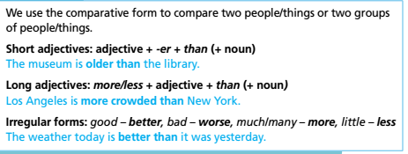  * Spelling rules  + one-syllable  adjectives + -er (long – longer)  + -e + r (nice – nicer)  + one-syllable adjectives ending in consonant + vowel + consonant: double the last consonant + -er (thin – thinner)  + two-syllable adjectives ending in consonant + -y: -y + -ier  (happy – happier)  - Ask Ss to close their books. Explain that we use the comparative form to compare two people/  things or two groups of people/things. We usually use than with comparative adjectives (e.g. Julie is shorter than John.).  - Explain that with one-syllable and two-syllable adjectives, we form the comparative by adding -er (clean – cleaner). Tell Ss that with adjectives of  more than two syllables, we form the comparative with more (exciting – more exciting).  • Explain that with some two-syllable adjectives, such as clever, narrow, gentle, friendly etc., we form the comparative either with -er or with more (e.g. gentle – gentler – gentlest or gentle – more  gentle).  - Explain that with one-syllable adjectives ending in -e, we add -r in the comparative form (e.g. nice – nicer).  - Explain that with one-syllable adjectives ending in consonant + vowel + consonant, we double the last consonant and add -er. (e.g. hot – hotter).  - Explain that with two-syllable adjectives ending in -y or -ly, we change the -y to –i and add -er. (e.g. healthy – healthier).  - Ask Ss to open their books. Go through and read out the Spelling Rules! box. Drill Ss around the class by giving them adjectives and asking for the comparative form. | - Listen to teacher’s explanation.  - Read the language box and the spelling rules.  - Take notes.

C. Practice: 15 minutes
a. Objectives: to help Ss practise the comparative.
b. Content: task 1 and task 2.
c. Expected outcomes: Ss can understand how to use the comparative, do the task correctly.
d. Organization:
Teacher’s activities | Students’ activities
Task 1: Choose the correct option.  1 Brown Street is busier than/from Main Street these days.  2 This coat is much more nice/nicer than that one.  3 To me, hoverboards are more interesting/interesting than scooters.  4 The food in Ben’s Café is tastier/more tasty than the food in Stella’s.  5 There is little/less traffic in the countryside than in the city.  6 This museum is worse/bad than the one we visited last week.  - Explain the task using IWB and give Ss time to complete it.  - Check Ss’ answers. | - Listen to teacher’s explanation and read the sentences and do the task.  - Check answers.  Answer Keys:  1. than 2. nicer 3. more interesting  4. tastier 5. less 6. worse
Task 2: Look at the table and compare the places.  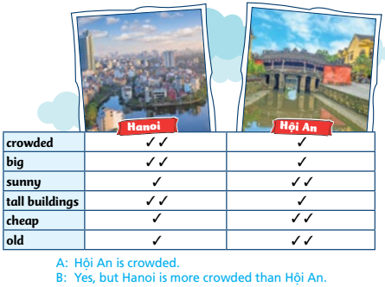  - Explain the task and read out the example.  - Give Ss time to complete it in groups.  - Check Ss’ answers using IWB. | - Listen to teacher’s explanation and read the example.  - Do the task in a small group.  - Check answers.  Suggested Answers  A: Hôi An is big.  B: Yes, but Hanoi is much bigger than Hôi An.  A: Hanoi is sunny.  B: Yes, but Hôi An is much sunnier than Hanoi.  A: Hôi An has tall buildings.  B: Yes, but Hanoi has much taller buildings  than Hôi An.  A: Hanoi is cheap.  B: Yes, but Hôi An is much cheaper than  Hanoi.  A: Hanoi is old.  B: Yes, but Hôi An is much older than Hanoi

D. Production: 10 minutes
a. Objectives: to help Ss use the target language and information in the real situation.
b. Content: Task 3.
c. Expected outcomes: Ss can make sentences to compare two places in Vietnam, using the comparative.
d. Organization

Teacher’s activities | Students’ activities
Task 3: Use the headings in the table in Exercise 2 to compare the place you live with another one in Vietnam.  - Explain the task and give Ss time to complete the task in pairs.  - Check Ss’ answers using IWB. | - Work with partner to make the comparisons, using the comparative.  - Read aloud the sentences to the class.  Suggested Answer:  Ho Chi Minh City is more crowded than  Hanoi. It is also bigger than Hanoi. It is  sunnier than Hanoi. It has taller buildings  than Hanoi. It isn’t as cheap as Hanoi. It isn’t  as old as Hanoi.

E. Consolidation and homework assignments: 5 minutes
- Grammar point: the comparative.
- Do the exercises in workbook on page 43.
- Complete the grammar note in TA7 Right On! Notebook page 37.
- Prepare the next lesson: Grammar 5b (cont., page 83).
5. Reflection

a. What I liked most about this lesson today:
…………………………………………………………………………………………
b. What I learned from this lesson today:
…………………………………………………………………………………………
c. What I should improve for this lesson next time:
…………………………………………………………………………………………

