Mã đề 6.2.62 | ĐỀ KIỂM TRA CUỐI HỌC KỲ 2  MÔN TIẾNG ANH - LỚP 6  NĂM HỌC 2022-2023  Thời gian: 60 phút - Không kể thời gian giao đề  (Đề thi gồm 4 trang)

Họ tên: …………………………….. Lớp: ………. Số báo danh:……

SECTION A: LISTENING (2 point)
I. Listen to five short recordings and for each recording you have to choose the best of three pictures (A, B C or D).(1.0point)
E.g:What’s Mary making ?
A. a cup of tea B. some sandwiches C. an icecream D. a cup of coffee
1. What’ s the weather like this morning ? (NB)
A. windy B. sunny C. raining D. cold
2. Where are Nick’s shoes now? (NB)
A. in his bedroom B. in the garden C. in the hall D. in the balcony
3. Who’s going to the shops with Daisy? (TH)
A. with her Mum B. with her friend C. with her grandpa D. with her teacher
4. What’s inside the cage ? (NB)
A. a lizard B. a snake C. bat D. a cat
5. How old is Sally’s grandmother? (TH)
A.64 B.65 C.57 D. 87
II. Listen to Kate telling Emma about her family. Tick T (True) or F (False). You will listen twice (1 point)
1. Kate’s mother is going to the hairdresser this morning. __________( NB)
2. Kake helps Tanya to buy some new shoes.___________ ( NB)
3. Both Tanya and Emma’s daughter love shopping alone. ___________( TH)
4. Len is going to the concert this evening because he enjoys classical music.__________(TH)
5. Kate’s father used to play golf ._________ (VD)
SECTION B: LANGUAGE (2 POINTS)
I. Choose the word whose underlined part pronounced differently from that of the others by circling A, B, C or D (0.4 point)
1. A. narrow B. crowd C. now D. about (NB)
2. A. spare B. play C. game D. table (NB)
II. Choose the best option (A, B, C or D) to complete these sentences. (1.6 point)
1. If you study hard, you ______________ the exam.
A. pass B.passing C. passed D.will pass (NP) (NB)
2. People ________ on Mars in the future, but it is too expensive to travel there now. (NP) (NB)
A. live B.are living C. will live D. have lived
3. My family enjoys watching game shows___ they are very exciting and interesting. (NP) (TH)
A. because B. so C. but D. and
4.VTV 1 is a _______TV channel in Viet Nam. (TV) (NB)
A. wide B. local C. national D. international
5. They think Da Lat is ________place they have ever visited. (NP) (TH)
A. more beautiful B. most beautiful
C. the most beautiful D. the more beautiful
6. Bring your umbrella - it __________ rain later. (NP) (TH)
A. can B. might C. must D. should
7. To ________ waste we should avoid buying products with a lot of packaging. (TV) (TH)
A. recycle B.reuse C. reduce D. remake
8. Mai: “ Let’s go out for a walk. It’s so beautiful today.” Nga: “____________”( LF) (TH)
A. You’re welcome B. That’s a good idea!
C. Not at all D. Yes, please
SECTION C: READING (2 POINTS)
I. Read the passage and then choose the correct answer to each question. (1 point)
My dream house is different ___________ (1) the others. I love ___________ (2) in a
motorhome. It will look like a normal truck, ___________ (3) there will be hi-tech
appliances inside. I might change my address regularly. One day I might be in a
beach. The other day I might move to the mountain. I will grow vegetable on the
windows. There will be ___________ (4) automatic cleaner, a modern dishwasher,
and a hi-tech fridge. I will install a wireless TV and Wi-Fi ___________ (5) the
weather forecast, news and entertainment programs. I love my dream house so much.
1. A. in B. from (NB) C. at D. of
2. A. living (NB) B. live C. lived D. will live
3. A. and B. so C. but (TH) D. because
4. A. a B. an (NB) C. the D. x
5. A. to do B. to take C. to give D. to watch(TH)
II. Read the passage carefully and choose the correct option (A, B, Cor D) to complete the questions. (1.0 point)
London, the capital of Great Britain and United Kingdom, is situated on the Thames River. It is one of the largest cities with a population of over 8 million. London is divided into four parts: the city, Westminster, the West End and the East End.
The city is small in area but it is the commercial heart of London. Many banks and offices are situated there. St. Paul's Cathedral in the city is very large and beautiful. It was designed in the late 17th century by Sir Christopher Wren one of the most famous English architect, and was completed in 1710. If the city is called the commercial heart of London, Westminster is the center of the administration. We can see the Houses of Parliament there. The West End with the best and most expensive clubs, restaurants and theatres, beautiful houses and parks is the place where rich people live. Working people live in the East End where there are no parks or gardens and no fine houses.
1. What is the population on London? (TH)
A. about 8 million B. over 8 million C. 8 million D. under 8 million
2. How many parts is London divided into? (NB)
A. 2 B. 3 C.4 D. 5
3.Who designed St. Paul’s Cathedral? (TH)
A. Westminster B. St. Paul C. West End D. Sir Christopher Wren
4. What is the first paragraph about ? (VD)
A. Westminster B. The West End C. London D. The city
5. Do rich people live in the East End ? (TH)
A. Yes B. No C. No information D. They live in West End.
SECTION D: WRITING (2 POINTS)
I. Find out the mistake in each following sentence. (0.4 point)
1. She usually have lunch at 11.30 a.m , and now she is having lunch. . => (NB)
A B C D
2. Nam is the taller student in his class. => (NB)
A B C D
II. Rewrite the following sentences as directed ( using the suggested words) so that the meanings stay the same. (0.6 pt)
1. What sport do you like best? (VD)
→What is ........................................................................................................
2. You don’t get a visa . You can’t visit the United Kingdom . (VD)
→If you …………………………………………………………………………………
3.Travelling by bus is cheaper than travelling by train. (VD)
→Travelling by train ..............................................................................
III. Use the given words to complete sentences of a postcard . (1 pts)
Dear Hoa,
1. We/ having/ great time/ here / Ha noi! (VD CAO)
→.......................................................................................................................
2. The weather / fire /lovely. (VD CAO)
→.......................................................................................................................
3. The food /delicious /good. (VD CAO)
→.......................................................................................................................
4. The people / friendly /hospitable. (VD CAO)
→.......................................................................................................................
5. Yesterday, we visit / museum /zoo. (VD CAO)
→.......................................................................................................................
We feel very happy. Wish you were here .
Love,
Trang

SECTION E: SPEAKING (2 POINTS)
1. Introduction: (NB)
Introduce yourself with basic information (name, class, age, hobby, family, etc.)(0.5 point)

2. Each of you will now receive a card. On the card there is a picture and clues for five questions. You should use the words to make questions and ask your friend. Your friend will answer the questions based on the picture he/she has. (1.0 points) ( TH+ VD)
Use the words given below to make questions. Ask your friend about his/her picture and listen to the answers
1. What type of future house do you think it will be ?
2. Who will you live with in it?
3. Where will it be ?
4. What will it looklike ?
5. How many rooms will it have ?

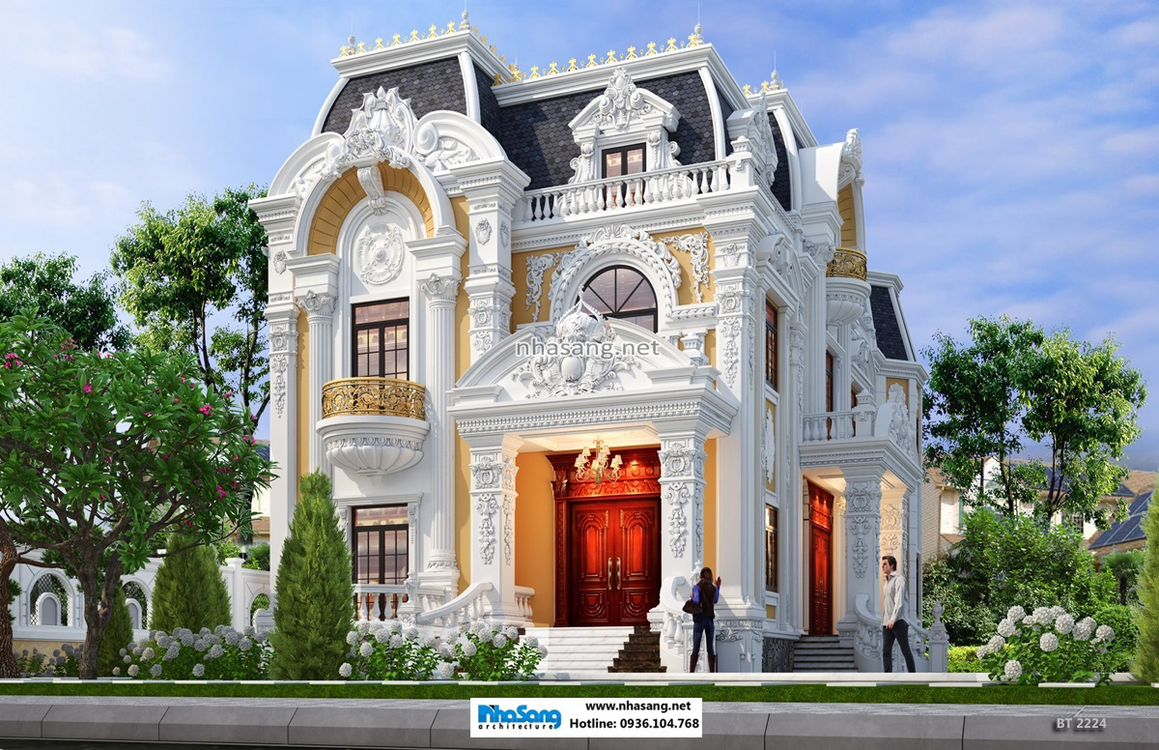

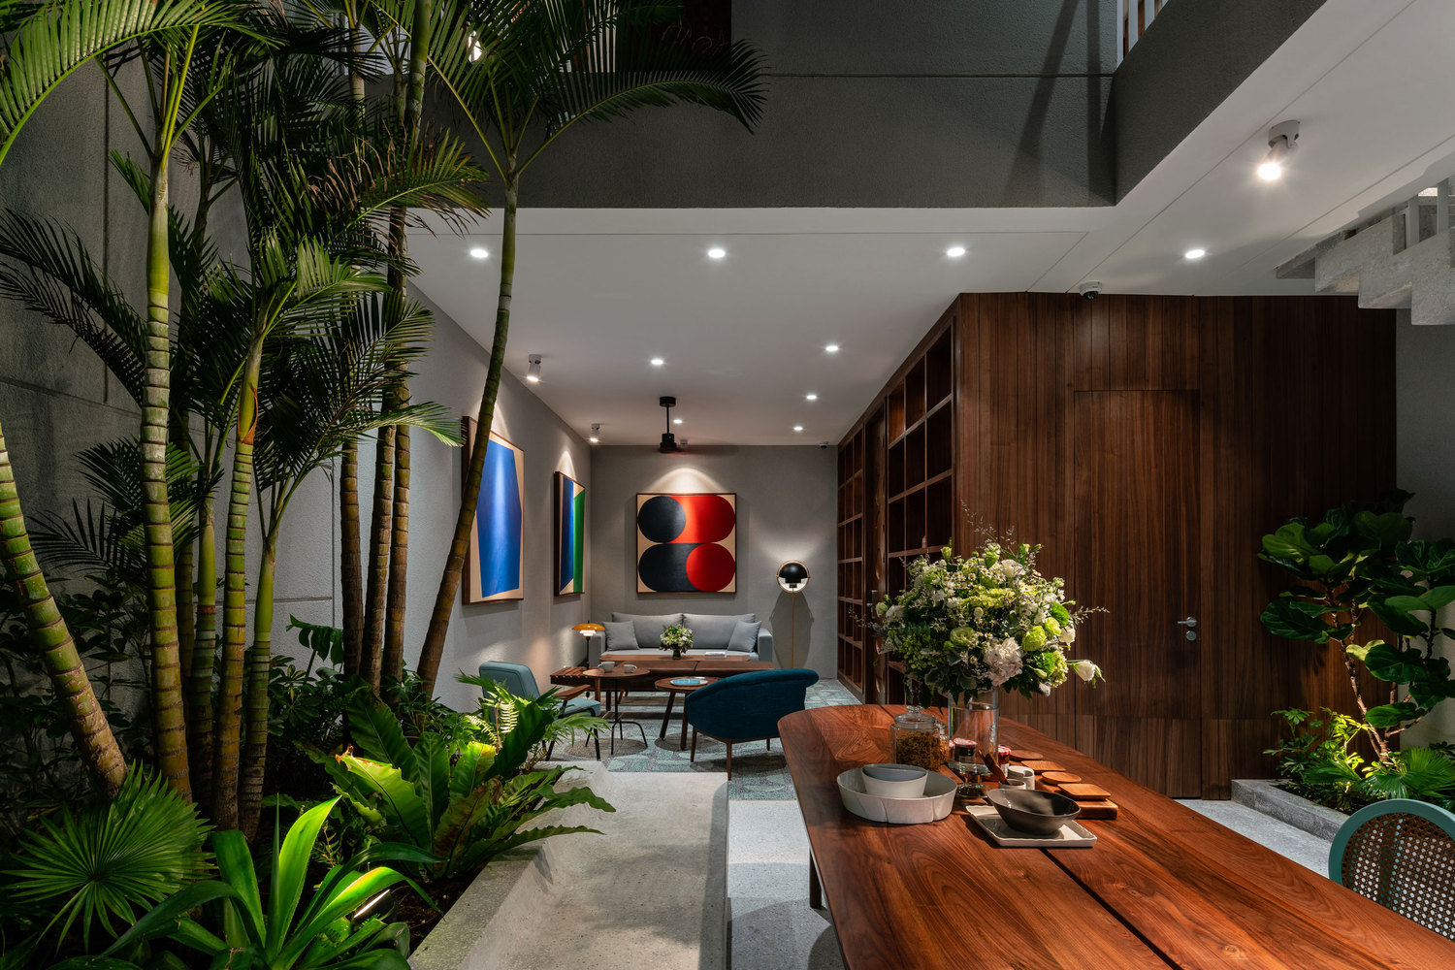

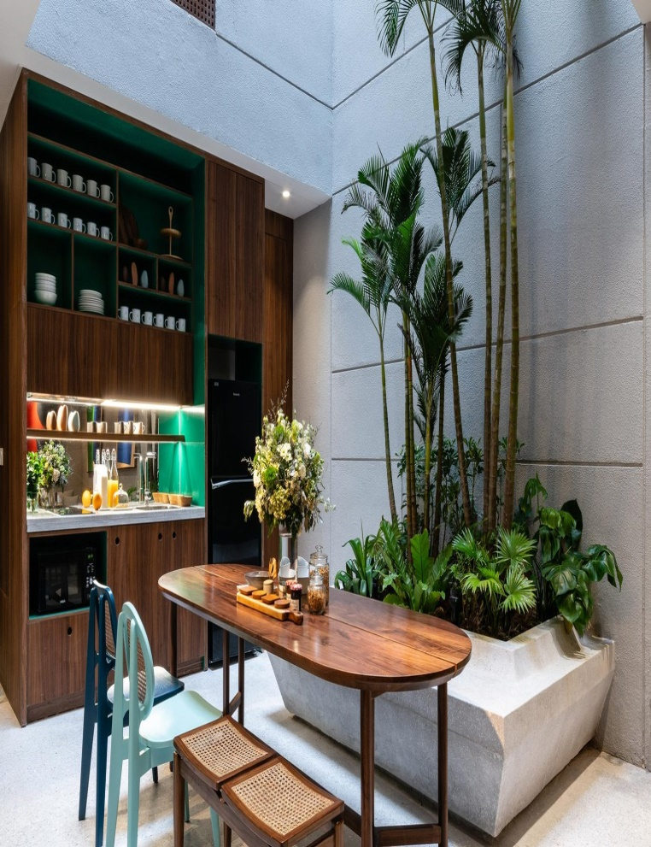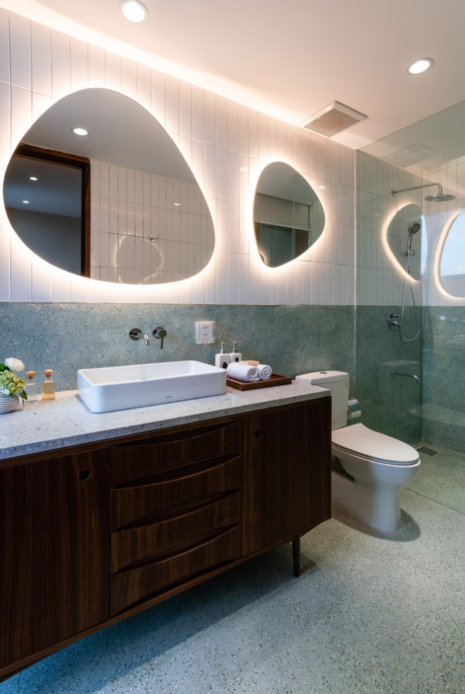
3. Answer further questions (0,5 point) (VD cao)
- Ask sts some questions that relate to the future house.

ANSWER KEY
SECTION A: LISTENING (2 point)
I.Listen to five short recordings and for each recording you have to choose the best of three pictures (A, B C or D).(1.0point)
1- C 2- B 3- A 4- B 5- A
Task 2: Listen to Mira talking about her neighborhood. Tick T (True) or F (False). You will listen twice (1 point)
1. F
2. T
3. F
4. T
5. T
SECTION B: LANGUAGE (2 POINTS)
I. Choose the word whose underlined part pronounced differently from that of the others by circling A, B, C or D (0.4 point)
1. A 2. C
II. Choose the best option (A, B, C or D) to complete these sentences. (1.6 point)
1. D 2. C 3. A 4. D 5. C 6. B 7. C 8. B
SECTION 3: READING (2 POINTS)
I. Read the passage and then choose the correct answer to each question. (1 point)
1. B 2. A 3. C 4.B 5. D
II. Read the passage and choose the correct answer for each question (1 point)
1. B 2.C 3.D 4.C 5. B
SECTION D: WRITING (2 POINTS)
I. Find out the mistake in each sentence. (0.4 point)
- A 2. B
II. Rewrite the following sentences as directed ( using the suggested words) so that the meanings stay the same. (0.6 point)
1. What is your favourite sport?
2. If you don’t/ do not get a visa, you can’t/ cannot visit the United Kingdom.
3.Travelling by train is more expensive than travelling by bus.
III. Use the given words to complete sentences of a postcard . (1 pts)
Dear Hoa,
1. We’re having a great time here in Ha noi!
2. The weather is fire and lovely.
3. The food is delicious and good.
4. The people are friendly and hospitable.
5. Yesterday, we visited the museum and the zoo
We feel very happy. Wish you were here .
Love,
Trang
* Tapesrcipt.
Task1:
E.g:What’s Mary making ?
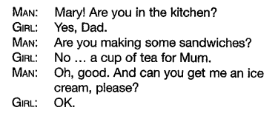
1. What’ s the weather like this morning ?
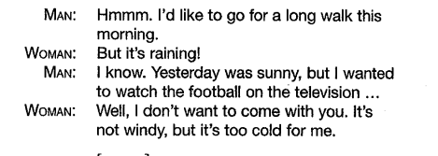
2. Where are Nick’s shoes now?
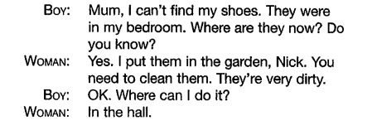
3. Who’s going to the shops with Daisy?
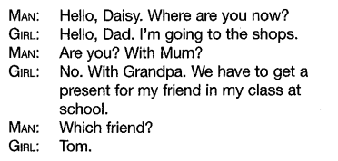
4. What’s inside the cage ?
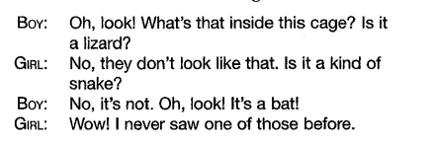
5. How old is Sally’s grandmother?
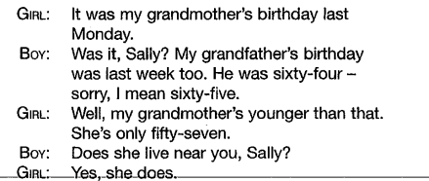
Task2:

