**LỚP HỌC THẦY (CÔ) ___________________________** **ĐỀ ÔN TẬP: READING SIGNS/ NOTICES – A2**

**Test 6**

*Thời gian làm bài: [Time]*

Họ và tên: ________________________________________________ Lớp: 9/___

**Nội dung:**

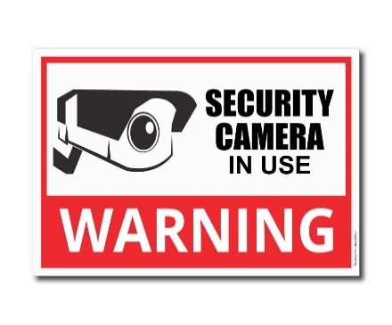**Question 1:** What does the sign say?

**A.** Security cameras are not being used in this area**.**  
**B.** Security cameras are watching and recording in this area**.**  
**C.** There are no security cameras around this building.  
**D.** Security cameras are only active during the night.

**Question 2:** What can't theatre customers do?

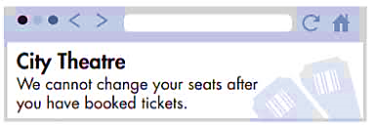

**A.** ask for different seats after they've paid **B.** choose where they sit before they book

**C.** get their money back on tickets. **D.** buy tickets at the City Theatre

**Question 3:** What does the sign say?

**A.** You are allowed to take photos in this area**.**  
**B.** Photography is not allowed in this area at any time.  
**C.** You can take photos if you have permission.  
**D.** Taking photos is encouraged and permitted here.

**Question 4:** Why has Josh sent this message?



**A.** to ask George to go camping with him next weekend**.**

**B.** to ask if George will lend him some camping equipment.

**C.** to tell George about a new tent he's going to buy.

**D.** to tell George to buy a tent

**Question 5:** What does the sign say?

**A.** You can get assistance and help at this location.  
**B.** This desk is closed and cannot provide any help.  
**C.** Help is not given at this location right now.  
**D.** This desk is only for the use of staff members.

**Question 6:** Which information is **correct** from the announcement?

Art workshop

Saturdays 10.30 – 12.30

From 15 September for 5 weeks

Suitable for all abilities

**A.** There will be five workshops each week.

**B.** You don't have to be talented to go to the workshops

**C.** The final workshop is on Saturday 15 September

**D.** The workshop is for good painters.

**Question 7:** Which information is correct from the announcement?

**Announcement:**  
*Library Hours  
Monday - Friday: 9 AM - 6 PM  
Saturday: 10 AM - 4 PM  
Closed on Sundays*

**A.** The library is open every day of the week. **B.** The library closes at 6 PM on weekdays.

**C.** The library opens at 9 AM on Saturdays. **D.** The library is open on Sundays.

**Question 8:** What does the sign say?

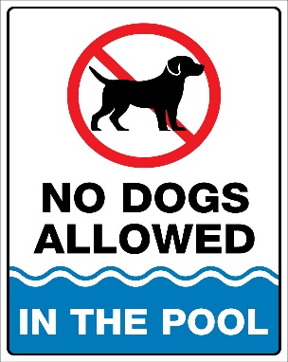

**A.** Dogs are always allowed to be in the pool area**.**  
**B.** Dogs are not usually allowed in the pool area, but there are exceptions.  
**C.** Dogs can swim in the pool whenever they like.  
**D.** Dogs cannot be in the pool area at any time.

**Question 9:** Which information is correct from the announcement?

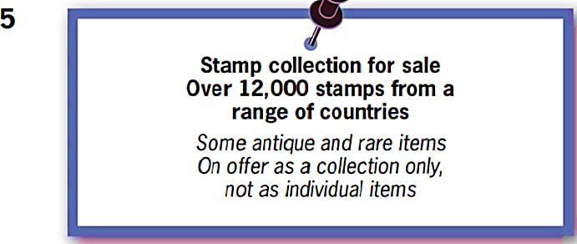

**A.** The stamps are all very old**.** **B.** Some of the stamps are very unusal.

**C.** You can buy just a few of the stamps. **D.** You can buy any single stamp.

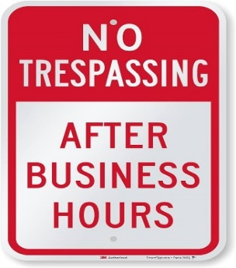**Question 10:** What does the sign say?

**A.** You are allowed to enter this area at any time.  
**B.** Do not enter this area after the designated hours.  
**C.** Entry is only allowed during regular working hours.  
**D.** You cannot enter this area, even with special permission.

**[HẾT]**