Week:  Period: | Date of planning:  Date of teaching:

UNIT 12: LIFE ON OTHER PLANETS

Lesson 2: A closer look 1
I. OBJECTIVES
By the end of this lesson, Ss will be able to:
1. Knowledge
- Use the words related to outer space.
- Use intonation for making lists correctly.
2. Competences
- Be collaborative and supportive in pair work and team work
- Access and consolidate information from a variety of sources
- Actively join in class activities
3. Personal qualities
- Promote planets in solar system.
- Develop knowledge about other planets.
II. MATERIALS
- Grade 8 textbook, Unit 12, Getting started
- Computer connected to the Internet
- Projector / TV/ pictures and cards
III. PROCEDURES
1. WARM-UP (5 mins)
a. Objectives:
- To create an active atmosphere in the class before the lesson
- To lead into the new unit.
b. Content:- Introduce about the solar system.
c. Expected outcomes:
- Ss have general ideas about the solar system.
d. Organisation

TEACHER’S AND STUDENTS’ ACTIVITIES | CONTENTS
Lucky number  - Teacher divides class into 2 groups.  - The teacher gives ss some numbers with questions about solar system and lets them answer their answers on the mini-board. The team has the most correct answers will get the star.  Ss do the task in groups. | Question:  - How many planets do we have in our solar system?  - Is the sun a planet or a star?  - Have humans ever walked on Mars?  - How many moons (including moonlets) does Saturn have?  - Which galaxy is the Earth found in?  Answer keys:  - 8 planets 2.A star  3.No/Not yet. 4.150  5.Milky Way Galaxy

2. ACTIVITY 1: PRESENTATION (15 mins)
a. Objectives: - To present some vocabulary related to the outer space.
b. Content:
- Vocabulary Study (crater, galaxy, rocket, telescope, UFO, Jupiter, Mars, Mercury, Neptune, Uranus, Venus)
c. Expected outcomes:
- Ss know how to pronounce new words correctly and use them in appropriate situations.
d. Organisation

TEACHER’S AND STUDENTS’ ACTIVITIES | CONTENTS
Vocabulary Pre-Teaching
- Teacher introduces the vocabulary by:  + Providing the definition of the words  + Providing the pictures of the words  -Teacher asks sts to match the words with the given pictures and check their answers  - Teacher asks students for the Vietnamese meanings of these phrases.  - Ss say the words.  - Other Ss correct if the previous answers are incorrect.  - Teacher shows and says the words aloud and asks Ss to repeat them | Vocabulary:  Galaxy (n) ngân hà  Telescope (n) kính viễn vọng  UFO (n) vật thể bay k xác định  Jupiter (n): Mộc tinh  Mars (n) Hoả tinh  Mercury (n) Thuỷ tinh  Neptune (n) Hải vương tinh  Uranus (n) Thiên vương tinh  Venus (n) Kim tinh
Task 1: Put the eight planets in order from the closest to the farthest from the sun. (Ex 1,p.126)
- T read out the name of each planet and asks Ss to repeat it in chorus. Then calls some Ss to read out the names of the planets. Correct their pronunciation mistakes if needed.  WC do the task in chorus.  - T has Ss work individually to put the eight planets in order from the closest to the farthest from the sun.  Ss do the task individually.  - Let Ss work in pairs to compare their answers before sharing their answers to the class. Check and confirm the correct answers. Call on some Ss to say the names of the eight planets in Vietnamese.  Ss compare answer in pairs. | Answer keys:  1. Mercury 2. Venus 3. Earth  4. Mars 5. Jupiter 6. Saturn  7. Uranus 8. Neptune
Task 2: Match the words (1 - 5) with the pictures (a - e). (Ex 2,p.126)
- T has Ss individually match the words given to the pictures in the right column.  Ss do the matching individually.  - Then T asks Ss to check their answers with their partners. If needed, provide translation of some of the words given to check their understanding.  Ss answer individually.  - With a stronger class, ask Ss to make some examples with the words they have learnt. If there is enough time, ask some Ss to write their answers on the board. | Answer keys:  1. e 2. d 3. a 4. b 5. c

3. ACTIVITY 2: PRACTICE (5 mins)
a. Objectives:
- To help Ss use the words related to outer space that they have learnt in Activity 2 in specific contexts.
b. Content:- To fill in the blanks with right words.
c. Expected outcomes:- Students can understand words relate to outer space
d. Organisation

TEACHER’S AND STUDENTS’ ACTIVITIES | CONTENTS
Task 3. Complete the following sentences with the words from the box. (5 mins) (Ex 3, p.126)
- T asks Ss to do the exercise individually  Ss do the task individually.  - T and WC check the answer.  - When checking, T asks Ss to refer to Activity 2 to make the meanings of the words clearer to them. | Answer key:  - craters 2. rocket 3. telescope  4. Venus 5. galaxy

4. ACTIVITY 3: PRONUNCIATION (18 mins)
a. Objectives: – To teach Ss the use of intonation to make lists of people or things;
– To help Ss practice using intonation for making lists.
– To give Ss practice in identifying tones in sentences that include lists of people or things;
– To give Ss practice in using intonation for making lists.
b. Content:
- To practice intonation for making lists.
- To listen and repeat the sentences.
- Listen and practice the conversation.
c. Expected outcomes:- Students can use intonation correctly.
d. Organisation

TEACHER’S AND STUDENTS’ ACTIVITIES | CONTENTS
Pronunciation: Intonation for making lists (5 mins)
- Teacher teaches sts how to use intonation correctly.  - Teacher lets Sts look at the remember box in p.126.  - Teacher demonstrates and lets sts practice.  Ss practice individually or in pairs. | 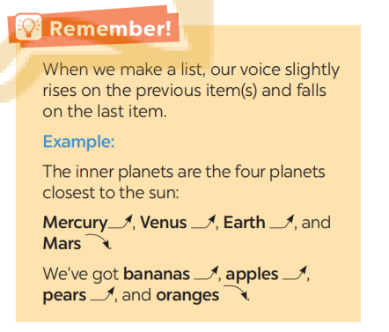
Task 4. Listen and repeat the sentences. Pay attention to the tones of the underlined words in each sentence. (6 mins) (Ex 4, p.127)
- T explains to Ss how to make a list by playing part of the conversation in GETTING STARTED that includes a sentence in which a list is made: “It’s about four creatures Titu, Kaku, Hub, and Barb”. Ask Ss to pay attention to the intonation of the sentence. Ask them to give comments.  - T has Ss read through the instructions and the example in the Remember! box. Answer any questions and ensure that Ss understand the instructions. Calls on some Ss to read out the example. Comments and corrects mistakes.  Ss do the task individually  - T plays the recording as many times as necessary.  WC listen  - T calls on some Ss to read out the sentences. Invite comments from other Ss and correct any mistakes if available.  Ss practice individually. | Audio script – Track :76  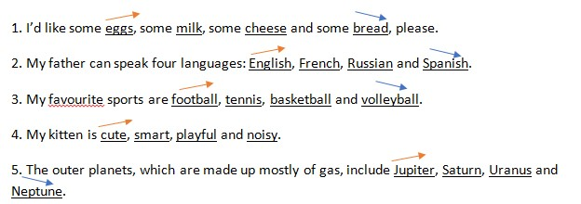
Task 5: Listen to the conversations. Do you think the voice goes up or down on the underlined words in each second sentence? Draw a suitable arrow (↗ or ↙ ) on each underlined word(7 mins) (Ex 5, p.127)
- T has Ss quickly read the four conversations. Then play the recording for Ss to draw appropriate arrows to indicate the rising and falling intonations of the underlined words in each response of the conversations.  Ss listen and do the task individualy.  - T invites some Ss to share their answers. Confirms the correct ones. Calls on some pairs to read the conversations out loud. Comments and corrects any mistakes.  Ss answer individually. | 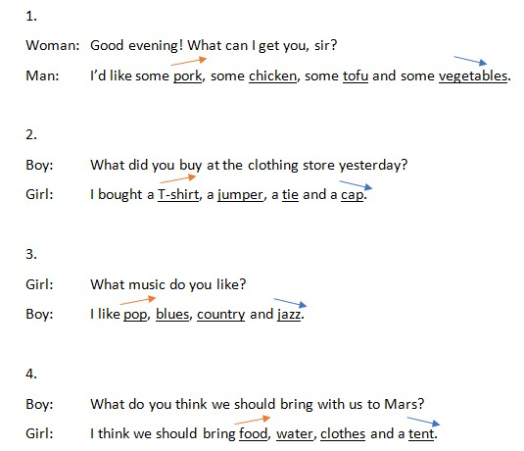  Key + Audio script – Track 27:

5. CONSOLIDATION
a.Wrap-up - Ask one or two Ss to summarise what they have learnt.
- Draw Ss’ attention to the objectives on the board or show them the slide with the objectives.
- Tick the objectives that have been covered
b. Homework
- Learn new words by heart.
- Practice using intonation
- Prepare the next lesson: Unit 12 – Lesson 3: A closer look 2
(Ask Ss to get information about reported speech with questions and review reported speech with statements.)

