Tiếng Anh 6 i-Learn Smart World - Unit 10.1
Time allotted: 60
PART 1. Pronunciation (4 questions)
Question 1. Choose the word whose underlined part is pronounced differently.
1. A. three B. there C. these D. they
2. A. weather B. together C. mother D. author
Question 2. Choose the word that has a different stressed syllable from the rest.
3. A. statue B. downtown C. palace D. landmark
4. A. expensive B. vacation C. attraction D. capital
PART 2. Vocabulary and Grammar (12 questions)
Choose the best option (A, B, C or D) to complete each of the following sentences.
5. Last year, I visited Buckingham ______________. Queen Elizabeth and the royal family live there sometimes.
A. Palace B. Tower C. Park D. Museum
6. The ______________ of King Leonidas of Sparta in Greece is bigger and taller than a real man.
A. tower B. bridge C. statue D. museum
7. Disneyland is one of the biggest ______________ in the USA. It’s full of magic, roller coasters and entertainment for all ages.
A. museums B. amusement parks C. shopping malls D. buildings
8. The Leaning Tower of Pisa is one of Italy’s most famous ______________.
A. attraction B. building C. malls D. landmarks
9. The weather here is ______________ than in my hometown. It’s too cold here.
A. worse B. better C. worst D. best
10. I think people in Brazil are ______________ people in the UK.
A. the friendliest B. more friendly C. friendlier than D. the most friendly
11. The Dragon ______________ is one of the most popular tourist attractions in Da Nang. It is 666m long and crosses the Han river.
A. statue B. bridge C. tower D. park
12. I think the British Museum is ______________ museum in London.
A. the more popular B. more popular C. popular D. the most popular
13. I ______________ Camden, the most famous street market in London if I ______________ time.
A. will visit/ have B. visit/ will have C. visit/ have D. will visit/ should have
14. A: What is the largest country in the world?
B: ______________
A. Russia is larger than China.
B. Russia is a large country.
C. I think Russia is the largest.
D. There are many large countries in the world
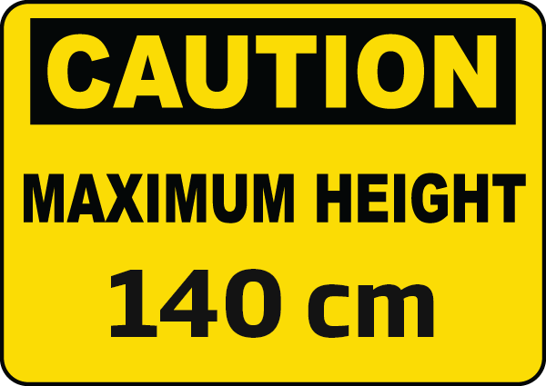
15. What does the sign mean?
A. This roller coaster is 140cm high.
B. You have to be 140 cm tall to ride on this roller coaster.
C. If you are shorter than 140 cm, you can’t ride on this roller coaster.
D. If you are taller than 140 cm, you can’t ride on this roller coaster.
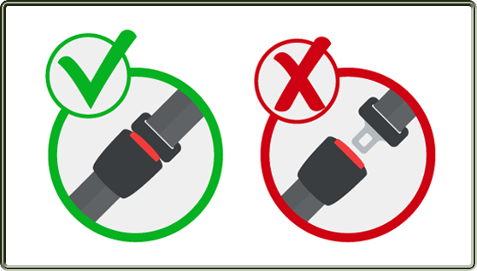
16. What does the sign mean?
A. You must keep your seat belt fastened.
B. You can wear your seat belt if you want.
C. It’s not good to fasten your seat belt.
D. You need to bring a seat belt.
PART 3. Word Formation (6 questions)
Question 1. Write the correct forms of the words in the brackets.
17. China is the most ___________ country in the world with more than 1,4 billion people. (POPULATION)
18. According to World Air Quality, China is more ___________ than Vietnam. (POLLUTION)
19. The downtown area of Shanghai is always ___________ with hundreds of people, visitors, cars, buses and taxis. (CROWD)
20. Living in the countryside is more ___________ than in big cities. (PEACE)
21. Beijing, the capital of China, is an interesting city; it has the most popular tourist attractions and the ___________ restaurants and cafés in the country. (GOOD)
22. It’s ___________ to live in big cities than in the countryside. (NOISE)
PART 4. Listening (10 questions)
Question 1. Listen to two students talking about some cities in the USA and complete the notes. Write NO MORE THAN TWO WORDS AND/OR A NUMBER for each blank. (5 questions)
CITIES IN THE USA
(23)___________is the most populated cities in the USA with about (24)___________ people in 2019.
The 25 (25) ___________ city is Buford City. (26) ___________ there.
New York is also the most (27) ___________city the country.
Question 1. You will hear Kathryn and Tom talking about a vacation. Listen and match the information with the places. (5 questions)
28. The Royal Palace a. It’s near the opera house.
29. Dam square b. Kathryn will stay there if the weather is not good.
30. The opera house c. It’s a beautiful place where visitors can walk around.
31. The park d. It is very crowded on Saturdays and Sundays.
32. The hotel e. You have to buy tickets to visit this place.
PART 5. Reading (10 questions)
Question 1. Read passage and write short answers to the following questions. (5 questions)
My name is Akiko and I was born in Tokyo – the capital of Japan. The city is huge with a population of 14 million people, but it is one of the safest cities in the world. The most beautiful time of year is from March to April, when the famous cherry blossom is on the trees. If you come to Tokyo, remember to visit the Imperial Palace. Guided tours last about 75 minutes and are available daily except on Sundays and Mondays. At the moment, I’m studying in London – the capital of England. London is home to about 8.9 million people. With hundreds of castles, museums, gardens, theaters and cinemas, London is one of the most popular destinations to visit in the world. The best time to go to London is between March and May when the temperatures are pleasant and the city’s parks are green and blooming.
33. When can visitors see cherry blossom in Tokyo?
→___________
34. Can visitors take guided tours in the Imperial Palace every day?
→ ___________
35. Which city is more populated, Tokyo or London?
→ ___________
36. Which city is safer, Tokyo or London?
→ ___________
37. Which city has more visitors, Tokyo or London?
→ ___________
Question 2. Read the information in the notes and complete the passage about Shanghai. For each question, write NO MORE THAN TWO WORDS and/or A NUMBER. (5 questions)
Where on the east coast of China
Population 24 million, bigger than New Zealand
Temperature 1℃ (January) – 32℃ (July)
Famous destinations - the Bund – traditional part of the city
- Shanghai World Financial Center – second tallest building in China
Shanghai is the most populated city in China with more than (38)___________ people. More people live in this city than in the entire country of (39) ___________. It is located on the (40) ___________ of China on the Huangpu River. The hottest month is July and the coldest month is (41) ___________. One of its most famous tourist sites is the Bund – the older part of the city with traditional houses built by the French. Another popular attraction is the Shanghai World Financial Center. This is the (42) ___________ skyscraper in China. Visitors can take an elevator to the top of the building to enjoy the amazing views of the Bund and the Huangpu River.
PART 6. Writing (8 questions)
Question 1. Anna is going to spend her vacation in Paris. Look at her plans, use the given words to write complete sentences. (4 questions)
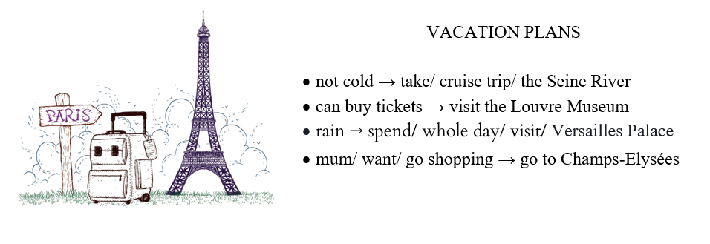
43. Anna will take ___________
44. If she can ___________
45. If it ___________
46. They will ___________
Question 2. Rewrite the following sentences without changing the meaning.
47. Hurry or you will be late for the performance.
→ If you don’t___________
48. If we can’t buy tickets for the British museum, we will go to Kensington Gardens.
→ Unless___________
49. The Nile is longer than any other river in the world.
→ The Nile is___________
50. The average temperature in Sydney is 18.3℃ and the average temperature in Toronto is 7.4℃.
→ Toronto is___________
---THE END---

