Họ tên thí sinh: .................................................................
Số báo danh: ......................................................................
Mã Đề: 027.
Câu 1. Where does Rafa suggest meeting Mark instead of the café?
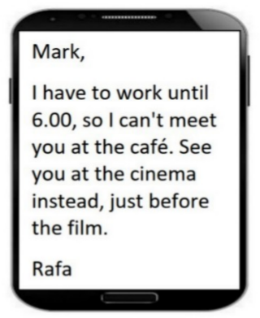
A. At work B. At the cinema C. At home D. At a restaurant
Câu 2. What is the main reason Emma cannot attend Dorothy's birthday party?
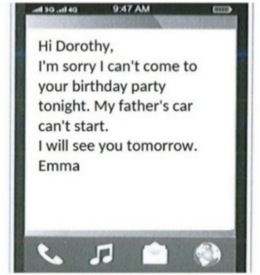
A. She has another commitment B. She is sick
C. Her father's car won't start D. She forgot about the party
Câu 3. What does the sign say?

A. Smoking is not permitted here. B. Smoking is optional here.
C. Smoking is useful here. D. Smoking is compulsory here.
Câu 4. What is the purpose of the charity event on November 10 at the Hilton Hotel?
You're invited to join us for our charity event on November 10 at 7 pm at the Hilton Hotel. We'll have a silent auction, live music, and cocktails, with all proceeds going towards supporting the homeless in our community. We hope you can make it!
A. To celebrate the end of the year B. To support the homeless in the community
C. To raise money for a political campaign D. To promote a new product
Câu 5. Look at the signs. Choose the best answer for the question.
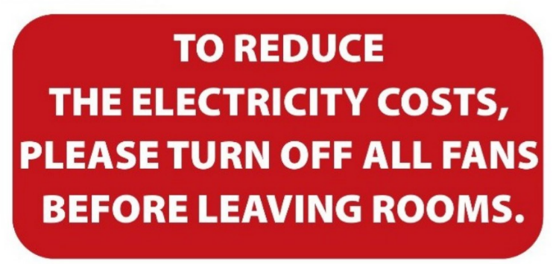
A. Please switch off fans when you finish using a room to save electricity.
B. When you leave, please reduce the number of fans in your room.
C. Please reduce the costs of electricity by leaving the room.
D. Please leave the fans in the room after you go out.
Câu 6. Who is Andrew planning to go to the cinema with?
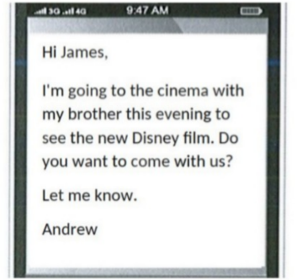
A. His parents B. His brother C. Alone D. James
Câu 7. What alternative does Missie suggest if Tess can't lend her laptop?
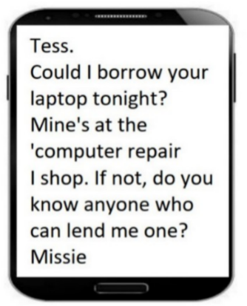
A. Using a desktop computer B. Asking Tess to help with her work
C. Finding someone else who can lend a laptop D. Going to an internet cafe
Câu 8. Look at the signs. Choose the best answer for the question.
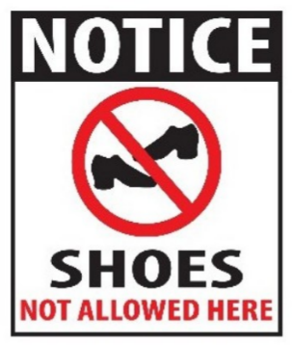
A. Please take off your shoes when entering this place.
B. You don’t have to wear shoes in this place.
C. You can’t buy any shoes in this place.
D. Please put on your shoes when entering this place.
Câu 9. What activity is being proposed in the message?
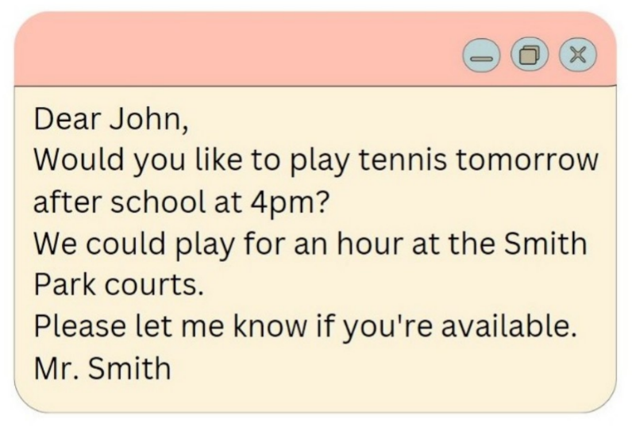
A. Playing basketball B. Going swimming C. Going for a run D. Playing tennis
Câu 10. Look at the signs. Choose the best answer for the question.
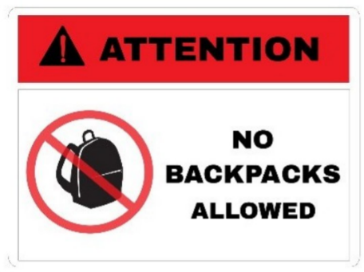
A. Backpacks are not allowed in this area without your attention.
B. You shouldn’t carry a backpack when you’re in this area.
C. You cannot bring your backpacks into this area.
D. You must pay attention when you bring a backpack.
----HẾT---

