TIẾNG ANH 8 – FRIENDS PLUS
REVIEW (UNITS 3 – 4) – TEST 2
I. PRONUNCIATION
Câu 1. Which word has the underlined part pronounced differently from that of the others?
A. wave B. danger C. label D. yacht
Đáp án đúng: D
A. wave /weɪv/
B. danger /ˈdeɪndʒə/
C. label /ˈleɪbl/
D. yacht /jɒt/
Câu 2. Which word has the underlined part pronounced differently from that of the others?
A. bite B. club C. climb D. label
Đáp án đúng: C
A. bite /baɪt/
B. club /klʌb/
C. climb /klaɪm/
D. label /ˈleɪbl/
Câu 3. Which word has a different stress pattern from that of the others?
A. typical B. newspaper C. canyon D. underground
Đáp án đúng: D
A. typical /ˈtɪpɪkl/
B. newspaper /ˈnjuːzpeɪpə/
C. canyon /ˈkænjən/
D. underground /ˌʌndəˈɡraʊnd/
Câu 4. Which word has a different stress pattern from that of the others?
A. caterpillar B. spectacular C. participate D. Australia
Đáp án đúng: A
A. caterpillar /ˈkætəpɪlə/
B. spectacular /spekˈtækjələ/
C. participate /pɑːˈtɪsɪpeɪt/
D. Australia /ɒˈstreɪliə/

II. Choose the answer (A, B, C or D) that best fits the space in each question.
Câu 5. This chapter deals mainly ______ food security and agricultural development in sub-Saharan Africa.
A. to B. for C. with D. about
Đáp án đúng: C
Câu 6. Rachel Ridley enjoys her own ______ when she is travelling, but she is still looking for partners to join her journey around the world.
A. company B. factory C. pharmacy D. bakery
Đáp án đúng: A
Câu 7. You’d better have a shower ______ a bath to reduce the amount of water you waste.
A. in case of B. because of C. in spite of D. instead of
Đáp án đúng: D
Câu 8. ______ form when wind blows sand into a sheltered area behind an obstacle.
A. Valleys B. Dunes C. Caves D. Falls
Đáp án đúng: B
Câu 9. One of the main advantages of underground ______ is that less space is required to achieve the same level of productivity.
A. farm B. farms C. farmer D. farming
Đáp án đúng: D
Câu 10. Jennifer ______ the bedroom. It looks lovely.
A. has been redecorating B. has redecorated C. is going to redecorate D. is redecorating
Đáp án đúng: B
Câu 11. Which one is incorrect?
A. She’s read 10 books this summer. B. An email has been written to you by Sam.
C. Tennis has been being played for an hour. D. Jackie has been working for Google for 10 years.
Đáp án đúng: C
Câu 12. You are interested in protecting the environment, ______?
A. aren’t you B. are you C. do you D. don’t you
Đáp án đúng: A
Câu 13. Don’t forget to check the fridge, ______?
A. shall we B. do you C. is it D. will you
Đáp án đúng: D
Câu 14. Phoenix: “______” – Mandy: “Let’s get that one, then.”
A. It’s only $30. B. I’ve been busy. C. I love it, too. D. How much is it?
Đáp án đúng: A

III. Look at each sign or notice. Choose the best answer (A, B, C or D) that matches its meaning.
Câu 15. On which item can you see the logo?
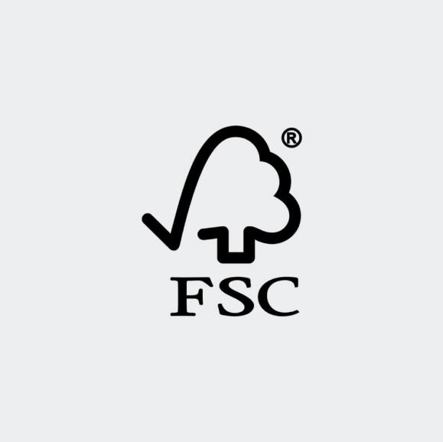
A. recyclable containers at home B. packages made from recycled material
C. plastic bottles that can’t be recycled D. wood products from well managed forests
Đáp án đúng: D
Câu 16. What will happen from 15 September?
Snow Valley
CLOSED
due to winter storm and blizzard
Re-opens 15 September
Early-bird special: 35% OFF

A. The resort will be struck by winter storm. B. Snow Valley will close for maintenance.
C. Tourists will get a discount for early booking. D. Tourists must take guided tours.
Đáp án đúng: C

IV. Read the following and do as directed.
One of the essential high-tech products to promote the green movement is the multi-functional solar lamp. Powered by the energy of the sun, the LED lamp fits to several needs in multiple usages including lighting, warning in accidents or natural disasters and killing pests. It is integrated with basic features of an ultra-modern gadget: light yet robust, portable and waterproof; therefore, it is suitable for outdoor activities. The biggest advantage is the ability to be used in places without direct sunlight. The lighting time runs between 18 and 24 hours on a full battery charge so that the lamp can run all night after a day of average sunlight.
True/False Questions:
Câu 17. The light is designed only for lighting.
A. True B. False
Đáp án đúng: B
Câu 18. The light runs on petroleum.
A. True B. False
Đáp án đúng: B
Câu 19. The light is suitable for activities in the open air.
A. True B. False
Đáp án đúng: A
Câu 20. The long lighting time is the lamp’s key strength.
A. True B. False
Đáp án đúng: A
Choose the correct answer to each question:
Câu 21. What is not mentioned as a characteristic of the lamp?
A. weighing a lot B. easy to carry C. not likely to break D. not damaged by water
Đáp án đúng: A
Câu 22. What can be inferred from the passage?
A. The green movement has increasingly become popular in Viet Nam.
B. The lighting can be chosen as flashing or stable light from type options.
C. The item helped prevent natural disasters in the past.
D. Fully charged, the lamp can be used on a cloudy day.
Đáp án đúng: D

V. Choose the word (A, B, C or D) that best fits each blank space in the following passage.
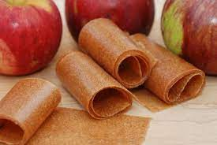
APPLE LEATHER
With the hope of replacing animal skins and saving natural (23) ______ that are running out, Alberto Volcan, an Italian inventor, (24) ______ up with the idea of creating an eco-friendly material, that is, apple leather. Unlike synthetic material made from (25) ______ fuels, apple leather is a bio-based material coated onto a cotton and polyester canvas. The resultant fabric is durable but soft, (26) ______ is perfect for hardwearing small accessories.
What makes apple leather special is that it is made from the apple waste. In most cases, the apple pomace and peel in the fruit juice and confectionery industry ends (27) ______ in landfills. Recycling the waste (28) ______ the CO2 impact significantly compared to artificial leather.
Câu 23. Choose the correct answer.
A. colours B. measures C. resources D. ingredients
Đáp án đúng: C
Câu 24. Choose the correct answer.
A. put B. came C. threw D. went
Đáp án đúng: B
Câu 25. Choose the correct answer.
A. fossil B. nature C. solar D. gasoline
Đáp án đúng: A
Câu 26. Choose the correct answer.
A. that B. which C. what D. why
Đáp án đúng: B
Câu 27. Choose the correct answer.
A. up B. by C. off D. with
Đáp án đúng: A
Câu 28. Choose the correct answer.
A. reuses B. resumes C. renews D. reduces
Đáp án đúng: D

VI. Supply the correct form of the word given in each sentence.
Câu 29. The government is trying to ______ as many reforestation projects as possible with the aim of planting billions or trillions of trees. (MATERIAL)
Đáp án đúng: materialize / materialise
Câu 30. Trees are going to be planted in our neighbourhood to keep the air pure and ______. (POLLUTE)
Đáp án đúng: unpolluted
Câu 31. Oscar has a ______ passion for recycling. He loves spending his leisure time separating and packaging rubbish into different categories. (CONSUME)
Đáp án đúng: consuming
Câu 32. The living room was ______ furnished with antiques. (EXPENSE)
Đáp án đúng: expensively
Câu 33. ______ skills are the ability to identify problems, brainstorm, analyze answers and implement the best solutions. (SOLVE)
Đáp án đúng: problem-solving
Câu 34. A frequent source of ______ in the office is the seat. I wish it would be replaced by a beanbag chair. (COMFORTABLE)
Đáp án đúng: discomfort

VII. Rearrange the groups of words in a correct order to make complete sentences.
Câu 35. minimize the effects / that measures / of global warming. / It’s important / be taken to

Đáp án đúng: It’s important that measures be taken to minimize the effects of global warming.
Câu 36. an exploratory expedition / It’s / up the Amazon. / my dream / to go on

Đáp án đúng: It’s my dream to go on an exploratory expedition up the Amazon.

VIII. Rewrite each of the following sentences in another way so that it means almost the same as the sentence printed before it.
Câu 37. Being able to hold your breath for a long time is what you need to play underwater hockey. (MUST)
In order
Đáp án đúng: In order to play underwater hockey, you must be able to hold your breath for a long time.
Câu 38. Is the electronic skateboard used to get to school more quickly? (FOR)
Can we
Đáp án đúng: Can we use the electronic skateboard for getting to school more quickly?
Câu 39. Why is eating insects a good idea? (Use indirect question)
I don’t know why
Đáp án đúng: I don’t know why eating insects is a good idea.
Câu 40. You have lost your door key twice.
This is
Đáp án đúng: This is the second time you have lost your door key.

------ HẾT ------

